**Trigger OpenShift Build After GitHub Repository Update**

**General Discussion**

If the OpenShift deployment is created from GitHub repository, we’d like to update the OpenShift build after the GitHub repository is updated. This is achieved by either defining a GitHub Webhook or manually running a build.

**References**

<https://docs.openshift.com/container-platform/4.4/builds/triggering-builds-build-hooks.html>

**Create a GitHub webhook to trigger a build automatically when the change is pushed to GitHub**

Create GitHub Webhook from oc

oc describe bc/userreg

This generates a webhook GitHub URL:

https://api.us-east-2.starter.openshift-online.com:6443/apis/build.openshift.io/v1/namespaces/dannyproject/buildconfigs/userreg/webhooks/<secret>/github

OpenShift Web Console

Administrator Perspective

Builds - Build Configs – userreg

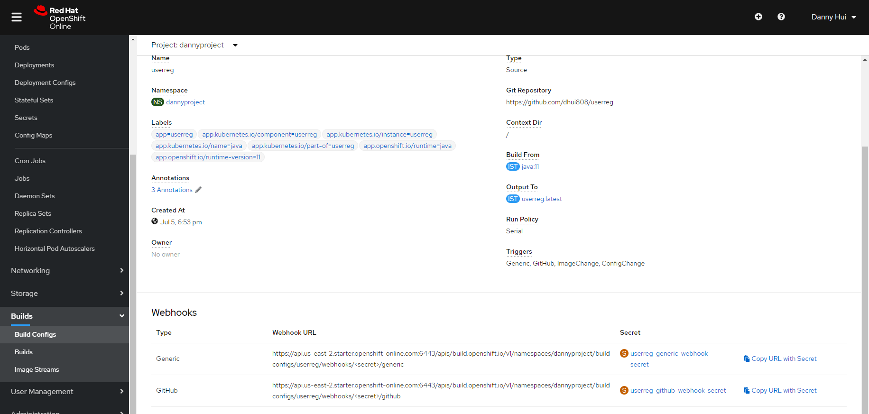

Click Copy URL with Secret (GitHub)

In your GitHub repository, select **Add Webhook** from **Settings → Webhooks**

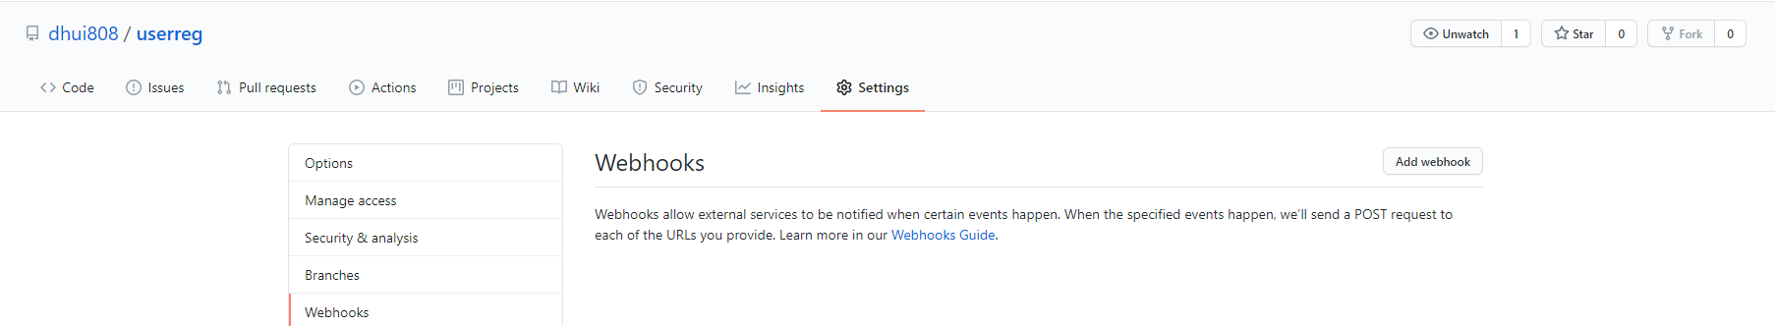

Paste the URL into the **Payload URL** field

Change the Content Type to application/json

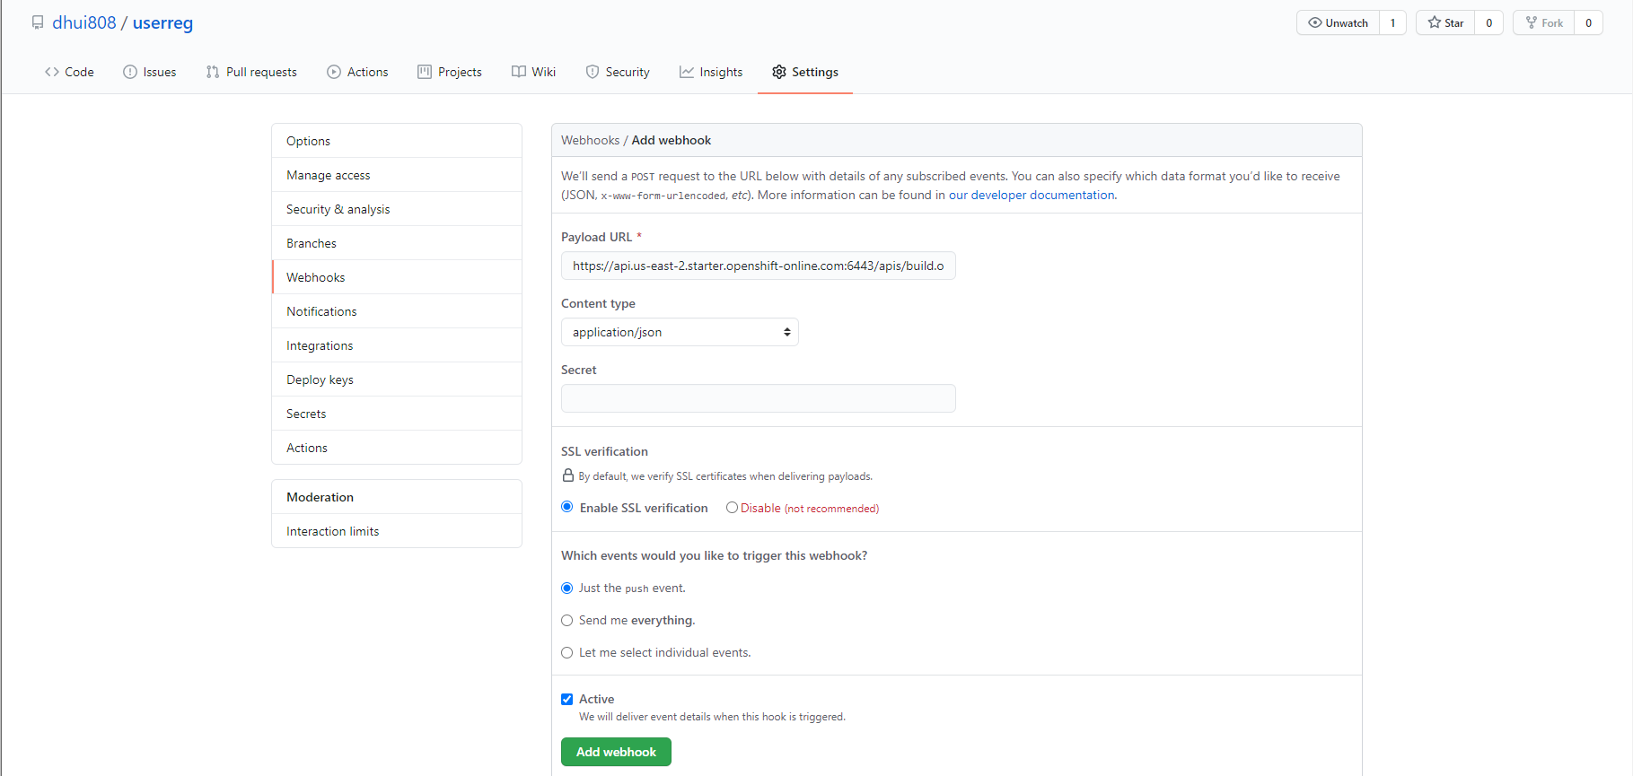

Click Add webhook

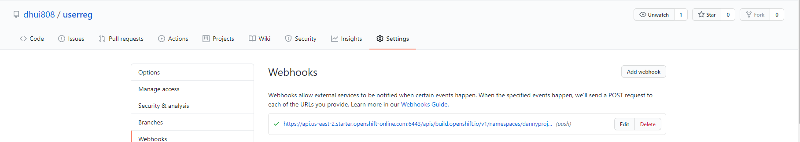

**Manually trigger the build**

Builds - Build Configs – userreg – Actions – Start Build

**Test new build with curl**

curl -X POST -d @testdata/register1.json http://userreg-dannyproject.apps.us-east-2.starter.openshift-online.com/user/register --header "Content-Type:application/json"

curl -X GET http://userreg-dannyproject.apps.us-east-2.starter.openshift-online.com/users/findAll --header "Content-Type:application/json"

curl -X DELETE http://userreg-dannyproject.apps.us-east-2.starter.openshift-online.com/user/1 --header "Content-Type:application/json"