Login to OpenShift

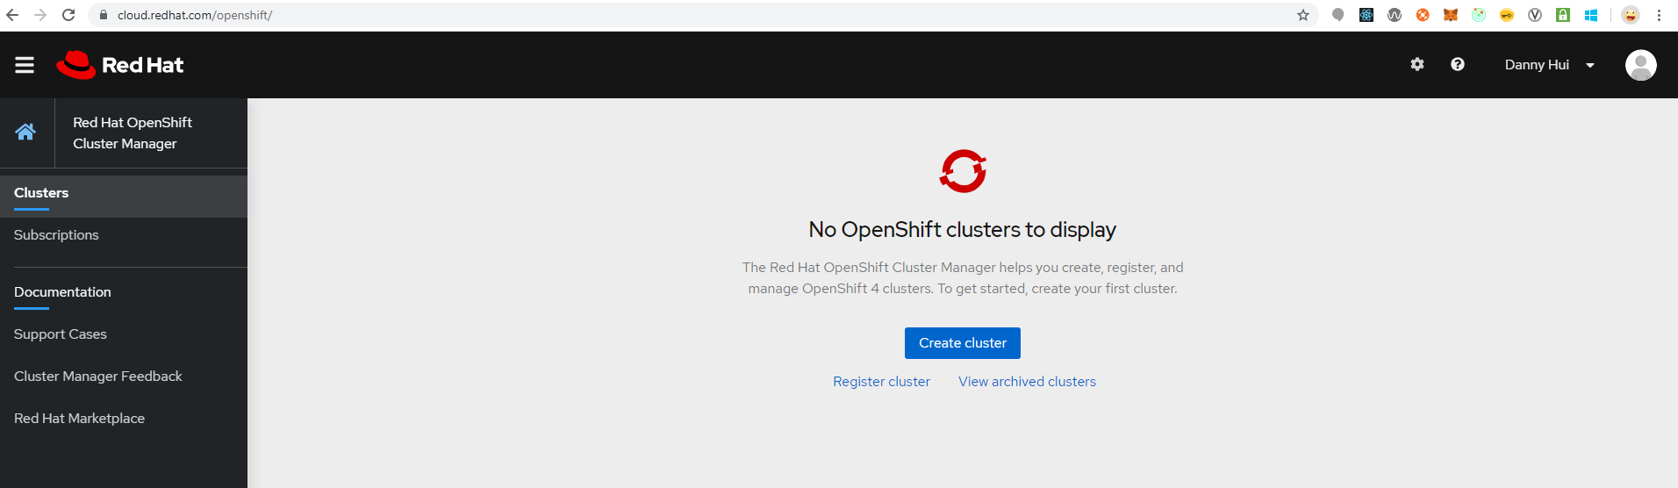

Click Create cluster

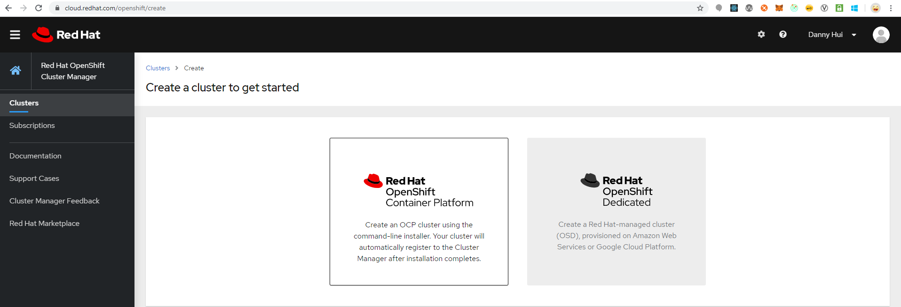

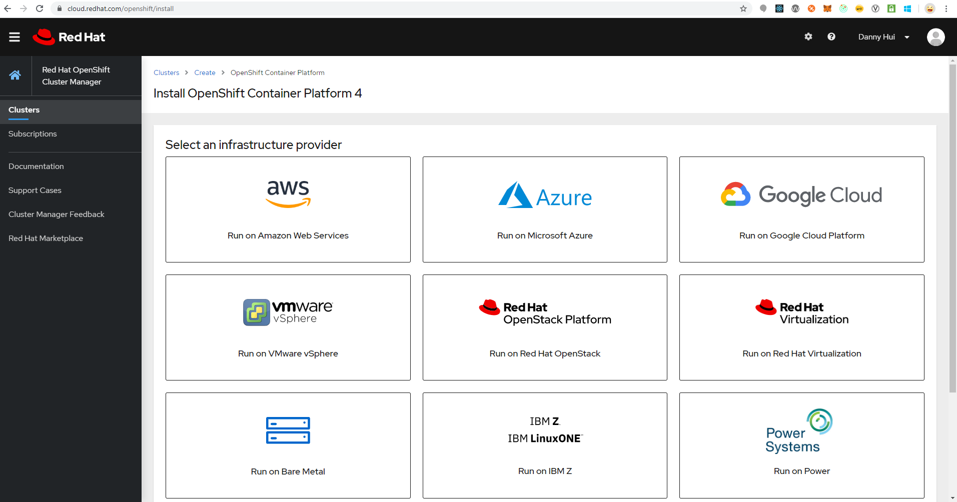

Click Azure

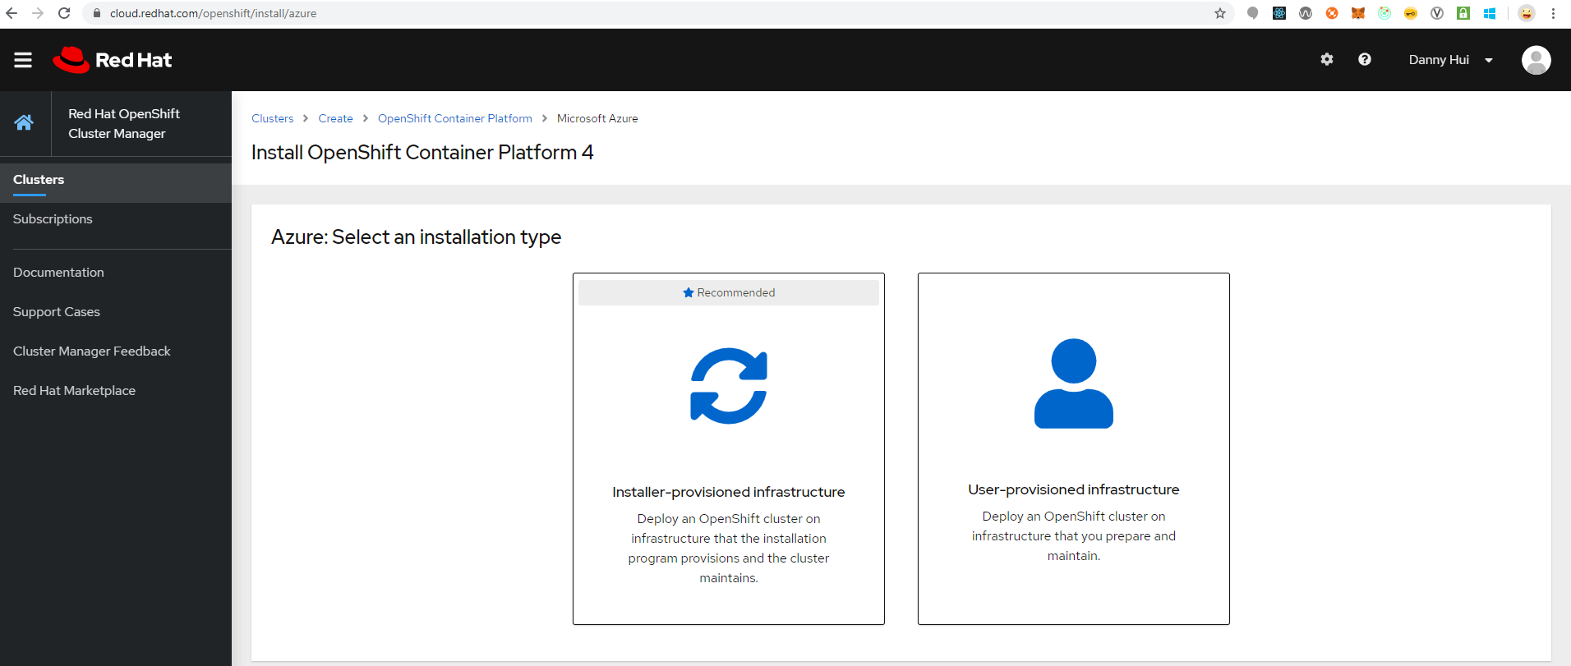

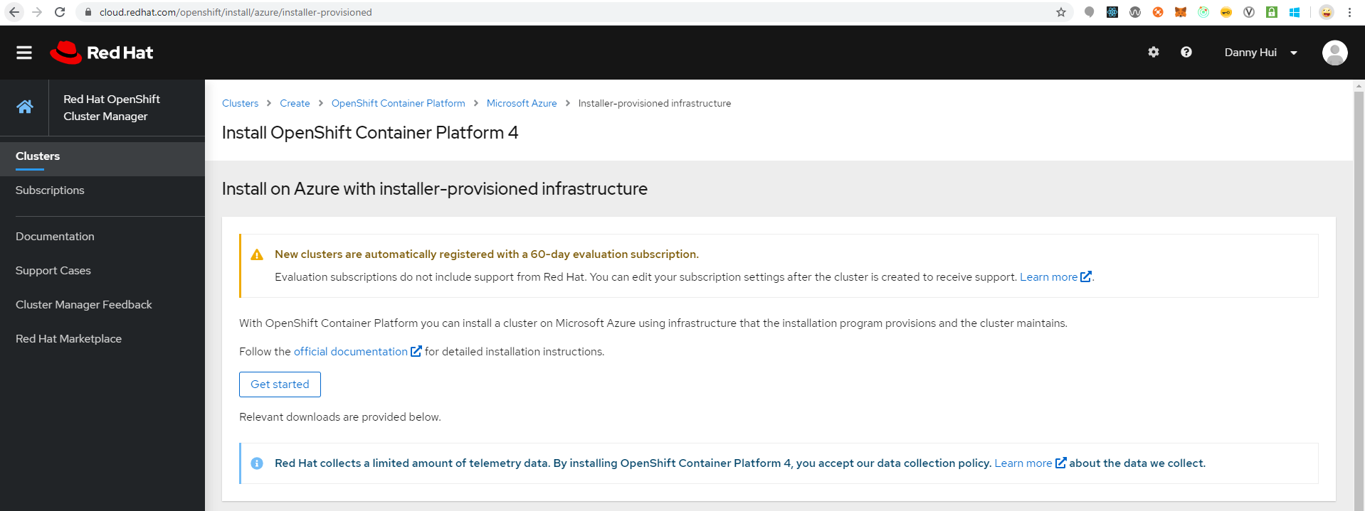

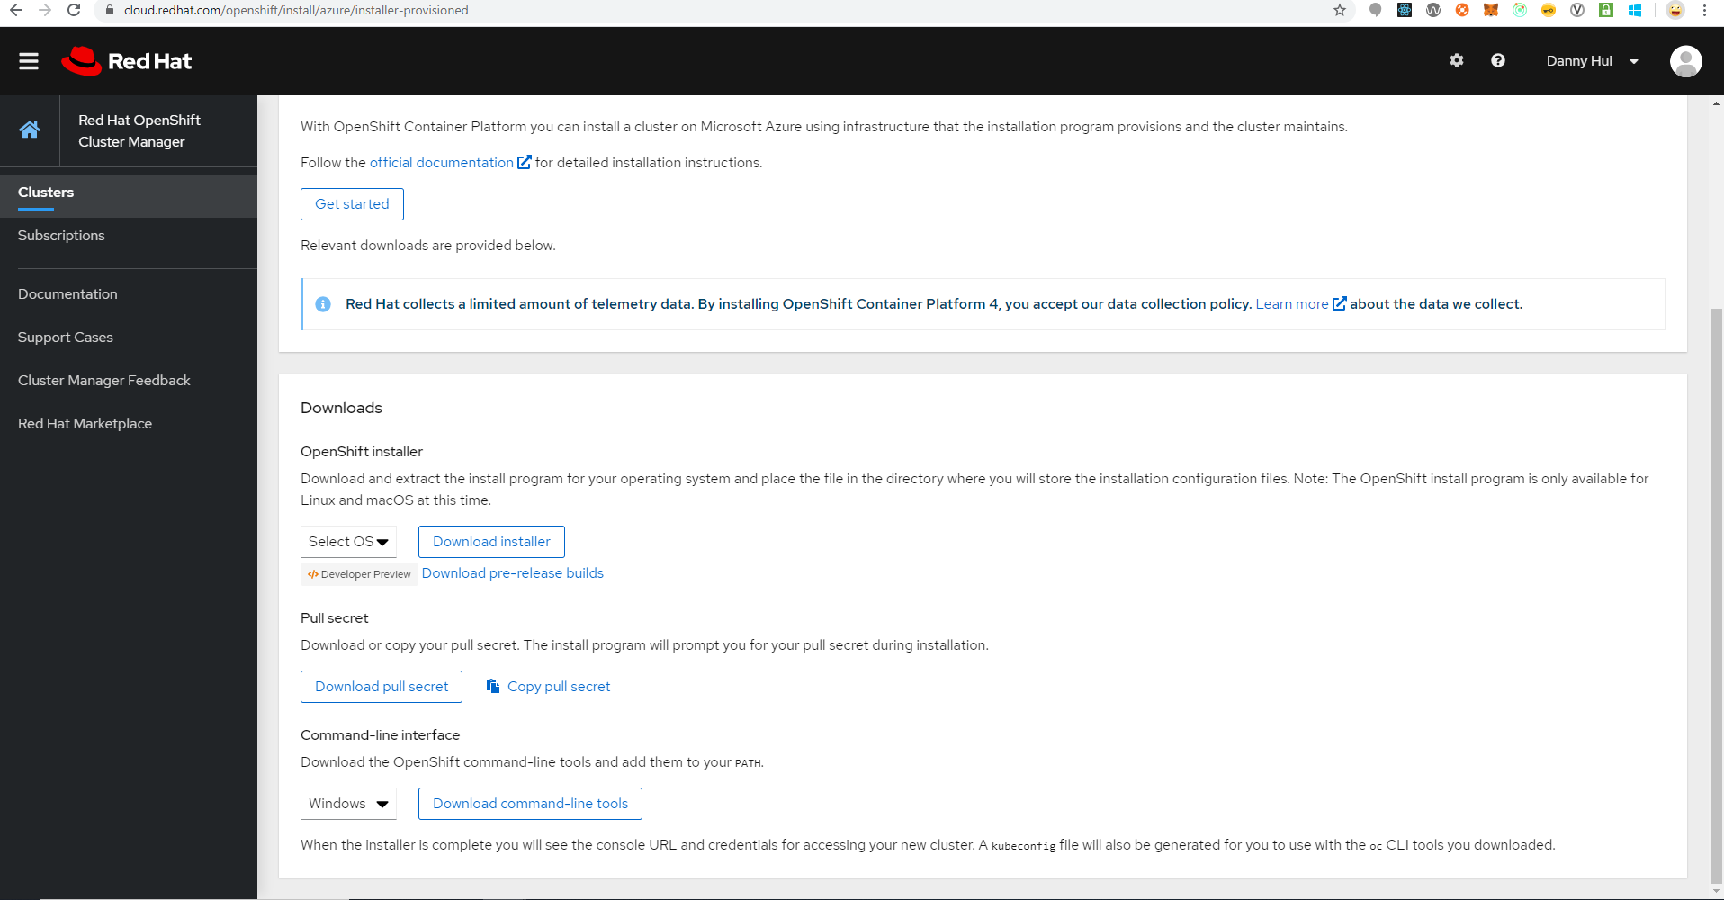

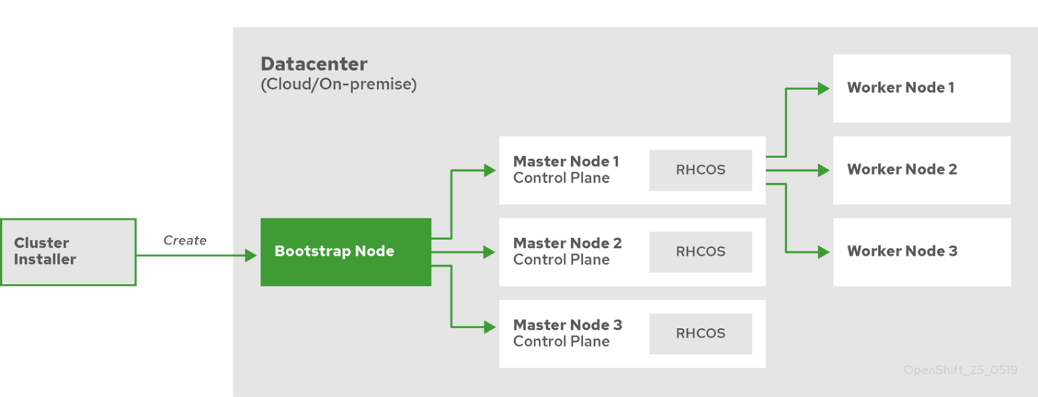

Installing a cluster quickly on Azure

## Obtaining the installation program

download the installation file on a local computer

## Deploying the cluster

* Configure an account with the cloud platform that hosts your cluster.
* Obtain the OpenShift Container Platform installation program and the pull secret for your cluster.
* Run the installation program

./openshift-install create cluster --dir=<installation_directory> \

--log-level=info

Provide values at the prompts:

### Installing the CLI

## Logging in to the cluster