Deploy Database – OpenShift 3.11

OpenShift 3.11
Brower Catalog – Databases - MySQL
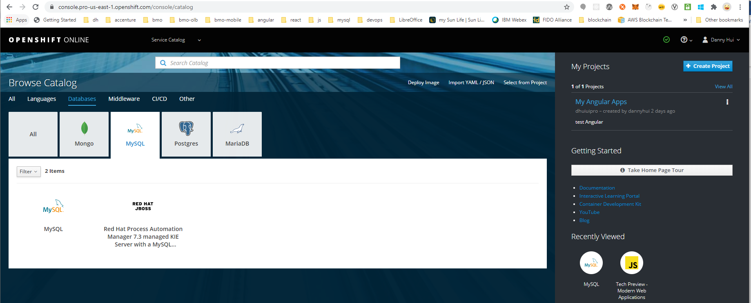
MySQL
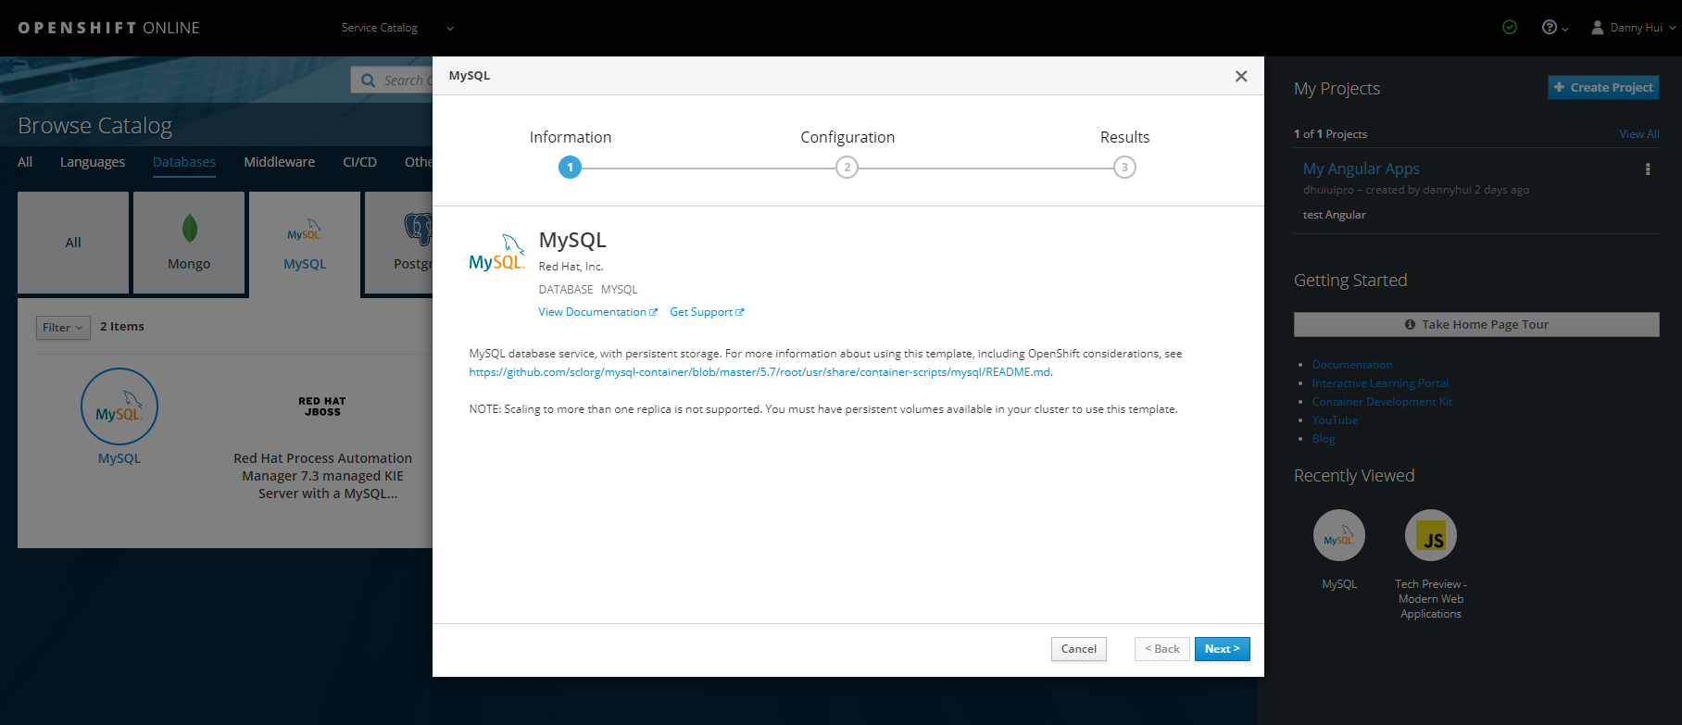
Next
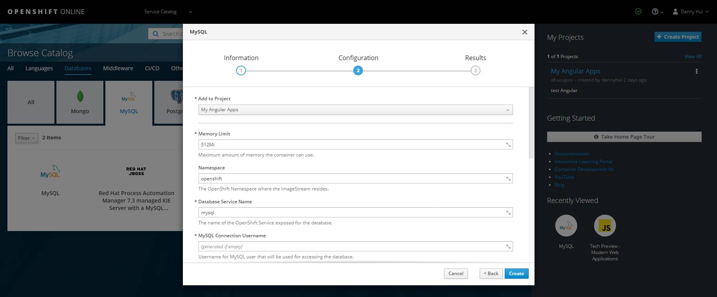
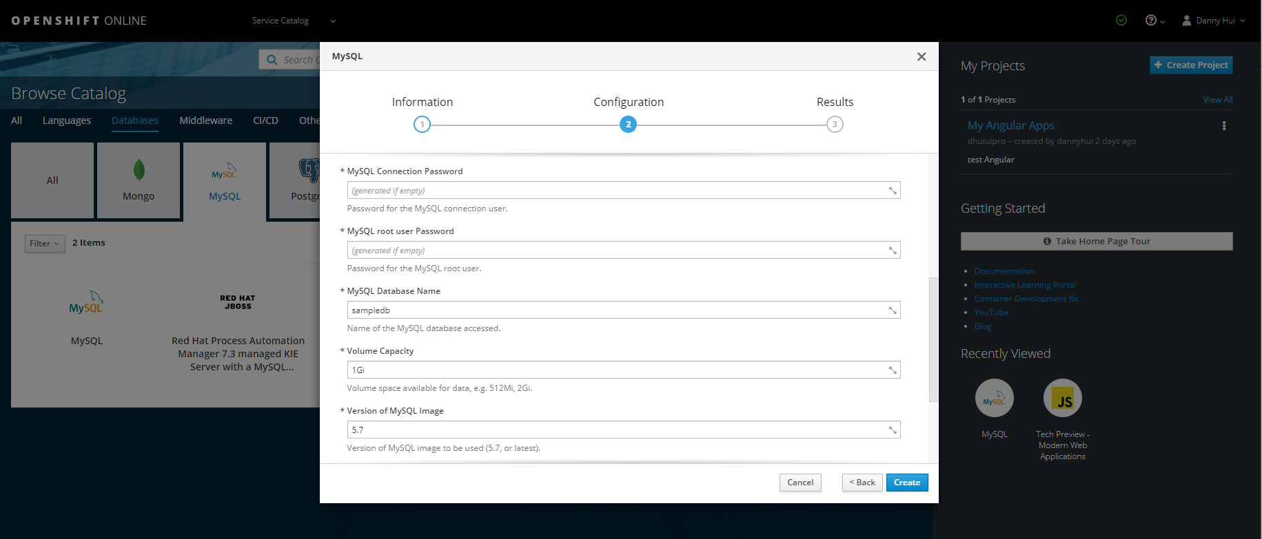
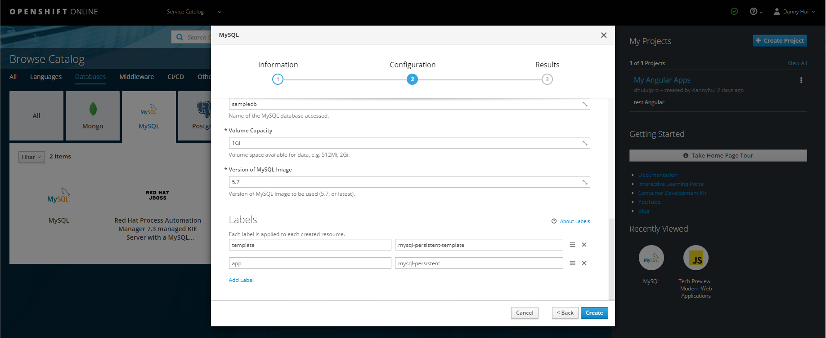Create
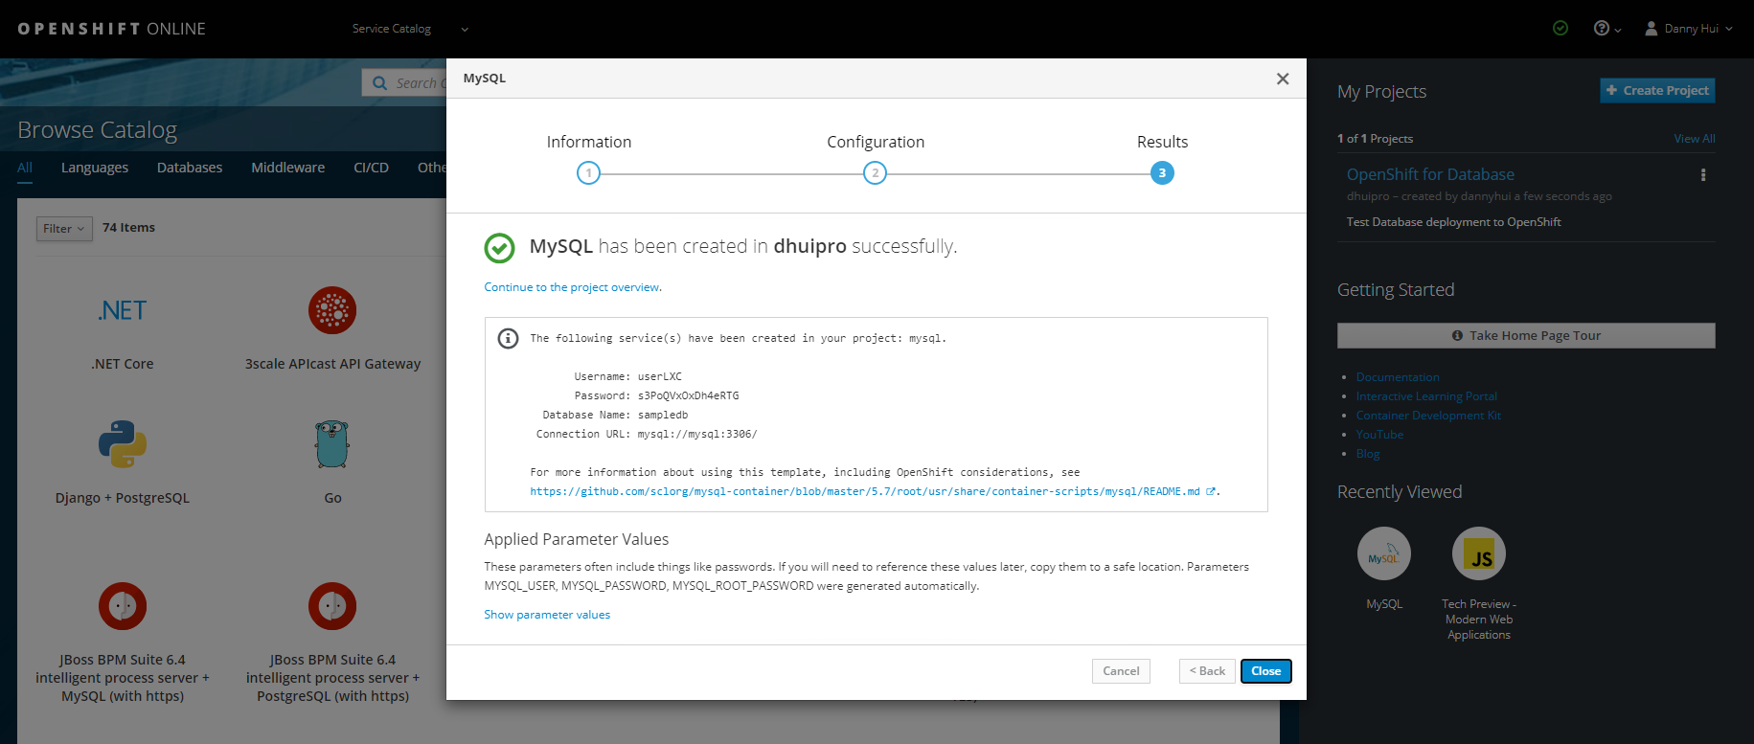
Note:
Namespace: openshift
Service: mysql
Username: user375
Password: 3AGMbOVxshouuwHJ
Database Name: sampledb
Connection URL: mysql://mysql:3306/

MYSQL_ROOT_PASSWORD: pRu6ulT4wLFvNFsT

Close

Verify the MySQL database is working

Applications -Pods
mysql-1-cjrln
Terminal
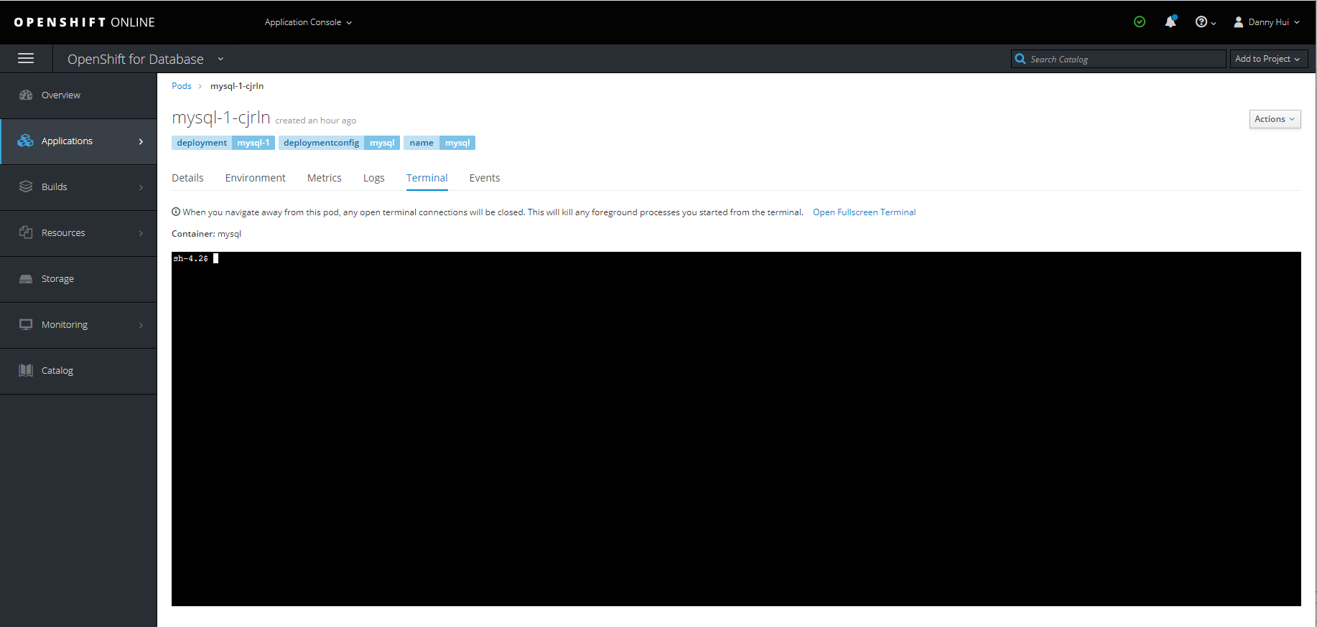

mysql -u user375 -p
(Enter password 3AGMbOVxshouuwHJ)
use sampledb;
show tables;
quit

Access MySQL database from application

The database access configuration is defined in Spring Boot application.properties.

spring.profile.active=cloud
spring.jpa.properties.hibernate.dialect = org.hibernate.dialect.MySQL5Dialect
spring.datasource.url=jdbc:mysql://mysql:3306/sampledb
spring.datasource.username=user375
spring.datasource.password=3AGMbOVxshouuwHJ
spring.jpa.hibernate.ddl-auto=update

server.servlet.contextPath=/userreg
server.port=8080
appversion=5
spring.application.name=User Registration Services
logging.config=file:/opt/userreg/config/logback/logback.xml

