Deploy Database

Developer Perspective
+Add – Database
Type
Check all checkboxes
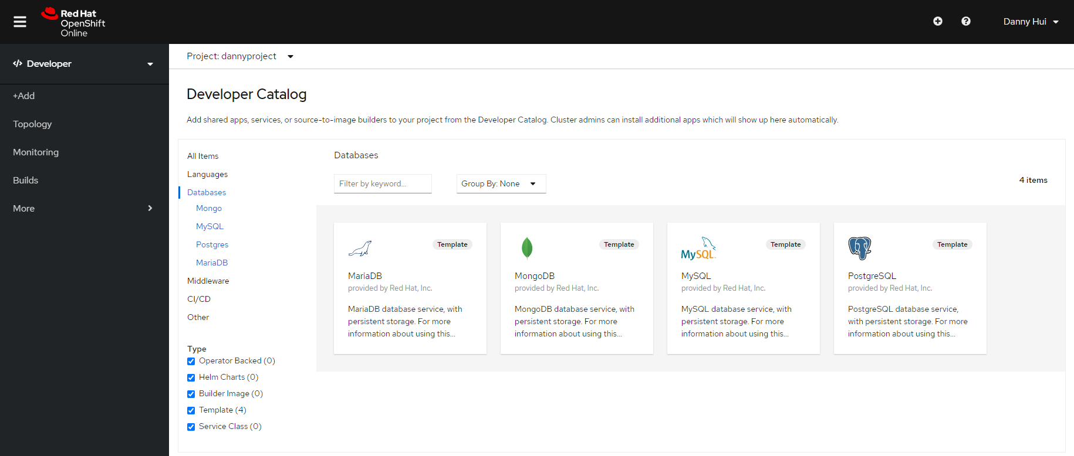
MySQL
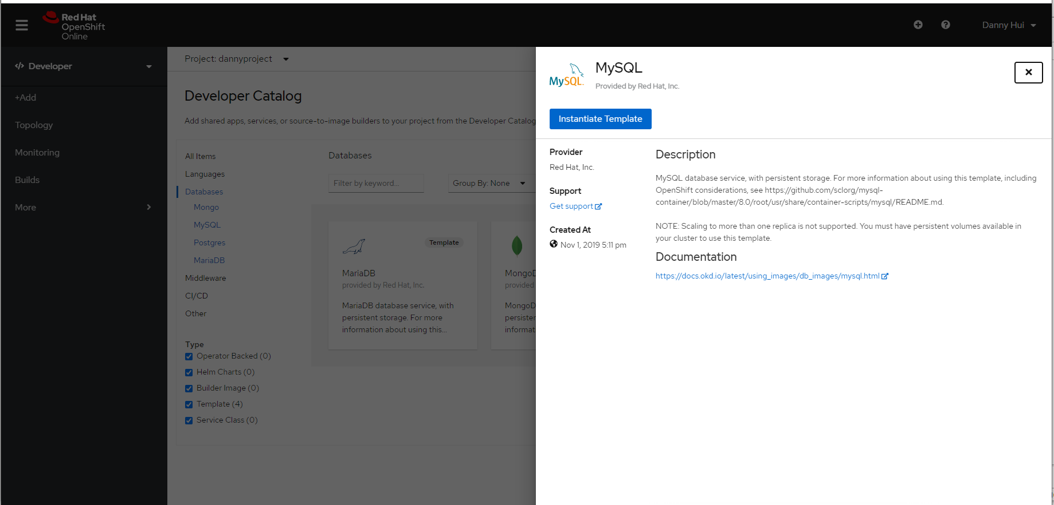
Instantiate Template

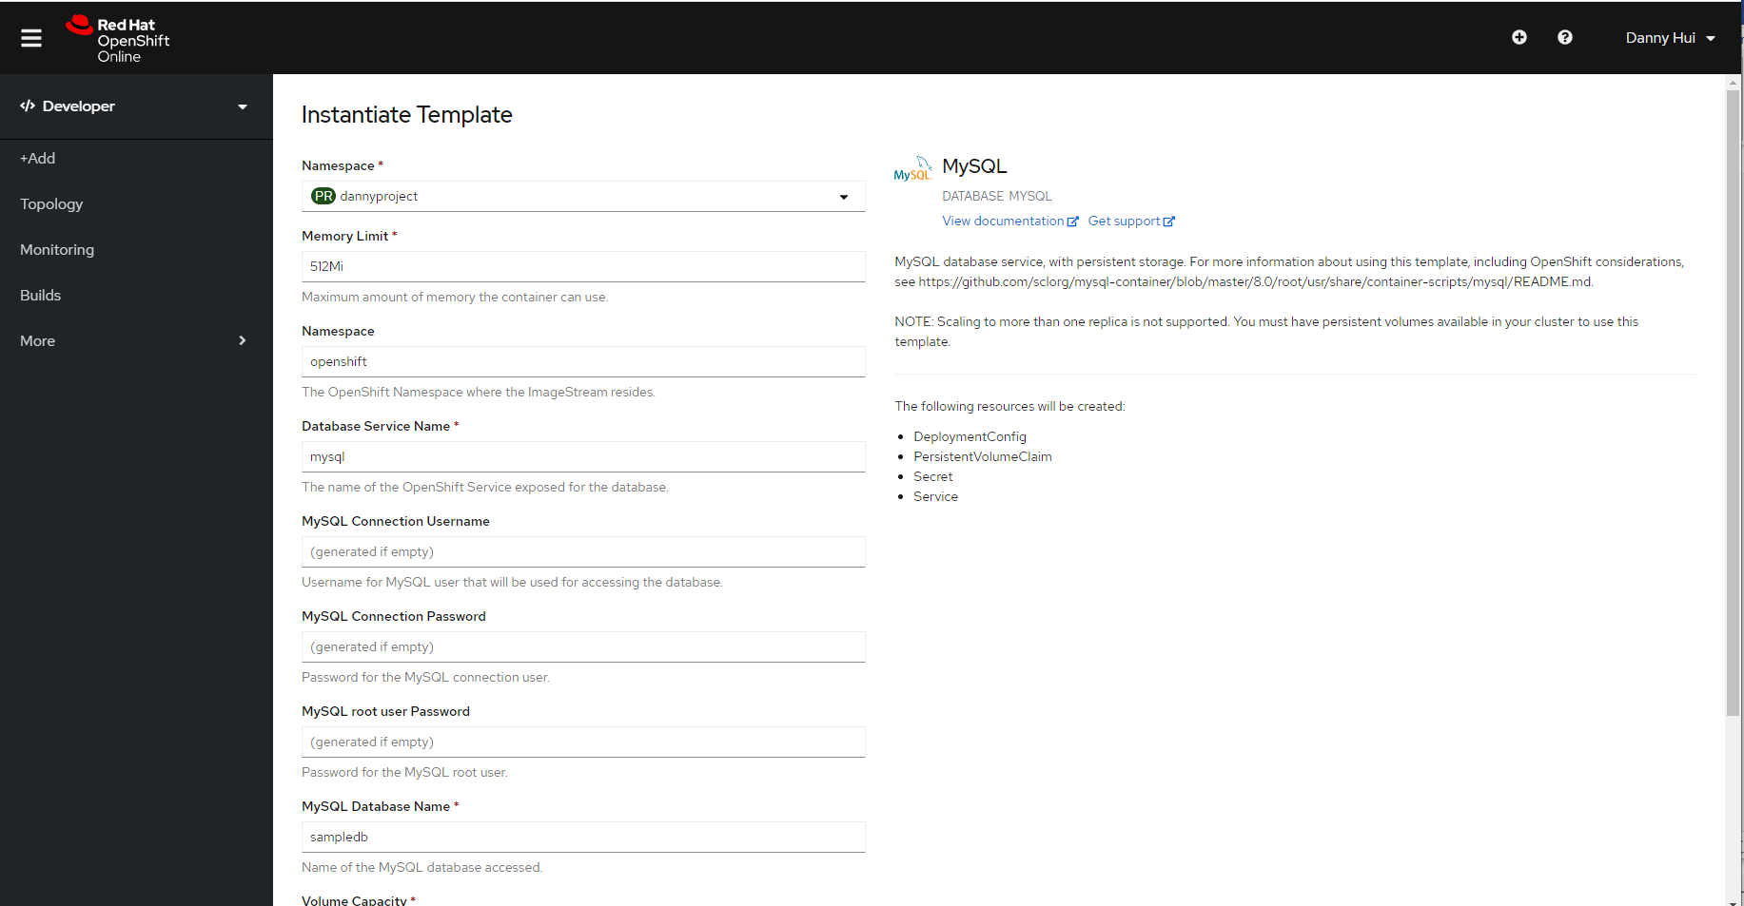

Create
Workloads – Secrets - mysql

database-name
sampledb
Copy to Clipboard
database-password
yv1tYxur7RsajyjP
Copy to Clipboard
database-root-password
PWJGoXrJq6wf0r8D
Copy to Clipboard
database-user
userO1F

Verify the MySQL database is working

Administrator Perspective

Workloads -Pods - mysql-1-zswd4

Terminal

mysql-u userO1F -p
(Enter password yv1tYxur7RsajyjP)
use sampledb;
show tables;
quit

Access MySQL database from application

The database access configuration is defined in Spring Boot application.properties.

spring.profile.active=cloud
spring.jpa.properties.hibernate.dialect = org.hibernate.dialect.MySQL5Dialect
spring.datasource.url=jdbc:mysql://mysql:3306/sampledb
spring.datasource.username=userO1F
spring.datasource.password=yv1tYxur7RsajyjP
spring.jpa.hibernate.ddl-auto=update

server.servlet.contextPath=/userreg
server.port=8080
appversion=5
spring.application.name=User Registration Services
logging.config=file:/opt/userreg/config/logback/logback.xml

