Securing Service Traffic

Use Edge Termination: Encrypted HTTPS traffic between the client and the router proxy . The pod exposes non-encrypted HTTP endpoint. Below we secure service traffic with OpenShift CA certificate.
Approach 1: using oc CLI:
oc create route edge userreg --service=userreg
Approach 2: creating secure route from Web Console
Networking – Routes – Create Route
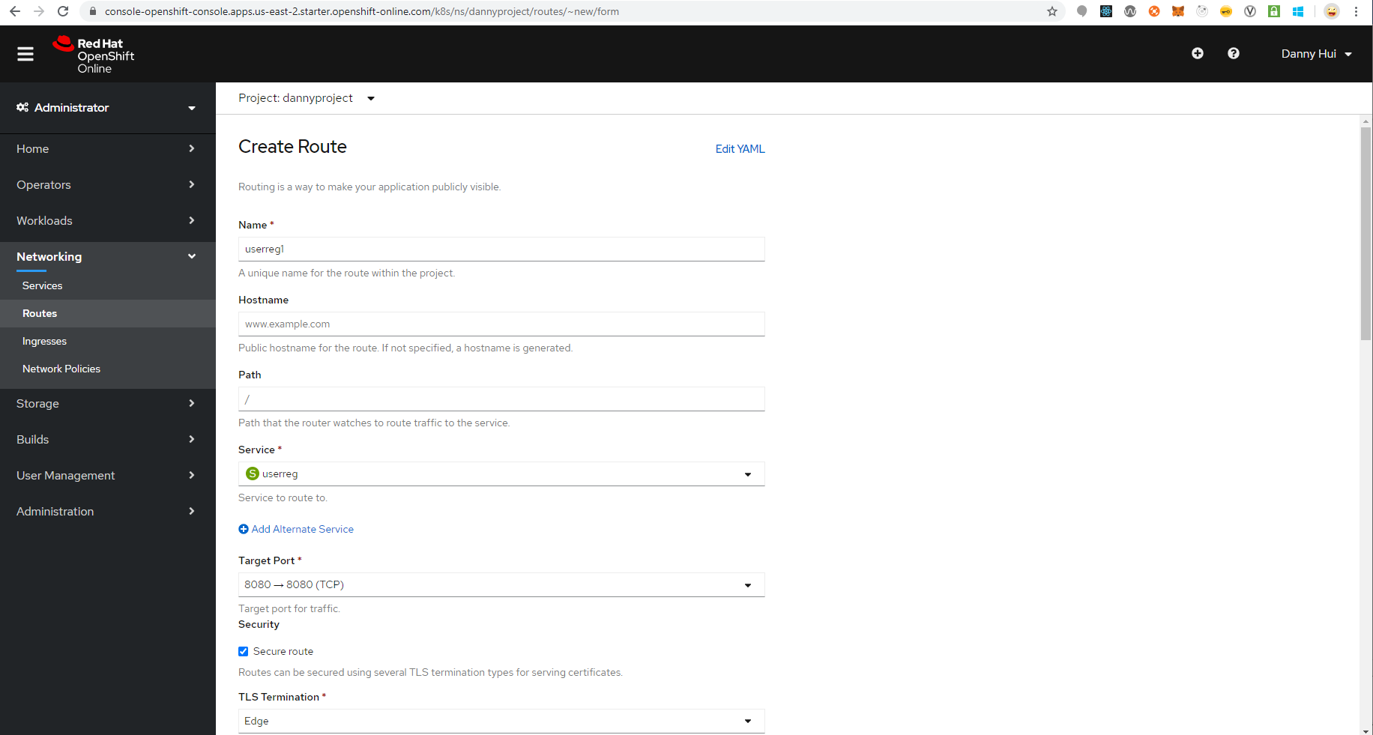
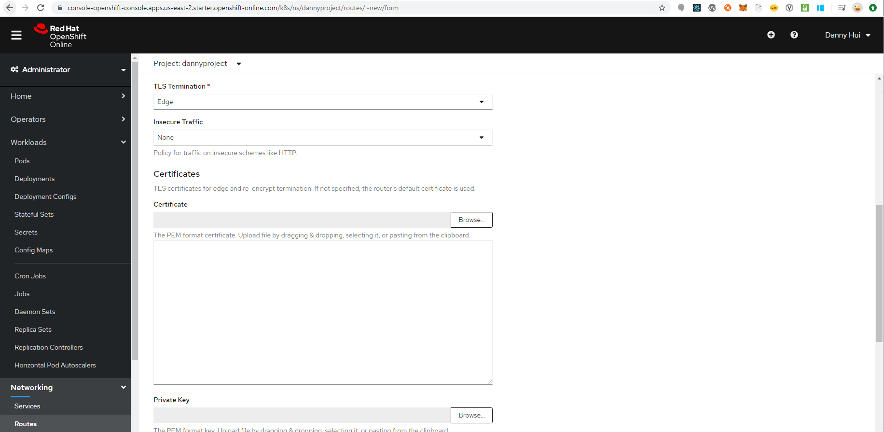
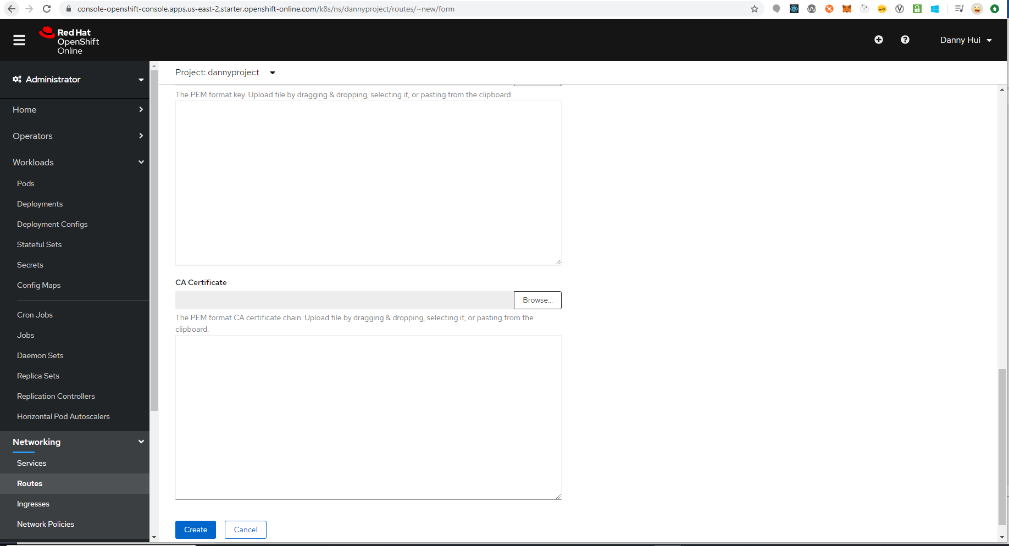
Leave Certificate, Private Key and CA Certificate blank
Create
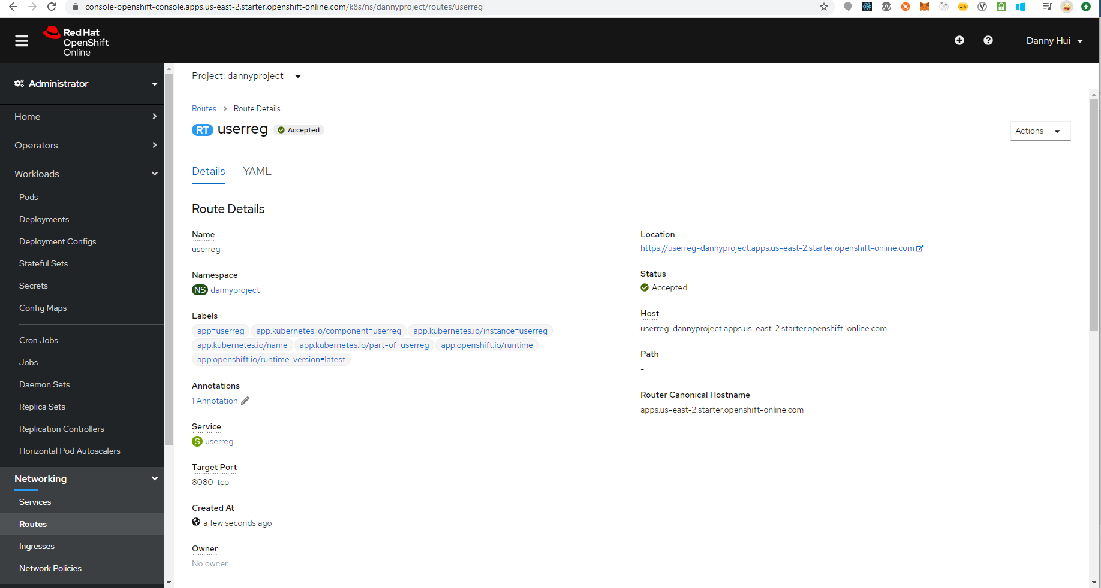
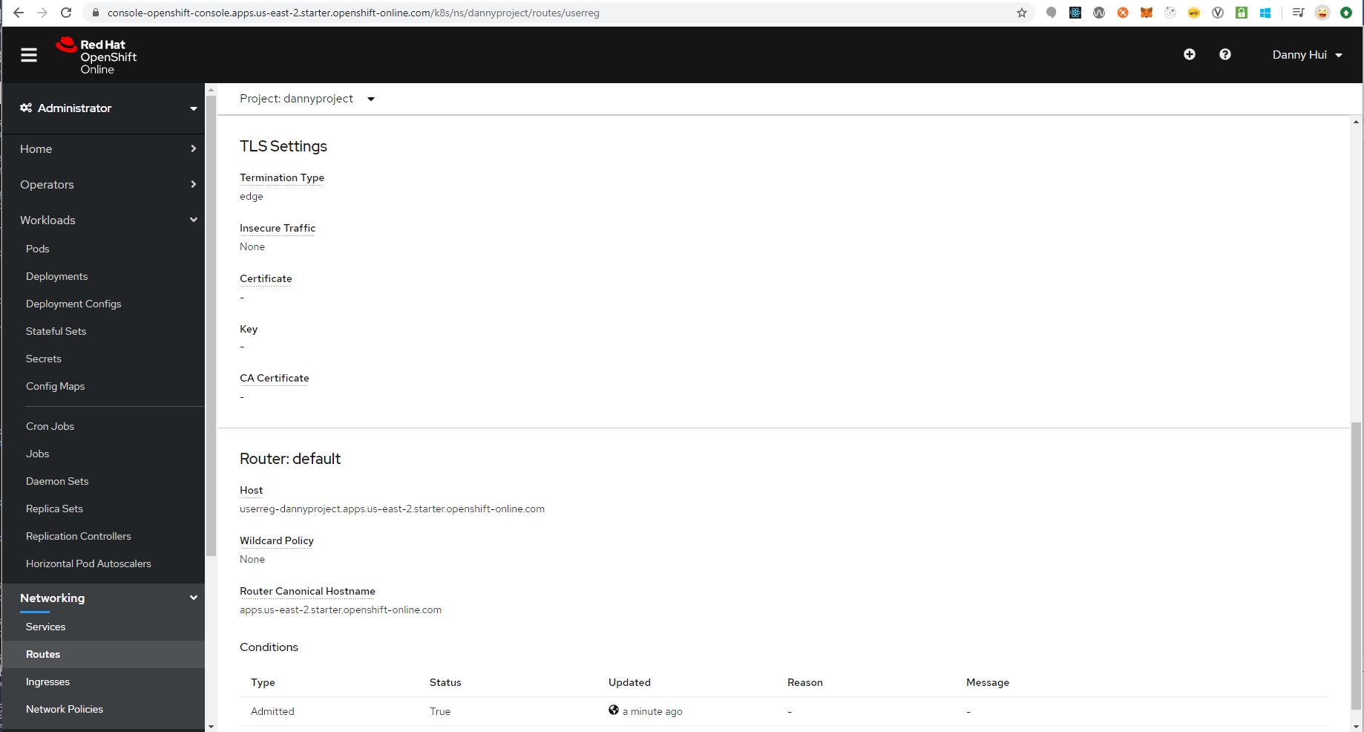
Approach 3: modifying ono-secure route from Web Console
Under spec, add
tls:
termination: edge
insecureEdgeTerminationPolicy: None
Save
Test:
curl -X POST -d @testdata/register1.json https://userreg-dannyproject.apps.us-east
-2.starter.openshift-online.com/user/register --header "Content-Type:application/json"

Response
{"status":"success","userId":2}

Voila!

