Deploy Spring Boot Web Application
from Docker Image

Developer Perspective
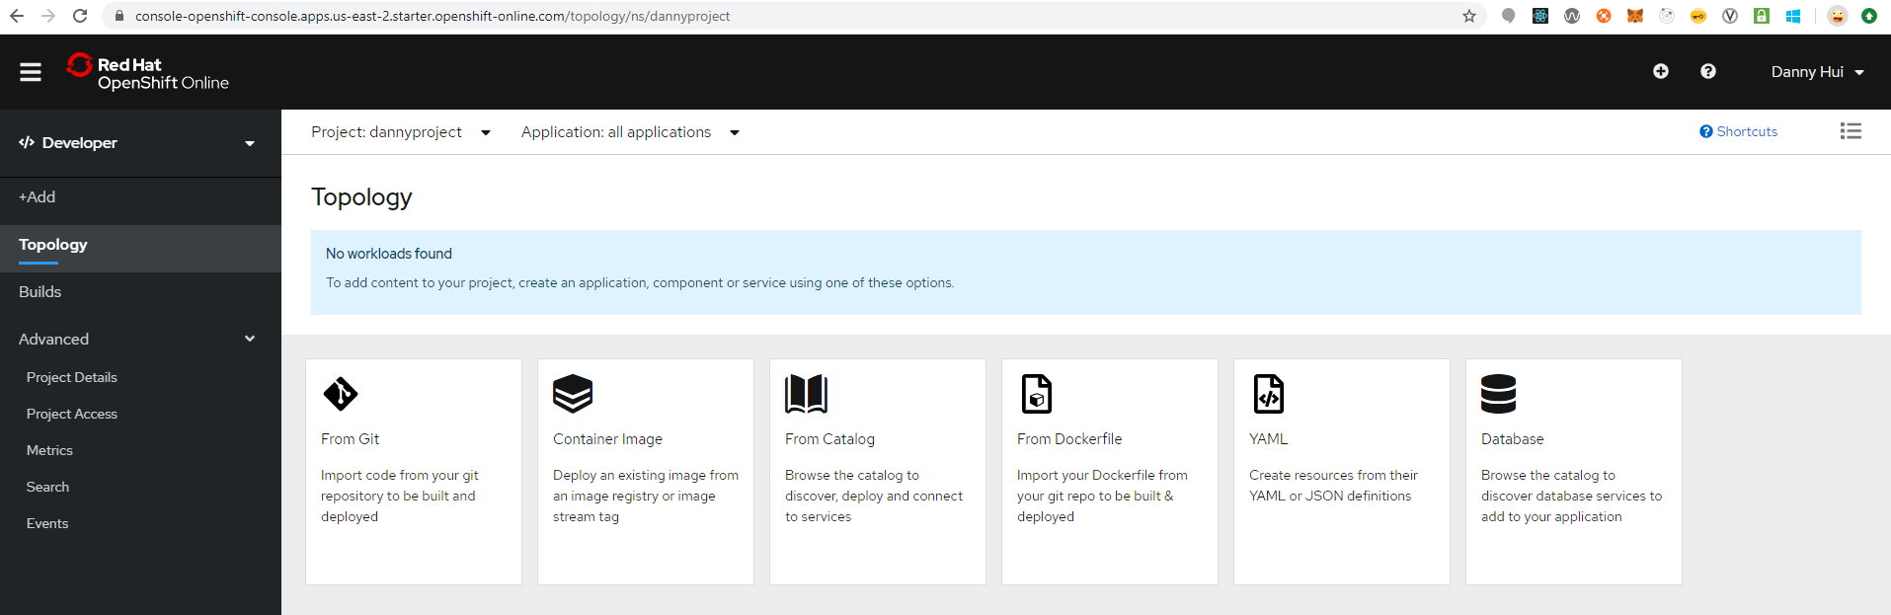
Source:
https://github.com/dhui808/userreg
+Add
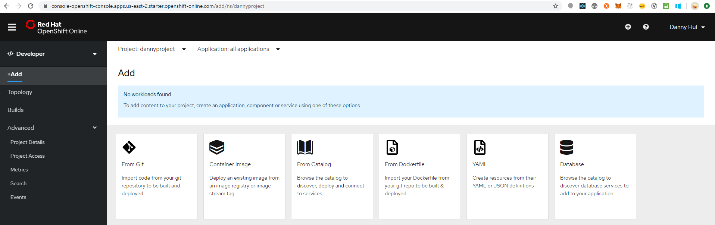
Container Image
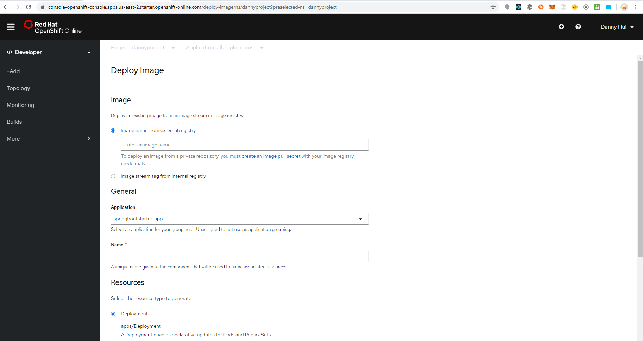
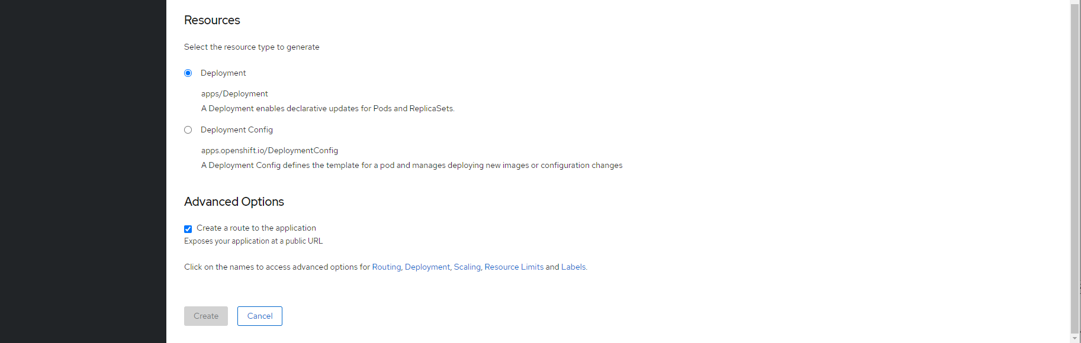
Image name from external registry
docker.io/dannyhui/userreg
Application
Create Application
ApplicationName
userreg
Name
userreg
Deployment
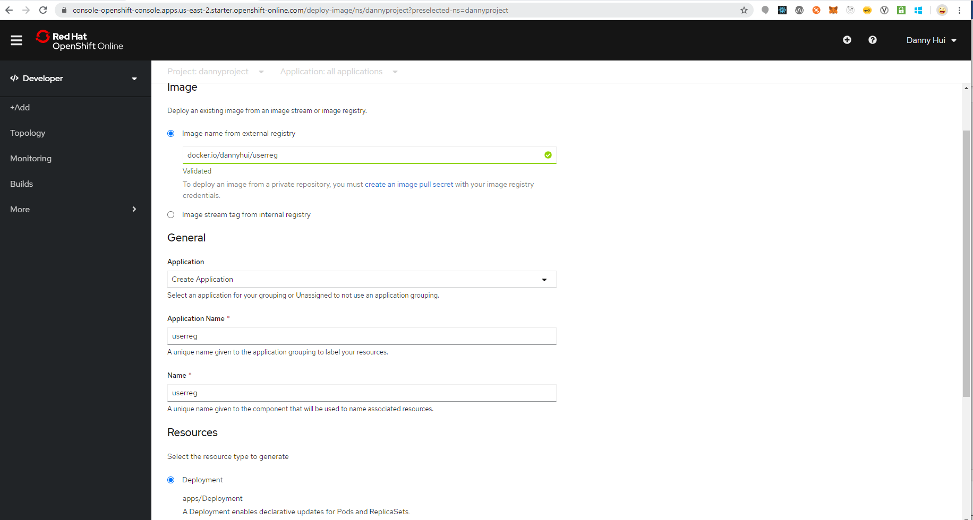
Create
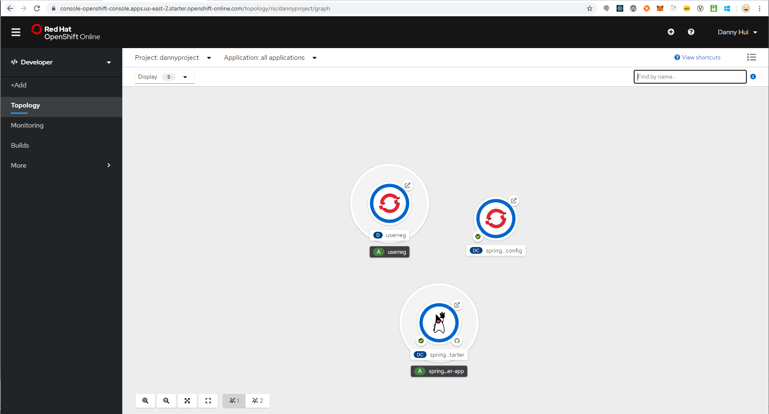
Test 1
curl -X POST -d @testdata/register1.json http://userreg-dannyproject.apps.us-east-2.starter.openshift-online.com/user/register --header "Content-Type:application/json"
Response
{"status":"success","userId":1}
Test 2
curl -X POST -d “” http://userreg-dannyproject.apps.us-east-2.starter.openshift-online.com/users/findAll --header "Content-Type:application/json"
Response
{"status":"success","users":[{"username":"marksmith","firstname":"Mark","lastname":"Smith","telephone":"6476785678","email":"mark.smith@uvw.com","mobile":"4169084567","address":"100 Bay St Toronto Q1J7S2 CA"}]}
Voila!

