Deploy Spring Boot Web Application
from OpenShift Web Console
This document shows the basic steps to deploy a Spring Boot web application to OpenShift using OpenShift Web Console.
To make the document simple and clean, I just list each button/link/menu item that is clicked or selected, without wording like “click Create button” or “click Actions dropdown and then click menu item Edit Route”. So you will simply see:
Create
Actions – Edit Route
For the mandatory input filed, the label and the value typed are listed. For instance:
Name: dannyproject
The screenshots are captured before and after a button click.
Let’s get started.

Login to OpenShift 4.4
Administrator Perspective
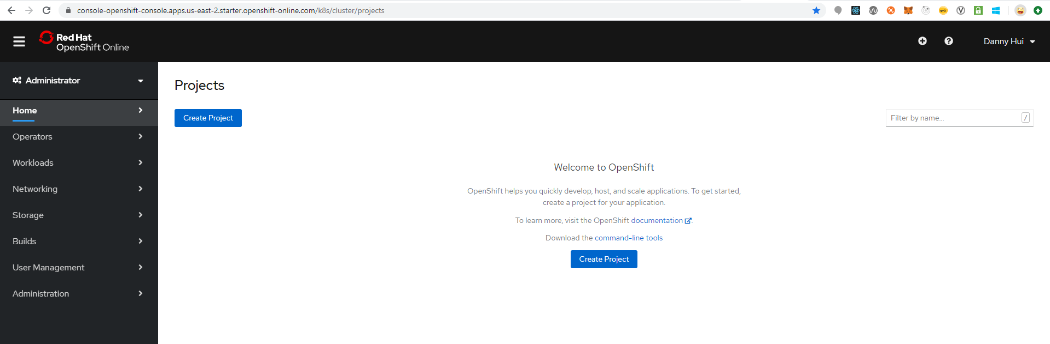
Create Project
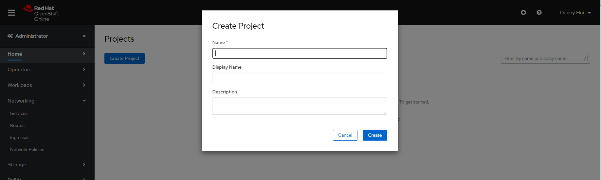
Name: dannyproject
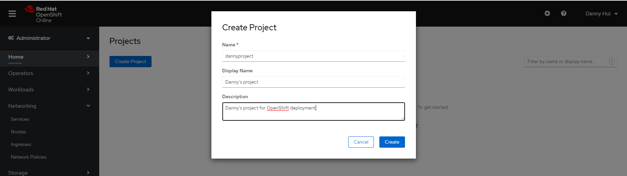
Create
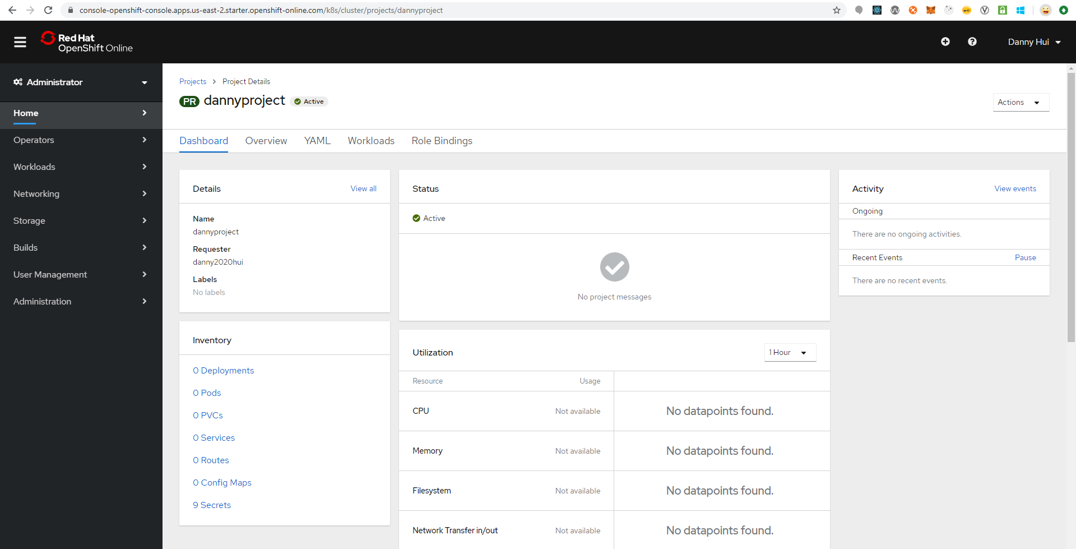
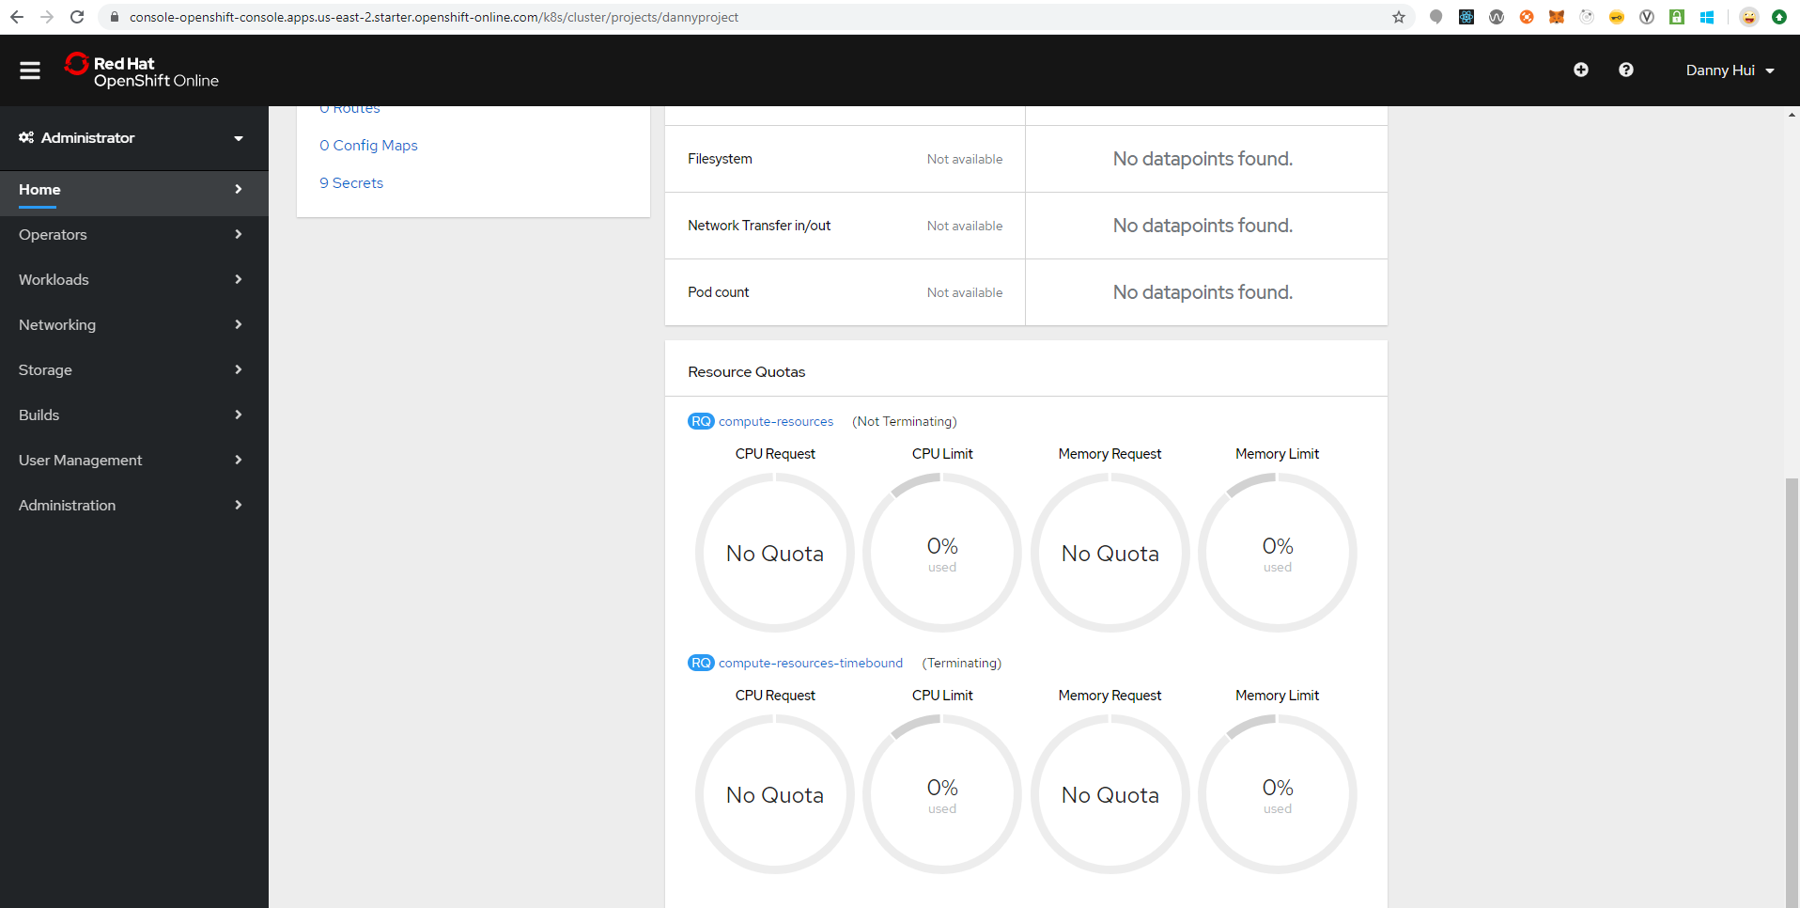
Developer Perspective
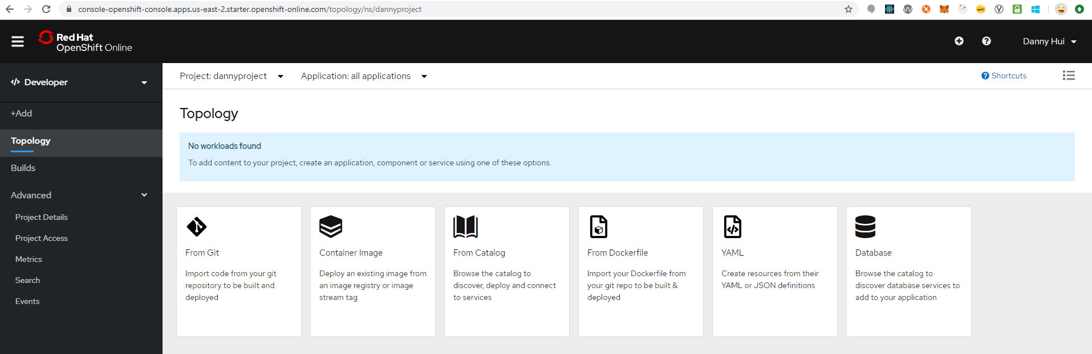

Deploy Spring Boot Web Application
Source:
https://github.com/dhui808/springbootstarter
+Add
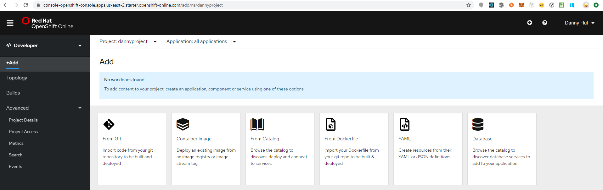
From Git
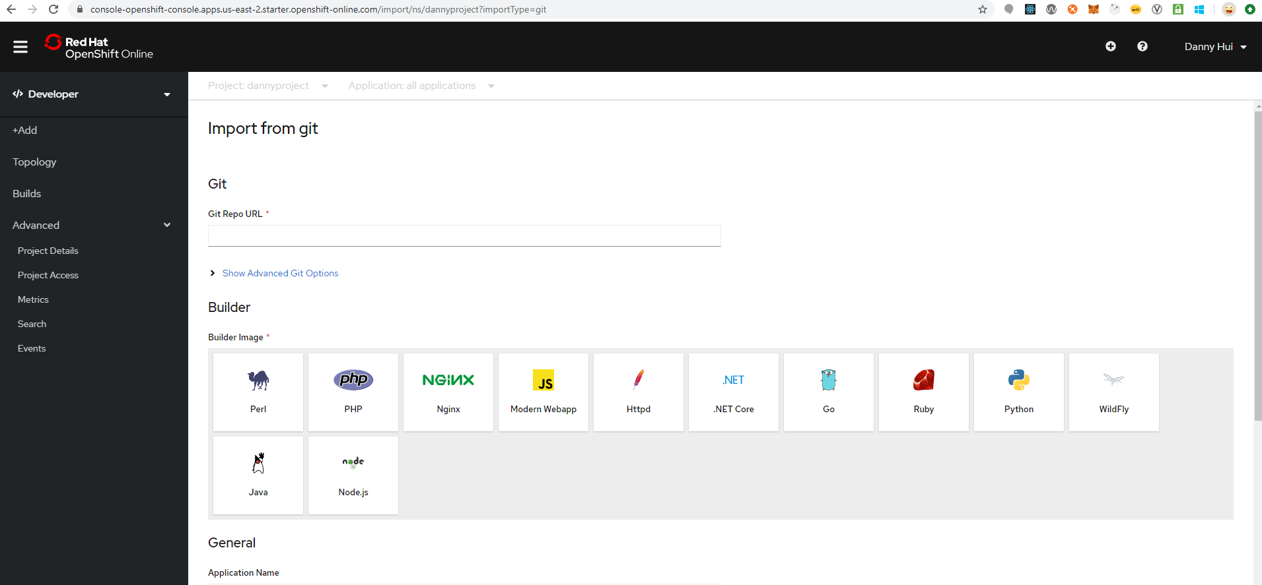

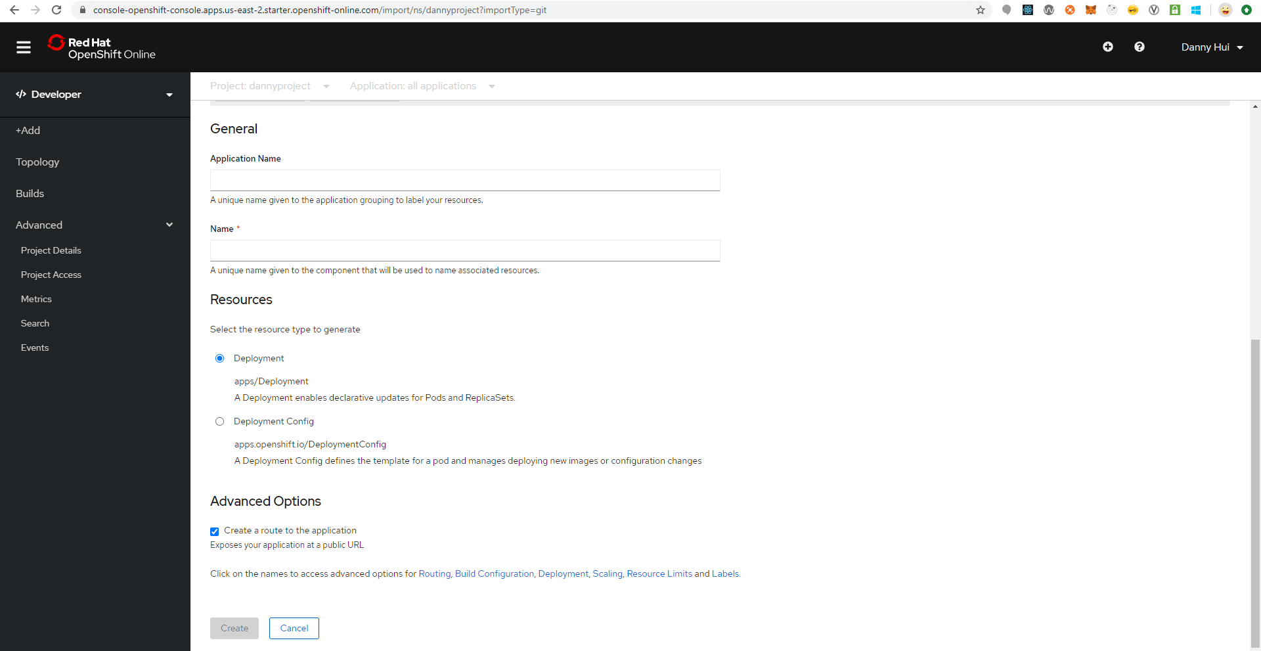
Git Repo URL
https://github.com/dhui808/springbootstarter
Build Image
Java
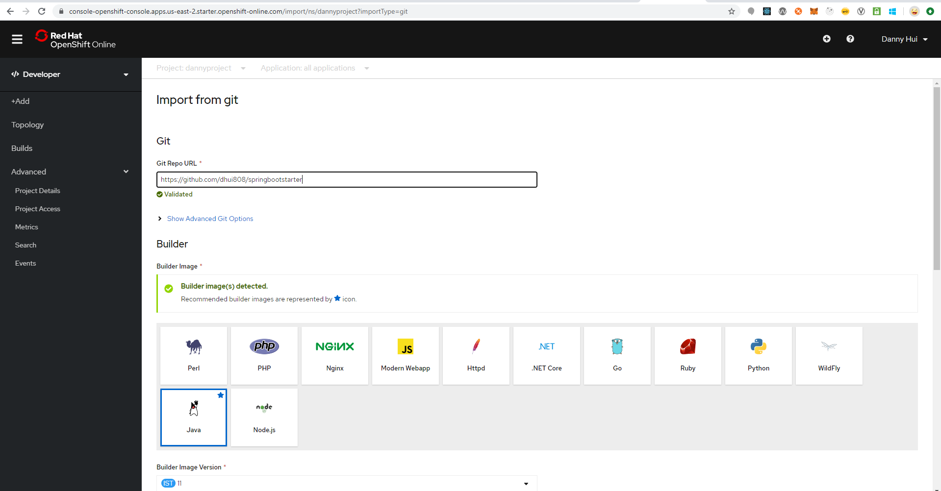
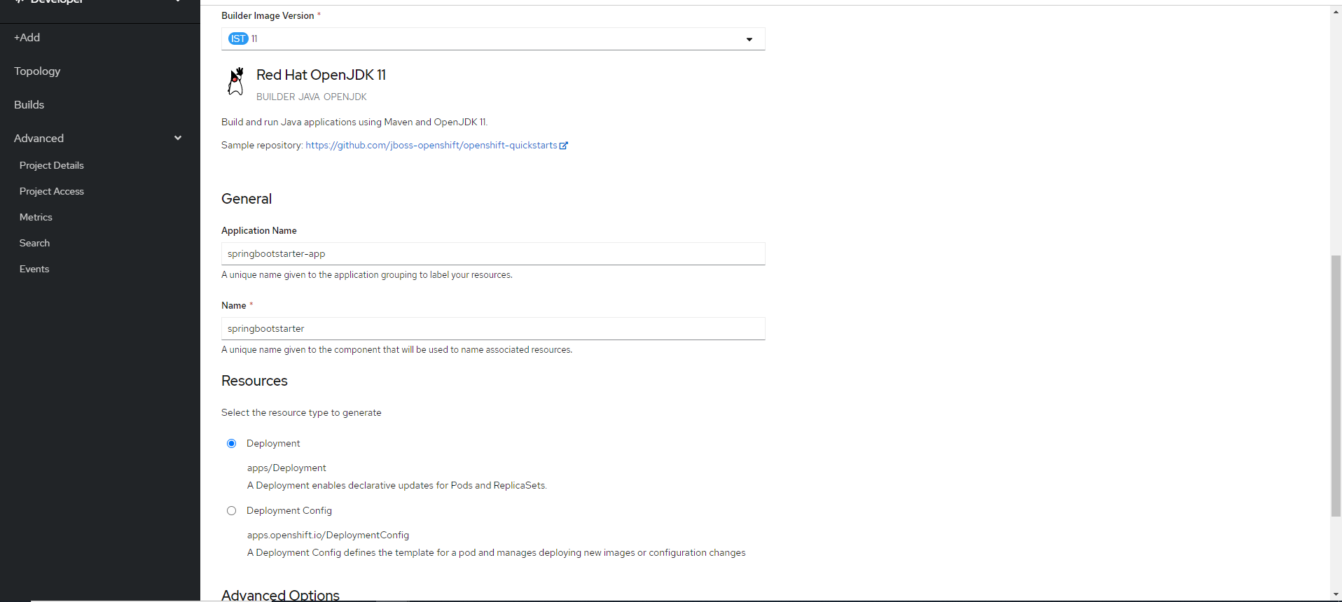

Deployment (default selected)
Create
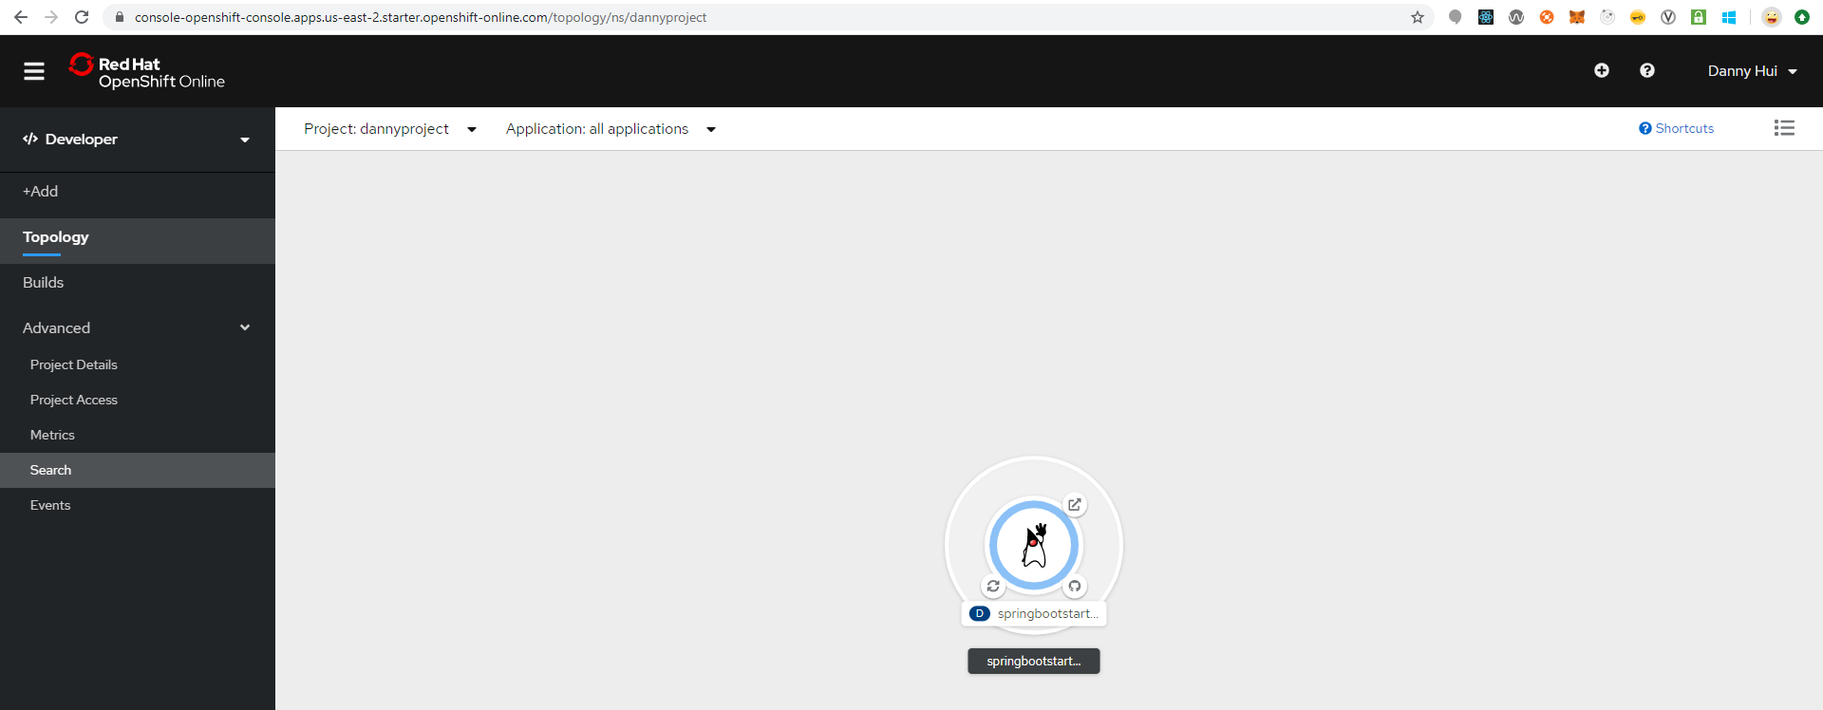
Java Duke icon
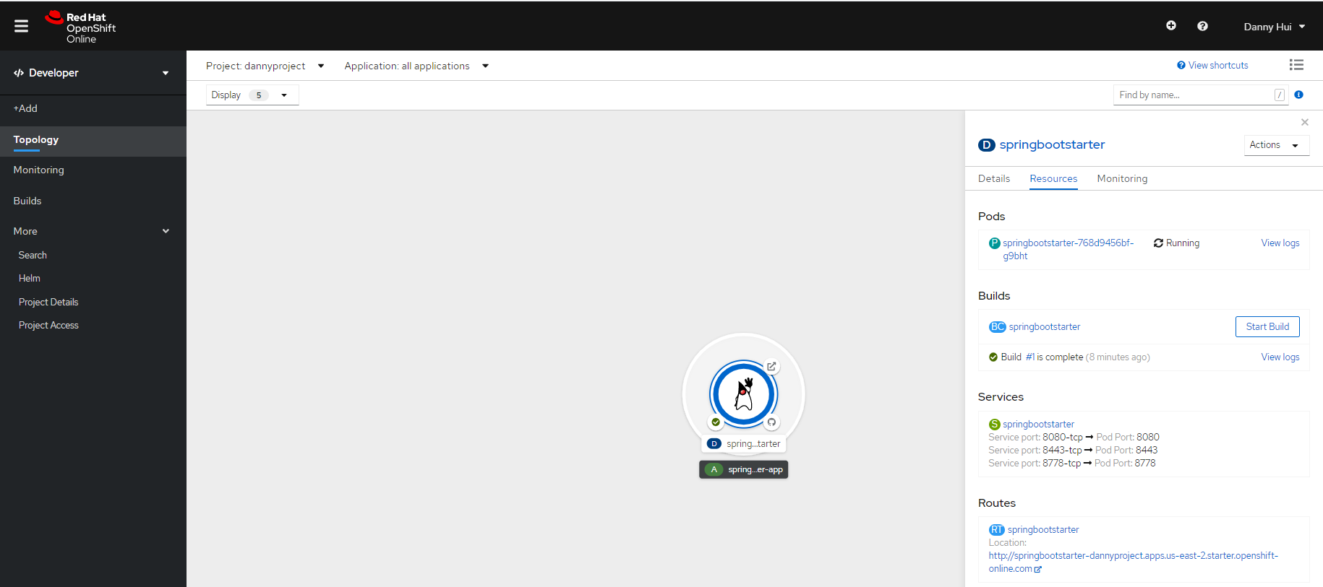
This is application URL

From browser:
http://springbootstarter-dannyproject.apps.us-east-2.starter.openshift-online.com/springbootstarter/hello
Voila!

