Deploy Spring Boot Web Application with External Configuration File
from OpenShift Web Console and oc

General discussion
A Spring Boot web application is essentially a Java application. There are two ways to load configuration files into the application: an external configuration file from the file system and a configuration file packaged inside the jar/war file. The former approach is the best industry practice, since it allows the configuration being modified and re-deployed without re-deploying the application.
For a Java application to load an external configuration file from the file system, the configuration file needs to be physically located in the specified path and we need to tell JVM the file path via JAVA_OPTIONS environment variable. For Cloud containers, this means we need to do two things: mount the file in the volume with the specified path and define the JAVA_OPTIONS environment variable. To mount the file in the volume, we need to use CongMap. Since we have two configuration files for this example: application.properties for Spring Boot and logback.xml for logging configuration, we need to create two ConfigMap objects. After the Deployment Config object is created, we need mount both files to their respective volumes, by modifying the Deployment Config object.
The last thing I’d like to highlight is that the port 8082 is used intentionally, instead of the default 8080.
For Spring Boot application, this port is defined in the configuration file application.properties:
server.port=8082
By not using the default port 8080, we can easily find whether JVM is able to load and use application.properties or not.

Create ConfigMap from oc (two ConfigMap objects as discuss abobe)
oc create configmap springbootstarter-w-config-application-properties --from-file=/opt/springbootstarter-w-config/config/application.properties
oc create configmap springbootstarter-w-config-logback-xml --from-file=/opt/springbootstarter-w-config/config/logback/logback.xml

OpenShift Web Console
Developer Perspective
+Add
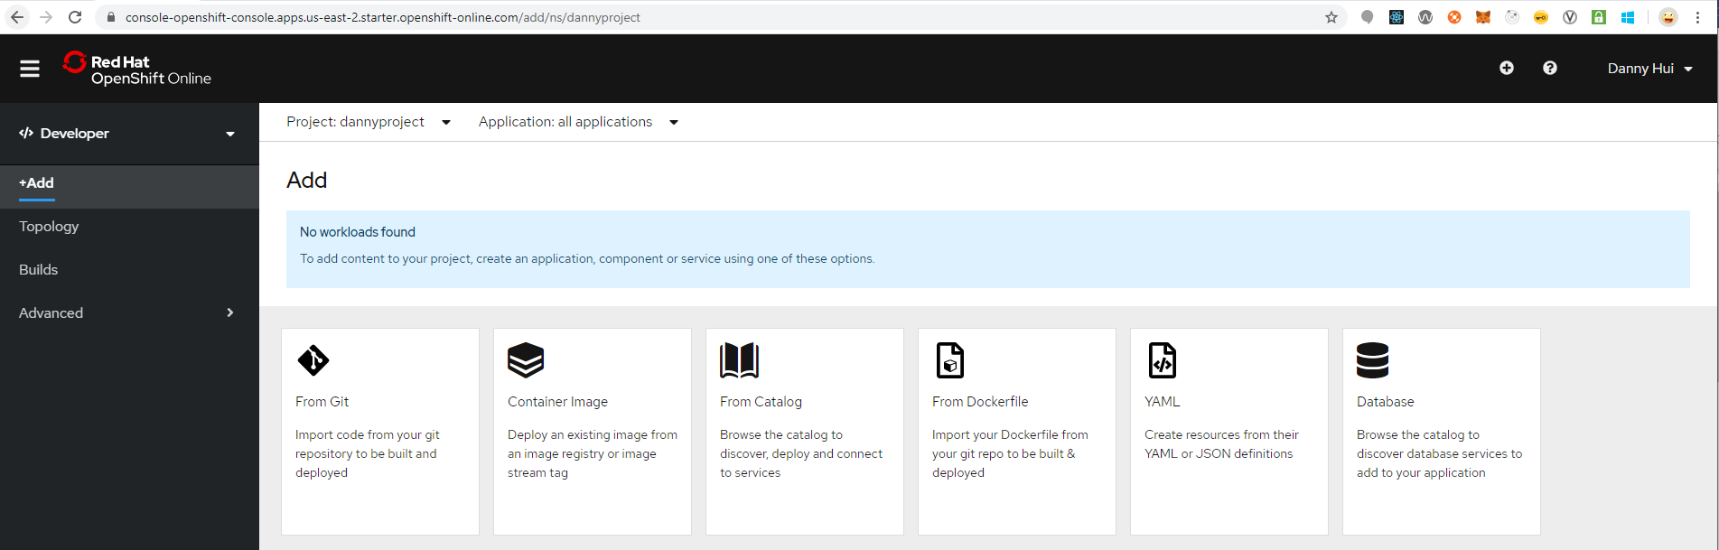
From Git
Git repo URL
https://github.com/dhui808/springbootstarter-w-config
Builder Image
Java
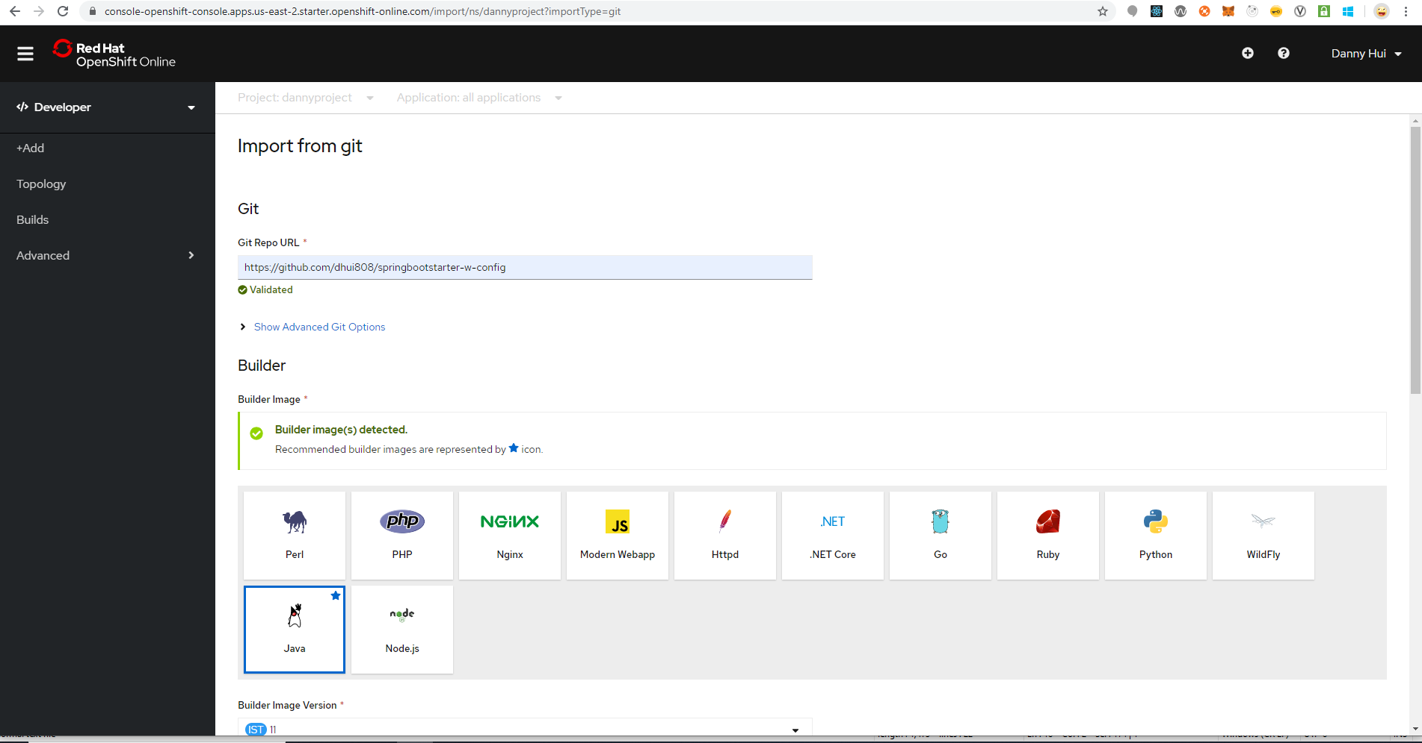
Select Deployment Config
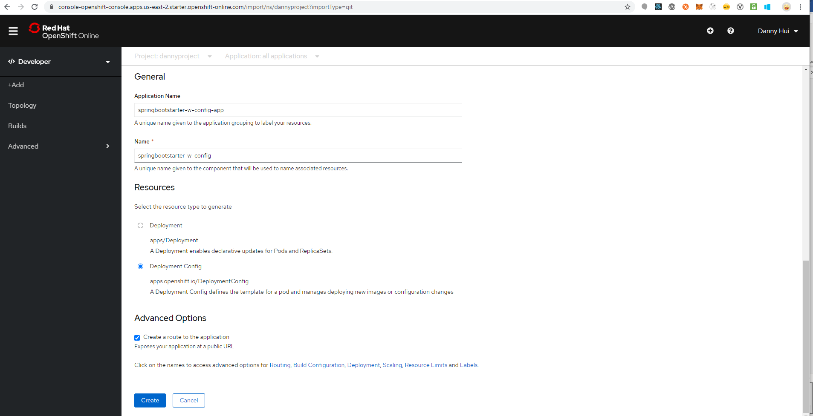
Click Deployment link (above the buttons)
Environment Variables (Runtime only)
NAME
JAVA_OPTIONS
VALUE
-Dspring.config.location=file:///deployments/config/application.properties
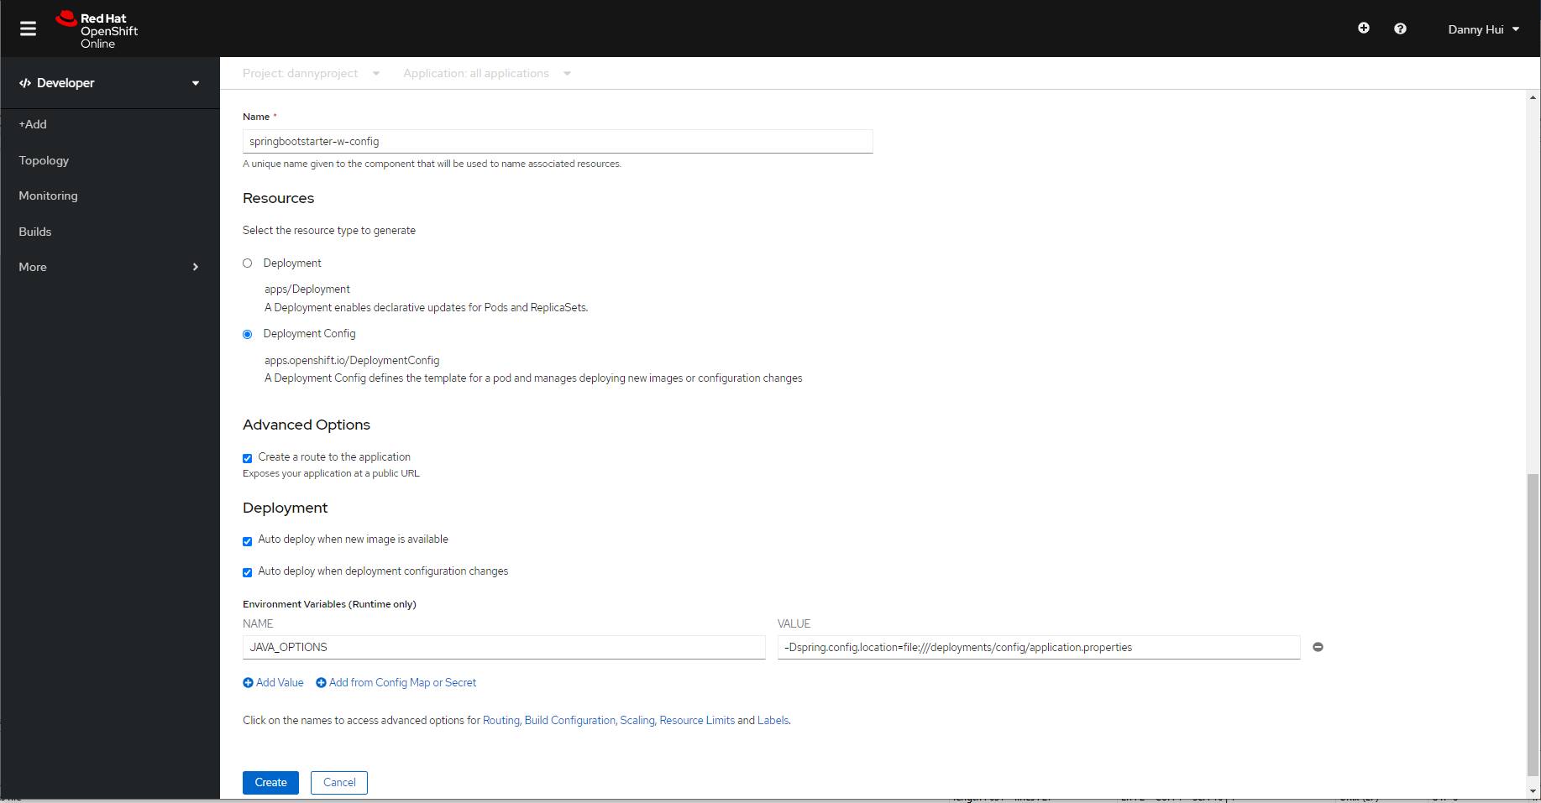

Create
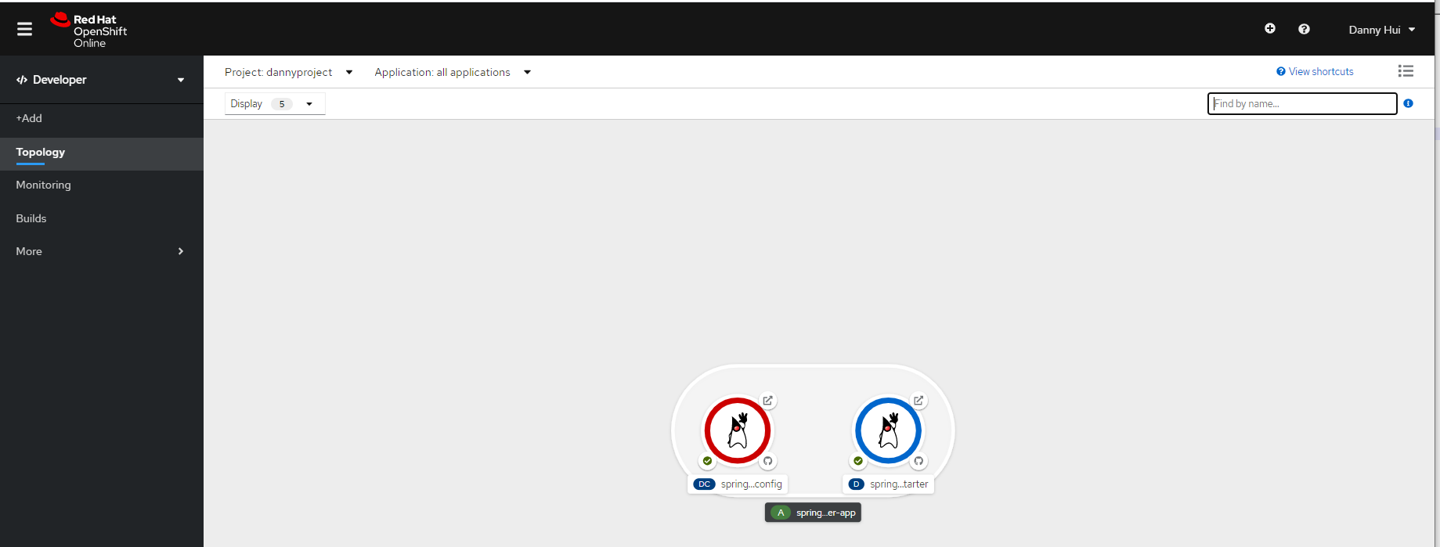
Add Volume and Volume Mount from oc
(springbootstarter-w-config is the name of the newly created Deployment Config)
oc set volume dc/springbootstarter-w-config --add --name volume-config -t configmap --configmap-name springbootstarter-w-config-application-properties -m /deployments/config -o yaml
oc set volume dc/springbootstarter-w-config --add --name volume-logback-config -t configmap --configmap-name springbootstarter-w-config-logback-xml -m /opt/springbootstarter-w-config/config/logback --read-only=true -o yaml

Now we need to tell OpenShift Container that the Pod should use port 8082 instead of 8080.
Administrator Perspective
Networking – Services - springbootstarter-w-config - YAML
Under spec – ports
- name: 8082-tcp
protocol: TCP
port: 8082
targetPort: 8082

Save
Networking – Routes - springbootstarter-w-config - YAML
Under spec (actually we do not need to specify path)
port:
targetPort: 8082-tcp
path: /springbootstarter
Save
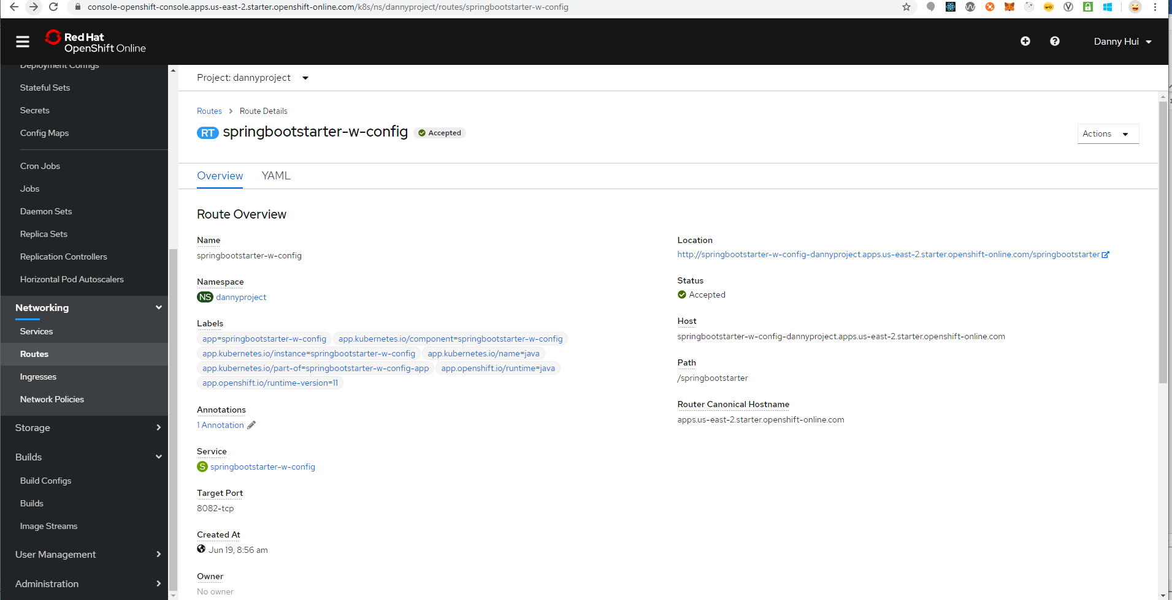
Browser
http://springbootstarter-w-config-dannyproject.apps.us-east-2.starter.openshift-online.com/springbootstarter/hello

Voila!

