Login to OpenShift
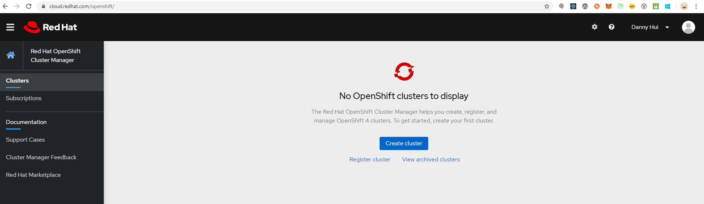
Click Create cluster
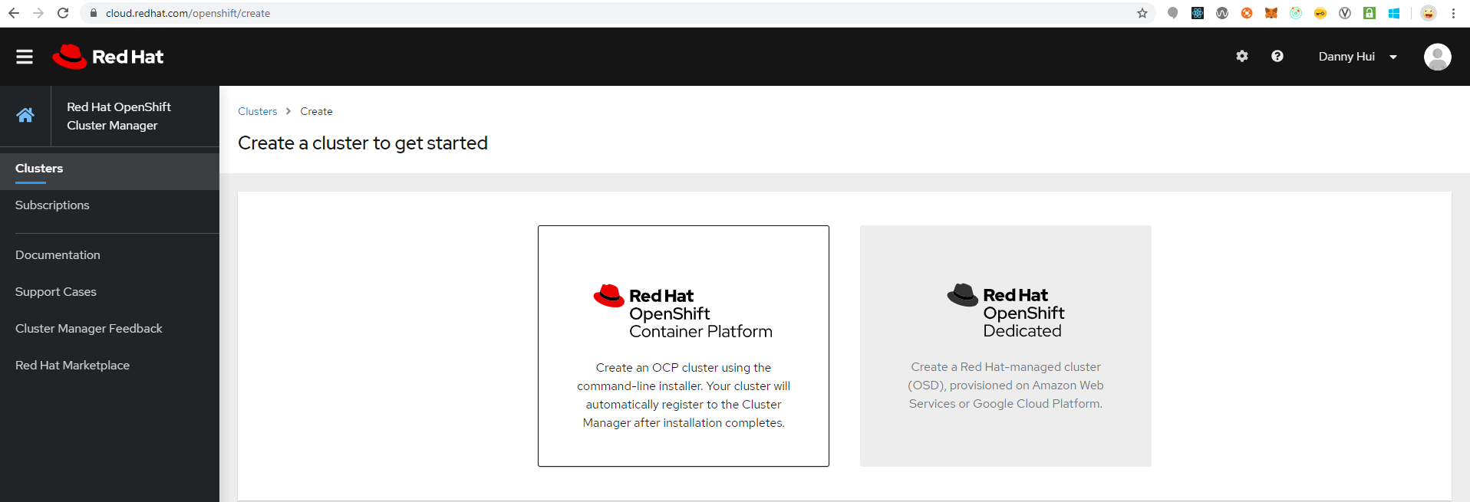
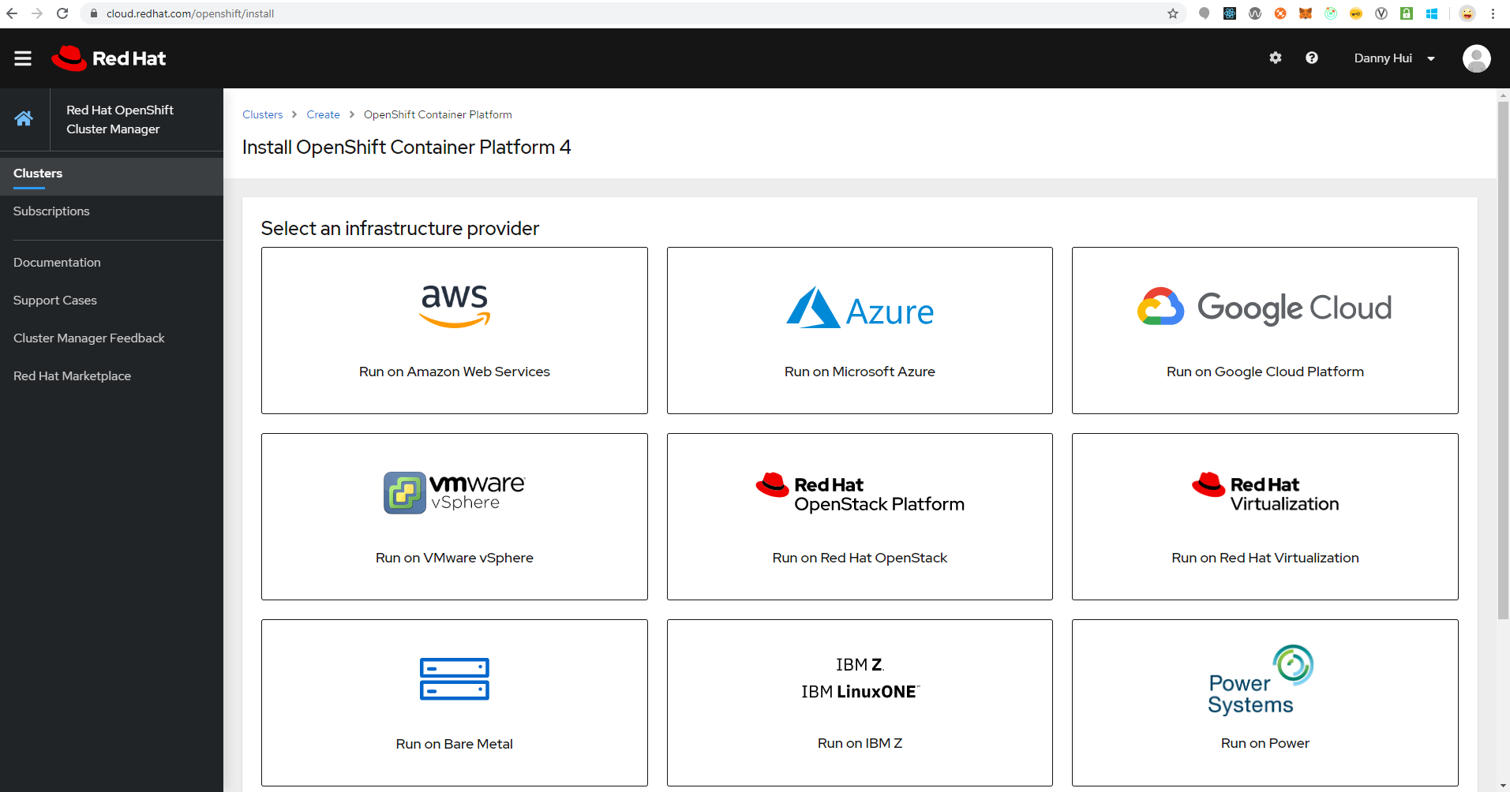
Click Azure
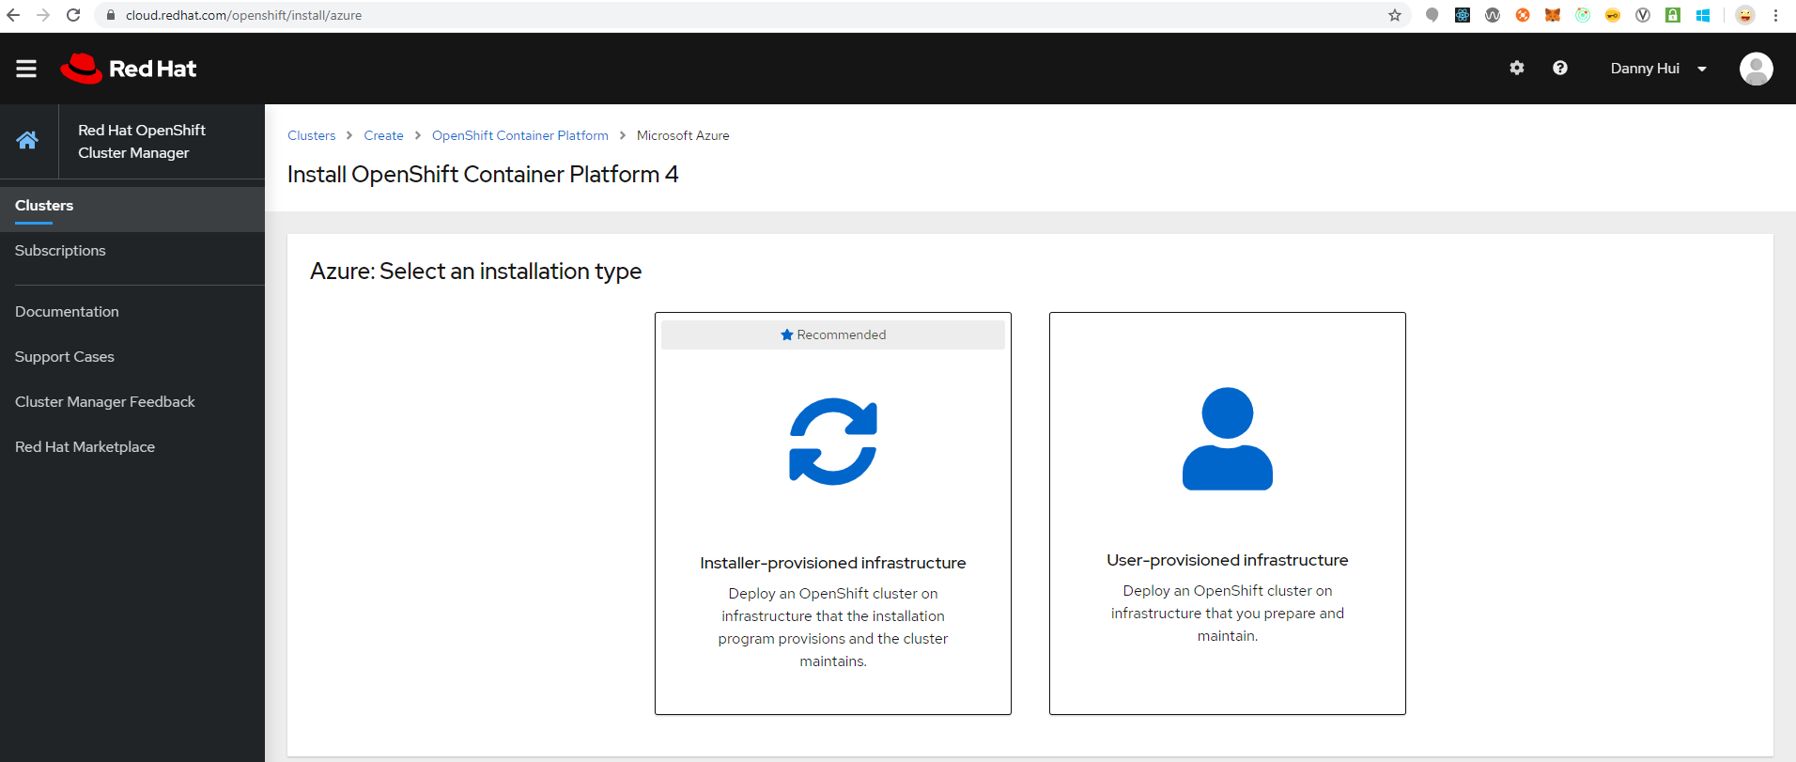
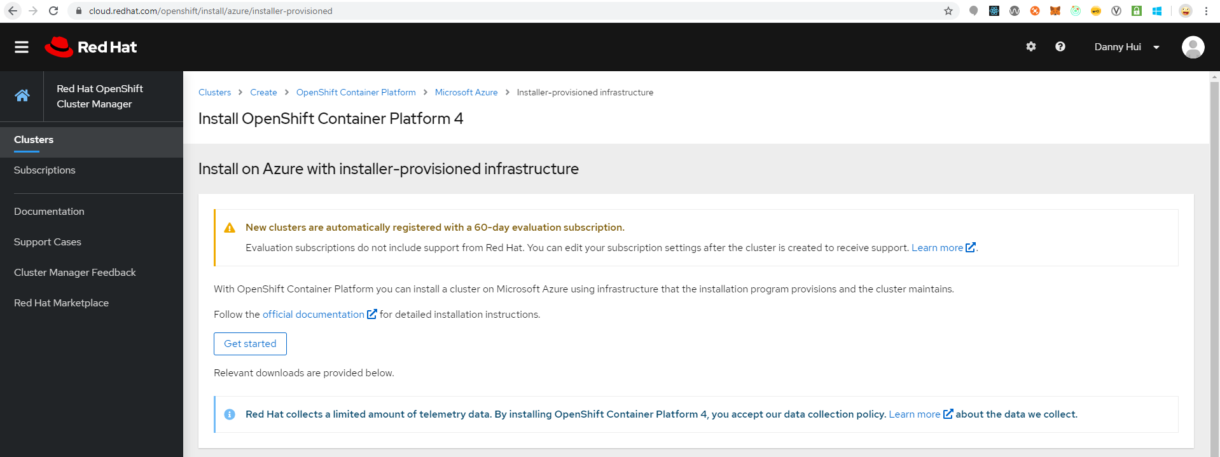
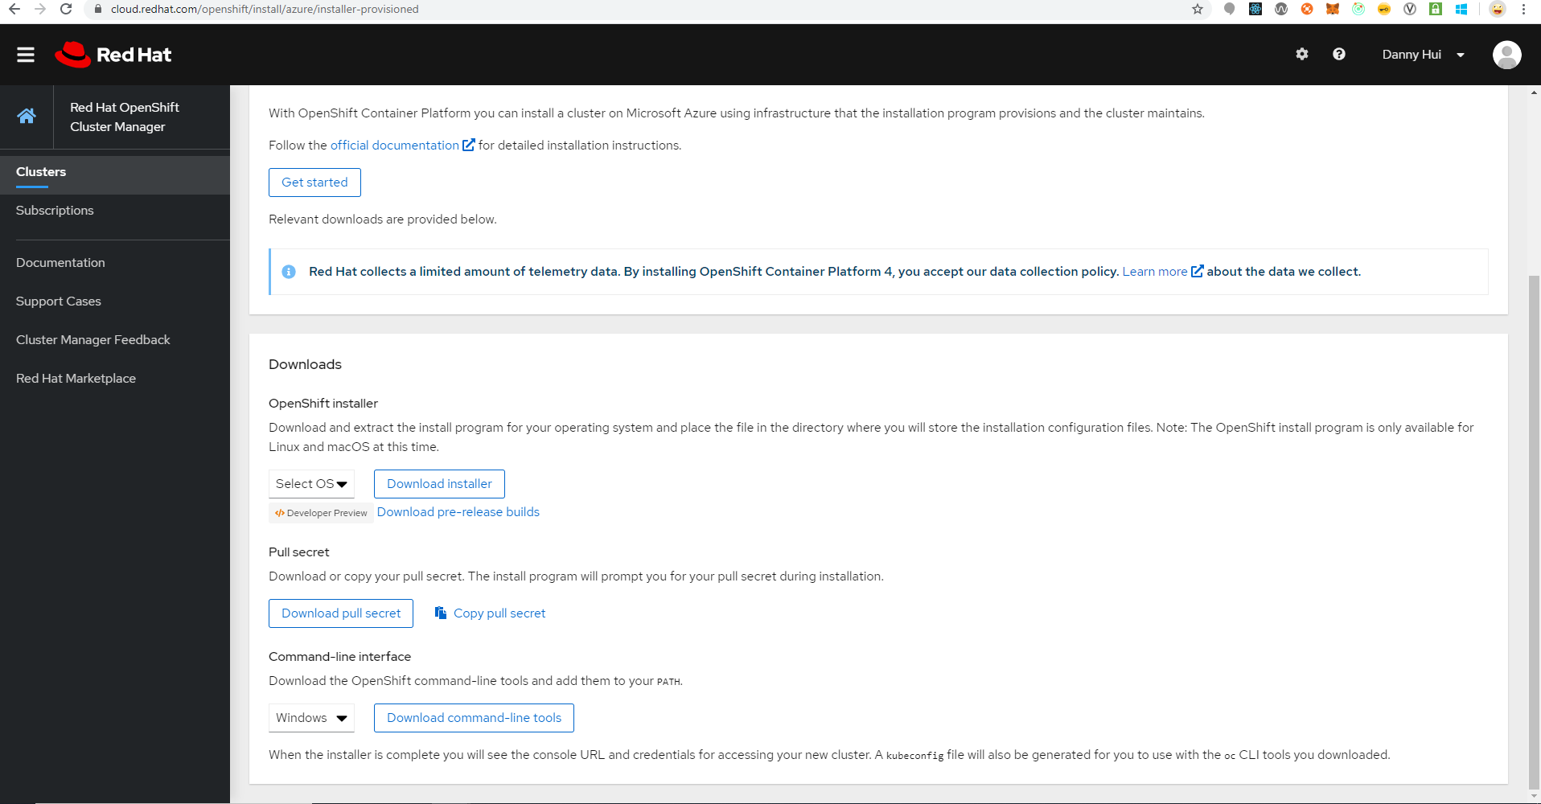
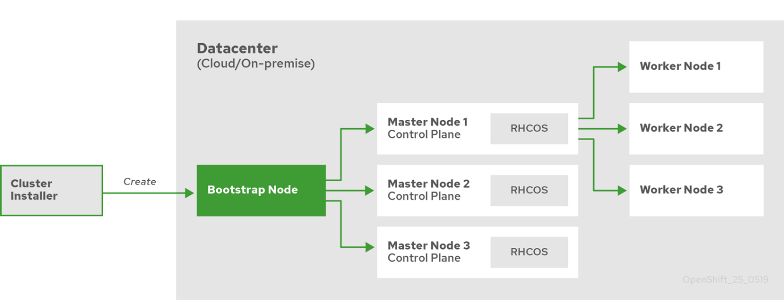

Installing a cluster quickly on Azure

Obtaining the installation program
download the installation file on a local computer

Deploying the cluster
- Configure an account with the cloud platform that hosts your cluster.
- Obtain the OpenShift Container Platform installation program and the pull secret for your cluster.
- Run the installation program
./openshift-install create cluster --dir=<installation_directory> \
--log-level=info
Provide values at the prompts:

Installing the CLI

Logging in to the cluster

