Deploy Spring Boot Web Application with external configuration files
from OpenShift Web Console
Source:
https://github.com/dhui808/springbootstarter-w-config
Create ConfigMap from oc
oc create configmap springbootstarter-w-config-application-properties --from-file=/springbootstarter-w-config/config/application.properties
configmap/springbootstarter-w-config-application-properties created
OpenShift Web Console
Developer Perspective
+Add
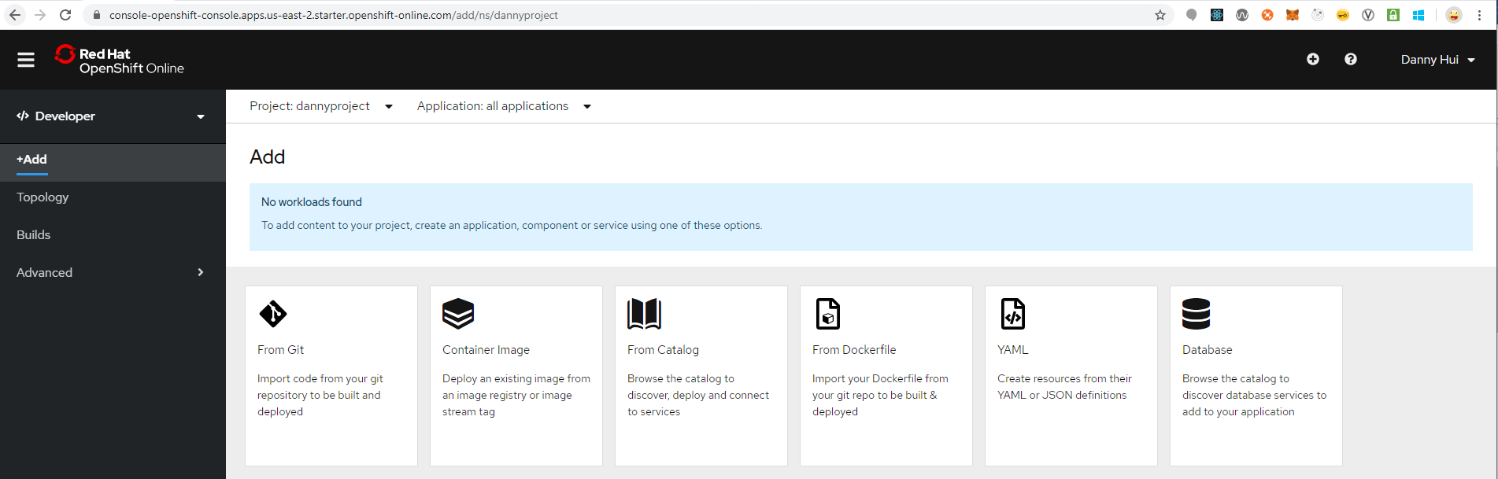
From Git
Git repo URL
https://github.com/dhui808/springbootstarter-w-config
Builder Image
Java
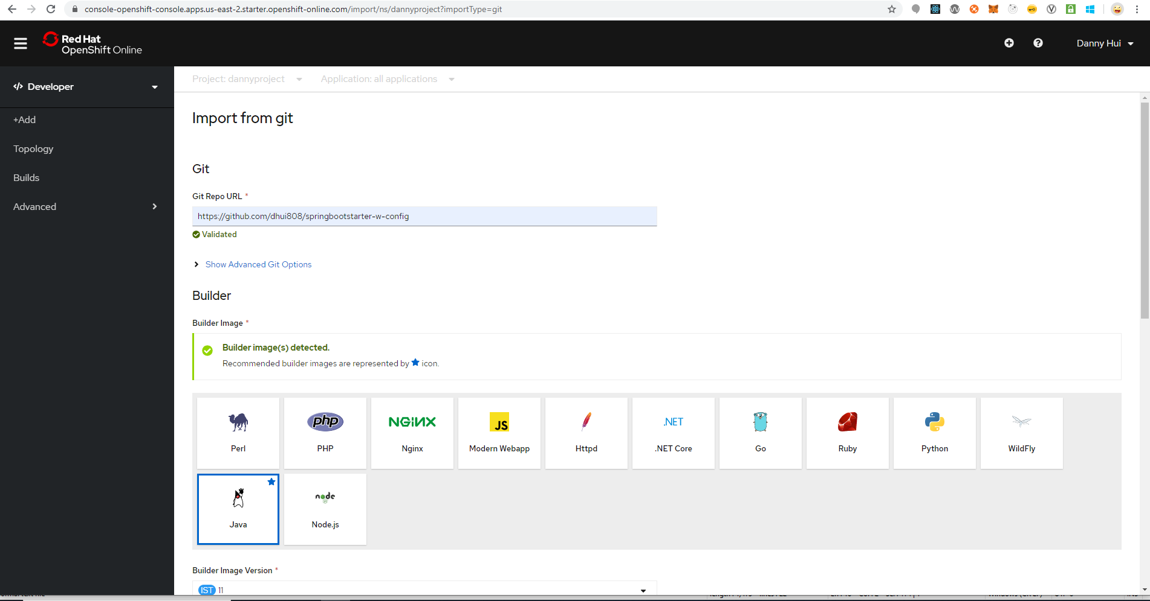
Select Deployment Config
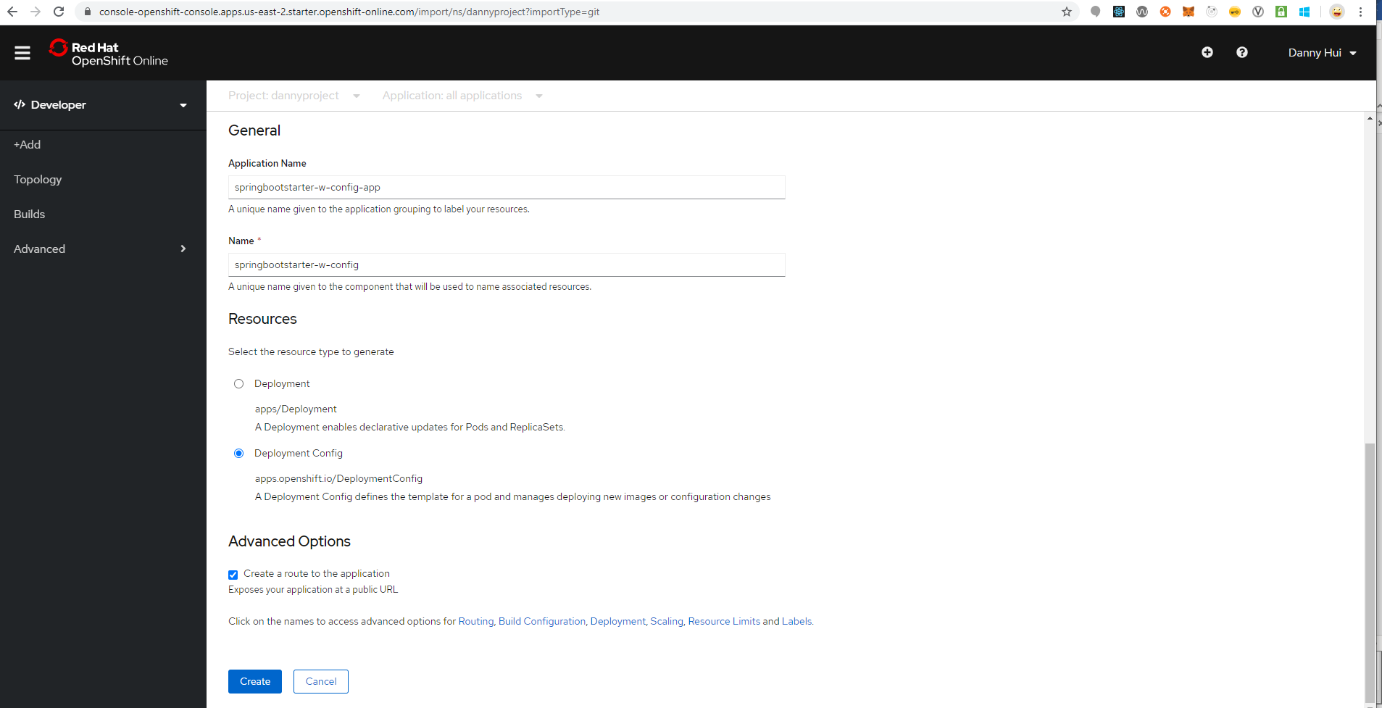
Click Routing (not providing routing configuration?)
Click Deployment
Environment Variables (Runtime only)
NAME
JAVA_OPTIONS
VALUE
-Dspring.config.location=file:///deployments/config/application.properties
Click Add from ConfigMap or Secret
Select a resource
springbootstarter-w-config-application-properties
Select a key
application.properties
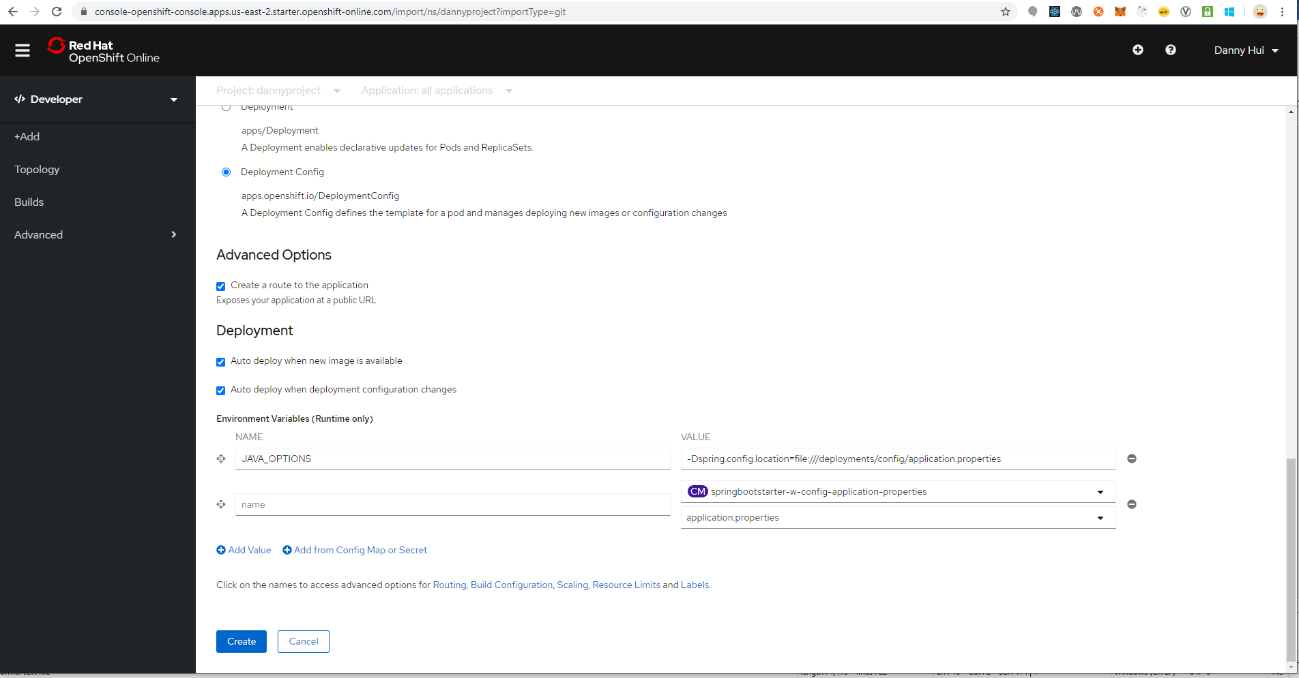
Create
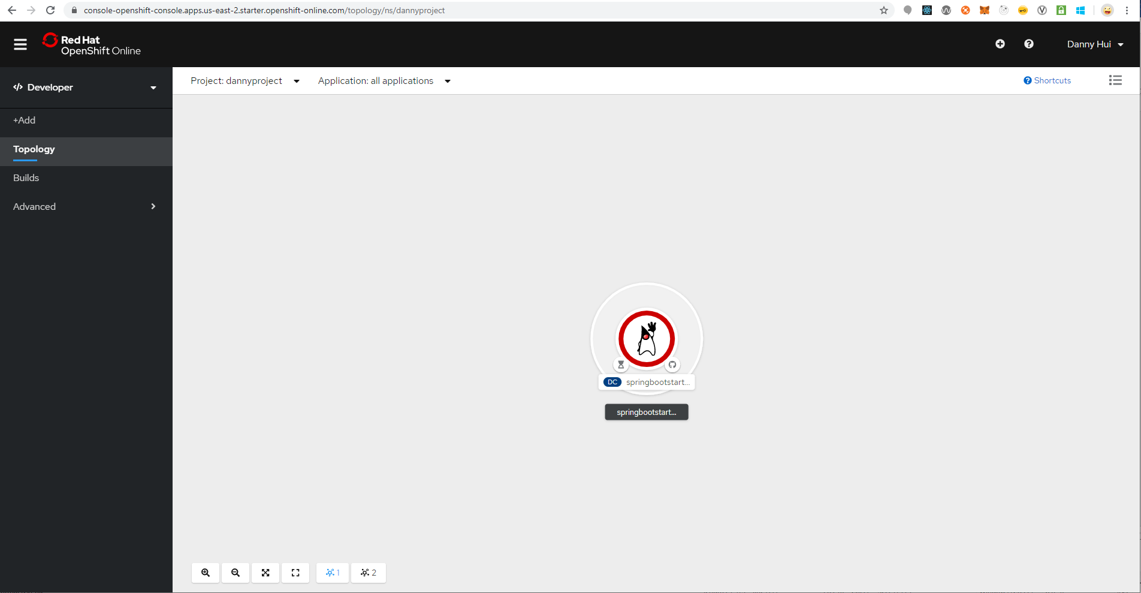
Add Volume and Volume Mount from oc
(springbootstarter-w-config is the name of the newly-created Deployment Config)
oc set volume dc/springbootstarter-w-config --add --name volume-config -t configmap --configmap-name springbootstarter-w-config-application-properties -m /deployments/config -o yaml

Administrator Perspective
Workloads – Deployment Configs - springbootstarter-w-config – YAML
containerPort: 8082
- containerPort: 8082
Save
Networking – Services - springbootstarter-w-config - YAML
Under spec – ports
- name: 8082-tcp
protocol: TCP
port: 8082
targetPort: 8082
Save
Networking – Routes - springbootstarter-w-config - YAML
Under spec

port:
targetPort: 8082-tcp
path: /springbootstarter
Save
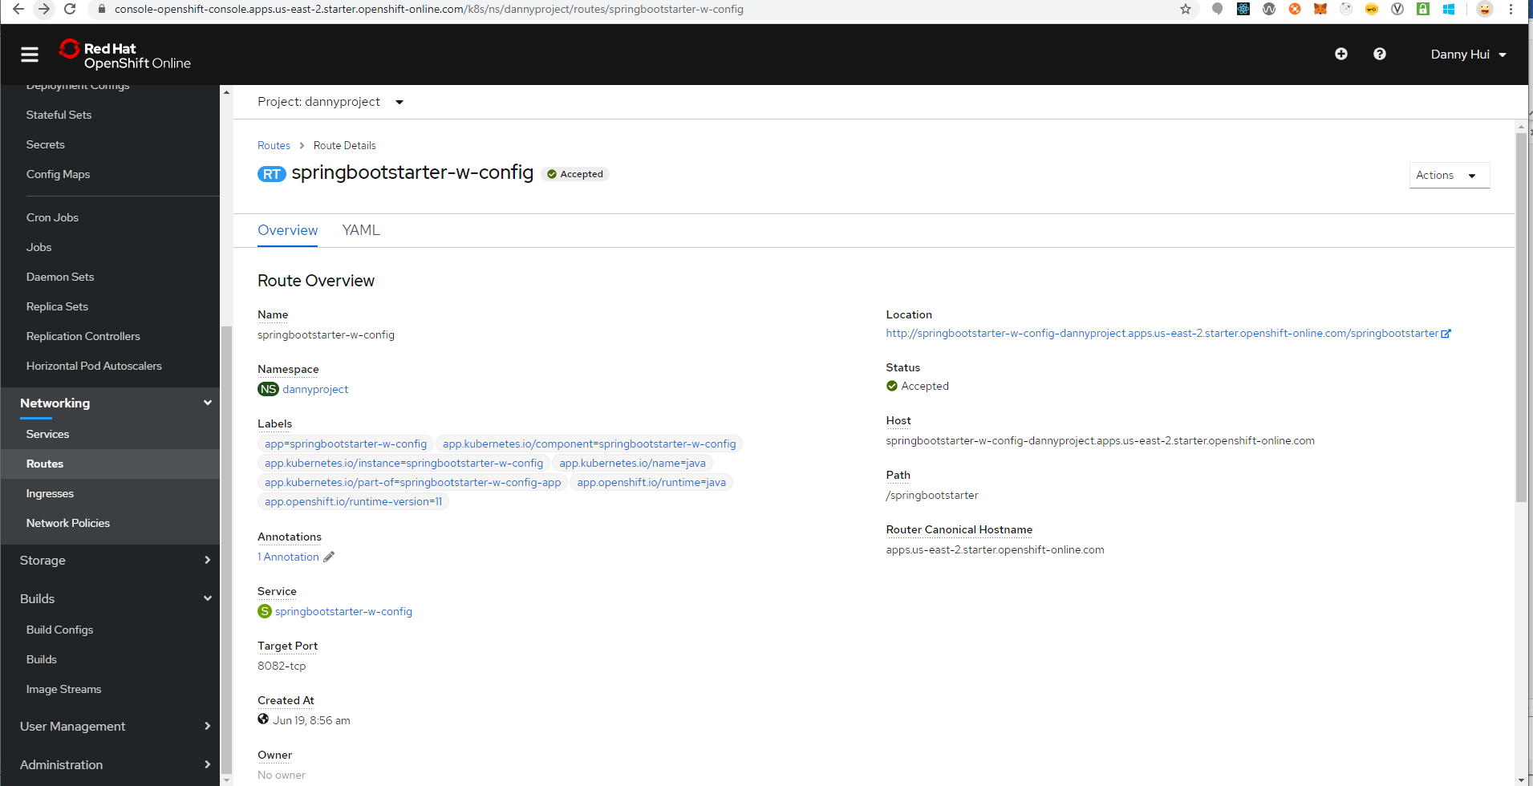
Browser
http://springbootstarter-w-config-dannyproject.apps.us-east-2.starter.openshift-online.com/springbootstarter/hello
Voila!

