Trigger OpenShift Build After GitHub Repository Update

General Discussion
If the OpenShift deployment is created from GitHub repository, we’d like to update the OpenShift build after the GitHub repository is updated. This is achieved by either defining a GitHub Webhook or manually running a build.
References
https://docs.openshift.com/container-platform/4.4/builds/triggering-builds-build-hooks.html

Create a GitHub webhook to trigger a build automatically when the change is pushed to GitHub
Create GitHub Webhook from oc
oc describe bc/userreg
This generates a webhook GitHub URL:
https://api.us-east-2.starter.openshift-online.com:6443/apis/build.openshift.io/v1/namespaces/dannyproject/buildconfigs/userreg/webhooks/<secret>/github

OpenShift Web Console
Administrator Perspective
Builds - Build Configs – userreg
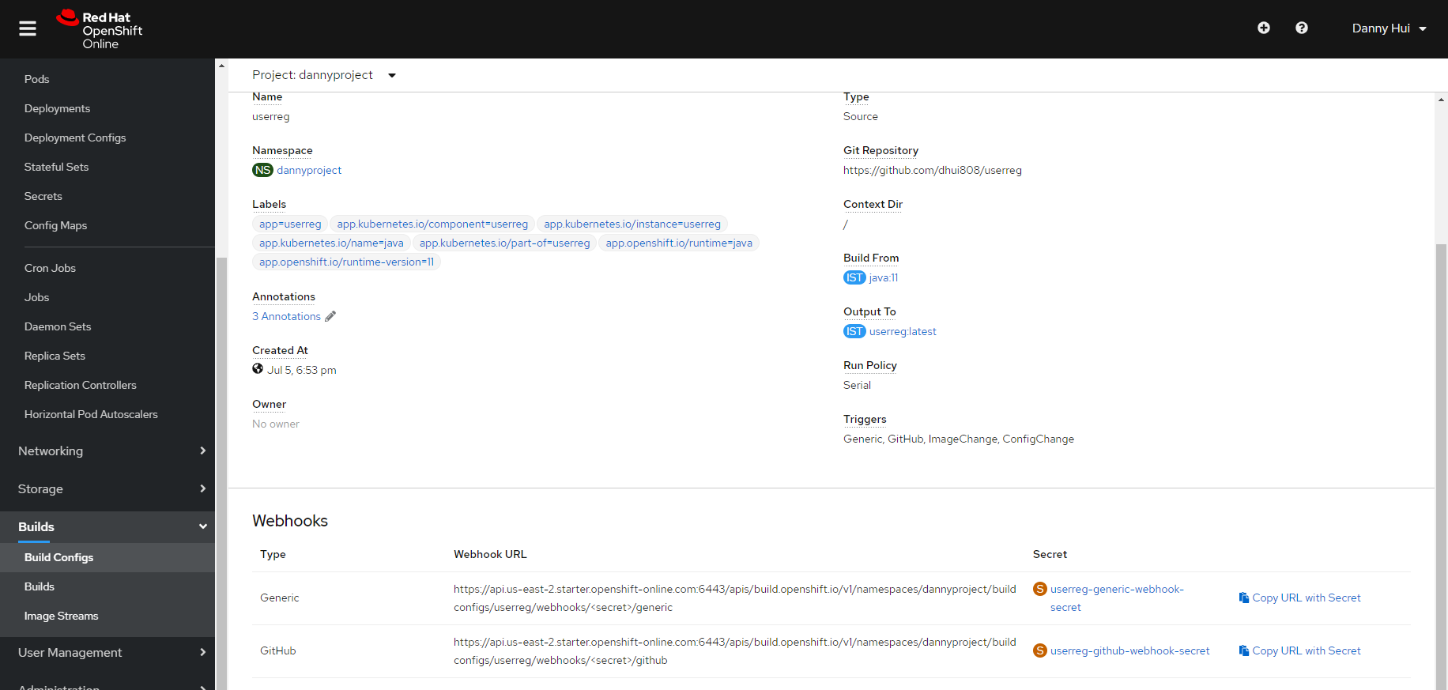
Click Copy URL with Secret (GitHub)
In your GitHub repository, select Add Webhook from Settings → Webhooks
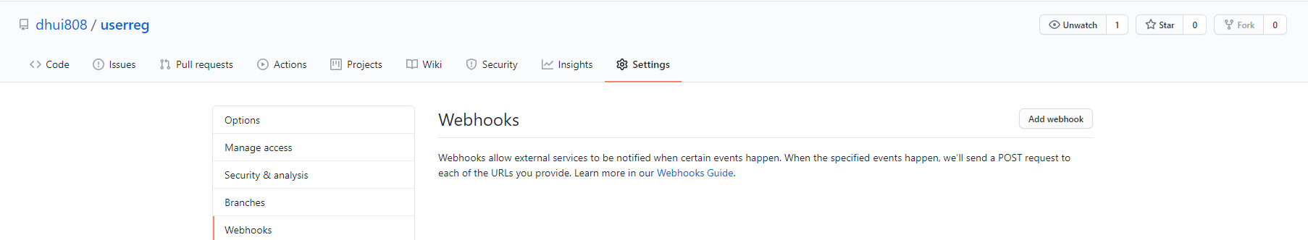
Paste the URL into the Payload URL field
Change the Content Type to application/json
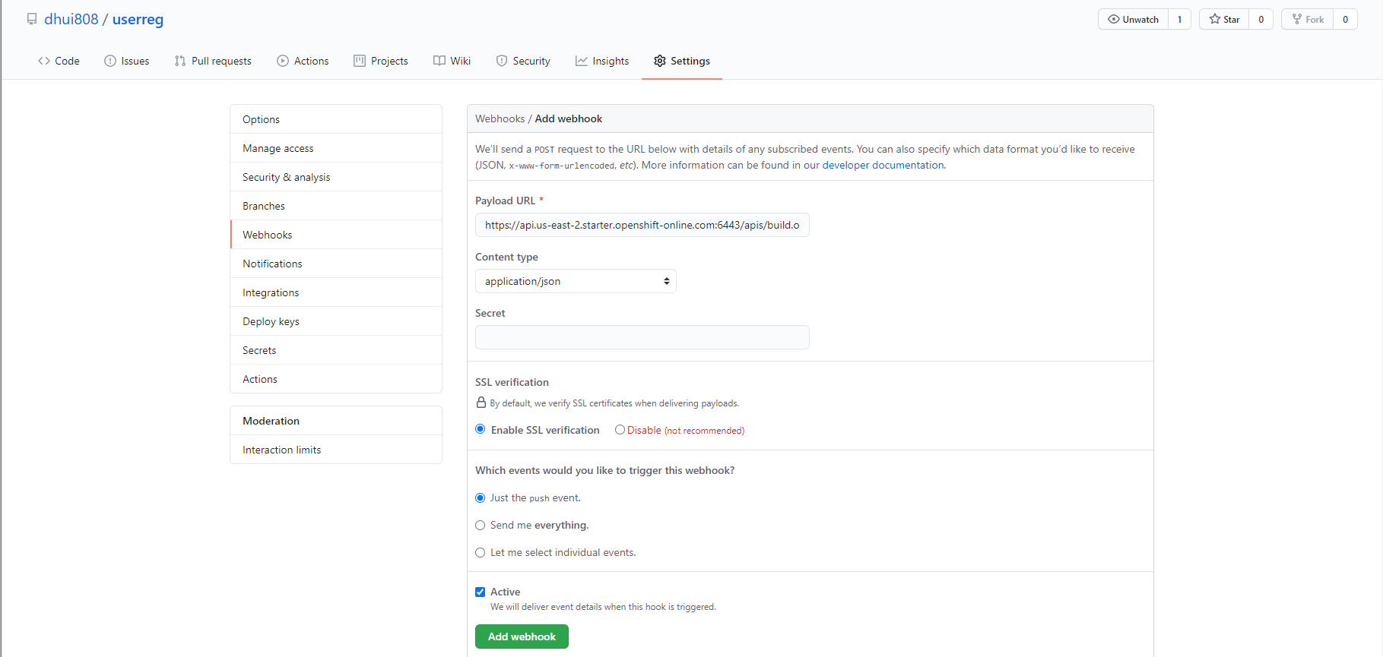
Click Add webhook
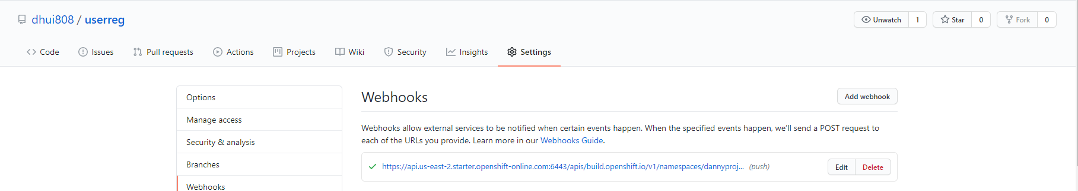

Manually trigger the build
Builds - Build Configs – userreg – Actions – Start Build

Test new build with curl
curl -X POST -d @testdata/register1.json http://userreg-dannyproject.apps.us-east-2.starter.openshift-online.com/user/register --header "Content-Type:application/json"

curl -X GET http://userreg-dannyproject.apps.us-east-2.starter.openshift-online.com/users/findAll --header "Content-Type:application/json"

curl -X DELETE http://userreg-dannyproject.apps.us-east-2.starter.openshift-online.com/user/1 --header "Content-Type:application/json"

