**Deploy Spring Boot Web Application**

**from OpenShift Web Console**

Login to OpenShift 4.4

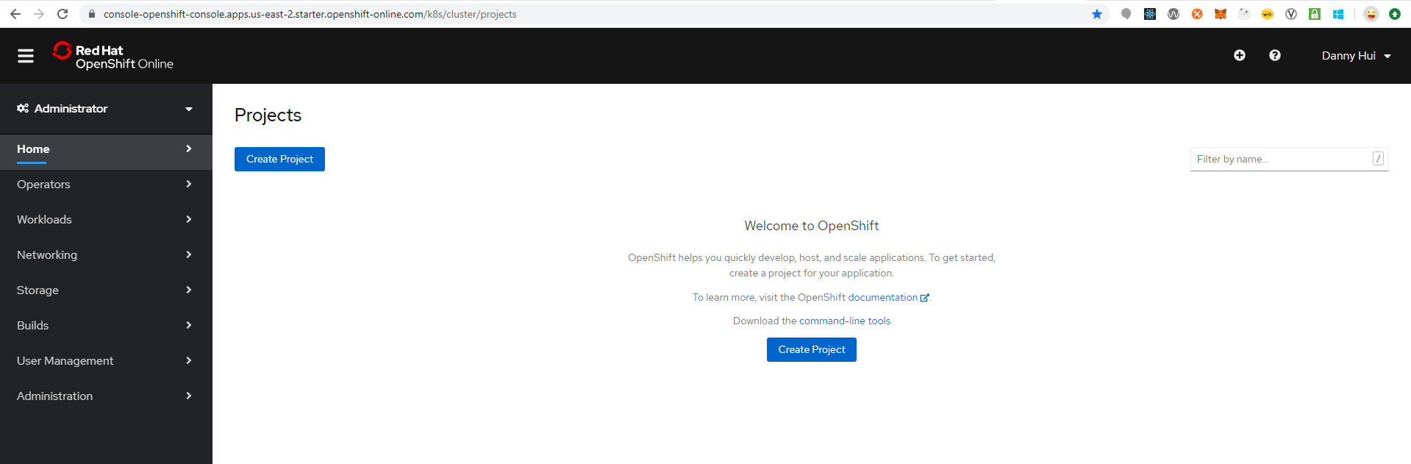

Create Project

MyProject

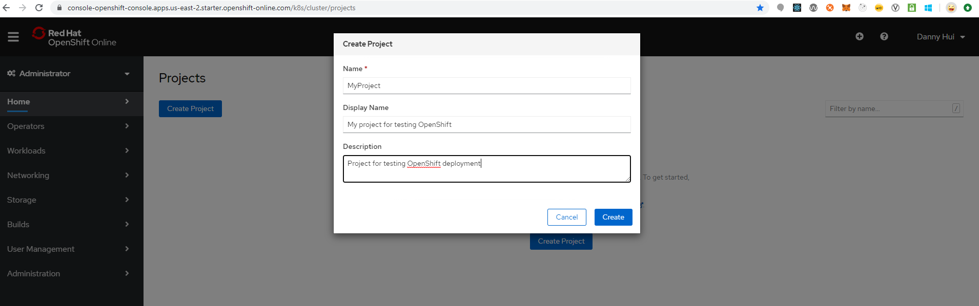

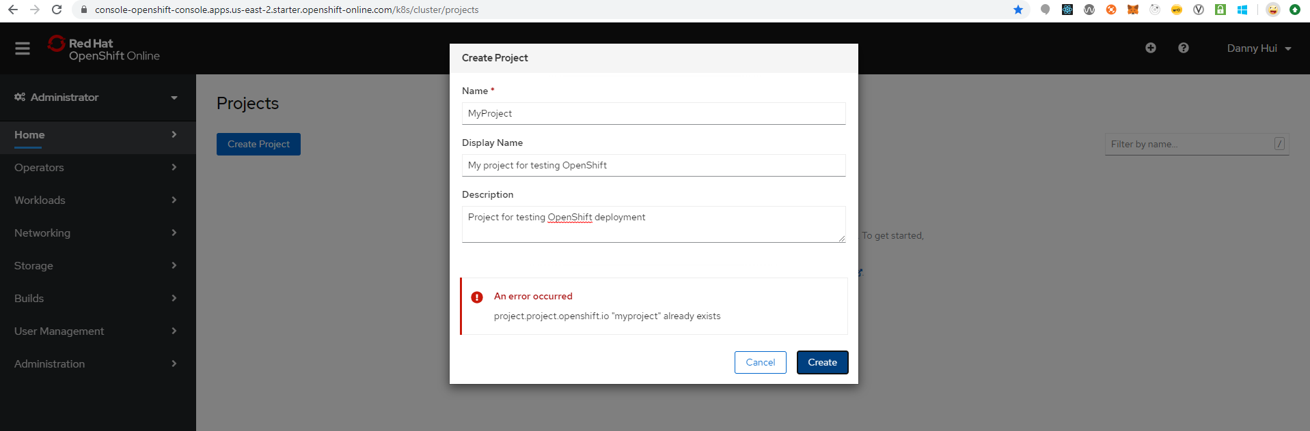

Obviously, OpenShift requires a project name unique across OpenShift – this is nonsense. Should be cluster-wide unique only.

MyFirstProject

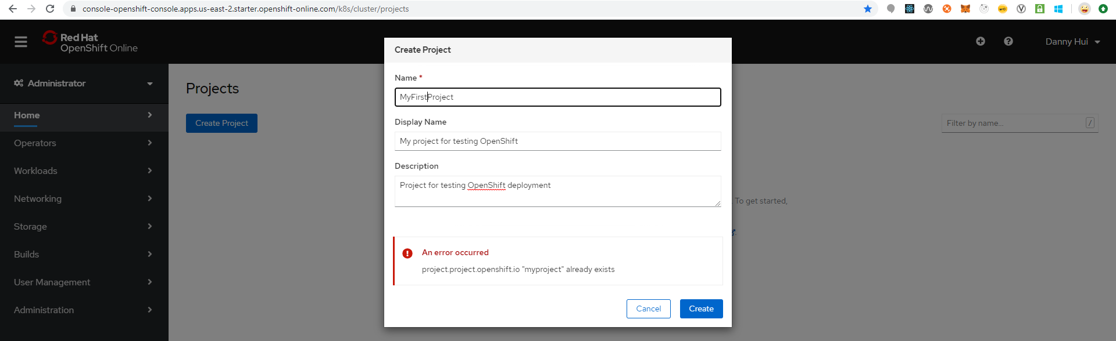

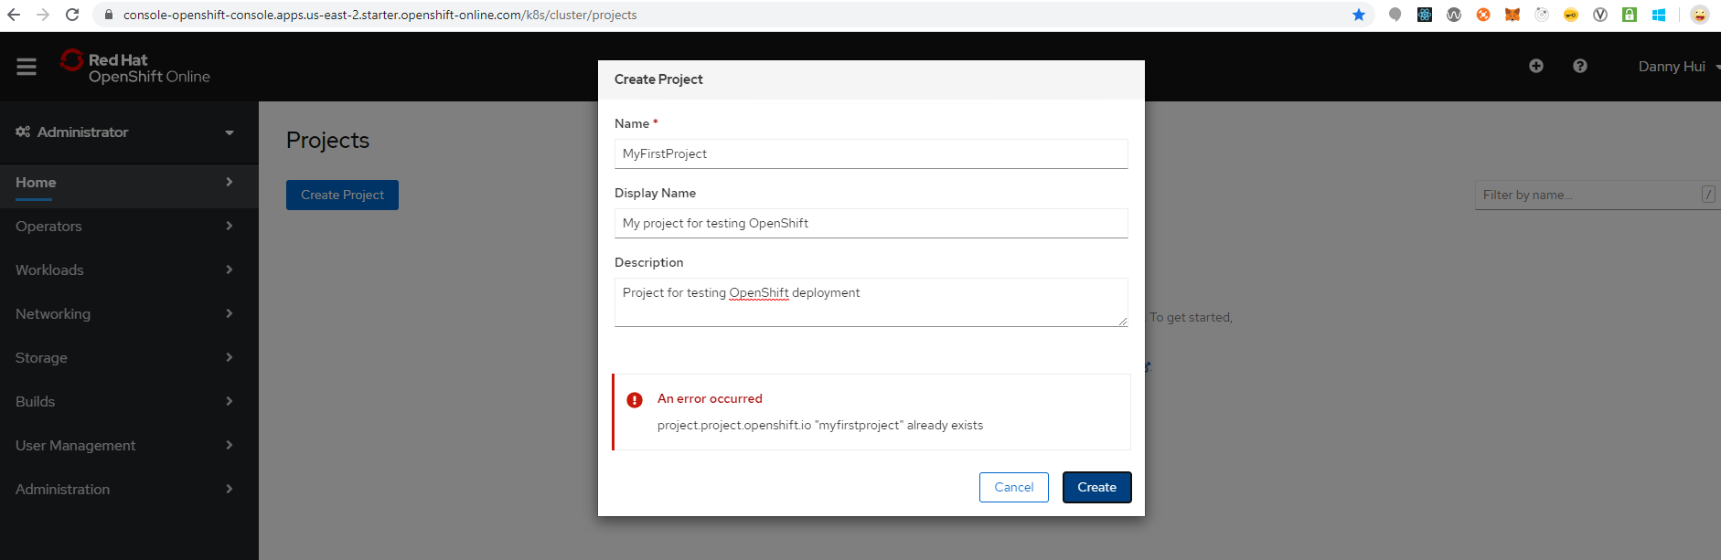

DannyProject

Dashboard

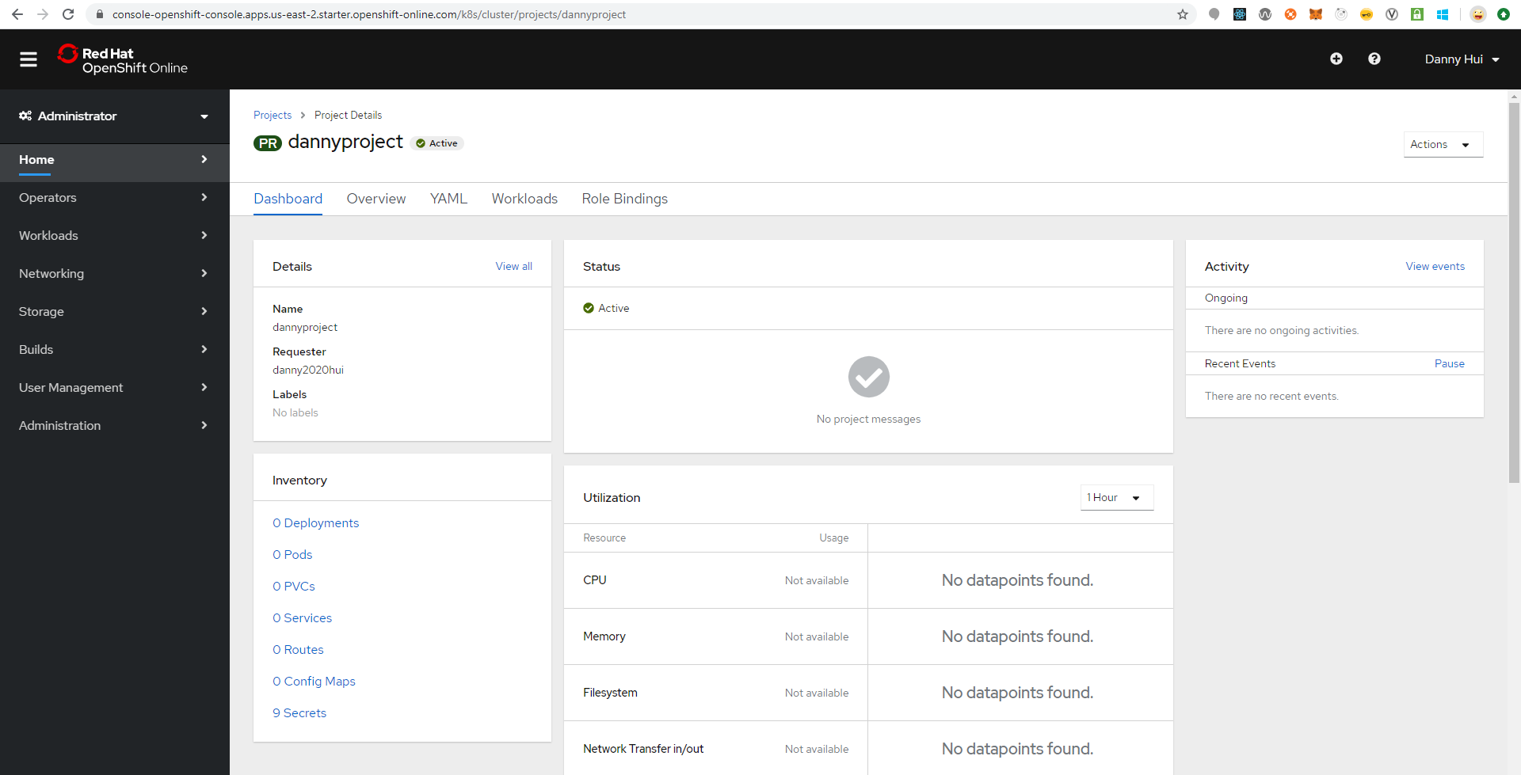

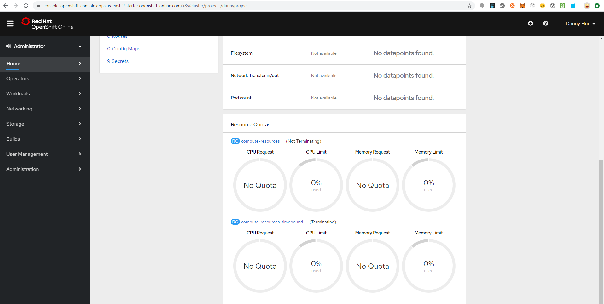

Overview

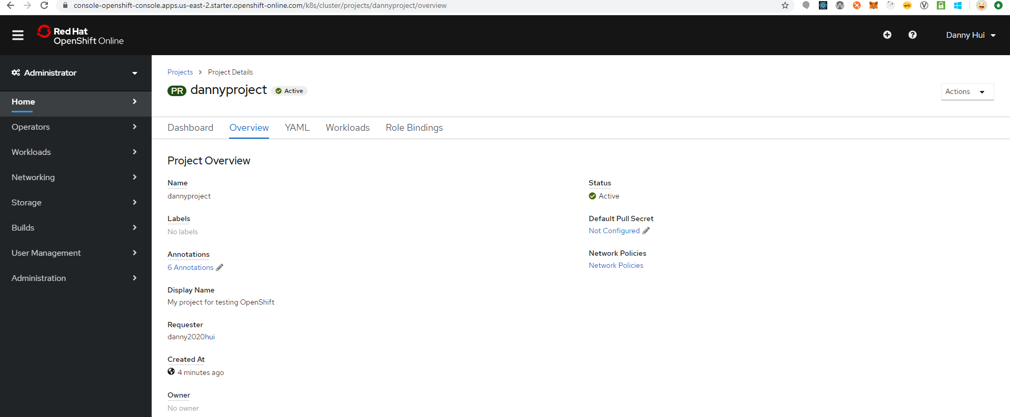

YAML

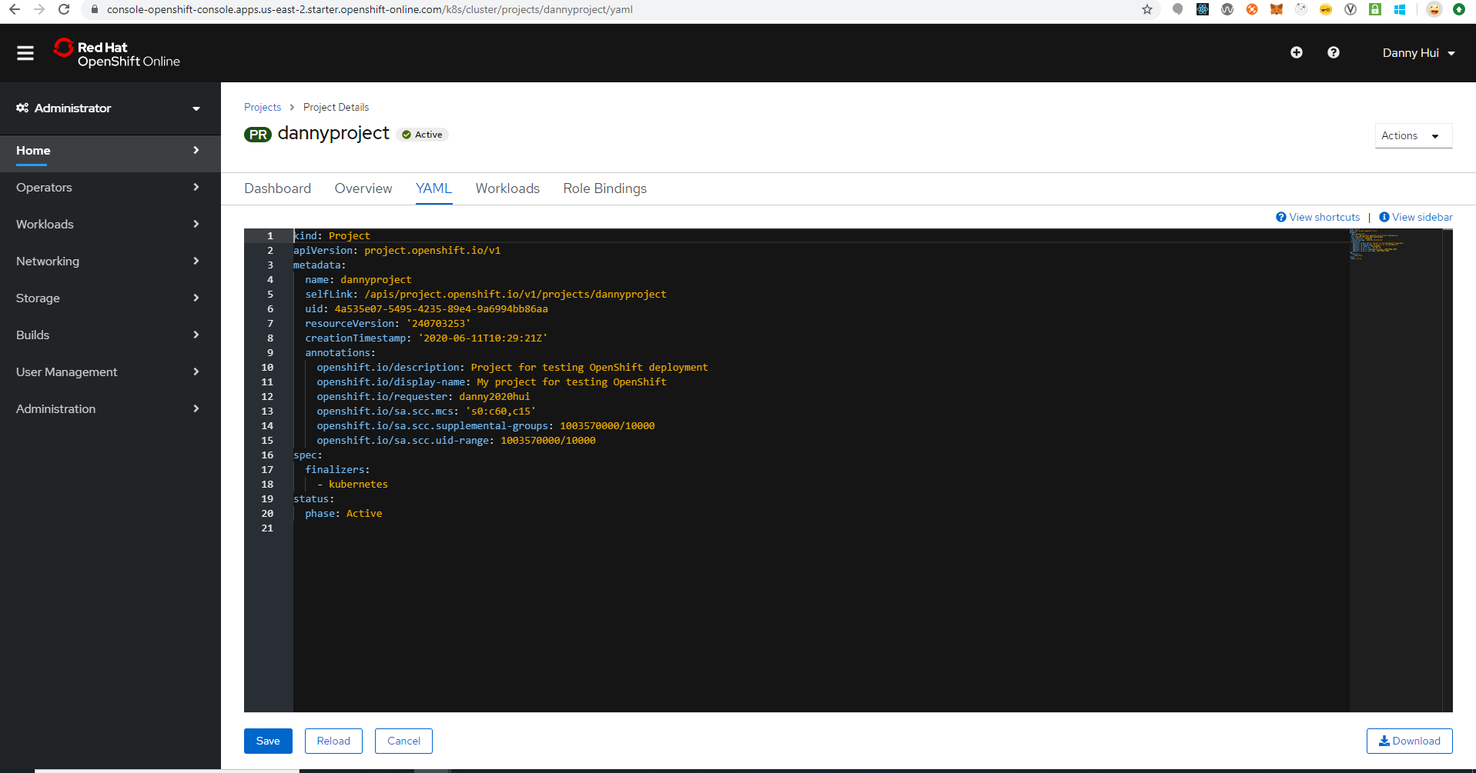

Workloads

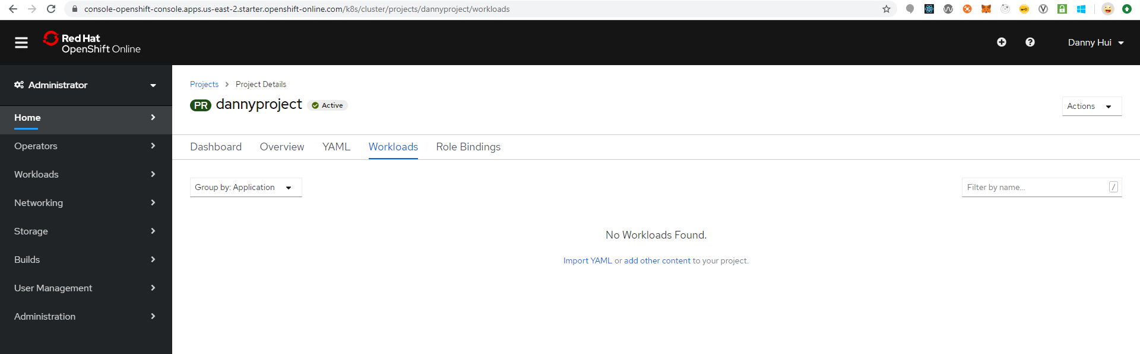

Roles Bindings

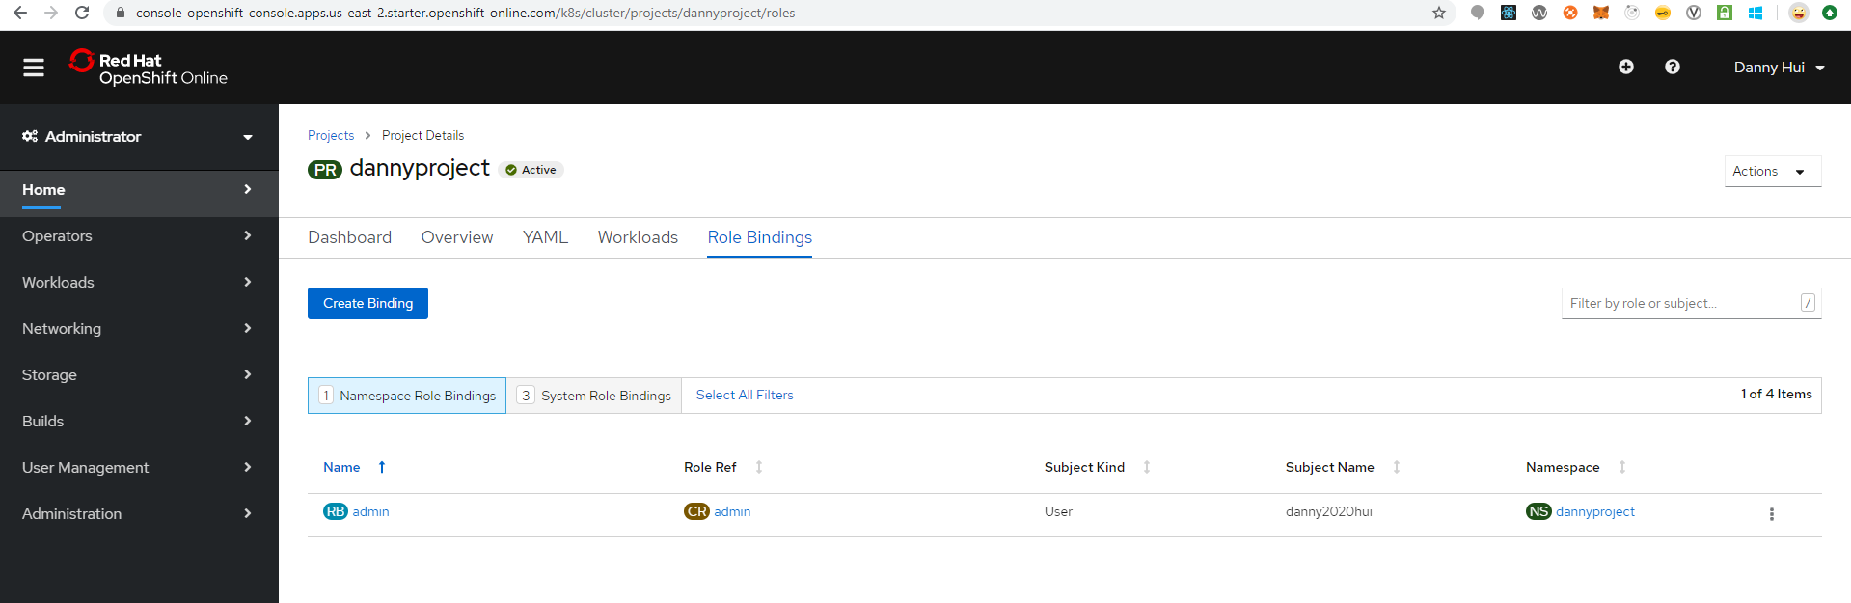

Home – Projects

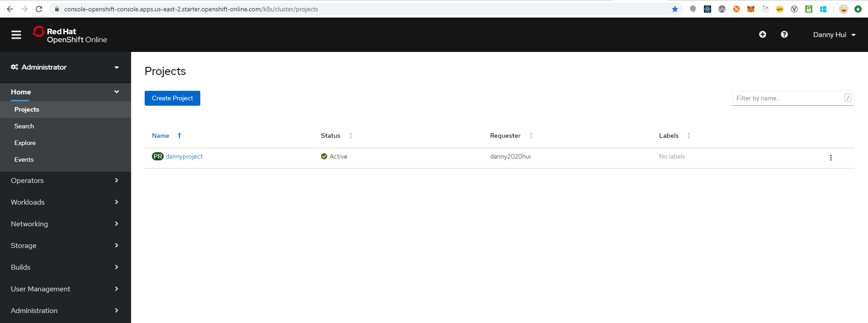

Developer Perspective

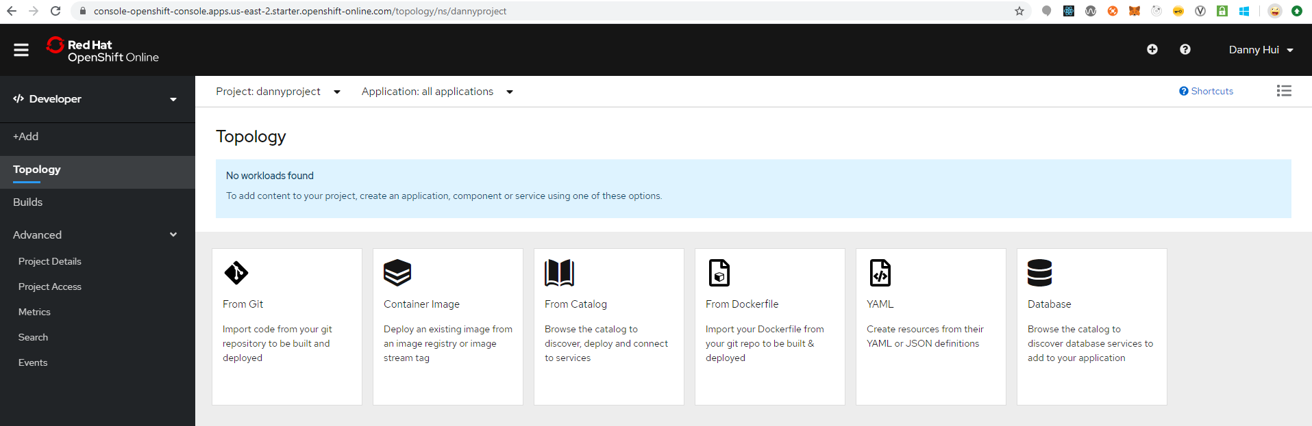

Deploy Spring Boot Web Application

Source:

<https://github.com/dhui808/springbootstarter>

+Add

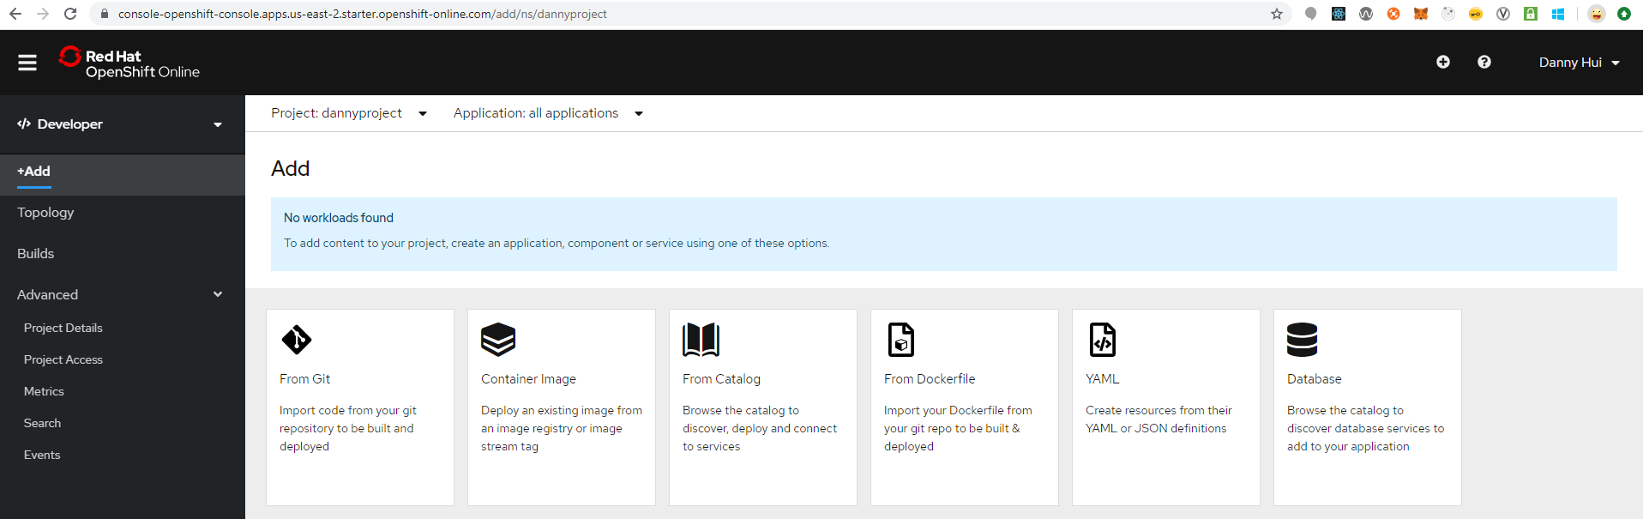

From Git

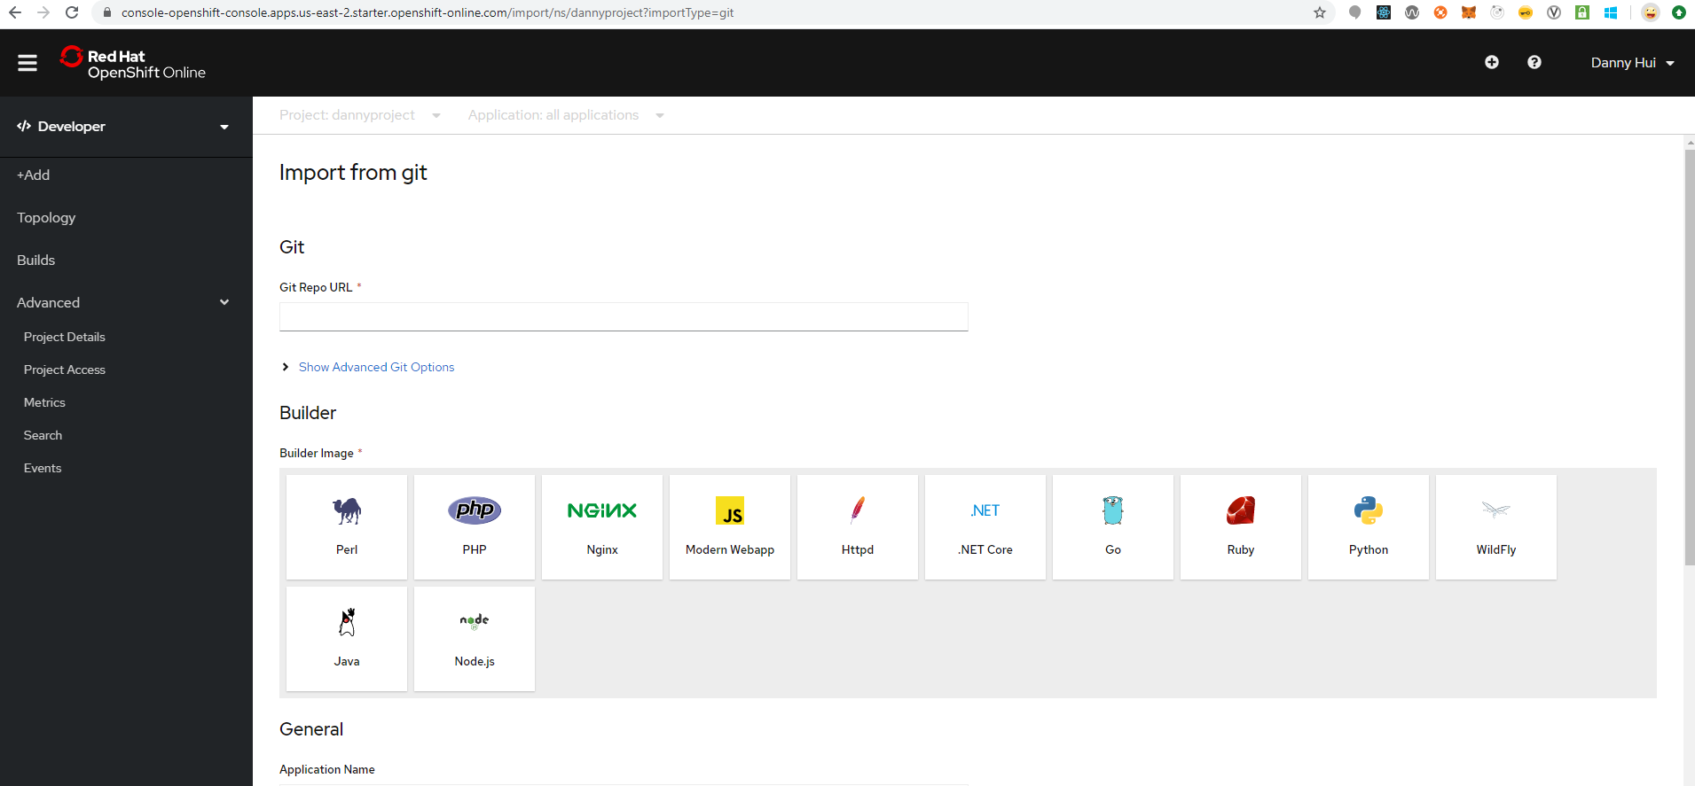

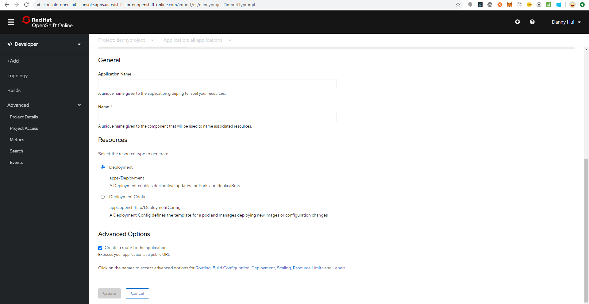

Show Advanced Git Options

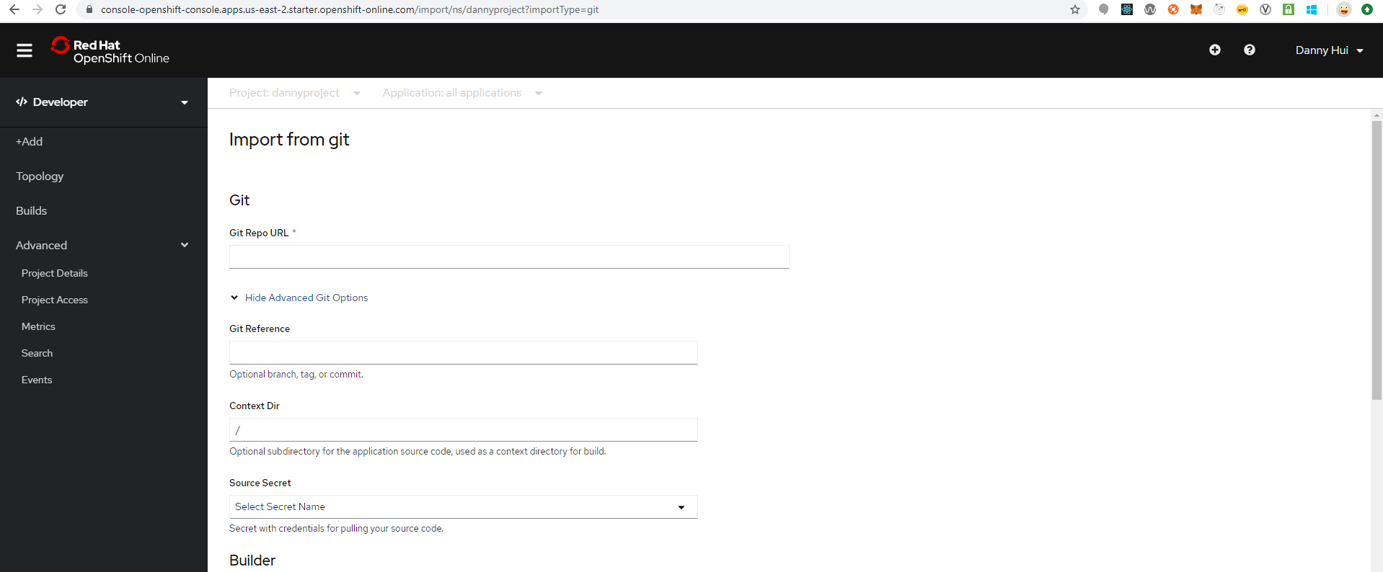

Git Repo URL

<https://github.com/dhui808/springbootstarter>

Build Image

Java

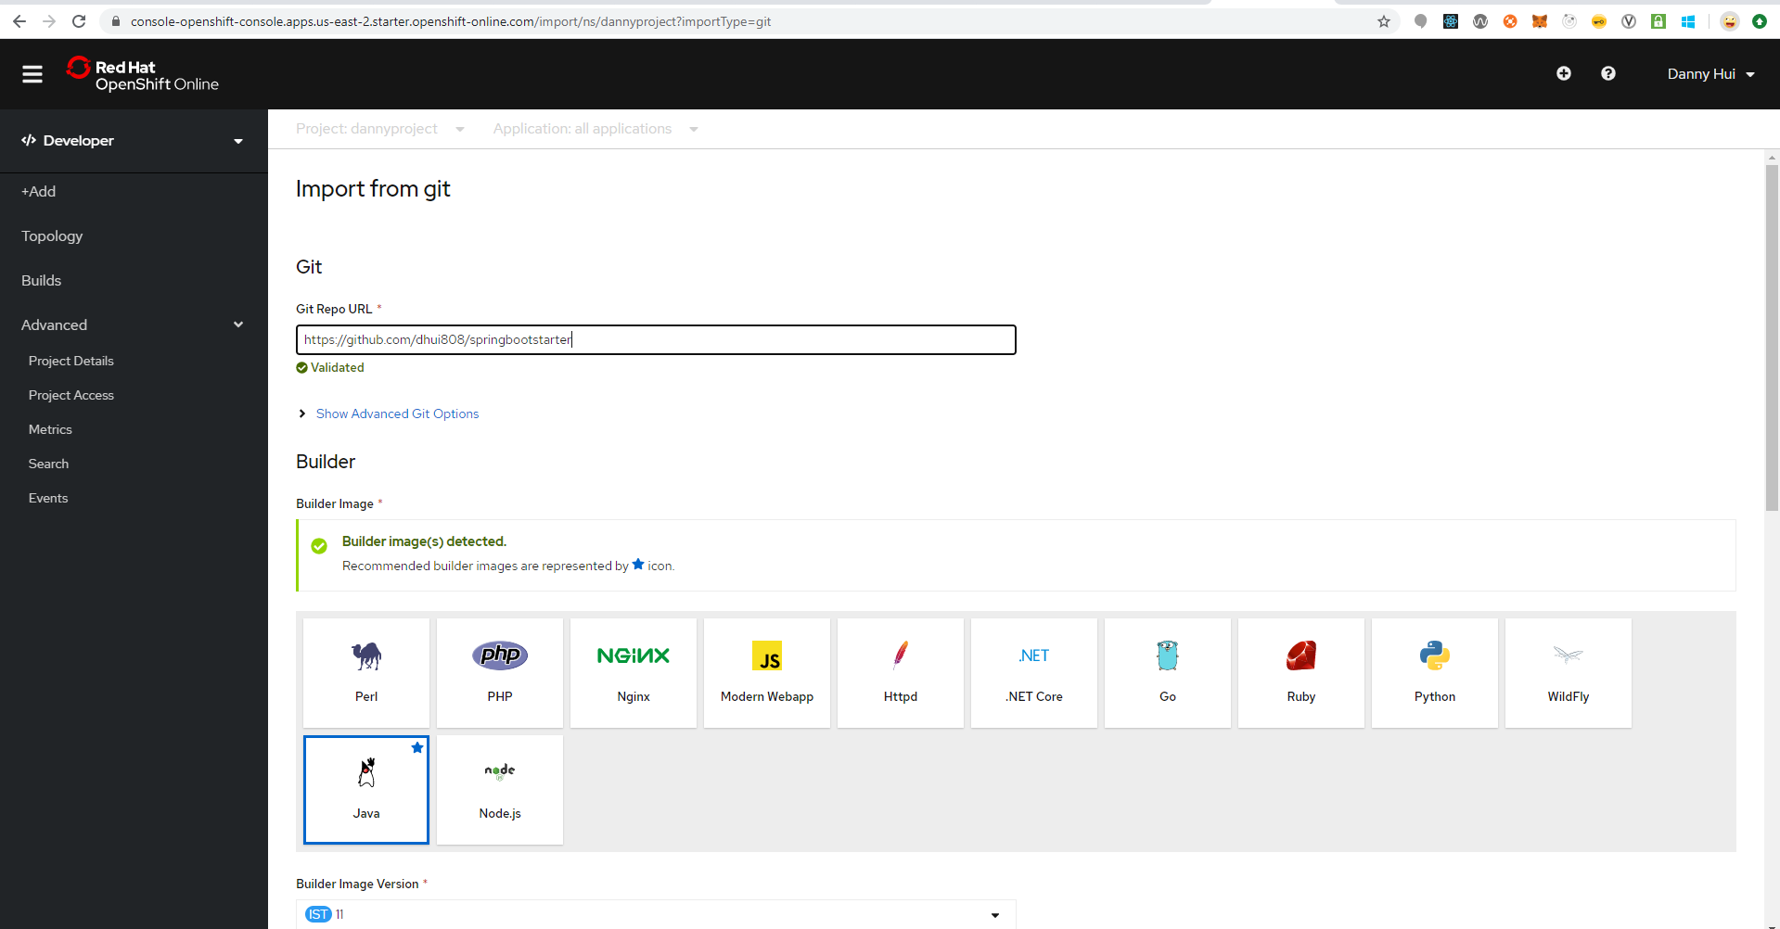

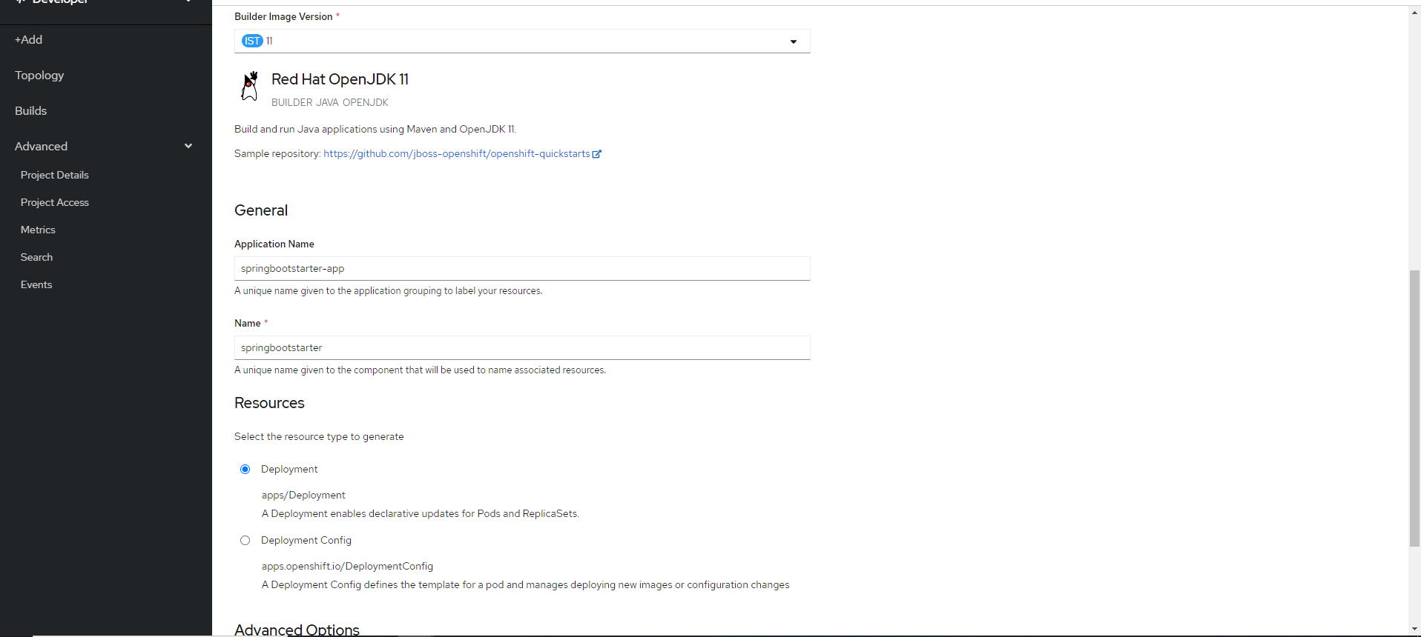



Select either Deployment (OpenShift recommendation) or Deployment Config (allowing adding volume)

Create

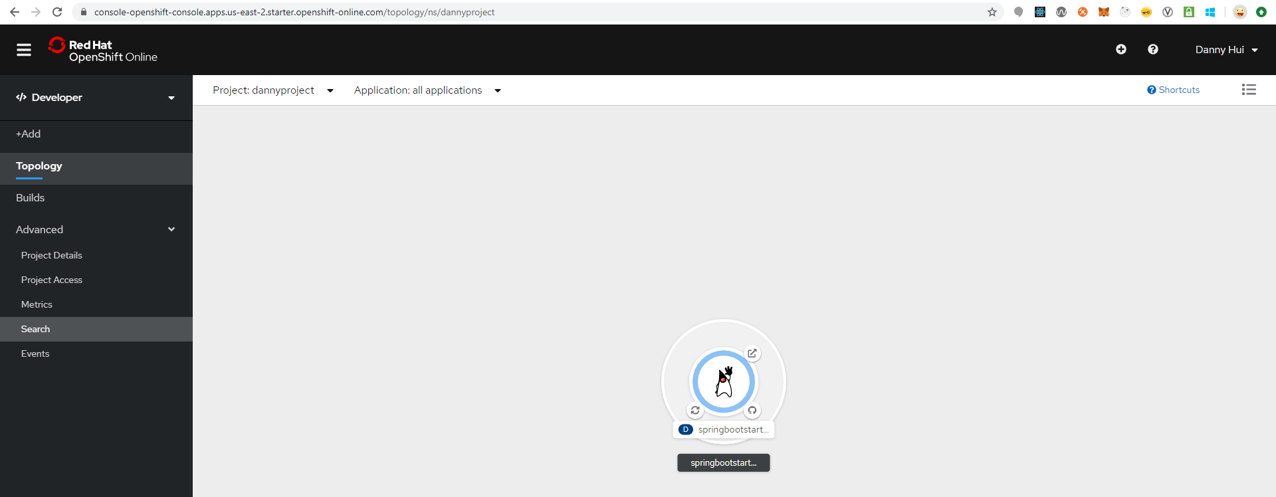

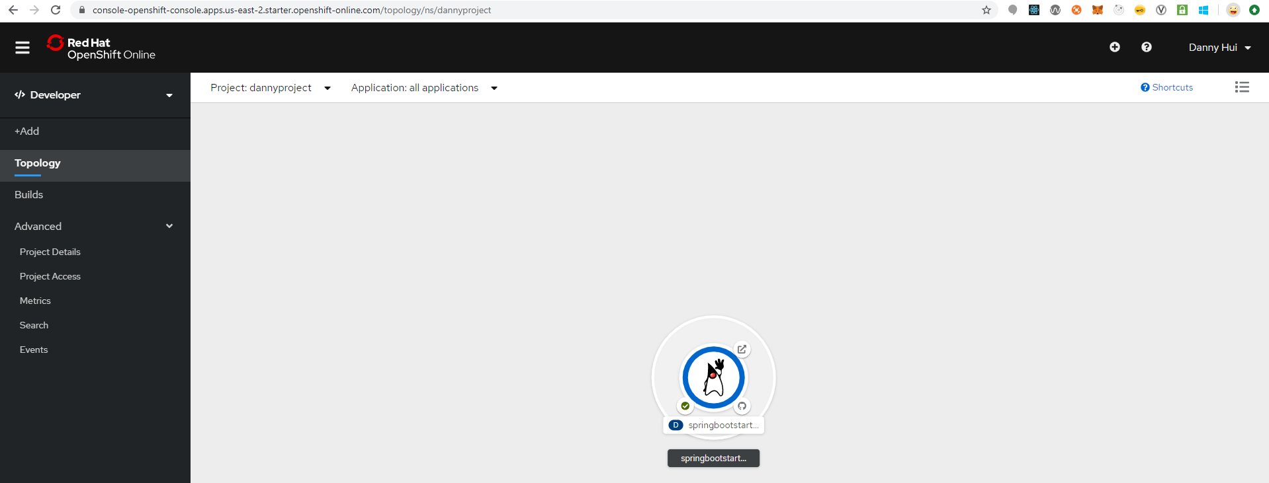

List View



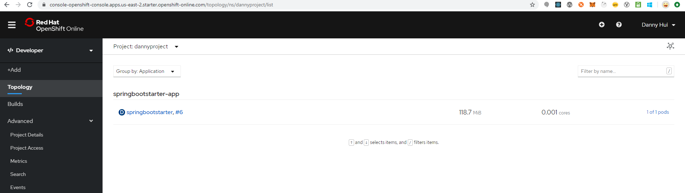

springbootstarter

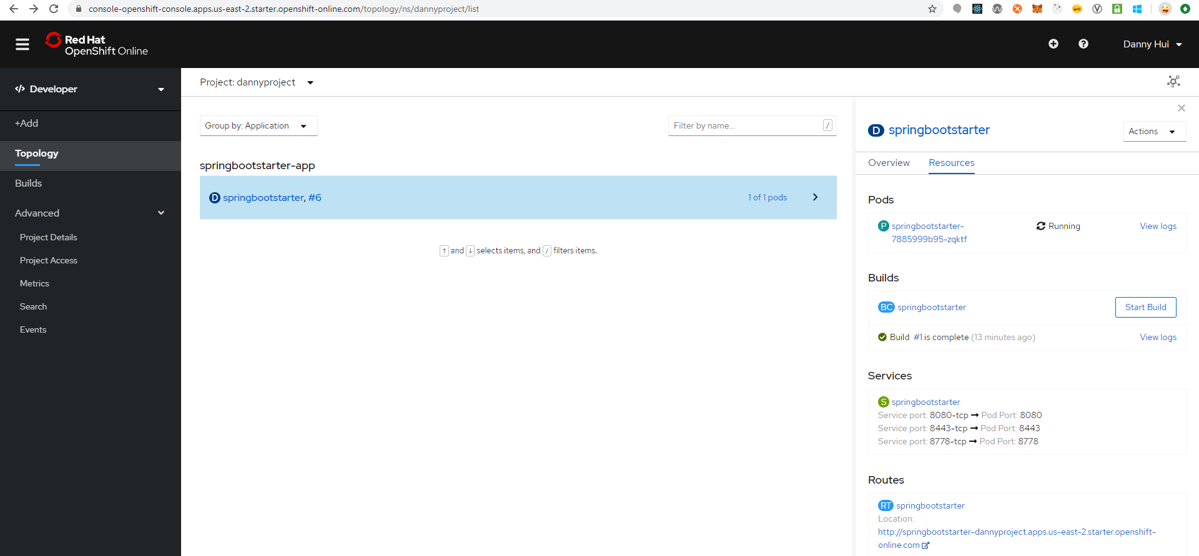

View Logs

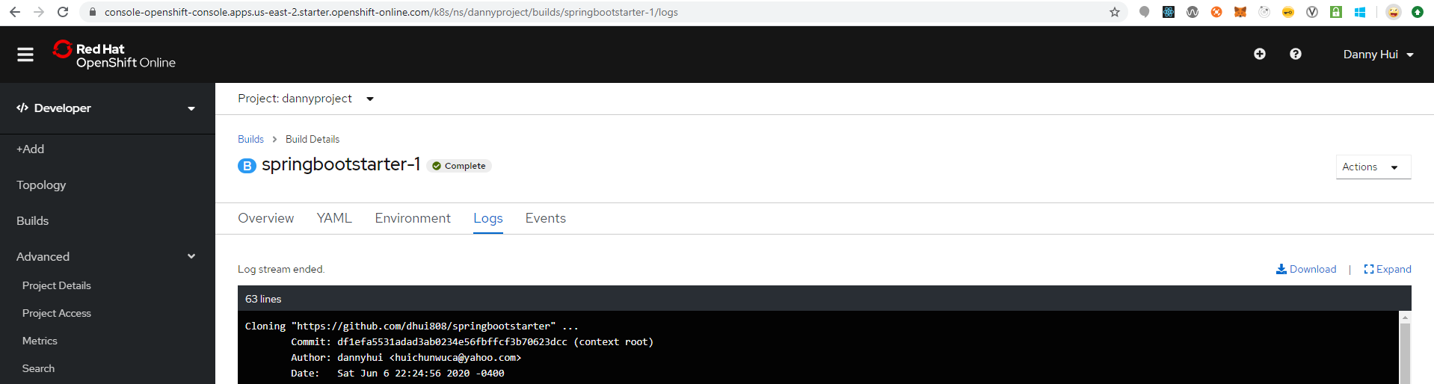

Cloning "https://github.com/dhui808/springbootstarter" ...

Commit: df1efa5531adad3ab0234e56fbffcf3b70623dcc (context root)

Author: dannyhui <huichunwuca@yahoo.com>

Date: Sat Jun 6 22:24:56 2020 -0400

ntral: https://repo1.maven.org/maven2/net/java/dev/jna/jna-platform/5.5.0/jna-platform-5.5.0.jar (2.7 MB at 14 MB/s)

[INFO] Downloading from central: https://repo1.maven.org/maven2/org/sonatype/sisu/sisu-guice/3.2.5/sisu-guice-3.2.5-no_aop.jar

[INFO] Downloaded from central: https://repo1.maven.org/maven2/org/codehaus/plexus/plexus-component-annotations/1.5.5/plexus-component-annotations-1.5.5.jar (4.2 kB at 25 kB/s)

[INFO] Downloading from central: https://repo1.maven.org/maven2/com/google/guava/guava/16.0.1/guava-16.0.1.jar

[INFO] Downloaded from central: https://repo1.maven.org/maven2/org/sonatype/sisu/sisu-inject-plexus/2.6.0/sisu-inject-plexus-2.6.0.jar (20 kB at 97 kB/s)

[INFO] Downloading from central: https://repo1.maven.org/maven2/org/apache/maven/shared/maven-shared-utils/3.1.0/maven-shared-utils-3.1.0.jar

[INFO] Downloaded from central: https://repo1.maven.org/maven2/org/sonatype/plexus/plexus-sec-dispatcher/1.4/plexus-sec-dispatcher-1.4.jar (28 kB at 134 kB/s)

[INFO] Downloading from central: https://repo1.maven.org/maven2/org/apache/maven/maven-plugin-api/3.6.3/maven-plugin-api-3.6.3.jar

[INFO] Downloaded from central: https://repo1.maven.org/maven2/org/sonatype/sisu/sisu-inject-bean/2.6.0/sisu-inject-bean-2.6.0.jar (45 kB at 205 kB/s)

[INFO] Downloading from central: https://repo1.maven.org/maven2/org/eclipse/sisu/org.eclipse.sisu.plexus/0.3.4/org.eclipse.sisu.plexus-0.3.4.jar

[INFO] Downloaded from central: https://repo1.maven.org/maven2/org/sonatype/sisu/sisu-guice/3.2.5/sisu-guice-3.2.5-no_aop.jar (400 kB at 1.8 MB/s)

[INFO] Downloading from central: https://repo1.maven.org/maven2/javax/enterprise/cdi-api/1.0/cdi-api-1.0.jar

[INFO] Downloaded from central: https://repo1.maven.org/maven2/org/apache/maven/maven-plugin-api/3.6.3/maven-plugin-api-3.6.3.jar (47 kB at 201 kB/s)

[INFO] Downloading from central: https://repo1.maven.org/maven2/javax/annotation/jsr250-api/1.0/jsr250-api-1.0.jar

[INFO] Downloaded from central: https://repo1.maven.org/maven2/org/apache/maven/shared/maven-shared-utils/3.1.0/maven-shared-utils-3.1.0.jar (164 kB at 691 kB/s)

[INFO] Downloading from central: https://repo1.maven.org/maven2/org/eclipse/sisu/org.eclipse.sisu.inject/0.3.4/org.eclipse.sisu.inject-0.3.4.jar

[INFO] Downloaded from central: https://repo1.maven.org/maven2/javax/enterprise/cdi-api/1.0/cdi-api-1.0.jar (45 kB at 177 kB/s)

[INFO] Downloading from central: https://repo1.maven.org/maven2/org/codehaus/plexus/plexus-utils/3.2.1/plexus-utils-3.2.1.jar

[INFO] Downloaded from central: https://repo1.maven.org/maven2/org/eclipse/sisu/org.eclipse.sisu.plexus/0.3.4/org.eclipse.sisu.plexus-0.3.4.jar (205 kB at 796 kB/s)

[INFO] Downloading from central: https://repo1.maven.org/maven2/org/codehaus/plexus/plexus-classworlds/2.6.0/plexus-classworlds-2.6.0.jar

[INFO] Downloaded from central: https://repo1.maven.org/maven2/javax/annotation/jsr250-api/1.0/jsr250-api-1.0.jar (5.8 kB at 23 kB/s)

[INFO] Downloaded from central: https://repo1.maven.org/maven2/com/google/guava/guava/16.0.1/guava-16.0.1.jar (2.2 MB at 8.3 MB/s)

[INFO] Downloaded from central: https://repo1.maven.org/maven2/org/eclipse/sisu/org.eclipse.sisu.inject/0.3.4/org.eclipse.sisu.inject-0.3.4.jar (379 kB at 1.4 MB/s)

[INFO] Downloaded from central: https://repo1.maven.org/maven2/org/codehaus/plexus/plexus-classworlds/2.6.0/plexus-classworlds-2.6.0.jar (53 kB at 166 kB/s)

[INFO] Downloaded from central: https://repo1.maven.org/maven2/org/codehaus/plexus/plexus-utils/3.2.1/plexus-utils-3.2.1.jar (262 kB at 818 kB/s)

[INFO] Replacing main artifact with repackaged archive

[INFO] ------------------------------------------------------------------------

[INFO] BUILD SUCCESS

[INFO] ------------------------------------------------------------------------

[INFO] Total time: 21.791 s

[INFO] Finished at: 2020-06-11T11:33:33Z

[INFO] ------------------------------------------------------------------------

[WARNING] The requested profile "openshift" could not be activated because it does not exist.

INFO Copying deployments from target to /deployments...

'/tmp/src/target/springbootstarter-0.0.1.jar' -> '/deployments/springbootstarter-0.0.1.jar'

STEP 9: CMD /usr/local/s2i/run

STEP 10: COMMIT temp.builder.openshift.io/dannyproject/springbootstarter-1:666d7b7b

Getting image source signatures

Copying blob sha256:d36cbe2189eee00ed8ca8fe17d5894e2a6caf033c379c20d5b07713d125b8dc6

Copying blob sha256:ac22a347ac5d9884944bea9c8af6095d120459af968d14b7fffed52c18a5f1a3

Copying blob sha256:866a160adfee45a957908a361602ffe00a6c604522b5657b9d3b8290595e9762

Copying blob sha256:c983ce6b869d99f2f1d6614a344a6f5eb452cc99205b608b9ada2f6d7ad8b08a

Copying config sha256:6865d4747dd63cd2027bc696e3d37cd8c47972a57412d6186613628c42097b52

Writing manifest to image destination

Storing signatures

6865d4747dd63cd2027bc696e3d37cd8c47972a57412d6186613628c42097b52

6865d4747dd63cd2027bc696e3d37cd8c47972a57412d6186613628c42097b52

Pushing image image-registry.openshift-image-registry.svc:5000/dannyproject/springbootstarter:latest ...

Getting image source signatures

Copying blob sha256:c983ce6b869d99f2f1d6614a344a6f5eb452cc99205b608b9ada2f6d7ad8b08a

Copying blob sha256:51e9f237b750efcda2d5755785cdb8dd080d51585ae35d368e4f9b29a11b1994

Copying blob sha256:0bf63f6bfea73e8ea01220862087cf57c5eeedfea1218feb575f8834a36c805f

Copying blob sha256:6c85ac87d44df4b64d7c273886fc5aed55a28422df33dcb641884ffa419db218

Copying config sha256:6865d4747dd63cd2027bc696e3d37cd8c47972a57412d6186613628c42097b52

Writing manifest to image destination

Storing signatures

Successfully pushed image-registry.openshift-image-registry.svc:5000/dannyproject/springbootstarter@sha256:3c6fe16df35bfc87845fc5e348cbf79544342027ac2152004fbf1ae88d240c73

Push successful

Topology – List View

#6

-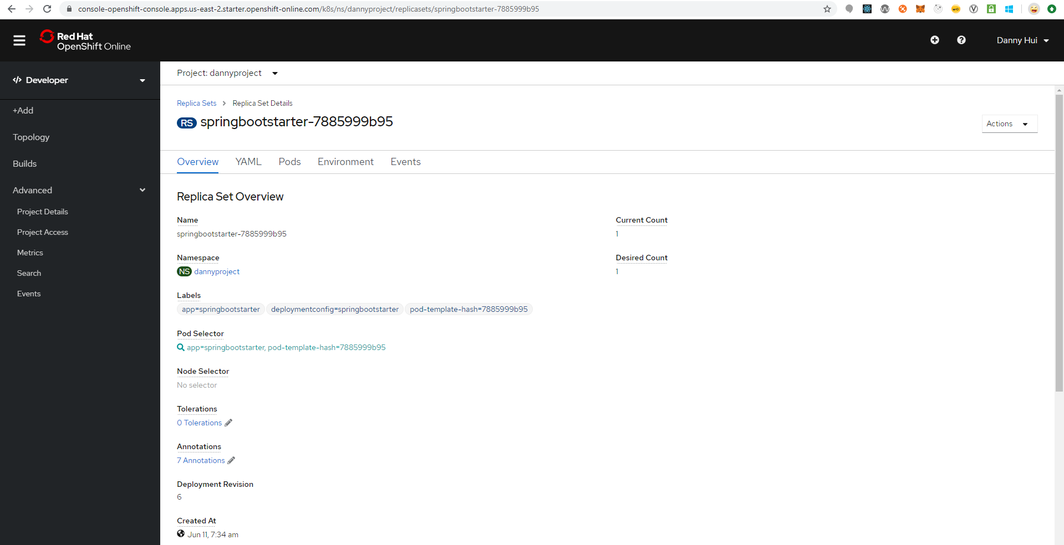

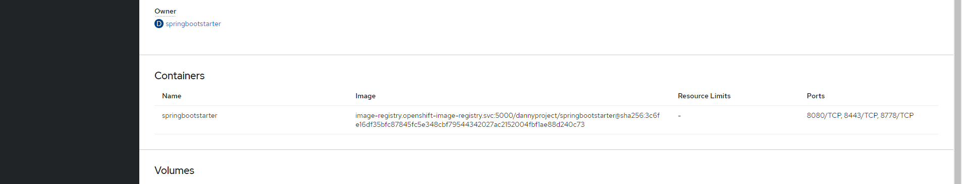

Logs

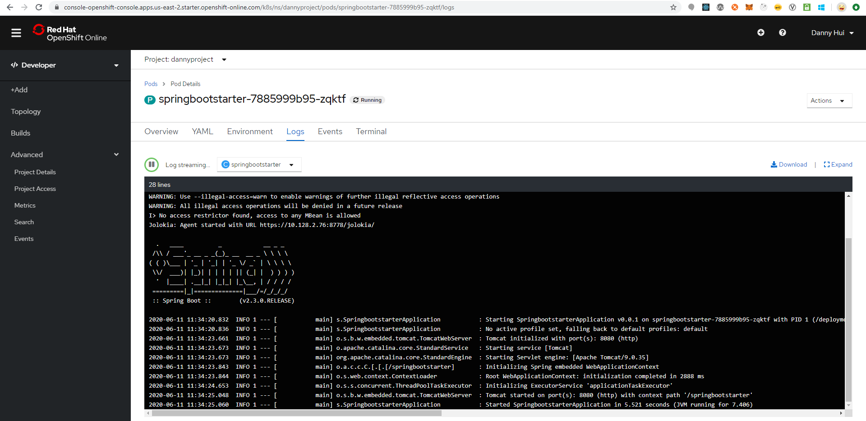

From browser:

<http://springbootstarter-dannyproject.apps.us-east-2.starter.openshift-online.com/springbootstarter/hello>



Voila!