**Deploy Spring Boot Web Application**

**from Docker Image**

Developer Perspective

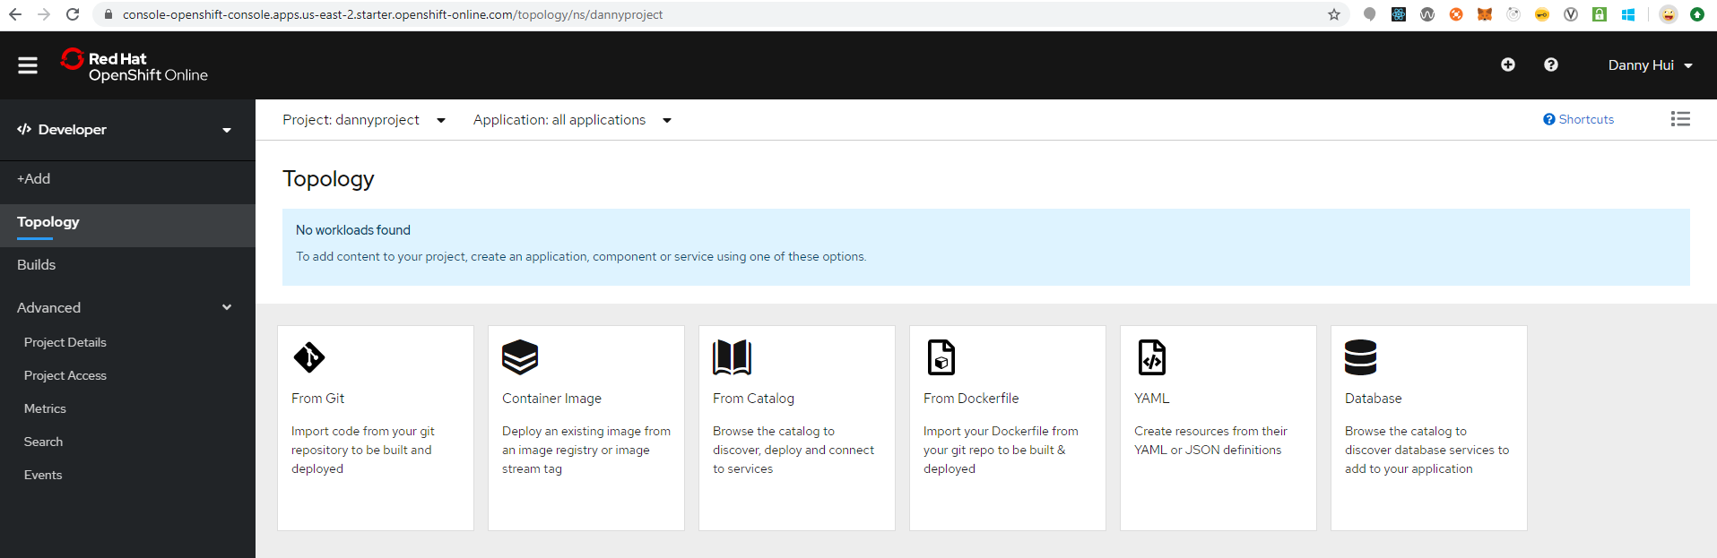

Source:

<https://github.com/dhui808/userreg>

+Add

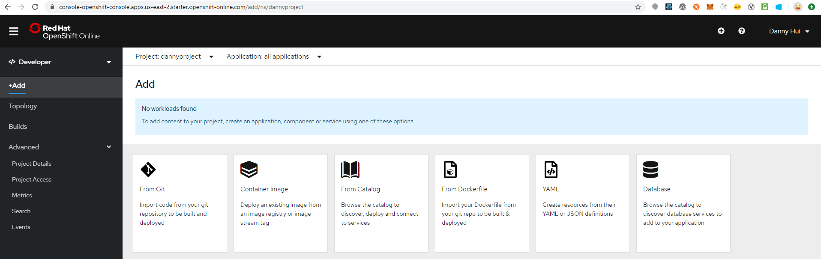

Container Image

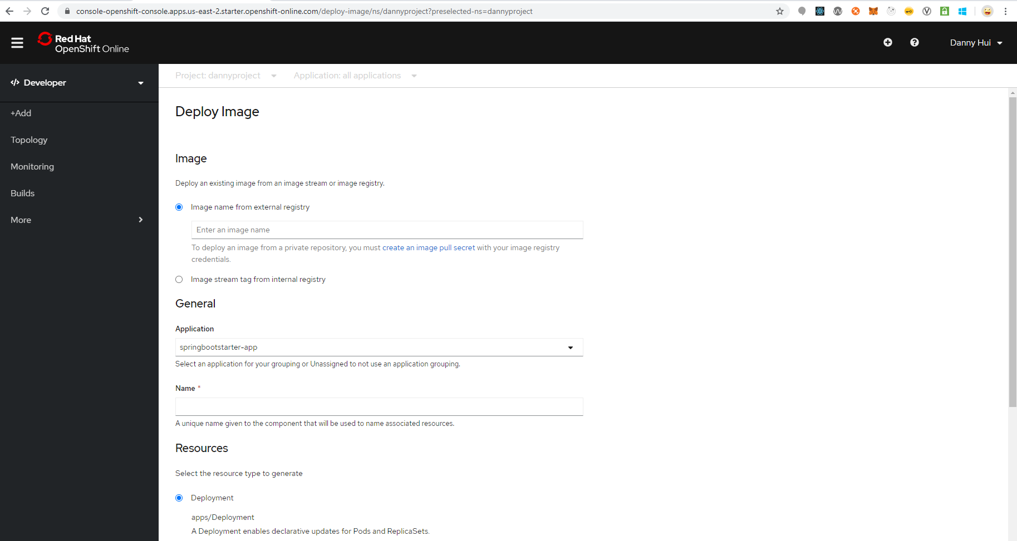

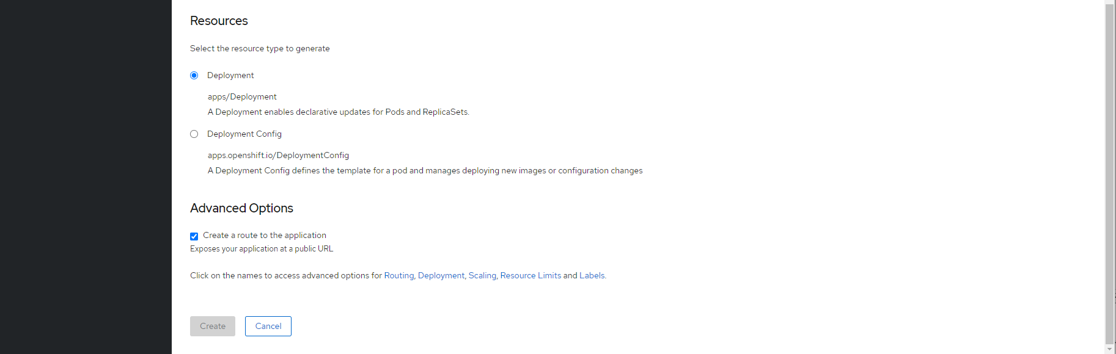

Image name from external registry

docker.io/dannyhui/userreg

Application

Create Application

ApplicationName

userreg

Name

userreg

Deployment

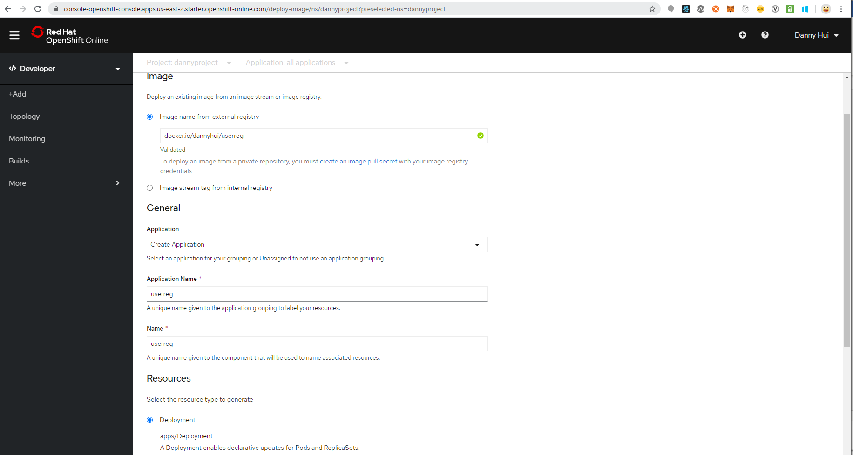

Create

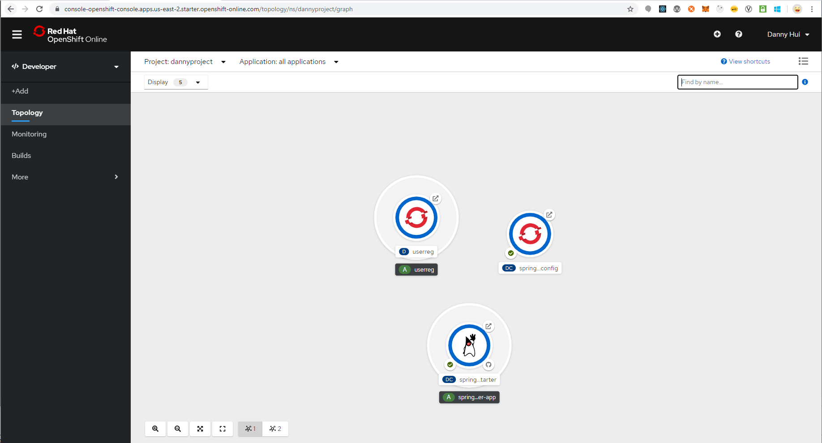

Test 1

curl -X POST -d @testdata/register1.json http://userreg-dannyproject.apps.us-east-2.starter.openshift-online.com/user/register --header "Content-Type:application/json"

Response

{"status":"success","userId":1}

Test 2

curl -X POST -d “” http://userreg-dannyproject.apps.us-east-2.starter.openshift-online.com/users/findAll --header "Content-Type:application/json"

Response

{"status":"success","users":[{"username":"marksmith","firstname":"Mark","lastname":"Smith","telephone":"6476785678","email":"mark.smith@uvw.com","mobile":"4169084567","address":"100 Bay St Toronto Q1J7S2 CA"}]}

Voila!