CS1412, Spring 2021 Problem Solving & Program Design in C

Name: Bibek Dhungana

Lab 2 - In Lab Assignment

Due end of the lab session

Acknowledge your collaborators or source of solutions, if any. **Submission by the end of the LAB is required.** Please type your answers, handwritten submission will not be accepted. Do all of the following. A subset of your solutions will be graded.

1. What will the following program print? #include <stdio.h>

int main(void) {

int x =5;

int y =7;

int z =50;

if (!(x < y && z > (z/x -y )) ){

printf("Case 1\n");

} else {

}

printf("Case 2\n");

return 0;

}

**OUTPUT: Case 2**

It is simply if else condition. x < y is true.

z > z/(x-y) is true.

So, overall condition is true. But there is negation(!). So, the if condition becomes false.

Hence, else part is executed. Case 2 is printed.

1. Write a program that asks the user to enter a temperature in Fahrenheit and convert the temperature to Kelvin. You need to use functions for the calculation using the formula given below. Print the results using a meaningful statement (see example).

Formula:

**K = (F** − 32) × 5/9 + 273.5

K represents the output in kelvin F represents input in Fahrenheit

Sample input and output:

Input: Please enter the temperature in Fahrenheit: 100

Output: The temperature in Kelvin is 311.28.

/*

//AUTHOR: Bibek Dhungana

//FILENAME: Lab2.c

//SPECIFICATION: program that asks the user to enter a temperature in Fahrenheit

and convert the temperature to Kelvin

//FOR: CS 1412 Programming Principles 2 Section 504

*/

//importing all the required libaries

#include <stdio.h>

/*function prototype for fahrenheitToKelvin function*/

double fahrenheitToKelvin(double fahrenheitTemp);

int main(void) {

    /*initialing the variables to store kelvin temperature and fahrenhiet temperature*/

    double kelvinTemp;

    double fahrenheitTemp;

    /*taking fahrenheit temperature from user as input*/

    printf("Please enter the temperature in Fahrenheit:");

    scanf("%lf",&fahrenheitTemp);

    /*calling the fahrenheitToKelvin function*/

    kelvinTemp = fahrenheitToKelvin(fahrenheitTemp);

    /*Printing the output to the user*/

    printf("The temperature in Kelvin is %.2f\n",kelvinTemp);

return 0;

}

/*

//function declearation of fahrenheitToKelvin

//NAME: fahrenheitToKelvin

//INPUT: Double (temperature in fahrenheit)

//OUTPUT: Double (temperature in Kelvin)

//SPECIFICATION:function to convert fahrenheit to Kelvin

*/

double fahrenheitToKelvin(double fahrenheitTemp){

    double kelvin;

    kelvin =  (fahrenheitTemp - 32.0) * (5.0/9.0) + 273.5;

    return kelvin;

}

The output of program is:

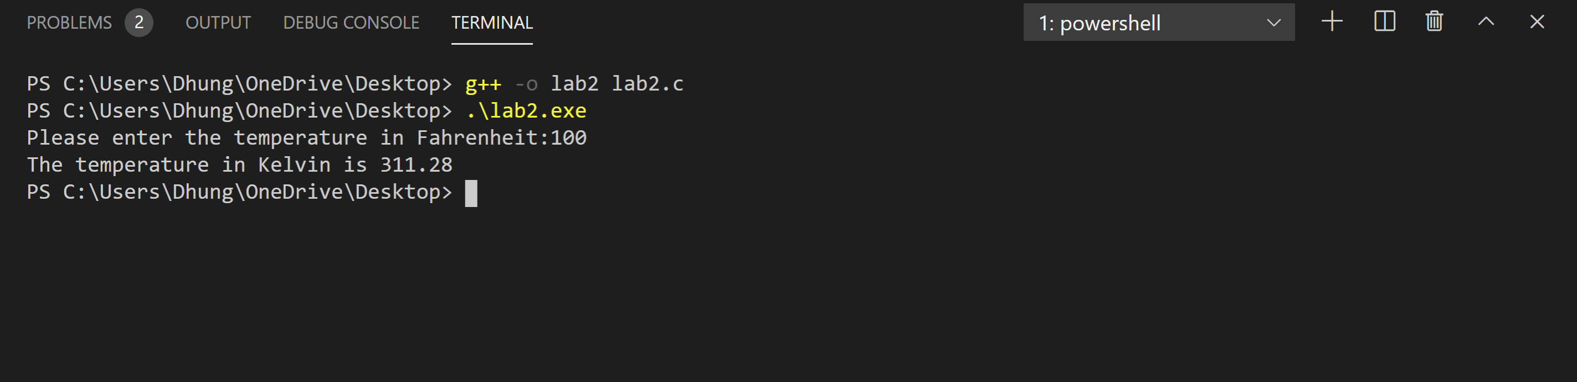

1