Understanding Algorithm Efficiency and Scalability: Randomized Quicksort and Hashing with Chaining

Priyanka Dhungana
University of the Cumberlands
Algorithms and Data Structure
November 5, 2026

Introduction
Algorithm efficiency is an important part of software development because it affects how quickly programs process information and how well they handle increasing amounts of data. An algorithm may perform well with a small dataset but become much slower when the amount of data increases. Understanding these differences helps developers choose appropriate solutions for real-world applications.
The purpose of this assignment was to implement and evaluate two important algorithmic techniques: Randomized Quicksort and hashing with chaining. Python was used to develop the algorithms and test their functionality. Randomized Quicksort was compared with Deterministic Quicksort using different dataset sizes and arrangements. A hash table was also implemented to demonstrate key-value storage, collision handling, searching, deletion, and dynamic resizing.
The experiments provided an opportunity to connect theoretical time complexity with actual program performance.

Part 1: Randomized Quicksort Analysis

Implementation of Randomized Quicksort
Quicksort is a divide-and-conquer sorting algorithm that divides an array into smaller sections and recursively sorts them. The algorithm selects an element called a pivot and separates the remaining elements based on whether they are smaller than, equal to, or greater than the pivot.
In Randomized Quicksort, the pivot is selected randomly rather than from a fixed position. This helps reduce the risk of consistently unbalanced partitions, especially when processing already sorted or reverse-sorted data (Cormen et al., 2022).
For this assignment, Randomized Quicksort was implemented in Python using the random.choice() function to select a pivot uniformly at random. The implementation divided the elements into three groups and recursively sorted the smaller and larger groups.
The algorithm was tested using random arrays, sorted arrays, reverse-sorted arrays, repeated elements, empty arrays, and single-element arrays. All test cases passed, confirming that the implementation produced the expected sorted results.
Figure 1
Randomized Quicksort Test Results
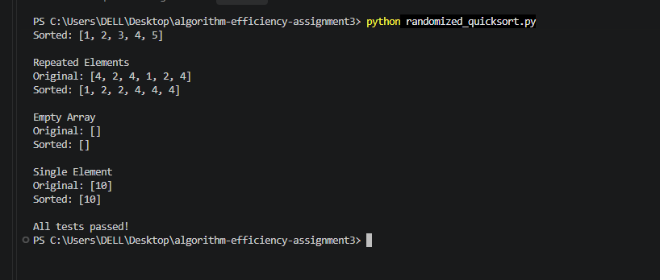

Time Complexity Analysis
Randomized Quicksort has an expected running time of O(n log n), although its worst-case running time remains O(n²).
The algorithm divides a problem into smaller subproblems and performs work to partition the elements at each recursive step. When partitions are approximately balanced, the running time can be represented by the recurrence:
T(n) = 2T(n/2) + O(n)
Here, the two recursive calls process approximately half the elements each, while O(n) represents the partitioning work.
Using the Master Theorem:
a = 2, b = 2, and f(n) = O(n)
Since n^(log₂2) = n, the recurrence gives:
T(n) = Θ(n log n)
However, the balanced-partition recurrence does not by itself prove the expected complexity of random pivot selection. A more rigorous analysis considers the expected number of comparisons.
For n distinct elements, let Xᵢⱼ be an indicator random variable equal to 1 when elements of ranks i and j are compared, and 0 otherwise.
The probability that these two elements are compared is:
P(Xᵢⱼ = 1) = 2/(j − i + 1)
Using linearity of expectation, the expected number of comparisons is:
E[C] = Σᵢ<ⱼ 2/(j − i + 1)
This can be simplified to:
E[C] = 2(n + 1)Hₙ − 4n
where Hₙ is the nth harmonic number. Since Hₙ = Θ(log n), the expected number of comparisons is Θ(n log n).
Because each partition requires linear processing and the random pivot is equally likely to be selected from the current subarray, the expected overall running time is Θ(n log n). This analysis applies directly to distinct keys; the three-way partitioning approach used in this assignment also handles duplicate keys efficiently.
The worst-case running time is O(n²), which occurs when the pivot repeatedly produces highly unbalanced partitions. Randomization reduces the likelihood of this behavior but does not completely eliminate it (Cormen et al., 2022).
The Python implementation also creates additional lists during partitioning. Therefore, it uses more memory than an in-place Quicksort implementation. Its expected auxiliary memory usage is O(n), while unfavorable partitioning can increase temporary memory requirements.

Comparison With Deterministic Quicksort
To evaluate the practical differences between the two algorithms, Deterministic Quicksort was implemented using the first element as the pivot. Both algorithms were tested using arrays containing 100, 500, 1,000, and 2,000 elements. Four input distributions were used: random, sorted, reverse-sorted, and repeated elements. Each experiment was executed five times, and the average running time was measured in seconds using Python's time.perf_counter() function. Both algorithms processed the same input values within each trial, and their sorting results were checked for correctness.
Table 1: Execution Time Comparison of Randomized and Deterministic Quicksort
Array Size | Data Type | Randomized (s) | Deterministic (s)
100 | Random | 0.000183 | 0.000127
100 | Sorted | 0.000132 | 0.000461
100 | Reverse-sorted | 0.000200 | 0.000639
100 | Repeated | 0.000062 | 0.000044
500 | Random | 0.001382 | 0.000841
500 | Sorted | 0.001124 | 0.017196
500 | Reverse-sorted | 0.001020 | 0.015713
500 | Repeated | 0.000238 | 0.000255
1,000 | Random | 0.002933 | 0.002272
1,000 | Sorted | 0.047566 | 0.324172
1,000 | Reverse-sorted | 0.005529 | 0.190761
1,000 | Repeated | 0.000728 | 0.000620
2,000 | Random | 0.008365 | 0.006674
2,000 | Sorted | 0.007118 | 0.288840
2,000 | Reverse-sorted | 0.004723 | 0.280081
2,000 | Repeated | 0.001214 | 0.001534
Note. Values represent average execution times from five trials for each dataset size and input distribution. Results were obtained from the Python implementations developed for this assignment.

Discussion of Experimental Results
The results showed noticeable differences between Randomized Quicksort and Deterministic Quicksort, particularly when processing sorted and reverse-sorted arrays.
For an already sorted array containing 2,000 elements, Randomized Quicksort completed the operation in 0.007118 seconds, while Deterministic Quicksort required 0.288840 seconds. This made the deterministic implementation approximately 40.6 times slower in that experiment.
A similar pattern appeared with reverse-sorted arrays. The randomized implementation completed the 2,000-element test in 0.004723 seconds, compared with 0.280081 seconds for the deterministic implementation.
These findings are consistent with the theoretical explanation that selecting the first element as the pivot can produce highly unbalanced partitions when the input is already ordered.
For randomly generated arrays, the deterministic implementation was slightly faster in several tests. This does not contradict the theoretical analysis because randomized pivot selection introduces some additional overhead, and both algorithms can create reasonably balanced partitions when the data is randomly distributed.
Arrays containing repeated elements were processed efficiently by both implementations. This was mainly because the algorithms used three-way partitioning to group values equal to the pivot, reducing unnecessary recursive processing.
One unexpected observation was that Randomized Quicksort required 0.047566 seconds for a sorted array of 1,000 elements but only 0.007118 seconds for 2,000 elements. The deterministic implementation also produced a slightly lower average time for 2,000 sorted elements than for 1,000.
These results do not establish that larger inputs require less work. Possible explanations include system background activity, Python memory management, variation between random pivot selections, and measurement noise. Repeating the experiments with more trials and a controlled testing environment would help produce more stable results.
Overall, the experiments demonstrated that theoretical complexity provides a useful prediction of algorithm behavior, but actual execution times are also influenced by implementation details and system conditions.

Part 2: Hashing With Chaining

Hash Table Implementation
Hashing is a technique used to store and retrieve data efficiently by calculating a location from a key. A hash function converts a key into an index that identifies where its associated value should be stored.
For this assignment, a hash table was implemented in Python using chaining for collision resolution. Each bucket contained a list of key-value pairs, allowing multiple elements to be stored at the same index.
The implementation supported three main operations:
Insert: Adds a new key-value pair to the appropriate bucket. If the key already exists, its value is updated.
Search: Calculates the bucket index and searches the bucket for the requested key.
Delete: Locates a key and removes its associated value from the bucket.
The program was tested using sample records such as 101: Apple, 102: Banana, and 103: Mango. It successfully inserted records, searched for existing keys, deleted a record, and updated an existing value.

Hash Function and Collision Handling
The implementation used a randomized hash function based on a universal hashing approach.
The function was defined as:
h(k) = ((ak + b) mod p) mod m
where k represents the key, a and b are randomly selected parameters, p is a prime number, and m is the number of buckets.
The use of randomly selected hash functions can help limit expected collisions. Carter and Wegman (1979) demonstrated how choosing functions from universal hash families provides useful expected performance guarantees.
In this implementation, integer keys were used, with a prime modulus of 1,000,003. The standard universal-hashing guarantee applies when the key universe is restricted appropriately and the function is selected from the corresponding family.
A collision occurs when two different keys are assigned to the same bucket. Instead of overwriting an existing value, chaining stores both key-value pairs in the bucket.
This allows the table to preserve all records even when collisions occur.

Expected Time Complexity
The efficiency of hashing depends on the distribution of keys and the number of elements stored in each bucket.
Under the assumption of simple uniform hashing, elements are distributed approximately evenly across the available buckets (Cormen et al., 2022).
The load factor is calculated as:
α = n/m
where n represents the number of stored elements and m represents the number of buckets.
The expected time complexities are summarized below.
Table 2: Expected Time Complexity of Hash Table Operations
Operation | Expected Time | Worst-Case Time
Insert | O(1) amortized | O(n)
Search | O(1 + α) | O(n)
Delete | O(1 + α) | O(n)
Note. Expected performance assumes approximately uniform hashing and a bounded load factor. Insertions that update existing keys also require searching their bucket. When the load factor remains low, most buckets contain relatively few elements. As a result, searching, inserting, and deleting records generally require very little time.
However, if many keys are stored in the same bucket, operations may take O(n) time because the program must examine a longer chain.

Load Factor and Dynamic Resizing
The load factor is an important measure of hash table performance because it indicates how full the table is relative to its capacity.
A higher load factor generally increases the expected number of collisions and can make searching and deletion slower.
To address this problem, the hash table was designed to resize automatically when its load factor exceeded 0.75.
Initially, the table contained seven buckets. After additional elements were inserted, the load factor exceeded the selected threshold, causing the capacity to increase to 15 buckets. The original records were then redistributed into the expanded table using the hash function. After resizing, six elements were stored across 15 buckets, resulting in a load factor of:
α = 6/15 = 0.40
This reduced the average number of records per bucket and provided additional space for future insertions. Although resizing temporarily requires O(n + m) work to allocate the new table and redistribute records, the cost is spread across multiple insertions. This supports efficient amortized performance. Other useful techniques for reducing collisions include selecting suitable hash functions, using appropriate table capacities, and monitoring the load factor as the number of records increases.
Figure 2
Hash Table Operations and Dynamic Resizing
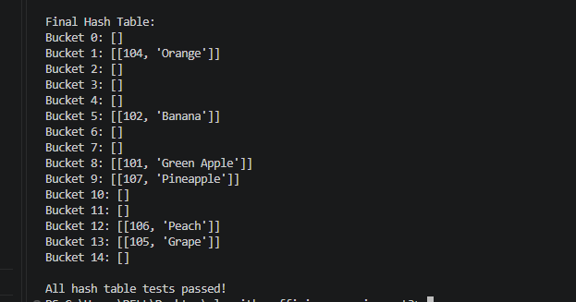

Practical Applications
Randomized Quicksort and hashing with chaining are useful for different types of problems.
Randomized Quicksort can be used when a program needs to organize large collections of records, such as sorting product prices, student scores, or transaction values. Random pivot selection helps reduce dependence on the original arrangement of the data.
Hash tables are particularly useful when information needs to be located quickly using a unique key. Examples include retrieving customer records, managing inventory items, and looking up application settings.
These algorithms illustrate that choosing the right solution depends on the task. Sorting algorithms organize collections of data, while hash tables support fast key-based access.

Conclusion
This assignment helped demonstrate the relationship between theoretical algorithm efficiency and practical performance. By implementing and testing Randomized Quicksort and Deterministic Quicksort, I was able to observe how pivot selection affects sorting efficiency under different input conditions.
The experimental results showed that Randomized Quicksort generally performed better on already sorted and reverse-sorted arrays, while both implementations performed well on random data and repeated elements. The results also highlighted the importance of considering measurement variation when evaluating algorithm performance.
Implementing hashing with chaining provided a better understanding of how hash functions, collisions, and load factors affect data retrieval. Dynamic resizing demonstrated how a data structure can adapt as additional information is stored.
Overall, this assignment reinforced the importance of evaluating both theoretical complexity and empirical results when designing efficient and scalable software.

References
Carter, J. L., & Wegman, M. N. (1979). Universal classes of hash functions. Journal of Computer and System Sciences, 18(2), 143–154. https://doi.org/10.1016/0022-0000(79)90044-8
Cormen, T. H., Leiserson, C. E., Rivest, R. L., & Stein, C. (2022). Introduction to algorithms (4th ed.). MIT Press.

