Table of Content
Chapter 1 Introduction to Insurance management system 4
Introduction 4
Problem Statement 5
Objectives 5
Specific Objectives 5
Scope and LImitation 6
Limitations 6
Development Methodology 7
Report Organization 7
Chapter 2: Background Study and Literature Review 8
Background Study 8
Literature Review 8
Chpater 3 : System Analysis and Design 10
System Analysis 10
Requirement Analysis 10
Functional Requirement 10
Non Functional Requirement 11
Technical 11
Operational 11
Economic 12
Case Diagram 12
Class Diagrams 13
Activity Diagram 14
14
Sequence Diagram 15
15
Project Timeline 16
Algorithms 17
Descision Tree Algorithm 17
Input Parameters 17
Algorithm Pseudo Code 18
Chapter 4: Impementation and testing 20
Implementation and Testing 20
Case tools, Language,database 20
Testing 20
Cases for Unmit Testing 20
Test Cases for System Testing 21
Result Analysis 22
Application overview 22
Chapter 5: Conclusion and Future Recommendations 26
Conclusion 26
Future Recommendation 26
References 28

Table of Figures
Fig1:class diagram 12
Figure 2:er diagram 14
Figure 3 class diagrams 17
Figure 4:class diagram 19
Figure 5:gantt chart 21

Chapter 1 Introduction to Insurance management system

Introduction
In Nepal, the insurance sector is gradually transitioning from traditional paper-based and semi-digital processes to more structured digital systems. Many insurance companies still rely on manual record keeping, spreadsheet-based tracking, or isolated software tools to manage clients, policies, premiums, and claims. These practices often create challenges such as data inconsistency, delayed claim processing, difficulty in tracking policy and claim status, and limited reporting capabilities.
With the increasing number of insured clients and the growing complexity of insurance products, there is a strong need for an integrated system that can manage insurance operations efficiently and accurately. A centralized insurance management system helps insurance organizations maintain reliable records, improve operational transparency, and reduce dependency on manual processes.
The Insurance Management System is a web-based application developed to support the core operational needs of insurance management within a practical and realistic local context. The system focuses on managing clients, members, insurance groups and packages, premium calculation, policy issuance and renewal, and the complete claim lifecycle including submission, verification, screening, scrutiny, and settlement.
The application is developed using Laravel framework with Blade templating, PostgreSQL database, Bootstrap, and jQuery, which are widely used and suitable technologies for developing secure, scalable, and maintainable web applications. By automating routine insurance operations, the system aims to improve efficiency, reduce errors, and support better decision-making through structured data and reporting.

Problem Statement
In the context of Nepal, many insurance organizations still depend on manual procedures, paper-based documentation, or partially automated systems to manage insurance operations. These traditional approaches make it difficult to efficiently handle growing volumes of data related to clients, policies, members, premiums, and claims.
Manual and fragmented systems often lead to several operational problems such as delayed claim processing, difficulty in tracking claim status, inconsistent premium calculations, duplication of records, and limited access to real-time information. Additionally, the lack of integrated systems creates challenges in monitoring claim workflows, managing policy renewals, and generating accurate reports for management and regulatory purposes.
As insurance processes involve multiple stages including claim submission, verification, screening, scrutiny, and settlement, the absence of a centralized and automated system increases the risk of errors and reduces transparency. Furthermore, inadequate role-based access control may expose sensitive data to unauthorized access.
Therefore, there is a need for a centralized, web-based insurance management system that can automate insurance operations, maintain accurate records, improve claim processing efficiency, and support secure and organized data management suitable for the operational environment of Nepalese insurance organizations.

Objectives
The main objective of this project is to design and develop a web-based Insurance Management System that automates and manages core insurance operations efficiently, accurately, and securely.

Specific Objectives
- To develop a centralized system for managing insurance clients, members, and policies
- To automate premium calculation and policy management processes
- To digitize the complete insurance claim lifecycle including submission, verification, screening, scrutiny, and settlement
- To implement role-based access control for secure system usage
- To maintain accurate and consistent insurance records using a relational database
- To generate reports that support monitoring, decision-making, and record analysis
- To reduce manual work, processing time, and human errors in insurance operations

Scope and LImitation
The scope of the Insurance Management System includes:
- User authentication and role-based access management
- Management of insurance clients, members, groups, and packages
- Policy issuance, renewal, and status management
- Premium calculation and premium updates
- Claim submission and resubmission processes
- Claim verification, screening, scrutiny, and settlement workflows
- Notification handling and status updates
- Report generation for claims and client-related data
- Centralized database management using PostgreSQL

Limitations
The limitations of the system are as follows:
- The system is accessible only through a web browser
- Internet connectivity is required for system operation
- Payment gateway integration is not implemented
- Advanced analytical tools and AI-based decision support are not included
- Mobile application support is not provided in the current version
- External system integrations are limite

Development Methodology
The development of the Insurance Management System was carried out using a structured and incremental development approach, suitable for an academic project completed within a limited time frame of approximately three to four months. This approach was selected to ensure systematic progress while allowing flexibility during development.
The project was divided into several phases, and each phase was completed within a defined period to ensure timely completion.

Report Organization
This project report is organized into five chapters, each focusing on a specific aspect of the Insurance Management System.
- Chapter 1 provides an introduction to the project, including the problem statement, objectives, scope and limitations, development methodology, and overall structure of the report.
- Chapter 2 presents the background study and literature review related to insurance management systems and relevant technologies.
- Chapter 3 discusses system analysis and design, including requirement analysis, feasibility study, and system modeling.
- Chapter 4 describes the implementation and testing of the system, including tools used, testing methods, and result analysis.
- Chapter 5 concludes the report and provides future recommendations for system enhancement.

Chapter 2: Background Study and Literature Review

Background Study
In Nepal, the insurance sector is gradually shifting from manual and semi-digital systems to more organized digital platforms. Many organizations still rely on paper-based records, spreadsheets, or isolated tools to manage clients, policies, premiums, and claims. These traditional methods create challenges such as delayed claim processing, data inconsistency, difficulty in tracking policy or claim status, and limited reporting capabilities.
A centralized web-based insurance system addresses these issues by automating essential operations, maintaining accurate records, and improving transparency. The proposed system focuses on key insurance workflows such as client and member management, policy issuance and renewal, premium calculation, and the complete claim lifecycle.
Technologies like Laravel (MVC framework), PostgreSQL, Bootstrap, and jQuery provide a suitable foundation for building scalable and maintainable web applications that meet the operational needs of Nepalese insurance organizations.
References supporting this background: Pressman (Software Engineering), Sommerville (Software Engineering), Laravel Official Documentation, PostgreSQL Documentation.

Literature Review
n Nepal, the insurance sector is gradually shifting from manual and semi-digital systems to more organized digital platforms. Many organizations still rely on paper-based records, spreadsheets, or isolated tools to manage clients, policies, premiums, and claims. These traditional methods create challenges such as delayed claim processing, data inconsistency, difficulty in tracking policy or claim status, and limited reporting capabilities.
A centralized web-based insurance system addresses these issues by automating essential operations, maintaining accurate records, and improving transparency. The proposed system focuses on key insurance workflows such as client and member management, policy issuance and renewal, premium calculation, and the complete claim lifecycle. Technologies like Laravel (MVC framework), PostgreSQL, Bootstrap, and jQuery provide a suitable foundation for building scalable and maintainable web applications that meet the operational needs of Nepalese insurance organizations [1].
Existing studies and implementations emphasize the importance of automation, centralized data management, and secure system design in insurance systems:
- Automated claim processing significantly reduces human error and processing delays.
- Role-based access and centralized databases improve security, consistency, and reporting accuracy.
- MVC-based web frameworks like Laravel facilitate modular design, maintainability, and separation of concerns .
- Relational databases such as PostgreSQL ensure data integrity, support complex queries, and handle transactional operations efficiently [4].
- Responsive front-end frameworks like Bootstrap enhance usability, accessibility, and user experience, while jQuery provides smooth interactivity [5].
While existing systems provide automation, many are complex or not tailored to local operational requirements. The proposed system addresses these gaps by offering a practical, localized, and scalable solution suitable for Nepalese insurance organizations.

Chpater 3 : System Analysis and Design

System Analysis
System analysis involves understanding the current processes and defining requirements for the new Insurance Management System. The goal is to identify problems in the existing manual or semi-digital processes and propose a system that automates and organizes insurance operations efficiently.Key processes analyzed:
- Client and member registration and management
- Policy creation, issuance, and renewal
- Premium calculation and updates
- Claim submission, verification, screening, scrutiny, and settlement
- Notifications and report generation
- Role-based access for administrators and staff
The analysis showed that manual and semi-digital operations result in delays, data inconsistency, and difficulty in monitoring claim statuses. The proposed system addresses these gaps through automation, centralized data management, and structured workflows.

Requirement Analysis

Functional Requirement
The system should perform the following functions:
- User Management – Admin and staff login, role-based access, password management.
- Client and Member Management – Add, update, and delete client and member records.
- Policy Management – Create, issue, renew, and track policies.
- Premium Calculation – Automatic calculation based on policy and client details.
- Claim Management – Submit claims, resubmissions, verification, screening, scrutiny, and settlement.
- Notification Management – Notify clients and staff about status updates.
- Reporting – Generate client, policy, and claim reports for management review.

Non Functional Requirement
Non-functional requirements define system attributes and constraints:
- Performance: The system should handle multiple users and processes simultaneously with minimal delay.
- Security: Role-based access control, data validation, and secure authentication.
- Usability: User-friendly interface using Bootstrap and responsive design.
- Maintainability: Modular design for easier updates and future enhancements.
- Reliability: Accurate premium calculations and consistent data management.
Feasibility Analysis

Technical
- Developed using Laravel (MVC framework) and PostgreSQL, widely supported technologies.
- Frontend uses Bootstrap and jQuery for responsive UI.
- Modular design allows integration of future features and scalability

Operational
- Designed for Nepalese insurance organizations, practical for current workflows.
- Reduces manual workload and increases staff efficiency.
- Supports multiple users with role-based access and notifications.

Economic
- Built using open-source technologies, minimizing licensing costs.
- Reduces operational costs by automating manual tasks and reducing errors.
- Deployment on a standard web server is cost-effective.

Use Case Diagram
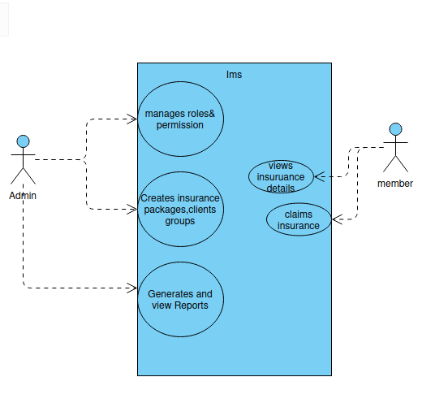
Fig1:case diagram

Project Timeline
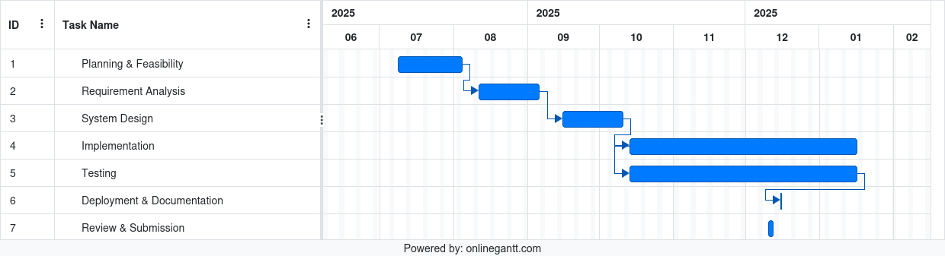
Figure 5:gantt chart

Class Diagrams
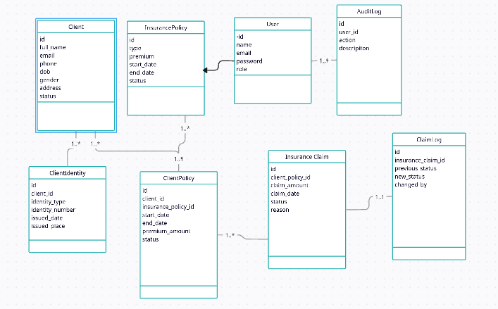

Activity Diagram

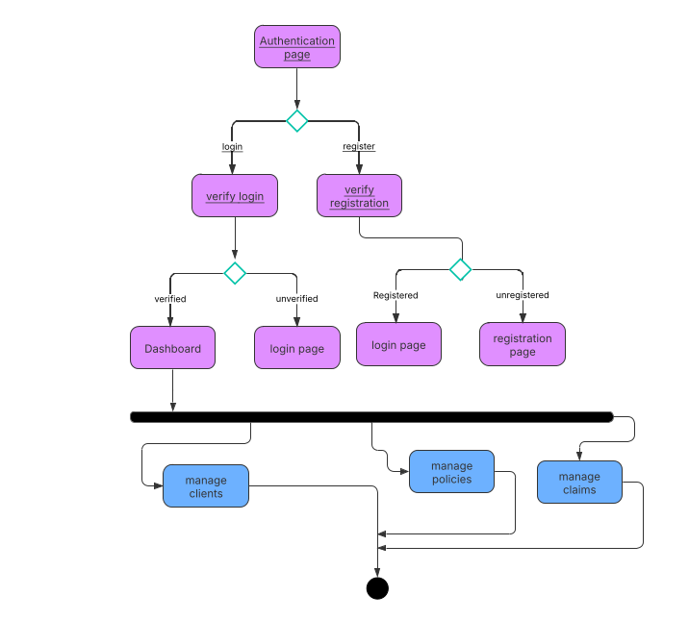

Sequence Diagram

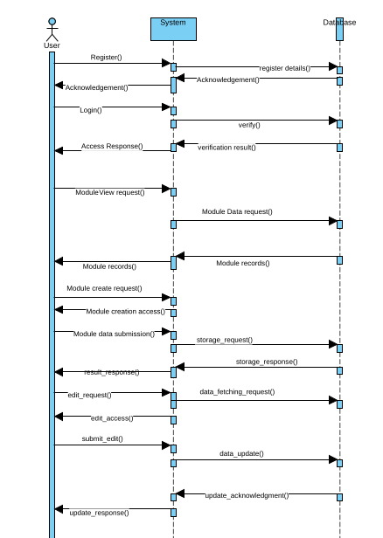

Algorithms
In an insurance management system, multiple business decisions must be taken during policy handling and claim processing. These include determining claim eligibility, calculating policy premiums based on risk factors, and controlling claim state transitions. Implementing separate algorithms for each decision can increase complexity and redundancy.
To solve this problem efficiently, a single unified decision tree algorithm is used to evaluate all insurance-related decisions in a structured and hierarchical manner.

Descision Tree Algorithm
The Unified Insurance Decision Tree Algorithm evaluates insurance rules step-by-step using conditional decision nodes. Each node represents a business rule, and the traversal of the tree leads to a final decision outcome.
The algorithm performs the following tasks:
- Validates claim eligibility based on policy status and claim limit.
- Calculates insurance premium using predefined risk factors.
- Determines the claim state based on user action and current system state.
This ensures consistent decision-making and prevents invalid operations in the insurance workflow.

Input Parameters
- policy_status – Current status of the policy (Active / Inactive)
- claim_amount – Amount requested by the client
- policy_limit – Maximum allowable claim amount
- base_premium – Base insurance premium
- client_age – Age of the insured client
- policy_type – Type of insurance policy (Health, Life, etc.)
- action – Action taken on claim (Approve, Reject, Settle)
Output
- Final calculated premium
- Claim approval or rejection status
- Updated claim state (Pending, Approved, Rejected, Settled)

Algorithm Pseudo Code
INPUT:
policy_status, claim_amount, policy_limit,
base_premium, client_age, policy_type, action

IF policy_status != "Active"
RETURN "Claim Rejected"
ENDIF

IF claim_amount > policy_limit
RETURN "Claim Rejected"
ENDIF

premium = base_premium

IF client_age > 50
premium = premium + (premium * 0.20)
ENDIF

IF policy_type == "Health"
premium = premium + (premium * 0.10)
ENDIF

state = "Pending"

IF action == "Approve"
state = "Approved"
ELSE IF action == "Reject"
state = "Rejected"
ELSE IF action == "Settle" AND state == "Approved"
state = "Settled"
ENDIF

RETURN premium, state

Chapter 4: Implementation and testing

Implementation and Testing
The implementation phase of the Insurance Management System involved developing and integrating all functional modules using Laravel, PostgreSQL, Bootstrap, and jQuery. The system was implemented according to the design specifications outlined in Chapter 3, ensuring that the core insurance workflows were automated, reliable, and maintainable.
The testing phase was conducted to verify that the system performs as expected, identify errors, and validate all functional and non-functional requirements. Both unit testing and system testing approaches were applied.

Case tools, Language,database
- CASE Tools: Visual Paradigm / draw.io (for creating class, object, sequence, activity, and component diagrams).
- Programming Language / Framework: PHP (Laravel Framework, Blade templates).
- Frontend Technologies: HTML5, CSS3, Bootstrap, jQuery.
- Database: PostgreSQL – used to store client, member, policy, premium, and claim data.
- Development Environment: XAMPP / Laravel Valet / Local development server.

Testing

Cases for Unmit Testing
- Each module (Client, Member, Policy, Premium, Claims) was tested individually.
- Functions like client registration, policy creation, premium calculation, and claim submission were validated for correct behavior.
Module | Test Scenario | Expected Result
Client | Add new client | Client saved in database
Policy | Create policy | Policy details saved and associated with client
Premium | Calculate premium | Correct premium calculated based on formula
Claim | Submit claim | Claim saved and status set to “Submitted”
Notification | Send notification | Notification displayed for relevant user

Test Cases for System Testing
- Integrated modules were tested together to ensure smooth workflow between modules.
- End-to-end scenarios like “Submit Claim → Verify → Screen → Scrutinize → Settle” were tested.
- User authentication and role-based access control were verified
Test Case | Description | Expected Outcome
Claim Workflow | Submit Verify - Screen -Scrutinize - Settle | Status changes correctly at each stage
User Roles | Admin and Staff login | Access controlled by role
Report Generation | Generate client or claim report | Report displays accurate data
Data Consistency | Update client or policy | Changes reflected across related modules
- .

Result Analysis
- All modules functioned according to the defined requirements.
- Premium calculation and claim workflows were automated successfully.
- Role-based access control and notifications improved operational efficiency.
- Minor issues found during unit testing were fixed before system testing.
- The system successfully reduced manual effort and provided a centralized, reliable solution for insurance management in a local context.

Application overview
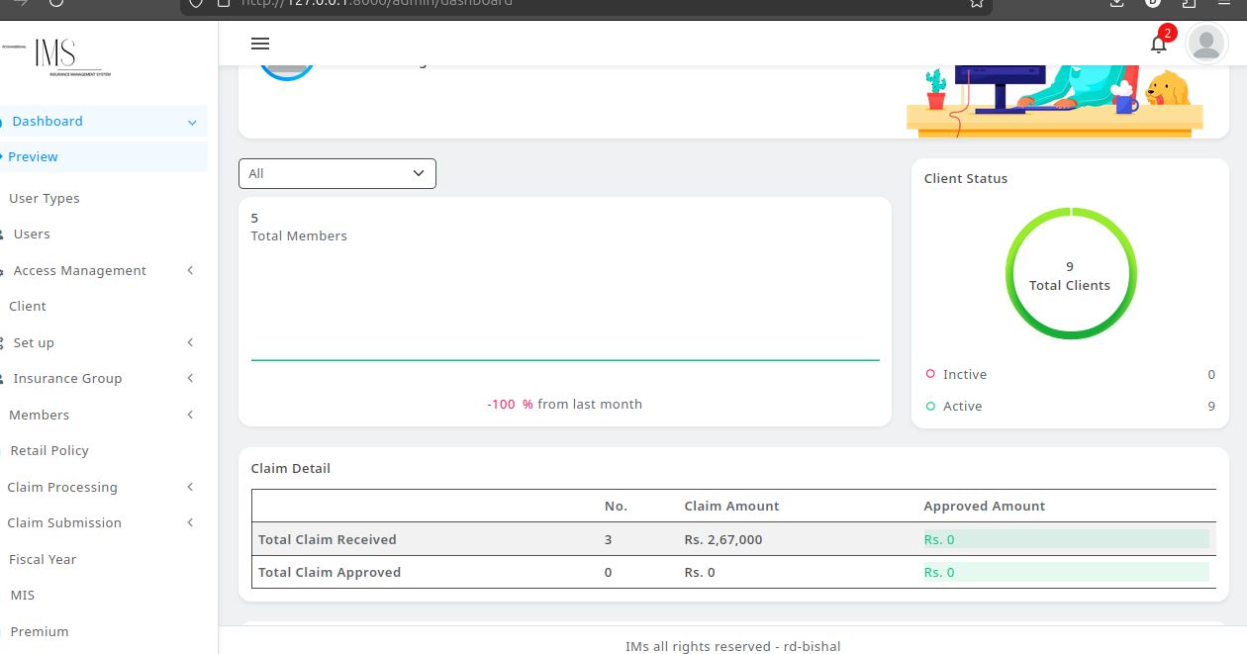
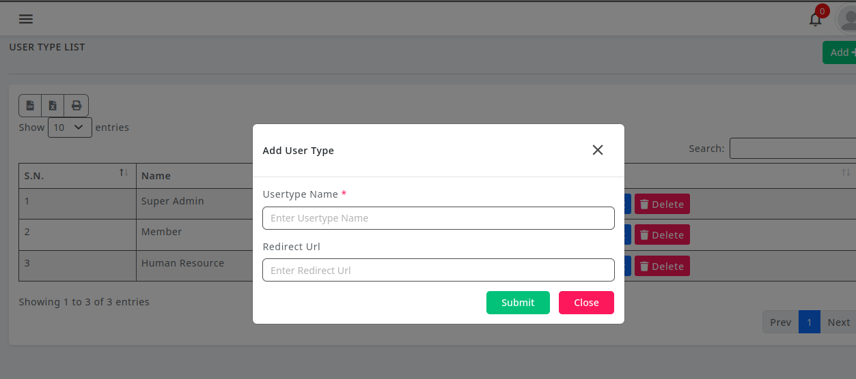
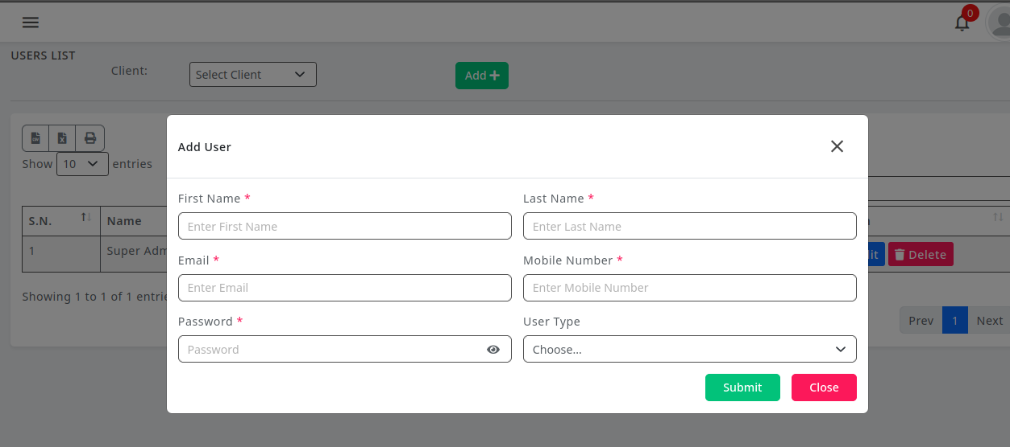
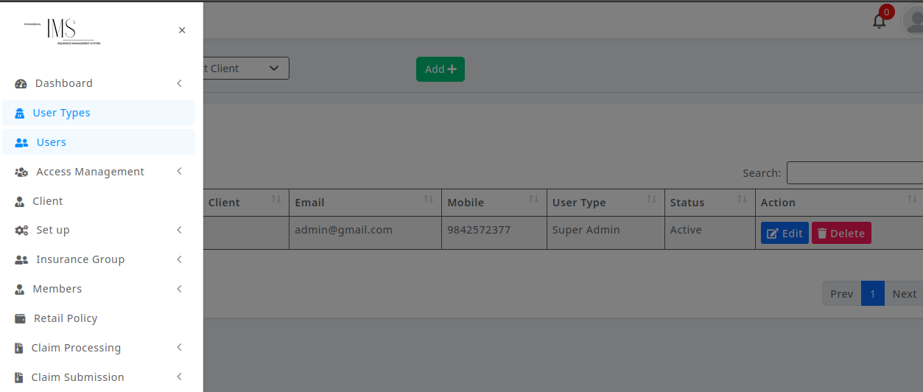
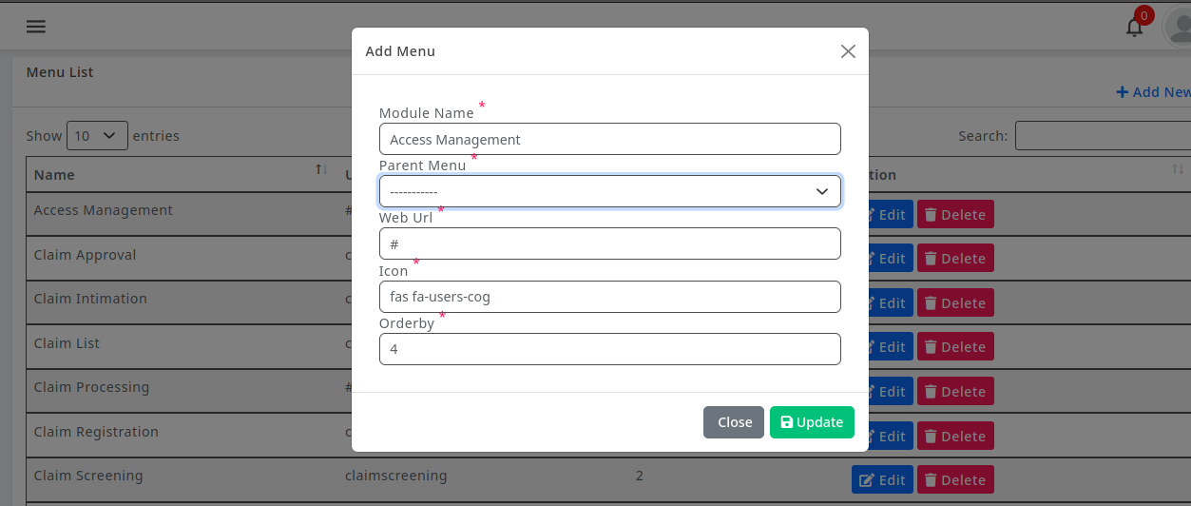
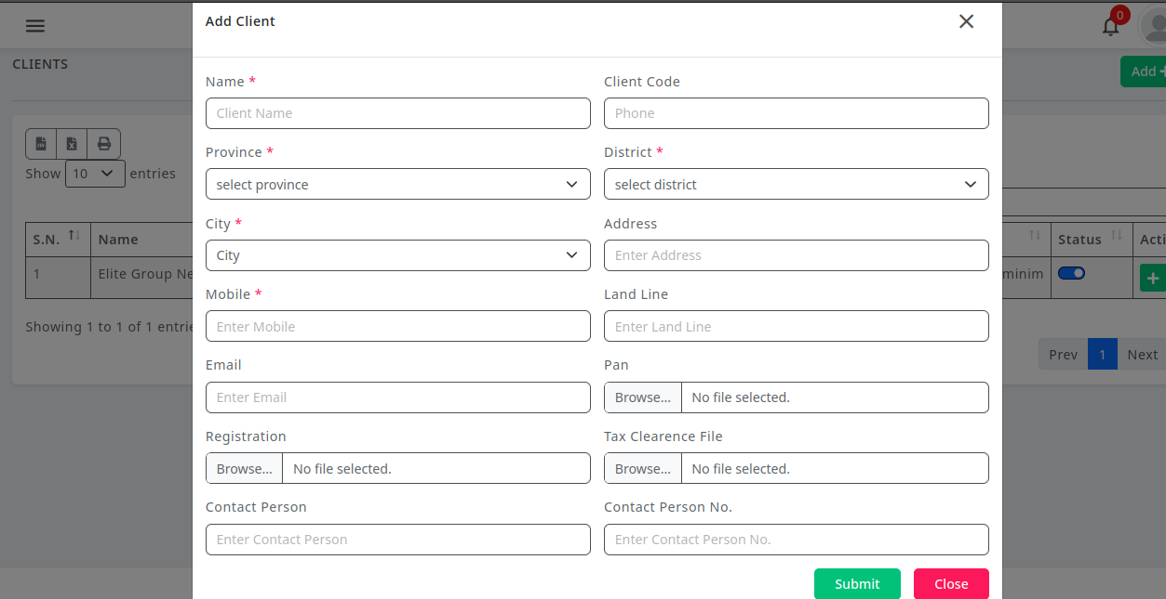

Chapter 5: Conclusion and Future Recommendations

Conclusion
The Insurance Management System developed in this project provides a centralized, automated, and user-friendly solution for managing insurance operations. The system successfully addresses common challenges in Nepalese insurance workflows, including manual record-keeping, delayed claim processing, and inconsistent premium calculations.
Key achievements of the system include:
- Efficient client and member management
- Automated policy issuance, renewal, and premium calculation
- Complete claim lifecycle management (submission, verification, screening, scrutiny, settlement)
- Role-based access control and notification system
- Reliable data management using PostgreSQL and modular architecture using Laravel

Future Recommendation
While the current system covers core insurance operations, several enhancements can be considered for future development:
- Mobile Application Support: Develop a mobile version to allow staff and clients to access services on-the-go.
- Payment Gateway Integration: Enable online premium payments and claim reimbursements.
- Advanced Analytics and Reporting: Implement dashboards and predictive analytics to assist decision-making.
- Integration with External Systems: Connect with national insurance databases or other financial systems for seamless data exchange.
- Enhanced Security Measures: Add features like multi-factor authentication and audit logging.
- Artificial Intelligence Support: Use AI to detect fraudulent claims or suggest premium adjustments based on historical data.

References
[1] R. S. Pressman, Software Engineering: A Practitioner’s Approach, McGraw-Hill Education.
[2] I. Sommerville, Software Engineering, Pearson Education.
[3] Laravel Official Documentation, Laravel Framework. [Online]. Available: https://laravel.com/docs
[4] PostgreSQL Global Development Group, PostgreSQL Documentation. [Online]. Available: https://www.postgresql.org/docs/
[5] W3Schools, Web Development Tutorials and References. [Online]. Available: https://www.w3schools.com[6] IEEE, Software Engineering Standards and Documentation. [Online]. Available: https://www.ieee.org/

