Simple example of For..Next to calculate the factorial of a number

Controls:
Form frmFactorial
NumericUpDown nudInput
Button btnCalculate
Label lblResult

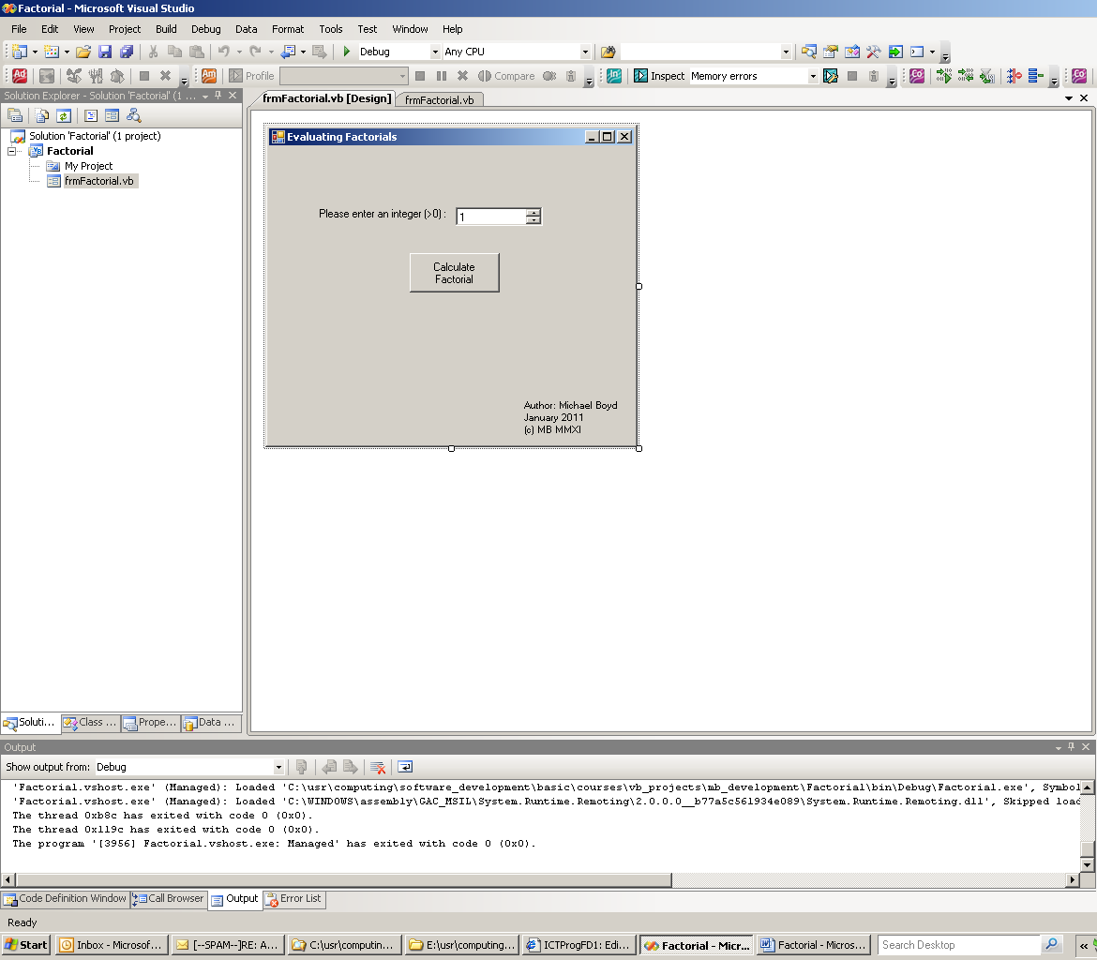

Public Class frmFactorial
'
' Author: Michael Boyd
' Date: 17-JAN-2011
' Project: Factorial
'
' Evaluates the factorial of a natural number
' (i.e. an integer > 0)
'
' Example 6! = 6.5.4.3.2.1
'
'
Private Sub btnCalculate_Click(ByVal sender As System.Object, ByVal e As System.EventArgs) Handles btnCalculate.Click

' Declare variable to hold factorial result as Double,
' since the factorial function grows exponentially.
' Initialise to 1 (since 0! defined as 1)
'
Dim Factorial As Double = 1.0
Dim iLoop, InputValue As Integer

' Read input value from form NumericUpDown control
InputValue = nudInput.Value

' Calculate factorial of the value
' in 'going-up' loop.
' n! = n.(n-1.n-2). ... 1 => going-down iteration
' = 1. ... (n-2)(n-1)n => going-up iteration
For iLoop = 1 To InputValue
Factorial *= iLoop
Next

' Display result
lblResult.Text = "The factorial of " & CStr(InputValue) & _
ControlChars.CrLf & "is " & _
CStr(Factorial)
lblResult.Visible = True

End Sub
End Class

