Simple example of For..Next

Controls:
Form frmForNext
Listbox lsbNames

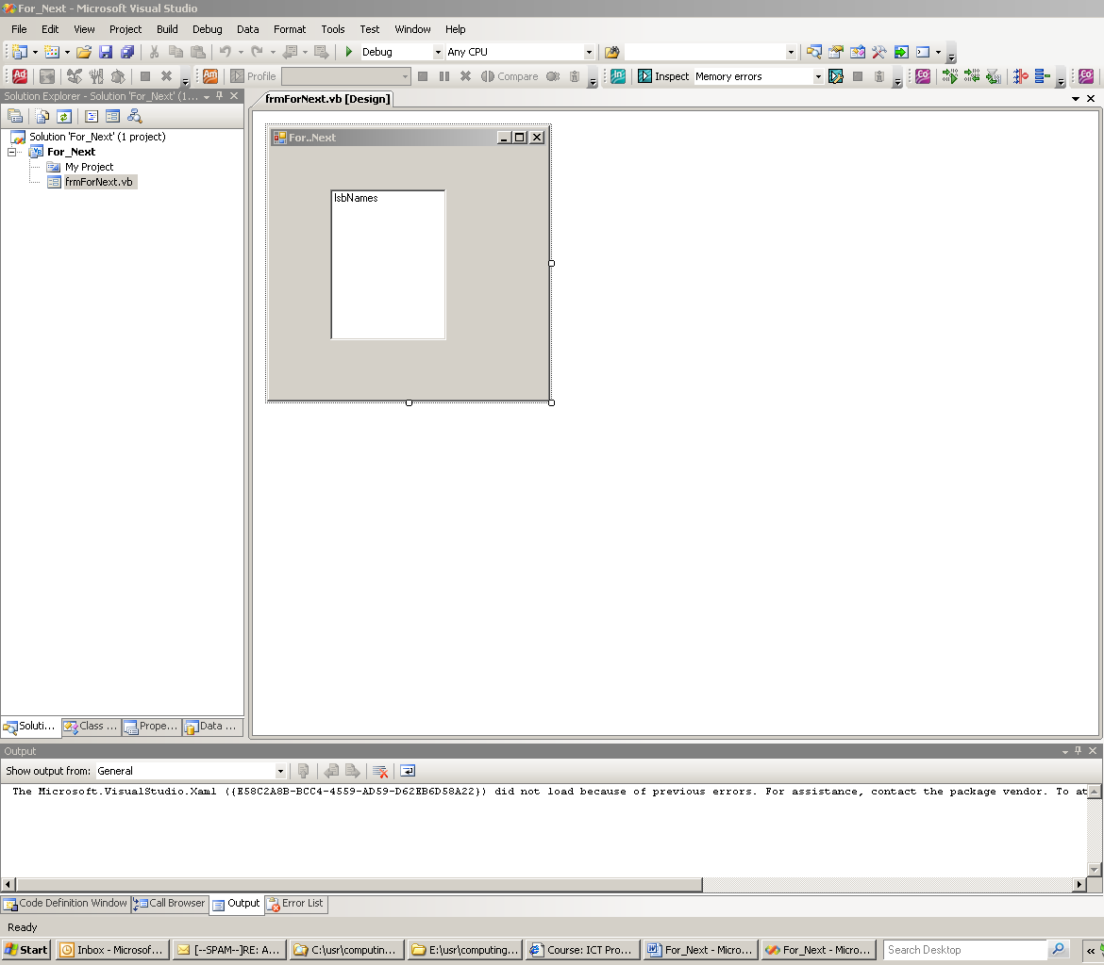

Public Class frmForNext

Public Const Max As Integer = 10

Private Sub frmForNext_Load(ByVal sender As System.Object, ByVal e As System.EventArgs) Handles MyBase.Load
Dim i As Integer
Dim InpName As String

For i = 1 To Max
InpName = InputBox("Enter your name or type Done to quit.")
If InpName = "Done" Then Exit For
' Add name to List Box
lsbNames.Items.Add(InpName)
Next i

End Sub
End Class

