Simple example of Select..Case

Controls:
Form frmSelectCase
Buttons btnTest1, btnTest2
Textbox txbInputAge
Label lblShowAdvice

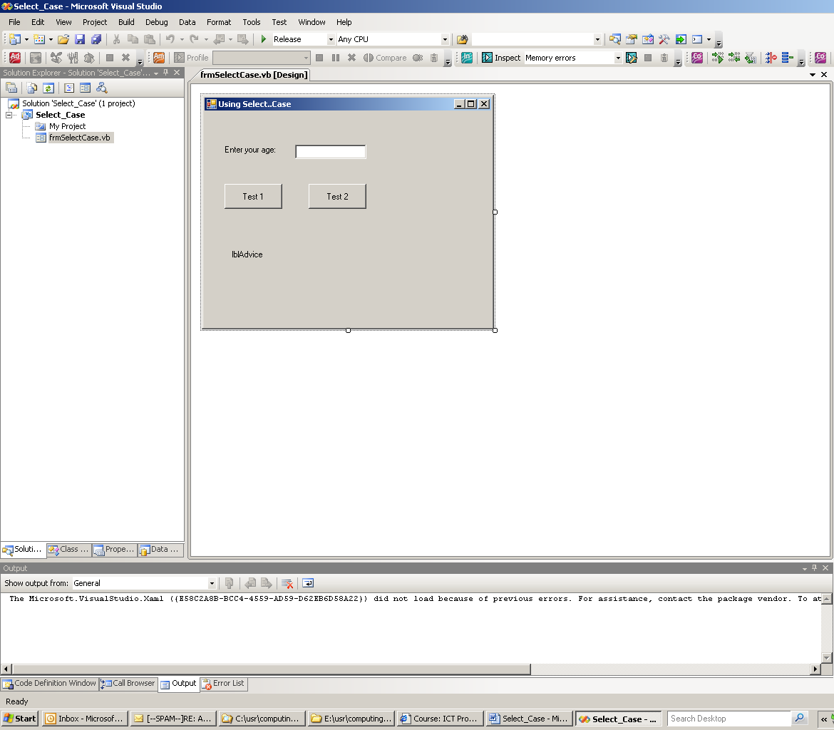

Public Class frmSelectCase

Dim age As Integer

Private Sub btnTest1_Click(ByVal sender As System.Object, ByVal e As System.EventArgs) Handles btnTest1.Click

age = CInt(txbInputAge.Text)

Select Case age
Case 16
lblShowAdvice.Text = "You can drive now!"
Case 18
lblShowAdvice.Text = "You can vote now!"
Case 21
lblShowAdvice.Text = "You can buy a house."
Case 65
lblShowAdvice.Text = "Time to retire and have fun!"
Case Else
lblShowAdvice.Text = "That's a good age to be!"
End Select

lblShowAdvice.Visible = True

End Sub

Private Sub btnTest2_Click(ByVal sender As System.Object, ByVal e As System.EventArgs) Handles btnTest2.Click
age = CInt(txbInputAge.Text)

' Test variable: age
Select Case age
' Case Is compares the test variable to the expression
' listed after 'Is', e.g. '< 13'
Case Is < 13
lblShowAdvice.Text = "Enjoy your youth!"
Case 13 To 19
lblShowAdvice.Text = "Enjoy your teens!"
Case 21
lblShowAdvice.Text = "You can buy a house."
Case Is > 100
lblShowAdvice.Text = "Looking good!"
Case Else
lblShowAdvice.Text = "That's a good age to be!"
End Select

lblShowAdvice.Visible = True
End Sub
End Class

