Worksheet – Introduction to Basic Data Types & Variables

Introduction:

This worksheet session will introduce you to the main mechanism for storing information while you are programming through a discussion of data types and variables, and re-inforce these ideas through some simple practical exercises.

Please note: tasks from this point on will no longer give specific instructions on how to create a new application project. You must refer to the previous worksheets to remind yourself how to do this. Just remember to select a sensible name (e.g. ‘Variables_Lab’) and location (for example, under your ‘H:’ drive, select the ‘VisualProgramming/WeekX’ folder) for your project in the appropriate dialogue!

Basic Concepts – Datatypes and Variables – storing and manipulating data

Most of the early programming we have done to date has primarily involved capturing data from the user interface screen (through Form based controls such as TextBoxes and ComboBoxes) and using it directly in some event-handler somewhere – hence not requiring you to think about how you could save it in memory for ‘later use’.

For example, you may have used the ‘go’ button’s event-handler in your Web browser application to directly navigate to the web page specified in the Text/Combo Box – i.e.:

Private Sub btnGo_Click(ByVal sender As … ) Handles btnGo.Click
‘ take URL directly from screen and browse to it wbBrowser.Navigate(tbWebsite.Text)
End Sub

But consider the scenario whereby you wished to store the last page the web browser attempted to navigate to – so that if the Browser failed to load the page it could give the user an option to retry that page later without having to type it again. In this case, the web browser application would need to remember that address even after the user had typed another address in the text/combobox.

For this, and other similar purposes, we need our program to ‘remember’ information after it is in use by the screen. This purpose is well served by using Variables in programming – e.g. we could declare a variable of the datatype ‘String’ to save our URL for later use:

‘ declare variable called URLString of datatype String
Dim URLString As String
Private Sub btnGo_Click(ByVal sender As … ) Handles btnGo.Click
‘ save our URL for later use in URLString variable
URLString = tbWebsite.Text
‘ use our URL to browse this time
wbBrowser.Navigate(URLString)
End Sub

What is a Variable?
- Variables are like ‘pigeon-holes’ that allow you to ‘save’ your information for later use or manipulation.They are placeholders (locations in memory) for data to be stored until the use of that data is required for an operation in progress.

- Variables vary in their use and lifespan. It is possible to have variables that remain ‘alive’ for the entire duration of a programs life.

- A Variable should only be created for the absolute minimum amount of time required, for a program to be efficient.

- A variable’s lifespan and visibility are collectively known as its ‘scope’.

- Variables must also be typed (have a data type assigned to them when they are declared / defined).

What is a data type?

- A data type is a way of representing information that needs to be entered into a computer.

- Data types indicate what some data is likely to be used for. E.g. Numbers may be used for calculations and words may be used to make sentences, but it is not really possible to make a sentence from numbers!

Why do we need data types?

- To make interpretation quicker and easier for a computer,

- To allow the compiler to check that your program is returning the right sorts of answers.

What are the .NET Data types

- The same data types are supported across the whole of the .Net framework (although they may be called slightly different things by other languages to VB).

- Data types are used to define the constraints (limitations) surrounding variables.

- Just to confuse matters, in .NET all of the data types are themselves objects (more on Objects later). This actually makes sense, what better way of storing a list of constraints than in the properties area of the object it represents.
Data types for whole numbers – Integer, Short, Long, Byte
- In Mathematics whole numbers are referred to as ‘Integers’ and include any whole number, negative or positive.
- As a variable needs to reserve some memory to hold its ‘state’, sometimes an indicator needs to be given to the system as to how much room should be reserved. This amount of space to be reserved is normally given in bytes.
- In the .NET framework there are four main data types dedicated to holding data in the form of whole numbers. They are:

Size | Data Type | Min Value | Max Value
1 byte | Byte | 0 | 255
2 byte | Int16 or Short | -32768 | 32767
4 byte | Int32 or Integer | -2.147 Billion | 2.147 Billion
8 byte | Int64 or Long | -9.1 Quintrillion | 9.1 Quintrillion
- If you need to store a whole number, you would chose your data type based on which is the most ‘space efficient’ for your purpose. For example:
- If you need to store a Student’s age, you could use Byte
- If you need to store the number of students in a University, you might use Short
- If you need to count a country’s population, you might use Integer
- If you need to record inter-galactic distances, you might use Long.

…etc…
Data types for ’real’ numbers – Single, Double
- So far, only whole numbers have been discussed. But, inevitably, there are applications that will require the storage and manipulation of numbers that hold fractional values - real numbers (also referred to a ‘floating point’). Some such applications might be in banking (pounds and pennies) or engineering (precision measurements)
- These types of numbers need are supported in the VB.NET framework by two main datatypes (and one general purpose type) they are:

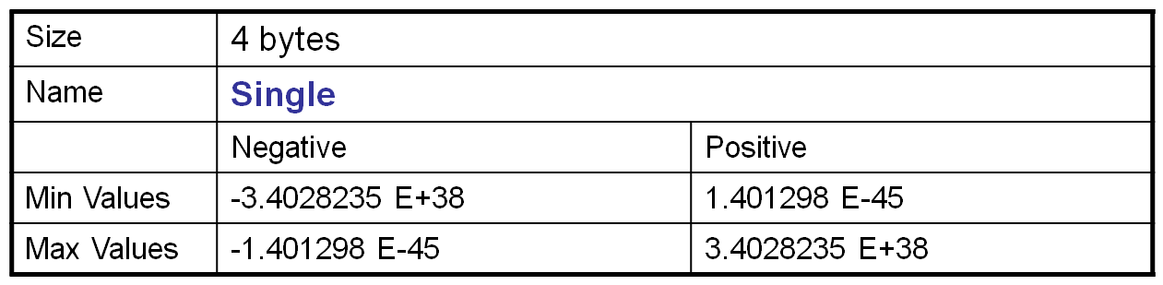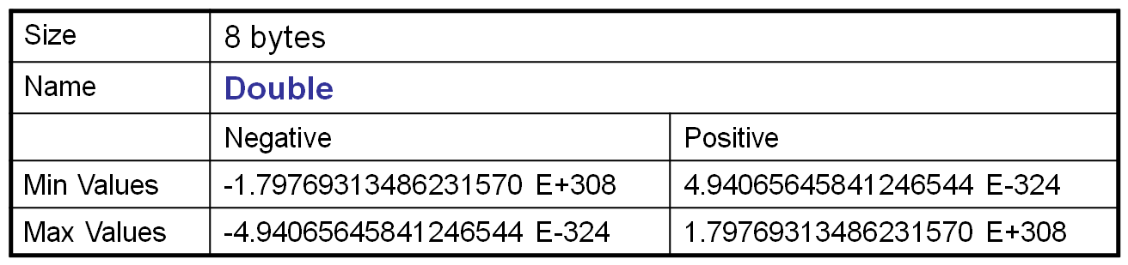

- The ‘general’ data type for floating point / real numbers, supported by VB.NET is Decimal. Like singles and doubles it is capable of holding fractional values and can support up to 28 digits – with the position of the decimal point being ‘movable’. Decimal value type is appropriate for financial calculations requiring large numbers of significant integral and fractional digits and no round-off errors. The Decimal type does not eliminate the need for rounding. Rather, it minimizes errors due to rounding. For example, if you need a result of 0.99999999999999999999999999 rather than 1.
Data types for Text – Char, String
- A lot of the information that computers are used to process contain textual information - for example:
- A student’s first initial would be stored as a single character of text – e.g. ‘H’
- A student’s gender (sex) may be stored as a single character – e.g. ‘M’ or ‘F’
- A student’s surname would be stored as a sequence of characters – e.g. ‘Singh’

- To this end, the .NET framework allows the storage of textual information in one of two ways:

- Char: The Char data type may only hold one character that is stored in Unicode (2 bytes are used per character) format. Unicode is an extended character set that includes characters beyond the standard ASCII character set to include more special and characters from other languages beyond English.

- String: The String data type can hold many (approximately 2 billion) characters and again each character is stored in Unicode format. A string is a sequential collection of Unicode characters that is used to represent text. A String object is therefore a sequential collection of Chars that represent a string. The value of the String is immutable. A String object is called immutable (read-only) because its value cannot be modified once it has been created (more on this in a later session).

Other Data types

- There are a may other data types that are available in VB.NET for the storage of data, some of which are in very common use because of their purpose:

- Boolean: this is a type that can only store one of two values - true or false; (to represent yes or no; on of off, etc..). This datatype is very useful in creating variables within programs that use conditions to determine their outcomes (which is a large proportion of all programming tasks as you will see later!).

- Date: (known generally as ‘DateTime’ in the .NET framework) this datatype is used for storing any date and/or time value. Variables of this data type can then be manipulated to display dates and times in a variety of formats. The Date value type represents dates and times with values ranging from 12:00:00 midnight, January 1, 0001 Anno Domini (Common Era) through 11:59:59 P.M., December 31, 9999 A.D. (C.E.) Time values are measured in 100-nanosecond units called ticks, and a particular date is the number of ticks since 12:00 midnight, January 1, 0001 A.D. (C.E.) in the ‘Gregorian’ calendar. For example, a tick value of 31241376000000000L represents the date, Friday, January 01, 0100 12:00:00 midnight.

Declaring Variables
The datatypes described previously are used for creating Variables in programming to store type constrained information in (volatile) memory.
- Before a variable can be used;
- a space must be reserved in memory for it, and,
- a name must be mapped to that location so that it can be referenced in future.
- This process is known as declaration.
- The most common way of declaring a variable in VB.NET is to use a ‘Dim’ statement:

Dim VariableName As VariableType
- Some examples might be:
Dim age As Byte
Dim numStudents As Short
Dim distance As Integer
Dim currentBalance As Double
Dim pi As Decimal
Dim initial As Char
Dim studentName As String
Dim enrolmentDate As Date
Dim isInternationalStudent As Boolean
- The name of a Variable is also called its identifier, there are certain rules for naming variables:
- Variable names Must begin with an alphabetic character or an underscore (_).
- Variable names Must contain only alphabetic characters, decimal digits, and underscores.
- Variable names Must contain at least one alphabetic character or decimal digit it if begins with an underscore.
- Variable names Must not be more than 1023 characters long.
- The following example shows some valid and invalid variable names:
- aB123__45 ' Valid.
- _567 ' Valid.
- _ ' Invalid - consists of an underscore only.
- 12ABC ' Invalid - begins with a decimal digit.
- xyz$wv ' Invalid - contains an invalid character.
- To declare a variable inside a subroutine or procedural structure the keyword Dim must be used. A variable declared (in this way) in one procedure may not be used in any other procedure as when the procedure ends that variable effectively ‘dies’ and is erased (see next section on variable scope).
Scope of Variables
- The duration for which a variable stays ‘alive’ or ‘visible’ is known as its scope.
- ‘alive’ refers to the variable’s existence in memory – i.e. when is it ‘deleted’.
- ‘visible’ refers to the ability of your program’s code to access it’s value.
- In terms of visibility, scope may extend over 4 basic areas:

Location | Description
Block | If you declare a variable within a block construct such as an If statement, that variable's scope is only until the end of the block. The lifetime is until the procedure ends.
Procedure | If you declare a variable within a procedure, but outside of any If statement, the scope is until the End Sub or End Function. The lifetime of the variable is until the procedures ends.
Module/Class | You can declare a variable outside of any procedure, but it must be within a Class…End Class or Module…End Module statement. The scope is any procedure within this module. The lifetime for a variable defined within a class is until the object is cleaned up by the garbage collector. The lifetime for a variable defined within a module is until the program ends.
Project | You can declare a Public variable within a Module…End Module statement, and that variable's scope will be any procedure or method within the project. The lifetime of the variable will be until the program ends.
- If several variables are given the same name, by definition only the variable with the most local scope will be referenced.
- There are several keywords in Visual Basic .NET that allow the scope of a variable to be defined at declaration:

Term | Visibility
Public | Anywhere in or outside of a project
Private | Only in the block where defined
Protected | Can be used in the class where defined. Can be used within any inherited class.
Friend | Can only be accessed by code in the same project/assembly.
ProtectedFriend | Combination of Protected and Friend

- At this point, we only need to be interested in how to declare a variable at ‘module’ or ‘class’ level. For the keywords Private or Public should be used.
- A variable declared as Private is available to use at any point (including subroutines) within that module.
- A variable declared as Public is available to use at any point (including subroutines) within that module. However, a Public variable is visible to other modules too, if addressed the correct way.
- Even if a variable is defined in a given location, that variable should not be used before it is instantiated i.e. before the program has executed the line of definition / declaration.

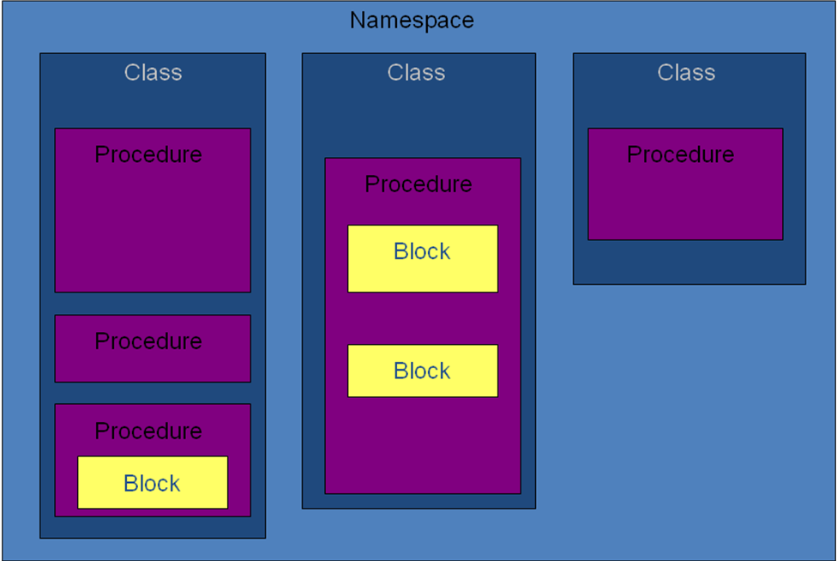

‘Violating’ some scope rules using static variables

- The use of the keyword Static to replace Dim in a declaration allows for variables to be kept alive even though the code they are declared in may not actually be in use – i.e. not ‘alive’ anymore (defeating scope rules in a way).
- The values of Static variables are kept in memory until the next time that specific variable comes back into use.
- Note: A Static variable can only be used after it has been given a value, i.e. the point of declaration is also the point of instantiation, on the first pass.

- Static variables can be defined in any of the following ways:
- Static MyNumber as Integer
- Public Static MyNumber as Integer
- Private Static MyNumber as Integer
- The previous statements show that by combining Static with other keywords the functionality (persistence) of static can be combined with other functionality (scope).

Other types of Variable declaration
- As mentioned before, there are some other keywords that can be used in declaring variables, these include:
- Shared
- Protected
- Friend
- The above are very important in .NET and will need to be used frequently in future. However, they will be discussed as they become more relevant, further on in the course (i.e. when we talk about Object Oriented programming).
Assigning values to declared Variables

- Once a variable has been declared, it can take it’s value in a variety of different ways:
  - From a control, e.g.:
Dim URLString As String
URLString = tbWebsite.Text

  - From a method that returns the same data type as a result, e.g.:

URLString = wbBrowser.URL.ToString()

Dim today As Date
today = Date.Now()

  - From a literal value that conforms to the data type, e.g.:

URLString = "www.google.com"

Dim tomorrow As Date
tomorrow = #1/1/2010 8:30:52 AM#

  - Or, as a result of a calculation that returns a value of the data type, e.g.:

Dim sum, value As Integer
value = 100
sum = value + 10
  - …etc

Demonstration – Using variables and datatypes

Your tutor will demonstrate the different forms of variable declaration, to include:

- Writing a simple variable declaration using the Dim statement

- Using online resources (such as MSDN) to discover different data types

- Using different data types in different programming contexts

- Testing and agreeing naming conventions for variables

- Testing and appreciating scope rules

- Using Private and Public as alternatives to Dim to illustrate scope

- Using Static to illustrate ‘safe scope violation’

- Assigning value to variables

Task 1 – Using local variables

The aim of this exercise is to get you using one of the data types introduced in the lecture, the Integer data type.

- Create a new project called ‘Variables_Lab’, and save it to your network (normally ‘H:’) drive.

- On the form that is displayed, create a label control and a button control.

- Change their Name properties to ‘lblCount’ and ‘btnLocalCount’ (or something sensible) respectively.

- Set the Text property of the label to ‘0’ (zero). This is where counting will start from.

- Set the Text property of the button to ‘Increment Count (Local)’.

- You may set other properties as you see fit (e.g. change the font, minimum size and colour of the label).

Hint - refer to previous labs and MSDN for help on how to do this.

Your form should now look similar to the one on the following page:

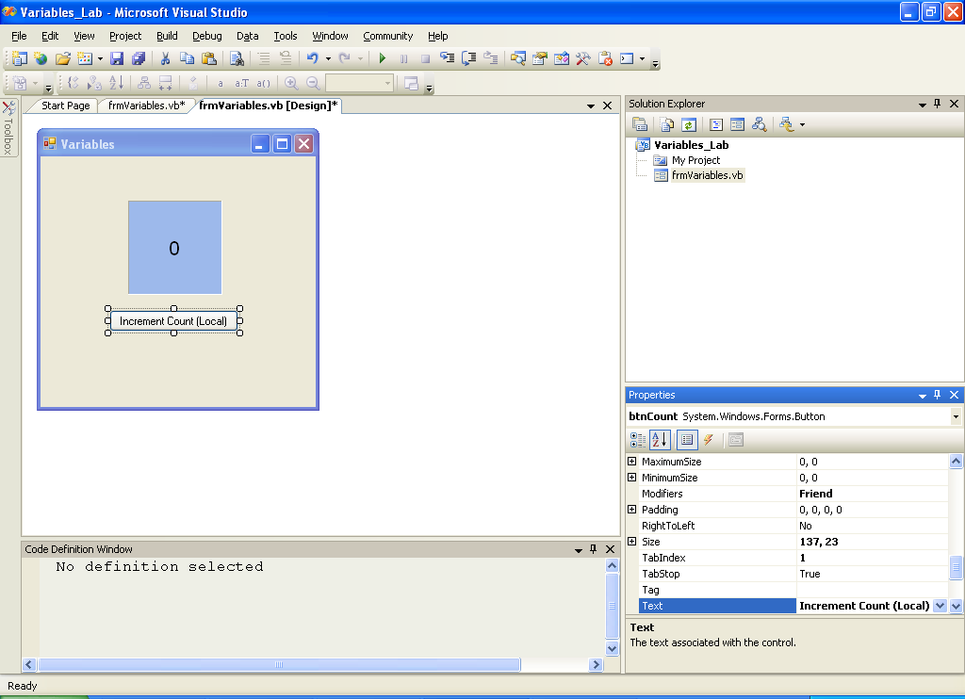

- Add an ‘event handler’ for the click event to the button named ‘btnLocalCount’. The code window should show as below:

Hint – refer to the previous labs for instructions on how to do this

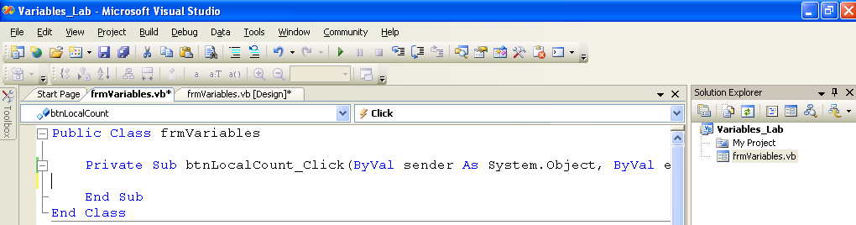

- Add the following code to the ‘click’ event handler code generated for you by Visual Studio (between the ‘Private Sub btnLocalCount_Click…’ and ‘…End Sub’ lines).

Dim count As Integer
count = count + 1
lblCount.Text = count

- What do you think the first line of the code in the previous step does?

- Before you run the code, make an ‘educated’ guess as to what will happen each time you click on the button.

- Now run the program (refer to previous labs on how to do this), does it perform as you expected? If not, note down what was different, and try to work out why.

Task 2 – Using static variables

The aim of this exercise is to make you aware of how variable scope works, by looking at another way of doing what we were in task 1.

- We will continue building the project called ‘Variables_Lab’, that you started in the previous task.

- On the main form add a new button control.

- Change it’s Name property ‘btnStaticCount’ (or something sensible).

- Set the Text property of the button to ‘Increment Count (Static)’.
Your form should now look similar to the one below:

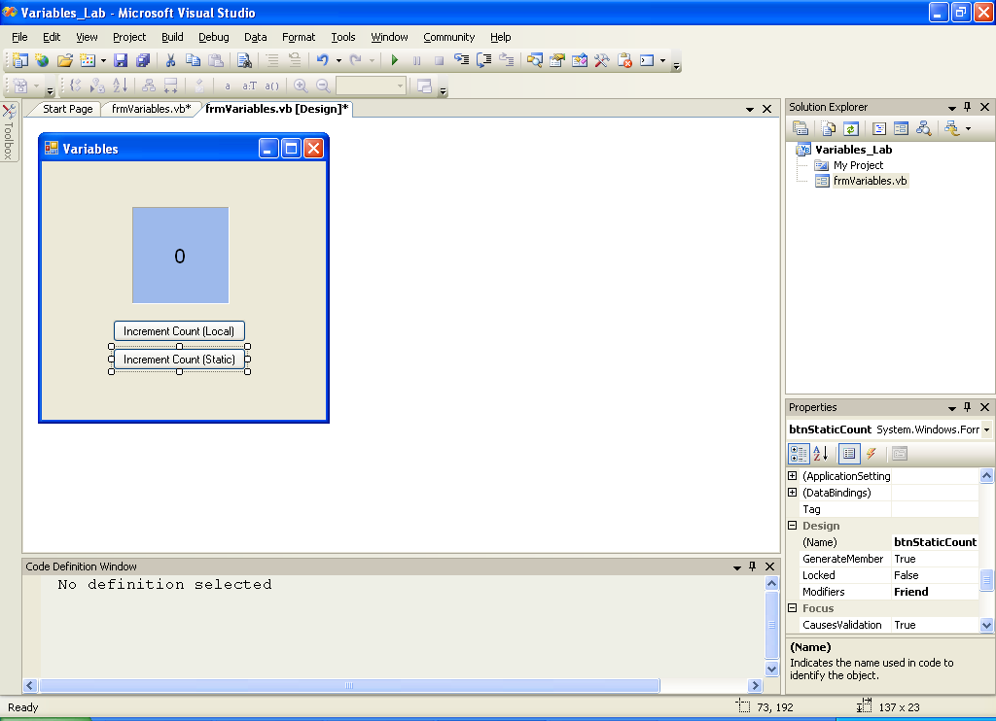

- Add an ‘event handler’ for the click event to the button named ‘btnStaticCount’. The code window should show as below:

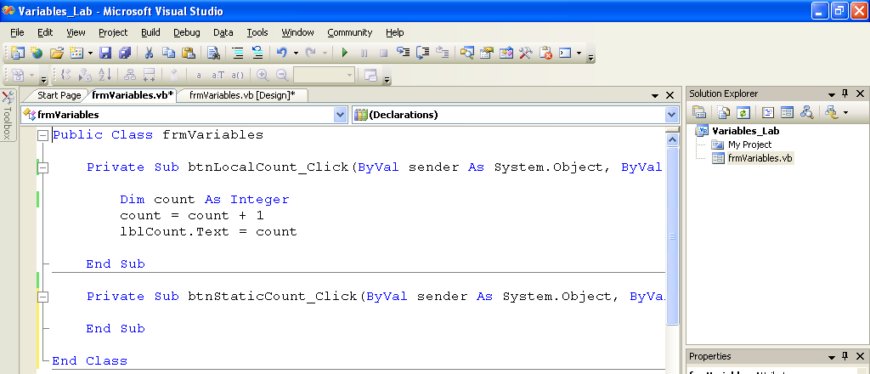

- Add the following code to the ‘click’ event handler code generated for you by Visual Studio (between the ‘Private Sub btnStaticCount_Click…’ and ‘…End Sub’ lines).

Static count As Integer
count = count + 1
lblCount.Text = count

- What do you think the first line of the code in the previous step does?

- Before you run the code, make an ‘educated’ guess as to what will happen each time you click on the button.

- Now run the program (refer to previous labs on how to do this), does it perform as you expected? If not, note down what was different, and try to work out why.

- How has the behaviour of the application changed since Task 1?

Task 3 – Using global variables

The aim of this exercise is to make you aware of the use of global variables.

- We will continue building the project called ‘Variables_Lab’, that you started in the previous tasks.

- On the main form add two new button controls.

- Change their Name properties to ‘btnGlobalCount1’ and ‘btnGlobalCount2’ respectively (or something sensible).

- Set the Text property of the buttons to ‘Increment Count (Global1)’ and ‘Increment Count (Global2)’ respectively.

Your form should now look similar to the one below:
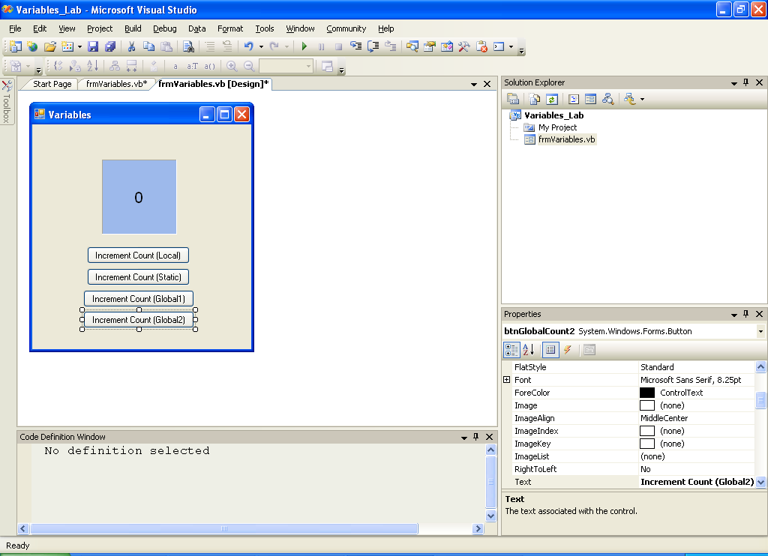

- Add event handlers for the click event of both the new buttons – and add the same code to both of them, as follows:

count = count + 1
lblCount.Text = count

- Just above the newly added event handlers (outside of any ‘Private Sub … End Sub’ blocks) add in the declaration for the global count variable:

Private count As Integer

The end part of your code window should look something like the one illustrated below. Note: do not remove any of the previous code for the existing buttons.

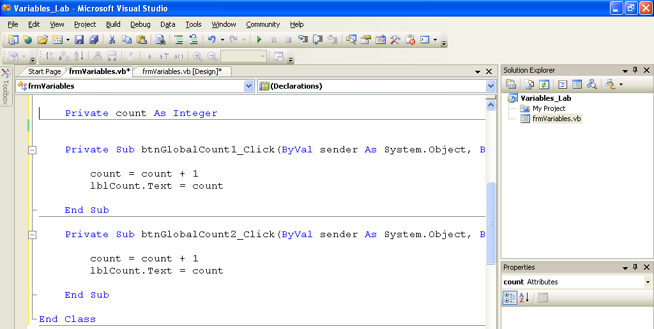

- What do you think the first line of the code in the previous step does?

- Before you run the code, make an ‘educated’ guess as to what will happen each time you click on either of the 2 new buttons. What about the existing buttons?

- Now run the program (refer to previous labs on how to do this), does it perform as you expected? If not, note down what was different, and try to work out why.

- How is the behaviour of the 2 ‘global’ buttons different from the ‘static’ button created in the previous task? Try to explain why this is.

Task 4 – Using variables of other Data Types

The aim of this exercise is to get you using more of the data types introduced in the lecture. The String type is re-introduced, as well as the Boolean and Date types.

- Create a new project called ‘DataTypes_Lab’, and save it to your network (normally ‘H:’) drive.

- For the form that is displayed, set it’s name property to ‘frmDataTypes’ and it’s Text property to ‘VB.NET Data Types’

- Create the following controls, on the form, with appropriate properties set as indicated in the table below:

Control | Name Property | Other Properties
Label | lblInitial | Text := “Please enter your first Initial”
Textbox | tbInitial
Label | lblSurname | Text := “Please enter your Surname”
Textbox | tbSurname
Label | lblDOB | Text := “Please enter or select your Date of Birth”
DateTimePicker | dtpDOB | Value := 01/01/1986
GroupBox | gbxGender | Text := “Please select your Gender / Sex”
RadioButton | rbtnFemale | Text := “Female”
RadioButton | rbtnMale | Text := “Male”
Button | btnShowDetails | Text := “Show summary of Details”
RichTextBox | rtbxShowDetails

The form should now look something like the following:

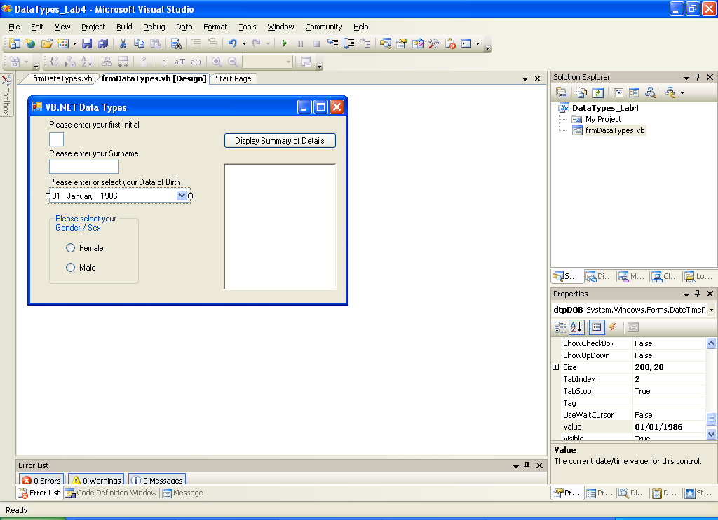

- Once the form is set up, double-click on the ‘btnShowDetails’ control and typ in the following code into the Event Handler stub ( between ‘Private Sub btnShowDetails_Click … End Sub’) that is presented to you in the code window:

Note: the variable declarations at the beginning of the code do not have data types identified – instead they are replaced by ‘????’. See next step to fix this.
The rest of the code has no errors – so long as you have made sure you have named your controls as per instructions in step3.

Dim myInitial As ????
Dim mySurname As ????
Dim myDateofBirth As ????
Dim myGenderisFemale As ????

'get a SINGLE CHARACTER as first initial for tbInitial
myInitial = tbInitial.Text

mySurname = tbSurname.Text

'get the value property from the date-time-picker control as a DATE type
myDateofBirth = dtpDOB.Value

If rbtnFemale.Checked Then
myGenderisFemale = True
Else
myGenderisFemale = False
End If

'if male, refer to as “Mr”, if female, refer to as “Ms”
Dim mySalutation As String
If myGenderisFemale Then
mySalutation = "Ms"
Else
mySalutation = "Mr"
End If

' get the DAY of your birth from the date of birth entered
Dim myDayofBirth As String
myDayofBirth = System.Threading.Thread.CurrentThread. _
CurrentUICulture.DateTimeFormat. _
GetDayName(myDateofBirth.DayOfWeek)

'display all the gathered and derived information in the rich text box
rtbxShowDetails.Clear()
rtbxShowDetails.AppendText("Hello " & mySalutation & "." _
& myInitial & " " & mySurname & vbCrLf)
rtbxShowDetails.AppendText("You were born on " & _
myDayofBirth & " the " & _
myDateofBirth.ToLongDateString & vbCrLf)
- Referring back to the code in the previous step, make a judgement as to which data type to use in place of the ‘????’s in the code.

Hint: each of the types must be one of Char, String, Date or Boolean. You will need to look at the usage of the variables to try to determine the most appropriate type. Hopefully, my naming of Controls and Variables and the added Comments should help!

- You may wish to rename the variables with prefixes that indicate their type, e.g. myGenderisFemale could become blnMyGenderIsFemale, or myDateofBirth could become dteMyDateOfBirth.

- Run the program (it should look like below) and test it.

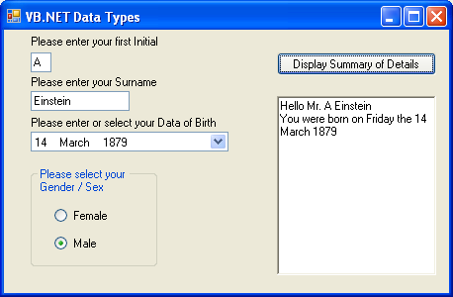

Task 5 – Using variables of other Data Types

The aim of this research based exercise is to get you experimenting withusing more of the data types of .NET

- Consider how you would extend the behaviour of the program you created in the last task (e.g. – using an Integer type to work out and store number of days left to someone’s birthday – you will also need to look at the ‘Now’ method of the Date type for this).

- You will need to refer to the MSDN (and any other web based programming resources you like) to complete this task. A good starting point is: http://msdn.microsoft.com/library/default.asp?url=/library/en-us/vbcn7/html/vbconDataTypes.asp

END OF WORKSHEET

