Programming Worksheet

Using Conditional Operators for Program Control

Introduction:

Computers are not ‘intelligent’ entities in themselves and are unable to make decisions by themselves. But, from the point of view of a user, computers seem to be able to make decisions and perform ‘intelligent’ tasks with relatively little effort of input.

Your job as a software developer (programmer) is to make the software designed for the user work ‘intelligently’ and intuitively (in a user friendly way). If a piece of software is difficult to use, it is either because:

the software was designed to do something very (sometimes unnecessarily) complex,

or, because the developer didn’t fully understand what was expected of the program,

or, the developer did not know how to integrate the relevant programming features in a logical way.

In order to control what a program does, the developer needs to lay out, in a logical and methodical way, the processes he/she expects the user and computer to perform throughout the lifetime of the program.

The term program control flow is often used in programming to indicate the techniques by which decisions should be made in your program.

Program control flow is supported in most programming languages by several common features:
- Conditional Operators – that allow ‘comparisons’ to be made in your program
- Logical Operators – that allow ‘complex’ comparisons to be built up
- Branching statements – that allow your program to support ‘logical decisions’
- Looping statements – that allow sections of your program to be repeated based on (changing) conditions

This worksheet will get you to practice some of these programming skills using conditional and logical operators and branching. The next worksheet will focus specifically on looping.

Please note: tasks now no longer give specific instructions on how to create a new application project. You must refer to the previous labs to remind yourself how to do this. Just remember to select a sensible name (e.g. ‘Conditions_Lab’) and location (for example, under your ‘H:’ drive) for your project in the appropriate dialogue!.

Basic Concepts: Conditional and Logic Operators in VB.NET

Conditional Operators:

Conditional Operators provide ways in programming by which the values of variables can be evaluated against each other, against some constant values, or in themselves (remind yourself of what a variable is from a previous worksheet).

Conditional operators provide results for decisions to be made. This is why the results of an evaluation or comparison must only ever yield a Boolean result (i.e. the result of the conditional statement can only be true or false – no maybes!!). This is regardless of the conditional operators used.

In the simple scenario of an evaluation / comparison statement using conditional operators, only one conditional operator type can be used in comparisons (e.g. 3<5<7 is not allowed).

The main types of conditional operators are as follows:
Operator | Description | Example  (say: x=3, y = 6) | Result
= | Is Equal to | x=y | False
<> | Not Equal To | x<>y | True
> | Is Greater Than | x>y | False
>= | Is Greater than or Equal To | x>=y | False
< | Is Less Than | x<y | True
<= | Is Less than or Equal To | x<=y | True

Some examples of creating results using conditional operators:

Private Sub btnCompare_Click(…) Handles btnCompare.Click

Dim result As Boolean
Dim x, y As Integer

x = nmX.Value
y = nmY.Value

result = (x = y)
lblXEqualToY.Text = "X = Y is " & result

result = (x <> y)
lblXNotEqualToY.Text = "X <> Y is " & result

result = (x < y)
lblXLessThanY.Text = "X < Y is " & result

result = (x > y)
lblXGreaterThanY.Text = "X > Y is " & result

result = (x >= y)
lblXGreaterThanOrEqualToY.Text = "X >= Y is " & result

result = (x <= y)
lblXLessThanOrEqualToY.Text = "X <= Y is " & result

End Sub

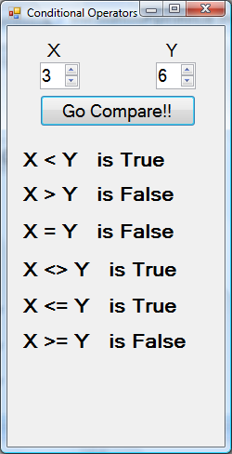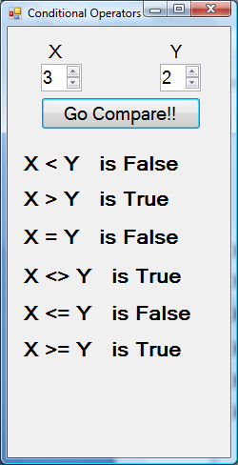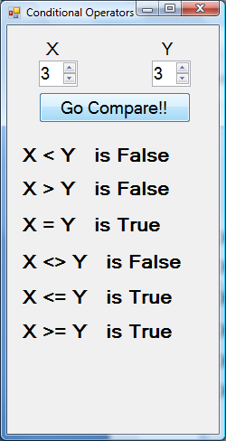
Logical Operators:

There are many situations in programming where a simple comparison between 2 values may not be enough – for example, if I only want to send a special message about pensions to employees in a company, who are in the age range of 21 to 65. As we are not allowed to check more than one condition at a time using the standard conditional operators, we need to ‘append’ two of these comparisons together. In this case, as the whole statement (do not worry about the “If … Then … Endif” bit, it will be explained soon) must meet both conditions, we use a special logical operator called And:

If employeeAge >= 21 And employeeAge <= 65 Then
MessageBox.Show("Please come to Pensions meeting!")
End If

Logical Operators allow means of testing several conditions in one statement. Again, the result can still only ever be True or False – i.e. Logical operators allow for the checking of multiple conditional statements to give a composite boolean result.

The main Logical Operators available in VB .NET are:

Operator | Description | Example  e.g. employeeAge = 45
And | Returns a True result only if both expressions evaluate to True. | (employeeAge >= 21) And (employeeAge <= 65)  [True] And [True] is True
Or | Returns a True result if any of the expressions evaluate to True. | (employeeAge >= 21) Or (employeeAge = 65)  [True] Or [False] is True
Xor | Returns a result of True if only one of the expressions evaluate to True. | (employeeAge >= 21) Xor (employeeAge <= 65)  [True] Xor [True] is False!!
Not | Inverts the value of the Expression. i.e. Returns false if expression is true, and vice-versa. | Not (employeeAge = 65)  Not [False] is True
AndAlso | If Expression1 evaluates to False Expression2 is ignored and a value of False is returned. | (employeeAge = 21) AndAlso (employeeAge <= 65)  [False] AndAlso [Ignored] is False
OrElse | If Expression1 evaluates to True, Expression2 is ignored and a value of True is returned. | (employeeAge <= 21) OrElse (employeeAge = 65)  [True] OrElse [Ignored] is False

Some examples of creating results using conditional operators:

Private Sub btnTestTheLogic_Click(…) Handles btnTestTheLogic.Click

Dim result As Boolean
Dim x, y As Integer

x = nmX.Value
y = nmY.Value

result = (x <= y) And (x >= y)
lblAND.Text = lblAND.Text & " " & result

result = (x > y) Or (x < y)
lblOR.Text = lblOR.Text & " " & result

result = (x = y) Xor (x = y)
lblXOR.Text = lblXOR.Text & " " & result

result = Not (x = y)
lblNOT.Text = lblNOT.Text & " " & result

result = (x <= y) AndAlso (x >= y)
lblANDALSO.Text = lblANDALSO.Text & " " & result

result = (x <= y) OrElse (x >= y)
lblORELSE.Text = lblORELSE.Text & " " & result

End Sub

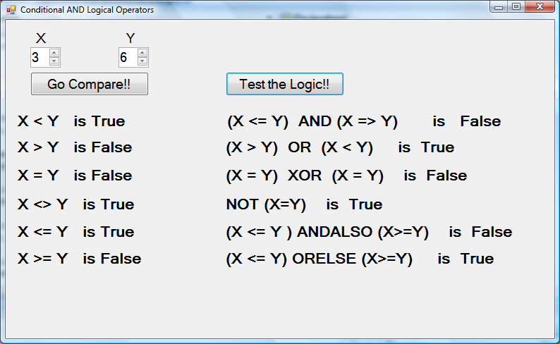

Branching Statement Constructs:

The conditional and logical constructs we have seen so far in programming come into effective use when decision making statements are constructed. The intent of these statements is that if a condition is met then the program reacts / redirects appropriately, i.e. If the thing to check meets some expectation Then do something.

In an everyday situations, logic is applied by human beings almost without thought, for example - If the Kettle is empty Then fill it with water.

With some thoughtful programming, these situations can be mirrored in programming. In fact applications need to continually respond to user actions / input and depending on the environment under which an action occurs to be interactive.

We have already come across event-handlers that implement this type of behaviour ‘behind the scenes’. Take the following; If a user clicks on a button an action may only be required if the user clicks with the left mouse button. In this case:
If mouse button clicked then
perform action required (e.g. change colour of label to red.)

With the branching statements in Visual Basic.NET, you can express control over the flow of control in your code explicitly. There are several forms of branching statement constructs available to VB.NET programmers:

- If … Then … Endif
- If … Then … Else … EndIf
- If … Then … ElseIf … Then … Else … EndIf
- Switch .. Case

If … Then ... EndIf statement:

The basic syntax (language formation) for an If … Then ... EndIf statement must follow the following structure:

If Condition is met Then
Perform Action(s)
End If

For example:

If employeeAge >= 21 And employeeAge <= 65 Then

SetPensionRate = 3.25
MessageBox.Show("Please come to Pensions meeting!")

End If

The following graphic shows the expected behaviour of an If…Then…EndIf clause:

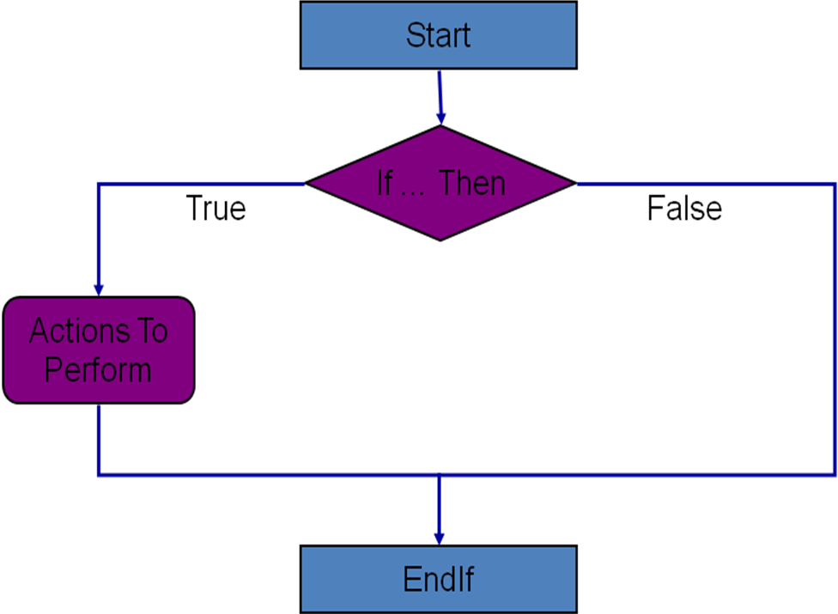

If … Then … Else ... EndIf statement:

Quite often, we are interested in the outcome that is ignored in the basic form of the If statement – i.e. what if the condition evaluates to false? The previous version of the If statement will ignore the ‘false case’ and continue with the code, but there is a variant available that covers this scenario – through the If…Then…Else…EndIf statement.

In an If…Then…Else statement the condition is evaluated, and if it is met (i.e. it is true) then some action is performed (as expected), however if the condition is not met (i.e. it is false) then another set of tasks may need to be performed.

In essence:
If the following condition is True then
perform the following actions;
otherwise
do something else.

Note that in the If…Then statement, if the condition is not met then effectively nothing happens - and the computer does not care! This is why we need a more ‘advanced’ form of the If … Then … EndIf statement clause.

The syntax of the If…Then…Else … EndIf statement clause must adhere to the following structure:

If Condition is met Then
Perform Action(s)
Else
Perform Different Action(s)
End If

For example:

If employeeAge >= 21 And employeeAge <= 65 Then

SetPensionRate = 3.25
MessageBox.Show("Please come to Pensions meeting!")

Else

SetPensionRate = 1.50
MessageBox.Show("You do not need to attend Pensions meeting!")

End If

The following graphic shows the expected behaviour of an If…Then…Else … EndIf clause:

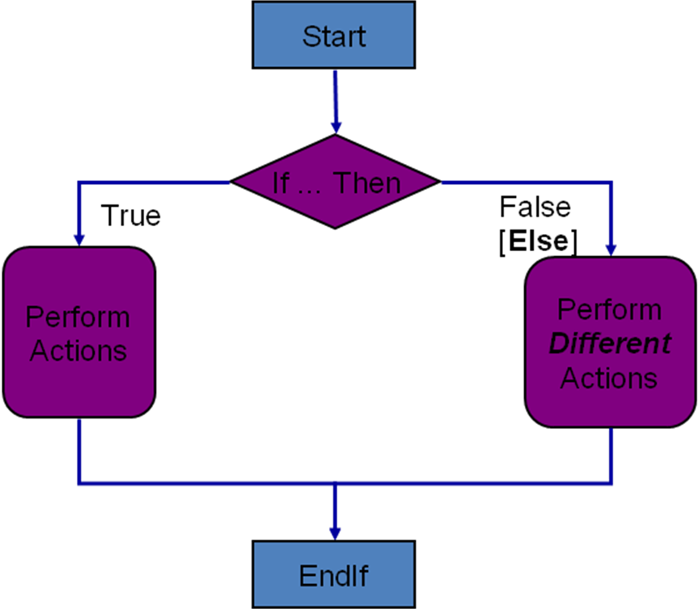

If…Then…ElseIf…Then …Else…EndIf statements:

Of course, extending from the justification for the need for the Else clause in the previous discussion, there are occasions when many conditions need to be evaluated as a group – whereby they are ‘mutually’ exclusive’ to each other (i.e. each condition has it’s own unique behaviour required).

Therefore, another variant of the If…Then group of statements is offered in the If…Then…ElseIf…Then …Else…EndIf statement.

This statement allows several conditions to be evaluated in a sequential (one after another) format. Once a condition is met the remaining evaluations are immediately forgotten about and the statement is exited via End If.

An If…Then...ElseIf statement follows this type of syntax:

If condition1 = True Then
Execute Code Block A
ElseIf condition2 = True Then
Execute Code Block B
ElseIf condition3 = True Then
Execute Code Block C
…
…
Elseif conditionN = True Then
Execute Code Block N
…
…
Else
Execute Code Block Z (i.e. none of the above)

End If

For example:

If employeeAge >= 21 And employeeAge <= 65 Then

SetPensionRate = 3.25
MessageBox.Show("Please come to Pensions meeting!")

ElseIf employeeAge >= 18 And employeeAge <= 21 Then

SetPensionRate = 1.50
MessageBox.Show("You do not need to attend Pensions meeting!")
Else

SetPensionRate = 0.0
MessageBox.Show("You do not earn a Pension st the moment!")
End If

The following graphic shows the expected behaviour of an If…Then…ElseIf…Else… EndIf clause:

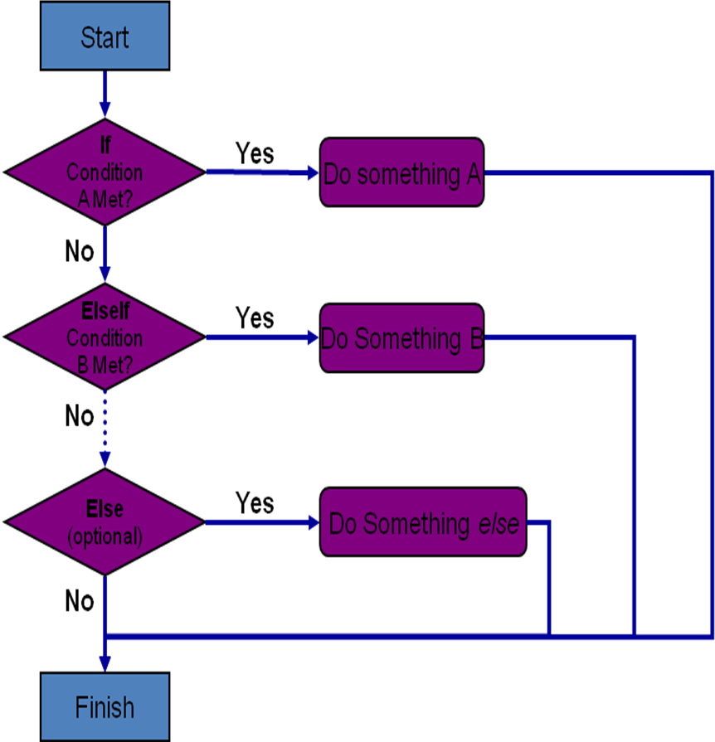

Select … Case statements:

As can be seen from the previous discussion of the syntax of the If statement where several ElseIf clauses are required, the statement set can become quite complex. Although this is clearly necessary where ‘ranges’ of values need to be evaluated (as in our code example) – if there is a simpler variable that needs to evaluated for fixed values only, Select … Case statements can be used in place of If…Then …ElseIf … EndIf statements.

Select … Case statements are generally used in places where there are many conditional branches.

Select cases are the best choice when there is only one condition value to be check for each subclause. The other reason for their choice over the If statement may be program performance - Select Case statements actually execute marginally faster than If statements as they are ‘precompiled’.

The syntax for a Select Case statement is as follows (assuming that the variable or control can only return values between 1 and 3):

Select Case Variable Name / Control Name
Case 1
‘Do Something A
Case 2
‘Do Something B
Case 3
‘ Do Something C
[Case Else]
‘Do Something D
End Select

The effect of the statement clause is the same as that depicted in the previous graphic for the If…Then…ElseIf statement.
Arithmetic Operators:
Although we have moved rapidly on to looking at conditional and logical operators, because of their importance in programming and program flow control; however, one of the main reasons the computer is perceived as such a useful tool is because of it’s computational ability!

Throughout programming, computers excel in the manipulation of numbers and related data. It is therefore wise to become fluent in some basic mathematical / arithmetic terminology – provided through the arithmetic operators.

The most basic types of calculation involve the simplest operators, as taught at primary school level. The representation, however, of some of these symbols may be a little strange at first – the following table shows equivalent symbols used in programming to represent standard arithmetic symbols:

Name Of Operator | Common Symbol | VB.NET Symbol
Addition | + | +
Subtraction | - | -
Multiplication | × | *
Division | ÷ | /

The behaviour of the arithmetic operators is pretty much as expected – but you need to become familiar with the syntax for performing and storing the results of calculations.
Some examples:

Dim firstNum, secondNum, sum, difference, product,
quotient,square As Integer
firstNum = 15
secondNum = 5

sum = firstNum + secondNum 'sum = 20
difference = firstNum - secondNum 'difference = 10
product = firstNum * secondNum 'product = 75
quotient = firstNum / secondNum 'quotient = 3
square = firstNum * firstNum 'square = 25

Dim Pi As Single = 3.142
Dim radius, cylinderlength As Integer
Dim circumference, area, volume As Single

radius = 5
cylinderlength = 10

circumference = 2 * Pi * radius 'circumference = 31.42
area = Pi * (radius * radius) 'area = 78.55
volume = area * cylinderlength 'volume = 785.5
The meaning of the following code should be immediately apparent:

Dim intMyNum As Integer = 50
Dim intResult As Integer

intResult = intMyNum + 24

But, what do the following statements evaluate to? (assuming that each statement is executed after intMyNum has been instantiated to its value as above).

intMyNum += 34 'shorthand for intMyNum = intMyNum + 34
intMyNum *= 40 'shorthand for intMyNum = intMyNum * 40
intResult /= intMyNum 's/hand for intResult = intResult / intMyNum

Often, in the interest of programmer’s speed, shorthand arithmetic statements may be used as above. However, in the interest of readability, this is discouraged.

As you’re aware, the four operators introduced previously are not enough to do everything in your calculations. Therefore, there are a few other Arithmetic operators on offer in the VB.NET environment. They include:

Name | Symbol | Example | Description
Power Of | ^ | 3 ^ 3 ^ 3 = 19683 | Raises a number to the power of another number.
Integer Division | \ | 100 \ 3 = 33 | Performs an integer division where any remainder is removed from the result
Modulus | Mod | 18 Mod 4 = 2 | Provides the remainder of two numbers after they have been divided.

Demonstration – Conditional and Logical Operators and Branching

Creating Boolean results form simple comparisons using conditional operators
- Creating Boolean results from compound comparisons using logical operators
- Using results of comparisons in simple branching code (If…Then…Else…Endif)
- Using results of comparisons in more complex branching code (If…Then…ElseIf…Endif)
- Using alternative techniques for branching (Switch … Case)

Task 1 – Using the basic conditional operators

The aim of this exercise is to get you using the basic conditional operators introduced in the preceding ‘Basic Concepts’ section.

- Create a new project called ‘Conditions_Lab’, and save it to your network (normally ‘H:’) drive.

- On the form that is displayed, create two TextBox controls, one Label control and six button controls.

- Set the form and control properties as follows:

Control | Name Property | Other Properties
Form | frmConditions_Lab | Text := “Using Conditional Operators”
Label | lblResult | Text := “True/False”
Textbox | tbValue1 | Text := “”
Textbox | tbValue2 | Text := “”
Button | btnEqualTo | Text := “= (Equal To)”
Button | btnNotEqualTo | Text := “<>(NotEqualTo)”
Button | btnLessThan | Text := “< (Less Than)”
Button | btnGreaterThan | Text := “> (Greater Than)”
Button | btnLessThanOrEqualTo | Text := “<= (Less Than or Equal To)”
Button | btnGreaterThanOrEqualTo | Text := “>= (Greater Than or Equal To)”

- Now Change the Font and / or Size properties of the controls to make the form appear as illustrated below:

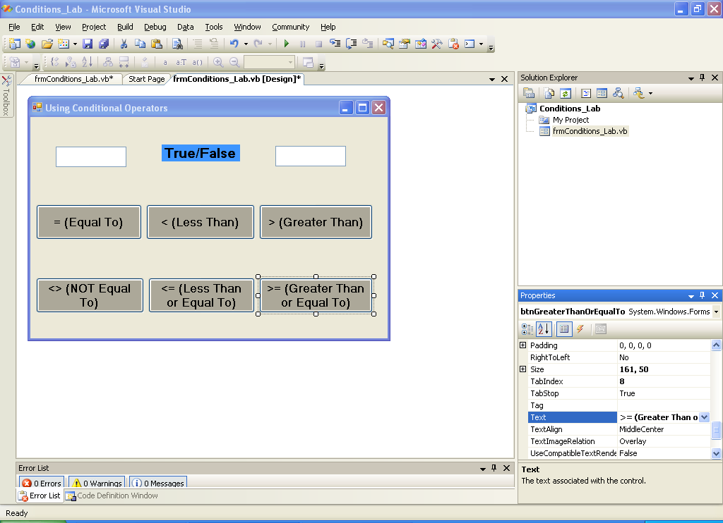

- Add a ‘Click’ Event Handler to the button entitled “= (Equal To)” (remind yourself how to do this from previous labs). In the code stub that appears, add the following code:

' button-click event handler for the btnEqualTo button
Private Sub btnEqualTo_Click(ByVal sender As System.Object, ByVal e As System.EventArgs) Handles btnEqualTo.Click

'check if the value in the first textbox is the same as the one in the second one
If tbValue1.Text = tbValue2.Text Then
'if they're the same, display the word "True" in the label
lblResult.Text = "True"
Else
'if they're not, display the word "False" in the label
lblResult.Text = "False"
End If

End Sub

- Take some time to figure out how the code you have added works. The comments (green lines with an apostropphe (‘) symbol at the start) should help. Use the following questions to test your understanding and explain it in your own words.

- What do you think the first line of code (beginning with Private Sub btnEqualTo_Click ) – added by Visual Studio for you - does ?

- What about the first line of code you added (If tbValue1.Text = tbValue2.Text Then). Which of the other lines of code are needed to complete the conditional ‘If’ statement?

- Now run the partially completed program (refer to previous labs on how to do this), does the first button perform as you expected? If not, note down what was different, and work out why.

- Now complete the code, by adding ‘Click’ Event Handlers for the rest of the buttons on the form.

- For each new button’s click event handler, you will need to work out what code you need to add to achieve it’s desired behaviour.
Hint: Use the code already added for the ‘btnEqualTo’ button’s click event in step 5 to decide how you want the code behind the other buttons to behave (and look like). You will need to look at your lecture notes on conditional operators and the ‘If … Then … Else’ statement clause, to figure out what to do.

- Run the fully completed program (refer to previous labs on how to do this), do all the buttons perform as you expected? Start with numerical comparisons, but then try it with characters and text. Use the table below to test your program, record your findings and try to work out why the output is produced:

Value 1 | Value 2 | = | <> | < | <= | > | >=
4 | 3
3 | 3
-8 | 8
A | b
G | G
True | True
False | True
45 | Tree

Task 2 – Using the conditional operators to control program flow

The aim of this exercise is to demonstrate how conditional statements can be used to control the branching and flow of logic within a program.

The program we are going to create will emulate a simple ‘Higher or Lower” number gussing game. It will generate a random number between 0 and 100, and ask the user to enter guesses. On every guess it will add the number to one of two higher or lower values listboxes – or give a message if the number was guessed correctly.

- Create a new project called ‘Program_Flow_Lab’, and save it to your network (normally ‘H:’) drive.

- Rename the main form to something sensible (e.g. ‘frmProgram_Flow_lab”). Set it’s title (Text property) to something relevant, such as “Higher Lower Game”.

- Add the following controls to the form, and set their properties as given in the table below:

Control | Name Property | Other Properties
Label | lblGuessPrompt | Text := “Guess the number I'm thinking of (0 -100):”
MaskedTextbox | msktbGuessNumber | Text := “000”  Mask :=”000”
Button | btnGuessNumber | Text :=”Guess Number >>”
Label | lblGuessNumber | Text := “I have a number, Start Guessing !!”
Label | lblTooHigh | Text := “Guesses too High”
List box | lstHigherValues
Label | lblTooLow | Text := “Guesses too Low”
List box | lstLowerValues
Label | lblGuessesSoFar | Text := “Number of Guesses so far: 0”

- Look up the MaskedTextBox control on MSDN (or your other favourite VB.NET programming resource). Look at its description, properties, methods and events, then answer the question - Why did we use this control instead of a ‘normal’ Textbox control?

__________________________________________________________________

__________________________________________________________________

- Although we have been using lots of the VB.NET controls so far without any great thought as to why - Review your basic understanding of what a control is and then answer these questions:

  - What is a VB.NET control? Use an example to answer this question.

__________________________________________________________________
__________________________________________________________________

  - What are properties (in relation to controls)? Use an example to answer this question.

__________________________________________________________________
__________________________________________________________________

  - What are events (in relation to controls)? Use an example to answer this question.

__________________________________________________________________

__________________________________________________________________

  - What are methods (in relation to controls)? Use an example to answer this question.

__________________________________________________________________

__________________________________________________________________

- Now use your judgement and the skills learnt in previous lab tasks!) to improve the ‘look and feel’ (aesthetics) of the form (by setting properties of controls) – perhaps so it looks something like the one below:

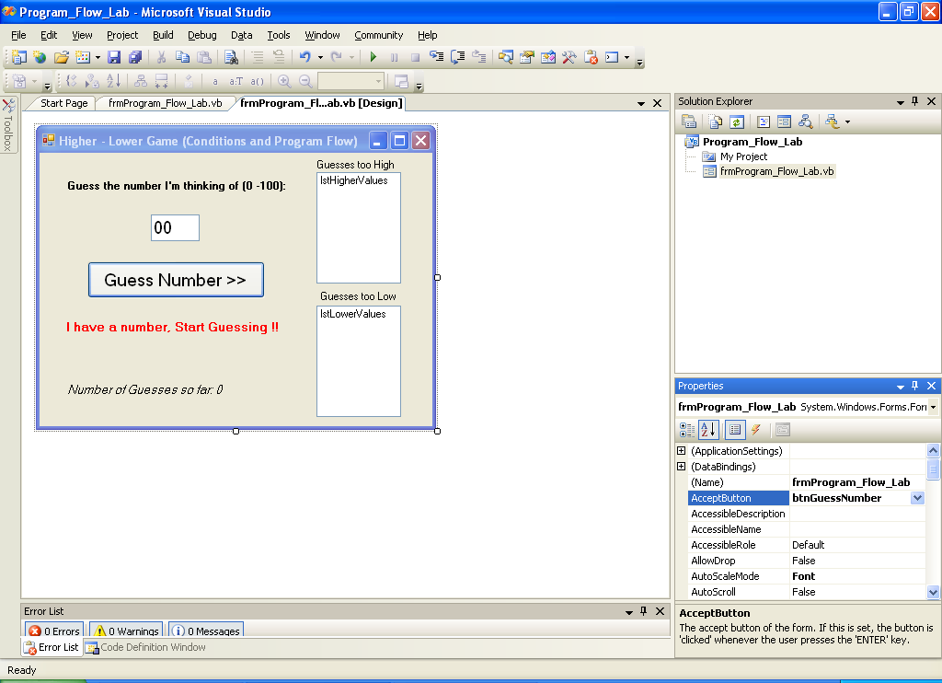

- Alter the form’s AcceptButton property to ‘btnGuessNumber’. Why did we do this? (refer to last lab on the ‘Web Browser’ for clues).

__________________________________________________________________ __________________________________________________________________ __________________________________________________________________

- Open the ‘form load’ event-handler for the main form. How would you do this?

__________________________________________________________________ _____________________________________________________________

- Add the following code to the code to the code stub that is displayed in step 8:

Private Sub frmProgram_Flow_Lab_Load(ByVal sender As System.Object, ByVal e As System.EventArgs) Handles MyBase.Load
'get the next random integer number between 0 - 100 to be guessed
NumberToGuess = RandomGenerator.Next(0, 100)
End Sub

Note: the extensive use of code comments (lines in green beginning with an apostrophe (‘)) throughout the code. This is added to help you understand what the code is intended to achieve.

- While you are in the code window, add the following global declarations to the form’s class as follows:

Public Class frmProgram_Flow_Lab

' declare a global variable to hold the number to be guessed
Private NumberToGuess As _______
'create a global random number generator using the .NET 'Random' class
Dim RandomGenerator As New Random

Note: There are sections of the code missing (replaced by _____ ). You are required to work out what that code should be and correct it.

- Open the ‘click’ event-handler for the ‘btnGuessNumber” button. Add the code on the following page to it:

Important Note: There are sections of the code missing (replaced by _____ ). You are required to work out what that code should be and correct it. The code will not work without these corrections. Most of the corrections are to do with choosing appropriate data types or conditional operators – both topics have been covered in the last two lectures.

Private Sub btnGuessNumber_Click(ByVal sender As System.Object, ByVal e As System.EventArgs) Handles btnGuessNumber.Click
'declare a local integer variable to hold the guess
Dim GuessedNumber As _______
'declare a 'static' integer to keep track of number of guesses made
______ NumberofAttempts As Integer
'declare a local boolean variable to indicate if this guess was successful
Dim GuessedCorrectly As _______ = False
'increment number of attempts made and display it
NumberofAttempts = NumberofAttempts + 1
lblGuessesSoFar.Text = "Number of attempts so far: " & NumberofAttempts
'get the entered text and convert it into an Integer
GuessedNumber = Convert.ToInt32(msktbGuessNumber.Text)

'if the guess is correct...
If NumberToGuess ___ GuessedNumber Then
lblGuessNumber.Text = "Well Done!!" & vbCrLf & "You Guessed it in " & NumberofAttempts & vbCrLf & "Start Guessing Again..."
GuessedCorrectly = True
'otherwise, if the guess is too low
ElseIf GuessedNumber ____ NumberToGuess Then
'add number to the 'too low' list
lstLowerValues.Items.Add(GuessedNumber)
lblGuessNumber.Text = "Try Again" & vbCrLf & "Your guess was too LOW "
'otherwise, if the guess is too high
ElseIf GuessedNumber ____ NumberToGuess Then
lstHigherValues.Items.Add(GuessedNumber)
lblGuessNumber.Text = "Try Again" & vbCrLf & "Your guess was too HIGH "
End If

'if the guess was correct...
If GuessedCorrectly Then
'get the next random integer number between 0 - 100 to be guessed
NumberToGuess = RandomGenerator.Next(0, 100)
'clear the listboxes for next set of guesses
lstHigherValues.Items.Clear()
lstLowerValues.Items.Clear()
lblGuessesSoFar.Text = "Number of attempts so far: 0"
End If

'clears and set focus to the number text box for next guess
msktbGuessNumber.Clear()
msktbGuessNumber.Focus()
End Sub

- Run and test the program, and make notes on your findings. The screenshot below shows an example of the output of the program.

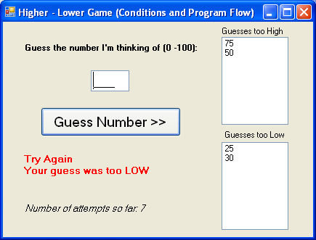

- The program as it stands has a bug (logical error) to do with keeping count of the number of attempts made (Careful observation of the given screenshot illustrates this). Find and fix the bug.

Note: some of the techniques to be researched in the next task may help.

Task 3 – (Research Task) Debugging facilities in Visual Studio 2008

- Research the use of debugging facilities in Visual Studio .NET 2008 on MSDN.

- You should look into facilities such as:

  - Setting and using Breakpoints

  - Using Watches

  - Single Stepping (Step into, step over, run to cursor) through your code

  - Use of the Immediate Window to dry run fragments of code

  - Use of the Output Window to use in-code debugging techniques (i.e. to write program data to the system Console instead of forms and controls).

END OF WORKSHEET

