Programming Worksheet

Loops and program control

Introduction:

One thing that computers are very good at, and do so without ‘complaining’, are tasks that we would consider to be ‘drudgery’ !

For example, if you wanted to go through every student in this faculty and check their study status (i.e. full-time or part-time) for some sort of summary report. Not too bad, you say? What if we extend this out to the whole University, or every University in the country?

Obviously, one of the factors that would make this a ‘tedious’ task would be the fact that you need to repeat exactly the same search for every record under scrutiny.

Repetition is something we expect computers to handle as a matter of course. For this reason, there is a program structure provided by most programming languages – derived from the branching idea we were looking at previously – known as looping.

Loops come in many forms in VB.NET, but hinge around the core idea of being able to repeat a piece of programming code based on the satisfaction (or otherwise) of a condition (hence the link to branching).

Loops allow developers to perform tasks which require program sections (lines of code) to be performed numerous times consecutively (repeated), thus reducing the amount of code needed to perform repeatable tasks.

Loops initially require a bit more thought and planning than writing code straight out.

The process of looping is sometimes known as iteration. The number of iterations required can often be predefined or variable depending on the nature of the program task.

There are 3 (groups of) defined ways of performing looping operations in the VB.NET programming environment:

- For …Next

- Do …Loop While and Do While… Loop

- Do …Loop Until and Do Until … Loop

In reality both varieties of the Do … While and Do … Until loops are very similar with subtle but important differences.

This session will pick up from where the previous session left off – with the idea of using conditional control statements – but this time for loops. We will:

- define the concept of loops for repetition,
- look at some of the core differences between the different styles of loop that can be implemented in VB.NET,
- the impact that loops can have on the execution of code.

This workshop session will get you to practice programming skills using the various types of loops available in VB.NET.

Please note: worksheets now no longer give specific instructions on how to create a new application project. You must refer to the previous labs to remind yourself how to do this. Just remember to select a sensible name (e.g. ‘Loops_Lab’) and location (for example, under your ‘H:’ drive, select your ‘Programming’ folder etc) for your project in the appropriate dialogue!

Types of loops in VB.NET

For…Next Loop:

For…Next Loops are based on iterative processes which know (up-front) how many times they will execute.

The syntax for a For…Next Loop uses the following formula:

For Counter = Start To Finish [Step Value]
‘ Do something
Next

Note- the square brackets [] indicate that the code is optional and not necessary. Also Start and Finish should be of a ‘whole number’ type – e.g. Integer.

For example;

For intCounter = 1 To 12 Step 2
intResult = intCounter * 10
lstResult.Items.Add(intCounter & " x " & 10 & " = " & intResult)
Next

The graphic below illustrates the expected behaviour of the For … Next loop:

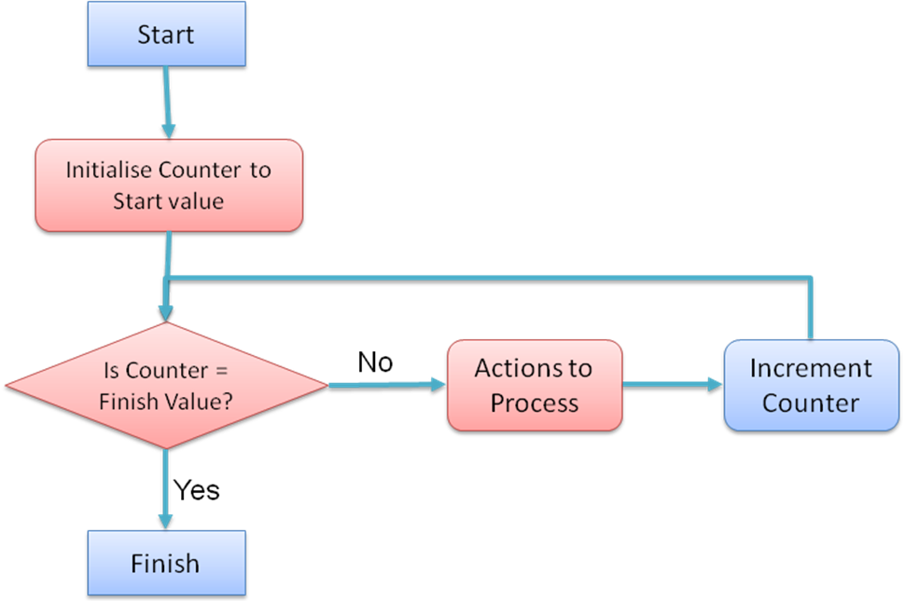

- A Counter variable is used to track how many times the code in a loop has been executed – and must be declared as such. This counter is automatically initialised and incremented / decremented for you – depending on how the loop is declared (see next point), e.g;

Dim intCounter, intResult As Integer

For intCounter = 1 To 12
intResult = intCounter * 10
lstResult.Items.Add(intCounter & " x " & 10 & " = " & intResult)
Next

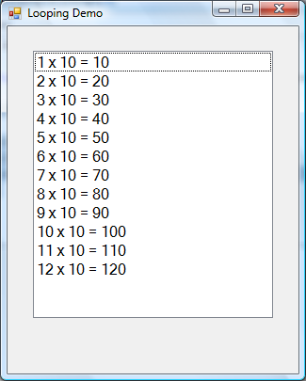

- The counter variables in For…Next statements can be modified to count in different stepping intervals (not just units of one) – the step Value will determine the size of the steps e.g. Step 2 has the following effect;

For intCounter = 2 To 12 Step 2
intResult = intCounter * 10
lstResult.Items.Add(intCounter & " x " & 10 & " = " & intResult)
Next
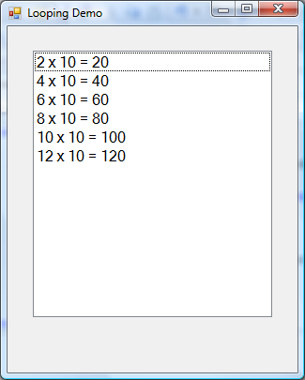

- For…Next loops can also have counter variables that are either incremented or decremented. i.e. the step Value described in the previous point can also be positive (for incrementing) or negative (for decrementing). However, if decrementing, you will need to ensure that the order of the start and finish values is correct – i.e. Start > Finish so that decrementing makes sense. E.g. -2 for going ‘backwards’ in steps of 2.

For intCounter = 12 To 2 Step -2
intResult = intCounter * 10
lstResult.Items.Add(intCounter & " x " & 10 & " = " & intResult)
Next
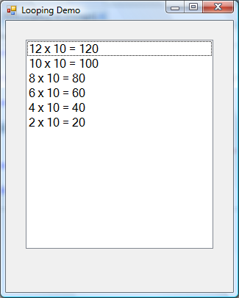

Do…Loop Loops:

The For … Loop construct is extremely useful as it takes away the need to be checking conditions (i.e. Counter >= Start?), and incrementing / decrementing the loop counter – both are done ‘automatically. Thus it is particularly useful for iterating through collections of information – such as ‘Arrays’ (which we will do a worksheet on later).

For situations that are not as clearly pre-defined as the one described above, a different type of loop is required where the programmer needs to take control of the condition checking and incrementing / decrementing of the loop variable. For this purpose, VB.NET provides several other loop constructs based on the Do … Loop keyword construct.

Most loops that use the keyword Do are generally accepted as loops that by definition do not necessarily have a definitive range over which they will run – i.e. the condition to terminate the loop could occur at any time - as the condition is usually determined by a variable that is manipulated in the body of the loop.

i.e. By definition, a ‘For loop’ has the start and finish conditions declared that the loop SHOULD execute to the full – whereas a ‘Do Loop’ iterates for a non-predetermined number of times.

Therefore, the Do … Loop can run indefinitely or while / until a condition is met.

There are 4 styles of Do … Loop; they are grouped into 2 subtypes by the point of checking of the loop condition. They can be top-exit (the condition is checked at the start of the loop body) or bottom-exit (condition is checked at the end of the loop body). The significance of these subtypes is one of the major criteria in choosing the appropriate loop types when programming:

- In a top-exit loop, as the condition is checked at the start of the loop, there is always a possibility that the conditions stops the loop from executing even once – i.e. in a top-exit loop, the loop may NEVER be executed – 0 times.
(note that the For…Next loop is also a top-exit loop)

- In a bottom-exit loop, regardless of the initial outcome of the condition, as it is checked at the end of the loop body, the loop body will always be executed at least once – i.e. in a bottom-exit loop, the loop MUST be executed AT LEAST ONCE.

- Top exit ‘Do’ loops - Do While …Loop / Do Until …Loop:

Top-exit Do loops must follow one of the following syntaxes (there are two types):

- Do While …Loop

Do While Condition = True
‘Do Something
Loop

For example;

Dim intCounter, intResult As Integer

'the onus for initialising loop counters is now on the programmer
intCounter = 1

Do While intCounter <= 12

intResult = intCounter * 10
lstResult.Items.Add(intCounter & " x " & 10 & " = " & intResult)

'incrementing the counter is now the programmers responsibility
intCounter = intCounter + 1

Loop
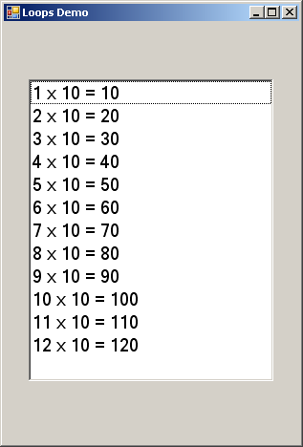

The graphic below illustrates the expected behaviour of the Do While … Loop construct:

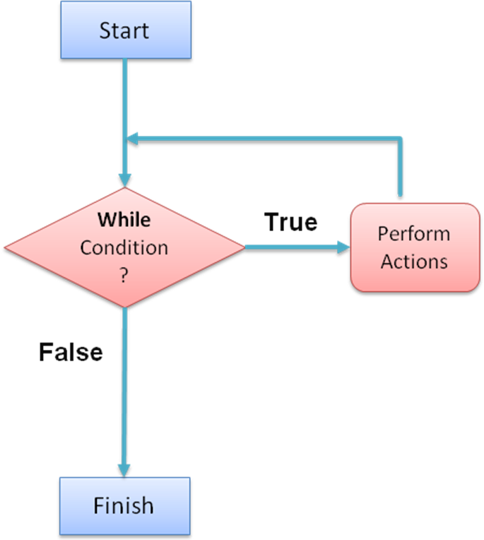

- Do Until …Loop.

Do Until Condition = True
‘Do Something
Loop

For example;

Dim intCounter, intResult As Integer

'the onus for initialising loop counters is now on the programmer
intCounter = 1

'note the subtle chane in the condition for UNTIL
Do Until intCounter > 12

intResult = intCounter * 10
lstResult.Items.Add(intCounter & " x " & 10 & " = " & intResult)

'incrementing the counter is now the programmers responsibility
intCounter = intCounter + 1

Loop

The graphic below illustrates the expected behaviour of the Do Until … Loop construct:

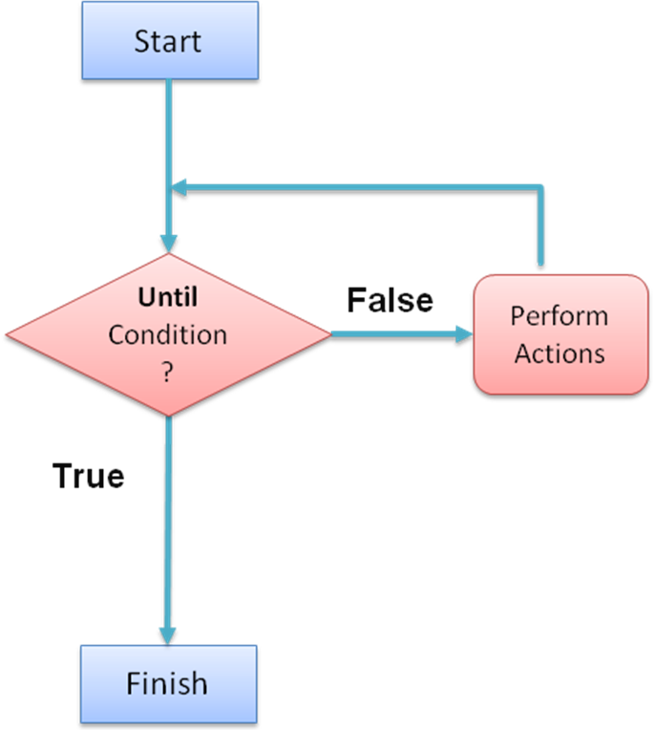

- Bottom exit ‘Do’ loops - Do …Loop While / Do …Loop Until:

Bottom-exit Do loops must follow one of the following syntaxes (there are two types):

- Do …Loop While

Do
‘Do Something
Loop While Condition = True

For example;

Dim intCounter, intResult As Integer

'the onus for initialising loop counters is now on the programmer
intCounter = 1

Do
'this code block will now execute at least once
intResult = intCounter * 10
lstResult.Items.Add(intCounter & " x " & 10 & " = " & intResult)

'incrementing the counter is now the programmers responsibility
intCounter = intCounter + 1

Loop While intCounter <= 12

The graphic below illustrates the expected behaviour of the Do … Loop While construct:

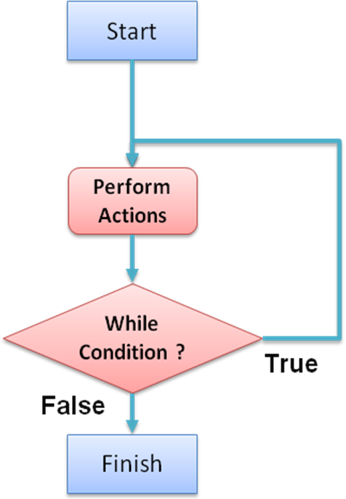

- Do …Loop Until

Do
‘Do Something
Loop While Condition = True

For example;

Dim intCounter, intResult As Integer

'the onus for initialising loop counters is now on the programmer
intCounter = 1

Do
'this code block will now execute at least once
intResult = intCounter * 10
lstResult.Items.Add(intCounter & " x " & 10 & " = " & intResult)

'incrementing the counter is now the programmers responsibility
intCounter = intCounter + 1

Loop Until intCounter > 12

The graphic below illustrates the expected behaviour of the Do … Loop Until construct:

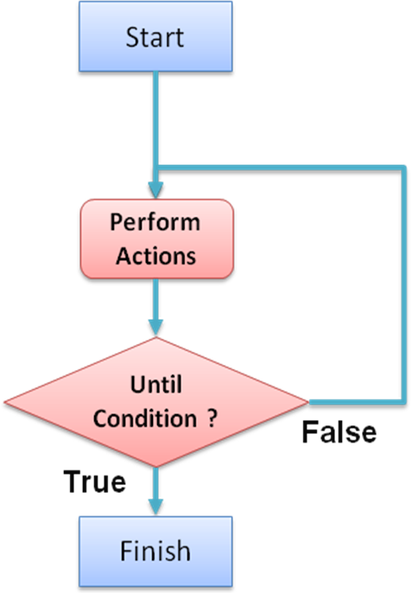

Infinite Loops and ‘DoEvents’

When programming loops the developer needs to extra careful with do loops as they are able to permanently ‘lock a program’ in an infinite loop if the condition to exit the loop is never met. This means that the program will no longer appear to respond.
Therefore a developer needs to make sure when programming a do loop that at some point the loop will exit from continuous execution.

Very occasionally a do loop may actually need to (be intended) run for a long period of time. If this is a natural course for the loop, the user may well think that the program has crashed even if it is still working. It is at this point that the DoEvents method comes in useful.

The DoEvents method basically forces the loop to release some of the processor time to perform other tasks. This ultimately means that the computer looks at any other actions that are attempting to be executed – and intermittently allows them to happen.

The Application.DoEvents() statement needs to be put inside the loop in which it is required:

Do While Condition = True
Application.DoEvents()
‘Do Something
Loop

Note that sometimes the effect of the program being locked in an infinite loop is also useful - i.e. when you need to continually to monitor some condition while the program is running.
The example below illustrates the combined effect of a infinite loop and the DoEvents( ) method. The graphic below that shows the output of the code shown.

Why is the loop considered an ‘infinite loop’?

Why did the exception raise when the loop counter got to 3,277?

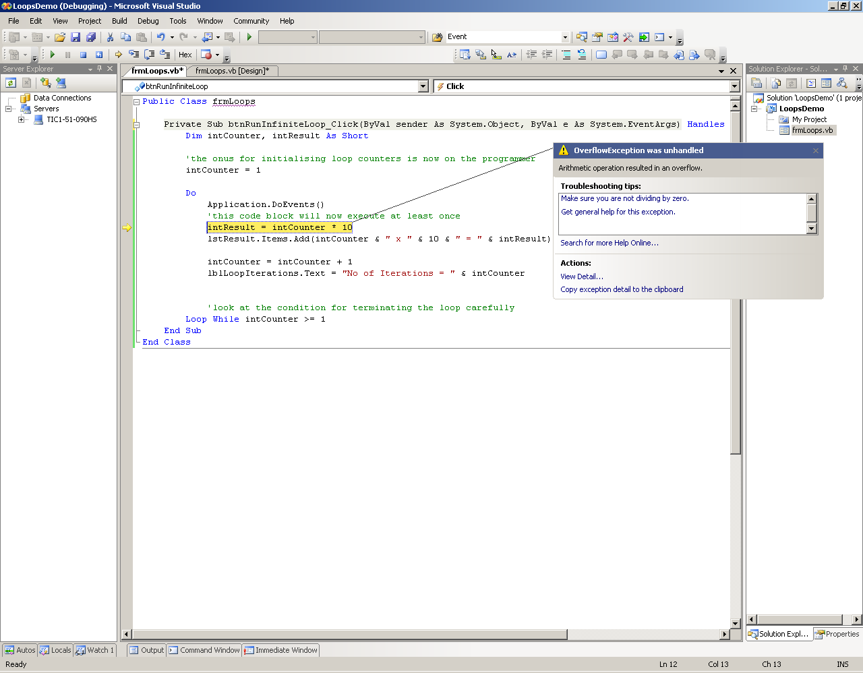

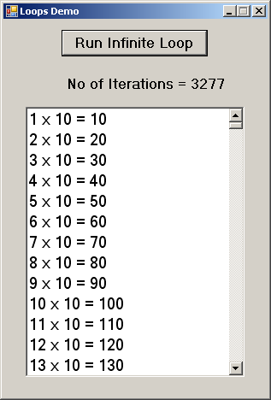
Leaving Loops Early – and other Early Exits

On some occasions there is a need to exit a loop, conditional statement or even
procedure (we’ll look at these later) early.

Exit statements can save a lot of extra processing for your program.

Statements ‘blocks’ that can be exited from include:

- For loops Exit For

- Do loops Exit Do

- If Statements Exit If

- Case Statements Exit Select

- Try Statements Exit Try (will discuss later)

- Procedures Exit Sub / Exit Function (will discuss later)

For example, the following code leaves the ‘Do’ loop early when a condition other than the loop’s termination condition is met:

Dim intCounter, intResult As Short
intCounter = 1

Do

'this early exit will get rid of our 'infinite loop’ problem
If intCounter >= 12 Then
Exit Do
End If

intResult = intCounter * 10
lstResult.Items.Add(intCounter & " x " & 10 & " = " & intResult)
intCounter = intCounter + 1
lblLoopIterations.Text = "No of Iterations = " & intCounter

Loop While intCounter >= 1

Demonstration – Using loops of all types

Your tutor will demonstrate the use of the various types of loop constructs available in VB.NET. The demonstration will also include:

an illustration of an ‘infinite loop’

the use of DoEvents in long loops,

and how to exit a loop early.

Task 1 – Using loops for a fixed /variable number of iterations

The aim of this exercise is to get you using the standard loops as discussed in the lecture:

- Create a new project called ‘Loops_Lab’, and save it to your network (normally ‘H:’) drive.

- On the form that is displayed, create four Label controls, one Listbox control, two NumericUpDown controls and two Button controls.

- Set the form and control properties as follows:

Control | Name Property | Other Properties
Form | frmLoops_Lab | Text := “Using Loops”
Label | lblSelectNumber | Text := “Please select number to calculate table for:”
NumericUpDown | nmSelectNumber | Maximum:= “100”
Button | btnCalculateTable | Text := “Calculate times table up to 12 >>”
Label | lblLimit | Text := “OR select a new Limit:”
NumericUpDown | nmChangeLimit | Maximum:= “100”
Button | btnChangeLimit | Text := “Change Limit and calculate>>”
Label | lblTimesTable | Text := “Times table for:”
Label | lblUpTo | Text := “Up to:
Listbox | lbxTimesTableDisplay

- The completed form should appear as below:

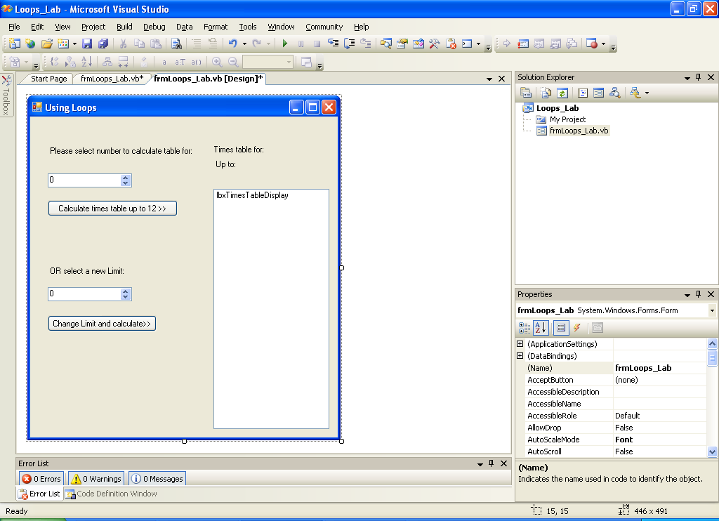

- Add a ‘Click’ Event Handler to the button entitled “Calculate times table up to 12>>” (remind yourself how to do this from previous labs). In the code stub that appears, add the following code:

'what do the following two lines of code do?
Dim LoopCounter As Integer
Dim CurrentValue As Integer = nmSelectNumber.Value

lblTimesTable.Text = "Times table for: " & CurrentValue
lblUpTo.Text = "Up To 12"

'what does the following line of code do?
lbxTimesTableDisplay.Items.Clear()

'set up FOR...NEXT loop to calcuate times table from 1 to 12
For LoopCounter = __ To ___
'create the formatted string to be displayed...
DisplayString = CurrentValue & " Times " & LoopCounter & " = "& (CurrentValue * LoopCounter))

'... and display it
lbxTimesTableDisplay.Items.Add(DisplayString)
Next

- Take some time to figure out how the code you have added works. The comments (green lines with an apostropphe (‘) symbol at the start) should help. Use the following questions to test your understanding and explain it in your own words.

- The code, as it stands, will not work, Why? Fix the error.

- What do you think the first two lines of code (starting with ‘Dim’) do ?

- What about the line of code that reads - lbxTimesTableDisplay.Items.Clear() ?

- Complete the line of code that starts the loop (starting with ‘For…’) – use the comment to guide you.

- Now run the partially completed program (refer to previous labs on how to do this), does the first button perform as you expected? If not, note down what was different, and work out why.

- Now add the second button ‘Click’ event handler for the button entitled “Change Limit and Calculate”.

- Before you write any code, what do you think the purpose of this button is?

- For the new button’s click event handler, you will need to work out what code you need to add to achieve it’s desired behaviour. You must use any loop other than the ‘For … Next’ loop to achieve the functionality expected (as the limit is now a variable rather than pre-fixed at 12)
Hint: Use the code already added for the ‘btnCalculateTable’ button’s click event in step 5 to decide how you want the code behind the other button to behave (and look like). You will need to look at your lecture notes on loops and the.

- Which loop construct did you chose in the last step? Why?

- Remind yourself of the distinction between ‘top-exit’ and ‘bottom-exit’ loops (see lecture notes). If you chose a ‘top-exit’ loop in the previous steps, try changing it to one of the ‘bottom-exit’ loops (and vice-versa). Does the code behaviour change?

- Remind yourself of the distinction between ‘While’ type and ‘Until’ type loops (see lecture notes). If you chose a ‘While’ type loop in the previous steps, try changing it to one of the ‘Until’ type loops (and vice-versa). Does the code behaviour change?

Task 2 – (Assignment preparation task)
This task is intended to give you a feel for the type of instructions you will be given for your programming assignment (assignment 2). As you will see not much specific instructions or code are given, only the REQUIREMENTS. You are expected to ‘analyse’ and interpret the requirements, and apply your programming knowledge to write a program to achieve the expected functionality.

- Write a program to display the steps for calculating a factorial for a selected whole number between 0 and 15.

- One of the first things to decide is what TYPE of data will the variable to store your result be? How did you decide?

- A typical iterative algorithm (that would lead to the output in step 3) for Factorials is:

'Declare a loopcounter as a whole number…
'…and a (whole number)variable to hold the chosen number
'Initialise a varialbe to hold the Factorial as 1
'Clear out display area (e.g. Listbox)
'Get selected (whole number) value from user (e.g. using a NumericUpDown)
'start a loop to iterate up to selected number
' update Factorial value b multiplying rpevious result by current loopcounter value
' create a formatted string to be displayed...
'... and display it
'end of loop
'format string to display final message “Factorial of x is y”
'... and display it

Hint: To get you started, Create the form based on what you see in step 4, create the appropriate button click event handler, and add the comments above as a template for writing the actual code (‘Pseudo code’)

- Typical output from the factorial program can be illustrated as below:

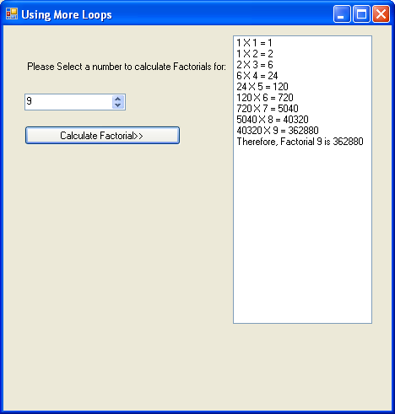

Task 3 – (Research Task) Debugging facilities in Visual Studio 2008

- Research the use of debugging facilities in Visual Studio .NET 2008 on MSDN.

- You should look into facilities such as:

  - Setting and using Breakpoints

  - Using Watches

  - Single Stepping (Step into, step over, run to cursor) through your code

  - Use of the Immediate Window to dry run fragments of code

  - Use of the Output Window to use in-code debugging techniques (i.e. to write program data to the system Console instead of forms and controls)

END OF WORKSHEET

