Analysing a Problem to Design your Solution

Introduction:

You will note that in the programming course so far, you have been dealing with writing short programs from (usually!) well specified instructions from your tutor.

Obviously, in ‘real life’, things are not so straightforward. Quite often, programmers are given a ‘problem to solve’. If you are lucky, this will be a clearly defined problem – nevertheless – it is a problem, not a solution. Your job is to get to the solution by understanding the problem and designing your program based on that.

Therefore, if you are to be a ‘more rounded’ software developer – you need to begin to understand the whole of this process – often referred to as the software / systems development lifecycle (SDLC). There are many approaches to achieve progression through this lifecycle. Given the nature of the programming that we are doing in VB.NET – Object Oriented programming (as you will see from later workshops) – a particular approach suits our purpose best – Object Oriented Analysis and Design (OOAD).

This worksheet will introduce the ideas behind a lifecycle approach to you, along with some of the tools and techniques at your disposal, so that you are able to start considering your own approach to how you will get from a problem to a solution when you are faced with this scenario in the future (such as in your assignment).

Note: that the subjects of OOAD and software development lifecycles warrant a module in themselves – so we can only treat these workshops as ‘awareness’ sessions – without expecting a full in-depth treatment of the tools and techniques mentioned.

What is a software development lifecycle, and OOAD?

Your customer / user will expect you to start by understanding their problem domain (i.e. how they work/ what their processes are, what the important concepts / things are in their work, and so on). For this purpose, you need to be able to fully understand, or analyse, the customer’s problem. The problem is generally specified as a set of customer requirements. These requirements are what form the basis of your analysis of the problem- and therefore need to be well captured and specified.

Only when you have a good understanding of the problem (i.e. have completed an analysis requirements that has been validated by your user / customer), can you hope to suggest a useful solution. This solution will need to be designed by you, but informed by your analysis of the customer’s / user’s requirements.

Finally, when you feel you have a good, workable, usable, robust and scalable design, will you attempt to implement the designed solution. This is normally the only area that you, as a programmer, have been concerned with in this module – the analysis and design has been ‘done’ for you already.

How do you know you have met the requirements in your solution / implementation? – you will need to finally test your program.
The above implies a process for designing software. There are many processes used for designing software, but they are all based around these core concepts of the SDLC lifecylcle.

Typically, a software development lifecycle can be expressed as:

ANALYSIS
DESIGN
IMPLEMETATION
TESTING

As you’re aware, the types of programs that we are writing are based on Classes and Objects – due to the object oriented nature of VB.NET. For this reason, the application of this process, along with the technique discussed below, to the development of these types of programs is often referred to as Object Oriented Analysis and Design. The main reason for this is that the approach to analysis and design is geared towards being able to identify programmable Classes and Objects from the concepts that are in the user’s world (domain) – such as Students and Courses.

As you progress through such a lifecycle, you will need to be able to explain and express your ideas to others – they’re not much good ‘if they are all in your head’. Therefore, to be able to express your understanding of the problem, or the structure of your design – it is useful to have some commonly understandable language or technique available.

The Unified Modelling Language (UML) is a useful (and very popular) technique for this purpose.

UML

The UML provides a (mainly) graphical language for expressing, discussing, validating and progressing your ideas when you are designing software solutions.

Although UML is quite a diverse language used for many purposes (see www.uml.org) – for our purposes we will focus on just two of its many diagrams.

The diagrams of interest to us are the Use Case Diagram (useful for the Analysis phase – to describe the problem to be solved) and the Class Diagram (useful for the Design phase – to describe your proposed solution).

UML: Use Case Diagram:

The Use Case diagram is very useful for understanding a problem during our analysis stage in order to capture, express and understand the user’s requirements.

There are three main parts to a Use Case Diagram:
- Use Cases – these are the expected interactions between the user of your program and the features that your program has. These are the most important element of this diagram as they inform the design stage as to what features are expected to be supported by your program. They are notated using an oval shape (see figure below). They should express the functional requirements of your program. As they are capturing ‘interactions’ they should normally have a verb based description - some examples are ‘Enrol on a Course’ or ‘Pay Fees’ and so on…
- Actors – these are normally the ‘roles’ that the users will play when interacting with your program (but can occasionally be other programs / systems as well). They are notated using a ‘stick person’ shape (see example below). Some examples are Lecturer, Student and so on…
- Associations – these are notated as lines to show the interaction between Actors and Use Cases (primarily) or occasionally to show a relationship between use cases themselves. They are not usually annotated with words (see example below).

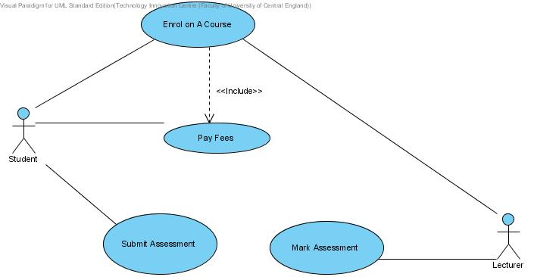

UML: Class Diagram:

The Class diagram is particularly useful when you are trying to propose a solution to a problem you have already analysed, to be able to capture, express and understand the planned program’s design.

A starting point for drawing a class diagram is to understand the user’s world (domain) and the important concepts within it. For example, in a library, a Book would be considered an important concept – and needs to be modelled as such. As another example, in a University, a Course would be considered an important concept – and so on…

Once captured, these concepts can then go on to become (re-usable) parts of the final program you develop through Classes and Objects in your VB.NET code.

The Class diagram has two main components:

- Class – this is obviously the most important aspect of a Class diagram (as the name would suggest!). Typically a class is a rectangular box (see figure below) which can have up to three sections, which are (in order):

  - Name – this is the identifier that is used to create objects from the class. It is normally named after the real life concept it is trying to capture in the design – e.g. ‘Book’, ‘Course’, etc.
  - Attributes – These are the things that can be used to describe objects of the class – e.g. a ‘Book’ would have an ‘Author’ and a ‘Title’ , or a ‘Course’ class would expect to have a ‘Duration’ or ‘Level’ etc. Note: remind yourself of ‘properties’ of form controls when you are designing a form – e.g. a TextBox has ‘Text’ or ‘BackgroundColour’ etc…
  - Operations – These are the behaviours you can expect from a Class object – for example, you may be able to ‘Borrow( )’ a ‘Book’ or ‘Join( )’ a ‘Course.
(the use of brackets after the operation name is a reference to it’s purpose in programming and helps to clearly distinguish operations from attributes). Note: remind yourself of ‘methods’ of form controls when you are programming in VB.NET – e.g. a WebBrowser control has a ‘Navigate( )’ or ‘GoHome( )’ method etc...

- Association – this basically expresses the way a particular class may be related (associated) with other classes in the same diagram. There are several types of association, that serve different purposes, in a class diagram:
  - Simple Association – this is a notated as a simple straight line (occasionally with an arrow to show direction) joining two classes together to show that objects of one class need to ‘be aware’ of the existence of another class’s objects so that they may ‘communicate’ (i.e. one class’s object can call the methods of another’s).
  - Inheritance – this is notated as a line between two classes with a small triangle at one end to express a more stronger relationship between two classes – that of inheritance. This is a very important concept in Object Oriented design and programming. The relationship expressed is that of a ‘parent to child’ or ‘superclass to subclass’. (The triangle should appear on the end of the parent class – pointing to it). For example, ‘Animal’ is the parent to which ‘Pet’ may be a child.
  - Aggregation – this is notated as a line between two classes with a small diamond shape at one end to express another stronger relationship between classes – that of aggregation. This is another relatively important concept in OO design – but does not always manifest as important in programming. The relationship expressed is that of a ‘whole to part-of’ or ‘containment’. (The diamond should appear on the side of the class that is the ‘whole’). For example ‘Book’ is the whole and ‘Page’ may the part.

The acceptance of UML as a standard language for expressing analysis effort and design artefacts is evidenced by the fact that Visual Studio 2008 – the IDE we have been using for programming – allows the class diagram to be drawn directly within the IDE from scratch to automatically generate VB.NET code templates.

The diagram below has been drawn using VS.NET:

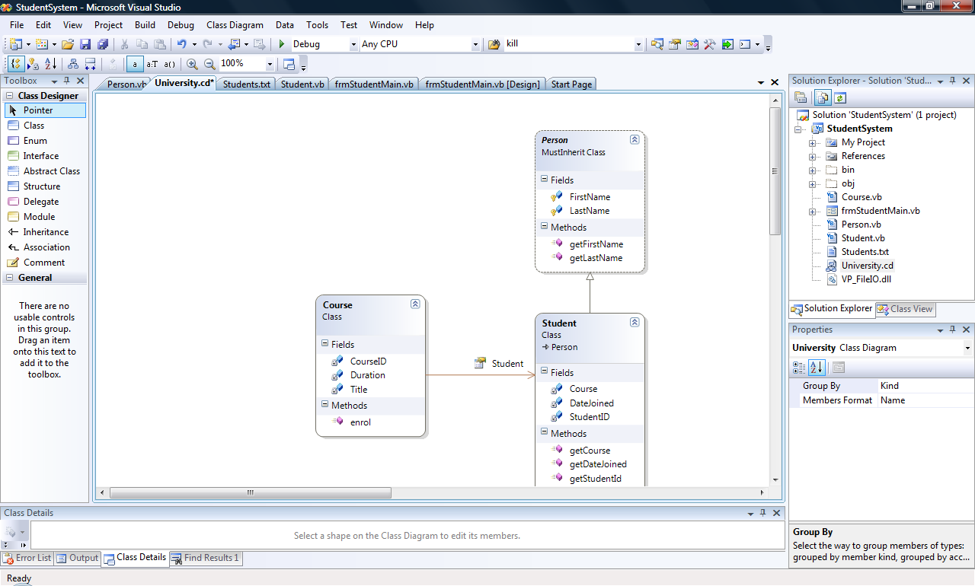

Task 1 – Setting up the CASE tool (‘Visual Paradigm’)

Once you are familiar with the UML technique for expressing your ideas, you will probably want a handy tool for expressing these ideas readily. In order to ‘draw’ the suggested UML diagrams you have many options for the tools available to you. They can range from:

- simple drawing tools (such as Microsoft’s Visio), that essentially understand the ‘syntax’ of drawing UML diagrams through designated templates and allow you to draw the diagrams using predefined components, but with little ‘understanding’ of the ‘rules’ UML (for example how diagrams may be related to each other, or how to auto-generate program code templates);
- …to the more ‘intelligent’ CASE (Computer aided software engineering) that do allow the ‘enforcement’ of UML’s ‘semantic’ rules (such as code generation and linking of diagrams).

The tasks in this worksheet expect you to work with the ‘Visual Paradigm’ case tool (which the University has a license for), but you may use the simpler drawing tools if needed.

  - Downloading and Installing the CASE tool

Task 1.1. is only necessary depending on which lab you are working in; you may find that the Visual Paradigm CASE tool is either installed in ‘Programs->Programming Tools->Visual Paradigm for UML’ folder, or not.
Even if the tool is already installed – the first part of this task (on downloading and installation) would be useful to you if you decide to use this CASE tool for the design part of your programming assignment later in the module. The CASE tool is licensed to the University for students to be able to install the ‘Standard’ version of the case tool off-site (i.e. on your own PC / Mac etc.)
Of course, you are not obliged to use just this tool, providing whichever CASE / drawing tool (e.g. Microsoft Visio) you select allows you to draw UML standard Use Case and Class diagrams.

- Download the currently licensed version of the UML Case tool – called Visual Paradigm – from the following link:
https://mytid.bcu.ac.uk/staff/singhh/IntroToUML/Resources/Case Tool/Visual Paradgm 4.0/VP_Suite_Windows_4_0_20090704.exe

- When prompted, Save the downloaded ‘.exe’ file to a suitable place on your student network drive (e.g. ‘H:\ICTProgrammingUG2\Visual Paradigm’ – you may need to clear some space!!) – Note: if you are low on space on your H: drive –you may wish to select ‘Run’ instead of ‘Save’ and go though the following steps appropriately) :

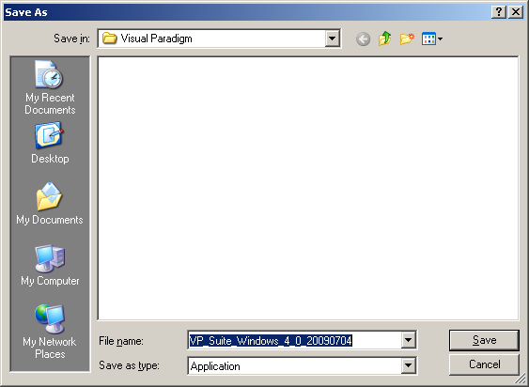
The program executable will begin the download for the file as shown below:

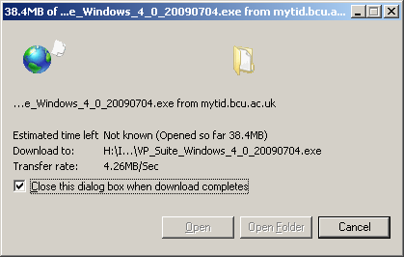

- Double-click on the downloaded executable file to run it, the following dialogue should appear:

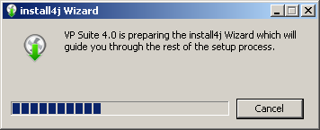

Followed by:

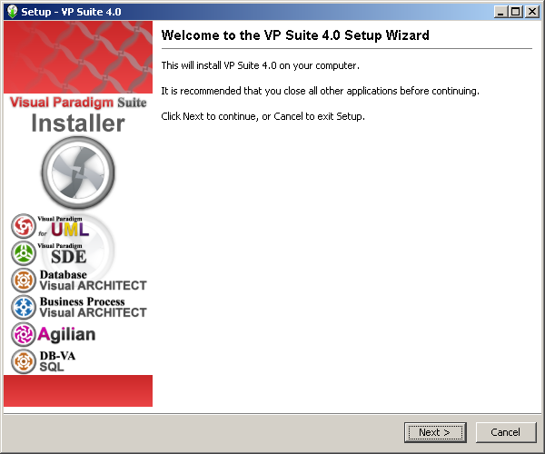

- Clicking ‘Next’ on the dialogue will prompt you to read and accept the license agreement – do so and click ‘Next’ again:

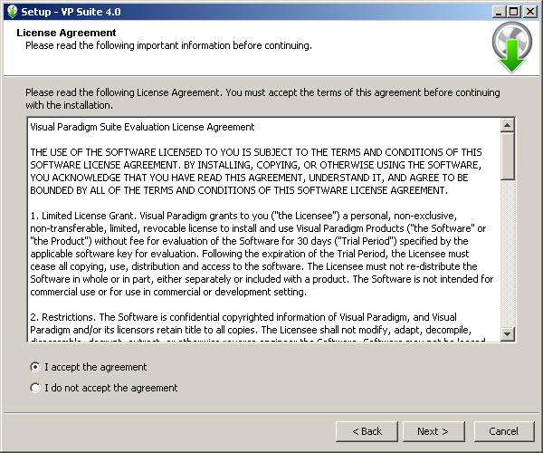

- You will next see the ‘Select Destination Directory’. Make sure you select your network drive directory on the ‘H:’ drive and not the ‘C:’ drive:

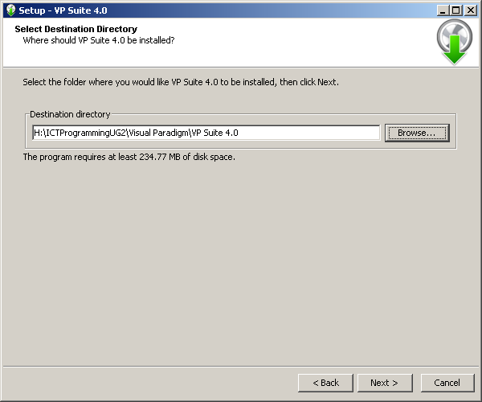
- Once you have set the install path for the software, simply select the defaults on the next part of the dialogue (“Select Start Menu Folder”) and click ‘Next’:

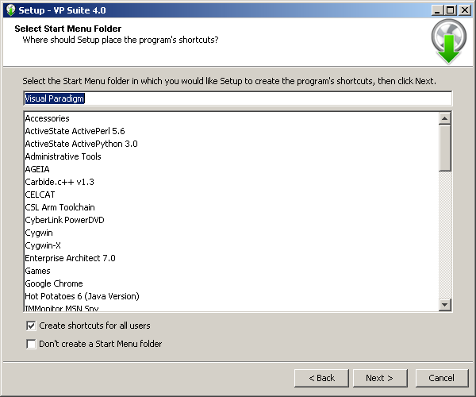

- Do the same for the ‘Select File Associations’ dialogue (keep the defaults)– and click ‘Next’

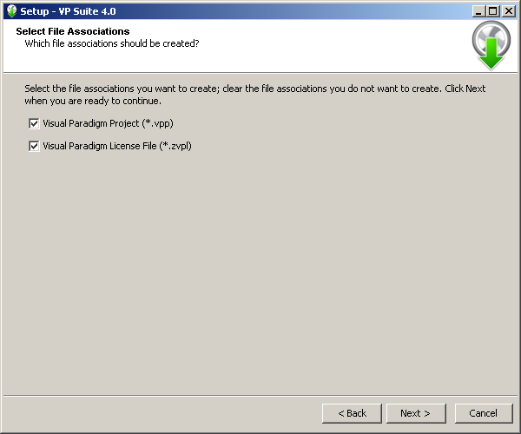
- On the ‘Select Products’ page – only select the first option ‘Visual Paradigm for UML (VP-UML)’ – and click ‘Next’:

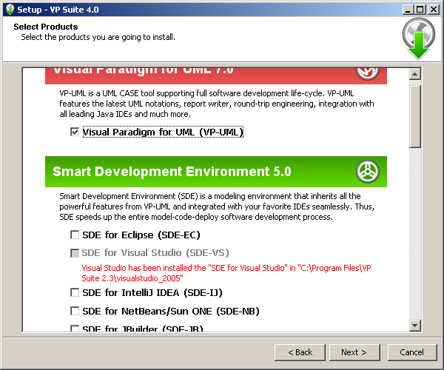

- Similarly, on the ‘Products Configuration’ page – set the edition to ‘Standard’ – and click ‘Next’ to continue:

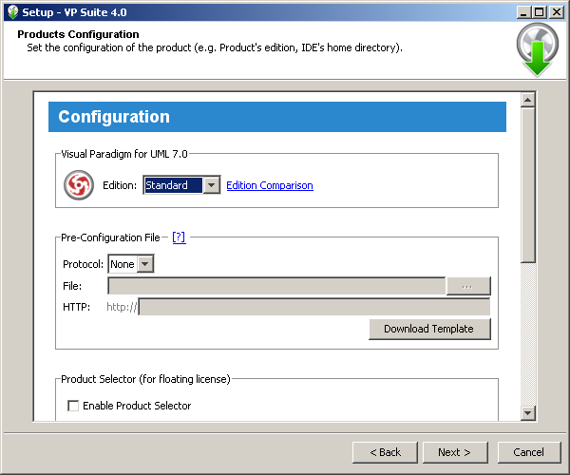
- As we will set up the license key in a later part of this task (when we run the CASE tool for the first time) – simply click ‘Next’ on the ‘Product License’ page as well:

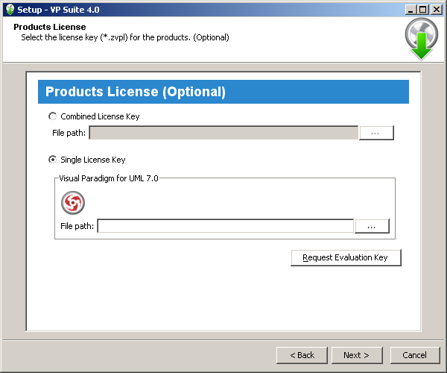

- The installation process should now start – wait while the software installs :

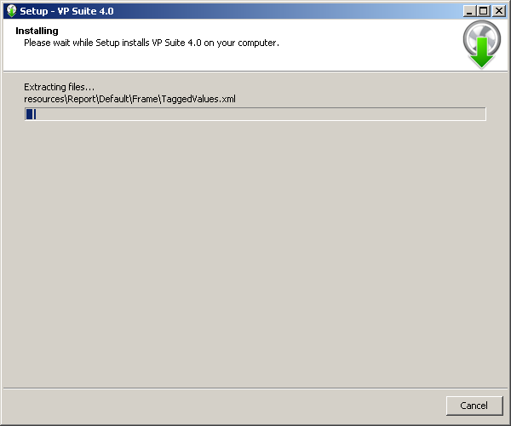

- When the installation process completes – the following page of the dialogue should show – simply click ‘Finish’ to complete the installation dialogue and run the program:

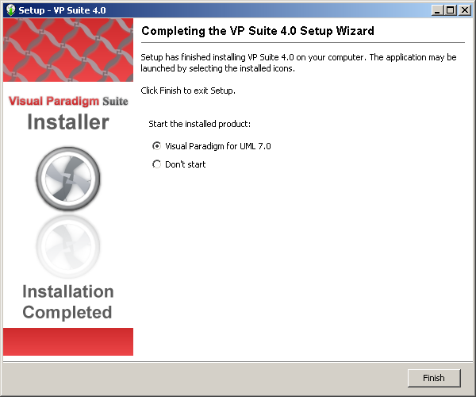

  - Running ‘Visual Paradigm’

- If the program does not automatically start at the end of the installation process (1.1) – or you are running a pre-installed version of the program for the first time, do the following:
Start VP-UML by executing the launcher labeled ‘Visual Paradigm for UML 7.0 Standard Edition’ (or similar) in the ‘Programming Tools’ submenu of the ‘Programs’ menu at the ‘Start’ button (in the labs where it is already installed). If you have installed the tool to your ‘H:’ as per step 1.1., then start it by double-clicking on its icon (labelled ‘Visual Paradigm for UML 7.0’) in the ‘/bin’ folder of the path where you installed it, e.g.:

“H:\Programming\Visual Paradigm\VP Suite 4.0\bin”

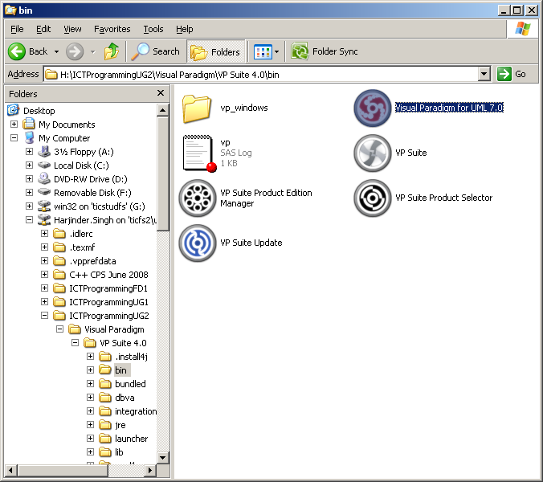

- When the ‘Workspace Launcher’ appears (as below). Specify the workspace folder as one where you will be storing your work for later retrieval – a good place is again your University Network drive space – the ‘H:’ drive (see next graphic – ‘Select Directory’).
Note: A workspace is a repository of the UML projects. Besides storing projects, it stores also the settings, user interface perspectives and other preferences defined for the working environment.
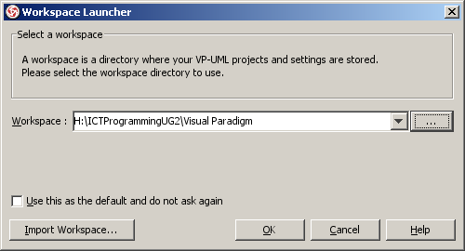
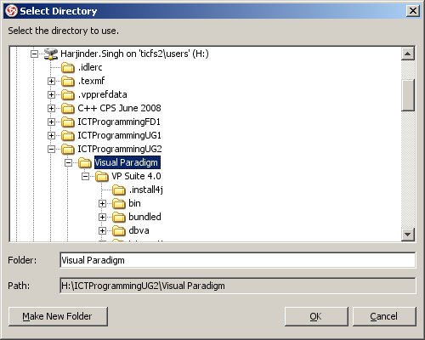

- If you do not want the ‘Workspace Launcher ‘ dialog box to appear again, check the ‘Use this as the default and do not ask again’ box. This will cause VP-UML to open the specified workspace folder automatically the next time.

- If you already have an existing workspace, you can import the settings from there by clicking Import Workspace...

- Click OK to continue.

- Next we will set up the license for the software.

Very Important!: For the first time you do this step you will need a valid license key for this version of ‘Visual Paradigm’ it can be downloaded and saved (to your ‘H:’ drive!) from:
https://mytid.bcu.ac.uk/staff/singhh/IntroToUML/Resources/Case%20Tool/Visual%20Paradgm%204.0/Technology_Innovation_Centre_(Faculty_of_University_of_Central_England)_5781271397790995_vp-uml_7-0_se.zvpl

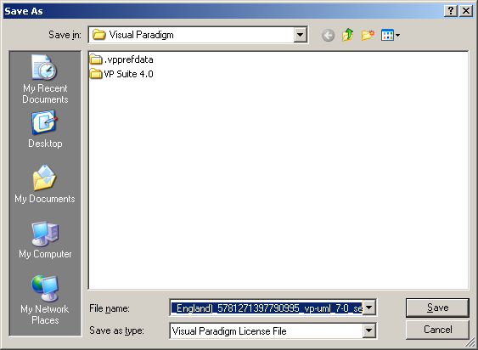
- If you have imported a valid license key before, VP-UML should be started now. If not, the License Key Manager appears as soon as Visual Paradigm starts up.
Note: The License Key manager is a utility for importing a license key.

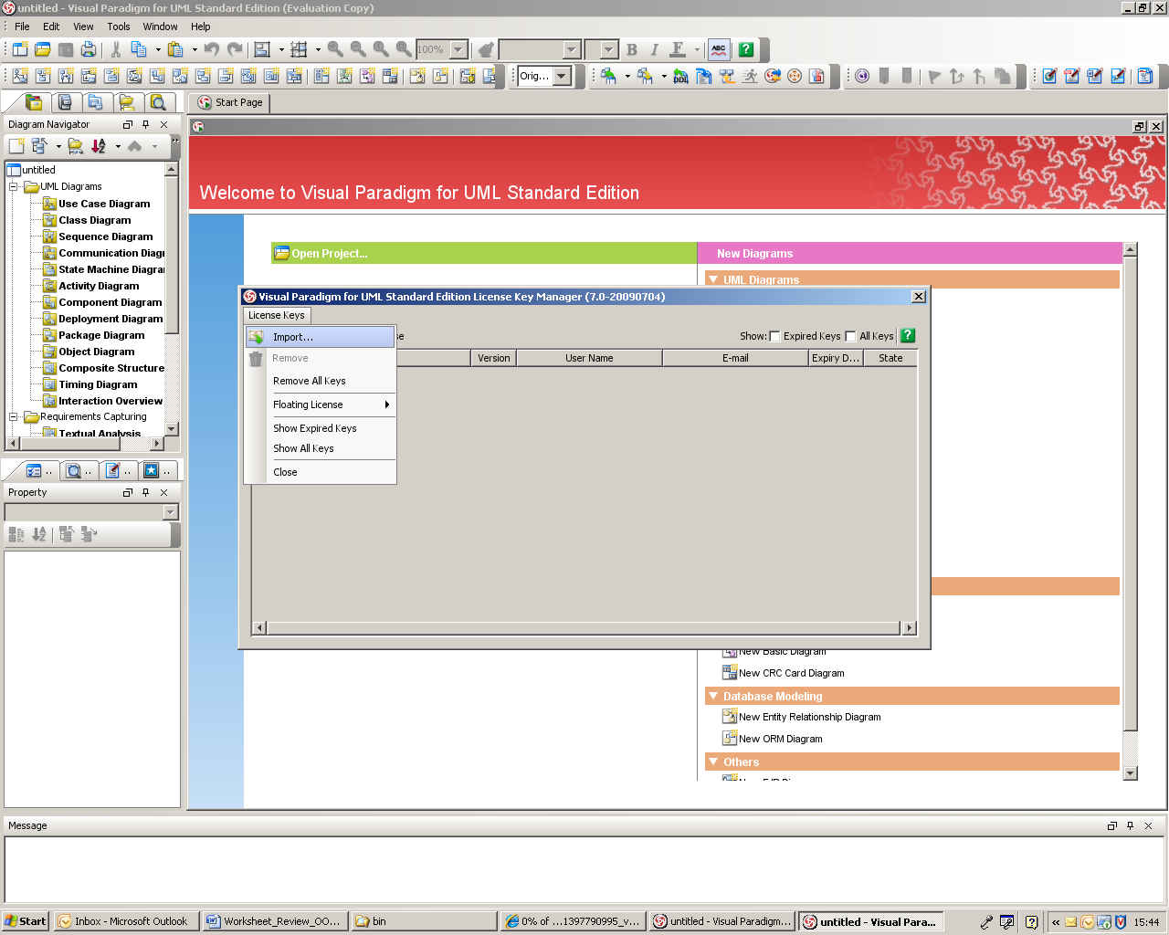

- Select License Keys > Import... from the ‘License Key Manager’ menu. The ‘Import License Key’ dialogue should appear – you should browse to where you saved your license key (in step 6) and select the ‘.zvpl’ file there:

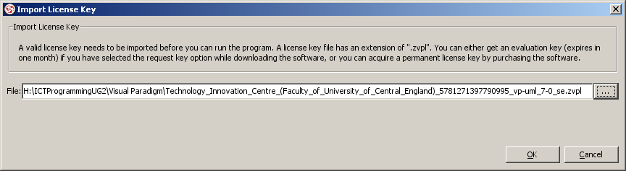

- Click the ‘OK’ button to import the key file into Visual Paradigm. If successful – the ‘License Key Manager’ should now look something like this (if not, try checking the ‘All Keys’ box at the top right hand corner of the dialogue):
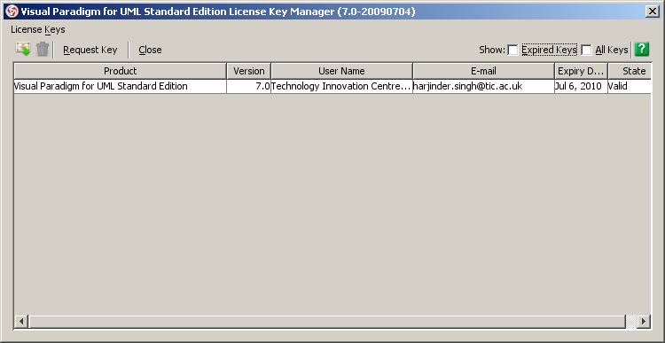

- Select the ‘Close’ option to save and close the License Key Manager and start VP-UML.
If it prompts you with an ‘invalid license key’ message, make sure the key you imported does match with the tool that you are running in terms of the following aspects:
- Product (i.e. Visual Paradigm for UML)
- Version (i.e. Version 7.0)
- Edition (i.e. Standard Edition)
If successful, the following message should appear.
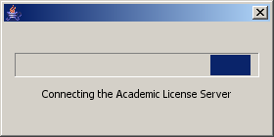
Important Note: if you are trying to do this at home – you may not automatically be on the internet – you need to connect to to the internet when you start up this CASE tool as it needs to validate your license key against an ‘Academic License Server’ hosted on the Web.

- Finally, the following dialogue temporarily appears before the case tool starts up as below:
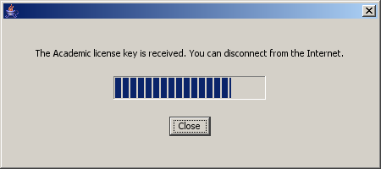

- The Visual Paradigm application should now start up and look something like the following screenshot – you can now go ahead and design your program! :

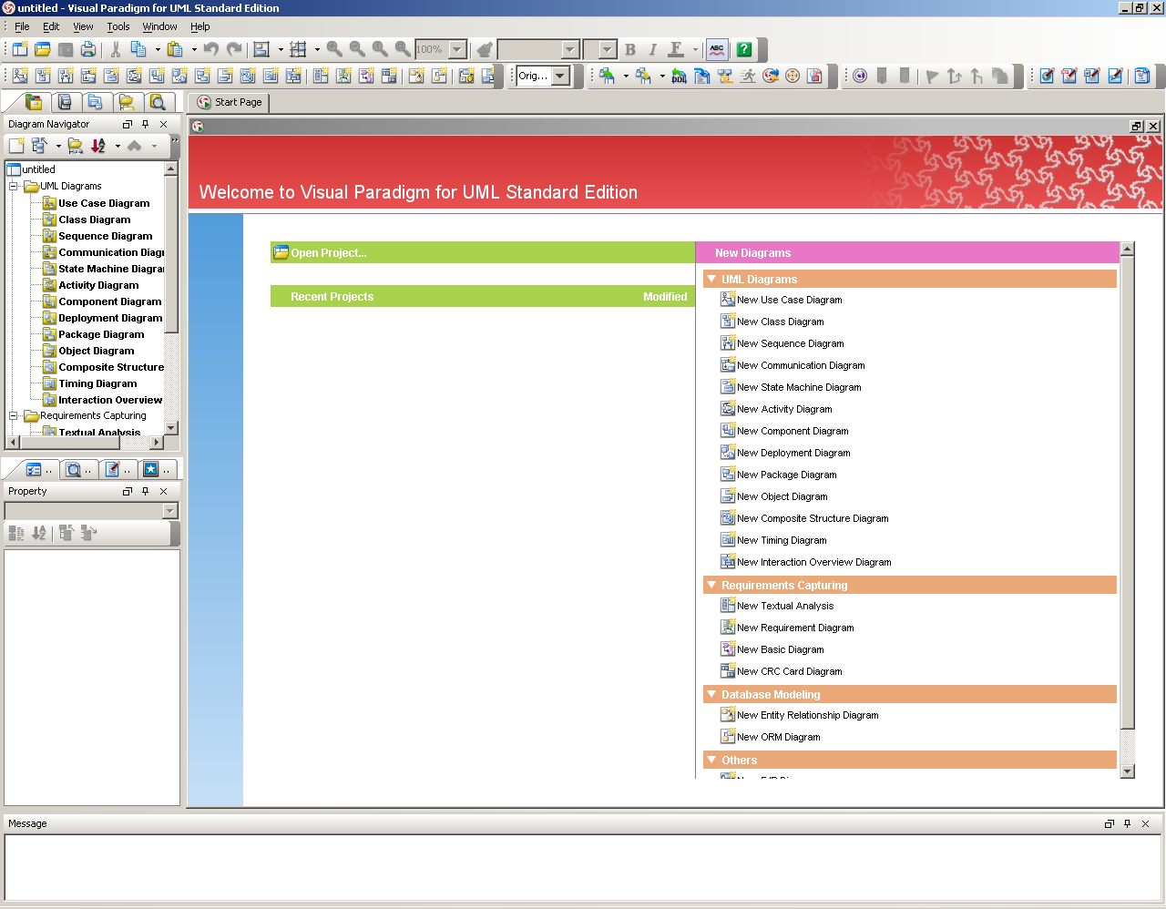

Task2: Learning about UML Use Case diagrams

Your tutor will demonstrate the basic concepts of drawing use case diagrams (using a selected CASE tool), but you will need to investigate the technique in further detail to appreciate fully the technique’s use and purpose.

Investigate and find, using any combination of resources available to you – as suggested by your tutor – an example of a use case diagram that you feel able to explain in detail.

Make notes on the diagram and use them to re-enforce your understanding of this diagram.

Task3: Learning about UML Class Diagrams

Your tutor will demonstrate the basic concepts of drawing class diagrams (using a selected CASE tool), but you will need to investigate the technique in further detail to appreciate fully it’s use and purpose.

Investigate and find, using any combination of resources available to you – as suggested by your tutor – an example of a class diagram that you feel able to explain in detail.

Make notes on the diagram and use them to re-enforce your understanding of the class diagram.

Note: you will need to aim to have a good visual understanding of these diagrams for the next worksheets on this topic – that will require you to apply these techniques to a given problem scenario.

END OF WORKSHEET

