Introduction to Visual Studio.NET (Part 2)

Introduction:

This worksheet is the second of two that will introduce you to the Programming Environment (IDE) we will be using throughout this course, Visual Studio.NET 2008.

Basic Concepts – Running you program, and adding code to it

- Once you have designed your user interface (Forms(s)), and wish to test it, you simply press the ‘play’ 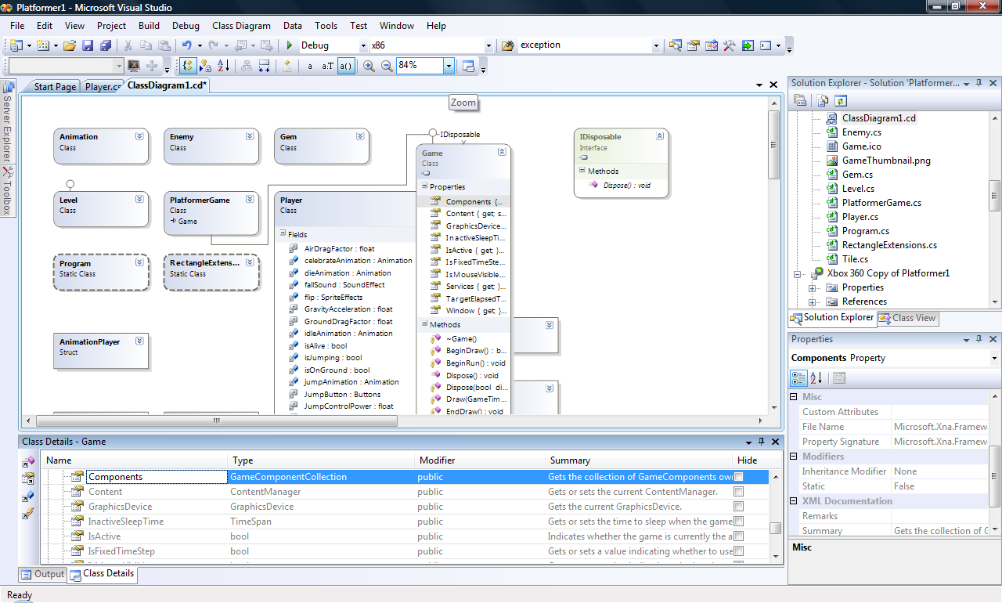 button, or select the appropriate option to run the program from the Visual Studio ‘Debug’ menu.

- This will ‘Compile’ your program as part of a ‘Build’ process for your project. What this means is that it will effectively ‘translate’ your code (yes, there is code in your program – even though you were not aware of writing it yourself’ – ask you tutor to show you!)

- Once this has been done, the IDE will automatically ‘run’ your program (in this case in ‘debug’ mode – more on this later). You will note that, along with any other currently executing program (such as Visual Studio itself, or internet explorer etc) your program will also appear as a running program at the bottom of your screen, and your program’s main form will display outside of Visual Studio – e.g:
(What does this tell you about your program?... Yes, it seems to running as an ‘.exe’ type of program – just like word, or excel, or internet explorer! Ask your tutor to show you where this ‘.exe’ file is so you can later give it out to your mates as a polished product!!)

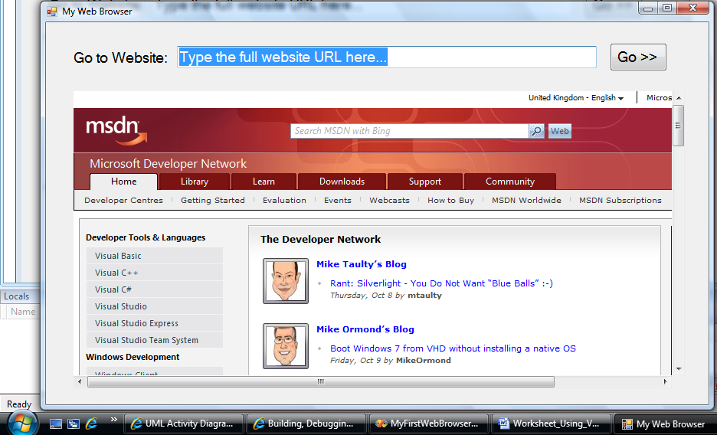

- You could now ‘try out’ your program, like any other one that is running (e.g. test out the functionality automatically provided by the browser).

You may find that although your program is running – you have very little control over what it does (if you have used some ‘high powered’ controls on your program – like a web-browser – it may seem like it does a lot, but remember that functionality is already built into this very complex control!).

So the next stage is to take control of your program and make it do something interesting. This means adding some code to your application yourself (rather than Visual Studio doing it for you). This is what programming is all about – and what this course is all about!!

Typical steps to achieve this would be:

- Stop the program from ‘running’ by clicking on the ‘Stop debugging’ button that is now enabled:
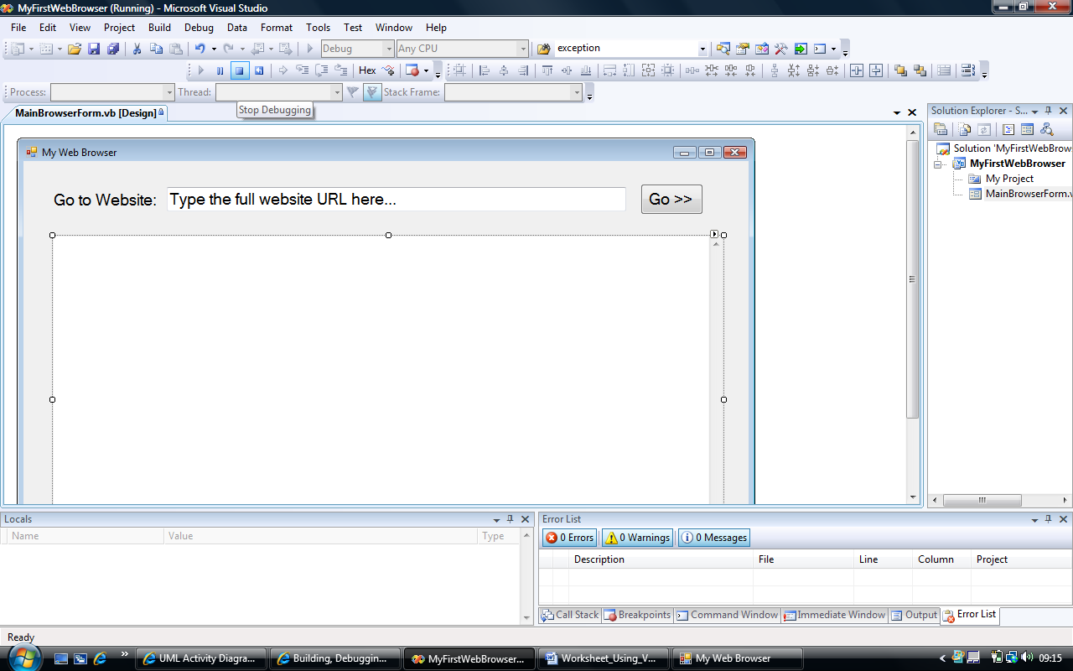

- Once the environment is returned to a ‘non-executing’ state, the original design version of the form is the only one displayed. (Important note: you need to be very conscious of which version of the form you are looking at – the running version or the design version. Why?)

- The next step in your program construction would be to provide your own functionality to your program – to be able to control what it does according to what you need. This can be done to some extent by changing properties of the controls added to your forms – but real control inevitably requires you to write some code…

- The way you normally add code in Windows Forms application is as ‘code behind forms’ – i.e. you add event handlers to controls (This is a very important aspect of this type of programming – and will be explained in some detail by your tutor).

- Most of the controls (components) you add to your form from the toolbox have 3 important aspects to them - understanding about these holds the key to Forms based VB.NET programming (and Windows Forms programming in general):

  - Properties: These are the things that describe the control in question. I.e. what the control knows about itself - you may have already discovered a few of these, such as Name, Text, Background Colour, Font, URL etc. etc
  - Events: In the type of programming that we are doing – ‘Windows Forms’ – events are a very important concept. Every control that you use will be able to respond to events in it’s environment – that it basically ‘sits and waits’ for to happen. For example, a Button control, expects someone to click on it, a form might be waiting for someone to close it down, or a textbox might wait for someone to change it’s text. The way you normally program for VB.NET is by writing your own event-handlers to respond to these events if and when they occur.
  - Methods: These are the behaviours that a control can have and use when it is asked to respond to an event. For example, you could ask a WebBrowser to Navigate( ) to a particular website or URL, or you could ask a Button to Hide( ) itself when it’s clicked…
(Note: the use of brackets after method names is intentional and will become clear to you when you learn more about modular programming and methods in VB.NET)

- If you select a control that you have added to the form and ‘double-click’ on it, the environment will automatically add a default event-handler to the code behind your form – and take you straight into the code-editor view (see below). The default event-handler that is selected and added depends on the control. For example, for a Button the default event would be to ‘click’ on it (i.e. that’s the most likely event on a button that you would expect to write code to respond to).
( Note: that does not mean that a ‘click’ is the only event that a button can respond to – e.g. you may wish to respond to the mouse simply moving over the Button. Later, your tutor will demonstrate how to write code to respond to this and other events – for the moment we will stick to default events...)

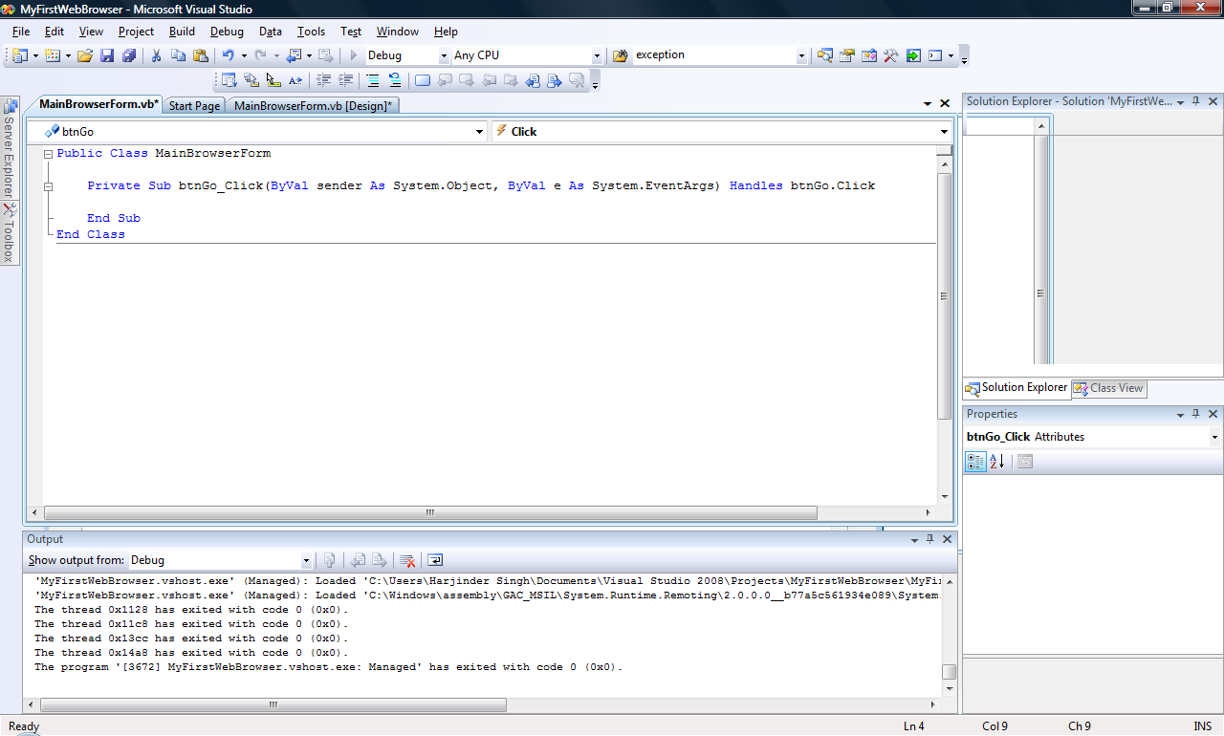

- Seeing this view for the first time may be slightly unnerving to you if you have not done any ‘programming’ before. Do not worry, take a logical approach to understanding what you see in front of you (before you ‘dive-in’ and start writing your own code) – and, with the help of your tutor you will see the ‘sense’ of it! Lets break down what we see before us:
  - What has happened is that a new window (in our example it’s named ‘MainBrowserForm.vb’) has opened up as a result of you double clicking on the Button. Your familiar ‘design view’ of the form is still there – where do you think it is?
  - The first and last lines of VB.NET programming code that you see here represent the ‘bounds’ of the whole of your form (MainBrowserForm) – i.e:

Public Class MainBrowserForm
…
End Class

  - Any code you add to this form must appear between these lines. (Note: think of them as ‘brackets’ if it helps).

  - Similarly to the concept of a form’s code, is the concept of the event-handler’s code. Again, these are contained within the ‘brackets’ of the ‘Private Sub…’ and ‘End Sub’ statements. i.e:

Private Sub btnGo_Click(ByVal …) Handles btnGo.Click

End Sub

  - The useful thing that the IDE has done for you is to indent this section of code inside the code of the form. Pay particular attention to this, as it clarifies that the code for the event-handler belongs within the form for the code.
Important note: You will mostly write your code between these 2 lines – i.e. within the event-handler, unless you wish some information to be shared by all parts of a form.

- To finally add your own code to make this program do something useful, type in the following line of VB.NET into the click event-handler for the go button:

wbBrowser.Navigate(tbWebsite.Text)

- Your code editor screen should now look something like this:
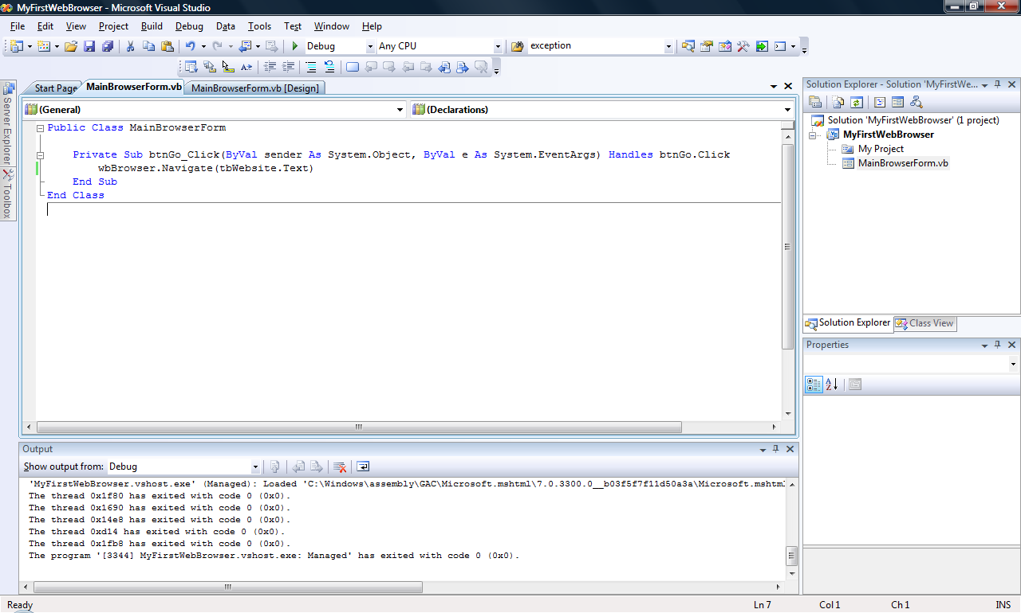

- Again, do not worry if you did not fully understand what we just did there, the rest of this course is all about understanding just that. But a brief analysis of the code may help you start you on a ‘thought process’ for when you write code:
  - What we have done is to write a single line of VB.NET instruction, that will be invoked when someone ‘clicks’ on the ‘btnGo’ button (Handles btnGo.Click), that tells the browser control named ‘wbBrowser’ to Navigate or Browse (wbBrowser.Navigate) to whichever website is currently typed (by your user) into the text of the Textbox named ‘tbWebsite’ ((tbWebsite.Text)).

- The effect of this statement can be seen when running the program (use your ‘play’ button) as below:
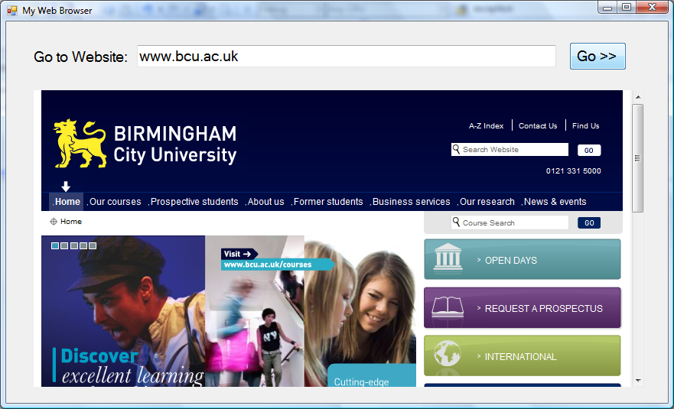

Demonstration – Adding code to an application and testing it

Your tutor will demonstrate the steps to adding basic code to your program – following steps as per the basic concepts section above:
- Create a ‘Click’ event handler for the ‘Go’ button on the Web Browser main form.
- Add a single line of code that allows the browser to Navigate to the website typed into the Textbox on the screen.
- Save your work
- Test this change

Task 1 – Making our first application do some useful work

The aim of this exercise is to continue with the ‘Web Browser’ application you would have started previously. In this first task we will add very basic functionality to our browser, by adding a single line of code to allow you to browse to a different website every time you click on the button provided.

- First off, we need to start up the Visual Studio.NET environment again, the steps are the same as the last session. Click on the following in the given order:
    - Start (button) on the desktop
    - Programs (folder)
    - Programming tools (folder)
    - Visual Studio 2008 (folder)
    - Visual Studio 2008 (shortcut)

- The Visual Studio .NET 2008 application will start displaying the following screen, but in this session we will not be creating a new application, instead we will re-open our application from the last session. So make sure that the link named ‘MyWebBrowser’ (or whatever you called your application when you created it last session) and then select the ‘Open: Project…” link as indicated below:

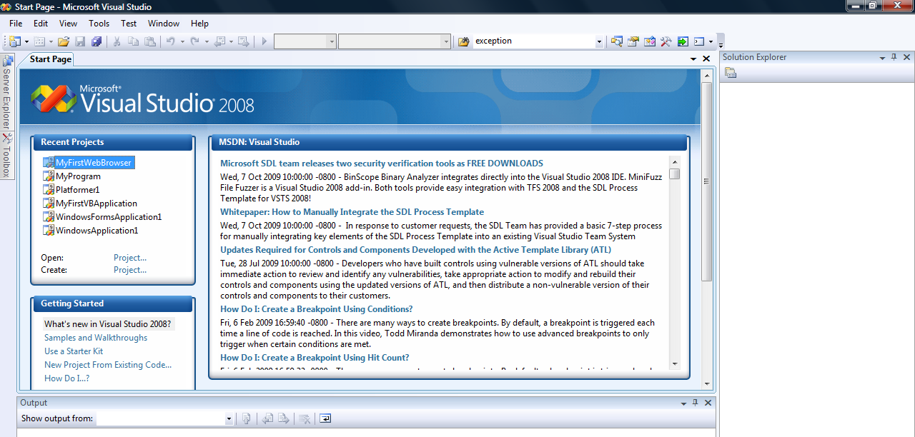

The application you started during the last session should be re-opened and its main form displayed as follows:
(Note: there are lots of ways to re-open a project, for example, if you do not see the link mentioned in the previous step – you can locate and open your project solution file (.sln) using ‘File -> Open Project’ menu options on the main menubar)

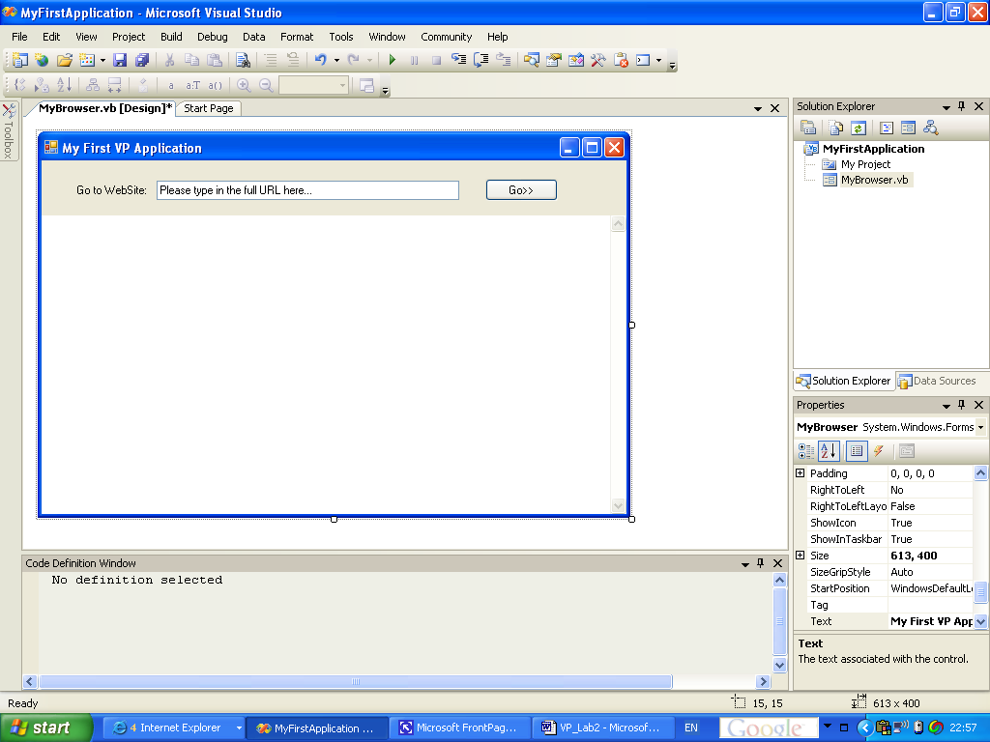

- Once your program re-opens – you may need to ‘double-click’ on the name of your form in ‘Solution Explorer’ to start with a view of it (as above). We will now add some VB.NET code behind this form to make it do something useful – i.e. allow us to type in the URL of the website we wish to view, and then browse to it.

- Double click on the button labelled ‘Go>>’ on your form to open the ‘Code Window’ entitled ‘MyBrowser.vb’ (without the suffix ‘[Design]’ after it). The code window should be opened displaying some of the underlying application code as follows:
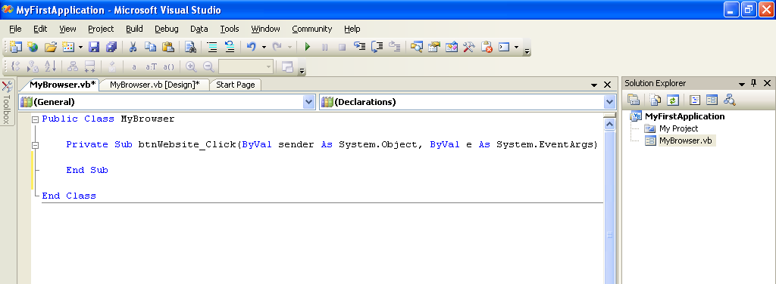

- In the opened code window, type in the following code between the ‘Private Sub…’ line and the ‘End Sub’ line:

wbBrowser.Navigate(tbWebsite.Text)

- The code you have entered simply reads the text the user enters into the Textbox control, and causes the WebBrowser control to navigate to it – every time the Button control (‘btnWebsite’) is clicked. The behaviour is illustrated below, you can view this behaviour by selecting ‘Run’ (‘play button’) from the toolbar at the top of the IDE:

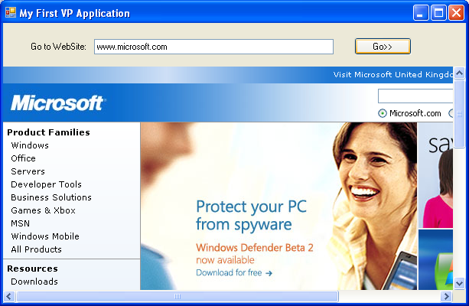

Task 2 – Expanding your first VB.NET Application

For this task, we will improve the behaviour of the simple ‘Web Browser’ that we have been building so far.

As you will note the basic web browser we have created so far is quite limited in it’s functionality, it simply navigates to and displays the URL you type. In this task we will add some extra controls to make the functionality to improve the functionality of the browser to be more robust and usable.

- You may have noted that when resizing the application’s main window (the form), the browser control does not adjust appropriately. You will need to change the Anchor property of the WebBrowser control to ‘Top,Left,Bottom,Right’, this will cause the browser control to maintain it’s position and proportion when the form is resized.

- Replace the TextBox control used in task 1 with a Combobox control, to allow a ‘history’ of visited sites to be maintained.

  - Remove (delete) the existing textbox – ‘tbWebsite’ from the previous task.

  - Go to the code window (see tabs at top of designer window) and remove the button-handler code you added in task 1 – step 6 of this lab.

  - Change the Name of the existing Button, from ‘btnWebsite’ to ‘btnGo’.

  - Change the Name property of the ComboBox to ‘cbWebsite’,

- Now you will add new controls to the Form to add new functionality, and enhance existing functionality.

  - Add a new Button control adjacent to the existing ‘Go>’ button. Change its Name property to ‘btnBack’. Change its Text property to ‘<<Back’.

  - Add a new Button control adjacent to the existing ‘<<Back’ button. Change its Name property to ‘btnForward’. Change its Text property to ‘Forward>>’.

  - Add a new Button control adjacent to the existing ‘<<Back’ button. Change its Name property to ‘btnHome’. Change its Text property to ‘Home’.

  - Add a new Panel control to occupy the right hand side of the form. Change its Name property to ‘pnlSearch’. Change its BackColor property to white (or something similar).

  - Add a new TextBox control to the ‘pnlSearch’ control added in the last step. Change its Name property to ‘tbSearch’.

  - Add a new Label control to the ‘pnlSearch’ control just above the ‘tbSearch’ control in the last step. Change its Name property to ‘lblSearch’. Change its Text property to ‘Please type in Search Text’. You may also wish to change its BackColor property to a different color.

  - Add a new Button to the panel. Change its Name property to ‘btnGoogle’. Change its Text property to ‘Google’.

  - Add a new Button to the panel. Change its Name property to ‘btnMSN’. Change its Text property to ‘MSN’.

  - Add a new Button to the panel. Change its Name property to ‘btnAskJeeves’. Change its Text property to ‘AskJeeves’.

Note: the form should look as it does in the figure below after you have done the changes in the previous steps.

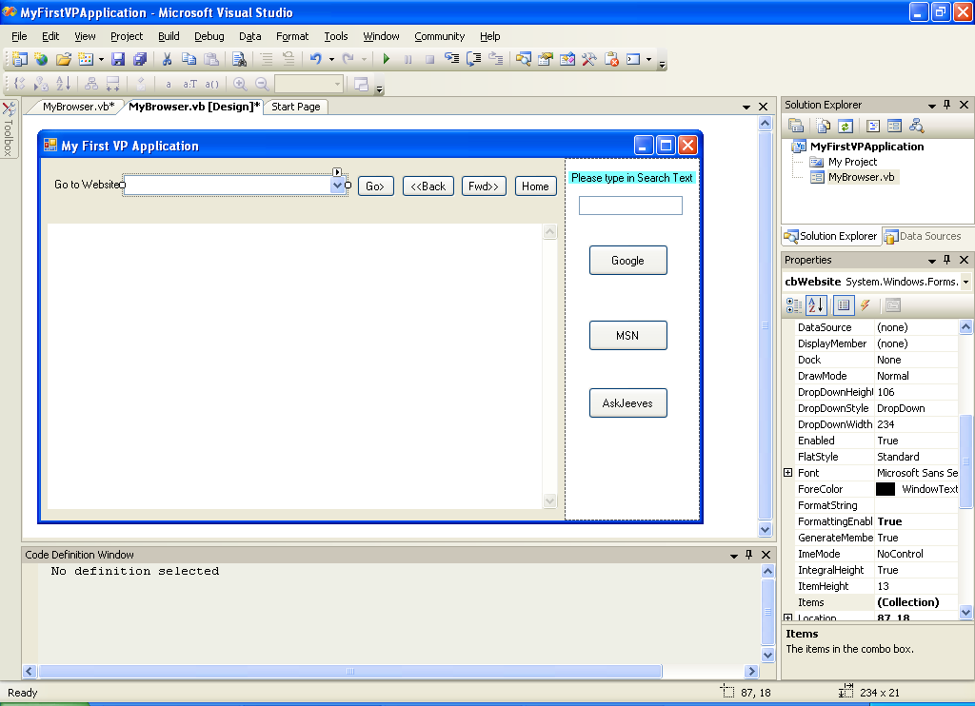

- Now we will add the Code behind the controls to give the desired behaviour to the application.

  - Double click on the btnGo button, and add the following code into the event handler stub that is displayed in the code window:

If cbWebsite.SelectedItem = "" Then
URLString = cbWebsite.Text
Else
URLString = cbWebsite.SelectedItem
End If
GoToURL(URLString)

(You will note that some of the text in the code you typed is underlined (in error) – this is because the underlined items have not been declared by us yet – this problem will be sorted out as you go through the next few steps)

  - While you are in the code window, add the following code just below the first line of code at the top (the one that declares your Class):

Dim URLString As String
Dim HomeURL As String = "http://www.tic.ac.uk"

  - Remaining in the code window, now add the code (below the previous code in (b) or anywhere outside of a ‘Private Sub…End Sub’ set of statements) to navigate to the selected webpage, and maintain the list of visited sites in the combobox control:

'This is our own module that causes the browser to naviagate to the link selected elsewhere
Private Sub GoToURL(ByVal SelectedURL As String)
wbBrowser.Navigate(SelectedURL)
If (cbWebsite.FindStringExact(URLString) < 0) And (URLString <> Nothing) Then
'if not already in list - add this url to the combobox
cbWebsite.Items.Add(URLString)
End If
End Sub

  - Return to the form designer window (by clicking on the tab labelled ‘MyBrowser.vb[Design]’. Double click on the btnBack button, and add the following code into the event handler stub that is displayed in the code window:

wbBrowser.GoBack()

  - Return to the form designer window (by clicking on the tab labelled ‘MyBrowser.vb[Design]’. Double click on the btnForward button, and add the following code into the event handler stub that is displayed in the code window:

wbBrowser.GoForward()

  - Return to the form designer window (by clicking on the tab labelled ‘MyBrowser.vb[Design]’. Double click on the btnHome button, and add the following code into the event handler stub that is displayed in the code window:

GoToURL(HomeURL)

  - Return to the form designer window (by clicking on the tab labelled ‘MyBrowser.vb[Design]’. Double click on the btnGoogle button, and add the following code into the event handler stub that is displayed in the code window:

URLString = "http://www.google.co.uk/search?hl=en&q=" & tbSearch.Text

GoToURL(URLString)

  - Return to the form designer window (by clicking on the tab labelled ‘MyBrowser.vb[Design]’. Double click on the btnMSN button, and add the following code into the event handler stub that is displayed in the code window:

URLString = "http://search.msn.co.uk/results.aspx?q=" & tbSearch.Text

GoToURL(URLString)

  - Return to the form designer window (by clicking on the tab labelled ‘MyBrowser.vb[Design]’. Double click on the btnAskJeeves button, and add the following code into the event handler stub that is displayed in the code window:

URLString = "http://uk.ask.com/web?q=" & tbSearch.Text

GoToURL(URLString)

Note: the final code should look similar to that displayed below:

Public Class MyBrowser

Dim URLString As String
Dim HomeURL As String = "http://www.tic.ac.uk"

'This is our own module that causes the browser to naviagate to the link selected elsewhere
Private Sub GoToURL(ByVal SelectedURL As String)
wbBrowser.Navigate(SelectedURL)
If (cbWebsite.FindStringExact(URLString) < 0) And (URLString <> Nothing) Then
'if not already in list - add this url to the combobox
cbWebsite.Items.Add(URLString)
End If
End Sub

Private Sub btnGoogle_Click(ByVal sender As System.Object, ByVal e As System.EventArgs) Handles btnGoogle.Click
URLString = "http://www.google.co.uk/search?hl=en&q=" & tbSearch.Text
GoToURL(URLString)
End Sub

Private Sub btnMSN_Click(ByVal sender As System.Object, ByVal e As System.EventArgs) Handles btnMSN.Click
URLString = "http://search.msn.co.uk/results.aspx?q=" & tbSearch.Text
GoToURL(URLString)
End Sub

Private Sub btnAskJeeves_Click(ByVal sender As System.Object, ByVal e As System.EventArgs) Handles btnAskJeeves.Click
URLString = "http://uk.ask.com/web?q=" & tbSearch.Text
GoToURL(URLString)
End Sub

Private Sub btnGo_Click(ByVal sender As System.Object, ByVal e As System.EventArgs) Handles btnGo.Click
If cbWebsite.SelectedItem = "" Then
URLString = cbWebsite.Text
Else
URLString = cbWebsite.SelectedItem
End If
GoToURL(URLString)
End Sub

Private Sub btnBack_Click(ByVal sender As System.Object, ByVal e As System.EventArgs) Handles btnBack.Click
wbBrowser.GoBack()
End Sub

Private Sub btnForward_Click(ByVal sender As System.Object, ByVal e As System.EventArgs) Handles btnForward.Click
wbBrowser.GoForward()
End Sub

Private Sub btnHome_Click(ByVal sender As System.Object, ByVal e As System.EventArgs) Handles btnHome.Click
GoToURL(HomeURL)
End Sub

End Class

- Save and Run the completed application. Test the behaviour of all the buttons and controls, and make notes as you do this.

Note: the application should look something like the screenshot below when it runs. Note also the functionality of the features such as searching and history as illustrated.

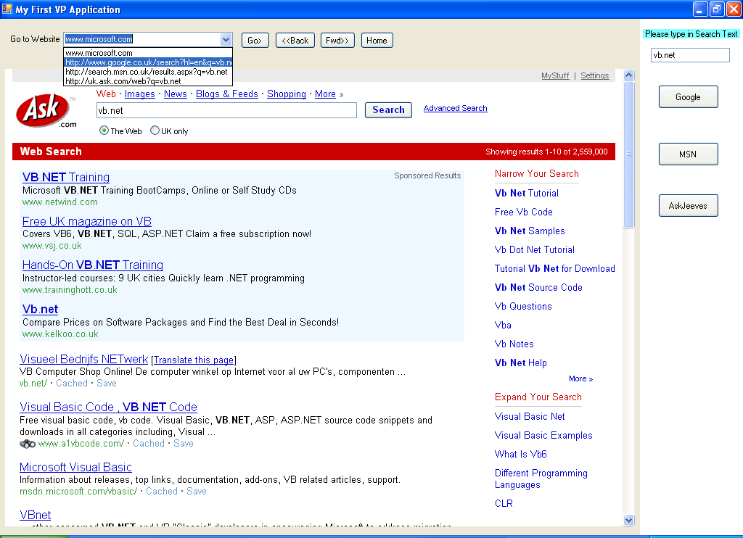

- Review the behaviour of all the application features against your expectations of this as a Web Browser application, and attempt to answer some of these questions:

  - Is the application behaving as you expected it to, i.e. is it intuitive?

  - Is the application resilient to user errors (e.g. no website selected), i.e. is it robust?

  - Are the features provided sufficient for a basic web browser, i.e. is it functional?

- Stop running the application, go back to the code page, and add comments to the code to explain what is happening.

Note: a comment is free form text to explain what the program is doing, and can be added anywhere in the code by starting a line with a single apostrophe – (‘)

- Finally, consider how would you improve this application’s intuitiveness, robustness and functionality? (For example, what about the intuitive behaviour for when a user enters a website URL and presses ‘enter’ on the keyboard – rather than having to click your ‘Go’ button every time? – you will need the help of MSDN and perhaps your tutor to find out how to do this)

END OF LABORATORY

