Introduction to Visual Studio.NET (Part 3)

Introduction:

This worksheet is for a supplementary session that will give you practice in developing a fully ‘adorned’ application based on the Browser application you completed in the previous 2 sessions. To this end, this is a slightly more open ended session that will expect you to use more of your initiative during some of the tasks - in designing a functional, robust and intuitive application.

Please note: for the programming tasks in this lab, you should continue to build on the ‘Web Browser’ application we started in the last couple of sessions. You will not be given specific instructions on how to create and open projects in Visual Studio anymore, you will need to refer back to the first two worksheets if you can’t remember how to do that.

Also, the tasks in this lab are for you to research and find out how to do, based on your references to the MSDN resource at http://msdn.microsoft.com . So, specific instructions may not always be given on how to achieve the task – just what is required to be done.

Some Basic Concepts – Improving the user interface – menus and toolbars

As you are becoming aware, one of the core aspects of ‘Visual Programming’ that you have been using so far is the setting of properties, handling of events and even calling of the methods provided by some of the controls you have added to your application. Examples are: setting the ‘URL’ property of the web-browser control, handling the ‘Click’ event for the ‘Go’ button you have added to provide some program code that allows you to call the ‘Navigate’ method of the web-browser, and so on. These are the aspects of programming that you need to understand to start to make your program functional.

However, as well as making your program functional, you should also aim to make it more ‘usable’ and intuitive.

To this end, Visual Studio provides lots of ready made components / controls that allow you to build a ‘professional’ looking and user friendly Graphical User Interface (GUI).

Some of the components available to do this are:
- MenuStrip – a control that provides the full functionality of a menu bar to your application, to allow the features of the program to be offered more ‘elegantly’.
- ToolStrip – a control that provides the full functionality of a menu bar to your application – like a menu bar, but with buttons.
- StatusStrip – a control that provides a status bar (that normally appears at the bottom of your application screen), to allow monitoring information to be provided.
- ToolTips – this component allows you to add ‘incidental’ information to any other control on the form, which gives the user more information about it when the mouse is passed over the control.
- ProgressBar – this control can appear as part of the status bar, or independently, and can be used to provide feedback to your user on long tasks (e.g. loading a large page when browsing).

There are many more such controls, waiting to be discovered by you in Visual Studio’s toolbox, at http://msdn.microsoft.com, or at your favourite programming learning resource!

These controls are reasonably easy to configure and use. Here are some examples, your tutor will demonstrate others:

To add and configure a MenuStrip control to your browser:
- Select the Menustrip control from the ‘Menus and Toolbars’ category of the toolbox

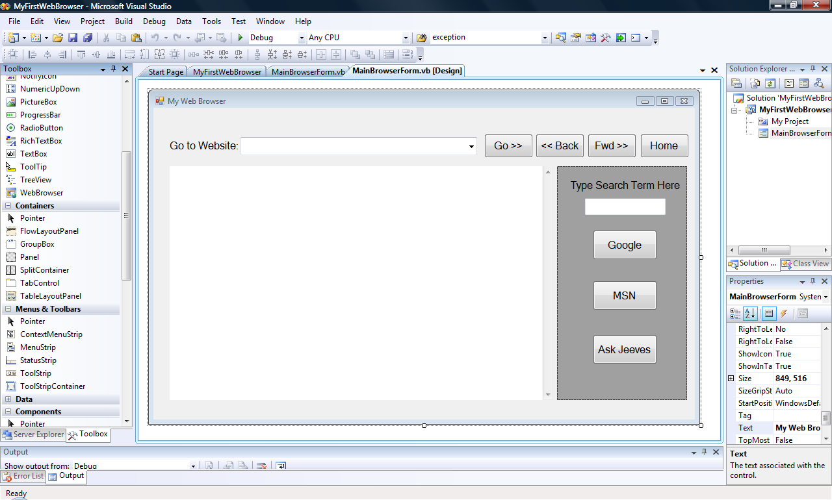

- When you drag it to the Form, it will not place itself like your regular controls (where you drop them), instead it ‘docks’ itself at the top of the form and places an icon just below the form.

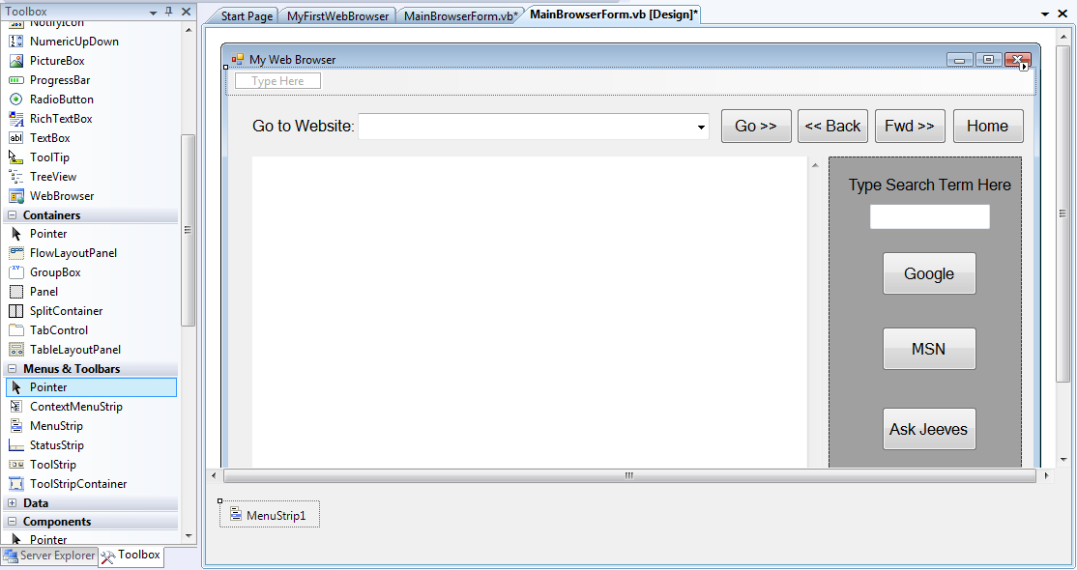

You should rename the MenuStrip control to something sensible – e.g. mnuBrowser etc.

- To start setting up the options, you simply type them into the spaces proved (that say ‘type here’). Obviously, you should give some though to how you are going to set out the menustrip control in advance (perhaps sketch it out on paper).

- The menustrip (and toolstrip control – that your tutor will demonstrate) are quite sophisticated controls. For example, you can add many levels of submenus to you menustrip if you wish – but be careful not to get carried away with these features – remember, the purpose of this exercise is to make your program more usable!

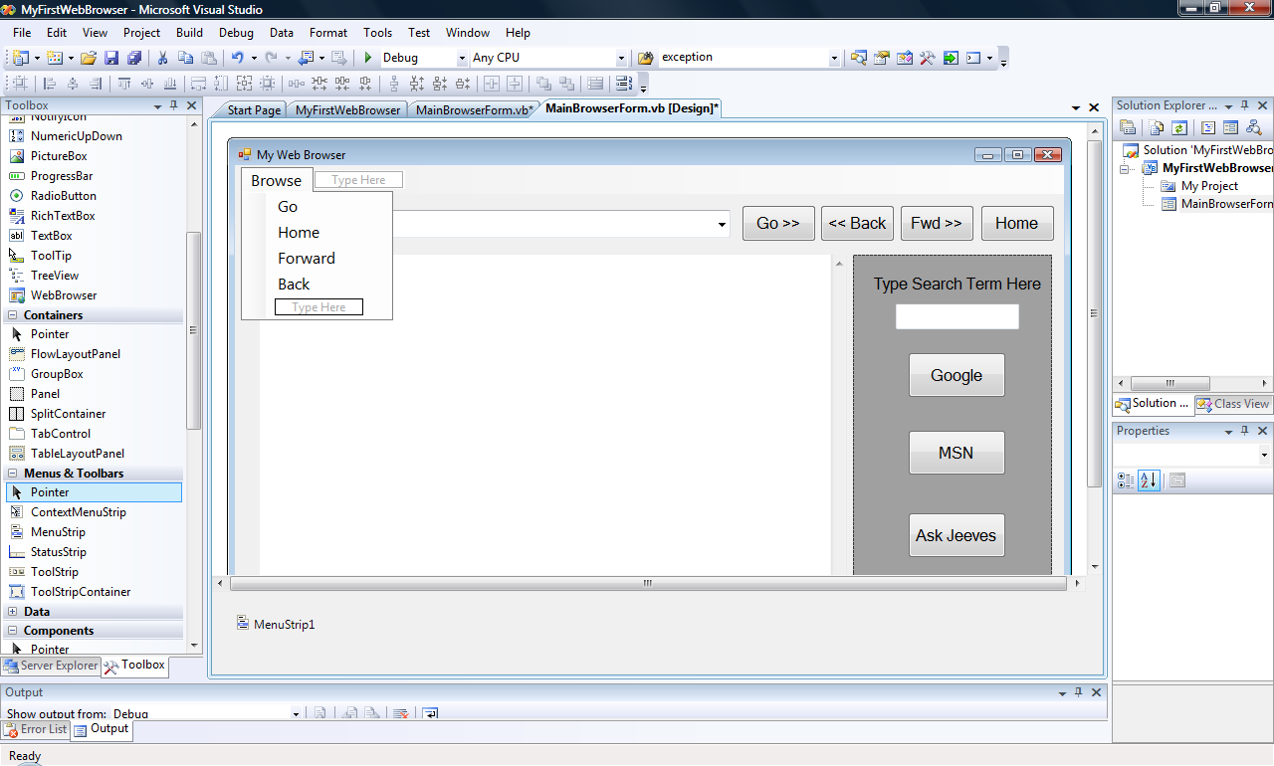

- You may also use a special dialogue that is context-specific to the menubar control and appears if you right-click on the menubar item and select ‘Edit Dropdown Items’. Here, you can fully configure a menu to:
  - Add / Remove / Reposition menu items
  - Rename menu items
  - Set ‘tool tip’ text for additional information
  - …and many others

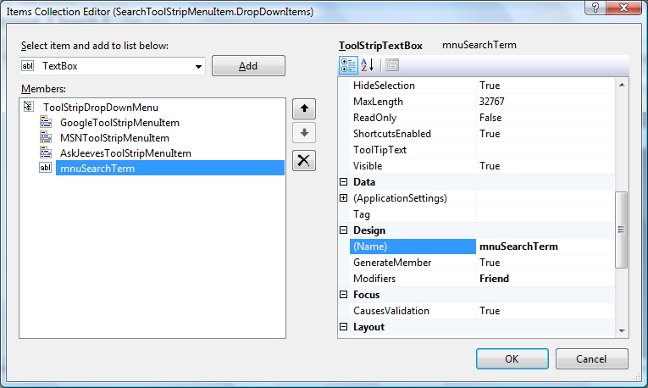

- Those observant amongst you, may have also noticed that it is not just menu options (MenuItems) you can add to a menu, you can also add:

  - Separators – to allow a menu to be partitioned
  - TextBoxes – to allow text to be typed into the dropdown menu directly (for example, when searching in our Browser)
  - ComboBoxes – To allow selection of dropdown options from within an option.

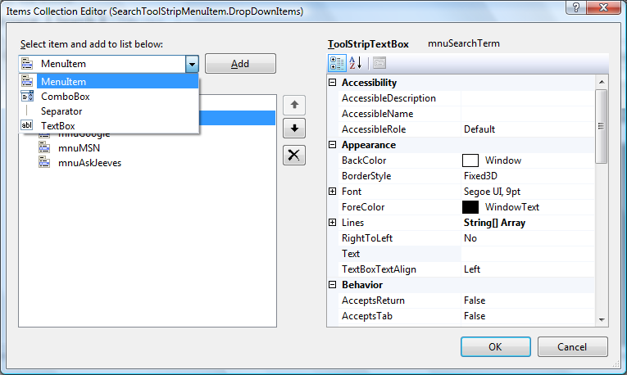

- Also, you can implement ‘shortcut keys’ for menu options quite easily by simply inserting an ‘&’ character just before the character you wish to use as a keyboard shortcut. E.g. If you type ‘Ask&Jeeves’ , ‘J’ will become the keyboard shortcut for that option when the menu is open.

- Once you have setup the layout of the menus, it is time to add some functionality behind. There are 2 ways to do this:

  - Add a new ‘click’ event-handler for each selectable item – this is simply done by selecting and double-clicking the item. This will take you to the code view in the same way that double clicking a button does, and you can add new code in the event-handler stub that is presented.

  - Wire up a menu option to and existing event-handler. To do this:
    - Select the menu option at design time
    - Go to the properties window and switch to Events view (click on the ‘lightning flash’ icon)
    - Select the ‘Click’ event and view the list of existing event-handlers that are displayed
    - Select the appropriate event-handler from the list (e.g. the btnGo_Click event handler provides the functionality that mnuGo needs).
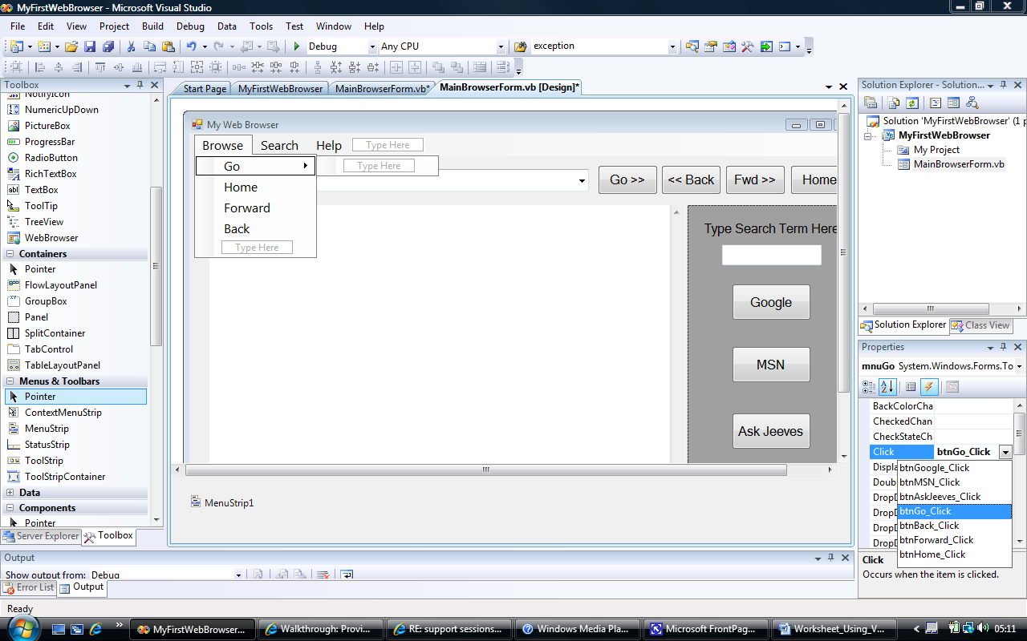

- The procedure for setting up toolbars is somewhat similar to menus, and will be demonstrated by your tutor

Demonstration – Ensuring your program works and setting up menus and toolbars

Your tutor will demonstrate:
- Check your program works well
- Add a new menustrip and start to configure it
- Add a new option-click event-handler
- ‘Wire up’ and existing event-handler to an option-click event.
- Add a new Toolstrip and start to configure it
- Add a new toolbutton-click event-handler
- ‘Wire up’ and existing event-handler to a toolbutton-click event.

Task 1 – Ensuring your program works and setting up menus and toolbars

- Ensure that you have ‘completed’ your web browser so that it works to the specification of Task 2 of the previous session.

How do you know that your program works as intended?

Formulate a ‘test plan’

How would you do this?

Hint: you need to go through the previous making a list of the main features of your web browser – and think of how you would reliably test each. For this you need to identify and list what results should come out of each test, even before you try the test.

- Test the application thoroughly (i.e. each button and dropdowns on the combobox, etc.), based on your test plan.

- Get in the habit of keeping a log of your test results and other observations (perhaps in a log-book). What are your results?

- When you are satisfied that your program works ‘correctly’, we will start adding additional features to improve the user interface.

- One of the User Interface features we will add is the ‘menustrip’ or menu bar control. The preceding ‘basic concepts’ section gives detailed instructions on how to do this. Go ahead and create your menu bar to offer (at least) the following options:

  - Browse (Menu)
    - Go (option item)
    - Home (option item)
    - Forward (option item)
    - Back (option item)
  - Search
    - (A menu based textbox to enter a search term)
    - Google (option item)
    - MSN (option item)
    - Ask Jeeves (option item)
  - Help
    - About (option item)

- Make sure that each of the selectable / referable items are sensibly name (e.g. mnuGoogle for the Google option item).

- Add event-handlers to each of the menu options (as per basic concepts and demonstration).

- Once you have completed the menu setup and have it functioning correctly, you can add a ‘toolstrip’ control.

- Instead of giving you specific instructions on how to add and configure a toolstrip control, you can research and complete this yourself (based on the demonstration, and by selecting the toolstrip control and pressing the ‘F1’ key to get help).

Note: you may also wish to research on the online resources for information – an important one is the MSDN resource. For example, one of the pages to help you with the toolstrip is http://msdn.microsoft.com/en-us/library/e58c44b8(VS.80).aspx

Tip: You should get in the habit of ‘hunting around’ for information as programming is such a big subject and your tutor can only provide you with the ‘essentials’.

- Once you have completed the menustrip and toolstrip setup tasks, test your program to see if it still works correctly and you haven’t ‘broken’ anything.

Some Basic Concepts – Improving the user interface with tooltips, statusbar and progressbar

The primary aim of the first task was to allow your user to control the behaviour of your program – menus and toolbars are mechanisms for user input.

The user will also need feedback from your application in order to monitor what is going on – for this purpose some other controls are provided that allow the application program to display information to the user conveniently and intuitively. Tooltips, status bars and progress bars serve such a purpose.

To use and configure a statusbar, the procedure is similar to menus:

- Drag and drop a ‘statusstrip’ control from the toolbox (also found in the ‘menus and toolbars’ category). It will appear ‘docked’ at the bottom of the form by default, and below the form as per the menustrip control.

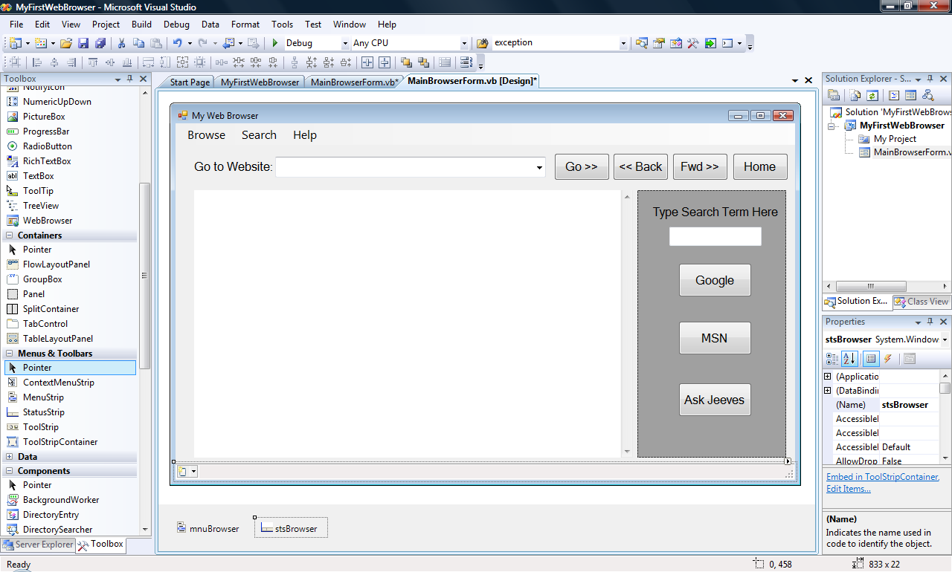

The easiest way to set up the status bar is to right-click on it and select ‘Edit Items…’. The ‘Items Collection Editor’ dialogue will be displayed.

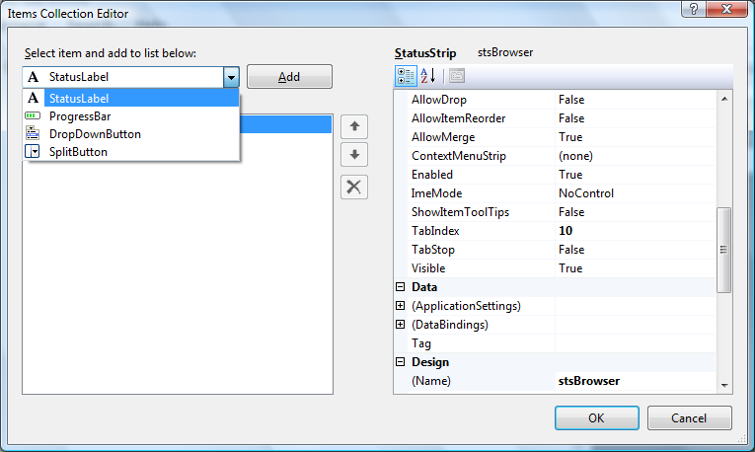

In the ‘Items Collection Editor’ dialogue, you will see that a status bar control allows 4 types of ‘sub – controls’ to be embedded:
  - StatusLabel – acts like a normal Label control, so you can use it’s Text property to display useful information to the user.
  - ProgressBar – acts like a normal (independent) ProgressBar control, discussed later.
  - DropdownButton – acts a bit like a Combobox control, but there are differences (look it up on MSDN!)
  - SplitButton – acts like a separator on menus and toolbars.

- The 2 main types of embedded control we are interested in are the statuslabel and the progressbar.

- To set up the statuslabel you simply set it’s name up to something sensible (e.g. stslblReady – to indicate when a browser page has been loaded for example), and set it’s text property at the appropriate point in your code (for example, when the ‘documentCompleted’ event is raised by the WebBrowser control). The following code may help:

stslblReady.Text = "Page " & e.Url.ToString & " is fully loaded!"

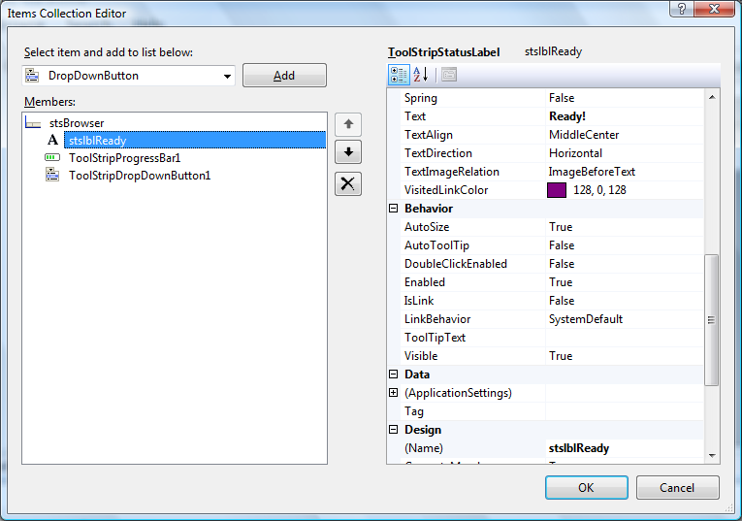

- To set up the progress bar (whether it is embedded in the statusbar or independent) the procedure is similar. Rename the progressbar to something sensible (e.g. stsprgPageLoadProgress – to indicate how far the current page being loaded by the WebBrowser has progressed). You may also want to set it’s ‘Maximum’ property to a sensible value such as 100 – to reflect that it will be displaying page load progress as a ‘percentage’ value.
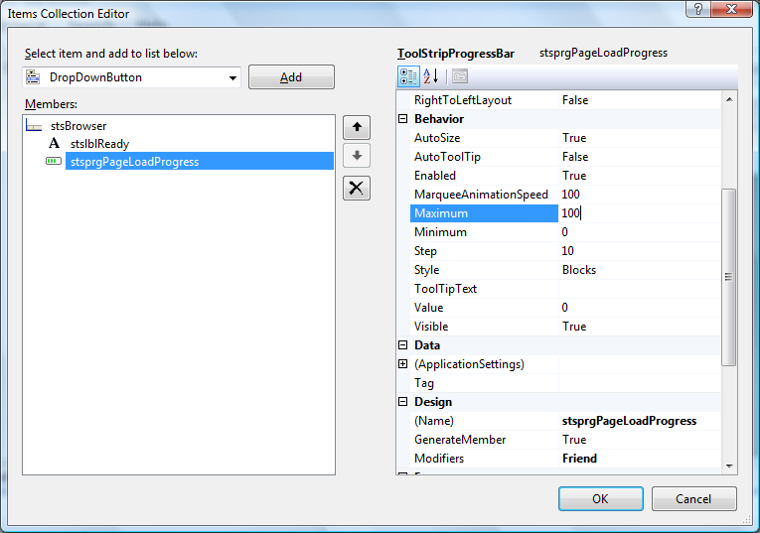

- Once the progress bar is configured, you can add some code to use it. Obviously, the event that updates the progressbar comes from elsewhere in our program. In this case it is the WebBrowser control – specifically the ‘ProgressChanged’ event of the WebBrowser.

- Therefore, to write the code to update the browser:
  - You need to select the WebBrowser Control on the form,
  - In the properties window, switch to ‘Events’ view (lightning flash’),
  - Double-click on the ‘progressChanged’ event in the list,
  - Add the following code in the event-handler stub that is presented when the code window opens:

'create a variable for the calculated page load progress percentage value
Dim progress As Double
'calcualte progress based on how much of the page has been loaded so far
progress = (e.CurrentProgress / e.MaximumProgress) * 100
'set to display progress percentage value on progressbar
stsprgPageLoadProgress.Value = progress

- Finally, to add a ‘tooltip’ to your program, you simply drag and drop a single ‘ToolTip’ control from the common controls section of the toolbox. Once you have renamed it – you will see it’s text property appear in all the other ‘tippable’ controls on the form!

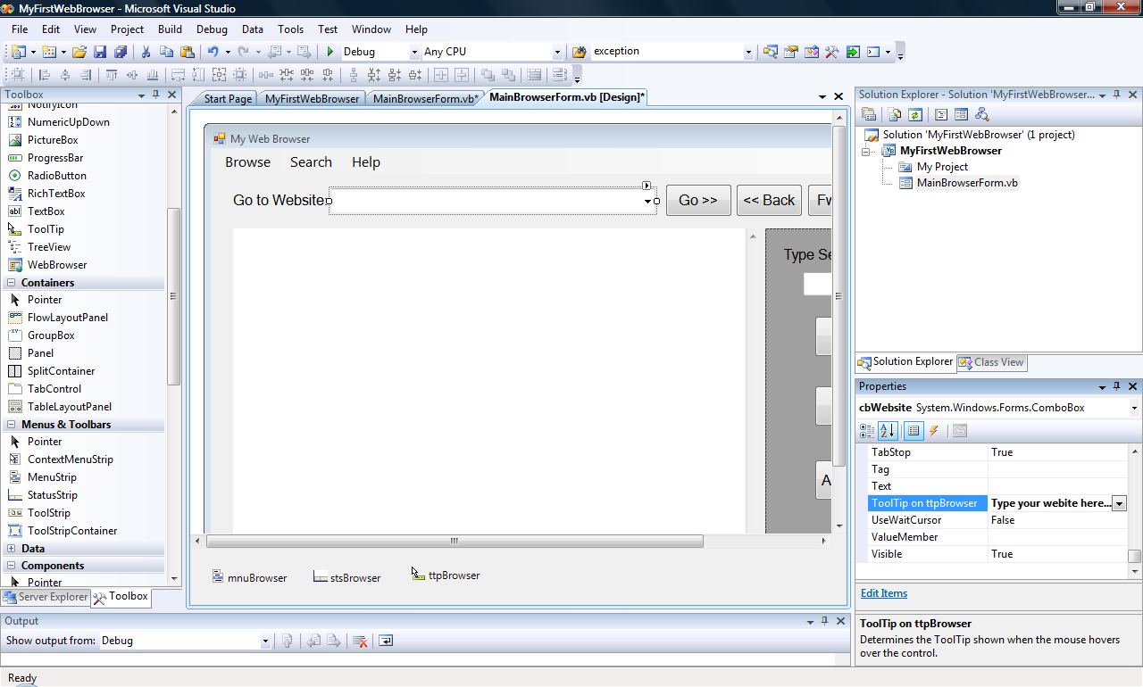

- When you have finished setting up tooltips for all your main controls on the screen, run and test the program. It should look something like the one below:

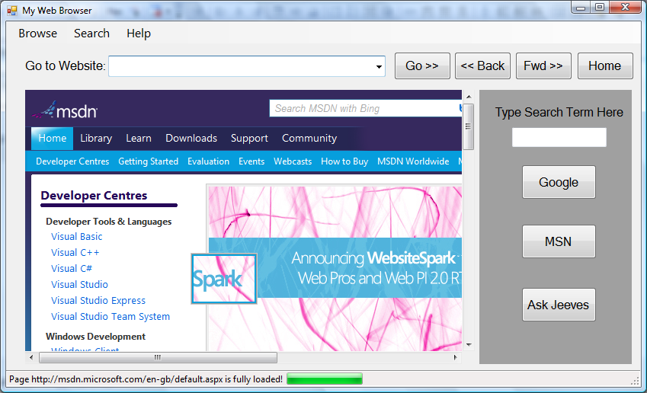
Tooltip should appear here

Demonstration – Using tooltips, statusbar and progressbar

Your tutor will demonstrate how to:
- Add a statusbar and configure it
- Add a statuslabel and progressbar to the statusbar
- Add event handlers for the browser to indicate progress on the statusbar
- Add a tooltip and set it for certain controls

Task 2 – Improving the user interface with tooltips, statusbar and progressbar

For this task you simply need to re-produce what the tutor has demonstrated (and explained in the related basic concepts section) to:

- Add a statusbar and configure it

- Add a statuslabel and progressbar to the statusbar

- Add event handlers for the browser to indicate progress on the statusbar

- Add a tooltip and set it for certain controls

Task 3 – Improving the user interface with additional ‘intuitiveness’ features

The aim of this final task is to make sure the application’s interface also performs intuitively and adequately – while still meeting the original functional specification.

Note: as this task is heavily self learning , for this task you will need to look things up on MSDN extensively. It’s a good habit to get into. You can get to the msdn resource (see link at the start of this lab) via a browser (perhaps your own!) or by selecting ‘Help’ on the Visual Studio menu.

This final open ended ‘research’ task is intended to encourage you to add new functionality (through extra windows components, for example) that will improve the behaviour of your application in terms of user friendliness and features.

- What happens when you resize the application window?

Note: if you built the application exactly to the lab specification, you may find that resizing the application window causes the browser window and / or the search panel to move to undesired positions – how would you fix this?
Hint: Review the ‘Anchor’ and ‘Dock’ properties of the controls on MSDN.

- The ‘intuitive’ thing that we all seem to have got into the habit of doing (from using other browsers such as Internet Explorer) is to type your destination URL into the combobox and simply press the Enter key (instead of having to press the ‘Go>>’ button every time). Find out how you would enable your application to do this, and try it.

Hint: There are several ways to achieve this, as you will find when you look on MSDN and other .NET programming forums on the web. A relatively simple way is to realise that the enter key event is picked up from the Form itself, rather than a particular button or control – check out the ‘AcceptButton’ property of a Form on MSDN.

- The other ‘intuitive’ thing to do when selecting a URL from ‘already visited’ list in the combobox, is to simply click the one you want without having to press the ‘Go>>’ button afterwards. Find out how you would enable your application to do this, and try it.

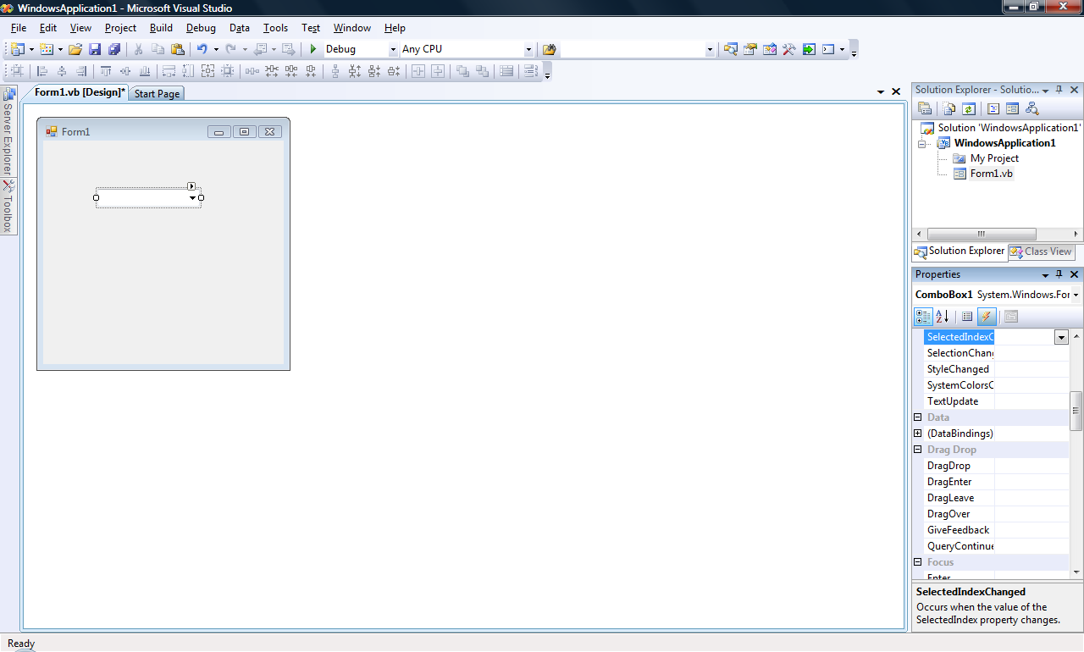
Hint: Check out the ‘Events’ that a Combobox can handle – e.g. the mouse-click or double-click event – on MSDN. Once you have identified the event that you need to handle – you can write your own event handler for this.

One way is to select the combobox control on your form and click on the ‘event’ button (‘lightning flash’ symbol at the top of the window) in the properties window (as illustrated).

This will bring up the list of all the events as recognised by this control – so you can identify the one of interest to you and write your event handler for it (easiest way is to double-click on the selected event to take you to the right place in the code window).

Hint: take a look at the ‘SelectedIndexChanged’ event for the combobox (as illustrated)

- What other features can you implement (without adding ‘new’ components) that will make you application behave more intuitively and be more user friendly.

Hints: for example, making the form ‘look nicer’ by changing colours and other properties in order to improve the ‘look and feel’ of the user interface. Try to think of the user of your program when doing this – would the user interface (your form layout) help or hinder the way they use your browser?

Note: If you selected the events view in the previous step – remember to switch back to the properties view by clicking the icon on the immediate left of the ‘lightning flash’ icon you selected previously.

- (**Extremely difficult!!**) You may have become familiar with the idea of having new ‘tabs’ each time you want to browse to a new URL (as per new versions of browsers such as Internet Explorer or Firefox).

  - Add some Tab controls to your web browser and see if you can browse to a new page on the selected tab – whilst maintaining what was previously browsed on the other tabs.
Hint: you will need to add a separate browser control to each tab – and refer to that each time.

  - To emulate the tabbing behaviour of popular browser accurately, you should really generate new tabs as required, and then use the new tab for all browsing until another tab is requested – or a previous tab is selected.
Hint: This is a very advanced feature and you may need to do some ‘programming’ to achieve it – so I am not expecting all of you to even attempt it! But it certainly leaves you with a real challenge if you feel up to it!!

- What other controls and components can you add to your application to improve its usability and feature set?

END OF WORKSHEET

