Programming Worksheet

Object Oriented Programming in VB.NET - Review

Introduction:

This worksheet is intended to review the topic of Object Oriented Programming in VB.NET.

Please note: the tasks in this worksheet do not give specific instructions on how to create a new application project. You must refer to the previous session materials to remind yourself how to do this. Just remember to select a sensible name (e.g. ‘TimeApplication’ or ‘AccountApplication’) and location (for example, under your ‘H:’ drive) for your project in the appropriate dialogue!

You should also be in the habit of naming your controls sensibly so no specific instruction on naming of controls will be offered.

Basic Concepts – Object Oriented Programming support in VB.NET

As you will have become aware in previous sessions on UML and basic programming, the concept of object orientation is very well established in the field of programming. There are several reasons for this, but primarily code re-use and less code complexity are the main reasons for wanting to adopt it as your programming ‘paradigm’ of choice as a software developer.

Particularly if you are using UML as your technique for analysing the given problem (Use Cases) and designing your solution (Class diagrams), the OO features of VB.NET will be a natural way to implement your proposed design / solution.

To understand the core concepts of object oriented programming – you need to start by addressing some questions:

What is an Object?

In the real world it is:
- A tangible thing - such as your car
- Can be a conceptual thing - such as a Loan (in a library)

Also, particularly when translated into the software world:

- It must have a unique identity
- It has state – defined by the current settings of attributes
- It can have behaviour – defined by its operations / methods
- It may behave differently in different states

What is a Class?

A class is what is used to define objects, it acts as a template for objects to be created:

- It is a type of object - such as (all) cars
- It should be an abstract or general description (not every detail has to be captured)
- It has (undefined) attributes and operations which it gives to its Objects

In fact:
- Objects are instantiations of classes.

What are the core Object Oriented concepts?

There are several ‘difficult’ sounding concepts that support good OO design and programming. Although at this point we will simply list them with their ‘disctionary’ definitions – and may mean little to you – we will point them out to you as we come across them in our design / programming:

- Abstraction:
A mechanism for capturing only the important details of an object.
- Encapsulation:
A mechanism for data hiding.
- Inheritance:
A ‘general-special’ relationship for classification and re-use.
- Polymorphism:
‘Many methods, single interface’.
- Aggregation:
A ‘whole-part’ relationship to show containment in classes.

What is UML?

UML stands for Unified Modelling Language, and is a very popular technique used to develop object oriented programming applications. We have already come across a couple of it’s diagramming techniques in other sessions.

UML is:
A modelling language - i.e. a means of giving an abstract description (e.g to the design of a software system)
A graphical language (rather than pure text)
UML is not:
A methodology - i.e. it does not describe a process to follow

The UML originally defined 9 diagrams (now 13):
- Use Case Diagrams (we have already seen these…)
- Class Diagrams (…and these)
- Sequence Diagrams, Communication Diagrams, Object Diagrams, Activity Diagrams, Statechart Diagrams, Component Diagrams, Deployment Diagrams etc, etc

Drawing a Class in UML

A Class is described in UML as:
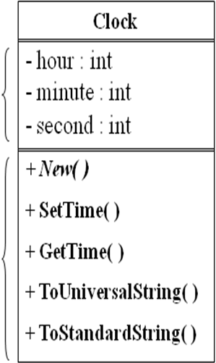
Class name -----------------------------------------------------------------à
Used to instantiate objects of the class

Class Attributes-------------------------------------------------------------à
Defines static properties of the class
Used to store data (like variables)
Used to maintain state of objects

Class Operations / Methods---------------------------------------------à
Defines dynamic properties of the class
Used to provide functionality (like procedures)
Used to provide behaviour to objects

+ indicates Public – methods provide class’s (public) interface.
- indicates Private – attributes should be private to enforce encapsulation.

Declaring a class in VB.NET

When declaring a class in VB.NET – the whole of the definition of the class should be enclosed in between a Public Class … End Class clause, (where have we seen this before? – that’s right, all our Forms are classes!) – and should ideally be in a separate file.

Visual Studio allows you to add your own custom classes to your projects (New File-> Class). The following is an example of the declaration of the ‘Clock’ class as described in the previous UML diagram (note, for initial clarity the definition has been ‘collapsed’ to omit the method detail – it is shown in full on the following page):

Public Class Clock

'encapsulate the attributes - make them private
Private hour As Integer
Private minute As Integer
Private second As Integer

'constructor for objects of this class
Public Sub New() …

'accessor - used to maintian encapsulation
Public Function GetTime() As String …
'mutator - used to maintain encapsulation
Public Sub SetTime( hr As Integer, mn As Integer, sc As Integer) …

'other methods of the class...
Public Function ToUniversalString() As String …
Public Function ToStandardString() As String …

End Class
This is a fully detailed view of the ‘Clock’ class:

Public Class Clock

'encapsulate the attributes - make them private
Private hour As Integer
Private minute As Integer
Private second As Integer

‘constructor
Public Sub New()
SetTime(0, 0, 0)
End Sub

‘accessor
Public Function GetTime() As String
Return (hour.ToString + " , " + minute.ToString + " , " + second.ToString)
End Function

‘mutator
Public Sub SetTime(ByVal hr As Integer, ByVal mn As Integer, ByVal sc As Integer)
If (hr >= 0 And hr < 24) Then
hour = hr
Else
MsgBox("Invalid hour value entered, will be set to 0")
hour = 0
End If
If (mn >= 0 And mn < 60) Then
minute = mn
Else
MsgBox("Invalid minute value entered, will be set to 0")
minute = 0
End If
If (sc >= 0 And sc < 60) Then
second = sc
Else
MsgBox("Invalid second value entered, will be set to 0")
second = 0
End If
End Sub

‘other methods…
Public Function ToUniversalString() As String
Return String.Format("{0:D2}:{1:D2}:{2:D2}", hour, minute, second)
End Function

Public Function ToStandardString() As String
Dim ampm As String
Dim standardHR As Integer
If (hour < 12) Then
ampm = "am"
Else
ampm = "pm"
End If
If (hour = 12 Or hour = 0) Then
standardHR = 12
Else
standardHR = hour Mod 12
End If
Return String.Format("{0}:{1:D2}:{2:D2} {3}", standardHR, minute, second, ampm)
End Function
Creating and using Objects in .NET

Once we have declared the Class, we (or other programmers who wishe to use our class in their program – because that’s what it’s all about – re-use!) are ready to start using it as our ‘template’ for creating any number of objects. It’s these objects that the program code will interact with by calling the methods provided by the original Clock class to manipulate each object individually.

In this case we have created a separate ‘TimeForm’ form - see below - where we will create and use objects of our ‘Clock’ class:

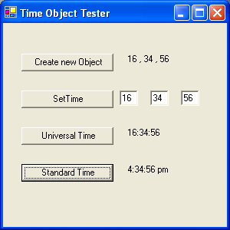

Public Class TimeForm
‘declare a ‘reference’ variable to hold the object that we will instantiate later
Private Clock As Clock

Private Sub btnNew_Click(ByVal sender As System.Object, …) Handles btnNew.Click
‘instantiate the Clock based object…
myClock = New Clock
‘and call its accessor method
lblTime.Text = myClock.GetTime()
End Sub

Private Sub btnSetTime_Click (ByVal sender As …) Handles btnSetTime.Click
Dim hrs, mins, secs As Integer
hrs = Convert.ToInt32(tbHour.Text)
mins = Convert.ToInt32(tbMinute.Text)
secs = Convert.ToInt32(tbSecond.Text)
‘continue to use the previously instantiated object wherever it’s in scope
myClock.SetTime(hrs, mins, secs)
lblTime.Text = Clock.GetTime()
End Sub
…………………..

End Class

Task 1 – Creating a ‘TimeForm’ test program for the ‘Clock’ class

For this exercise, you will begin the ‘TimeApplication’ program by creating the ‘TimeForm’ Form which will be used to test the ‘Clock’ class (as per the previous ‘basic concepts’ section).

- Create a new project called ‘TimeApplication’, and save it to your network (normally ‘H:’) drive.

- Create a simple ‘TimeForm’ form (as per illustration) based on a single form that comprises of the following controls:

- Four buttons, named appropriately – based on the displayed text, e.g. ‘btnCreateNewObject’ for the button displaying the text ‘Create New Object’, etc.

- Three labels, named appropriately – based on the text displayed on the associated button, e.g. ‘lblCreateNewObject’ for the label next to the button displaying the text ‘Create New Object’, etc.

- 3 textboxes adjacent to the ‘Set Time Button’ to allow the user to enter the new time (hour, minutes, seconds), named appropriately – e.g. ‘tbSetTimeHR’, etc.

- The completed form (when running) should look like the one illustrated below:

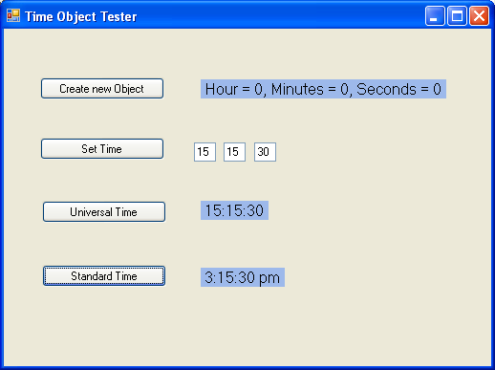

Task 2 – Creating the ‘Clock’ Class

This task will build the ‘Clock’ class as illustrated in the previous basic concepts section, using Visual Studio’s Class Designer facility.
- Staying with the application your started in task1; right-click on the application’s name (e.g. ‘TimeApplication’) in the Solution Explorer window. From the pop-up menu that is displayed select ‘Add Item’ followed by ‘Add New Item…’. This should display the ‘Add New Item’ dialog (see below). Select ‘Class Diagram’ and change the name to ‘Time.cd’ and click ‘Add’.

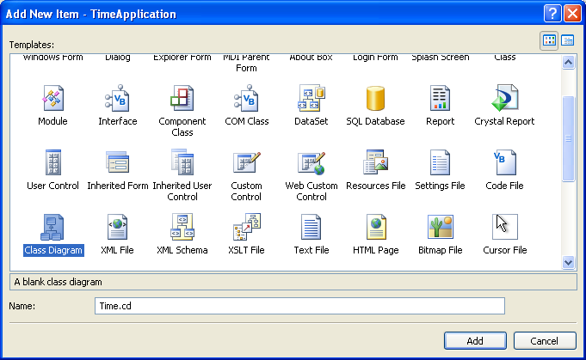

- In the blank window that is displayed (entitled ‘Time.cd’), select and drop a Class ‘control’ from the Class Designer pane that is displayed in the Toolbox window. This should throw up a ‘new class’ dialogue for you to set the name of the class to ‘Clock’ (as below).

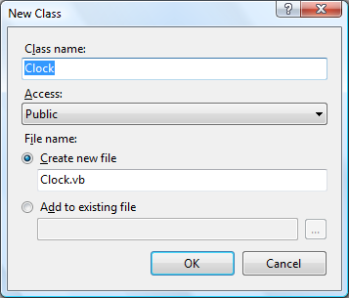

Optionally, when the class appears in the class diagram, you can change the name of the class in the Properties Window,
- Right Click the class, select ‘Add’ from the pop-up menu, and select ‘Field’. Add the three attributes for hour, minute, second to your class. Ensure they are all of type Integer (the ‘Class Details’ pane at the bottom of the screen should allow you to do this).

- Right Click the Class, select ‘Add’ from the pop-up menu, and select ‘Method’. Add the methods / operations as given in the basic concepts notes. The class should finally look as below.

Note: where the methods are Functions rather than Subs (remember the difference?!), you will need to set the return type in the ‘Class Details’ window as below. All Fields should be private, all Methods should be public.

Note: ‘New ()’ is a special type of ‘method’ that is known as a ‘Constructor’. So when adding it to the class, you must right click the class, select ‘Add’, and select ‘Constructor’ from the pop-up menu. Constructors are used to create a new instance object from a class – take some time out to research about constructors – they’re very important in OOP!

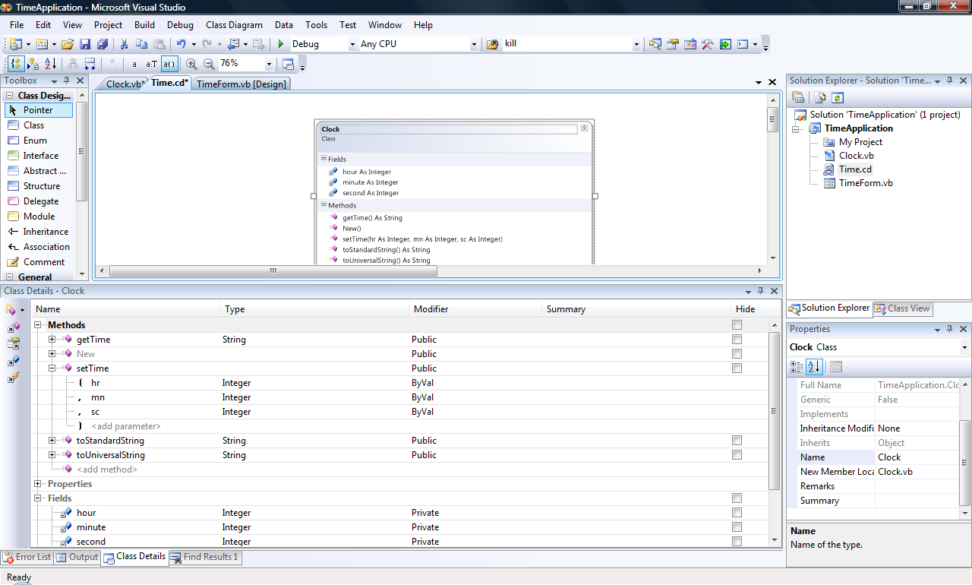

- While you have been visually editing the class, Visual Studio has been maintaining the code in a file called ‘Clock.vb’. Click this file in Solution explorer to open and edit it. Use the basic concepts notes to add code to the ‘method stubs’ provided for you. Your class should eventually look as below:

Public Class Clock

Private hour As Integer
Private minute As Integer
Private second As Integer

Sub New()
SetTime(0, 0, 0)
End Sub

Public Function GetTime() As String
Dim TimeString As String
TimeString = String.Format("Hour = {0}, Minutes = {1}, Seconds = {2}", hour, minute, second)
Return TimeString
End Function

Public Sub SetTime(ByVal hr As Integer, ByVal mn As Integer, ByVal sc As Integer)
If (hr >= 0 And hr < 24) Then
hour = hr
Else
MessageBox.Show("Invalid hour value entered, will be set to 0")
hour = 0
End If
If (mn >= 0 And mn < 60) Then
minute = mn
Else
MessageBox.Show("Invalid minute value entered, will be set to 0")
minute = 0
End If
If (sc >= 0 And sc < 60) Then
second = sc
Else
MessageBox.Show("Invalid second value entered, will be set to 0")
second = 0
End If
End Sub

Public Function ToUniversalString() As String
Dim TimeString As String
TimeString = String.Format("{0:D2}:{1:D2}:{2:D2}", hour, minute, second)
Return TimeString
End Function

Public Function ToStandardString() As String
Dim TimeString As String
Dim ampm As String
Dim standardHR As Integer
If (hour < 12) Then
ampm = "am"
Else
ampm = "pm"
End If
If (hour = 12 Or hour = 0) Then
standardHR = 12
Else
standardHR = hour Mod 12
End If
TimeString = standardHR & ":" & minute & ":" & second & " " & ampm)
Return TimeString
End Function
End Class

Task 3 – Writing Code to use the ‘Clock’ Class

For this final task, you will build the application to test the ‘Clock’ class created in the previous task, by using the ‘TimeForm’ form as your user interface.

- Revert to the ‘TimeForm’ form and add code behind each of the buttons as follows:
Note: you will need to ensure that your controls have the same names as mine!
Note: the purpose of this code is to ‘instantiate’ an Object of the Clock class (e.g. ‘myClock’) and test it’s methods.!
Add comments to your code to try to explain to yourself what is happening, see if they tie up with the explanations given in the basic concepts section.

Public Class TimeForm

Private myClock As Clock

Private Sub btnCreateObject_Click(ByVal sender As System.Object, ByVal e As System.EventArgs) Handles btnCreateObject.Click

myClock = New Clock()
lblCreateObject.Text = myClock.GetTime
End Sub

Private Sub btnSetTime_Click(ByVal sender As System.Object, ByVal e As System.EventArgs) Handles btnSetTime.Click

If myClock Is Nothing Then
MessageBox.Show("Please create a 'Clock' object First")
Else
Dim hrs, mins, secs As Integer
hrs = tbSetTimeHR.Text
mins = tbSetTimeMN.Text
secs = tbSetTimeSC.Text
myClock.setTime(hrs, mins, secs)
lblCreateObject.Text = myClock.GetTime
End If
End Sub

Private Sub btnUniversalTime_Click(ByVal sender As System.Object, ByVal e As System.EventArgs) Handles btnUniversalTime.Click

If myClock Is Nothing Then
MessageBox.Show("Please create a 'Clock' object First")
Else
lblUniversalTime.Text = myClock.ToUniversalString()
End If
End Sub

Private Sub btnStandardTime_Click(ByVal sender As System.Object, ByVal e As System.EventArgs) Handles btnStandardTime.Click

If myClock Is Nothing Then
MessageBox.Show("Please create a 'Clock' object First")
Else
lblStandardTime.Text = myClock.ToStandardString()
End If
End Sub

End Class

- Run and Test the application, and make notes on the behaviour.
Basic concepts – Inheritance and further OOP

In the previous basic concepts section, we came across a number of key concepts for object oriented programming – namely Aggregation, Inheritance, Abstraction, Polymorphism. We will now start to elaborate on these ideas so that we can make better use of the facilities afforded us by the OOP technique. The main concept we are interested in is inheritance, which forms the cornerstone of OOP. But, we’ll start with the simpler concept of aggregation that is clearly distinguished for a ‘normal’ association between classes by UML, but not often by most programming languages.

OO Concept: Aggregation

Aggregation is used to show containment of one object by another (‘Whole-part’ relationship). It shows a stronger communication relationship than a simple association. For example, in UML, it is represented by lines terminating in ‘diamond’ shapes:

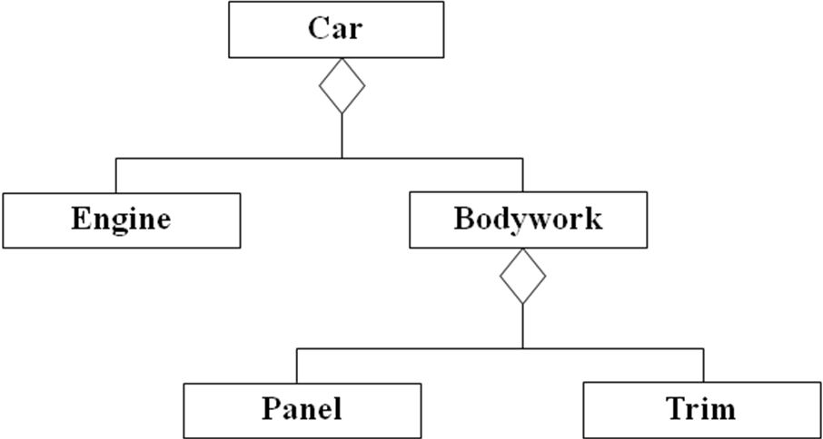

It is usually discovered in design if an operation is very complex or an attribute needs a complex structure (but only if meaningful). Aggregations can be reflexive (e.g. Panel can contain another Panel) and transitive (e.g. as a Car contains BodyWork, and BodyWork in turn contains Trim – by inference, a Car contains Trim).

However, in VB.NET aggregation is simply implemented the same way as a normal (weak) association between classes. You simply create a variable to hold a reference to the ‘part’ object in the ‘whole’ class, e.g.:

Public Class Engine
Private m_capacity As Integer
….
End Class

Public Class Car
Private m_Engine As New Engine
….
End Class

OO Concept - Inheritance: What is it? How does it work? Why is it useful?

The core OOP concept of inheritance is clearly distinguished in both design and programming (i.e. UML and VB.NET) as it is such an important concept for this paradigm. It is expressed in UML as a line terminating in a ‘triangle’:

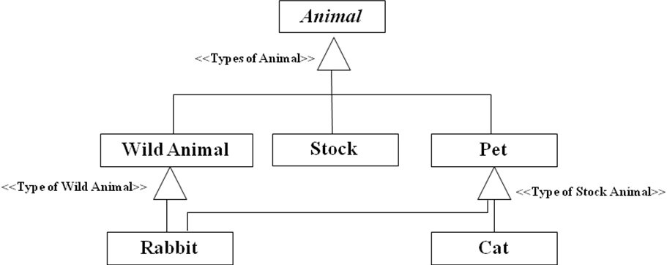

Inheritance should be read as a ‘type of’ relationship in the direction of the terminating triangle (e.g. A Cat is a ‘type of’ Pet – and so is a Rabbit. And so on).

The reason that inheritance holds such importance in OOP is because it promotes code re-use and stability. Inheritance is useful for many different reasons:

- Re-use: Primarily Inheritance allows for large scale code reuse without the modification of the core code.
- Code sharing: Once a class hierarchy has been developed the code can be “split” into chunks which can be written by different developers and then easily stitched together.
- Consistency: An inherited class’ code will behave exactly the same as that of the base class, unless alter in some way by the developer.
- Rapid prototyping and development: updating code becomes easier and less prone to random errors creeping in due to the data based nature of processing.
- Polymorphism: the extremely powerful ability for similar classes to perform very slightly different functions.
- Information Hiding (Encapsulation): Only the Public interfaces to a class are visible by users of the class, therefore the understanding required about what a class actually does is reduced significantly.

In an inheritance relationship, The ‘parent’ is referred to as the base or super class. The ‘child’ is referred to as the sub class.

Subclasses (derived) can inherit the attributes, operations and associations of the SuperClass (‘parent’). These subclasses can then add operations (or extend – override - the inherited operations) to make them special. This system can be used to create quite elaborate ‘frameworks’ of super-and-sub classes. The .NET framework is one example of this.

In VB.NET, Inheritance is expressed using the ‘Inherits’ Keyword:

Public Class Vehicle
'Base Class properties and methods...
End Class

Public Class Car
Inherits Vehicle
'Sub Class properties and methods and overridden base class methods
End Class

For example, given a class:

Public Class Person
Protected age As Integer
Protected name As String
…

Public Function getPersonalDetails( ) As String
Return name & “ is “ & age & “years old.”
End Function

End Class

The class can easily be extended using inheritance as follows
Public Class Student
Inherits Person

Private course As String
Private dateEnrolled As Date

Public Sub enrol()
…
‘code to enrol student
End Sub

End Class

Note that the ‘age’ and ‘name’ variables, and the ‘getPersonalDetails( )’ method, from the ‘Person’ base class do not need to be re-declared in the ‘Student’ sub class. They can be seen through inheritance since they are protected (which will also ensure they remain encapsulated). See later notes on Protected and other keywords.

But the real power of inheritance can be seen when objects of the ‘Student’ class are created and used:

‘two –step instantiation of a new ‘Student’ class’ object – named ‘aStudent’
Dim aStudent as Student
aStudent = New Student( )
‘now you can call one of the ‘Student’s methods – or a ‘Person’ method!
aStudent.enrol( ) ‘Student method
lblStudent.Text = aStudent.getPersonalDetails( ) ‘Person method!
Special keywords associated with OOP in VB.NET:

Friend
The Friend access modifier keyword can be used to control the ‘visibility’ scope of a variable in VB.NET. Using the keyword Friend is often likened (and confused) with using the keyword Public when declaring variable, methods or even classes. In reality, the scope of an item declared as Friend is reduced for one declared as Public.

The actual scope is the same as Public in so far as an item declared as such is viewable from anywhere within an application as it is being written.

If another application attempts to view an item declared as Friend in another application, it will be denied access. Public interfaces will still be visible.

Examples:
Variables (note that this is only allowed at class level):
Friend myVar As Integer
Methods:
Friend Sub ProcedureName()
‘Code here
End Sub
Classes:
Friend Class ClassName
‘Code here
End Class

Shared
The Shared keyword only applies to Variables, Methods, Events and Properties.
It is used to implement class level attributes and methods.

Using the keyword Shared allows for just one ‘instance’ of that occurrence to exist within the program limits – it belongs to the class rather than it’s objects.

For example, if there was a bank account class and there was a shared variable called ‘InterestRate’, then if one of the objects created from the class changed the value of the variable then the value of the variable would change for all of the other instances of the class (objects).

Examples:
Attributes (note that this is only allowed at class level):
Shared AccountNo As Integer
Methods:
Friend Shared Sub showNextAccNo()
End Sub

Protected
As well as Public, Private and Friend visibility, there is the concept of Protected.
In UML it’s represented by a #. For example, if we wanted to use the ‘Clock’ class as a base class – It would be better encapsulation if all its attributes were Protected:

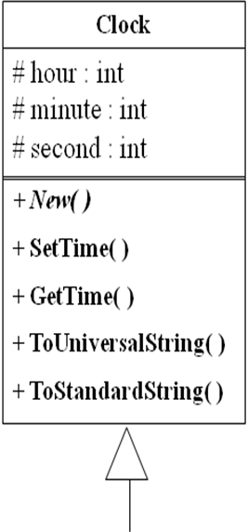

The Protected keyword in VB.NET operates on all of the same items as the Friend Keyword and only at class level.

Protected members (items) behave in much the same way as Private members, however, Protected members are able to be inherited (unlike Private members).

They are accessible only from within their own class or a derived class (NOT from classes outside of their hierarchy – or ‘parentage’).

Examples:
Variables (note that this is only allowed at class level):
Protected myVar as Integer
Methods:
Protected Sub ProcedureName()
‘Code here
End Sub

MustInherit / NotInheritable

The concept of abstraction is another core OOP concept and is used when the base class only exists to allow inheritance. The abstract base class cannot be instantiated (e.g., no objects of ‘Animal’ allowed by our UML diagram below – only ‘Wild Animal’, ‘Stock’ , ‘Pet’):

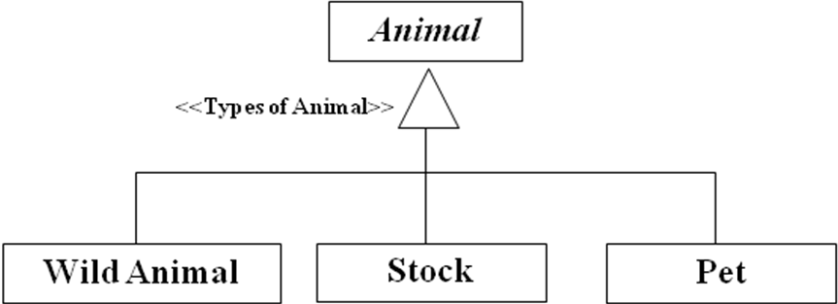

The MustInherit keyword in VB.NET forces a class to be inherited (e.g. Public MustInherit Class Animal…), this is particularly useful when a rigid structure needs to be imposed to meet some design criteria.

A class designated with the MustInherit keyword is never able to have an object created from it.

Classes using MustInherit are often created with a level of functionality built into them, but with a few “parts” missing which must be filled in when the implementation of the class is required.

The NotInheritable Keyword is the diametric opposite of the MustInherit keyword (and therefore obviously cannot be used in conjunction with MustInherit). It forces a user to use the class given to them to create objects. This is very important for security reasons, as it does not allow the base class to be inherited, polluted (changed) and replaced! It prevents other developers overwriting specific functionality that may affect stability of applications or introducing bugs.

Overriding
Override [Dictionary Definition]: To counteract the normal operation of (an automatic control).

Overriding is the main programming technique used to support Polymorhpism. This is a very powerful OO mechanism for code re-use and there are many ways to use it.
The example UML diagram below illustrates an example of polymorphism in design (the ‘ComputePay( )’ will be expected to behave differently depending on the type of employee you are computing the pay for – but may also maintain some common behaviour defined by the Employee class):

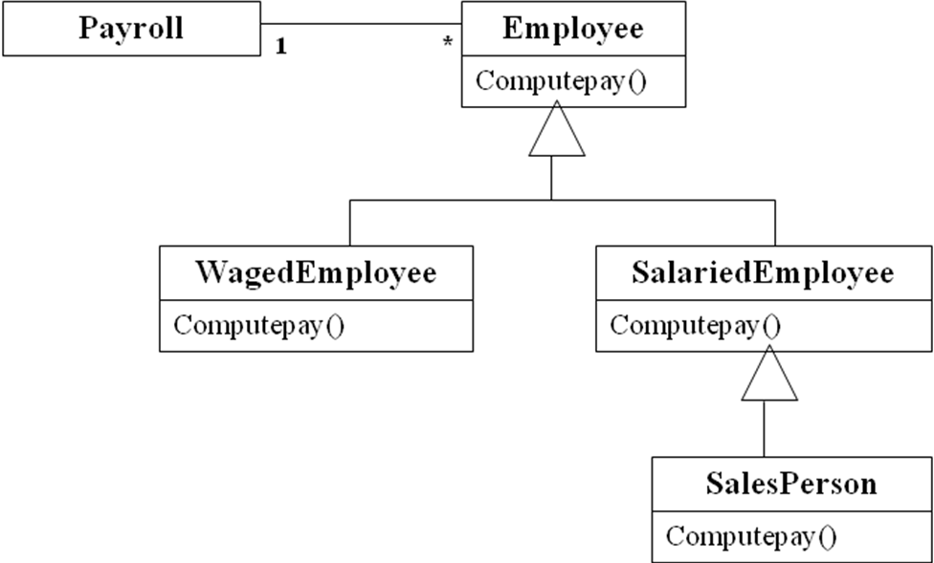

As indicated above in using inheritance in programming the normal functionality of sections of a class can be altered or ‘overridden’. This is done simply by adding the keyword Overrides to the method signature/declaration. The inherited code will then be ignored and the code that sits within the overriding method will be executed when called.

Note: All of the following uses of overriding apply only to methods and properties (NOT variables).

For a method to be Overridable it must be declared as such using the Overridable keyword in the method signature. This is another feature that ensures the security of an application.

For example:

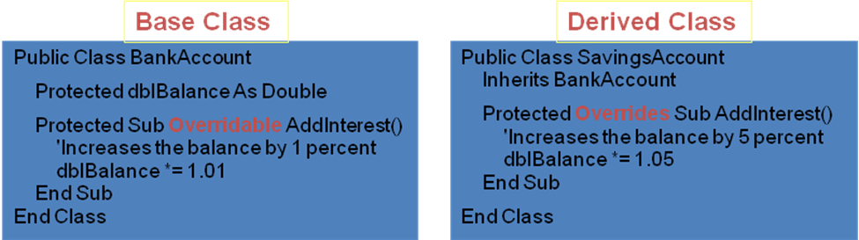

When using the MustOverride keyword, if a class is inherited then the programmer must write a section of code to replace the procedure. For this reason MustOverride methods tend to be left empty with no code in them.

NotOverridable: This keyword prohibits a developer from overriding the designated procedure in any way whatsoever. Note that this is somewhat of an unneeded extra as procedures are by default NotOverridable unless they are explicitly labelled with MustOverride or Overridable.

Task 4 – Defining the Account (Base) Class for Inheritance

The aim of this task is to define a class based on a given UML class specification – that we will eventually use for inheritance.

- Create a new VB.NET project called ‘AccountApplication’.

- Add a Class called ‘Account.vb’ by right-clicking the project name in the Solutions Explorer window and selecting the ‘Add new item…’ wizard (see graphic below).

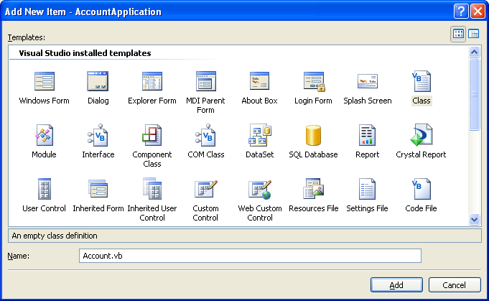

- The previous step should give you a blank code-page for the newly created class (as per graphic below).

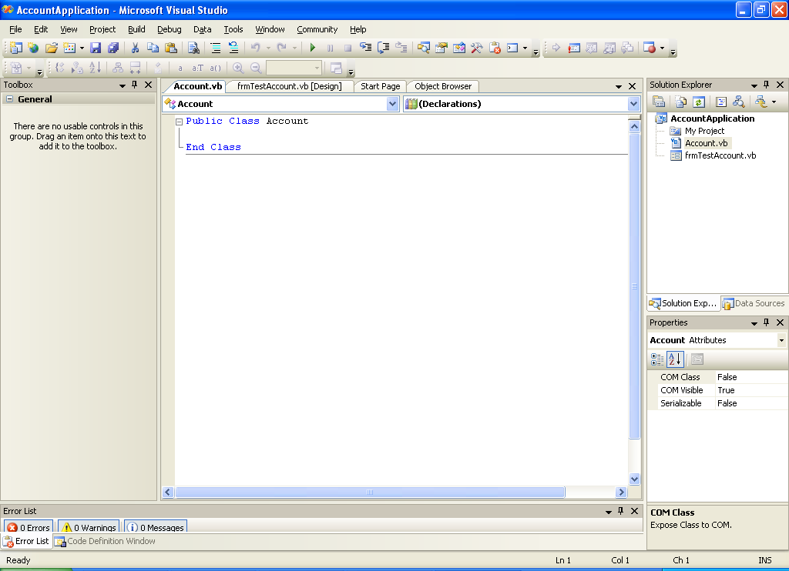

- Review the lecture notes for the Object Oriented Concepts lecture, and – using the UML class given below - write the code for the ‘Account’ class. Pay particular attention to visibility of attributes / methods.

- You will need the following additional information to achieve step 4 (as well as what’s given in the class diagram)

  - The constructor (‘New’ method) for the class should set the overdaftLimit to £100.00 (a ngative value may be easier to use later), and then call the setBalance method with an amount of £0.00.
  - Note, the setBalance method will never be called from outside of the class code due to its visibility – i.e. it is a helper rather than an interface method. The other (interface) methods should use it to safely manipulate the balance.
  - The deposit and withdraw methods should both check if the incoming amount is valid (i.e. not negative).
  - The withdraw method should also check if sufficient funds are available in the account – taking the overdraft limit into account.
  - The closeAccount method should withdraw the current balance from the account, resetting the balance to £ 0.00.
  - The constructor should accept an account number from the calling code, that should be unique (how would you ensure that as the user of the class?)

Account
- accountNumber: Integer
- currentBalance: Double - overdraftLimit: Double
+ New( accountNo: Integer )
+ getAccountNumber(): String
- setBalance( balance: Double )
+ getBalance( ): Double
+ deposit( amount: Double )
+ withdraw( amount: Double )
+ closeAccount( )

Task 5 – Testing the ‘Account’ class by creating and using Account Objects

The aim of this task is to allow you to create and use object(s) of the Account class.

- Create a form that displays details of two accounts as follows:

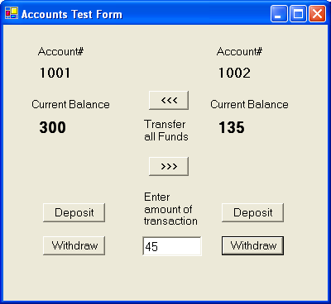

Notes: The two sets of deposit and withdraw buttons are to be associated with the account whose details are displayed directly above them. The amount used by the method calls will be the one currently entered into the shared editbox. The ‘>>>’ and ‘<<<’ buttons will both use a combination of the withdraw() and deposit() method calls to transfer ALL funds from one account to the other.

- Write code in the form’s load event handler to instantiate two account objects (e.g. AccountA and AccountB) from your previously defined Account class. Give the new accounts arbitary account numbers (e.g. 1001, 1002). The form-load event should also display the account numbers and initial balances as shown above.
Tip: Consider how you would manage the scope of these objects – make them visible to the whole form (easiest), or pass references between handlers (more difficult).

- Write button-click event handlers for the deposit, withdraw and transfer buttons to perform the specified functionality using the interface methods of the Account class.
Tip: Refer to lecture notes for an example of this.

- Test the application. Note down any observations.

- Ensure you have added in enough validation and verification of data so that the Accounts class only instantiates and manages ‘stable’ objects. E.g., if negative deposits and withdrawals are attempted – they should be detected and managed.

Task 6 - Ideas for extending the Account application.

The aim of this task is very experimental. You will attempt to ‘creatively’ modify the Accounts application so that it is more usable and robust. The following ‘steps’ may be tackled in any order.

- Consider using an array of account objects to allow the user o manipulate any number of accounts. Tip: the syntax for creating an using an array of objects is the same in VB.NET as for creating an array of any other standard type(such as integers). Being able to call the same method against any object of the class is an example of Polymorphism – the method will behave differently depending on the state (value in currentBalance etc,) of the object it is called against.

- Consider a better strategy for issuing account numbers – e.g. using a ‘static’ class variable that adds 1 to the account number of the last account created. E.g. The first account to be created could be # 1001, and any accounts thereafter will be 1002, 1003,.. and so on. How will this affect the definition of your constructor?
Tip: you an have any number of constructors – providing each one differs in the arguments it accepts; this very powerful feature is also an example of Polymorphism and is know as ‘Overloading’ in object speak. In this case the method behaves differently depending on the data passed to it – look it up!

- Consider creating another constructor for the account class – that allows the user to enter a starting balance for the account other than 0.00. You may need to also consider how you will expose this functionality through the user interface.

- We haven’t made very good use of the closeAccount() method. Consider how you would put this to better use when you have multiple account objects dynamically assigned to an array?

Task 7 – Create subclasses for the Account application

The aim of this task is to define a pair of subclasses for the previously created Account class, based on the given UML class specification.

- Add a new Class called ‘SavingsAccount.vb’ by right-clicking the project name in the Solutions Explorer window and selecting the ‘Add new Class…’ wizard (as per previous 2 labs)

- Add a second new Class called ‘CurrentAccount.vb’ by right-clicking the project name in the Solutions Explorer window and selecting the ‘Add new Class…’ wizard

- The previous two steps should give you a blank code-page for each of the newly created classes (CurrentAccount and SavingsAccount).

- Add the constructors for the subclasses.
Hint: The constructor is the special ‘method’ that is called automatically when objects of the class are instantiated (created). It always starts with ‘Public Sub New(…’.

- Review the notes for the Inheritance ‘basic concepts’ section, and – using the UML class diagram at the end of the sheet or the Vidusl Studio class designer version given below – write (or generate using the class designer in visual studio) the code for the ‘CurrentAccount’ and ‘SavingsAccount’ subclasses

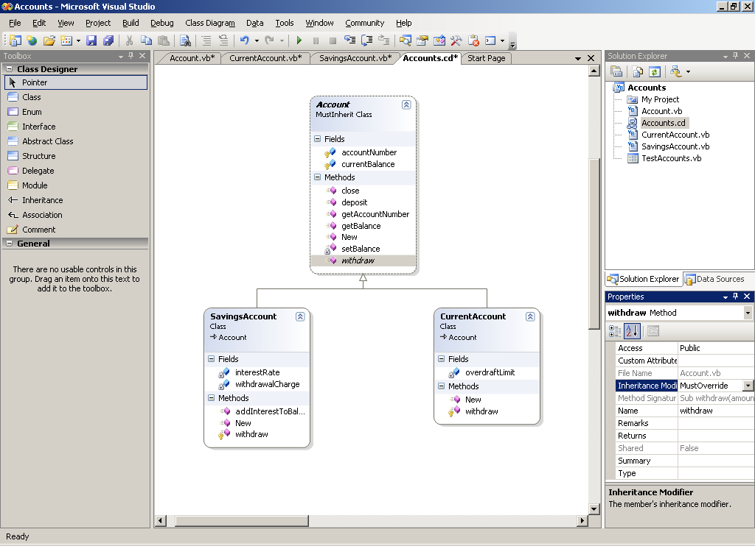

- Based on the information in your notes, and with reference to the MSDN resource at http://msdn2.microsoft.com/en-us/library/aee8f02w.aspx, modify the existing ‘Account’ class to make it an abstract parent class. Pay particular attention to visibility of attributes / methods.
- You will need the following additional information to achieve this step (as well as what’s given in the class diagram)
  - The constructors for the subclasses must call the base class constructor first – using the built-in ‘MyBase’ object.
  - Note that the overdraft limit attribute has been moved down to the current account class – as it does not apply to savings accounts.
  - Both the subclasses must provide their own implementation code for the common ‘withdraw()’ method, as it is to be declared as an abstract method in the base class now (MustOverride). Both versions will still need to check and modify the balance but will do this in their own way – the current account allows overdrafts and makes no charges for withdrawals, whereas the savings account has no overdraft facility and will charge a nominal fee for withdrawals.
  - All other aspects of the Account base class will remain the same and be inherited by the subclasses.
  - The SavingsAccount class will implement new behaviour by allowing the adding of interest to the current balance at an interest rate 5.5% per annum.

- To get you started, some template code for the original Account class is given here, you will need to modify certain aspects of it for it to be an ‘abstract class’:
Public Class Account 'you need to modify this class to make it ‘abstract’
Private accountNumber As Integer
Private currentBalance As Double

Public Sub New(ByVal accountNo As Integer)
accountNumber = accountNo
End Sub

Public Function getAccountNumber() As String
Return accountNumber.ToString()
End Function

Private Sub setBalance(ByVal balance As Double)
currentBalance = balance
End Sub

Public Function getBalance() As Double
Return currentBalance
End Function

' deposit is the same for both types of accounts - so can be defined here
Public Sub deposit(ByVal amount As Double)
If (amount > 0) Then
currentBalance += amount
Else
MsgBox("Amount to be deposited / transferred is invalid - Deposit will NOT be made")
End If
End Sub

' *** Withdrawal will be different for both current and savings accounts,
' *** so is declared as OVERRIDABLE and ABSTRACT (no code)
' *** any subclass MUST have it's own version of this method to work.
Public MustOverride Sub withdraw(ByVal amount As Double)

Public Sub closeAccount()
withdraw(currentBalance)
End Sub
End Class

- Also a start for one of the subclasses (CurrentAccount) could be::

Public Class CurrentAccount
Inherits Account

Private overdraftLimit As Double

Public Sub New(ByVal accountNo As Integer)
'you must always call the base class constructor first
MyBase.New(accountNo)
'set fixed overdraft limit for this account on creation
overdraftLimit = -100
End Sub

'As 'withdraw' method in base class (Account) is not defined
'this subclass MUST provide the required behaviour for a current account
'so you OVERRIDE the 'withdraw' method here...(example of POLYMORPHISM)
Protected Overrides Sub withdraw(ByVal amount As Double)
If (currentBalance - amount) > overdraftLimit Then
currentBalance -= amount
Else
MsgBox("This amount of withdrawal exceeds you overdraft limit - not allowed")
End If
End Sub
End Class

Task 8 – Creating and using Objects

The aim of this task is to allow you to create and use object(s) of the CurrentAccount and SavingsAccount classes.

- Modify the test form created for the previous lab (that created and used two simple Account objects), such that it now creates an object of each of the Savings and Current accounts and manipulates those.

- Most of the look and feel can be the same as for the previous labs, but you should only allow transfers FROM the current account TO the savings one.

- Obviously, the behaviour for the existing methods will now change anyway – due to inheritance and overriding.

- Write code in the form’s load event handler to instantiate two account objects (e.g. AccountA and AccountB) from your previously defined CurrentAccount and SavingsAccount classes. Give the new accounts arbitary account numbers (e.g. 1001, 1002), or if you have already implemented this in the previous lab – you could generate consecutive numbers from the base Account class. The form-load event should also display the account numbers and initial balances as shown previously.
Tip: Consider how you would manage the scope of these objects – make them visible to whole form (easiest), or pass references between handlers(more difficult).

- Write button-click event handlers for the deposit, withdraw and transfer buttons to perform the specified functionality using the interface methods of the Account class.
Tip: Refer to lecture notes for an example of this.

- Test the application. Note down any observations.

Account
# accountNumber: integer
# currentBalance: double
+ New( accountNo: integer )
+ string getAccountNumber()
- setBalance( balance:double )
+ double getBalance( )
+ deposit( amount:double )
# withdraw( amount:double )
+ closeAccount( )

SavingsAccount
- interestRate: double
- withdrawalCharge: double

+ addInterestOnBalance( )
+ withdraw( amount: double )

CurrentAccount
- overdraftLimit: double

+ withdraw( amount: double )

END OF WORKSHEET

