Glossary
Adiabatic cooling - This is best described as conservation of energy effect. A fluid's total internal energy remains constant when it expands. Temperature is a measure of fluid energy per unit volume. The total energy remains the same when the volume of a fluid expands. Therefore, the energy/unit volume decreases reducing the fluid's temperature. The process is reversable.
Anus - The discharge port of a tornado.
Atlantic Atmospheric Circulation (AAC) - The clockwise circulation of air over the Atlantic Ocean due to TWF.
Atlantic Oceanic Circulation (AOC) - The clockwise circulation of the Atlantic Ocean due to TWF.
Centrifitate [sen-trif-uh-teyt] verb (used with object),
To move or force a fluid into ordered movement as determined by the fluid's density:
To move a substance with a force proportional to its density.
verb (used without object)
3. To arouse or attempt to public interest of persons according to intellectual density.
differential density - When comparing two packets of air the differential ratio is the difference in density of the two ratios divided by the smaller air density.
$$ifρ_{1}>ρ_{2} then \frac{ρ_{1}-ρ_{2}}{ρ_{1}} else \frac{ρ_{2}-ρ_{1}}{ρ_{2}}$$
Note: The order is only important to maintain consistency in reporting.
glare factor
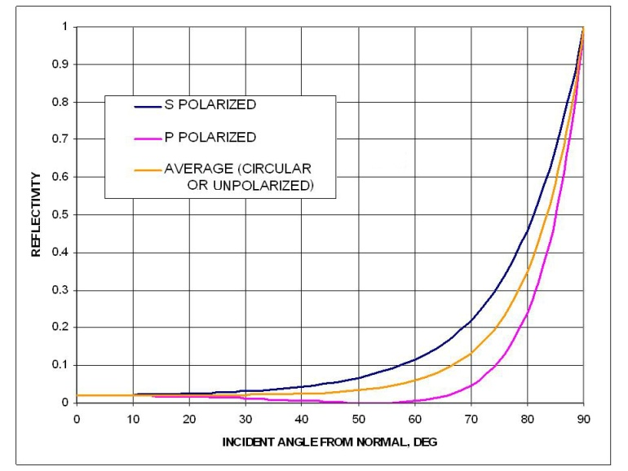
When light impinges on water surfaces, it reflects according to the angle of incidence. A chart is provided. "Incident angle from normal" means the angle from vertical or simply angle of incidence. This work refers to an angle of incidence of 48 degrees, which is apparently some type of standard. While this chart is helpful, it is for a single color of light. Fortunately, a precise measurement is not necessary for this work so I'll use this chart as the standard. If you want to get more specific, the sun emits green light at about 510nm after the low bandpass characteristic of atmospheric attenuation is considered. .
shiggles - Sh*ts and giggles - an old red neck phrase.
Oceanic Atmospheric Circulation (OAC) - OAC is the clockwise circulation of air over oceans in the Northern Hemisphere and counter-clockwise circulation over oceans in the Southern Hemisphere the Pacific Ocean due to TWF.
Oceanic Water Circulation (OWC) - OWC is the clockwise circulation of ocean water in the Northern Hemisphere and counter-clockwise circulation over oceans in the Southern Hemisphere the Pacific Ocean due to wind effects.
Northern Pacific Atmospheric Circulation (NPAC) - N PAC is the clockwise circulation of air over the Northern Pacific Ocean due to TWF.
Southern Pacific Atmospheric Circulation (SPAC) - SPAC is the counter clockwise circulation of air over the Northern Pacific Ocean due to TWF.
Southern Pacific Oceanic Circulation (SPOC) - The counter-clockwise circulation of Pacific Ocean water due to wind effects.
Solar equator - The latitude at which the sun is overhead at 12:00 noon local time.

Footnotes

