Hurricanes
Normally weather is the only factor on earth supporting life. Weather is a good thing! Hurricanes are one of the most impressive manifestations of earth's capability for destruction. There are volcanoes, which could end all biological life on the planet. From what you know is it conceivable that a string of tectonic shelf faults could be stressed to the point that a particularly large earthquake could trigger other faults to relax one after another along a fault line resulting in a line of tornados stretching hundreds of miles? Earth can truly be a mother!
You may find yourself needing to refer back to the sections on vertical weather, horizontal weather and tornado theory as espoused in this document. As of this writing, you will not find these theories anywhere else.

Hurricane generation
My primary thesis for this section is that the hurricane's eye wall is not a single entity but a collection of thunderstorms. The architecture for this thesis is that a hurricane is like a reverse sink drain. In both cases, gravity provides source energy. In a sink drain gravity exerts a force perpendicular to the horizon directly on the water. In a hurricane, force is exerted on heavier air to force surface level buoyant (heavier) air to rise.
My first challenge is to convince you that very buoyant air will move along the surface of the ocean for hundreds of miles to enter the bottom of a hurricane as depicted in the Hurricane Architecture drawing. The solution to my argument is to convince you that hurricanes can and do extend into the stratosphere. Therefore, the bottom of a hurricane can extend miles above the water's surface. In other words, the bottom of a hurricane can extend miles above the level of tropical thunderstorms.
In a manner similar to the stagnation layer of tornados there is an add humidity, become buoyant, rise, adiabatically cool, condense moisture, become heavier sink cycle that extends from ocean level up to cloud level and beyond.
I will also endeavor to convince you that nearly all the humid air powering a hurricane comes from within or near the ICTZ, that band of nearly continuous thunderstorms near the solar equator.
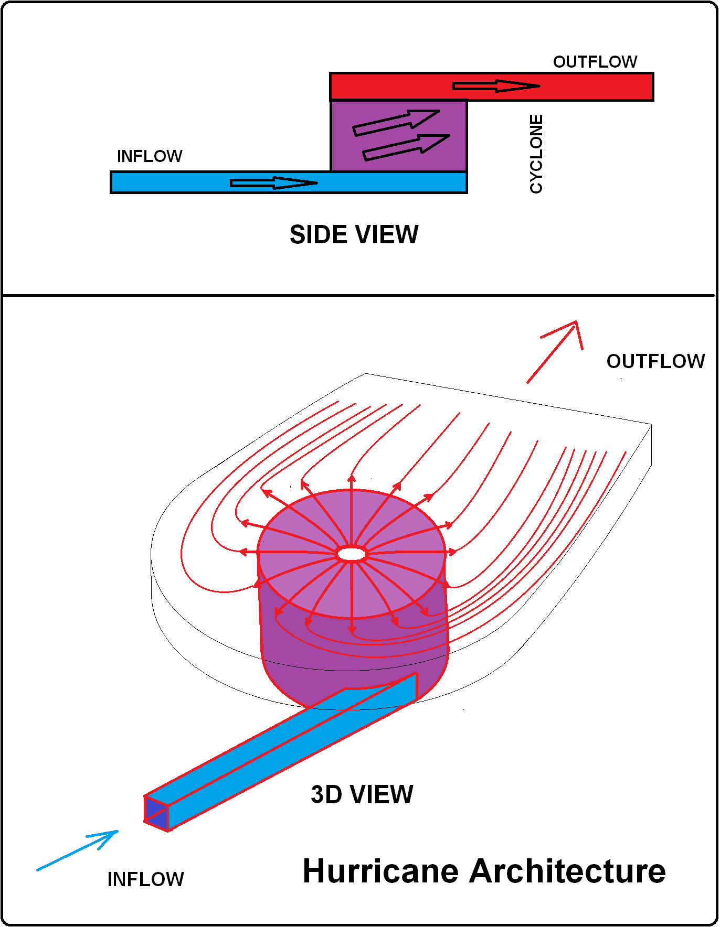
As discussed in the section on TWF, (Tangential Weather Force) the ICTZ is the result of reduced TWF and maximum solar absorption. This layer of very buoyant air extends north and south from the solar equator.
The process of creating a low-pressure zone and a hurricane are very similar. Two airflows interacting in opposite directions create a swirl. Since ocean circulatory air ~
Water temperature in the Caribbean does not create or intensify hurricanes. Despite the Gulf of Mexico's size, there is not enough energy between the water-air interface to create the humid air necessary to flood Western Carolina with many inches of rain over couple of dozen hours.
In fact water is a rather capable insulator at $0.6\frac{W}{m · °K}$. The transfer of stored heat from below the surface to the actual water air interface is rather slow, in fact much too slow to evaporate significant moisture into a saturated atmosphere which is essentially the same temperature as the water. It just can't happen.
Warm ocean water is no warmer or cooler after a hurricane has traveled over it. If there were an energy exchange between the water and the hurricane the water's surface temperature would have changed.
Rain does not cool when it falls. Explain how a hurricane can transport ocean level air into the stratosphere where it coalesces into cold rain, which falls to the water's surface without the water's surface not cool. and still be powered by the water, which it lifted into the atmosphere.
Explain how 6 inches of rain can be evaporated from the surface

Hurricane require a lot of moisture because of all the rain. When a hurricane is overheat it produces a lot of rain. When air falls it heats adiabatically. There is only one continuous band (corridor) of air from the source of low-density air to the hurricane. That band is either an umbilical cord or tail. (Tail is easier to spell!) If you follow the tail to its end, you will find this stream starts at the source of the low-density air, which powers the hurricane.
To recap,
- The essential difference between traditional hurricane theory and the theory espoused here is the source of the hurricane's energy. Traditional theory claims that local high humidity high temperature air is the source of a hurricane's power. This theory claims and demonstrates that a hurricane derives its power from close to the ICTZ. A band of high buoyancy air provides the hurricane's power. In the northern hemisphere, the hurricane's inflow air source is from a point southeast of original hurricane formation.
- The central core of a hurricane is a continuous wall of thunderstorms known as the eyewall. This document describes formation of that eyewall elsewhere. Generally speaking, rotation of the eyewall is due in large part to the off-center arrival of buoyant air via the inflow band known as the Coriolis Effect.
- In most cases, a hurricane has only one band, which wraps around the hurricane's many times. It is accurate to describe this band as the hurricane's tail. The tail becomes the primary source of buoyant air to the hurricane.
- While visible photography does not show any detail about the hurricane's tail in the vicinity of the hurricane's eye due to the cloud cover created by visible moisture over the hurricane's eye, radar analysis shows the tail extending from the ICTZ and wrapping around the hurricane multiple times before joining the eyewall thunderstorms.
- This paper discusses top and bottom fed tornados. A very similar mechanism powers a large hurricane. Surface level buoyant air provides surface level energy and solar heated thunderheads provide the storm's energy above cloud level.
- This paper also discusses inflow air's propensity to originate from the lowest density local air source. This is because of the obvious reason that low-density air accelerates more quickly for a given force.
- This paper also discusses how once an inflow air corridor through higher density air the air maintains the corridor intact and in place. Said another way, an established inflow corridor will provide buoyant air from the same source as long as the source is the lowest available buoyant air source. ICTZ air is a nearly inexhaustible source of buoyant air and as long as the hurricane is developing in areas of less buoyant air, the air inflow corridor will NOT expand laterally to established additional flow routes.
- In fact, once the first complete inflow loop is established it is the continual ingestion of less buoyant air from alternative less-buoyant sources keeps the band well formed all the way to the hurricane's eyewall.
- The outer eyewall consists of a ring of thunderstorms fed by inflow air arriving tangentially. The tangential nature of inflow air arrival, maintains the hurricane's counterclockwise flow in the northern hemisphere.
- The eyewall consists of layers of atmosphere formed from inflow air. Inflow air is primarily evaporated ocean level air of varying humidity and droplet density. The inflow air path is often hundreds of miles long.
- For a given storm intensity, inflow velocity/area profile is a function of differential air density with one exception. Sunlight heating of eyewall thunderheads increases differential density adding to hurricane power.
- Formation of a hurricane is usually as a frictional eddy between relatively stagnant ICTZ air and westward air. The westward flowing air travels at greater velocity as the latitude increases causing it to turn toward the ICTZ. The opposite effect is in place near the ICTZ causing ICTZ air to wrap toward the poles. The result is a counterclockwise flow of thunderstorms in the northern hemisphere.
- When the circle of thunderstorms is complete it includes a path for ICTZ air to flow into the base of the hurricane. This alone is adequate to create low-level hurricanes especially when there is adequate upper-level cold dry vertical inflow air.
- Inside the eyewall thunderstorms air with heavy droplets resist vertical transport (don't move upward as readily as other air) and resist vertical movement (don't fall as fast.) Air containing droplets of increasing size are 'sorted' to the outside of the rotating eyewall. This is the rain layer. Note that in this context a layer is a cylinder of air rotating helically (both around the eyewall and rising vertically.)
- Inside the rain layer (R) is a layer of air and small water droplets not large enough to see but still are significantly heavier than humid air.

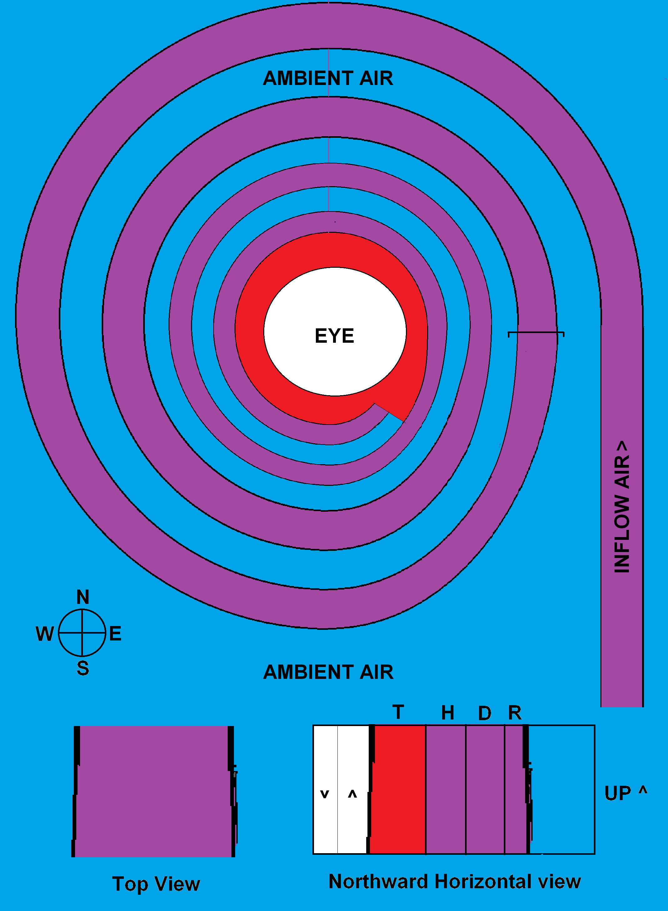
- Inside the small droplet (D) layer is a layer of moderate-temperature humid air.
- Inside the humid (H) air layer is a layer of heavy dry air.

- Inside the thunderstorm (T) layer are the constituents of a normal thunderstorm including rising humid air, small droplets and rain. At some point, the interior of the thunderstorm layer has minimal rotation velocity and maximal vertical velocity. These layers are not well defined but statistically distributed according to source air characteristics, ambient air characteristics and interior eye characteristics.
- Each layer from the outside to the inside rotates more slowly. This is due to an alternative source of cold dry air from above the hurricane. Vertical movement of the thunderstorm layer's internal wall draws air from the eye wall. The mixed air from the internal thunderstorm layer and upper level air creates relatively cool dry air that is heavier than the bulk of thunderstorm air. Since replacement air from above the hurricane is dense it doesn't rise quickly creating a markedly sharp transition from warm-humid buoyant thunderstorm air to cool-dry heavy interior eye air. When evaluating these descriptions keep in mind that the eye is probably tens of miles in diameter and the ground level inflow air spiral potentially begins hundreds of miles from the eye wall.
- The hurricane's centrifugal force 'slings' rotating air toward the outside of the vortex creating a low pressure inside the hurricane. Cold air from above the hurricane fills the low-pressure interior of the hurricane. As cold upper level air 'falls' into the eye of the hurricane, it heats adiabatically because of the increasing air pressure at lower altitude. At sea level the hurricane's vertical downward airflow air is dry and very nearly at ambient temperature.
- We now have two sources of inflow air. There is the ground level air from the ICTZ and the upper level air from the troposphere and stratosphere and the layer between them.
- There is a mixing function, which acts a bit like friction between the cyclonic layers resulting in the innermost low-level inflow air and upper level inflow air mix. The mixed air exits the hurricane. Previously invisible droplets coalesce into visible water droplets forming the umbrella like part of the hurricane.
- The dryer air propelled vertically out of the eye at the thunderstorm eye interface is lighter and invisible and continues vertically making room for more vertical inflow upper level air.
- Air containing any moisture is lighter than surrounding air causing its displacement toward the poles.
- And that is how a hurricane is generated and powered.
- The band begins at the ICTZ and extends up perpendicularly from the equator to the position the hurricane had low enough pressure to establish the tail. Because of the Coriolis Effect (There is no Coriolis Force, either real or imaginary - see Appendix).
- Because the hurricane core does not keep up with ICTZ velocity, the tail crosses the hurricane's latitude due to inertia. must overshoot and track back toward the hurricane. Again the tail overshoots and must curve toward the hurricane and toward the ICTZ a process which repeats itself until it winds down to the thunderstorms which form the hurricane's eye.
- Upon arrival at the hurricane eye storms the tail provides sea level buoyant air to the storms from the bottom.
- Air transported from the ICTZ is buoyant and rises at the periphery of the storms and exits vertically. Adiabatic cooling causes droplet formation including rain and clouds. The rain coalesced and fall to the ocean's surface cooling it. (Keep this in mind when I later claim that local water temperature has very little effect on hurricane generation!)
- Cloud droplets are propelled into the upper troposphere and beyond by the air column's inertia. Those clouds encounter tremendous solar heating, especially in the afternoon and after exceeding the ocean's glare-effect angle. Solar energy captured by thunderstorms above cloud level is the PRIMARY source of hurricane power.
- Adiabatic atmospheric cooling dries the high altitude air causing humidity to coalesce into visible cloud droplets and rain droplets, which we will return to in just a minute.
- The clear sky inside the hurricane eye is caused by moist air pumping. Vertically flowing air inside the thunderstorms
Oceans are immense heat sinks reducing atmospheric temperature and humidity differences. Density differences in water are due to either temperature or contaminates such as sea salt. As a result, vertical (gravity) sorting is from the cold (heavy) bottom of the ocean to the warm (light) top of the ocean. Without air movement, the ocean would be very stagnant, especially at depth.
I'm fairly certain that thunderstorms which fully surround ( and compose) a hurricane's eye wall were brought together by their individual tendency to travel from less dense surface level areas toward more dense surface level areas. I developed this more fully in the section on vertical weather.
This is not only possible, but likely if one of my previous theorems is accurate. Tornadoes and by extension thunderstorms, travel away from their source of high buoyancy air.
To recap the logic justifying that theorem
the area of lowest horizontal pressure differential is at the tornado funnel mouth, (bottom most area of primarily vertical travel)
- The funnel mouth is as close to the ground as possible while admitting the greatest inflow air velocity. If the mouth lifts inflow velocity decreases which decreases the mouth area again increasing inflow velocity and lowering the mouth, if the mouth falls inflow velocity ceases slowing inflow velocity)
- inflow velocity is greatest from the surrounding area of lowest external ground level air horizontal pressure because differential high buoyancy air is easiest to accelerate,
- inflow will congregate to a narrow(?) stream tangent to the tornado wall, (the overriding theorem is that greatest velocity is present at the greatest differential horizontal density)
- inflow air will overshoot the tornado wall's tangent point while wrapping around and into the tornado, (this creates a low pressure on the wall away from the point of highest inflow velocity, much like air wrapping around the top of an airplane wing)
- the process of wrapping overshoot and acceleration due to vertical differential density changes 1) creates a low pressure zone away from the source of greatest inflow air and 2) restricts inflow from the side of the tornado away from the highest velocity inflow air
In a tornado, the result is a push of inflow air inertia and pull of low-pressure air away from the area of lowest air density. Thus, the tornado (or thunderstorm) will travel away from the area of lowest available inflow air density without other external factors. While the greater amount of inflow air comes from the lowest density supply area some air comes from all points of the tornado / thunderstorm periphery, just at a reduced rate.
If you recall, this is the reason I believe tornadoes travel toward rain pumped cold airflow. In the case of an anvil cloud, the rain is falling from the anvil side of the storm creating a rain pumped down flow of cold air. The rain falls directly to the ground, not appreciably increasing humidity because of its minimal surface area. Thus, a tornado follows the nose of the anvil under an anvil cloud tornado because of rain cooling and dry rain pumped down flow air.
Back to hurricane thunderstorms.
Hurricanes that form outside the Caribbean are caused by thunderstorms, which form at the line separating westerly-flowing, recently-arrived Atlantic Circulatory Air (ACA) from off the coast of Africa. Tropical high-humidity high-heat mixes with cooler, dryer heavier air arriving from the north as previously surface-level, tropical air is displaced vertically by less buoyant ACA air. The simple act of rising causes humidity to condenses from rising tropical air creating visible droplets and eventually rain.
Keep in mind that air from which rain has condensed is heated due to the enthalpy of condensation becoming more buoyant.
The area of high buoyancy warmer humid air is to the south so the tropical ACI thunderstorms tend to travel away from the equator and toward the fresh Atlantic circulatory (trade winds) air stream. (Actually, in this case the heavier air from the north pushes under the lighter air from the south resulting in cool rain on the storm's northern periphery.
After making the westward turn, the Atlantic Circulatory Air is now expanding out into the central Atlantic Ocean to the north losing some of its westward velocity while tropical air has little initial velocity. This means that the tornado/thunderstorm tendency to flow toward least buoyant air is fully effective and will move the storms to the north and away from the tropics. We can designate the tornado's direction of travel (away from more buoyant air) as forward and that side of the tornado/thunderstorm as the front.
We can assume that all ACA/tropical storms are not be of equal size so one (probably the largest) will precede the other storms away from the tropics. Inflow air from the first storm will create a trailing zone of high buoyancy air which following storms will tend to avoid in their quest to approach the less buoyant Atlantic Circulatory Air. As following storms draw even with the trailblazing storm they will move around it to gain access to the cooler-denser ACA air. In fact, the combined action of two or more storms will create a slower but significant flow of denser air in their common or overlapping area of influence. Other storms, which also began life at the tropical / ACA boundary will pass the original storm's vertical progress and vector toward the river of Atlantic circulatory air.
Keep in mind that there is still eddy current mixing and inertial thermal and inertial energy sharing at the boundary. This process will slow Atlantic circulatory air at the boundary while the northern edge of the thunderstorm cluster is still progresses at full velocity. To say it another way stagnant tropical air is stationary while ACA air pushes the northern most edge (top) of the thunderstorm west imparting a rather large eddy current (pinwheel shape) spin to the storm cluster. This initiates a counter clockwise twirl of thunderstorms. This reminds me of the boy rolling a hoop with a stick in the 19th century. Eastern thunderstorms will tend to bypass the original thunderstorm beginning the CCW (anticlockwise) rotation of the thunderstorm cluster. Guess: I do not believe that the hoop roll action is as important to the process as the organized orientation of all thunderstorms to a single lower density zone, but we must consider both effects.
Let's now examine a micro effect of tornado genesis, namely the inflow of higher density air on the side away from maximum inflow. Bear (sic) with me, as this is very difficult to elucidate, especially when using words like elucidate. Air ingested at the front (side away from the highest buoyancy air) of the tornado is actually entering at a point vacated by rear air which has been accelerated both around and up into the tornado wall. In other words, air that was in the front of the tornado must move around the bottom of the funnel before it can enter the funnel bottom. This is because the air coming from the higher buoyancy region has much higher velocity.
Thunderstorms must have vertical air acceleration due to increased ground air buoyancy therefore, there must be inflow air to replace the rising buoyant ground air. In the absence of other influences, buoyant inflow air will arrive at a higher velocity than other ground level sources. The weight (mass acted on by the force of gravity) of cooler less buoyant air covering the inflow air before the more buoyant inflow is accelerated determines inflow velocity. Momentum transfer is a function of the square of velocity. Thus changes in ground level buoyant air velocity is dominant in momentum transfer as compared to more massive air from other directions. It is counter intuitive like much of my findings, but based on solid science. (and mathematics)
Eventually, the primary and secondary storms will migrate to point in the direction of least buoyant air. Remembering that with a solitary tornado eye wall, diameter is proportional to inflow velocity, which is proportional to differential air density (buoyancy). The relationship is not linear but it is mathematically continuous. (the derivative doesn't change sign)
Ok, up to this point I've got the Indians (thunderstorms) to circle the wagons creating the hurricane wall, but have still avoided the big hole in the center of a tornado. I shall continue to do so.
So, what is the power source for the hurricane?
The first root power source of hurricane power is the cold air drawn into the center of the hurricane eye from above the tabletop cloud. I continue to harp on the differential density (or buoyancy) of air, and hurricane dynamics are one of the most impressive demonstrations of that necessity.
It is cold and dry air potentially from the stratosphere. You know it is cold because of the altitude and you know it's dry because of the lack of visible moisture at such low temperatures. The second root power source of hurricane power is the moisture injected into the wall thunderstorms.
I have studiously evaded talking about processes outside the phase change region of liquid waters extremes except in the most general terms - until now. It is easiest to talk about temperatures and humidity in the range exhibited in the Continental United States. I do not talk about the temperature extremes of clouds, which form combination tornados because it is not necessary to explain the process.
Discussions of hurricanes begin outside the Continental United States and the energy involved requires much greater temperature extremes. I am going to claim that the close confines of hurricane wall thunderstorms provide the tremendous power of hurricanes. Hurricane Wilma (2005) is my first proof with an eye of 2 miles diameter and 184 mph winds. Wilma was the strongest Atlantic Hurricane. Then there is Hurricane Patricia with a wind radius of 25 miles and a seven-mile diameter eye. I come from an area with the largest consistent tornado intensities but even the largest and most destructive single tornados have a destruction path of about one mile width. Large hurricanes can have cloud cover of over 1,000 miles and tornados can have debris funnels a miles wide but the real power is in close and tight.
I contend that the land combination tornado has the greatest power because its power is both from high sun driven clouds and ground based moisture. I contend that the differential buoyancy of super-cold, super-dry high-altitude inlet air mixing with hurricane surface level, moist sea air in the hurricane wall powers these monsters.
Inflow air from 40,000 feet can be as low as .53 kg / m³ and 1.23 kg / m³ at sea level. Air descending from 40,000 feet will increase in temperature 144 ° by lapse rate alone. This means the 0% humidity -70 degree F air at 40,000 feet will compact to 230% of its original density and warm to 74 ° when descending a hurricane's eye. The density value is important because for a given tornado eye diameter the vertical surface speed will be 43% of the value when entering the hurricane eye, reducing air momentum allowing it to decelerate before mixing with eye wall tropical air - assuming a consistent eye wall diameter. In other words as air travels down from the stratosphere it is conditioned to maximize its ability to absorb humidity (0% humidity and 70+ °) and facilitate the mixtures ascent to the tabletop cloud. Oddly enough, the shading provided by the tabletop cloud is the only limiting factor to inflow air volume.
This miles-wide column of air descending from the stratosphere is part of the fearsome engine of the hurricane. The change in temperature of air arriving through the upper air portal is at nearly perfect mixing temperature with the warm-humid tropical air. The volume of air is limited only by the vertical lift provided by humid tropical inflow air.
Humid-tropical air is the source of hurricane power. Cold-dry upper atmosphere air provided through the hurricane's eye enhances the humid-tropical air's effectiveness.
Upper atmosphere vertical air inflow is the push power of a hurricane. Yes, nature is very consistent so there is a very significant pull factor and if you followed the Combination tornado discussion it is a familiar source.
If you look carefully at the clouds surrounding a hurricane's eye wall you will notice there are very high clouds directly above the eye wall thunderstorms. This was my personal key to understanding the hurricane blueprint. The pull is tall clouds collecting solar energy through radiation. Multiple gigawatts (scores of nuclear reactors) of energy are captured by each towering cloud in the afternoon sun.
- These clouds are in the upper atmosphere and approach 93 watts per square foot, much higher than on earth's surface. (5,280² * 93 watts * 40% energy capture percentage = 1 GW per square mile and each cloud is miles high and miles wide)
- They are fully illuminated unlike thunderstorms under the tabletop cloud.
- Air reaching that level has quickly transitioned from sea level to stratospheric level.
- In this case, water droplets act much like the vertical rain pump (discussed in Real World section of this paper) causing rising moisture and warmer air to flow horizontally after leaving the hurricane eye wall.
- They provide an increased height 'chimney' forcing higher altitude air into the hurricane's eye.
You see the high altitude inflow air provides the temperature differential and more importantly humidity differential to sustain such a powerful structure.

Cold air from above the tabletop cloud enters the eye traveling vertically to replace warm moist air in the hurricane eye wall. The warm moist air is the result of mixing of thunderstorm warm moist air with cold dry air resulting in highly buoyant medium temperature (not a large driver) very humid (very large driver) air with tremendous amounts of lift. This mix of upper level air and surface air is the power source for hurricanes.
You must pay particular attention to the tabletop cloud because it indicates airflow after mixing air exits the hurricane eye. There is some overshoot due to inertial momentum but the air generally takes horizontal turn and moves away from the hurricane's eye. Solar radiant energy has to be the overall source of energy since it is the only source of energy of the required magnitude, yet all the thunderstorms traveling into the eye are shaded by the tabletop cloud.
This brings up the difference between isolated land locked thunderstorms and ocean going thunderstorms. Plant humidity and respiration in ground level air are the primary source of ground level energy and of limited volume. Warm ocean water is in effectively infinite supply in the middle of the Atlantic Ocean. Tropical areas have fewer breezes to stir surface level humid air allowing ocean level humidity to build.
When comparing tornados to hurricanes one must consider that tornados require acre size areas to begin and square mile size areas of increased humidity to be self-sustaining. (again according to me) Hurricanes have hectare size areas to develop a number of thunderstorms and hundreds of square miles to provide energy sustenance once those thunderstorms have organized into a hurricane structure.
The question was, "What is the source of energy in the feeder band thunderstorms covered by the tabletop cloud? This has been the toughest question to answer (for me) so far. My top driven tornado theory is adaptable to the thunderstorms in the hurricane's eye. You can see the afternoon shadows of the tall vertical clouds harvesting thermal energy from afternoon sunlight. Ironically, this question provided the insight for bottom driven storms in the vertical weather section of this paper.
Feeder bands are much like the single thread of high velocity intake air of isolated thunderstorms. This is firmly established by analysis of drone video footage of high-intensity tornados. Air from 50' away from the tornado's base and 20' away from the feeder band has a shorter path to the feeder band than to the base of the tornado. This phenomenon creates a few (usually 1) streams or feeder bands from low-density areas around the tornado's base.
Hurricanes tend to be on the boundary between the tropics and low velocity (extremely low differential velocity) ACA western breezes. Therefore the area of low density air is nearly infinitely deep (extending southward from a prospective thunderstorm in the Northern Hemisphere) As I mentioned before there will probably be a number of initial thunderstorms each which establishes its own stream or feeder band. As the thunderstorms congregate toward the eye wall, they each establish and sustain their own feeder band. The feeder bands transport high-humidity air from the tropical area providing the energy to sustain themselves. I have no data but I suspect you will find that each feeder band sources air from both sides that is, toward the hurricane eye wall and away from the hurricane eye wall.
This makes each thunderstorm in each feeder band self sufficient with surface level humidity flowing from the tropical side of the hurricane eye wall which rises toward the bottom of the table top cloud, but reaching an equilibrium point below the table top cloud because of the lack of vertical stimulation normally provided by sunlight on taller clouds.
Simple answer is, "Under the table top cloud thunderstorm energy is provided by the limitless supply of tropical moisture at the base. The lack of a normal top driven energy source due to lack of tabletop cloud sunlight transmission limits the clouds to below table top level. When the tops of feeder clouds approach the tabletop cloud bottom cold table top air condenses feeder band moisture causing rain limiting vertical thunderstorm development.

"Woah, there big boy what is the big hole in the center?" you might ask. You have just hurt my feelings by calling me big boy. I am losing weight - occasionally.
The hurricane wall is warm and very humid air. Air from the wall storms spiral upward its warm-humid air mixes with air contacting the hurricane walls. So there is a vertical spiraling air flow in close proximity with the hurricane eye wall that travels vertically. There is also cold heavy dry stratospheric air above the tabletop cloud. The cold, heavy, dry stratospheric air falls into the eye replacing moist, high buoyancy air being raised and ejected horizontally. The eye wall is a rather large centrifuge. We are beginning to have a bit of knowledge about natural centrifuges. Heavier stratospheric air displaces moist, high buoyancy air in the wall rather violently creating nearly instantaneous mixing. The damp, lukewarm medium buoyancy eye wall air is ejected into the table top after mixing. The ejected air is quite visible because it contains quite a few water droplets, which remain suspended and liquid because they are ejected into very cold ambient air.
My theorem that high buoyancy air will route into the tornado after concentrating into a stream is also true for hurricanes. As far as I know hurricanes have a single feeder band consisting of thunderstorms caused by high humidity air entering the hurricane death spiral. I say death spiral because once again heavier air without moisture is separated toward the hurricane's periphery while high buoyancy air is concentrated in the clear areas of the bands.
"Hold on honcho," you bellow. Aren't the bands visible?
Each band consists of a visible portion containing visible water droplets and an invisible (clear) portion. There is rain in the visible portion, quite a lot of it in places. Therefore I claim that the two parts of each feeder band are the dry portion separated from the wet portion by centrifugal action. The dry portion is heavier and the wet portion is lighter air. The dry portion is clear and the humid portion has a lot of humidity. Lighter humid air cools adiabatically, as it rises creating condensation which heats the remaining air causing it to continue to rise while still lifting water droplets. The water drops coalesce into rain pumping cool air down to water level. Remaining dry cool air moves away from the center of rotation through centrifugal force keeping the bands separated.
The thermodynamic math in the feeder bands is nearly as complex as neutron propagation in an atomic reaction.
To recap:
- Mixing of tropical air and Atlantic boundary air creates multiple thunderstorms in close proximity.
- The thunders storms congregate by self-steering to encircle an area of low buoyancy.
- The common high-density area between storms promotes a vertical wall formation enhancing mixing of low-density and high-density air before ejecting them horizontally into the tabletop cloud.
- The vertical movement of air mixed in eye wall air creates a void filled by cold-dry-heavy air from the stratosphere (or at least above the tabletop cloud.)
Doesn't it seem sort of anti-climatic when explained that way.
I think this initiates when a thunderstorm ingests low moisture air such as might be available due to the down rush of rain pumped air. My guess is that this is from a second thunderstorm.
Once rain has created the downdraft a second storm (or possibly the first storm) ingests the rain pumped air and moves at an angle. When they encounter an energy deficient area they tend to continue to veer until better flow is established. Thunderstorms and tornadoes tend to develop toward high-humidity air and away from low-humidity air.
Yet another thunderstorm is moving toward the cluster and encounters the cold air downdraft and also diverts until it is in line with the previous thunderstorms avoiding the cold air downwash. Thunderstorms arriving from the north will diverge to the west. Thunderstorms arriving from the south will diverge to the east. Soon thunderstorms fully surround the eye of the developing hurricane. Upward vertical pumping of the hurricane's internal eye wall provides the energy to pump in air from above the tabletop. Interior eye wall air helps maintain the eye's interior dimensions.
The tabletop cloud is created as eye wall air is ejected. Vertical internal eye air is dry compared to above tabletop air but humid compared to tabletop ambient air. Air ejected from the eye (B) contributes to the tabletop cloud. The tabletop's top surface is determined by exiting humid air condensing as it travels horizontally from the top of the eye wall to entering downward inflow air. The upper boundary for air ejected from the eye is air entering the eye. (A)
Sunlight can't penetrate the tabletop keeping starving thunderstorm tops of energy.
Cool eye downward flow air (A) determines the tabletop's top surface. Humid air rising from water level in between thunderstorms determines the bottom of the tabletop.
Below tabletop hot-humid air inflow determines the eye's outer diameter. The vertical sides (nearly perpendicular to water surface) indicate that hot-humid inflow air is arriving at about the same velocity for most of the eye's external height.
Rising eye inflow air (B) mixes with eye wall air becoming more humid and warmer because of turbulence mixing. Both heat and humidity cause eye inflow air to expand as it flows down in the center of the eye..
If you examine the tabletop cloud formation you will see that it extends well past the hurricane's vertical air chimney, or wall. The tabletop provides what, at first, seems to be an important limiting function to the hurricane because it intercepts sunlight to the hurricanes feeder band thunderstorms. Like land hurricanes bottom fed thunderstorms and tornadoes have energy to continue for hours in low or no sunlight conditions. The only requirement is ocean level hot-humid air.
Check out the shadows popping up as the thunderstorms rise when they arrive directly below the eye wall exit. When feeder band thunderstorms reach the eye they become top driven monsters with energy supplied from water level (humidity driven) and upper air level (sunlight driven) in a push pull configuration. This configuration is the same as the largest land tornadoes.
Hurricanes formed at the confluence between either south-moving less buoyant air from the arctic over Africa or less buoyant south moving air from the North American continent. African hurricanes form when the south moving air vectors to the left resulting in clockwise (from space) motion. Static equatorial air to the south and west moving air to the north encourages the initial cyclonic action so close to the equator. It's sort of like pushing the top of a tire to the left while it is resting on the ground. The tire will move counterclockwise.
The weight of the dry-southbound, less-buoyant air is billions of tons. The air mass has accelerated for days.
Caribbean generated hurricanes form at the intersection of southbound moving weather fronts and a strong persistent weather fronts. A southbound cold front and north bound warm front forms a counter clockwise weather flow north of their intersection. The southbound front accelerates the storm south on the west side while the northbound warm front accelerates the storm north on the east side.
After all is said and done Atlantic Hurricanes are eddies created by the interaction of front driven (horizontal or tangential flow) atmospheric interaction. Interactions between horizontal or tangential flow fronts are also create continental low-pressure zones.
A hurricane is a circular front that wraps around a central point once circulation is established. Warm moist air is brought toward the 'eye' of the storm where it its buoyancy gives vertical velocity into the upper atmosphere. Upper atmospheric cooling creates clouds and rain.
My guess is that upper air currents bring in cold air in the space between the hurricane's core and upper atmosphere. To say that a different way, there is a volume between cloud level and dispersion level created by the high velocity (and volume) of rising air. The hurricane's rising air doesn't disperse locally but rises well above cloud level before dispersing into the tabletop. There is a calm area between the bottom of the table top and the highest inflow thunderstorms. Inflow air is from all directions, but the areas with the highest velocity create thunderstorms through the contrails, which develop into top driven thunderstorms.
Just like the tornado, the pinwheel thunderstorm effect is simply an artifact. The arriving thunderstorms are not 'converging' to create a hurricane, vertical airflow creates the hurricane and the surrounding thunderstorms are a result. Thunderstorms converge in an orderly manner to create hurricane eyes through cold air inflow, which becomes shared by multiple thunderstorms.
Do you have an idea about the next patent? I'll finish this after I've done the patent paperwork.
After consideration, the rarity of African generated hurricanes is amazing. They are more common because they have much more time to organize. Gulf of Mexico and Caribbean hurricanes develop quickly because they have higher differential vertical buoyancy. Yes hurricanes are created as horizontal weather eddies from a collection of vertical weather thunderstorms.
We can call the volume between horizontal inflow (E) at ground level and horizontal outflow (D) at elevated altitude the dry bubble. Horizontal outflow gradually cools by the upper atmosphere releasing rain and cold vertical outflow some distance from the hurricane's eye, reducing the effect of self-moderation experienced by a tornado.
Finally we get to the punch line. How does the hurricane eye form?

Recall from previous sections
Tornados and thunderstorms travel toward less buoyant air sources and away from more buoyant air sources.
- Rain falling in the direction of travel pumps cold air from above cloud level to ground level.
- Rain continues to fall to the ground while cold dry air is diverted horizontally by the ground providing a flow of cold air.
Add to this that:
- Thunderstorms will congregate to a source of low buoyancy air.
- Wherever two or more thunderstorms congregate they will bunch around a source of low buoyancy air.
- When multiple thunderstorms are providing rain, the effect is cumulative.
- Once downward vertical airflow is established in what will become the hurricane's eye the negative lapse rate, (increase in density with loss of altitude) will tend to perpetuate downward airflow.
- The one caveat is that the flow of mixed surface level air and high altitude air cannot exceed downward high altitude air. In fact, I posit that the mixed outflow rate is the determining factor in eye size (diameter).
- Hurricane eye size is proportional to inflow velocity. Inflow velocity is proportional to the differential buoyancy between surface inflow air and fallen high altitude air.
Congratulations, you now have an infant hurricane. In other words, you have a hurricane the second downward inflow air becomes self-sustaining. You also have a congregation of thunderstorms with a common source of cold-dry air, which mixes with high-humidity warm surface air providing the power to pump cold air from the stratosphere to the surface.

Push pull energy sources
In a fully developed hurricane the energy source is not only hot water at water level, it is sunlight at upper levels. Sunlight heats the top of a hurricane causing vertical movement from ocean to the hurricane's tabletop. The tabletop heats, but not evenly.
There is an eye wall bump where upward rushing air can't immediately transition between vertical and horizontal movement due to inertia. The bump manifests itself as multiple cloud peaks around the hurricane's eye. Morning and evening sunlight heats these peaks more than surrounding air increasing in cloud become buoyancy.
The volume and buoyancy of ocean level moisture moves air more quickly than upper air (which is thin) condenses the humidity into rain. Clouds and rain are distributed over a wide area away from the hurricane's eye eliminating the cool air feedback control mechanism present in tornadoes.
Buoyant air fuels both tornadoes and hurricanes at near ground (sea) level. The buoyant air comes from a single direction or the storms total periphery.

Hurricanes
The primary difference between a tornado and a hurricane is scale. The scale of a hurricane creates a single defining difference, the tabletop cloud. I contend that the tabletop cloud is the primary clue to the origin of hurricanes. I go on and on about flat top clouds when discussing tornadoes. The hurricane's tabletop cloud is a flattop cloud shared by a number of thunderstorms. Oh yeah, it's got this really big circular hole nearly in the middle of it.
Both cloud tops horizontally distribute rising air with visible water droplets horizontally, whether it is the crown on top of an isolated thunderstorm or a massive hurricane cap cloud with a hole for cold-vertical-downward airflow. Water droplets in the cloud grow to the size they can pump air and their mass is adequate to change air's vector 90 degrees. The trigger to turn vertical airflow to horizontal airflow is atmospheric conditions not dense enough to 'float' the water droplets and a lapse rate capable of wringing all humidity from the cloud into droplets which coalesce into raindrops.
The hurricane gives one more clue about the tabletop cloud's relationship with the eye wall. The clear (cloudless) area between the tops of thunderstorms and the bottom of the table top cloud indicates that dry air is ejected below the tabletop cloud. My old friend centrifugal force again takes center stage. Humid air is most buoyant, humid air with very small droplets is second most buoyant and cold dry invisible air is the least buoyant.
Centrifugal force separates suspended objects by mass. Cold air from the stratosphere 'sinks' into the hurricane's clear eye warming as it falls due to adiabatic warming. At bottom of the eye cool-dry-high-altitude air is horizontally drawn into and through the hurricane eye via inertial interaction (due to eddies) with the spinning, rising eye wall. Because dry clear air is the heaviest air, it is 'flung' toward the outer eye wall. Some makes it all the way to the outer eye wall and travels horizontally below ambient air containing visible moisture droplets (the bottom of the table top cloud) to at least the edge of the tabletop cloud. This prevents more buoyant air from the hurricane wall mixing with cold, dry, high-altitude inflow air enhancing hurricane power.
In the hurricane genesis section I discuss how centrifugal action sorts the humid air from the dry air. Lighter humid air migrates toward the hurricane's inner wall. Dry air from above the table cloud enters down the hurricane eye's center and exits up the hurricane eye's wall while mixing with surface level humid warm ai. Intermediate (mixed dry upper-atmosphere and humid sea-level air) air exits on a vertical anticlockwise spiral path Air with water droplets is too heavy to continue rising so it settles at the table top level causing the table top cloud to expand outwardly (horizontally). A flattop cloud is a flattop cloud whether it covers a large thunderstorm or a cluster of organized thunders storms organized into a hurricane.
I've heard stories of people in tornados seeing blue sky through the tornado's funnel. There is good evidence that heavier water droplets are flung out of the tornado center leaving nearly pure light humid air in the core. In other words, one of the positive feedback mechanisms for a tornado is that its rotation sorts heavier air to the outer edge and beyond while encouraging the most buoyant air into the funnel's center. Sorting buoyant air to the funnel's center increases lift and internal air velocity. I consider this one of the primary methods of establishing and maintaining the tornado chimney.
The enhancement mechanism for a hurricane is doubly complex.
The rising happens at lower levels and the horizontal transport happens at the uppermost level as the dry air with visible water droplets move toward the hurricane's center.
I've emphasized earlier that high humidity air separates into to water droplets and warmed air. The warmed air is more buoyant and the small infant droplets are simply along for the ride. So high humidity air rises to a point where the moisture condenses and the heated air continues to rise or migrate toward the axis of a centrifugal system.
The clear air between thunderstorms is actually very humid air without water droplets.
The tabletop is the continuous circular cloud with a hole in its center one sees from altitude. A developed hurricane collects extremely high altitude air (A) which is drawn into the center of the eye. This is eye inflow air. After eye inflow reaches the bottom of the eye it is drawn to the wall of the hurricane by momentum created by interaction between the dry inner wall and inlet air. Some of the momentum of water-level air transfers to the cold-dry eye inflow air causing it to rise with wall air (B) and exit the eye.

Hurricane eye structure
Note that eye inflow air is traveling down. Coriolis forces are clockwise because eye inflow air rotates clockwise as seen from overhead. The dynamics are difficult to explain but any fluid tends to add its momentum to any fluid it contacts. Once established, upward vertical air movement near the hurricane's interior eye wall pumps air up from the bottom of the hurricane's eye. Eye wall air is replenished from the top of the eye.
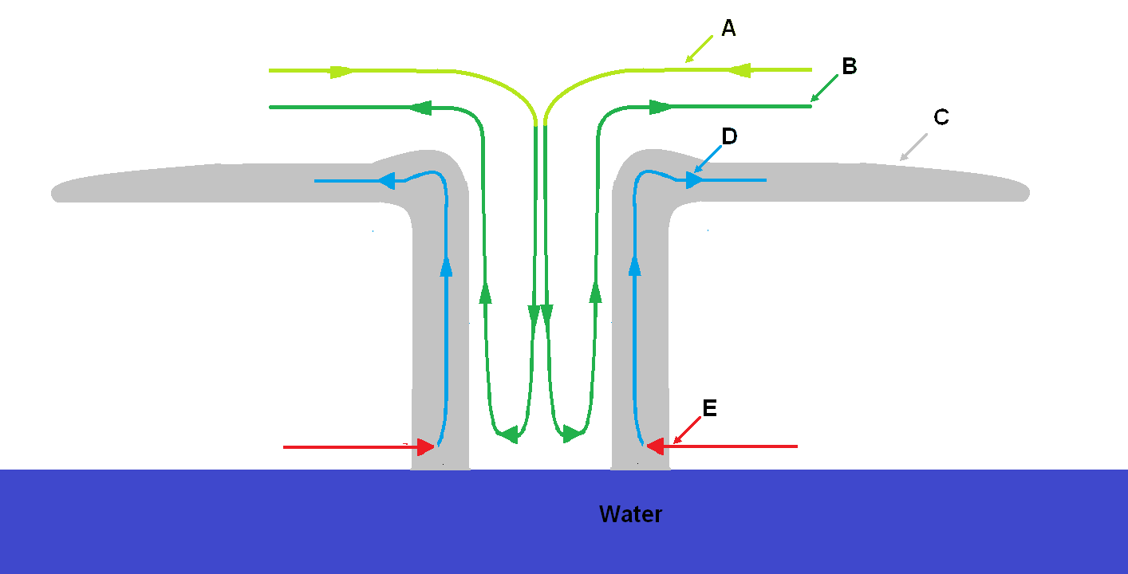
Keep in mind that eye downward inflow air comes from an extremely cold and extremely dry portion of the atmosphere. The eye inflow air compresses as it descends the center of the tornado's eye. Eye inflow air warms as it descends inside the hurricane's eye. Eye diameter is determined by centrifugal forces on the inside interacting with the inertia of ground level hot-humid sea level inflow air.

Takeaways so far
Local effects create vertical weather, which develops vertically due to vertical (perpendicular to the earth's surface) air buoyancy. Centrifugal effects create horizontal (tangential to the earth's surface) weather on a continental scale due to centrifugal effects on air buoyancy.
Some tornadoes are the result of warm-humid surface air setting above cold-dry cloud level air. This is often true of smaller isolated thunderstorm based summer tornadoes.
The two primary initiation events for larger tornadoes are above-cloud heating of thunderheads in the case of vertical ('supercell') tornadoes and cold front overrun of high buoyancy ground level air by low buoyancy air for horizontal (front generated) tornadoes.

Author's note This is a little white lie. You can find the ICTZ from satellite pictures by its consistent and constant band of thunderstorm clouds. Those clouds increase the albedo at the ICTZ reflecting solar radiance into space reducing ocean temperature below those clouds. The humidity is largely due to constant rain induced downdrafts. The rain induced down drafts are largely caused by southbound oceanic circulation airflow wedging under tropical air forcing humid surface level up in the atmosphere causing adiabatic cooling creating rain in the vicinity of the thunderstorms.
Author's note The tornado's mouth is not so much a function of the tornado's diameter at ground level, but the distance of the mouth from the ground. VERTICAL INFLOW If the tornado wall fully set on the ground there would be no route for inflow air because the spinning vortex ejects air due to centrifugal action. The direct inflow area is ridiculously difficult to define because of air vectors and gaseous momentum. I am certainly not a Dr. Bernoulli. Bu being an author I can partake in a bit of literary license. The vertical inflow area related directly to the tornado vortex is 3.1416 (pi) times the square of half its diameter. A = $\text{π * }r^{2}$ HORIZONTAL INFLOW Of course it's not that simple. The air is arriving horizontally so the inlet for horizontal inflow is $pi * D * h$ where pi is 3.1416, D is the tornado's wall and h is the height of the bottom of the tornado above the ground. Keep in mind that as inflow enters the tornado's interior it has to make some rather drastic changes in direction and velocity. The simplification here is that the horizontal inflow area has to be somewhat larger than the tornado's ground level vertical corridor area.
Author's note - Line in this case is slightly misleading but a better single word escapes me. The direct interaction band between ACA and tropical air might be hundreds of mile wide (from north to south.) Because of wedge displacement ACA air might extend dozens of miles under tropical air.
Author's note There is no implication that all the ACA flowing south on the eastern side of the northern hemisphere Atlantic Ocean turns west. Some pops up into the stratosphere due to channel area reduction and collision with stagnant (relatively) tropical air and some travels into interior Africa. The air is so dry that it is the reason northwestern Africa is a desert. The same air current carrying Caribbean moisture north makes northwestern Europe cold and wet. Remember all of Europe is north of Washington, DC. All of England is north of Bangor Maine. Thus it is no wonder that near Arctic cold wrings the moisture out of the air like a used wash rag. P.S. In the Pacific very similar circumstances make Washington State wet and Los Angeles a desert.
Author's note - Tornados have large air velocities and energy differentials compared to tornados therefore their propensity to travel toward less buoyant air and away from more buoyant air is not as great.
Author's note - Do not declare bullshit! Lower density air is less difficult to accelerate therefore achieves greater velocity in a given time.
Author's note This is important to keep relatively warm-moist surface level air from mixing with upper level air and removing energy from upper level cold-dry air.
Author's Note This theory is according to me, so don't forget the grain of salt. Get it? Ocean water and salt it wasn't on purpose, but I will still take full credit no matter how small. In any case I do hope that no one will take any of this as gospel, it is not. I believe the theory is reasonable and consistent probably with small discrepancies, or maybe a larger logical or mathematic fault. I have very strong belief in both genesis and energy portions of my tornado theory. I have a very strong belief in my tangential weather theory. I like my hurricane theories but wouldn't bet the farm on them, especially if I had a farm. The best of all worlds for me would be to have the theories investigated by people with no vested interest, especially non-meteorological thermodynamic physicists and fluid engineers.
Author's Note - I left in the guess because I didn't know at the time I wrote this.
Author's Note - I wrote this paragraph before I investigated hurricanes at all. Since I was on a roll, I soldiered on. That is the power of theory -based science. I knew that the upper atmosphere is a series of shields to vertical air movement. I guessed that the hurricane's vertical air velocity and volume was adequate to penetrate higher without a shield. It was obvious that if the tabletop was acting like a thunderstorm cloud there would be a continuous blanket or rain to the edge of the table top. If all that were true, why didn't the rain quench the hurricane? It was obvious that the tabletop didn't induce rain. Q.E.D. There must be a source of inflow air above the tabletop and there must be a source of inflow air at ocean level. Did I mention that I survived Hurricane Elena?
Author's note Fallen here refers to high altitude air which has traveled down to mixing level in the eyewall. It is rather obvious that the mixing level is quite low. I suspect (guess) that mixing can continue all the way from the surface to the tabletop cloud.

