Tornados
Tornados are primarily the result of vertical weather.
Tornados are a result of gravity's influence on air of differing densities. Gravity accelerates objects at 32.17 ft/sec² toward the center of the earth. All cyclones discussed here and especially tornados and hurricanes require gravity's force to provide atmospheric sorting due differential density.
TWF will be the focus of attention when discussing cluster tornados.

Vertical Weather Tornados
As discussed above tornados are circulating vortices of vertical moving air. Lower level air is usually warmer and contains more humidity than upper level air making it buoyant. Upper level air is usually cooler and dryer making it heavier. Like a child's teeter totter the heavier air will displace lower air if there is an established flow path.

Stagnation
The most mysterious part of vertical weather is stagnation. Stagnation is the unnatural state that occurs when a layer of heavier air sets quiescently over a layer of lighter air.

The lava lamp
Observation of a 1960's era lava lamp demonstrates the concept of vertical fluid motions. The lava lamp is filled with two fluids with a fixed buoyancy/temperature characteristic and nearly equal buoyancy. Given enough time in a fixed temperature environment, the heavier fluid will displace the lighter fluid at the bottom of the lava lamp. An ordinary light bulb heats the transparent fluid vessel the bottom and illuminates the semi-transparent fluid mixture.
The light bulb heater heats the heavier fluid on the bottom of the lava lamp adequately to reduce the heavier fluid's density. Since the heating can't be perfectly-uniform, the now lighter fluid will begin its languorous migration to the top of the lava lamp by creating a bubble shaped volume that resembles a drop forming at the bottom of a cave stalactite. The bubble eventually breaks free of the bottom fluid layer and 'floats' (is displaced vertically by heavier fluid) to the top of the lamp. Once at the top of the lamp the bubble cools increasing its density and returns to the bottom of the lamp.
Q: The question is, "Does the atmosphere operate the same way?"
A: Not always.
Q: Why?
A: Because the atmosphere's density/temperature curve is not linear.

Humidity non-linearity `
The mixture of air and evaporated water is definitely not linear. Temperature and humidity are the primary factor controlling the atmosphere's density. The above illustration demonstrates that as ambient temperature rises humidity's contribution to density increases greatly.
The concept of buoyant air trapped below denser air is a primary concept to this discussion. Please temporarily accept that buoyant air at ground level powers large tornados and that tornado activity is greatest by number and intensity during the spring.
Solar heating increases ground level air humidity. Plant life also increases ground level humidity. Plant life emits gaseous water (humidity) during spring months through the processes of photosynthesis and respiration. The amount of absorbed green sunlight limits photosynthesis humidity generation. Respiration is a 24 hour process particularly when seeds are germinating. The process of creating a plant from its seed metabolizes sugar stored in the seed. Metabolism creates a lot of oxygen and humidity. Metabolism increases with temperature. So increases in temperature increases humidity directly and multiplies that effect through increased plant metabolism.

Near ground stagnation
Just as a reminder, we're trying to determine why lower density ground air will not bubble up through higher density air like the liquids in a lava lamp. I have established that 1) atmospheric density to temperature ratio is not linear when humidity is a consideration, and 2) ground humidity increases during the spring growing season and 3) most tornado activity is during the spring growing season, which I've assured you by edict.
Having grown up in farming country, I will assure you that human agriculture is enhanced by plowing huge areas of land for the purpose of granting atmospheric access to accelerate early growth.

This multiplicative effect of temperature and plant generated humidity is the root cause of spring tornados. Everybody noticed the effect. This is the cause of some bottom driven spring tornados.
It is NOT the cause of the monster tornados.
Some tornados originate solely due to vertical flow of low-level air. Others originate due to vertical flow of high- level air.
As a result, I have divided tornados into bottom driven tornados such as dust devils and top driven tornados such as isolated supercell tornados and combination tornados such as front generated (cluster) tornados, which cause so much simultaneous damage over wide areas.
I began by developing the theory of atmospheric cyclones solely created and sustained by local air density differences. First was the simplest tornado, the dust devil, which fascinated me so much in my youth.
I then tackled the waterspout but couldn't resolve the increased power of a tornado over water vs. a tornado over ground. I correctly assumed water was the difference and it was. This was decades ago.
Over the years and for different reasons I learned about the effects of humidity on air. Humidity's effects on the atmosphere were the difference between dust devils and waterspouts. The energy budget and circumstances for bottom driven tornados did not adequately explain the power of some isolated supercell tornados.
I looked at the time of year most tornados occur, which is spring. I then realized that most of the monsters were near agricultural areas. Hot damn! What moves more water than plants? After quite a bit of research I had an idea of how a plant's life cycle could explain spring tornados.
At first, I was stuck on the fact that tornado season starts before crops are of an appreciable size. How could plant photosynthesis increase local humidity when they were so small. I kept looking and learned about plant respiration. Plants store sugar during the growing season and digest it at budding time burning their stored sugar, just like a hibernating bear. This gave me a power source (humidity) for early spring tornados.
My humidity theory would live to see another chapter.
But there was still a much more heinous level of tornado to explain. Ground heat and humidity wasn't adequate to power the monster tornados. I could see an F1 or F2 tornado but the power wasn't there for the F3 and above monsters.
I then literally decided to take a 60,000-foot view of the problem(s) and developed top driven tornado theory to explain the incredible power of an isolated supercell tornado.

Cluster tornados
Cluster tornados will make a person dramatic and I am certainly no exception. However I'm the one that decided to do something about them.
Living near the 35th parallel I developed a special interest in cluster (weather front driven) tornados. I have been literally dodging these monster stand-alone vehicles of destruction for decades. You cannot understand the respect and fear one of these behemoths unleash until you have stood on a hill in the half-mile wide swath of an F4 tornado which razed everything in sight to the ground for a far as you can see in either direction. I mean everything.
I have had a number of narrow escapes from F2 and above tornados over the past three decades. I also narrowly dodged a few F4 and F5 tornados in 2022. The 2022 tornados convinced me to publish these findings.

The 35th parallel
Tennessee, Mississippi, Alabama and Georgia share the 35th parallel as their state lines and I live within 20 miles of that arbitrary marker. Norman Oklahoma's Hurricane Center is also near the 35th parallel.
While the maximum force of TWF is at about 45° latitude, there is still plenty of force at 35° latitude and there is plenty of inertial force from the air behind a south moving front. While the 35° latitude area likely to have more stand-alone tornados, cluster tornados are much too common in northern areas.
Tornados associated with the arrival of cold fronts are a major concern in this part of the country to say the least. This is not to minimize the disasters experienced in other parts of the country, which also have stake in this research.
I have personally been much too near numerous tornados in this area. As a result, I developed the bubble theory of front tornados about fifteen years ago.
I know terror. My first mortar attack in Vietnam occurred with me caught in the middle of an open field. It changed my life profoundly. The first sensation was surprise, the second sensation was fear, the third sensation was escape and the final sensation was acceptance. I would do what I could but the eventual result was out of my hands. That is not fatalism, which is surrender, just the loss of the ego's fascination with total control.
With all the crowing of the weather service and local broadcasters, you would think they save everyone in danger if only they listen to the local weatherman's advice. The truth is that you never know where you'll be when the sirens sound. Many people don't have the facilities to run, or hide or do more than hope. Like during the mortar attack, we just have to accept. In truth, sometimes running away is more dangerous than staying in place.
I experienced the futility of finding quick adequate coverage during major tornado outbreaks and many similar incidents over the years due to tornados. Don't let media bullshit you, there are dozens of tornado warnings each year in this area. Most are false alarms. Many are at night.
Consider what you can do if a TV announcer tells you a tornado will arrive in fifteen minutes. How can you dress, get in the car, travel to a shelter, get out of the car and run into the shelter, all in 15 minutes. Even if you have your clothes laid out, the car warmed up and there is no wind damage, flooded roads or downed trees on the route to the storm shelter you might end up in a car during a tornado. There is a myriad of other obstacles to quickly gaining access to a safe haven. Then you have to return home and be at work on time the next day, again if you can get home with the straight line wind damage, downed poles and flood water.
My mortar attack experience showed me that I could let fear dominate my time in the war zone or concentrate on reasonable actions and otherwise let the chips fall where they may. Worrying was a waste of time. Many other people have come to the same conclusion about tornados because of the number of false alarms. Life goes on and the odds of today's alert being equivalent to Red Foxx's 'the big one, Elizabeth' are inadequate to ruffle feathers.
In 2022, yet another cold front weather line generating cluster tornados seemed to attack me personally. Yes, they attacked me, personally, both times. I had no place to run or hide, it was deja vu all over again. The event made me mad (angry) motivating me to immediate action and mad (crazy) dropping everything else in an obsession to determine the cause and effect.
I knew my vertical tornado theory concept was sound but couldn't reconcile it with current Hadley Cell theory. Still in a manic frenzy, I sought to explain why my tornado theory might, or might not conflict with current weather theory at every turn. Soon it became clear that I would have to conceive and introduce a new theory from foundation to cap shingles. (Those are a roof's top layer of shingles, which bridge the two slopes of a rooftop - not a new type of chicken pox virus.)

Discovery
To explain tornado cluster tornados I had to understand weather fronts. The large outbreaks are always associated with cold weather fronts, which begin rolling in hours or days before the tornados. At some point, conditions become rife to causing a number of tornados along the front(s) resulting in scores of deaths and billions of dollars of damage.
New think is making a guess and evaluating the possibilities that you're right. I guessed cold fronts initiate cluster tornados. Imagine that! There are other requirements for cluster tornados besides arrival of a cold front but I'd been down those roads before. Conditions must be conducive to creating tornados AND a cold front must arrive at the right time.
I also knew that a cold front normally slides under existing warm buoyant ground level air without any associated drama. The result is light air over heavy air.
I postulated that if a cold front were traveling quickly it could cover the warm buoyant air resulting in a temporary local inversion with warm - moist - buoyant air trapped under heavy cold less buoyant air. The warm-moist-buoyant air would then rise expeditiously once a vertical path is established.
There was no reason the premise wouldn't work. I had a theory.
All tornados (and hurricanes) are vertical in the sense that the power source is vertical differential atmospheric density. Essentially, a tornado is a kitchen sink in reverse. The release of buoyant air trapped under a layer of less buoyant air is the cause of a tornado or any other cyclonic air phenomenon.
Atmospheric stagnation due to adiabatic cooling and the heating of drying air creates a blanket of heavy air over light air. Once established, a channel through the stagnation layer allows heavy overlaying air to press down on the lighter air moving the lighter air up the newly created vertical channel, like a person setting on an air mattress to empty it.
Ground level air inflow begins to flow from the closest source of buoyant air. North flowing inflow air will arrive at the east side of the tornado's base and south flowing air will arrive at the west side of the tornado's base. This is the Coriolis Effect and it initiates tornado spin. You probably won't believe me now but the spin effect slows inflow air reducing inflow air. The inflow air does the damage created by tornados.
Northbound arriving inflow air arrives to the east of the vortex. Because the inflow air arrives tangentially, it initiates counter clockwise motion in the cyclone. Inflow air from the east lifts air due to the Coriolis Effect facilitating the entrance of northbound air into the cyclone. Southbound inflow air also increases counterclockwise motion. This is the Coriolis Effect. There is no Coriolis force.
The picture was complete. Arriving cold front air covered 'bubbles' of buoyant air under heavy cold front air. The recently arriving air is exceptionally cold, dry and heavy maximizing differential buoyancy and increasing intensity.
The result is the bubble theory of front generated tornados.
Once a cold front tornado is established, it is a vertical weather tornado although there are further complications to tornado activity associated with the passing of an energetic cold front. One of the most devastating is the weather created by the cold front's leading edge, which can cause heavy rain and high winds creating hazards for those attempting to escape the tornado's arrival, which is often at night.
Once I fully developed the bubble tornado creation theory, I needed to tie it all together with a front motion theory. Fortunately, the mania persisted subsequently reinforced by two recent near misses of less than five miles. I then developed the tangential (horizontal) weather theory, which I have been pursuing.
The (my) tangential (horizontal) weather theory totally discounts Hadley Cells, Ferrel Cells and Polar Cells. The disagreement with existing theory was so profound I began questioning myself and looking at available literature to determine what I missed.
I spent a few months trying to disprove my theory and could not. Tangential weather theory states;
- The most significant atmospheric movement is within the lower troposphere.
- Continental and ocean scale air movement is determined by centrifugal force acting within the confines of the atmospheric space.
- Less buoyant Polar air moving southward displaces more buoyant equatorial air due to centrifugal force (yes a real force) acting within the limits of the atmospheric envelope.
- Denser Polar air displaces less dense tropical air toward the earth's poles.
- Cold fronts are formed when waves of tropical air are cooled and dehumidified by natural radiation into space converting them to less buoyant Arctic air,
- Dense Arctic air flows toward the equator in the path of least resistance (least in-transit warming in the case of North America),
- Arctic air displaces warm, humid tropical air northward completing the cycle.
- North moving less dense air must encounter south moving arctic air creating the cyclonic storms known as lows. These front interaction lows are responsible for the intermittent nature of polar/equatorial airflow. Genesis of this type low is entirely separate and different from hurricane generation.
Once I established the concept of an air corridor tangential to the earth's surface acted on by centrifugal force all sorts of existing phenomenon began to make sense. Previous work on thunderstorms made sense of hurricanes in this theory including their gestation and birth.

Physics of two force fields
An original goal of this paper was to facilitate simulation of weather to improve forecasting.
I may have mentioned that I have background in electronics, physics and fields in general. I went back to Einstein's General Theory of Relativity to determine if there would be interaction between two fields. Most of Dr. Einstein's work is establishing the connection between gravity and inertia and their interactions.
I established that there is NO difference between inertia and gravity in other work. I also established that centrifugal force and gravity are forces created due to interaction of the same field. Two birds, one rock and the biblical David thought he was good with ballistic rocks.
VWF (Vertical Weather Force) is simply gravity acting on packets of air with differing densities. HWF (Horizontal Weather Force) is an inertial effect caused by acceleration due to the earth's spin about its axis acting on packets of air with differing densities. Fortunately, there is no significant interaction between the two forces making them linear on the earth's surface, and with similar reactions.
Therefore, it is certainly possible to consider VWF and TWF vectors to add linearly and interact with physical matter (the atmosphere in this case) in an identical manner to 0.1 ppm.
The result is two forces affecting weather due to differential atmospheric buoyancy. The greatest simplification is that at the surface of the earth the two forces are aligned at 90 degrees to each other at all points.
Simulation algorithms can assume they forces act independently. For example, the Vertical Weather Forces acting on air rushing into through and out of a tornado are of such greater magnitude than Horizontal Weather Forces that one can ignore non-linear HWF effects created by vertical acceleration.
Hurricanes are big tornados. I prove this later in the book, however for now I can say that both VWF and HWF effects are extremely important. As a brief introduction to whet your appetite, I will mention that HWF is virtually non-existent at the earth's equator (see Horizontal Weather) keeping hurricanes remote from the solar equator. There is always an umbilical cord of hot, humid buoyant air from the ICTZ forming the hurricane's inflow air band (there is only one band encircling a hurricane multiple times). HWF keeps the umbilical connected to the hurricane. Like in the tornado, inflow air does the damage.
Weather's largest display of temper, a hurricane's spin, is a fluid eddy in two dimensions. I mentioned it is both vertical and horizontal weather. The hurricane's eye is a circular wall of thunderstorms. These storms have a constant flow of ICTZ air arriving in a tail that has wrapped around the eye multiple times because of Coriolis effects. The ICTZ air delivered to the eye thunderstorms is very buoyant. The buoyant air flows to the upper atmosphere via the thunderstorms. The cold of the upper atmosphere causes humidity losses to rain but the inflow air is still more buoyant than ambient air so cooler-dryer displaces the eye's output horizontally to the northeast. Buoyant water-level air from the ICTZ flows to the hurricane eye's base, up to the stratosphere and to the Polar Regions. See the section on Hurricane Genesis.

The Hadley Cell
Basic Hadley Cell theory relies on Coriolis Effects. (There is no Coriolis Force) I delved deeply into Coriolis Effects and found that many authors and theories depend on the effect without fully understanding it. As usual, I had to ignore current discussions and go back to the originator of the theory (Coriolis not Hadley) to get a true understanding.
Because I took the trouble to inquire into generally accepted dogma, I developed the top-down theory of tornado generation. I've written an Appendix on perpendicular (to axis of earth spin) horizontal coriolis effects along with calculations. Once you shed the popular notion of a Coriolis force, it is really quite simple.
At the equator, the only force acting on vertical air is gravity because TWF is non-existent at the equator. The Coriolis Effect is also nearly non-existent and that is because the tangent is nearly zero. After you read the Appendix, you'll learn that the Coriolis Effect is a function of the difference between surface velocities at two points on the earth's surface but is not to centrifugal force. Now do you see why I referred back to Dr. Einstein?
Even as you move away from the equator, deflection due to Coriolis Effects is minimal. In other words, there is no atmospheric tendency to move toward either the east or west and therefore no Coriolis Effect. That is why I emphasize that there are only centrifugal forces and Coriolis Effects.
Heavier air moves toward the equator and lighter air moves toward the poles at ground and water level.
Tangential weather effects are predictable with a matrix of simple temperature, humidity instruments. It's simple. If you compare two stations arranged longitudinally and the southern station indicates less air density than the northern station then local air is moving north. Extreme weather effects (to include eddy-generated lows) are the exception.
Obviously, this is a vector effect. The general rule is that heavier air moves toward the Equator and lighter Air moves toward the poles.
THE IMPORTANT POINT IS THAT THE AIR MOVES AT SURFACE LEVEL NOT IN THE UPPER TROPOSPHERE AND DEFINITELY NOT IN THE STRATOSPHERE.
You will probably have to unlearn most of what you were told about Coriolis Effects. For example, Coriolis Effects are inadequate to provide the acceleration required to spin a three-inch diameter column of water going down a toilet bowl in a second. There's another theory down the drain.
The manufacturer's design of a commercial toilet bowl intentionally creates the highly energetic spin to rinse the bowl sides. It will spin the same direction on both sides of the equator. Accept this as a fact - it is.
Consider the lack of spin in your shower, which is falling a greater distance or the lack of spin when you spray water into the air from a water hose.
I became familiar with Coriolis Effects, from my military daze (I hold an expert marksman medal) and knew that it is a function of direction, speed and distance. Only recently did it occur to me that mass doesn't matter (pun intended). I'm developing a weather model, not a sniper's manual. My military service was simply serendipitous to understanding the effect. That understanding that caused me to question existing tornado generation theory. I'm just saying that I had to relearn Coriolis effects and I thought I knew a lot when I began this project.
You will find no reference to mass when calculating the Coriolis Effect emphatically proving it is not a force. You can find an appendix on computing Coriolis Effects as an Appendix to this paper.
To explain Coriolis Effect, I also had to develop the real world calculation example from scratch because most people that write about it have no idea about how it works.
At this point in time, August 2023, I have only developed polar (objects traveling in a line parallel to the earth's axis of rotation) Coriolis Effects which I needed for hurricane creation.
There is also an equatorial effect for objects traveling east and west as opposed to the polar effect with objects traveling north and south. Objects from the west are always effectively falling while objects to the east are always effectively rising. If you aim at a bull's eye west of your location the bullet will arrive high.
I am putting so much emphasis on the Coriolis Effect because it is essential to initiating tornado spin AND hurricane generation. Without the Coriolis Effect, you have a derecho instead of a tornado. Check it out there is no significant longitudinal (north-south) component to derecho winds.
I will do more on derecho in a subsequent edition of the book.

The quest
I used no federal, state or local funds to prepare this document. There was no initial profit motive involved.
I will introduce a plan to produce and distribute a weather station design. Look at the prices and you'll find the profit motive is not there. Also, notice that the plans are for non-government funding.
I wanted to do this earlier but didn't have the self-assurance. I assumed my input wouldn't matter because the expenditure of so many federal resources on these topics was so great. How could I have it right after the fed spent so much effort and money on alternative theories? In other words, I was awed by the decades of effort and billions of dollars previously expended. I am no longer awed.
In the third decade of the 21st Century, I see no progress in modeling and predicting weather. I am still dodging tornados while the government spends billions without any significant technological returns.
While writing this version of this paper I tried to use on-line government resources but couldn't qualify to sign in to the appropriate web sites. I tried to read research papers but they were not available without expenses I couldn't afford. I learned enough to apply for a patent with just the public Internet.
I am including text to a provisional patent as an appendix to this book. You will see how much I've learned since then. Even then I was so radical in comparison I felt it was necessary to make it a stand-alone theoretical document.

The tornado elimination reduction book is:
Dorothy's Revenge
ISBN-13: ‎ 979-8388253620.
My primary source of verification was Wikipedia. However, I do not use Wikipedia as a final arbiter of any information. I often look at the notes and/or discussion. I've found this is usually adequate to settle most questions. I also have a personal library including a copy of the CRC Handbook.
The original concepts presented here are my own. Some of my original concepts were correct and some simply silly.

This is personal
Spring and fall are tornado weather in the mid south. My tornado experiences are a string of good luck. Since I don't believe in luck, statistically I feel my existence is in peril. Because my good luck has been so spectacular due to near misses, I've put a lot of thought into the origins of tornadoes so I decided to take the opportunity to do some research now that I'm retired.

Vertical weather air density calculation
Vertical weather is density differences due to gravitational effects over small areas such as acres or square miles. Centrifugal effects create a one-way air density sorting mechanism in the tornado's eyewall. Elsewhere, I show the eye wall's sorting mechanism assures inflow air always enters the bottom of a tornado and sorted from inside to outside in the tornado's interior eyewall.
Simulation note: That last statement is more significant than is immediately obvious. Because of centrifugal density sorting the warmest and most moist air is the lightest air it will be closest to the tornado's interior eyewall. The coldest and driest air will be farthest from the tornado's interior eyewall. Keep in mind that hot moist air is the first to dry through condensation. Drying moist air becomes heavier due to loss of humidity, and warmer due to lost heat of evaporation. The result is that a tornado's condensation moisture becomes invisible in a space of inches (of radius). A tornado's damage signature is MUCH wider than the visible signature of a white tornado with a condensation dominated visible signature.
A quick word about non-white tornados. They are likely picking up particulate matter. Black coloration is usually topsoil or swampy soil. Red soil is usually clay (rare due to clay's plasticity) and so forth.
The rotational wall of a tornado creates a chimney just as effective as if the eyewall were made of brick or mortar.
The effective differential air density for a mesocyclone is the altitude corrected difference between inflow air and outflow ambient conditions.
Simulation note: A first pass simulation of a tornado can use the ambient pressure between the tornado mount and lower cloud level to initiate initial vertical motion. Once the tornado mouth reaches ground, interior pressures need to be more precise especially below the ground level stagnation layer and the under cloud stagnation layer.
Use of inflow air density at the tornado mouth is appropriate instead of ambient air density is appropriate because the source of inflow air might be surprisingly far away from the tornado's base. Inflow air also quickly develops 'branches' allowing air to travel at high velocity without incurring high ground level losses.
Elsewhere I show that inflow is a single 'river' of air with branched tributaries close to the ground below a stagnant air layer.

Real world implications
As stated above the atmosphere is contained within a space defined by earth's gravitational field and the earth's surface. The force field we experience as gravity isn't perfect in a number of ways. The atmosphere is packed near the earth's surface by the atmosphere above it resulting in a pressure / density gradient from 14.7 PSI to nearly 0 PSI in a distance of about 60 vertical miles.
Rising air vertically adiabatically cools due to pressure reduction. Lapse rate is the amount air cools with altitude change.

Humidity
Weather is an application of thermodynamics, the study of heat exchange with special emphasis on material phase changes. The primary material is water (H₂O) which changes phase at 32 ° F and 212 ° F at sea level. Water is nearly ubiquitous and exchanges huge amounts of energy when it changes state from solid to liquid, liquid to gas and vice versa.
Some weather is quite visible. We are all familiar with the altitude that water condenses or forms visible liquid droplets. I call it cloud level. This transition is very important in the study of weather.
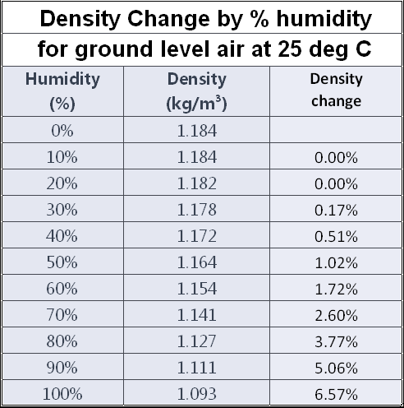
Gaseous water or humidity in the atmosphere makes the atmosphere less dense, which is another way to say more buoyant. I know this is counter intuitive since water is rather heavy and because many authors have referred humid days as having 'heavy' air. Remember humid air is light air. Heavier dryer cook air replaces warm, humid buoyant air causing the buoyant air to rise.
Air cools adiabatically as it rises because air pressure decreases. This is much like the action of Freon in an air conditioner or refrigerator. A motor and mechanical compressor compresses the gas refrigerant heating it up, cools the high-pressure gas and lets it expand. The resulting cold high-density gas removes heat from refrigerators, freezers, automobiles and homes. Water's role in the atmosphere is very similar to Freon in mechanical air conditioners.
The two most significant reasons ground level air becomes more buoyant are temperature and humidity. The humidity change can be huge. Humidity provides very significant density changes above about 20 °C (69 °F).
Even when the atmosphere is below freezing and the total water content is very low, there can be significant changes in total buoyancy with humidity changes.
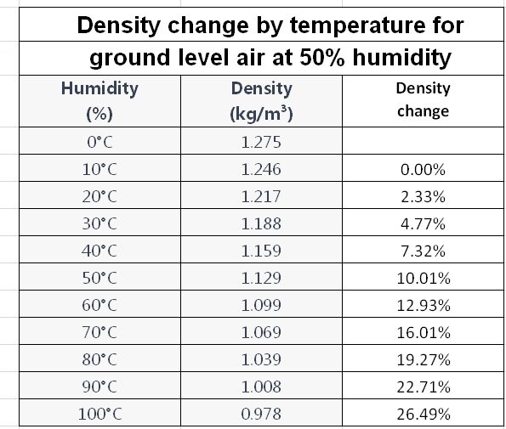
The following chart of density by temperature can be misleading. Large swings in humidity are common but changes of more than 10 ° C per hour are relatively uncommon. The adiabatic change (DALR) change in temperature is about 0.54 ° F per 1,000-foot change in altitude close to ground level.
This is a change in density of air for the first 1,000 ft can be
$$\frac{.54 degrees F}{459.67 degrees F} = 0.12 \%$$
Because of the stagnation layer, temperature and humidity changes can be quite large in the first few feet. This change will not usually be due to temperature but the change in density due to humidity can often be more than 10%. This density gradient is the fuel of tornados.
It is true that, "It isn't the heat that gets you, it's the humidity." even with tornados.
Large changes in atmospheric temperature at ground level are rare. For example, when a cold front containing tornadoes passes during summer the atmospheric temperature might change 10 ° C say from 40 ° C to 30 ° C. This is a density change of 2.6%. Ground level humidity might change by 90% while rising from ground level to cloud level resulting in a 5% density change. Together this is a 7.6% density change. The combination of temperature and humidity is the driving engine for tornadoes.
When you add gaseous water (humidity) to air the combination becomes lighter, less dense or more buoyant. Cooling humid air causes liquid water to condense in the form of minute water droplets. Humid ground-level air, which has risen and adiabatically cooled, reaches the point at which water condenses and becomes visible. The weight to surface area of these water droplets is so small they float around in the atmosphere much like dust motes. This point defines cloud level.
Water releases heat as it condenses. That heat transfers to air molecules heating them and making them lighter. Air warmed by water condensation continues to rise leaving the condensed water molecules behind at or near cloud level.
This concept is important because air movement without condensed water is nearly impossible to track vertically with a satellite. Even thermal techniques are difficult because of the small temperature differential.

Nerd talk
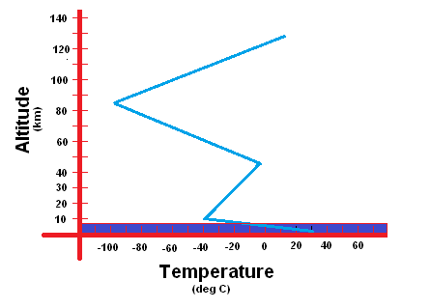
If you plot the atmosphere's temperature gradient with temperature on the x-axis and altitude on the y-axis the shape resembles the Greek letter Sigma (Σ). This graph is commonly available in weather literature. I've added a dark blue area near the x-axis. Half the planet's atmosphere is in this dark blue area, which extends from ground level to about 5,300 meters or 18,000 feet or about 3 1/2 miles.
I contend that virtually all weather occurs within that bottom 50% (by weight) of the atmosphere. Tornado power comes from buoyant air in the bottom 1,000 feet of the atmosphere.
There are two types of mesocyclone the global effect mesocyclone such as a hurricane and the local effect mesocyclone such as the tornado. The two common types of tornado are the isolated tornado associated with summer super cells and the cluster tornadoes associated with weather fronts.
Isolated tornadoes might have a temperature and humidity profile as presented here. Ground temperature is relatively high with a minimal vertical temperature gradient or a low temperature change between ground level and cloud level before a tornado. The lines marked B are before a tornado. The lines marked (A) are after a tornado. Notice that the (A) for humidity (green) changes hugely especially in the first 100 meters. I can show that is true in the first 100 feet from the ground.
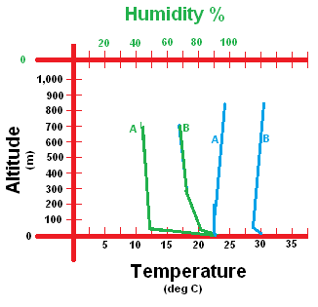
High humidity air is the source of tornado energy, especially in the larger tornadoes. Humidity is extremely high close to the ground due to the effects of plant photosynthesis and respiration. This is the reason nearly all inflow air is so very close to the ground. The same humidity profile can effect after light showers when a layer of high humidity air is close to the ground.
In the chart above the humidity (green) is extremely high before (B) but has fallen dramatically after (A) the tornado. Temperature (blue) before (B) the tornado is changed only slightly after (A) the tornado.
Humidity and temperature lower drastically after a tornado. High-humidity, high-temperature ground level air (B-Green and B-Blue) is lifted by upper level cool, dry air (A-Green and A-Blue). The vertical weather section of this document explains this process in detail.

Anvil clouds
Another characteristic of isolated tornadoes is the so-called anvil cloud. I refer to it as the flat top cloud because that cloud is associated with the formation of ice. The top of a flat top cloud indicates water's freezing point. When rising air crosses 'standard freezing level' its water tends to freeze. This is generally about 15,000 feet or about 3 miles altitude. Any humidity in the atmosphere quickly converts to tiny invisible ice pellets, not snow at that altitude. The altitude can vary widely depending on conditions. It is no coincidence that a flat top cloud indicates the possibility of hail. Ice is much denser and falls quickly, sometimes all the way to ground level. Nearly all atmospheric moisture becomes ice at this altitude. The ice formed is also nearly invisible to the naked eye, which is why the cloud top appears flat.
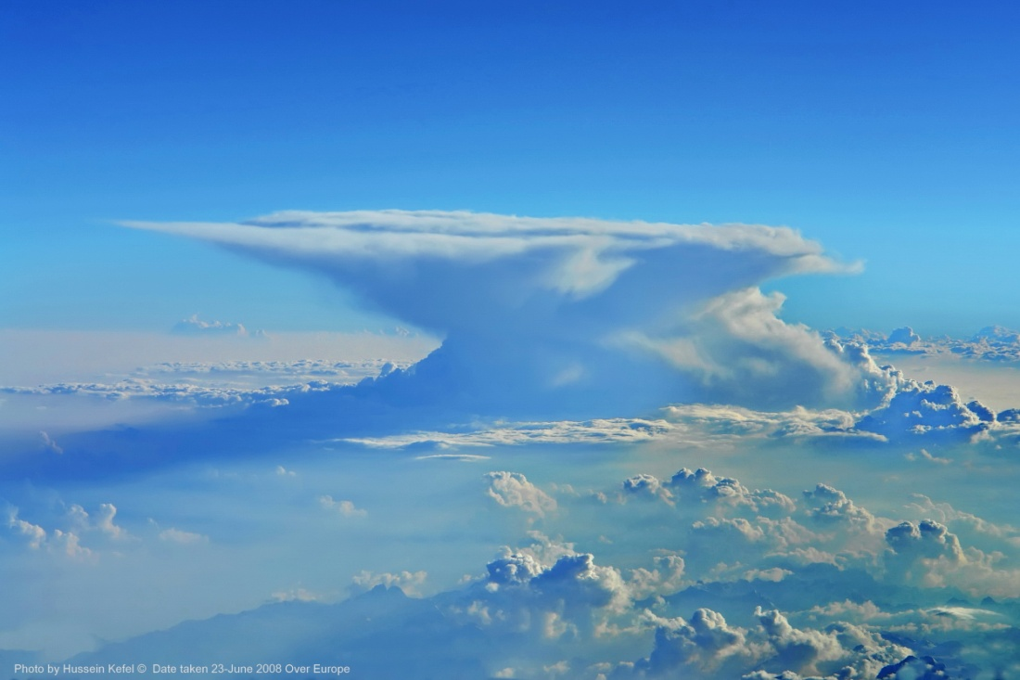
The tongue of some flat top clouds is due to stratosphere level wind blowing visible condensate to the side.
Notice the shadows. They would indicate that this picture was taken at about 2:00 in the afternoon local time. Notice that many clouds are rising as their sides facing the sun are heated.
The top of a flat top cloud indicates the other critical thermal extreme for water phase changes, ice. This is also the top of the troposphere and bottom of the stratosphere. That does NOT mean that air doesn't rise into the Stratosphere, it most certainly does. Not all moisture drops out of the atmosphere at the ice level. Not only that but humid air above the ice level has about the same buoyancy as humid air below the ice level. It is just invisible to the eye.
An oddity of weather is that air temperature in the stratosphere increases with altitude. Air heats as its moisture condenses. The remaining air rises while the moisture freezes and falls.
I posit this is because there is still moisture adding heat to air as it condenses and falls to the Troposphere where 1) evaporates or 2) continues to fall gathering other ice converting to hail.
Weather is actually quite simple once you understand a few basics.
What I'm discussing is a very powerful engine powered by water from the earth's surface stretching to the top of the stratosphere.
You may have noticed the down-sun side (the side away from the sun) of clouds is dark by comparison. This is because condensed water in the cloud adsorbs solar energy. I calculate the amount later in the text but a single supercell can absorb solar energy equivalent to a multi-reactor nuclear power plant.
The adsorbed heat on the west face of the clouds evaporates the condensed sunny side condensed water droplets, which warms the air around them. This greatly increases the air's buoyancy driving it into the stratosphere. This creates a vertical chimney of high velocity air, which will accelerate air vertically all the way down to ground level. Coriolis force will cause the rising columns to begin rotation creating an in-cloud cyclone. Low-density air enters the cyclone's bottom forcing the bottom down and expelling buoyant air out the top of the chimney.
Now you see why I discussed water exchange mechanisms in the stratosphere.

Wall cloud
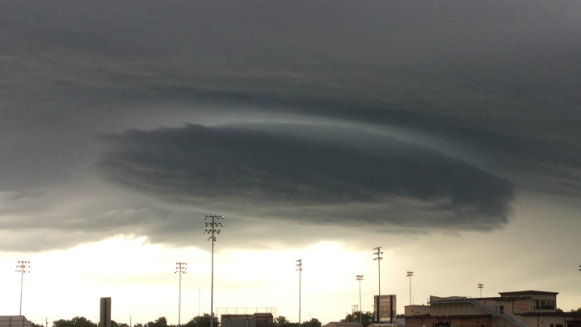
I discuss Coriolis effects in an appendix. The dimensions inside a cloud are adequate to cause rotation due to Coriolis effects. Once the air starts spinning it produces the same effect as the walls of a stove or fireplace chimney. Centrifugal force pumps heavier, less buoyant air to the chimney wall and lighter more buoyant air to the interior of the chimney enhancing the buoyant effect in the center of the chimney enhancing the mesocyclone's flow.
This high altitude chimney can sometimes extend to the ground from the sun-generated clouds miles above. While the cloud wrapped mesocyclone is in the clouds, air has lower differential buoyancy since there is little thermal storage, humidity is nearly homogenous and there are visible water droplets in the air. These factors contribute to a larger rotational diameter.
When the mesocyclone begins inflowing air from below cloud-level, there is an immediate step in vertical differential buoyancy causing the rotation to quicken. The rotational diameter decreases and inflow velocity increases. The increase in inflow velocity creates a pressure drop made visible by condensation (contrail like) effects making the vortex's circulation visible.
The result is what I call a barrel cloud that seems to drop from cloud level when in reality the upward inflow velocity is merely becoming visible.
The astute observer can occasionally see a ropey thin circulation "drop down" from the center of the wall (barrel) cloud, which is the infant tornado. It is thin and ropey because there has been a step increase in differential density.
More often than not, the initial formation of a tornado can't be seen because it does not create the condensation tail, which makes it visible.
When sunlight driven vertical atmospheric mesocyclones extend all the way to the ground and get access to very a high-humidity, high-buoyancy layer of air very close to the ground they become the largest of the monster tornados. These giants take lives and destroying property.
Also, note that the high altitude rising air does NOT lose all its energy when the sun goes down. Much inertial energy is stored in the vertical rising air column, which may contain many cubic miles of moisture-laden air. Much energy is stored in air-borne humidity, which heats the remaining dried air as it condenses.
That is why top and bottom drive tornados can persist well into the night.

Cloud level
Cloud level is that altitude where the dew point is equal to ambient temperature. Atmospheric moisture becomes visible at cloud level. Fog occurs when cloud level is at or below ground level. Another, slightly more scientific definition of cloud level is that altitude where the dew point is at the same temperature as 100% humidity. When rising ground level air crosses cloud level, it tends to condense becoming visible.
The spinning barrel cloud (or wall cloud for some unimaginable reason) is the proof of the above theory as well as another theorem. (Photo by Geo Lightspeed6) Tornado wall diameter has an inverse relationship to differential vertical density.
Put into practical terms for a ground observer the barrel cloud may be miles in diameter and apparently rotating slowly due to its distance from the viewer. Low inflow velocity limited by low differential density at that level accounts for the large diameter of the spinning barrel cloud.
When cyclonic inflow begins to take in air from below cloud level, the decrease in local pressure causes condensation causing the barrel's body to become visible. The barrel is not moving down, reduced air pressure due to increased up flow velocity is causing condensation making the low-pressure area visible.
Then a much smaller diameter conical flow might become visible in the center of the barrel cloud's rotation. This is the tornado. It might not be visible if humidity is low or differential pressure is low.
Simulation note: Inflow air can only enter from below a cyclone; therefore, the cyclone can only grow downward. However, the eyewall can't ingest air if it is too close to the ground since air cannot enter through the eyewall due to centrifugal effects.
You don't necessarily see the entire tornado. You can only see the area where differential pressure is low enough to cause condensation. This is the same condensation sometimes seen above airplane wings or under racecar wings.
Each of water's phase transitions from solid to liquid to gas and back again involves very significant transfers of energy. It requires one BTU to change a pound of water one degree Fahrenheit and 0.24 BTU to change one pound of dry atmosphere one degree Fahrenheit. It requires removing 144 BTU per pound to freeze water and adding 970 BTU per pound to evaporate water. It requires 186 BTU to heat one pound of water from 33° F to 219° F but 970 BTU to heat water from 219° F (liquid phase) to 221° F (gas phase).

Buoyancy
A dictionary definition of buoyancy is the ability to float in water. In this text, it is defined as the tendency for heavier fluids to displace lighter fluids within a confined space subjected to a gravitational field or centrifugal field such as earth's gravity or TWF. In either field, the heavier fluid displaces the lighter fluid away from the greater field strength.
Air at 0° Fahrenheit and 10% humidity has a density of approximately 0.03266 kilograms per cubic meter or 0.002039 pounds per cubic foot. Air at 90° Fahrenheit and 90% humidity is approximately 0.03121 kilograms per cubic meter or 0.001948 pounds per cubic foot. The ratio of cold-dry air density to warm-humid air density is approximately 4.6%. This small difference is directly responsible for most continental scale weather.
A hot air balloon demonstrates the vertical effects of atmospheric density. A balloon rising in the earth's gravitational field is an example of gravitational buoyancy. A cold front descending from Polar Regions displacing warm equatorial air is an example of horizontal or tangential buoyancy.
Enough words, would you like some math?

Centrifugal Field
The text above is for the lay U.S. reader familiar with feet and miles. The text here sacrifices Imperial enumeration since the units are difficult to follow even for many that can otherwise not relate to metric representation.
The earth's rotation creates a centrifugal acceleration force similar to gravity. Fluids in a spinning confined space will accelerate perpendicularly to the axis of rotation. In the thought experiment above, the confined space between the two spheres simulates such a space. Spinning the concentric globes about their axis created a field proportional to the distance from the axis of rotation.
Centrifugal force acts on the atmosphere but the curved volume of the atmospheric space reduces the effective force. The effective force is proportional to the sin of the curved space's latitude.
We will need the earth's velocity at the equator in m/s²
$$v= \frac{2*π*6.371 X {10}^{6}}{24h*3,600\frac{s}{hr}}=463.08\frac{m}{s^{2}}$$
where

To determine the centrifugal force at the equator the equation is:
$$F = m * \frac{v^{2}}{r}$$
where:
F is centrifugal force N,
m is mass (1kg),
v is velocity 463 m/s², and
r is path radius 6.38 X 10⁶ m.
Earth's centrifugal force at the equator is 0.0338 Newtons. However, none of that force at the equator affects weather because it is vertical to the earth's surface instead of tangential to the earth's surface. Also notice that .0338 N is 0.34% of the force of gravity.
Only tangential force will sort the atmosphere according to atmospheric density. Therefore, we have to calculate the centrifugal force tangent to the earth's surface.
To do that we must calculate latitude compensation.

Latitude compensation
As mentioned above centrifugal force diminishes to zero as one nears the poles, since the radius gets smaller as you approach the poles. Centrifugal force is the resting mass * the circular path's velocity squared / the circular path's radius.
The centrifugal force formula is:
$$F = m * \frac{v^{2}}{r}$$
where:
F is force in Newtons,
v is the rotational speed in meters per second
m is mass in kilograms, and
r is radius in meters.
We're going to need the rotational speed at a latitude.
Velocity is the distance around the circular path (circumference) divided by the time in seconds. The velocity formula is:
$$v=\left(\frac{d}{t}\right)$$
where:
d is distance or circumference of the planet at that latitude in meters, and
t is time in seconds and fixed at 24 hours * 3,600 seconds per hour.
We're going to need $d_{lat}.$
Velocity changes with latitude. To compute the velocity requires getting the path length or circumference at the particular latitude. The distance at a particular latitude formula is:
$$d_{lat} = d_{eq}* 2 *π*cos(l)$$
where:
$d_{lat}$ is distance (circumference) at latitude in m,
$d_{eq}$ is distance (circumference) at equator in m,
π is pi or 3.1416,
r is radius in meters, and
l is latitude.
To get the distance at latitude, we multiply the distance formula by cosine times the latitude in degrees.
We plug the distance formula in place of d in the velocity formula. We then plug the updated velocity formula into the centrifugal force formula giving us the general formula for centrifugal (tangential) force at latitude.
$$F = m * \frac{v^{2}}{r}$$
We substitute d/t for v.
$$F_{cen}= m * \frac{{\left(\frac{d_{lat}}{t}\right)}^{2}}{r}$$
Then we substitute
$r_{eq} *π *2* cos\left(lat\right)$ for $d_{lat}$.
We also need the diameter at that latitude $r\left(lat\right)= r_{eq}*cos(lat)$
giving us the generalized formula for centrifugal force at a latitude (lat) for a mass (m) where $r_{eq}$ is the earth's radius.
$$F = m * \frac{{\left(\frac{r_{eq}*2*π* cos\left(lat\right)}{t}\right)}^{2}}{r_{eq}*cos(lat)}$$

$$F = 1*\frac{{\left(\frac{6.371 X {10}^{6}*2*3.14* 0.707}{86,400}\right)}^{2}}{6.371 X {10}^{6}*0.707}$$

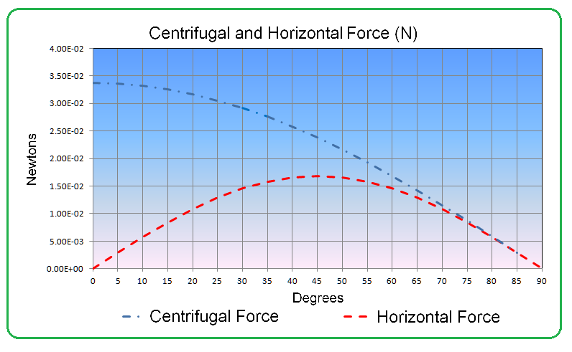
Maximum centrifugal force is at 0 degrees latitude (equator) and is 0.0369 Newtons. Maximum horizontal force is at 45° latitude and is 0.0168 Newtons.

TWF value considerations in North America
Buoyancy is simple but complex. Temperature affects buoyancy directly. If the temperature goes up 10%, the buoyancy goes down 10%. Keep in mind that this is not 10% from ice melt zero but instead from absolute zero.
If using the Celsius scale water freezes at 0 °C boils at 100 °C and absolute zero is at -273.15 °C. When you measure from absolute zero in degrees C, you are using the Kelvin system.
If you're using the Fahrenheit scale water freezes at 32 °F, boils at 212 °F and absolute zero is -459.67 °F. When you measure from absolute zero in degrees F, you are using the Rankine scale.
It is proper to say 0 °K = -273.15 °C and 0 °R = -459.67 °F.
For comparison sake, let's find out how many degrees are required to change buoyancy by 10% when starting at the freezing point of water.
Using the Celsius scale, water freezes at 273 °K. Ten percent of 273 °K is 27 °K (which is also 27 °C) so 273 + (273 * 0.10) = 300 °C Said another way changing the temperature of dry air from 0 °C to 27 °C changes air's density -10%. Notice that as temperature increases dry air's density decreases.
Don't forget that water freezes at 32 °F. Using the Rankine, water freezes at 457 °R + 32 °R = (0 °F). Ten percent of 489 °R is 49 °R (which is also 49 °F) so a 489 °R + 49 °R = 538 °R. The final temperature is 489 (457 °R +32°R = Freezing point) + 49 °R temperature rise or 81 °F.
The rule of thumb is that for dry air a 10% change reduction is the result of an increase of 27 °C or 49 °F temperature rise. Personally, I use 25 °C and 50 °F respectively for rule of thumb (mental) calculations.
The S.I. system does have advantages ... oh wait, is it the CGS system? Aren't they both the same? I prefer SI to CGS when metric system use is appropriate largely because kilometers seem more appropriate than meters in weather work. When writing for the U.S. Public, like in most of this book, I use Imperial Units. There is also the aeronautic world, they seem to talk and think in Imperial units such as miles to the runway and vertical altitude in feet.
This is important because 10% differential density is close to the threshold of causing severe weather.
Do you think it is easy to change systems when writing a book? But ... it's my book - so there. I write for the common man because I am he. I write for the pilots because they have my life in their hands. I write for the scientific community because they will soon have to continue my work.
Working through the above should have shown you that temperature affects on air density are relatively linear within normal air temperatures.
I am going to give you another rule of thumb. For temperatures below 80 °F (27 °C), you can ignore humidity differences. When the temperature rises above 120 °F (37 °C), calculate (or look up) everything. Don't even guess for order-of-magnitude approximations.
When people start waving their hands they are usually trying to distract you from what they are saying. Usually they are lying or vague about the subject or simply don't know.
I'm waving my hands in a virtual sense because there are more factors than I can measure and there is no helpful literature when you initiate a new theory from scratch. In other words, I'll only admit to purposefully being vague.

TWF density calculations
The author has only extended his studies to North America. North America's shape, large latitude to longitude ratio, and geography, north-south mountain ranges is amenable to TWF calculations.

Horizontal TWF density
TWF weather is air density differences that vary slowly such as degrees per day to degrees per week and during horizontal transits of hundreds to thousands of miles. Air near or above the polar circles might have temperatures of -50 °C (-58 °F) with 1% relative humidity (1.578 $\frac{kg}{m^{3}}$ density) and air from near the equator might have temperatures of 50 °C (122 °F) and relative humidity of over 99% (1.068$\frac{kg}{m^{3}}$ density). Atmospheric densities of 1.578 $\frac{kg}{m^{3}}$ and 1.068 $\frac{kg}{m^{3}}$ respectively results in a 32.2% differential density.
$$\frac{1.578 \frac{kg}{m^{3}}- 1.068\frac{kg}{m^{3}}}{1.578\frac{kg}{m^{3}} }=32.2\% diffential buoyancy$$
This temperature differential is at the extreme bounds for North American weather. While the winter might result in -50 °C nights, this probably wouldn't happen at the same time that the tropics experience 50 °C days.
A rare but more reasonable range of values might be 0°C (32 °F) at 0% RH and 40 °C (104 °F) at 99% RH giving densities of 1.29 kg/m³ - 1.12 kg/m³
$$=\frac{1.29 \frac{kg}{m^{3}}- 1.12\frac{kg}{m^{3}}}{1.29\frac{kg}{m^{3}} } =13\% diffential buoyancy$$
That is 13% differential buoyancy within the continent of North America.
Even that calculation is not very honest. Differential buoyancy tends to be mathematically continuous but when differential atmospheric density is thousands of miles apart, things like surface topology eddy losses and transit time can alter (reduce usually) the effects of differential buoyancy.
Even in the case of a tornado, which gathers its energy over a few acres of area there are losses reducing effective differential buoyancy.
Verticality is always significant. To compare differential buoyancy of two air masses they must be either be at the same altitude or altitude compensated in some manner.
Reality is that differential temperatures in the range of 0 °C to 40 °C are not permanent therefore high density air from near the poles can only influence weather after they have traveled thousands of miles.
Your takeaway for this should be that high precision long distance air density comparisons are not useful for instantaneous computation of horizontal atmospheric forces. The proper mathematic tools utilize infinitesimal calculus for short-term vertical weather effects or integration by parts methodology when simulating continental effects.
Also, keep in mind that TWF drops off quickly below 20° latitude and above 70° latitude giving an effective range of about 3,500 miles for TWF effects.

Vertical TWF density
Then there's the issue of verticality to consider. Hurricane Wilma's (2005) pressure measure 882 millibars compared to 1,013 millibars at Standard Temperature and Pressure (STP) conditions gives a vertical density differential of 12.9% assuming that the 882 millibars is normalized (adjusted) to equivalent sea level values.
This is a bit of a premature preview but low-density air that drives hurricanes originate near the Intertropical Convergence Zone (ITCZ) and travel in a snake like corridor to the hurricane without greatly increasing in density. After arriving the hurricane, the vertical density differences are responsible for the hurricane's eyewall thunderstorms where the low-density air is displaced vertically. The vertical transit of low-density air up the eye wall results in loss of water due to condensation but heating of remaining air molecules. The resulting high altitude warm air is displaced toward the poles in a single stream. To recap air for a hurricane begins as warm moist buoyant air from the ICTZ that travels to the hurricane at sea level, then the buoyant air rises in the eyewall thunderstorms and continues to travel toward the polar regions at high altitude.
This brings us back to the issue of where weather happens. In the case of a hurricane horizontal weather effects causes it to begin at the ICTC and ends up in polar-regions due to horizontal effects. During the transit, the air travels from sea level to high altitude in the eyewall thunderstorms due to vertical weather effects.

Barometric pressure and altitude
The weather services go to considerable services to normalize (adjust) barometric air pressure to sea level. Denver is about a mile or (1.6km) high. The weather service adjusts their barometric pressure to read about 1,015 millibars even though the air pressure is about 880 millibars maximum actual pressure. They do this for the convenience of pilots and weather forecasters.
I believe their method is according to an altitude pressure relationship similar to this one, except with much more precision.
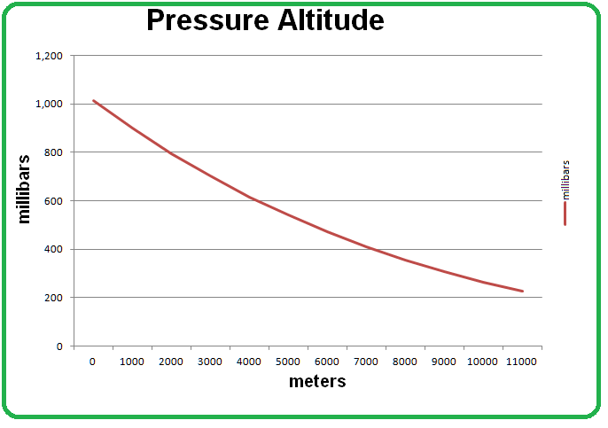
So how do you decide the differential pressure between two areas? You can 1) set an arbitrary vertical height (such as sea level) and adjust temperatures and humidity to compensate for adiabatic temperature/humidity changes or 2) only compare small adjacent areas.
The former method is quite tricky in a simulation environment because of the unknown nature of spaces between the computational points while the latter is exhaustive because of the number of computations involved.
I suspect that a practical solution will be a combination of the two methods. For example, altitude doesn't vary greatly over the Great Plains allowing a single set of vertical values to express large areas. The Appalachian Mountains area would need to have much smaller areas.
Another factor to keep in mind are that horizontal weather occurs over hours and days so the differential buoyancy will be the integral of a corresponding period of time with lags of hours or days between maximum and minimum values. Your results may vary and objects may appear closer than in your rear view mirror.

TWF results
What is the significance of such small force values? In today's media vernacular I could call TWF 840 micro Newtons and dismiss it out of hand since it doesn't match current 'accepted science.'
Please hang with me here and hopefully I'll convince you that 0.008 Newtons is adequate to whip the atmosphere into quite a tizzy, especially when applying the force for hours and days.

Tangential Force `
Just as a refresher, let's state specifically what this chart represents.
Gravity determines that down is the direction toward the sphere's center and up is the direction away from the sphere's center at every point on the sphere. Vertical movement within the atmosphere is limited the atmosphere's 60 mile height. The earth's surface limits the atmosphere's downward movement and gravity limits its upward movement.
We define horizontal defined as tangential to the earth's surface. At any point on the earth's surface, horizontal is perpendicular to vertical in any direction. Rotation of the earth about its axis creates a centrifugal force perpendicular to the earth's axis. The physical constraints of ground and gravity limits the force exerted on the atmosphere to vary by the cosine of latitude. Tangential force changes according to latitude.
The earth's atmosphere is constrained in a 60-mile high space setting on the earth's surface. Horizontal movement is mechanically unlimited since air at any point on that sphere simply wraps around after returning to the original spot after traveling the 25,000 miles circumference in any direction.
Maximum TWF is at 45° latitude. In North America that corresponds to the border between Vermont and Canada, Wyoming's northern border with Montana and Salem, Oregon.
The center of tornado activity includes areas such as Norman Oklahoma and North Alabama, North Mississippi, North Louisiana and North Texas, which are at 35° latitude. This is about 700 miles south of maximum TWF, which is still 81% of its maximum value.
This curve is the horizontal force on the atmosphere due to centrifugal force. In short, it is the artificial gravity created by the spinning of the earth on its axis and constraints of atmospheric limits.
After we have the problem solved for centrifugal force, we must then scale the horizontal (tangential) weather force to compensate for atmospheric buoyancy. Applying the low atmospheric density-differential (buoyancy) of about 5% between hot-humid air and cold-dry air makes the resulting horizontal (tangential) force seem miniscule, especially when compared to vertical (perpendicular to the surface) effects controlled by earth's gravity. See the Appendix on Centrifugal (Horizontal) buoyancy for details regarding buoyancy calculation.
The ratio of mass to buoyancy is the same for vertical and horizontal weather. The difference is that the vertical field is earth's gravity. The horizontal field is centrifugal force, which is much smaller. The primary difference is that vertical effects operate over feet and minutes while horizontal weather is in terms of furlongs and fortnights.
Centrifugal force is minimal near the poles because the surface path is small at those latitudes. Centrifugal force is maximal at latitudes near the equator due to high surface speed but the horizontal (tangential) effect approaches zero. Solving the combination of surface speed and tangential effects illustrates horizontal weather effects at various latitudes.
Referring to the table below note that the "miniscule" horizontal (tangential) weather force will accelerate objects to well over 50 miles per hour in half a day. I've colored the one hour to twenty four-hour hoour durations because they seem to be in a reasonable range.
The buoyancy differential between dry-cold air and hot-humid air will rarely be 4% making these velocities and distance calculations only barely representative. However, since I live in an area very near the horizontal (tangential) force peak (about 35 degree latitude) and the flat great planes between me and the source of North American cold air, I think this is certainly adequate justification to pursue this line of inquiry!

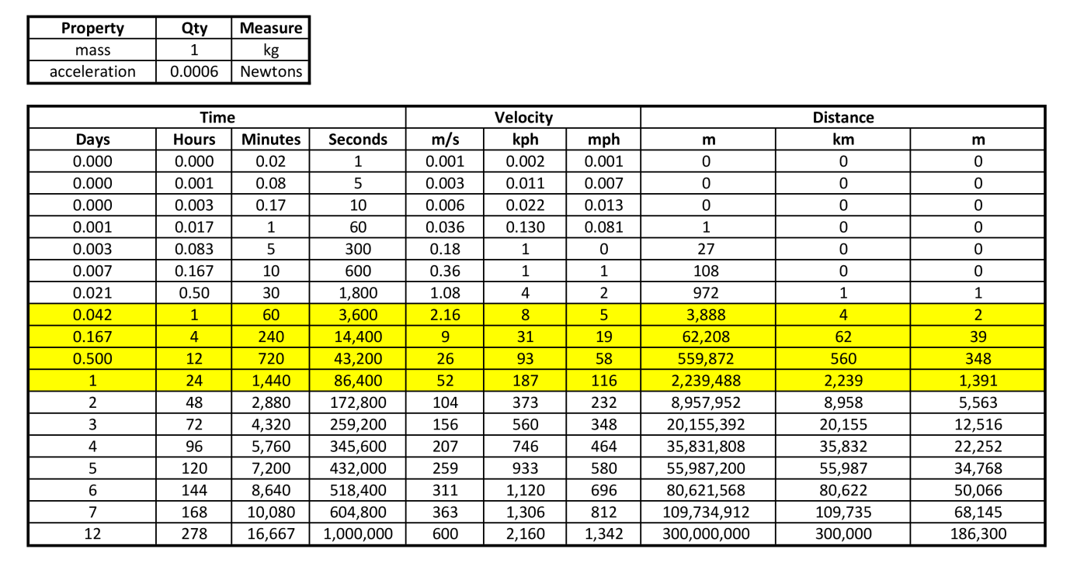
Figure 1 Horizontal (Tangential) weather Velocity vs. Distance table
One kilogram of air accelerated by .0006 Newtons for 12 hours or 1/2 day will accelerate to 26 meters per second as it travels 560 kilometers. These numbers seem to be in the ballpark of actual weather movement.
Now consider that air will not begin movement from a standing start. In the middle latitudes there is continuous continental air movement especially during spring and fall.
Take Figure 2 with a grain of salt. There are many sources to air resistance, the greatest of which is turbulence. Horizontal turbulence (with a vertical axis of rotation) accounts for the counter clockwise twirls we call low-pressure areas. There is also vertical turbulence (with a horizontal axis of rotation) created above the dominant airflow. Turbulence decreases velocity and distance traveled.
These numbers are reasonable and self-sufficient.
These numbers are also conservative. Cold-dry air can be much colder and warm-moist air can be more buoyant. Circulation is constant without requiring initial acceleration.

Perspective
Through popular literature I learned that current theory posited that ground level horizontal circulation (where the axis of circulation is horizontal and rolls like a tumbleweed or a log) is twisted and converted into vertical circulation (like a whirlpool or a dust devil) to form a tornado. The energy required to convert vertical circulation to horizontal circulation would have to be immense so I looked for alternative explanations.
I did find that all air enters a mesocyclone through the bottom and that as long as there is buoyant air to fuel it the mesocyclone will continue to grow downward. Its spin is created by the horizontal component of inflow air. Thus, a mesocyclone's rotation at altitude isn't necessarily great.
When a mesocyclone's mouth (bottom of the circulation) is at ground level nearly all inflow is horizontal, intensifying the Coriolis Effect.
Seriously, I expect a poor reception for this basic theory, especially in meteorological circles. They will claim, and I agree wholeheartedly, that their methods have decades of successful implementation. They will claim they have save thousands and possibly millions of lives, and I agree wholeheartedly. They are proud and with good reason.
But, my interests were self-preservation when I divined this theory. I did not see a credible theory regarding tornado generation anywhere I looked. I ruminated on this theory over a few decades. A particularly devastating near miss occurred in 1989.
Over the years my methodology and results improved and I could explain everything except the one thing I most wanted to solve. I wanted to understand Cluster Tornados.
I had a post sleep breakthrough on another problem of interest, which led me to discovering, understanding and quantifying cluster tornados. I have been working the problem seven days a week when healthy for three years.
One result is a Provisional Patent to prevent and/or minimize tornadoes before they are born. I did go back and read previous tornado patents. Some are laughable. One seemed alarmingly close to my proposed patent, until I read the claims. Can I eliminate tornadoes? The future will tell. I also published the patent application in a book I named Dorothy's Revenge. The concepts are now in the public domain.
So, am I seeking to overturn weather conventions? It was not a goal but I now believe that it is essential. I do hope to contribute a practical theory to augment the empirical methods currently in use. I also hope to become the Insurance Industry's best friend or worst enemy depending on how they feel about decreased claims.
Why did I apply for a patent? Because the cause and effect of a practical theory makes the solution to tornado prevention obvious and I did not want my work to fall in the bottomless well of corporate greed or governmental bureaucracy. If I own the patent, I have control, for a few years.

Improvements
A large part of my research involved the weather satellites operated by NASA and NOAA. These devices are wonderful and contributed in ways no other technology can. But, (again) I continuously and consistently claim that weather, and especially bad weather, exists in the first 1,000 feet of altitude. Weather satellites are the best solution by far for upper air evaluation. However, ground level inquires leave a bit to be desired when using satellites.
Satellites cannot 'see' the air. Satellites see condensed water in the form of droplets or ice. There are two problems with that approach. Most of the atmosphere has no appreciable 'visible' (detectable) condensation.
The problem is that seeing ground level moisture means they must look through the atmosphere from outside the atmosphere. Satellites have to look through 60 miles (minimum) of atmosphere to see the altitude in the bottom few thousand feet where weather occurs.
There are methods to subtract the interference of upper atmosphere moisture, but that is not the same as knowing ground level conditions with high resolution and accuracy.
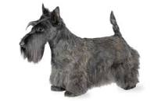
Toward that end, I am developing a local self-contained weather station (called Toto) that, I hope, people will purchase for themselves. The TOTO is a portable self-contained weather station to mount on a pole in a person's yard. The pole only needs to be high enough to be out of the reach of children and animals. The unit will communicate via WiFi much like their printers and phones do now. The unit will connect to an Internet site and upload stored weather data. WiFi has a distance problem. This was intentional. Atmospheric water attenuates the RF signal so that the limited reach of the radios results is a limited sphere of interference allowing a large number of WiFi radios in a small space.
There are limitations on where a Toto placement such as away from buildings and trees, (if possible) away from heat sources, away from wind dead spots and off the ground.
The selected solution is radios similar to the WiFi radios but at a different frequency reserved for industrial use. This will allow reliable radio operation between the Toto and its base station a base station that looks like a thumb drive.
Another Toto will be a wall wart looking like plug in phone chargers that receive the industrial radio signal and convert it to standard WiFi, which can connect via a cell phone or other WiFi device or blue tooth communications with a cell phone.
Normally the Toto will save data during the day and report during low traffic times. However, it is essential to have the capability to report more often when such things as high wind speed, large changes in barometric pressure or changes in wind direction. The Toto also has the option of texting or emailing information to the owner.
Oh yeah, the owner can also query the device for its data at will.
Normally, data use is less than 10 minutes per day and controlled by the owner. Packet size is very small, less than 10K bytes per transmission.
Each TOTO will measure:
- Temperature to 1%
- Humidity to 1%
- Wind speed to 1%
- Wind direction to 5 ° (winds are more shifty than Snidely Whiplash)
- Light level to 1%
- A pie-in-the-sky desired option is to bounce a radio wave vertically to determine the atmospheric humidity profile for the first few hundred feet.
The author is an experienced Electronic design engineer specializing in embedded hardware and software.

The target price is $125.
Each unit will belong to the individual. Unit installation is suitable for the do-it-yourself user if desired. The unit requires no wires or other complication other than mounting it on a pole. It would be best to mount the unit away from buildings, trees and other wind obstructions or shade. Each Toto will report data via the owner's wifi or telephone. A percentage of units will be capable of transmitting to satellites in case of widespread blackout.
A small solar cell and generator on the wind anemometer provides unit power. The anemometer is the spinning cups that measure wind speed and direction.
Why would I control the product? I have a decades-long background as a design engineer including years in high-volume electronics manufacturing and maintenance. I can professionally design, program, manufacture and maintain the units.
Why would I hesitate to let the government provide the product? You're kidding right? If this became a government project:
- it wouldn't come on the marked for decades,
- bureaucrats would re-designed it for unknown reasons,
- it would end up costing thousands of dollars per unit,
- funds allocated would be used for nefarious means and thrown away on a whim.
There is no a chance I give the government control of this design. They are welcome to the data, as would everyone else.
Why would individuals purchase these?
- It's the right thing to do.
- They would get a good weather station they could monitor with their phone.
- They would like to set an example of how to contribute to the common good without government involvement.
- They want to support my continued research!
- They can trust my decades of experience developing and manufacturing extremely high volume electronic products.
I would move product manufacturing to a contract manufacturer who could build it for less than what I would pay in parts.
Examples are firms such as Sanmina or Benchmark.

Vertical Weather Effects
For the purpose of this discussion, I must effectively make the convincing case that vertical weather affects local weather conditions and horizontal weather affects planetary weather conditions. this is necessary to make my alternative theory of weather work. I bet you haven't seen that type declaration in alternative high drama technical literature.
By the end of this section I will have explained the source and cause of one of vertical weather's most impressive manifestations, the tornado. I will also discuss horizontal weather's most impressive manifestation, the hurricane.
About tornadoes - the types of tornado, source of tornado energy and tornado genesis
Bottom driven tornado
The dust devil - The simplest tornado
The isolated vertical weather tornado
Top driven tornado
Inflow squeezing
Thunderhead driver
Combination tornado
Fortunate limits
Stagnation level
The chimney
Rain and hail effects
Anvil - actually flat top clouds
Visible barrel cloud
Invisible wall cloud
Localized weather fronts in Florida
Morning solar energy
Evening solar energy
A question of two answers
Why are there no daily tornadoes in Florida

About tornadoes
Tornado formation is a relatively simple process. Current theory seems to be based on observation of similar phenomenon occurring in proximate locations. The rolling action of a front does create the tornado's vertical air movement or spin. The only effect the front has on tornado development is to isolate areas of high atmospheric buoyancy under areas of low atmospheric density. Cold fronts generally flow under warm areas due to their higher density. Some factors, primarily cold front velocity can cause the less buoyant cold front to 'roll over' more buoyant stationary air. Front or horizontal weather tornadoes form when more buoyant air vertically 'escape' through the front's cold air confines. Other factors that cause cold front overflow (CFO) include various topology features such as elevation changes and surface flow restrictions.
Another proclaimed cause of tornadoes is the mesocyclone's spin. A theorem, axiom actually, of this theory is that vertical air movement causes spin. There is no spin without either or both horizontal velocity and vertical velocity. That is not to say that coriolis forces are the only mechanism creating mesocyclone spin, but rather that coriolis forces don't cause vertical or horizontal air movement; they are a result of horizontal or vertical air movement.
There are two distinct types of tornadoes. A vertical weather tornado's cause and effect are due to local conditions. A horizontal weather tornado's cause is horizontal air movement such as a cold weather front. Once a horizontal weather front has created tornado conditions, the self-sustaining tornado process is the same for both vertical weather tornadoes and horizontal weather tornadoes.

Topics
Bottom driven tornadoes - Common tornadoes from dust devils to the isolated vertical weather tornado
The dust devil - Simple but revelatory
The isolated vertical weather tornado - Terror of the mid-latitude states
Top driven tornado - What goes up sucks
Thunderhead driver - Sun driven destruction
Inflow squeezing - Concentration of forces
Combination tornado - These are the true monsters of the tornado family.
Fortunately - sort of
Stagnation level
The Chimney
Rain and hail effects
Anvil (flat top) clouds
Visible wall cloud
Invisible wall cloud

Bottom driven tornado
A bottom driven tornado only requires an updraft to establish a conduit for buoyant air to escape from ground level into upper atmospheric levels. In the case of the lowly dust devil, the entire process occurs in feet and usually lasts seconds to minutes. In the case of the isolated vertical weather tornado, humid ground level air is transported to the cloud layer initiating a vertical weather tornado. One workable theory is the concept that lightning strikes provide an initial vertical conduit for an air chimney. The lightening strike's advantage is a single upward air movement all the way from the cloud to the ground.
The lightning strike concept assumes that there is enough internal cloud movement to create an electrical charge capable of reaching the ground, which is certainly possible on summer afternoons as the sun is concentrated on the peaks of clouds accentuating their vertical movement.
Plant growth on a hillside provides an ideal vertical conduit for initiating vertical updrafts. The hillside angle reduces stagnation effects effectively creating a ground level channel for airflow.
A single tree in a field can initiate vertical updrafts because the open area below the leaves offers little resistance to vertical flow and leaves provide a vertical source of highly buoyant air. As mentioned above and prove below, the updraft will immediately move toward a less buoyant source of ground air.
The dust devil
The isolated vertical weather tornado

The dust devil
The simplest mesocyclone is the lowly dust devil Its energy mechanism is simply a thermal gradient of hot air on a flat surface covered by a layer of cooler stagnant air.
Ironically, the dust devil's thermal gradient is sometimes visible like a desert mirage. The thermal density gradient between undisturbed thermal layers reflects/refracts light from a distance appearing as a shiny mirror like surface from either above or below.
The difference in buoyancy between the hot air layer and the cold air layer displaces highly buoyant air from below the thermal gradient through the dust devil. Cooler air from above the gradient vertically replaces ground level hot air with less buoyant cooler air.
Any number of mechanisms can initiate a dust devil from simple build up of the hot air layer to animal movement. Once the chimney (vertical column of air) is established, the blanket of cooler air presses the hot air layer down until most or all the hot buoyant air transits the chimney.

The isolated vertical weather tornado
The prime difference between a dust devil and a killer tornado is humidity. Most of the time plant respiration and photosynthesis provides the bulk of that humidity. A recent light shower on dry ground can provide the same ground level high-temperature, high-humidity air, but the circumstances have to be exactly right.
The vertical weather tornado is a local phenomenon often associated with thunderstorms. They are especially prevalent over agricultural areas where plant-photosynthesis, plant- respiration and/or evaporating surface moisture create a high humidity layer close to the ground. This ground level high-temperature, high-humidity layer is covered by a stagnant relatively low-humidity, medium-temperature stagnant air layer extending to just below the cloud layer.
- Plant respiration and photosynthesis maximizes humidity close to the ground.
- Plants dampen local air movement minimizing horizontal and vertical air movement.
- Plants encourage thorough thermal mixing.
- Maturing plants have near blackbody adsorption of solar radiation. The result is humid, still, hot air captured close to the ground.
I'm rather specific about saying ground level humidity. Recent drone footage of tornadoes shows conclusively that high-energy, high-humidity air within a few feet of the ground fuels tornadoes.
Bottom driven tornadoes tend to be smaller because their energy source is smaller.

Top driven tornado
The top driven tornado begins life as air rising above cloud level. This is the most destructive tornado because of its dual sources of energy. The source of top (above cloud) energy is solar heated clouds. Sun heated clouds can tap into unimaginable energy exceeding that of nuclear reactors. The two most distinctive top driven tornadoes are the isolated thunder storm tornado and the hurricane core tornado.
A hurricane wall consists of a number of tornadoes combined and sharing a common down draft and flat top cloud. It sounds fantastic now but I think I can make you a believer after discussing the conception, gestation and birth of a hurricane. I've left out a couple of steps in hurricane genesis but please don't jump ahead. You must first fully understand the tornado.

Inflow squeezing
I need to introduce a novel concept I call inflow squeezing. The most general statement is that tornado diameters are inversely related to inflow velocity for a given air density. High velocity inflow air squeezes a tornado's wall diameter due to its inertia.
The proof is the so-called wall cloud. I say so-called wall cloud because to me it is actually more of a barrel in appearance and function. The wall/barrel cloud indicates rotation in a cloud extending below cloud level.
I've discussed the power and mechanism of rising cloud condensation and its ability to capture solar radiation. I've also discussed how remaining air is heated as gaseous humidity changes phase to liquid water droplets making the heated air more buoyant. The rising air continues to transport small water droplets to the flat top cloud level. During that travel water droplets are heated by the sun and transfer that heat to surrounding air (it is quite turbulent in the rising air chimney). The rising air begins to spin due to coriolis forces. Spinning air separates heavier objects, such as growing water droplets to the outer periphery the spinning air column and lighter molecules such as heated air to the spinning air column's interior. The trapped condensed air is why you see the column rising.
You might ask, "Woooah there partner! How can there be rotation in the cloud before the ground?"

Thunderhead driver
The thunderstorm's quickly rising clouds are your first glimpse one of nature's most amazing and powerful phenomena. The vertical rise of thunderheads creates some tornadoes. This process is sun driven. Tall standalone clouds capture tremendous amounts of heat. I deal with energy levels elsewhere, but a single thunderhead can create as much power as a nuclear power reactor at full power. A thick thunderhead cloud captures about 40% of sun energy as heat. Check out the shadows when you see overhead pictures of clouds. The shadows are heat energy lost from lower clouds.
A thunderhead can be miles high and miles wide. A small one-mile high by one-mile wide vertical thunderhead captures over 2.4 gigawatts. Clouds capture only about 40% of that captured energy by converting it to heat. Forty percent of 2.4 gigawatts is 960 megawatts or more than most nuclear reactors. Some thunderheads are miles high and miles wide.
A cloud capturing sunlight becomes warmer and more buoyant. Just a reminder, vertical air movement in a thunderstorm cloud is both visible condensed water droplets and invisible buoyant air. A column of air rising above cloud level draws air from lower in the atmosphere. Rising air inside the column begins coriolis spin because it is rising. Since by definition the spinning air inside a rising cloud column is cloud wrapped, it is also invisible to the eye. Coriolis spin tends to pull air in from below unless restricted causing the rising column to remain vertically compact which is another way of saying the column of air is tall and narrow. The net effect is that most vertically accelerated air enters through the bottom of the spinning mass. (It is not a tornado - yet. The velocity at the bottom of the spinning column can become quite high. ("No kidding!" you might say.)
The power for the spinning column is high in the atmosphere but will eventually migrate to cloud level below. The first visual indication on the ground is the wall/barrel cloud. This phenomenon is caused by the 'pull' of the thunderhead air column causing low pressure contrail. The wall/barrel cloud does not actually descend, but it seems to because condensation from accelerating vertical air makes it visible. The wall cloud can be miles in diameter and scores of feet tall.
Notice the diameter of the barrel/wall cloud. There is an even larger spinning mass above cloud level. The lack of differential buoyancy inside the cloud means low inflow velocity around the entire periphery of the spinning air mass. At cloud level and just below the differential buoyancy increases reducing the spinning air mass's diameter. As the atmosphere's differential buoyancy increases as the tornado approaches ground level resulting in the classic cone shape of a tornado. Please remember, there can be a high-speed tornado on the ground, but not visible because there is not enough humidity in the air to condense the atmosphere's moisture. For the discerning theorist this is largely because of a stagnation layer between ground level and cloud level. The stagnation level is caused by rising air cooling due to the lapse rate (cooling of air with altitude due to reduction of ambient pressure) without condensing moisture creating a negative feedback loop resulting in little vertical migration of high buoyancy air.
This is possible because air is relatively humid just below cloud level. Cloud level seems to be an abrupt transition when observed from the ground due to distance from the observer and the semi-transparent nature of clouds, but it is not.
Ambient temperatures and temperatures above cloud level are fractionally capable of sustaining visible water molecules. Temperature differences due to cloud masking of solar radiation provide colder temperatures at the bottom of clouds providing a small local inverse temperature/ altitude gradient. This inverse gradient produces the ceiling-like visible cloud layer at cloud level.
The above paragraphs seem to be conflicting; because they are conflicting. The thermo-mechanical relationships at cloud level are some of the most complicated in all of weather. The phrase thermodynamics is thrown around gratuitously in current meteorology but thermo-mechanical is more descriptive and thus more accurate.
Above-cloud-layer air contains a fraction of humidity compared to ground level air but was warmed when the humidity condensed; therefore, it is buoyant Air immediately below cloud level is much warmer and more humid contributing to rising energy after penetrating the cloud-layer inversion. In a matter of seconds, air pulled into the barrel cloud accelerates in response to the increased availability of medium-heat, high-humidity below-cloud-layer air.
Buoyant inflow air accelerates which in turn compresses the tornado's wall. Soon the air inflow acceleration creates a contrail giving you a small-diameter visible tornado as long as there is no visible debris. So what you see is a ceiling-like cloud level formation, then an apparently wide descending barrel/wall 'cloud' and then a much smaller cone shaped descending spinning tornado wall.
The tornado chimney diameter is a small fraction of the wall/barrel cloud because of increase inflow velocity below cloud level. This is inflow squeezing of the tornado/barrel cloud/wall cloud wall.
There is also the conservation of momentum consideration. A mass spinning at one rotational rate and diameter will have to decrease in diameter to support an increased spin rate.
RUN and HIDE! Seriously!

Combination tornado
The differential pressure at ocean level is rather low. Atmospheric humidity is as great over open water ground and especially ground with plant growth due to low surface area per mass of water.
A firenado, seen at particularly hot energetic fires is an example of a bottom driven tornado while a waterspout is an example of a top driven tornado. The firenado's energy source is below the tornado, the waterspout's energy source is above the waterspout.
When the top driven tornado progresses all the way to the ground, we now have a vertical conduit all the way from the thunderhead's vertical 'pull' to ground level air's 'push'. When these conditions combine, they create the world's most devastating and destructive tornadoes.
This combination combines the power of the vertical tornado developed within sun-heated clouds with the high-density ground air pinning the tornado to the ground.
I remember being under a wall/barrel cloud watching the circulation develop. The circulation was less than 200' over my head. I was in an area of many two story industrial buildings and now suspect that the cluster of tall-scattered industrial buildings inhibited clear inflow air and preventing tornado development. I just watched because I had no idea what was happening. Conditions were otherwise perfect and I feel lucky to have survived my ignorance. That experience helped develop this theory. You now have the story of my life in a paragraph. I made a dumb mistake and turned it into a largely ignored paper.

Fortunately
Fortunately, atmospheric conditions at ground level that decrease inflow velocity or increase inflow mass decrease tornado intensity, sometimes precluding ground level tornado activity altogether. Anything reducing atmospheric buoyancy at ground level reduces tornado intensity. A method to decrease ground level heat and humidity by increasing cloudiness in advance of cold fronts is a patent pending concept - Application number 63454679. Humidity, when present, is a primary driver of air buoyancy.
Fortunately, rising air expands adiabatically (without losing heat or mass) due to reduced ambient pressure. In other words, expanding air cools due simply to the reduction in air pressure. Two important things happen as the air cools, it becomes more dense and humidity is converted to visible air droplets.
The lapse rate is the rate at which rising air cools. A rule of thumb for atmospheric lapse rate is dry air cools 5.5 ° F per 1,000 feet and humid air cools at 3 ° F per 1,000 feet.
The relationship between humidity and buoyancy is extremely complicated. Rising air can become more humid by mass because of water's high specific heat causes it to warm more slowly than other atmosphere components. Water can become less humid by volume because water doesn't expand as quickly as other atmosphere components due to its higher specific heat.
Fortunately, cooling air looses it water in the form of condensation. Cooling and pressure changes associated with increased altitude causes this condensation. Lowering humidity reduces air's buoyancy. However, as the humidity condenses it loses some heat to the air, which increases bare air's buoyancy.
The loss of humidity buoyancy and temperature increase from heat of fusion is a trade off. In normal atmospheric conditions humidity loss is numerically more significant than temperature loss. This is the mechanism causing humid ground level air to rise to cloud level, create visible water droplets, and continue rising. Not all condensed air droplets stop rising, some continue to rise with the dryer air, though they tend to coalesce in to larger air droplets until their surface to mass ratio allows them to descend as rain. This mechanism is the source of the visible cloud level.
Ground level mechanisms that decrease tornado intensity generally include anything that decreases inflow velocity or mass. Inflow velocity increases with air buoyancy and decreases due to ground obstacles. Ground obstacles include virtually anything that can sustain the tornado's top speed and debris impacts while impeding straight-line flow toward the tornado below about 20 vertical feet.
The 20 vertical feet value is my own discovery. Once I realized that the tornado's cone shape was a function of inflow velocity (and indirectly vertical air velocity) I began to notice that debris was ejected from tornados at nearly ground level. Debris accelerated into a tornado would remain there unless inflow velocity were lower at higher altitudes. The observation is stat solus situ.
The visible portion of so-called wedge tornadoes is condensation and/or debris from a narrow vertical column of high velocity air. The reality of a wedge shape tornado is not exactly accurate. It is the vertical debris field that is wedge shaped. Material drawn into a tornado is quickly (a few revolutions) sorted by density. More dense items are centrifugally accelerated toward and then outside the tornado wall. The ejected objects encounter relatively static ambient air decelerating quickly with less aerodynamic objects remaining closer to the still very thin tornado. It is worthy to note that warm-humid air tends to migrate toward the center of the tornado wall while heavier dry air tends to migrate toward the periphery of the tornado wall.
High velocity tornadoes tend to be smaller in diameter because of high inflow air velocity. The white wide-wedge tornado is more indicative of condensed water droplets leaving the tornado cone due to centrifugal mass separation. Their continued visibility is due to high moisture in the stagnation area. The darker wide-wedge tornado is indicative opaque debris ejection.
The tornado inside the condensation or debris field has the same small diameter as other similar sized tornadoes with the same inflow velocity. Note that heavier debris creates eddies and heavier than air objects are vertically sorted by inverse mass to surface area ratio.
Fortunately, there are self-limiting factors reducing the destructive capabilities of tornadoes.

Stagnation Layer
"Why doesn't air rise directly from ground level to cloud level?" you might ask if you're a troublemaker. That question certainly caused me a bit of trouble. That's a good question and I'm glad you asked. (Of course I am, it took a LOT of work to understand this concept.) This was one of the stickiest problems developing this tornado theory. You've hit on a key point and I get make my spiel about plant respiration.
But first, I'd like to point out (again) that rising air experiences both loss of temperature and humidity due to the increase in altitude. That is until the adiabatic cooling become sufficient to cause humidity to condense. Condensing results in considerable warming of the remaining air making it more buoyant. The warmer, more buoyant remaining air continues to rise leaving most of the condensation behind. This is cloud level.
The stagnation level is that air between where buoyancy due to heat and humidity are highest due to solar heating, plant photosynthesis and plant respiration. Plants contribute to ground level moisture generation through both photosynthesis, the process of creating sugar and respiration the process of consuming sugar. Plant respiration is important because it increases humidity even though there is no photosynthesis. Each process involves the release of water and plant topology ensures that the water easily evaporates. Photosynthesis gathers solar energy, converts it to cellular mass and emits water and oxygen. Respiration oxidizes cellular mass and emits carbon dioxide hydrogen and water. Respiration occurs all the time. Both processes emit water. Photosynthesis only occurs naturally in sunlight but respiration occurs continuously and accelerated during the time seeds germinate.
You might ask, "If plants are so important to violent weather generation why is there so much bad weather in early spring when there is less photosynthesis?" In spring, when plants are 'waking up' they are emitting water vapor due to respiration alone. Seed plants, like corn are emitting moisture into the soil. Farmers till the soil to expedite air (and humidity) exchange during the budding season. Deciduous plants like maple trees are moving their sap and generating buds. You might say that nature obfuscates her methods, but only if you have a need to personify or personalize natural processes.
Fluids in contact with an object have zero velocity. It's a well know premise in fluid dynamics. Plant leaves are subject to the zero velocity law. Rough plant surface textures accentuate the effect. Air in the near vicinity of plants is difficult to detach from the surface of the plant.
Fun factoids, plants exude CO₂ during respiration. CO₂ is heavier than oxygen and/or nitrogen or atmospheric air. CO₂ emitted by plants thoroughly mix with surrounding atmosphere pinning respiration products (including oxygen and gaseous water) to the ground.
"Exude?" you ask.
Well, ok, you caught me. I'm just trying to emphasize that air in close proximity with plants have a strong propensity to retain high CO₂ concentrations. This factor alone highly contributes to the stagnation in the stagnate layer.
I haven't forgotten that I'm discussing atmospheric stagnation. High humidity air is buoyant. As the air rises, even slightly, it interacts with less humid air. Dispersion mixing is a relatively slow process but the distances are fractional inches to inches and air becomes less humid as it rises and mixes with surrounding air. Buoyancy in air recently in contact with plants reduced creating a 'fog.' I use the term fog with trepidation since it is not visible, but it is a stagnant area lingering in a particular area. These areas are high in CO₂, which is a heavy compound helping pin the atmosphere to the ground.
Fun fact about fog. It is heavier than normal air. Fog remains suspended because of its high surface area to mass ratio. Brownian motion bounces fog molecules around like pin balls without a slanted table. The trick is that visible fog is liquid water not gaseous water so its density increases atmospheric density. There is no conversion of humidity to water droplets therefore no heating of dry atmosphere like at cloud level.
Higher in the atmosphere (inches to feet) plant humidified and heated rising air encounters air that is slightly cooler and not as humid, therefore less buoyant. Humidity exchanged from more-humid air to less-humid air results in a loss of buoyancy of air contributing humidity. The result is a gradual gradient of high-density to low-density air resulting in a virtual cap of more dense stagnant air covering less dense air.
In other words on a low wind summer day there is a thick blanket of high density air covering a very buoyant ground level air. A tornado gives this low density ground level air a horizontal path to a vertical conduit allowing the heavier air to displace the lighter air effectively pushing it up the tornado's funnel.
Another byproduct of plant respiration is heat. It's not easy to measure oxidation generated (respiration) heat but the plant is always generating that heat - night and day.
Quick synopsis - plant photosynthesis during the day and plant respiration around the clock creates a blanket of high-humidity, high-buoyancy local moisture captured under a low-buoyancy stagnation layer, which will not migrate vertically without external impetus.
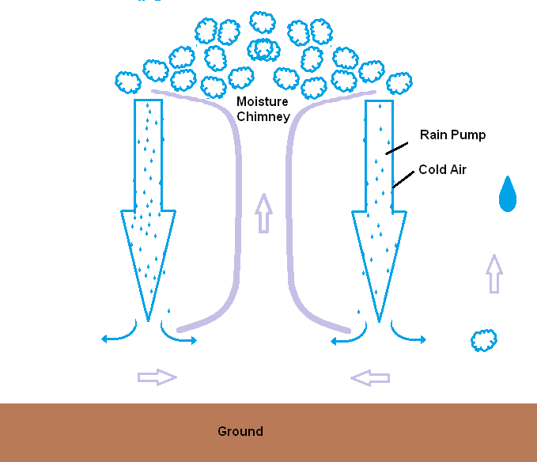
This layer of buoyant air is a tornado's lithium battery, very powerful for short periods of time and quickly charged.

The chimney
The chimney effect is essential to the understanding of tornadoes. I arrogantly thought I coined the word, but of course, I didn't. However, I hope I do a good job of explaining the chimney and relating it in to other pieces of this theory.

A tornado's energy source is highly buoyant air. Some mechanism creates a column of buoyant air. Over time, air gains vertical velocity depending on the buoyancy source. Please refer to "Tornado air movement with rain."
I mentioned the chimney in both the bottom driven and top driven tornado sections. A house chimney guides smoke from the interior of a house to the outside. This works because hot (buoyant) combustion air rises and is replaced by less buoyant air, keeping the dwelling free from smoke.
Tornado air movement with rain
Rising tornado air is also contained by a chimney consisting the tornado wall created by the spin created by coriolis forces rising air. I would like to reiterate that the spin does not create the rising air. Rising air creates the spin (actually the spin is created by the diversion of approaching air imparting the original spin forces, but that is another discussion created by misconception best discussed at another time and place.) Inflow air velocity nearly all of which must enter at the bottom of the tornado determines the tornado's diameter. (Yet another potential bone of contention to be discussed later)
The tornado wall is a centrifugal sorting device with lighter objects and fluids migrating toward the center and heavier objects and fluids migrating toward the outer wall and eventually outside the tornado. In other words, the tornado's spin assures that the lighter more buoyant air remains in the central vertical airflow channel due to centrifugal force enhancing central vertical funnel flow velocity. This is the mechanism of a tornado's robust sustainability.
High buoyancy ground moisture travels up the chimney to the cloud level. As hot - humid ground air moves above cloud level it cools, eventually leading to rain. The falling rain creates the downdraft of cold air. If there is little density change in ground level This is the mechanism of a stationary tornado in the mid-south. At first, the chimney is small because of the local nature of origination. As in the dust devil, the blanket of heavier dryer provides force moving ground-level high-humidity air toward the chimney.

The effect of rain and/or hail
Rain can be a very efficient air pump. Recently formed atmospheric water droplets are the smallest. These young droplets have a high surface area to mass ratio. They will remain suspended in the air in the form of ice crystals (including snow), fog or clouds. Water droplet size generally increases with time. As droplets grow in diameter, their surface area to mass ratio reduces making them less buoyant. Eventually they have enough mass to fall through rising buoyant air. When precipitation falls, especially from great heights it can evaporate before reaching the ground causing it to rise, beginning the cycle over again. Some droplets can be caught by higher velocity vertical wind gusts increasing their suspended time and size.
Small droplets travel with the wind and do not cause vertical air movement. Large droplets travel though the air with little effect. Middle size raindrops become very efficient air pumps because their optimal surface area to mass ratio. The result is a complicated relationship between pumping function and droplet size.
Some rain-pumped, cold-dry air mixes with high-temperature, high humidity ground level air reducing its buoyancy. A reduction in buoyancy results in less velocity in the tornado's chimney. This tends to reduce the diameter of the chimney. This is mentioned in the Fortunately section.
Rain pumped air also creates a steering effect. Chimney-induced rain on one side of a tornado results in less air buoyancy available to provide vertical velocity. The reduced inflow air will impede development in the direction of rain causing the tornado to move away from the greater source of hot humid ground air and toward from rain pumped cold cloud level air.
This theory sounds backward. First, as lower density air arrives it has a greater velocity. Higher air inflow air velocity must be overcome before the air can be redirected up the chimney.
Second, as air arrives at the tornado wall it enters to the right side of the tornado wall in the northern hemisphere. A low pressure is created 90 °rom the inflow point as the air is redirected around to the front (side away from the source of the lowest buoyancy inflow air) of the tornado. That low pressure point is directly away from the most buoyant air and toward the least buoyant air.
Chimney induced rain and resulting cold air on all sides of a tornado will starve it of energy and reduce or eliminate the tornado.

Anvil clouds
Clouds are normally limited to the troposphere, which is the bottom level of the atmosphere, where we live. Sometimes clouds penetrate the stratosphere. The primary difference between the troposphere (bottom layer) and the stratosphere (2nd layer) is the temperature lapse or change in temperature at each level. The troposphere's temperature falls from ground level to the top of the troposphere. The stratosphere's temperature rises from the top of the troposphere (bottom of the stratosphere) to the top of the stratosphere.
These clouds transport visible moisture to the top of the stratosphere. The transport mechanism is air. You can only see the visible moisture. I'm being redundant because it is important to realize that the visible part captures solar heat and transfers that heat to surrounding air. Reduced buoyancy and inertia creates a current of air well above the visible portion of the flat top cloud.
The flat top is extremely important because it becomes obvious that visible water droplets travel vertically to the top of the stratosphere before taking a turn and flow horizontally. After the 90 degree turn some droplets slow, mix and coalesce into heavier droplets causing them to fall back into the troposphere. There is invisible humidity in the vertical plume of air that creates a flat top cloud, which may convert directly into ice without transitioning through the liquid phase. These ice crystals can also coalesce into larger more visible ice crystals and fall to earth as ice and/or snow. You haven't lived until you've experienced an Atlanta ice storm, if you can call that living. Rain, ice, snow and hail generated in a flat top cloud that extends miles in all directions can be responsible for the rain pumped air you experience before a major thunderstorm or tornado. You might review the rain pump section in this paper if you don't yet understand.
Recall that the section on the chimney discusses a spinning column of air that extends downward in a cloud. Also, recall that the chimney's spinning wall assures that inflow air is primarily from the bottom of the chimney causing it to grow downward. The diameter of the spinning section is a function of inflow air velocity and mass. When the chimney forms high in the atmosphere, its diameter might be miles in diameter and spin at a rate too slow to discern from the ground. When the chimney reaches cloud level, it is smaller and spinning at a rate of fractional revolutions per minute. Air just below ground level will condense without requiring too much energy ( a strong sneeze ) so the descending chimney appears as a slowly rotating barrel descending from cloud level even though it is actually air being 'sucked up' into the cloud level cloud. The next phase is a smaller diameter funnel apparently descending from the barrel cloud. The funnel's diameter is smaller because the ambient high-humidity, high-temperature air accelerating rapidly toward and up through the tornado's funnel. Ambient air becomes more buoyant increasing inflow velocity and lower altitude increases inflow mass causing the tornado's diameter to reduce as it extends to ground level.
The power source for this type thunderstorm or tornado is probably a flattop cloud.

Remember, the funnel is visible only because airflow changes conditions abruptly enough to condense the atmosphere causing visible contrails. The barrel cloud and tornado funnel can form all the way to ground level without being visible. A black tornado is an example of a tornado that seems to rise from ground level for no reason. It is visible only because of debris it has pulled from ground level.
Significant air currents above cloud-level will move a rising thunderhead with the wind. This produces an 'anvil shaped' cloud. I like to think of them as Grinch cap clouds.
Anvil clouds are a subset of cumulonimbus clouds called cumulonimbus incus clouds. Current weather texts will tell you that the prefix cumulo is Latin for pile up, an alternative Latin meaning for the word cumulo is crown or top of such as the adornment on the top of the king's head. I contend that we should call the cumulonimbus cloud should the crown cloud if following Latin naming-conventions.
I remember as a child that some people were extremely concerned about a sickness until the doctor gave them a fifty-cent name. The concern often went away once their illness had a name. We are so modern today that we believe things with a Latin name, even if it's wrong. Sometimes people use big words they don't understand and reinforce that misunderstanding with big words. If we don't have to follow the fifty-cent rule then I suggest flat top cloud for the generic case and like the anvil cloud designation when the top is windblown. This convention actually tells you what its appearance, physical property that makes it important and even small children can pronounce the variations.
Seriously, weather is not that complicated unless obfuscators make it that way so they may wear the Wizard's cloak.
The word incus translates as anvil in Latin. This is also descriptive and obvious at first glance.
That's enough pontification for now.
Flat top clouds form from vertical air movement caused by sunlight heating of the tallest cloud(s). When you look down on a cloud cluster from above you can tell the tallest cloud because it casts the longest shadow in the afternoon. That shadow is proportional to the amount of sunlight captured in the cloud. Sunlight's lifting effect is strongest in the afternoon when the sun irradiates the clouds from the side. Not coincidentally, this is when the cloud makes the longest shadow and tornadoes generate the most destruction. Vertical air movement doesn't stop as soon as the sun sets. A column of air that weighs millions of tons and required hours to establish doesn't suddenly disappear. However, as the night wears on the destruction diminishes.
Atmospheric temperature rises with altitude in the stratosphere but begins falling again in the Mesosphere (the atmosphere's third level). The falling temperatures of the Mesosphere will not support atmospheric water resulting in a flat cloud top.

Visible wall cloud
This type tornado has one striking feature. The void created as sun-heated clouds rise creates a void filled from beside and below the cloud. The vertically pumped air of the cumulonimbus cloud creates a low-pressure area just below cloud level. The lower pressure causes localized vapor condensation below cloud level. To an observer on the ground it seems as if a cloud is dropping from the sky. In reality, what seems to be a descending cloud is air moving upward is actually the bottom of an ascending air mass.
Meteorologists call this a wall cloud. I think it should be renamed a barrel cloud. It may not be so 'scientific' but at least people would be able to identify one when they see it. This barrel is the bottom of a column of air that extends up and over other clouds and may be miles tall.
Coriolis effects are more likely to determine spin direction when the spinning mass is miles in diameter.
The thunderhead chimney grows requiring more inflow air. The trick is that it is growing down from cloud level. Inflow air comes from the bottom and sides of the wall cloud. As stated before inflow velocity determines the width of a tornado at any given altitude. This forms the classical cone shape of a tornado.
Once the inflow velocity and volume have increased sufficiently the bottom of the tornado cone will reach the ground. The availability of high-temperature high-humidity ground level air magnifies the tornado's power at ground level.

Invisible wall cloud
The same effects are possible without visible evidence. A dry tornado without the wind velocity to create a contrail is invisible unless it is picking up something visible. When it does 'set down' the ground debris is dark giving rise to the 'black tornado'.

Author's note: If anything I think that this paper should emphasize the problem of scientific over-specialization. I was a member of staff at the University of South Florida in the 1980s. The department did not differentiate between mechanical and electronic degrees. That supposedly archaic concept should be revisited as a preferred teaching methodology. Dr. Einstein's quantum (photon) theory was explained in terms of existing fluid science thought.
Author's note: Again this was the result of my background in nuclear physics. I was an engineer for a couple of companies that performed various services for nuclear power plants for companies such as Canadian Power, TVA, Florida Power and Florida Power and Light. Yep, I'm a name-dropper, but wouldn't you? I primarily worked on Health Physics equipment, which was used to manage of radiation dosage associated with nuclear power plants. However, I am the curious type. I became fascinated with the gourd shaped evaporation towers outside the plants. Visible steam sometimes wisps out of them and you would probably be surprised how much because of the scale of these towers. They are hundreds of feet tall. I hope to initiate a patent regarding the operation of those towers.
Author's note: Redneck synonym for eureka.
Author's note: I will explain the significance of this statement in the section on Horizontal Weather Force.
Author's note: My personal situation is an old house and caring for a person that uses a walker whom refuses to spend thirty minutes running from a tornado that is fifteen minutes away.
Author's note: That was Redd Fox on Sanford and Son who would often clutch his chest and exclaim , "It's the big one Elizabeth!" to get himself out of self-manufactured calamity.
Author's note: Manic frenzy in this case means concentrating on a single goal without regard to other goals. It is a wonderful psychological method to accomplish individual goals but not to grow relationships. I was fortunate to be surrounded by supporting and understanding people. Technically, it was hypomania with only goal-motivation increased. The theory it was so different from theory presented by existing experts and literature I was concerned that I was falling into the trap of personal grandiosity. I expect a strong negative reaction by entities entrenched in current theories and methodologies. I began realizing that my concern for theory acceptance might be a symptom of paranoia, a common component of mania. As an armed soldier whom spent a year in an active war zone, I assure you that sometimes they are out to get you, and it might not be personal. Bottom line, I believe that I accomplished a lot in a relatively short period of time and have not succumbed to grandiosity or paranoia. You will find references to a 'me vs. them' and 'mine is so much better than theirs' mentality. You be the judge - after you've read the paper.
Author's note: It is a matter of rotational inertia. If air molecules simply went into the funnel and straight up there would be no limit to the air's velocity. Air molecules turning to turn to enter the tornado removes kinetic energy from the air molecules. On the other hand, the tornado's spin keeps air from entering the sides of the tornado pinning the inflow port to the ground. But I'm getting ahead of myself.
Authors note: A discussion of Hadley cells is at https://en.wikipedia.org/wiki/Hadley_cell along with some mighty fine graphics and even a calculus expression. It is remarkable how a 1735 theory which postulating the movement moisture at over seven miles altitude and extremely cold (condensing) temperatures from the tropics to Arctic regions as the basis for England's rain. As you read this paper, keep in mind that the IPCC not only accepts but endorses Hadley, Ferrel and Arctic Cell theory.
Author's note The relevant document is Theory of Gravitation by A. Einstein [Schweizerische Naturforschende Gesellschaft, Vernahddulngen 96, part 2 (1913): 137-138] https://einsteinpapers.press.princeton.edu/vol4-trans/202 "With these restrictions on the reference system, one attains completely determinate equations of gravitation that satisfy all of the conditions that we may impose on the gravitational equations." In other words as long as each field is operating linearly their interaction is minimal.
Author's note: https://einsteinpapers.press.princeton.edu/vol4-trans/204 "A body on the surface of the Earth is acted upon by two generally differently directed forces, which together constitute the apparent gravity of the body: one of these forces, the gravitation proper, depends on the gravitational mass, while the other, the centrifugal force, depends on the inertial mass. By experiments with the torsion balance, Eötvös established that the ratio of these two forces is independent of the nature of the material; in that way he proved the agreement of the two masses of a body with an accuracy that rules out deviations [2] of the relative magnitude of 10-⁷."
Author's note: VWF is Vertical Weather Force.
Author's note: Remember that TWF is only the tangential dot product of centrifugal force within the atmospheric corridor.
Author's note: But not for the reason you think. Cyclones move from the source of buoyant atmosphere and toward the source of less buoyant air. It has to do with the buoyant air being easier to accelerate due to its mass/volume ratio (buoyancy). See, it this work is just a bit more exhaustive than obvious.
Author's note: The eye wall's strength is greater than stone because when heavy items break through the eye wall it immediately repairs itself.
Author's note: In fact, it is ground level obstructions such as roughness and vegetation that initiates the branching. Air will travel the least difficult path between differential pressure points.
Author's note: The reason I'm very specific here is that no all water droplets are visible. You usually can't see the water droplets forming a rainbow. You also couldn't see the droplets carrying the Covid-19 virus.
Authors note: The current habit of redefining everything in sight and renaming everything for personal ego gratification will not be entertained in this text. Centrifugal is a real force that will move a real mass in a direction perpendicular to the axis of rotation. End of story and conversation. My passive voice stating an affirmative position.
Author's note: Intuitively, it would seem that the cloud layer has plenty of moisture, but temperature differential is key. There is a very significant temperature difference in the first few hundred feet of atmosphere. High humidity air at ground level can retain much more water than the same air at 1,000 ft because the lapse rate (change in temperature for change in altitude) reduces the air. The lapse rate for the first 36,000 ft is about 6.5 degrees per 1,000 feet. However, for the first 1,000 feet that value is larger. Personal helicopter experience indicates a lapse rate more like 20 degrees F for the first 1,000 feet in tropical areas. The area above the first 2 - 200 feet begins a stagnation region where there is little air mixing.
Author's note: This is a variant on the glare factor discussed in early morning sun glare. It is also the factor enabling light transmission in a fiber optic cable.
Author's note: This is one of those aha moments!!! I would say Yahoo but don't want to be accused of crass commercialism. This the actual mechanism of hurricanes!!! Check out the satellite view of a hurricane's eye. Notice that there are thunderstorms in the wall and they form a wall of high altitude clouds. You can easily see the shadows in morning and afternoon shots. The eye of a hurricane is an organized group of thunderstorms. Cold air from above the tabletop rushes down into the hurricane eye limiting movement toward the eye core keeping the thunderstorms separated. (Tornadoes tend to move away from cold inflow) When the sun isn't shining there is adequate ground level inflow (probably due to inertia) to sustain circulation. Hurricanes live and die by the same rules as standalone tornadoes.
Author's note: YAAHM- Yet another ah ha moment. The twirling of a fully suspended top driven (thunderhead) tornado has no horizontal (tangential) flow nor does it have a ground level reference so the Coriolis Effect tends to hold a vertical shape perpendicular to gravity (or other field) extending flow downward vertically from established flow. In other words, this greatly increases its tendency to verticalize (yep, I get to make up words too) flow perpendicularly to the ground. Note; Examine the lack of coriolis flow at equatorial latitudes to NOT induce vertical internal flow.)
Author's note: Thin in this context can be thousands of feet in diameter. Later I will introduce a theorem stating that the diameter of a swirling vertical air mass is proportional to the inflow air energy or a non-linear product of its velocity and density. Beware of the oversimplification, it is appropriate now but not later.
Authors note: editorial actually I realize that sort of statement seems irreverent and it is but not to the extent you might think. Keep in mind that the basic science for this weather theory was available before large government grants became available for those that demonstrated appropriate reverence for the existing dogma. My real scientific love is physics. Early in the 20th Century the brilliance of physicists like Dr. Einstein, and who knows how many others, were diminished by the monetary endowment gifts available from Dr. Bohr. Funding and publishing empires did not understand the science resulting in their backing the wrong horse because they were betting on the wrong race. This is an exposition on an alternative theory of weather. I expect some acceptance as adequate and progress in the state of the science; I expect some of it to be wrong, relegating me to scientific obscurity as those in vulnerable positions struggle to save face. As Dr. Einstein would smile and say, "Scheiße passiert." or "Ich habe einen schnitzer." as the case may be.
Author's note - Inflow air has both horizontal and vertical velocity vector components. The horizontal component reduces the partial vacuum at the tornado's wall at the point of entry. The point of maximum acceleration into the tornado's air stream is a point after the wall's point of entry increasing the partial vacuum on the side of the tornado away from maximum inflow velocity. Thus, tornadoes travel away from the source maximum inflow velocity. P.S. Recent drone footage of tornado base inflow support this theory via contrail signatures. Bottom line the base of a tornado will travel away from high buoyancy air sources and toward low buoyancy air sources.
Author's note - The push is actually the weight of the stagnant layer squeezing air over to and up the tornado wall.
Author's note: Stat solum situ - Stands alone in this situation.
Author's note If I were a young scientist, I would investigate ocean plants, which generate and use sugar without sunlight. I predict that such a scientist would find that there is an ocean based plant life that lives at or on the ocean / atmosphere interface and creates atmospheric humidity on a schedule corresponding to the cycles of El Nino and La Nina. Just a thought. BTW, I would look at the ocean west of the shortest line between Hawaii and the equator.
Author's note: Fluid flow 101
Author's note: Vertical momentum discussion Localized vertical momentum causes include but are not limited to a localized area of high humidity, more sunlight on a cloud top, pileup of ambient wind, local lightening strike or other local phenomenon.
Author's note: Illustration courtesy of https://www.pngegg.com/en/png-bpsen/download
Author's note - Inflow velocity of a grounded tornado makes this assertion clear. Inflow air is greatest at ground (dirt/grass) level. The author's studies of drone video conclusively determine the velocity profile of a grounded tornado. Relative velocity is easily determined by various contrails such as the tornado's cone and air diverted over objects of various levels. The tornado's spin widens the cone and inflow air speed narrows the cone. The barrel cloud's inflow velocity is low because the differential buoyancy immediately above cloud level is low. When the barrel cloud descends below cloud level warmer, moister air creates a higher differential buoyancy. The greater buoyancy increases inflow speed (and vertical speed inside the tornado) and the tornado reduces (necks down) to a smaller diameter. A dry tornado's diameter is a visual graph of atmospheric density both above and below cloud level. It's just more difficult to see when encased in a cloud.

