Ideation Phase

Brainstorm & Idea Prioritization Template

|  |  |
| --- | --- |
| Date | 30 October 2023 |
| Team ID | NM2023TMID06777 |
| Project Name | FOOD TRACKING SYSTEM |
| Maximum Marks | 4 Marks |

Brainstorm & Idea Prioritization:

Team Gathering, Collaboration and Select the Problem Statement:

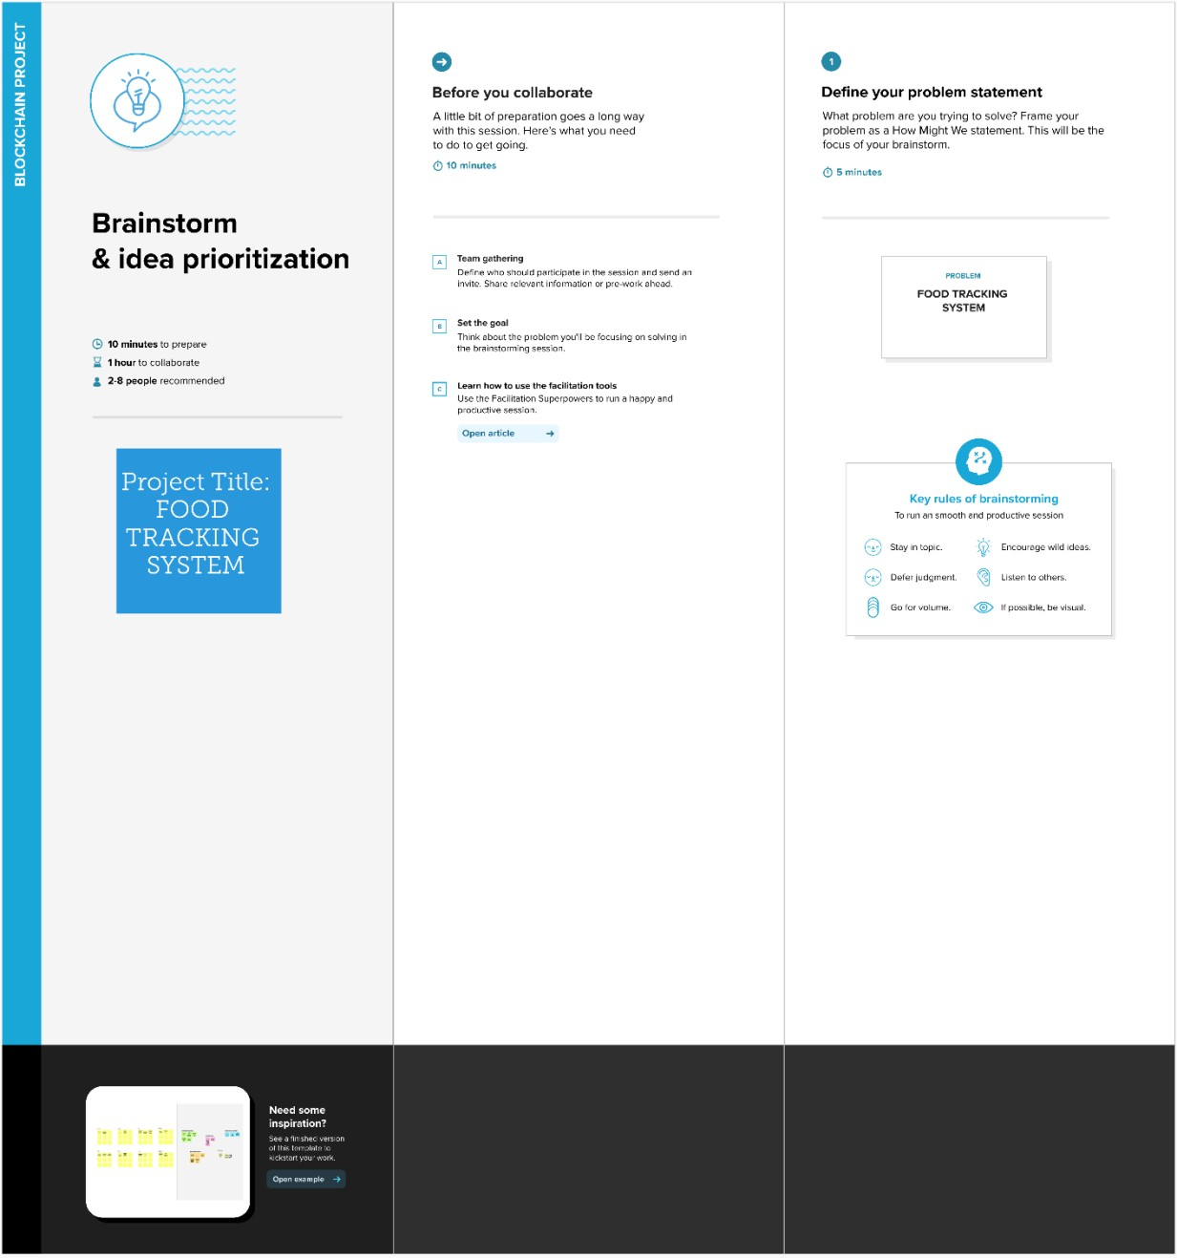

**Idea Prioritization:**

