POP PROJECT
Restaurant Search



National Institute of Technology Karnataka, Surathkal
Department of Information Technology

Group Members:
Sanjay Shetty 16IT136
Nishant Kumar 16IT123
Dhvanil Parikh 16IT217
Mahim Agrawal 16IT152
Declaration

We, Mahim Agrawal (16IT152), Dhvanil Parikh (16IT217), Sanjay Shetty (16IT136), Nishant Kumar (16IT123) students of 3rd semester Bachelor of Technology in Information Technology, National Institute of Technology Karnataka, Surathkal, hereby declare that the project work entitled “Restaurant Management” submitted to Ms. R. Priyadarshini during the academic year 2017-18, is a record of an original work done by us. This project is submitted in the fulfilment of the requirement by the course (IT206) – Paradigms of Programming.

Date: 27-11-2017 Sanjay Shetty
Place: Surathkal Nishant Kumar
Dhvanil Parikh
Mahim Agrawal

Table of contents

TOPICS Page No.
- Synopsis 1

- Introduction 2

- Problem statement. 3

- Objective. 4

- Methodology. 5

- System Specification 7

- Works done (with screenshots and explanation). 8

- Future works. 11

- Result and discussion. 12

- Conclusion. 13

- Reference. 14

- Appendix (Code). 15

- Synopsis
Restaurant Search is a project which aims in developing a computerized system to maintain all the daily work of different Restaurants. It has a facility of admin login through which the admin can monitor the whole system. It has also a facility where the user after logging in their accounts can see list of restaurants present in and around the city. Overall this project of ours is being developed to help the admin and the user as well as the restaurant owners to maintain the details of the hotels in the best way possible and reduce the human efforts.

1
2. Introduction
As we open the site there are two options one for the Admin and the other for the User. The Admin has permission to view, add and delete hotels. The User has permission to view and categorize hotels by:
1) Regions
2) Category
3) Rating

The user can also give reviews about the visited hotels.
The details of hotels contain:
1)Name
2)Place/Address
3)Rating
4)Reviews
Then at last there is an option to logout.

2
3. Problem Statement
To make a Project on Java which includes the concepts of includes class, objects, methods, encapsulation, abstraction, polymorphism, inheritance, interface.

Our Project:
The project is to make a Restaurant Search using the concepts of JAVA mentioned above. It also includes JAVA Swing for User Interface and MySQL for Database.

3

4. Objective
The project aims and objectives that will be achieved after completion of this project are discussed in this subchapter. The aims and objectives are as follows:
• Restaurant details
• Column for admin for including new hotels, view and delete hotels.
• User login page where he/she can find hotels through Restaurant Search.
• The user can also rate the hotels and search by different categories.
• All these features are implemented using the concepts of JAVA and MySQL and JAVA Swing.
• This project is done to sharpen our concepts of JAVA.

Restaurant Search is a computerized system which helps admin to manage the Restaurant daily activity in electronic format. It reduces the risk of paper work such as file lost, file damaged and time consuming. It can help admin to keep track of the hotels and record more effectively and thus is timesaving.

4
5. Methodology
We have used JAVA Swing for the User Interface part. MySQL is used for the storing of the data. The data includes the detail of the restaurants and the users. The details of the restaurant include ID, name, address, rating and number of ratings, email ID and phone number of the hotel. The details of the user are also stored in the database. It includes the name, phone number, email ID of the user.
JAVA Swing is used for the user interface part. It includes to make the Content Box, Buttons, Dialog Box and other styling part.

The first screen which opens after running the project is where the viewer decides to login as an Admin or a User. If the viewer is Admin, he/she can login using the admin name and the password. The Admin has the authority to add a new hotel. He/she can also the delete the hotel if required.
On the other hand, if the viewer is User he/she has to login with the username and password. The user can view the hotels present. He/she can search hotels based on different categories, like locality or ratings. The user can also rate the hotels which he/she has visited.

1. NORMAL USER
1.1 USER LOGIN
Description of feature:
This feature used by the user to login into system. They are required to enter user id and password before they can enter the system. The user id and password will be verified and if invalid id is there user cannot enter the system.
Functional requirements:
-User id is provided when they register
-The system must only allow user with valid id and password to enter the system
-The system performs authorization process which decides what user level can access to.
-The user must be able to logout after they finished using system.

5
1.2 REGISTER NEW USER
Description of feature:
This feature can be performed by all users to register new user to create account.
Functional requirements:
-System must be able to verify information
-System must be able to delete information if information is wrong
2. REGISTER NEW Restaurant by The Admin
Description of feature:
This feature allows to add new hotels to the Restaurant Functional requirements
-System must be able to verify information
-System must be able to enter number of copies into table.
- System must be able to not allow two restaurants having same id.

6
6. SYSTEM SPECIFICATIONS
As we all know java is platform independent it can run on any system in which java jdk is installed. It can be windows, mac os or any Unix distribution which has java jdk installed. Also, as we are using database for our project MySQL software must be installed. The system needs to have 10 MB of free space.

7
7. WORK DONE

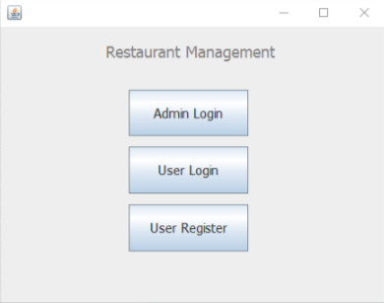
• The main screen of the application gives the user three options – Admin Login, User Login and User Register.

• Admin can add and view restaurants.

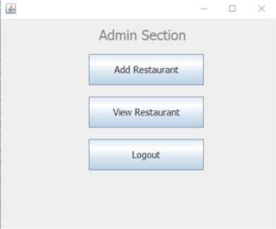

8

• Admin must give the details of the hotel before storing it into the database.
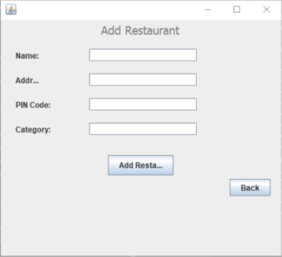
• The User Register page lets us create a new user
.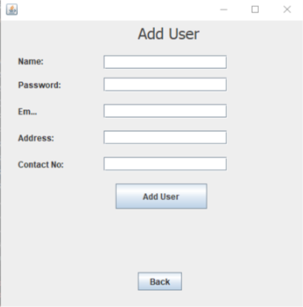
• After logging in, the user can view or rate restaurants.
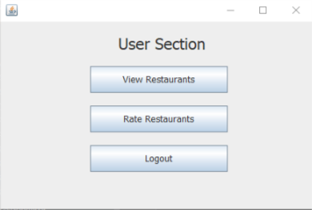
9

• View Restaurant page provides three options to filter – by Category, by Region, no filter.
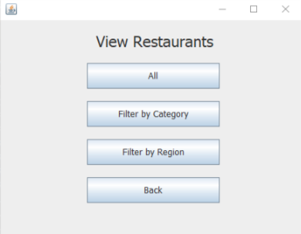

• The Rate Restaurants screen lets the user select stars out 5 according to their liking.

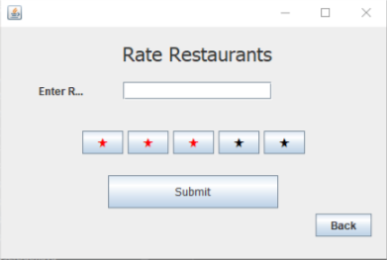

10

8. FUTURE WORKS
We have plans to add an online support to our Restaurant Search project. We are also planning to make an android app for the same and publish it. Also registering different type of restaurants to our app from in and around the country. And add the details of the restaurant if it has any other options like availability of rooms and their rents. It would help people and easy for them to search rooms. We are also planning to add the payment option which helps people go cashless.

11
9. Result and Discussion
The aim of the system testing process was to determine all defects in our project. The program was subjected to a set of test inputs and various observations were made and based on these observations it will be decided whether the program behaves as expected or not. Our Project went through two levels of testing
1. Unit testing
It is undertaken when a module has been created and successfully reviewed. In order to test a single module, we need to provide a complete environment that is besides the module we would require.
• The procedures belonging to other modules that the module under test calls
• Non-local data structures that module accesses
• A procedure to call the functions of the module under test with appropriate parameters Unit testing was done on each module that is described under module description.
1. Test for Admin login module
• Testing admin login form - This form is used for logging in of administrator of the system. In this we enter the username and password if both are correct administration page will open otherwise if any of data is wrong it will generate a dialog box and again ask for username and password
• Restaurant addition - In this section the admin can verify hotel details from Restaurant info and then only add hotel details to main database. It contains add and delete buttons if admin click add button data will be added to hotel database and if he clicks delete button the hotel data will be deleted.
2. Test for User login module
• Test for User Login Form - This form is used for logging in of the user. In this the user enters the username and password, if all these are correct user section dialog will open otherwise if any of data is wrong it will generate a dialog box and again ask for username and password.
• Test for account creation - This form is used for new account creation when user does not fill the form completely it asks again to fill the whole form when he/she fill the form fully it gets redirected to page which show waiting for conformation message as his data will be only added by administrator after verification.

2. Integration
In this type of testing we test various integration of the project module by providing the input. The primary objective is to test the module interfaces in order to ensure that no errors are occurring when one module invokes the other module.

12
10.Conclusion

We learned a lot through this project. This project has sharpened our concepts of JAVA and MySQL.

We learned a lot about different documentation. The piece of software we developed is intended to show the flexibility of JAVA. This project not only tested our technical skills but also our temperament.

There were many time we almost lost hope, but we recovered through constant concentration and hard work.

If any kind of suggestion, improvements, more efficient development ideas are found, please feel free to communicate with us.

13
11.REFERENCES
[1] Java™: The Complete Reference, Seventh Edition. Herbert Schildt.
[2] https://www.javatpoint.com/
[3] https://www.tutorialspoint.com/java/
[4] https://www.w3schools.in › Java
[5] https://www.guru99.com/java-tutorial.html

[6] https://www.guru99.com/java-tutorial.html

[7] https://docs.oracle.com/javase/tutorial/

[8] https://www.udemy.com/java-tutorial/

[9] https://www.journaldev.com › Java

