Dhvanil Shah

Professor Hakner

ECE-357

20 September 2018

Problem Set 1 – Question 3

**Program**

#include <fcntl.h>

#include <stdlib.h>

#include <stdio.h>

#include <unistd.h>

#include <string.h>

#include <errno.h>

// FUNCTION TO THROW ERRORS => INFLUENCED BY GRAPHQL QUERY ERROR REPORTING

void throwError(char *message, char *file)

{

if (file)

fprintf(stderr, "%s [%s]: Error code %i: %s\n", message, file, errno, strerror(errno));

else

printf("%s. Proper usage of the arguments is: [-b ###] [-o outfile]\n", message);

exit(-1);

}

int main(int argc, char *argv[])

{

int buffer = 4096, flag, fdo, fdi, amtRead, amtWritten = 0;

char *outfile;

// FIND THE [-b ###] AND [-o OUTFILE] OPTIONS USING GETOPT

while ((flag = getopt(argc, argv, "b:o:")) != -1)

switch (flag)

{

case 'b':

buffer = atoi(optarg);

break;

case 'o':

outfile = optarg;

break;

case '?':

throwError("Error: Unknown argument supplied", NULL);

default:

throwError("Error: The arguments '-b' and '-o' require arguments", NULL);

}

char *buff = malloc((sizeof(char)) * buffer);

//OPEN THE OUTFILE IF ONE IS SPECIFIED

if (outfile)

{

fdo = open(outfile, O_WRONLY | O_CREAT | O_TRUNC, 0666);

if (fdo < 0)

throwError("Error: Unable to open the output file", outfile);

}

else

fdo = STDOUT_FILENO;

// CHECK IF ZERO INPUT => IF TRUE, TREAT IT LIKE A "-" BY APPENDING "-" TO ARGV

if (optind == argc)

{

argc = 0, optind = 0;

argv[argc++] = "-";

}

//ITERATE THROUGH ARGUMENTS STARTING AT CURRENT OPTIND+1 ENDING AT LAST ARGUMENT

for (; optind < argc; ++optind)

{

if (!strcmp("-", argv[optind]))

{

fdi = STDIN_FILENO;

argv[optind] = "stdin";

}

// OPEN INPUT FILE FOR READ

else if ((fdi = open(argv[optind], O_RDONLY, 0666)) < 0)

{

throwError("Error: Unable to open the input file", argv[optind]);

}

// THE READ AND WRITE OPERATIONS WITH CORRECTION FOR PARTIAL WRITES

while ((amtRead = read(fdi, buff, (sizeof(char)) * buffer)) != 0)

{

if (amtRead < 0)

{

throwError("Error: Could not read from the input file", argv[optind]);

}

else

{

while (amtWritten < amtRead)

{

if ((amtWritten = write(fdo, buff, amtRead)) < 0)

{

throwError("Error: Could not write to the output file", outfile);

}

amtRead = amtRead - amtWritten;

buff = buff + amtRead;

amtWritten = 0;

}

}

}

}

// CLOSE THE OUTPUT FILE IF IT ISNT STD OUT

if (fdo != STDOUT_FILENO && close(fdo) < 0)

throwError("Error: Could not close the output file", outfile);

return 0;

}

**Successful Run of Program and Error Reporting**

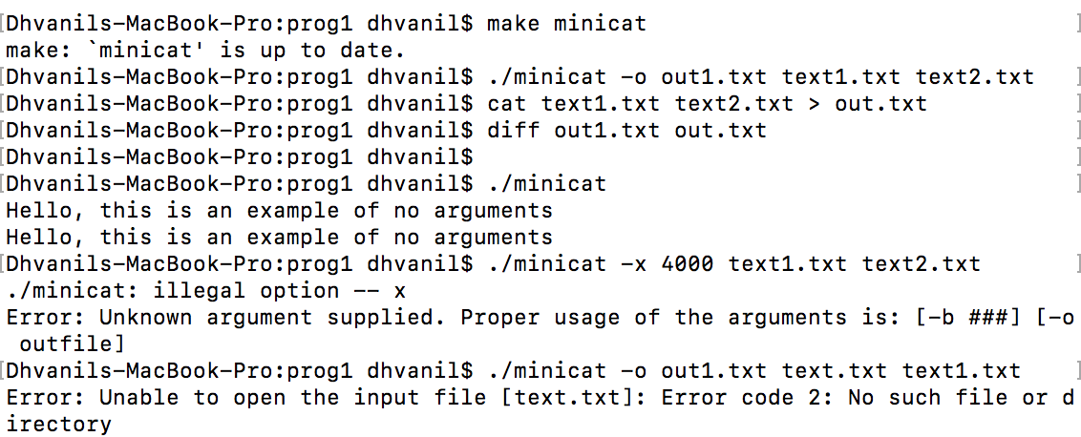

**Successful Run using Binary Files**

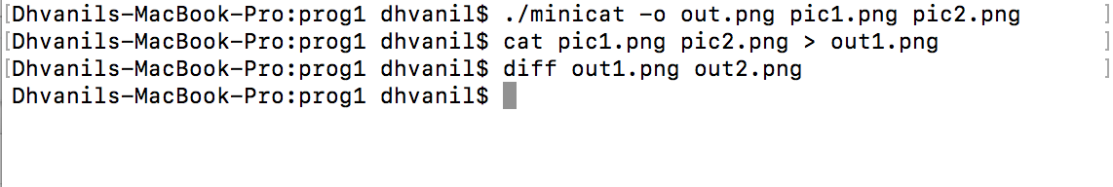

**Code to Test Buffer Sizes**

#!/bin/sh

rm times.txt

make minicat

i=0

echo running tests...

while [ $i -le 12 ]; do

rm out1.txt

b=$((2 ** i))

echo run $i of size $b >> times.txt

/usr/bin/time ./minicat -b $b -o out1.txt text1.txt text2.txt 2>> times.txt

echo run $i of size $b completed

diff out1.txt out.txt

i=$((i+1))

done

echo runs completed

**Run to Test Buffer Sizes**

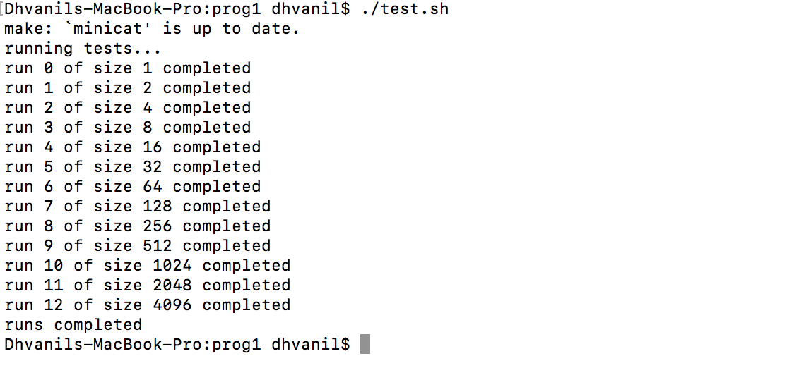

**Results of Buffer Size Test**

|  |  |
| --- | --- |
| **Buffer Size [-b ###]** | **Runtime (seconds)** |
| 1 | 30.96 |
| 2 | 15.53 |
| 4 | 7.48 |
| 8 | 3.85 |
| 16 | 1.85 |
| 32 | 0.97 |
| 64 | 0.62 |
| 128 | 0.25 |
| 256 | 0.13 |
| 512 | 0.08 |
| 1024 | 0.04 |
| 2048 | 0.03 |
| 4096 | 0.02 |

**Analysis**

The increase in buffer size causes a large reduction in the run time of the program. In order to achieve these results, “minicat” was tested on two large files of sizes 2 Mb and 3.4 Mb. The reason for this is that increasing the buffer size decreases the amount of read/write system calls the program makes. An appropriate analogy would be that you, a bus driver, have to transport 4,096 students from School A to School B. If your bus could only hold one student, you would have to make 4,096 trips. If your bus could hold 128 students, you would have to make only 32 trips. And ideally, if your bus could hold all 4,096 students, you would only have to make 1 trip. In our case, each bus trip is one read and one write system call. The run times of the program were tested using the time shell command.

**Question to Ponder**

To have a file name be “ - “, you can possible enter the file as ./- into the program.