Dhvanil Shah

ECE 357

Prof. Hakner

14 December 2018

Problem Set 6

Table of Contents

Write Up 1

Code

Makefile 4

tas64.S (MacOS) 5

spin.c 6

spin.h 7

sem.c 8

sem.h 10

fifo.c 11

fifo.h 13

testTAS.c 14

testFIFO.c 16

Write Up

Testing with **one reader and one writer** using 20 iterations. Each write and each read is sequentially outputted to two separate files. The “diff” command is used to indicate the write and read order is the same.

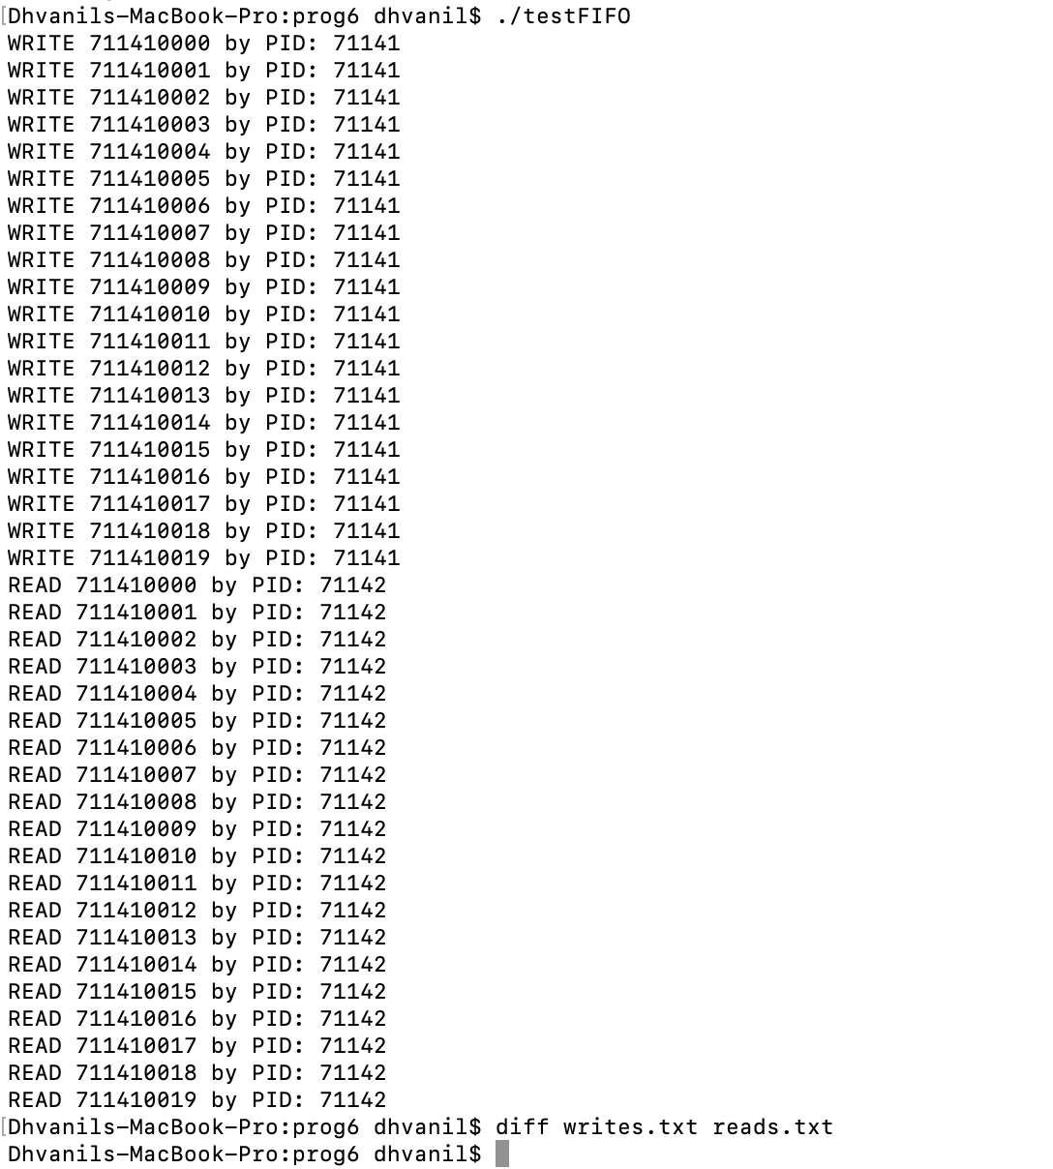

Testing with **multiple writes and one reader using many iterations**. Output is truncated but diff passes.

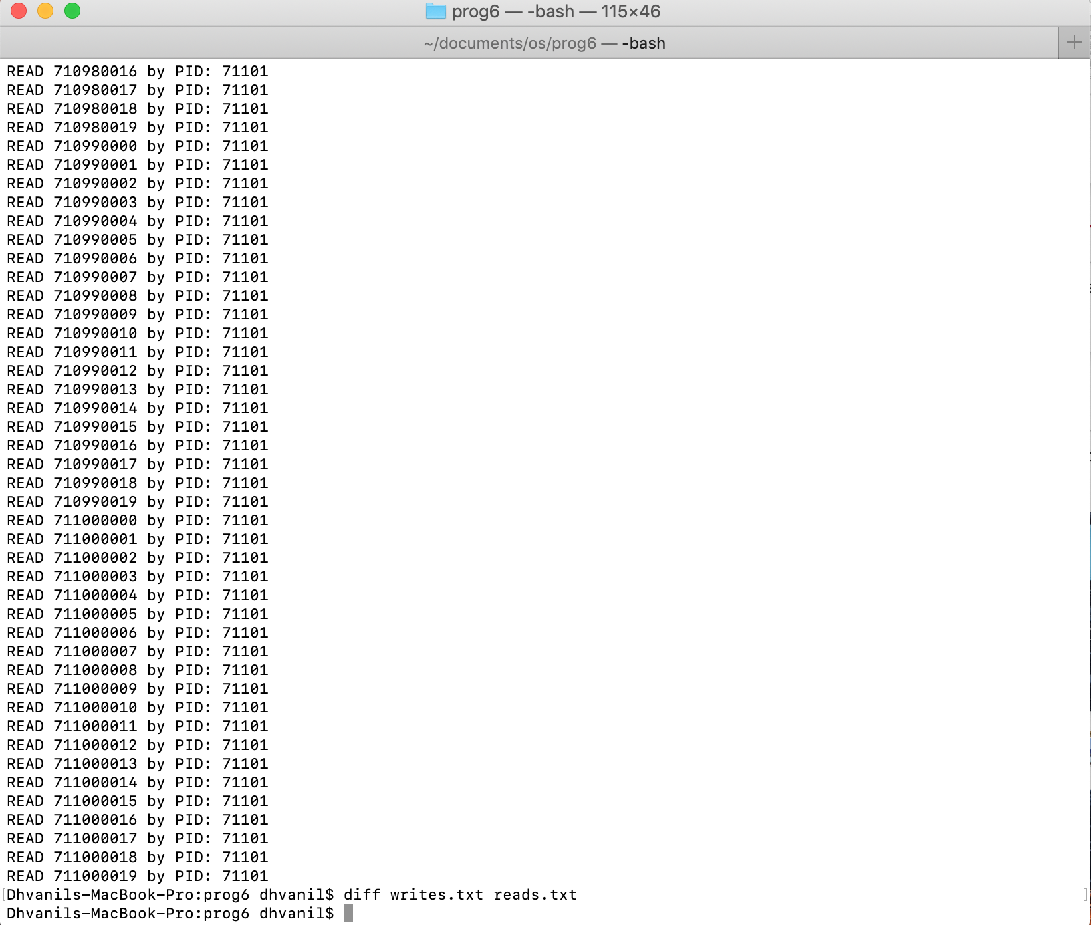

Testing by **changing the order of lock and unlock** in sem_inc(). The program hangs, indicating that it is broken.

