GUJARAT TECHNOLOGICAL UNIVERSITY
LABORATORY MANUAL

Branch: Master of Computer Application
Semester: 2
Subject: FULL STACK DEVELOPMENT
Subject Code: MC02094041

Submitted To
Prof. Himani Khodifad

Submitted By
Student Name: PRAJAPATI KRUPALI RAJENDRAKUMAR
Enrollment No.: 255490694107

College
R. B. Institute of Management Studies

Academic Year: 2025 – 2026

INDEX

Sr No | Practical Name
1 | Create a Website using HTML, CSS and JavaScript
2 | Build a Chat Module using HTML CSS and JavaScript
3 | Online MCQ Quiz App using NodeJS
4 | Blog Website using NodeJS and Database
5 | API Analysis of Amazon / Facebook
6 | Database Architecture for E-Commerce
7 | Simple Login Form using React JS
8 | Todo List App using ReactJS
9 | Voting Application using ReactJS
10 | Calculator Application using React
11 | Grocery Delivery Application Project

Practical - 1. Write a program to create a website using HTML CSS and JavaScript.
- Software Requirement
  - VS Code
  - Web Browser
- Program code
  - Index.html
<!DOCTYPE html>
<html>
<head>
<title>My Beautiful Website</title>
<link rel="stylesheet" href="style.css">
</head>
<body>

<!-- Navigation -->
<nav>
<h2 class="logo">RBIMCS</h2>
<ul>
<li><a href="#">Home</a></li>
<li><a href="#about">About</a></li>
<li><a href="#contact">Contact</a></li>
</ul>
</nav>

<!-- Hero Section -->
<section class="hero">
<div class="hero-content">
<h1>Welcome to My Beautiful Website</h1>
<p>Modern design created using HTML, CSS & JavaScript</p>
<button onclick="showMessage()">Explore More</button>
</div>
</section>

<!-- About Section -->
<section id="about" class="about">
<h2>About Us</h2>
<p>
We create clean and modern websites for beginners and professionals.
This layout is fully responsive and beautifully styled.
</p>
</section>

<!-- Footer -->
<footer id="contact">
<p>© 2026 MyWebsite | MCA -2 Practical</p>
</footer>

<script src="script.js"></script>
</body>
</html>

  - script.js
function showMessage() {
alert("Hello! Thanks for visiting my website ");
}

  - style.css
/* Reset */
* {
margin: 0;
padding: 0;
box-sizing: border-box;
font-family: 'Segoe UI', sans-serif;
scroll-behavior: smooth;
}

body {
background: #f5f7fa;
}

/* Navigation */
nav {
position: fixed;
width: 100%;
top: 0;
background: rgba(0, 0, 0, 0.7);
backdrop-filter: blur(10px);
color: white;
display: flex;
justify-content: space-between;
padding: 20px 60px;
align-items: center;
z-index: 1000;
}

.logo {
font-size: 22px;
font-weight: bold;
}

nav ul {
list-style: none;
display: flex;
}

nav ul li {
margin-left: 30px;
}

nav ul li a {
color: white;
text-decoration: none;
font-weight: 500;
transition: 0.3s;
}

nav ul li a:hover {
color: #00c6ff;
}

/* Hero Section */
.hero {
height: 100vh;
background: linear-gradient(135deg, #00c6ff, #0072ff);
display: flex;
justify-content: center;
align-items: center;
text-align: center;
color: white;
padding: 20px;
}

.hero-content h1 {
font-size: 48px;
margin-bottom: 20px;
}

.hero-content p {
font-size: 20px;
margin-bottom: 30px;
}

.hero button {
padding: 12px 30px;
font-size: 16px;
border: none;
border-radius: 30px;
background: white;
color: #0072ff;
cursor: pointer;
transition: 0.3s ease;
}

.hero button:hover {
background: #222;
color: white;
transform: scale(1.05);
}

/* About Section */
.about {
padding: 100px 20px;
text-align: center;
background: white;
}

.about h2 {
font-size: 36px;
margin-bottom: 20px;
color: #0072ff;
}

.about p {
max-width: 600px;
margin: auto;
font-size: 18px;
color: #555;
line-height: 1.6;
}

/* Footer */
footer {
background: #111;
color: #aaa;
text-align: center;
padding: 20px;
font-size: 14px;
}

/* Responsive */
@media (max-width: 768px) {
nav {
padding: 15px 20px;
}

.hero-content h1 {
font-size: 32px;
}

.hero-content p {
font-size: 16px;
}
}

Steps to Run the Program
  - Open Visual Studio Code.
  - Create a new folder for the website project.
  - Create three files named index.html, style.css, and script.js.
  - Write the HTML program in index.html.
  - Write the CSS styling code in style.css.
  - Write the JavaScript function in script.js.
  - Save all the files in the same folder.
  - Open index.html in a web browser like Google Chrome.
  - The website will run and display the designed webpage.

2. Write a program to build a Chat module using HTML CSS and JavaScript.
- Software Requirement
  - VS Code
  - Web Browser
- Program code
  - Index.html
<!DOCTYPE html>
<html>
<head>
<title>Simple Chat Module</title>
<link rel="stylesheet" href="style.css">
</head>
<body>

<div class="chat-container">

<div class="chat-header">
Chat Module
</div>

<div class="chat-box" id="chatBox"></div>

<div class="chat-input">
<input type="text" id="messageInput" placeholder="Type a message..." />
<button onclick="sendMessage()">Send</button>
</div>

</div>

<script src="script.js"></script>
</body>
</html>
  - script.js
const chatBox = document.getElementById("chatBox");
const messageInput = document.getElementById("messageInput");

function sendMessage() {
const message = messageInput.value;

if (message.trim() === "") return;

addMessage(message, "user-message");
messageInput.value = "";

setTimeout(() => {
let reply = getBotReply(message);
addMessage(reply, "bot-message");
}, 500);
}

function addMessage(text, className) {
const messageDiv = document.createElement("div");
messageDiv.classList.add("message", className);
messageDiv.innerText = text;
chatBox.appendChild(messageDiv);

chatBox.scrollTop = chatBox.scrollHeight;
}

function getBotReply(msg) {
msg = msg.toLowerCase();

if (msg.includes("hello")) {
return "Hello! 👋";
} else if (msg.includes("how are you")) {
return "I'm just a simple bot!";
} else if (msg.includes("bye")) {
return "Goodbye!";
} else {
return "I don't understand that.";
}
}

messageInput.addEventListener("keypress", function(e) {
if (e.key === "Enter") {
sendMessage();
}
});
  - style.css
body {
background: #f4f6f9;
display: flex;
justify-content: center;
align-items: center;
height: 100vh;
font-family: Arial;
}

.chat-container {
width: 400px;
height: 500px;
background: white;
border-radius: 10px;
box-shadow: 0 5px 10px rgba(0,0,0,0.2);
display: flex;
flex-direction: column;
}

.chat-header {
background: green;
color: white;
padding: 15px;
text-align: center;
}

.chat-box {
flex: 1;
padding: 10px;
overflow-y: auto;
}

.message {
padding: 8px;
margin: 5px 0;
border-radius: 5px;
max-width: 70%;
}

.user-message {
background: green;
color: white;
margin-left: auto;
}

.bot-message {
background: #e4e6eb;
}

.chat-input {
display: flex;
}

.chat-input input {
flex: 1;
padding: 10px;
border: none;
}

.chat-input button {
padding: 10px;
background: green;
color: white;
border: none;
}

3. Build an online MCQ quiz app. The questions and options should be fetched based on the chosen topic from a NodeJS server. The questions can be stored in a JSON file in the backend. Once the user has answered the questions, the frontend must send the chosen options to the backend and the backend must identify the right answers and send the score back to the front end. The frontend must display the score in a separate neatly designed page.
- Software Requirement
  - VS Code
  - Web Browser
- Program code
  - Public
    - Index.html
<!DOCTYPE html>
<html>
<head>
<title>Quiz App</title>
<link rel="stylesheet" href="style.css">
</head>
<body>
<div class="container">
<h1>Select Topic</h1>
<button onclick="startQuiz('javascript')">JavaScript</button>
<button onclick="startQuiz('html')">HTML</button>
</div>

<script src="script.js"></script>
</body>
</html>
    - Quiz.html
<!DOCTYPE html>
<html>
<head>
<title>Quiz</title>
<link rel="stylesheet" href="style.css">
</head>
<body>
<div class="container">
<h2 id="topicTitle"></h2>
<form id="quizForm"></form>
<button onclick="submitQuiz()">Submit</button>
</div>

<script src="script.js"></script>
</body>
</html>
    - Result.html
<!DOCTYPE html>
<html>
<head>
<title>Result</title>
<link rel="stylesheet" href="style.css">
</head>
<body>
<div class="result-container">
<h1>Your Score</h1>
<h2 id="scoreText"></h2>
<button onclick="goHome()">Back to Home</button>
</div>

<script src="script.js"></script>
</body>
</html>
    - Script.js
let selectedTopic = "";
let questions = [];

function startQuiz(topic) {
localStorage.setItem("topic", topic);
window.location.href = "quiz.html";
}

if (window.location.pathname.includes("quiz.html")) {
selectedTopic = localStorage.getItem("topic");
document.getElementById("topicTitle").innerText = selectedTopic.toUpperCase();

fetch(`/api/questions/${selectedTopic}`)
.then(res => res.json())
.then(data => {
questions = data;
const form = document.getElementById("quizForm");

data.forEach((q, index) => {
form.innerHTML += `<p>${q.question}</p>`;
q.options.forEach((opt, i) => {
form.innerHTML += `
<input type="radio" name="q${index}" value="${i}" required>
${opt}<br>
`;
});
});
});
}

function submitQuiz() {
const answers = [];

questions.forEach((q, index) => {
const selected = document.querySelector(`input[name="q${index}"]:checked`);
answers.push(parseInt(selected.value));
});

fetch("/api/submit", {
method: "POST",
headers: { "Content-Type": "application/json" },
body: JSON.stringify({
topic: selectedTopic,
answers: answers
})
})
.then(res => res.json())
.then(data => {
localStorage.setItem("score", `${data.score} / ${data.total}`);
window.location.href = "result.html";
});
}

if (window.location.pathname.includes("result.html")) {
document.getElementById("scoreText").innerText =
localStorage.getItem("score");
}

function goHome() {
window.location.href = "index.html";
}
    - Style.css
body {
font-family: Arial;
background: linear-gradient(135deg, #667eea, #764ba2);
display: flex;
justify-content: center;
align-items: center;
height: 100vh;
}

.container, .result-container {
background: white;
padding: 40px;
border-radius: 10px;
width: 400px;
text-align: center;
}

button {
padding: 10px 20px;
margin: 10px;
border: none;
background: #667eea;
color: white;
cursor: pointer;
border-radius: 5px;
}
  - Package.json
{
"name": "quiz-app",
"version": "1.0.0",
"description": "Online MCQ Quiz App",
"main": "server.js",
"type": "commonjs",
"scripts": {
"start": "node server.js"
},
"author": "",
"license": "ISC",
"dependencies": {
"cors": "^2.8.5",
"express": "^4.18.2"
}
}
  - Questions.json
{
"javascript": [
{
"id": 1,
"question": "Which keyword declares a variable?",
"options": ["int", "var", "define", "dim"],
"answer": 1
},
{
"id": 2,
"question": "Which company developed JavaScript?",
"options": ["Microsoft", "Sun", "Netscape", "Oracle"],
"answer": 2
}
],
"html": [
{
"id": 1,
"question": "HTML stands for?",
"options": [
"Hyper Trainer Marking Language",
"Hyper Text Markup Language",
"Hyper Text Marketing Language",
"Hyper Tool Markup Language"
],
"answer": 1
}
]
}
  - Server.js
const express = require("express");
const cors = require("cors");
const fs = require("fs");

const app = express();
app.use(cors());
app.use(express.json());
app.use(express.static("public"));

const questions = JSON.parse(fs.readFileSync("questions.json"));

// Get questions by topic
app.get("/api/questions/:topic", (req, res) => {
const topic = req.params.topic;
if (questions[topic]) {
res.json(questions[topic]);
} else {
res.status(404).json({ message: "Topic not found" });
}
});

// Submit answers
app.post("/api/submit", (req, res) => {
const { topic, answers } = req.body;
const quiz = questions[topic];

let score = 0;

quiz.forEach((q, index) => {
if (q.answer === answers[index]) {
score++;
}
});

res.json({ score, total: quiz.length });
});

app.listen(3000, () => {
console.log("Server running on http://localhost:3000");
});

4. Build a blog website where you can add blog posts through a simple admin panel and the users can view the blog posts. The contents of the blog posts can be stored in either MongoDB or MySQL database. The home page should contain the titles of the blog post and the full post can be viewed by clicking the title. Frontend can be built either using React or through template engines served by the NodeJS server.
- Software Requirement
  - VS Code
  - Web Browser
- Program code
- blog
  - Backend
    - Server.js
const express = require('express');
const mongoose = require('mongoose');
const cors = require('cors');

const app = express();
app.use(cors());
app.use(express.json());

mongoose.connect('mongodb://127.0.0.1:27017/blogDB')
.then(() => console.log('MongoDB Connected'))
.catch(err => console.log(err));

// Schema
const postSchema = new mongoose.Schema({
title: String,
content: String,
createdAt: { type: Date, default: Date.now }
});

const Post = mongoose.model('Post', postSchema);

// Routes

// Route for the blank URL (root)
app.get('/', (req, res) => {
res.send('Welcome to the homepage!');
});

app.get('/posts', async (req, res) => {
const posts = await Post.find().sort({ createdAt: -1 });
res.json(posts);
});

app.get('/posts/:id', async (req, res) => {
const post = await Post.findById(req.params.id);
res.json(post);
});

app.post('/posts', async (req, res) => {
const newPost = new Post(req.body);
await newPost.save();
res.json(newPost);
});

app.listen(5000, () => console.log('Server running on port 5000'));
    - Package.json
{
"dependencies": {
"cors": "^2.8.6",
"express": "^5.2.1",
"mongoose": "^9.4.1"
}
}
  - Client/public
    - Index.html
<html lang="en">
<head>
<meta charset="utf-8" />
<link rel="icon" href="%PUBLIC_URL%/favicon.ico" />
<meta name="viewport" content="width=device-width, initial-scale=1" />
<meta name="theme-color" content="#000000" />
<meta
name="description"
content="Web site created using create-react-app"
/>
<link rel="apple-touch-icon" href="%PUBLIC_URL%/logo192.png" />
<!--
manifest.json provides metadata used when your web app is installed on a
user's mobile device or desktop. See https://developers.google.com/web/fundamentals/web-app-manifest/
-->
<link rel="manifest" href="%PUBLIC_URL%/manifest.json" />
<!--
Notice the use of %PUBLIC_URL% in the tags above.
It will be replaced with the URL of the `public` folder during the build.
Only files inside the `public` folder can be referenced from the HTML.

Unlike "/favicon.ico" or "favicon.ico", "%PUBLIC_URL%/favicon.ico" will
work correctly both with client-side routing and a non-root public URL.
Learn how to configure a non-root public URL by running `npm run build`.
-->
<title>React App</title>
</head>
<body>
<noscript>You need to enable JavaScript to run this app.</noscript>
<div id="root"></div>
<!--
This HTML file is a template.
If you open it directly in the browser, you will see an empty page.

You can add webfonts, meta tags, or analytics to this file.
The build step will place the bundled scripts into the <body> tag.

To begin the development, run `npm start` or `yarn start`.
To create a production bundle, use `npm run build` or `yarn build`.
-->
</body>
</html>

    - Manifest.json

{
"short_name": "React App",
"name": "Create React App Sample",
"icons": [
{
"src": "favicon.ico",
"sizes": "64x64 32x32 24x24 16x16",
"type": "image/x-icon"
},
{
"src": "logo192.png",
"type": "image/png",
"sizes": "192x192"
},
{
"src": "logo512.png",
"type": "image/png",
"sizes": "512x512"
}
],
"start_url": ".",
"display": "standalone",
"theme_color": "#000000",
"background_color": "#ffffff"
}
  - Client/src
    - Admin.js
import React, { useState } from 'react';
import { container, card, titleStyle } from './styles';

function Admin() {
const [title, setTitle] = useState('');
const [content, setContent] = useState('');

const handleSubmit = async (e) => {
e.preventDefault();

await fetch('http://localhost:5000/posts', {
method: 'POST',
headers: { 'Content-Type': 'application/json' },
body: JSON.stringify({ title, content })
});

setTitle('');
setContent('');
alert('Post added 🌱');
};

return (
<div style={container}>
<h1 style={titleStyle}>🌿 Admin Panel</h1>
<form onSubmit={handleSubmit} style={card}>
<input
type="text"
placeholder="Title"
value={title}
onChange={(e) => setTitle(e.target.value)}
style={inputStyle}
/>
<textarea
placeholder="Content"
value={content}
onChange={(e) => setContent(e.target.value)}
style={{ ...inputStyle, height: '120px' }}
/>
<button type="submit" style={buttonStyle}>Add Post</button>
</form>
</div>
);
}

const inputStyle = {
width: '100%',
padding: '10px',
marginBottom: '10px',
borderRadius: '8px',
border: '1px solid #ccc'
};

const buttonStyle = {
backgroundColor: '#4CAF50',
color: 'white',
padding: '10px 20px',
border: 'none',
borderRadius: '8px',
cursor: 'pointer'
};

export default Admin;

    - App.css
.App {
text-align: center;
}

.App-logo {
height: 40vmin;
pointer-events: none;
}

@media (prefers-reduced-motion: no-preference) {
.App-logo {
animation: App-logo-spin infinite 20s linear;
}
}

.App-header {
background-color: #282c34;
min-height: 100vh;
display: flex;
flex-direction: column;
align-items: center;
justify-content: center;
font-size: calc(10px + 2vmin);
color: white;
}

.App-link {
color: #61dafb;
}

@keyframes App-logo-spin {
from {
transform: rotate(0deg);
}
to {
transform: rotate(360deg);
}
}
    - App.js
import React from 'react';
import { BrowserRouter as Router, Routes, Route, Link } from 'react-router-dom';
import Home from './Home';
import PostPage from './PostPage';
import Admin from './Admin';

function Navbar() {
return (
<nav style={{
backgroundColor: '#2e7d32',
padding: '15px',
display: 'flex',
justifyContent: 'space-between',
alignItems: 'center'
}}>
<h2 style={{ color: 'white', margin: 0 }}>🌿 Blog App</h2>
<div>
<Link to="/" style={navLink}>Home</Link>
<Link to="/admin" style={navLink}>Admin</Link>
</div>
</nav>
);
}

const navLink = {
color: 'white',
marginLeft: '20px',
textDecoration: 'none',
fontWeight: 'bold'
};

function App() {
return (
<Router>
<div style={{ backgroundColor: '#f1f8f4', minHeight: '100vh' }}>
<Navbar />
<Routes>
<Route path="/" element={<Home />} />
<Route path="/post/:id" element={<PostPage />} />
<Route path="/admin" element={<Admin />} />
</Routes>
</div>
</Router>
);
}

export default App;

// Shared Styles
const container = {
maxWidth: '800px',
margin: 'auto',
padding: '20px'
};

const card = {
background: '#ffffff',
padding: '20px',
marginBottom: '20px',
borderRadius: '15px',
boxShadow: '0 4px 12px rgba(0,0,0,0.08)',
borderLeft: '6px solid #4CAF50'
};

const titleStyle = {
color: '#2e7d32'
};
    - App.test.js
import { render, screen } from '@testing-library/react';
import App from './App';

test('renders learn react link', () => {
render(<App />);
const linkElement = screen.getByText(/learn react/i);
expect(linkElement).toBeInTheDocument();
});
    - home.js
import React, { useEffect, useState } from 'react';
import { Link } from 'react-router-dom';
import { container, card, titleStyle } from './styles';

function Home() {
const [posts, setPosts] = useState([]);

useEffect(() => {
fetch('http://localhost:5000/posts')
.then(res => res.json())
.then(data => setPosts(data));
}, []);

return (
<div style={container}>
<h1 style={titleStyle}>🌿 Blog Posts</h1>
{posts.map(post => (
<div key={post._id} style={card}>
<Link to={`/post/${post._id}`} style={{ textDecoration: 'none' }}>
<h2 style={{ color: '#388e3c' }}>{post.title}</h2>
</Link>
</div>
))}
</div>
);
}

export default Home;
    - index.css
body {
margin: 0;
font-family: -apple-system, BlinkMacSystemFont, 'Segoe UI', 'Roboto', 'Oxygen',
'Ubuntu', 'Cantarell', 'Fira Sans', 'Droid Sans', 'Helvetica Neue',
sans-serif;
-webkit-font-smoothing: antialiased;
-moz-osx-font-smoothing: grayscale;
}

code {
font-family: source-code-pro, Menlo, Monaco, Consolas, 'Courier New',
monospace;
}
    - Index.js
body {
margin: 0;
font-family: -apple-system, BlinkMacSystemFont, 'Segoe UI', 'Roboto', 'Oxygen',
'Ubuntu', 'Cantarell', 'Fira Sans', 'Droid Sans', 'Helvetica Neue',
sans-serif;
-webkit-font-smoothing: antialiased;
-moz-osx-font-smoothing: grayscale;
}

code {
font-family: source-code-pro, Menlo, Monaco, Consolas, 'Courier New',
monospace;
}
    - Postpage.js

import React, { useEffect, useState } from 'react';
import { useParams } from 'react-router-dom';
import { container, card, titleStyle } from './styles';

function PostPage() {
const { id } = useParams();
const [post, setPost] = useState(null);

useEffect(() => {
fetch(`http://localhost:5000/posts/${id}`)
.then(res => res.json())
.then(data => setPost(data));
}, [id]);

if (!post) return <p style={{ textAlign: 'center' }}>Loading...</p>;

return (
<div style={container}>
<div style={card}>
<h1 style={titleStyle}>{post.title}</h1>
<p style={{ lineHeight: '1.6', color: '#444' }}>{post.content}</p>
</div>
</div>
);
}

export default PostPage;
    - reportwebVitals.js
const reportWebVitals = onPerfEntry => {
if (onPerfEntry && onPerfEntry instanceof Function) {
import('web-vitals').then(({ getCLS, getFID, getFCP, getLCP, getTTFB }) => {
getCLS(onPerfEntry);
getFID(onPerfEntry);
getFCP(onPerfEntry);
getLCP(onPerfEntry);
getTTFB(onPerfEntry);
});
}
};

export default reportWebVitals;
    - setupTests.js
// jest-dom adds custom jest matchers for asserting on DOM nodes.
// allows you to do things like:
// expect(element).toHaveTextContent(/react/i)
// learn more: https://github.com/testing-library/jest-dom
import '@testing-library/jest-dom';
    - styles.js
export const container = {
maxWidth: '800px',
margin: 'auto',
padding: '20px'
};

export const card = {
background: '#ffffff',
padding: '20px',
marginBottom: '20px',
borderRadius: '15px',
boxShadow: '0 4px 12px rgba(0,0,0,0.08)',
borderLeft: '6px solid #4CAF50'
};

export const titleStyle = {
color: '#2e7d32'
};
  - client/Package.json
{
"name": "client",
"version": "0.1.0",
"private": true,
"dependencies": {
"@testing-library/dom": "^10.4.1",
"@testing-library/jest-dom": "^6.9.1",
"@testing-library/react": "^16.3.2",
"@testing-library/user-event": "^13.5.0",
"react": "^19.2.5",
"react-dom": "^19.2.5",
"react-router-dom": "^7.14.0",
"react-scripts": "5.0.1",
"web-vitals": "^2.1.4"
},
"scripts": {
"start": "react-scripts start",
"build": "react-scripts build",
"test": "react-scripts test",
"eject": "react-scripts eject"
},
"eslintConfig": {
"extends": [
"react-app",
"react-app/jest"
]
},
"browserslist": {
"production": [
">0.2%",
"not dead",
"not op_mini all"
],
"development": [
"last 1 chrome version",
"last 1 firefox version",
"last 1 safari version"
]
}
}

5. Take Amazon ecommerce or Facebook social media website/app. Analyze what the API endpoints would have been used for and how the frontend interacts with the backend. The networks tab in the browser’s developer tools can be used if required.

Analysis of API Endpoints Using Browser Developer Tools

Aim
To analyze API endpoints of a real-world web application (Amazon or Facebook) and understand how frontend communicates with backend using Developer Tools.

Objectives
- Understand working of modern web apps
- Learn Developer Tools (DevTools)
- Identify API endpoints
- Analyze request & response

Tools Required
- Browser: Google Chrome / Microsoft Edge
- Internet connection
- Website: Amazon or Facebook

Theory

What is an API?
API (Application Programming Interface) is a bridge between frontend and backend.
Example:
Search on Amazon → API request → results returned

Frontend vs Backend
Component | Description
Frontend | UI (what user sees)
Backend | Server + database
API | Communication bridge

What is DevTools?
DevTools is a built-in browser tool used to inspect and debug websites.

DevTools Interface Overview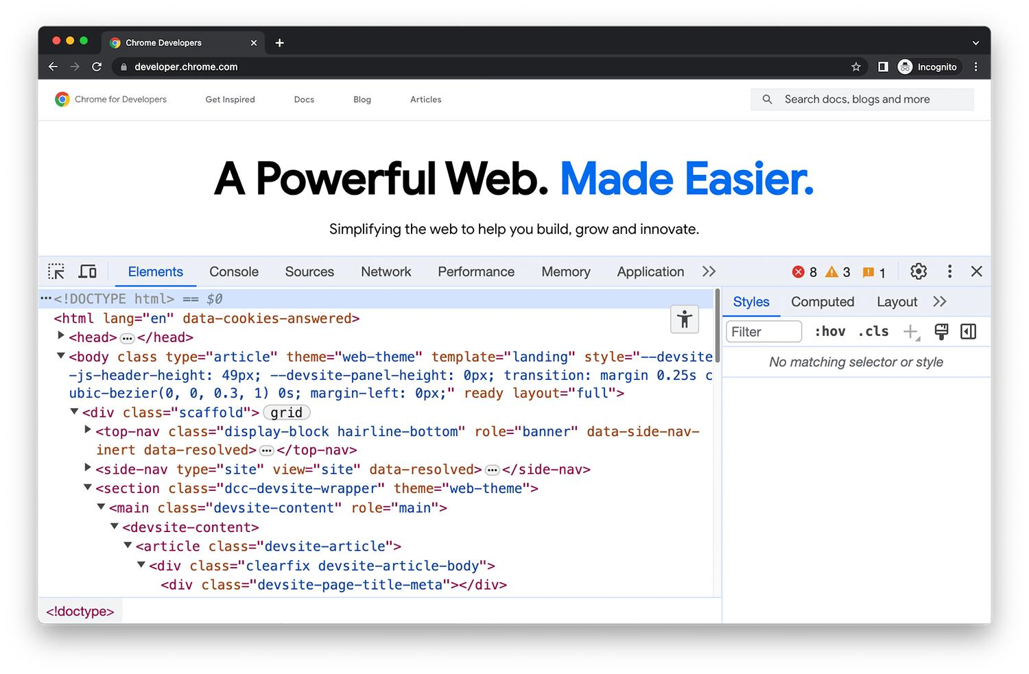
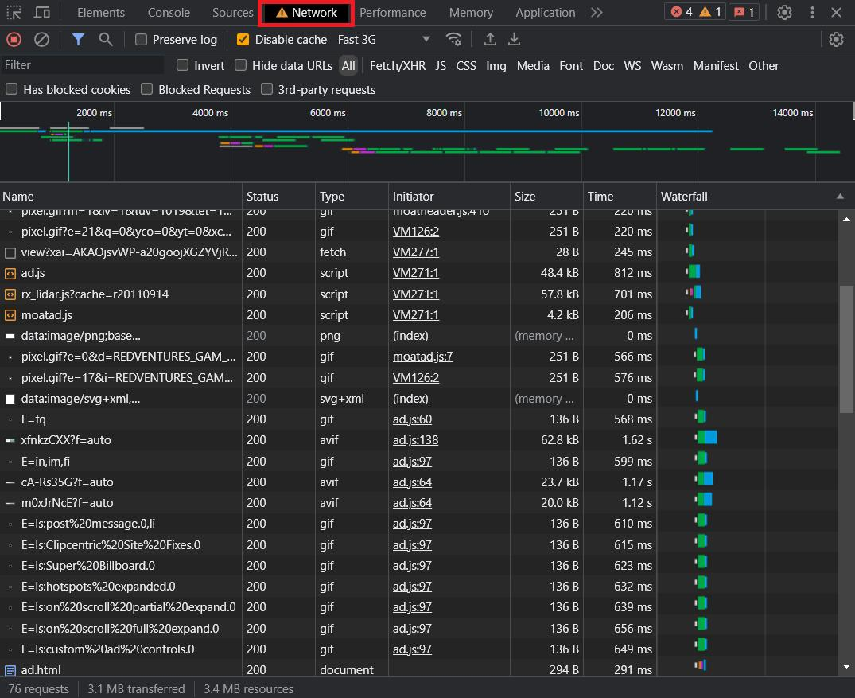
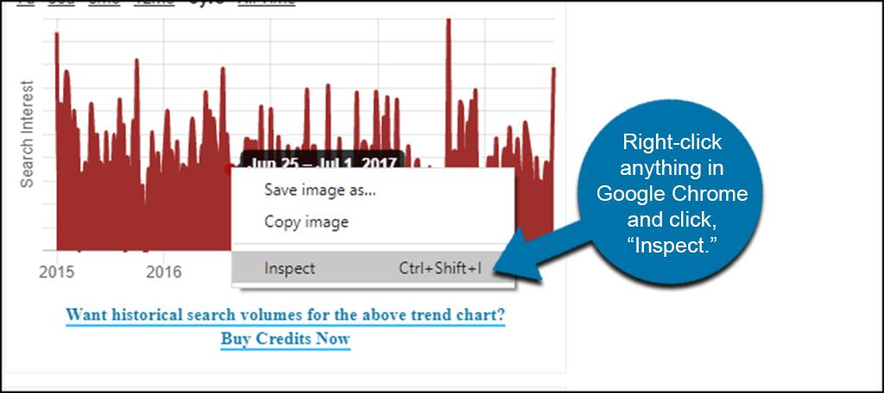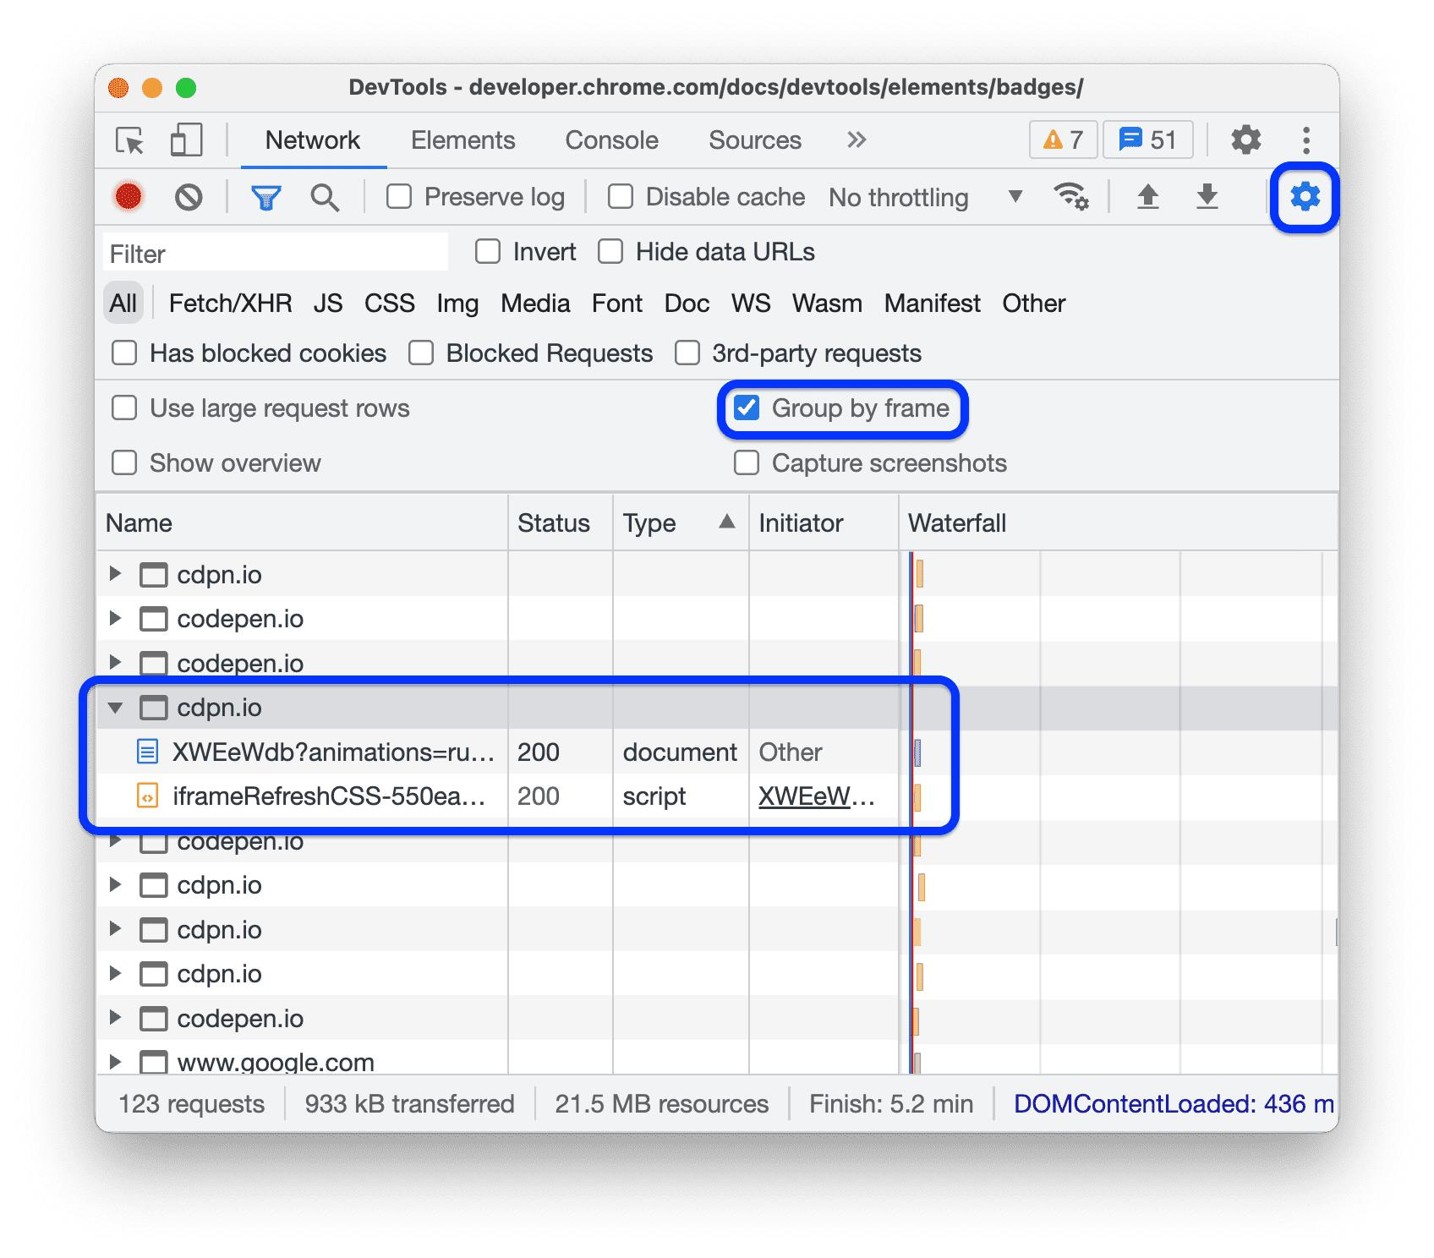
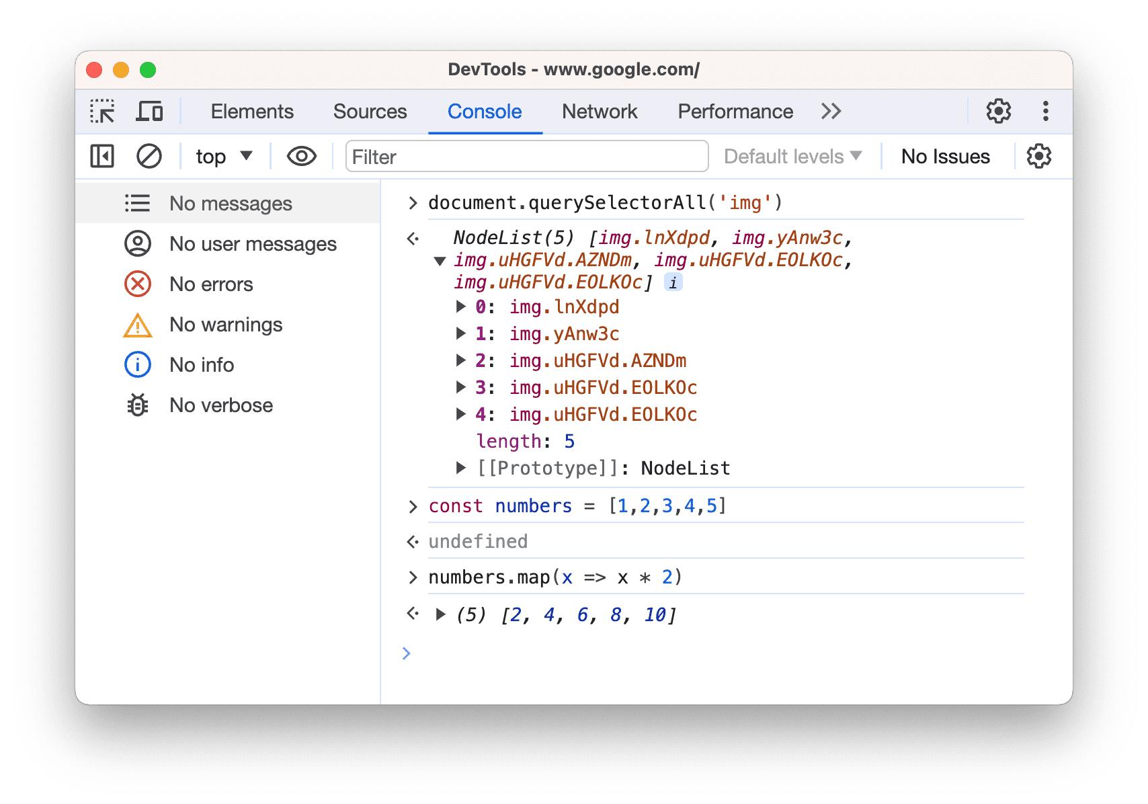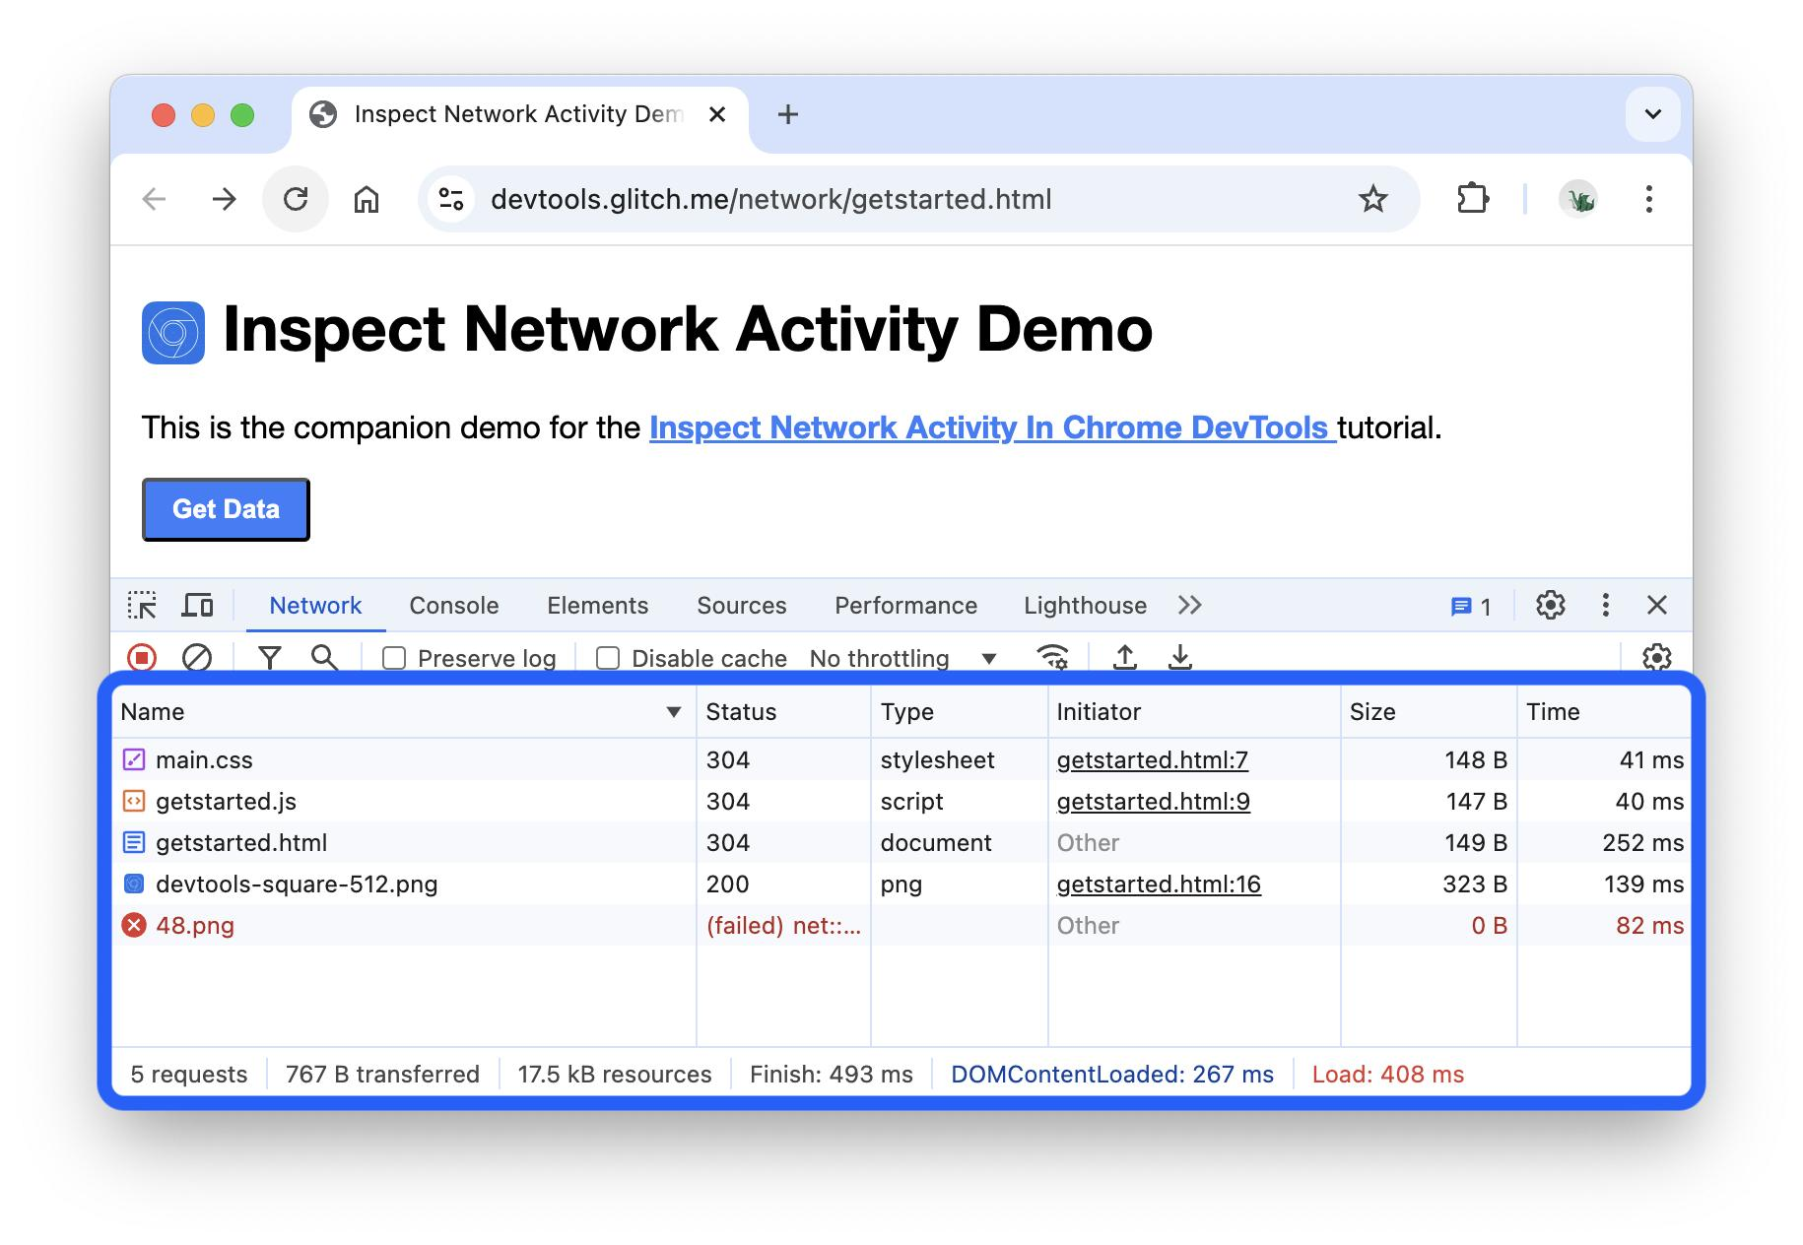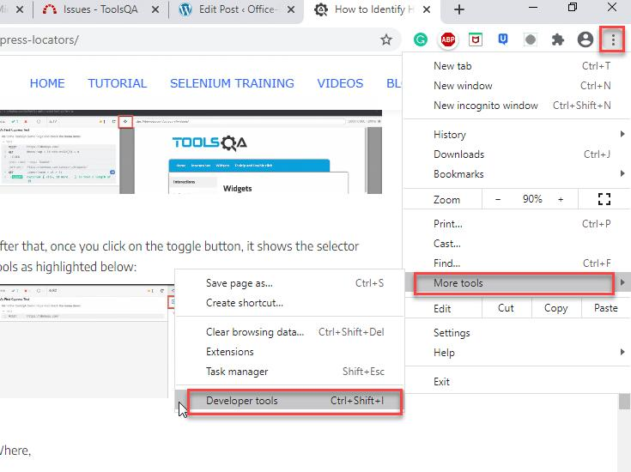

Important Tabs
Tab | Use
Elements | HTML structure
Console | Debugging
Network | API tracking
Application | Storage
Network tab is most important

Procedure (Step-by-Step)

Step 1: Open Website
Go to amazon.in OR facebook.com

Step 2: Open DevTools
- Press F12
- OR Right-click → Inspect
Step 3: Open Network Tab
Network Tab View
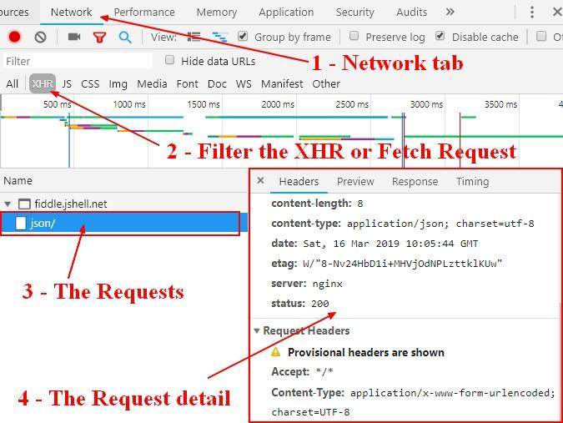

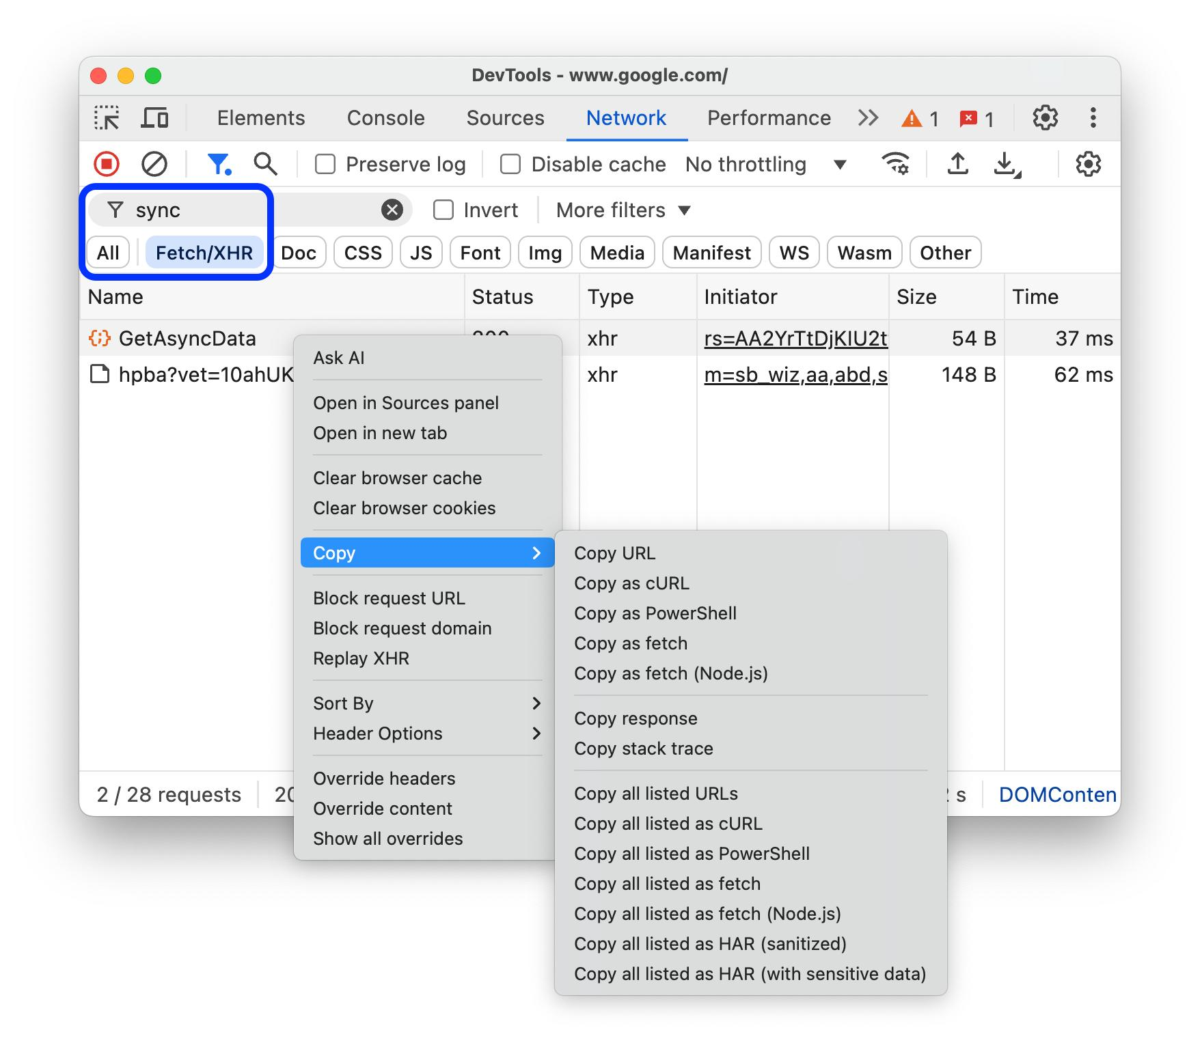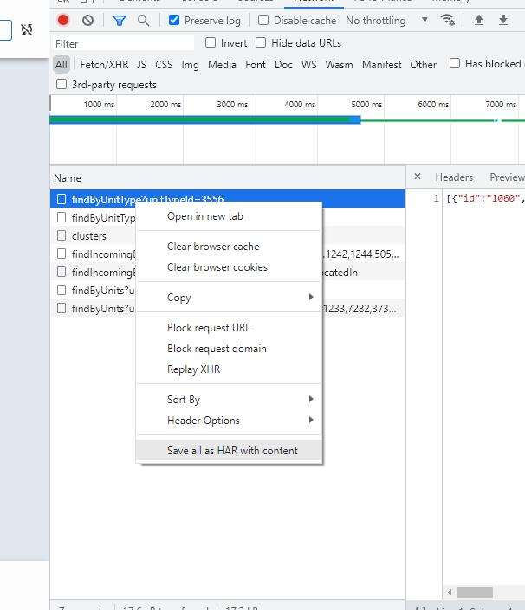
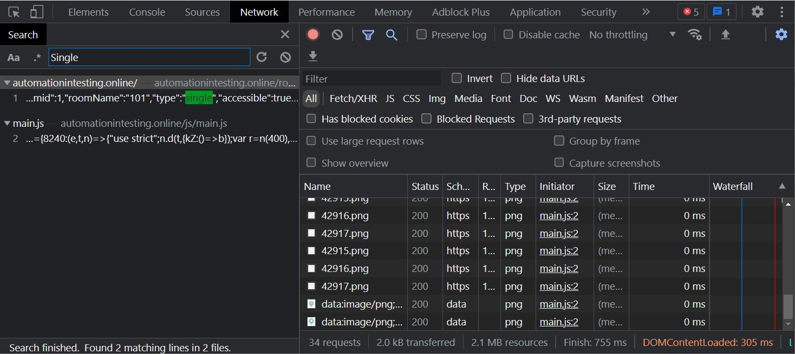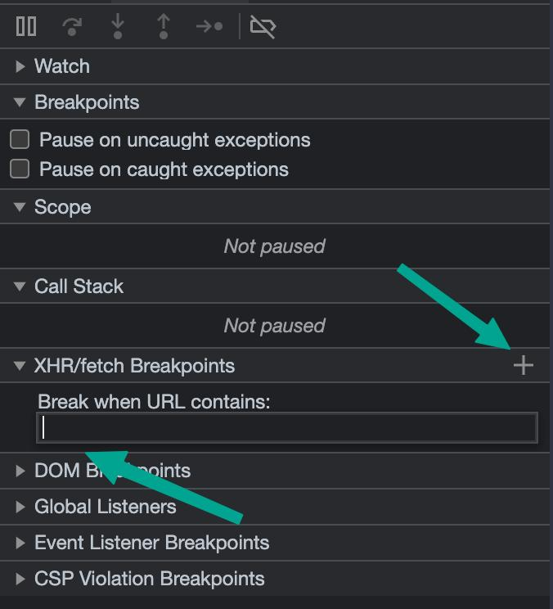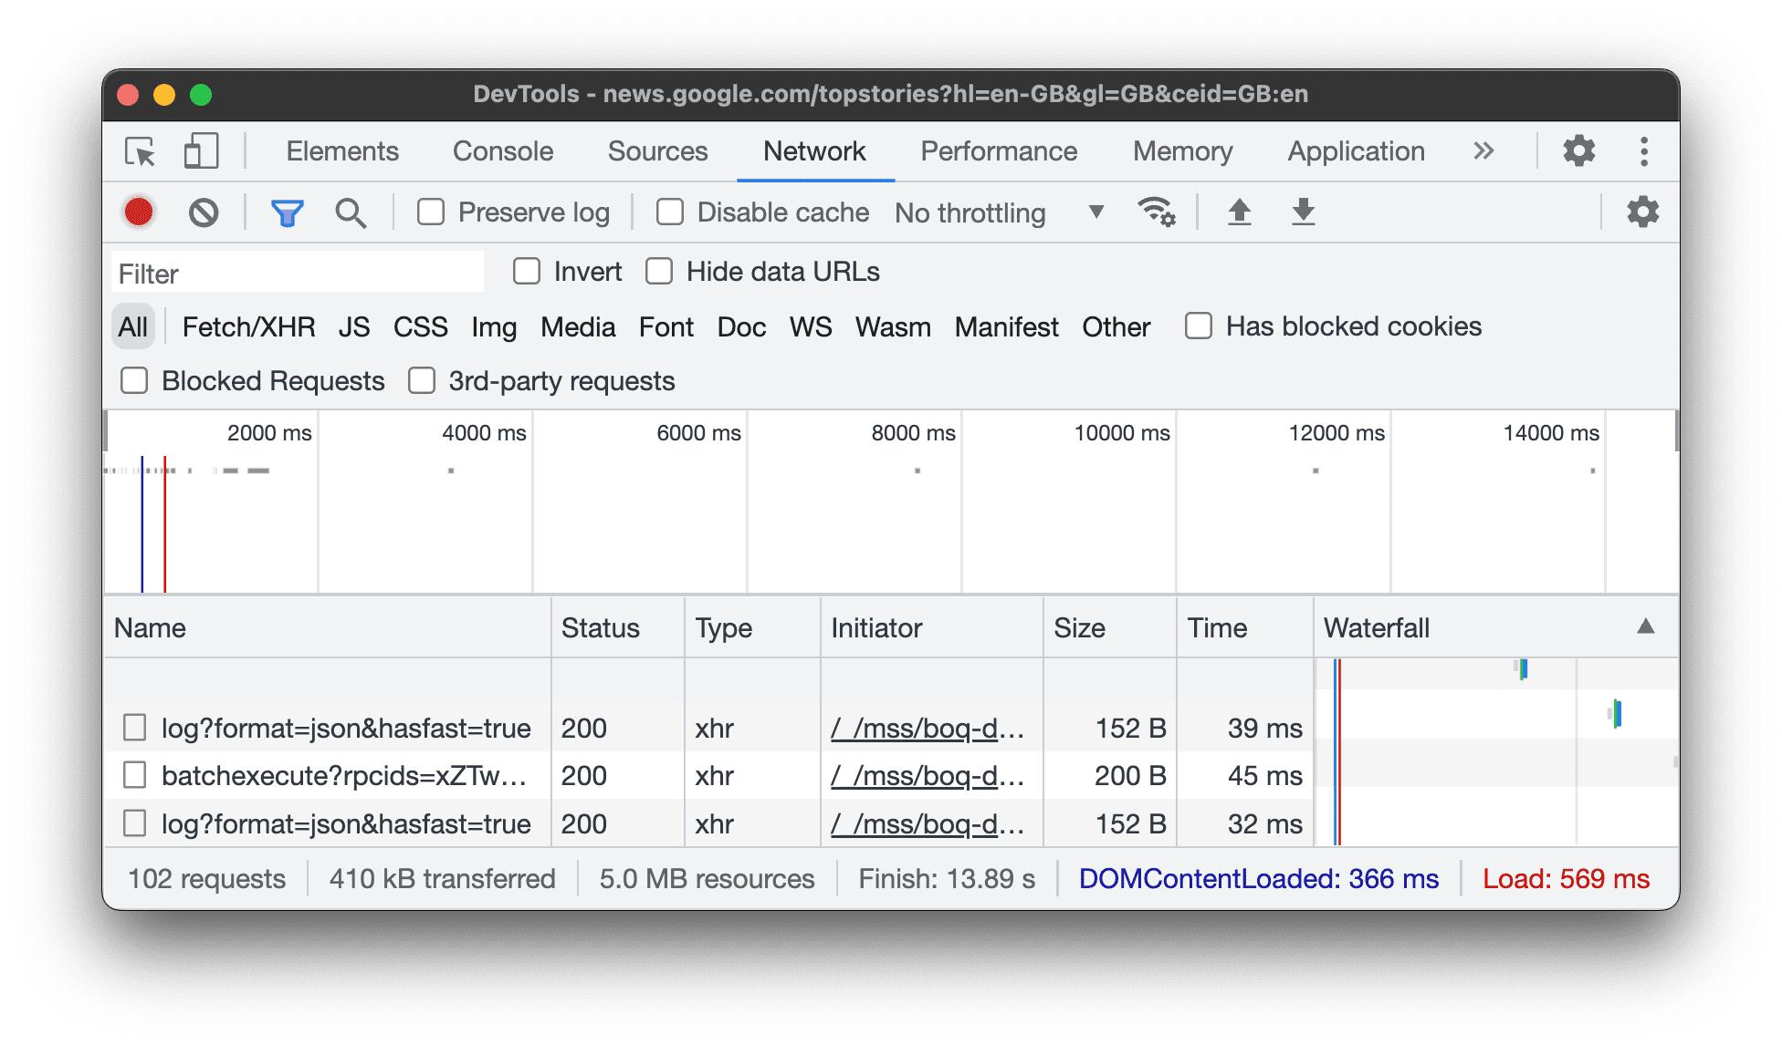

Step 4: Setup
- Click Clear (🚫)
- Enable:
  - Preserve Log
  - Disable Cache

Step 5: Filter API Calls
- Click Fetch/XHR
Shows only API requests

Step 6: Perform Action

Example:
- Amazon → Search "laptop"
- Facebook → Scroll feed

Step 7: Observe Requests
- Multiple API calls will appear
- Click any request

Step 8: Analyze Request

API Request Details


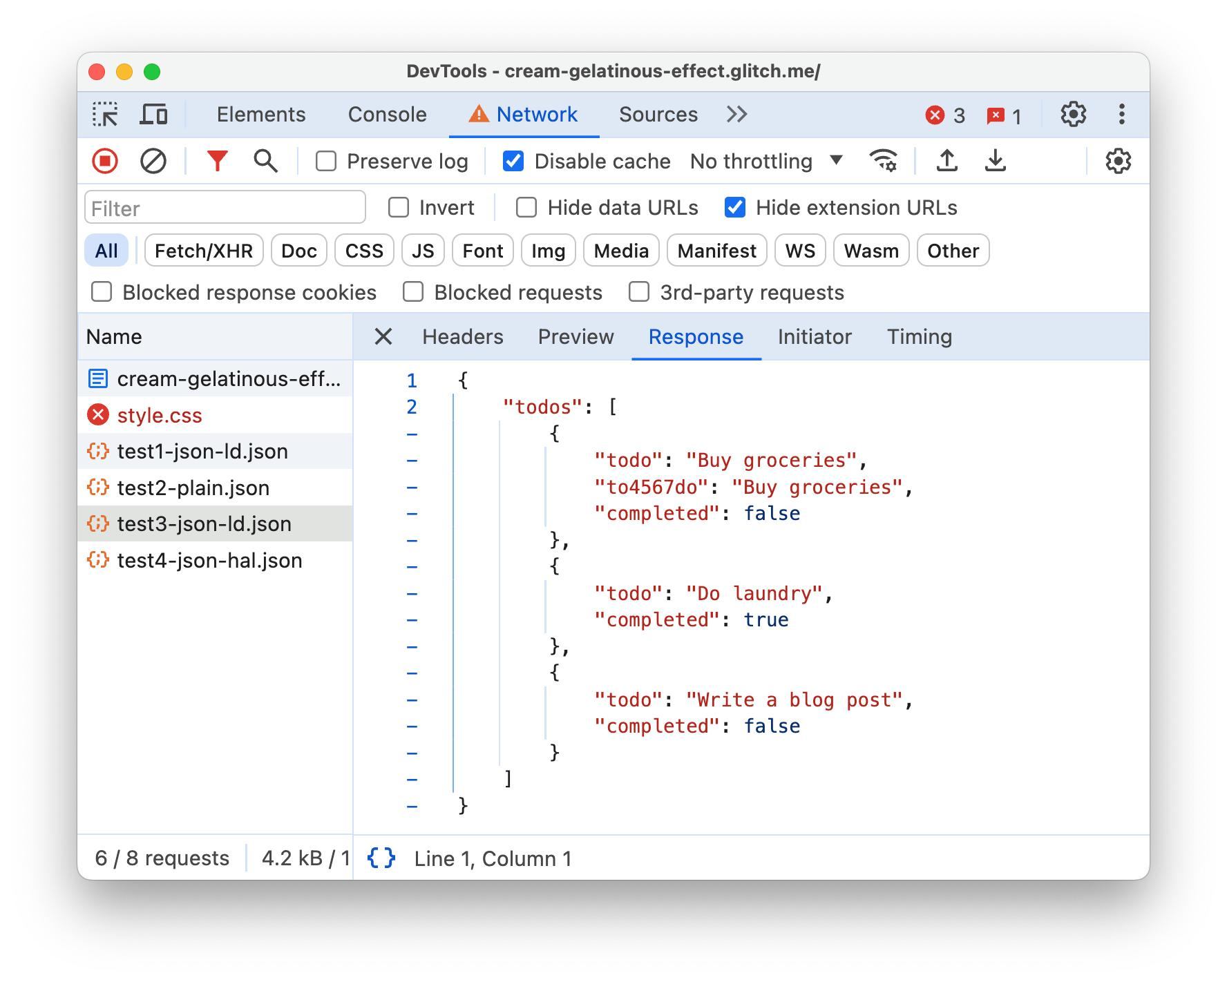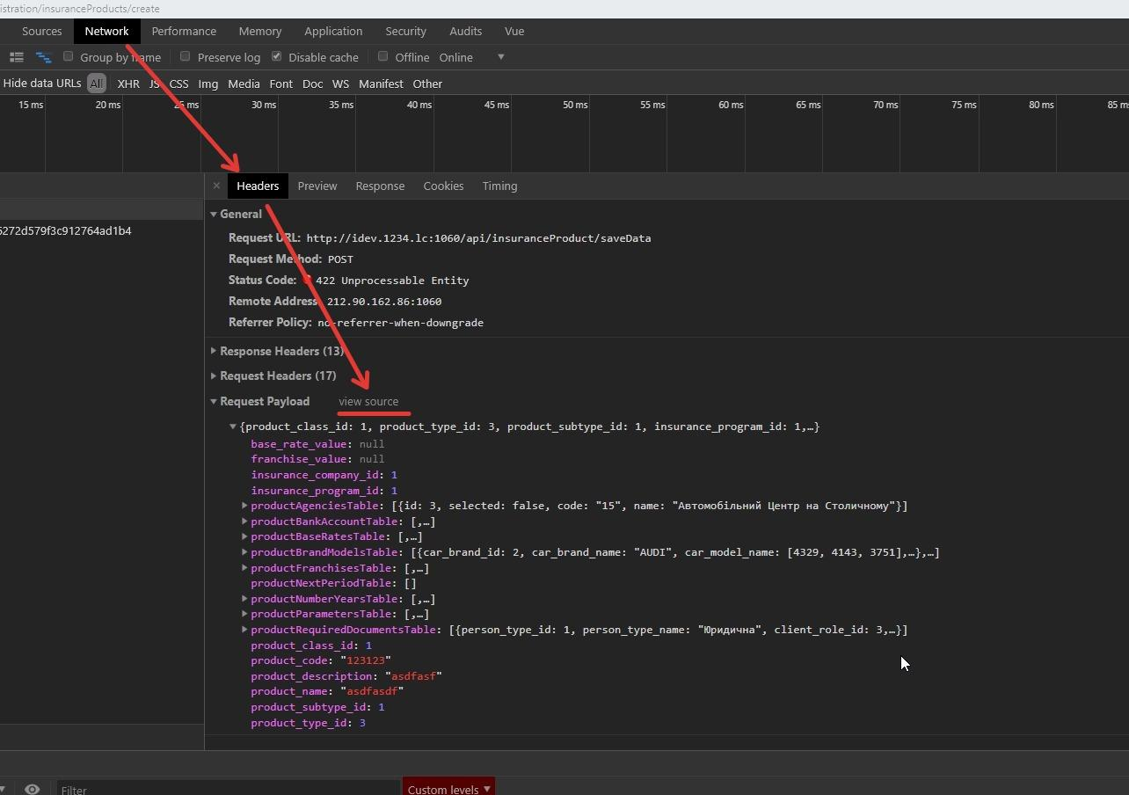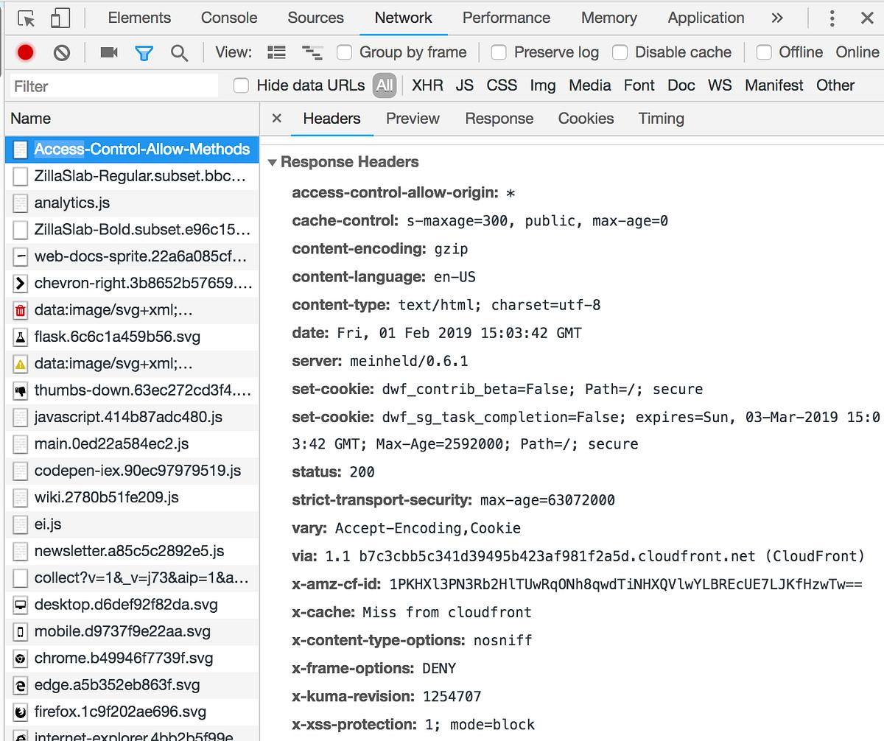
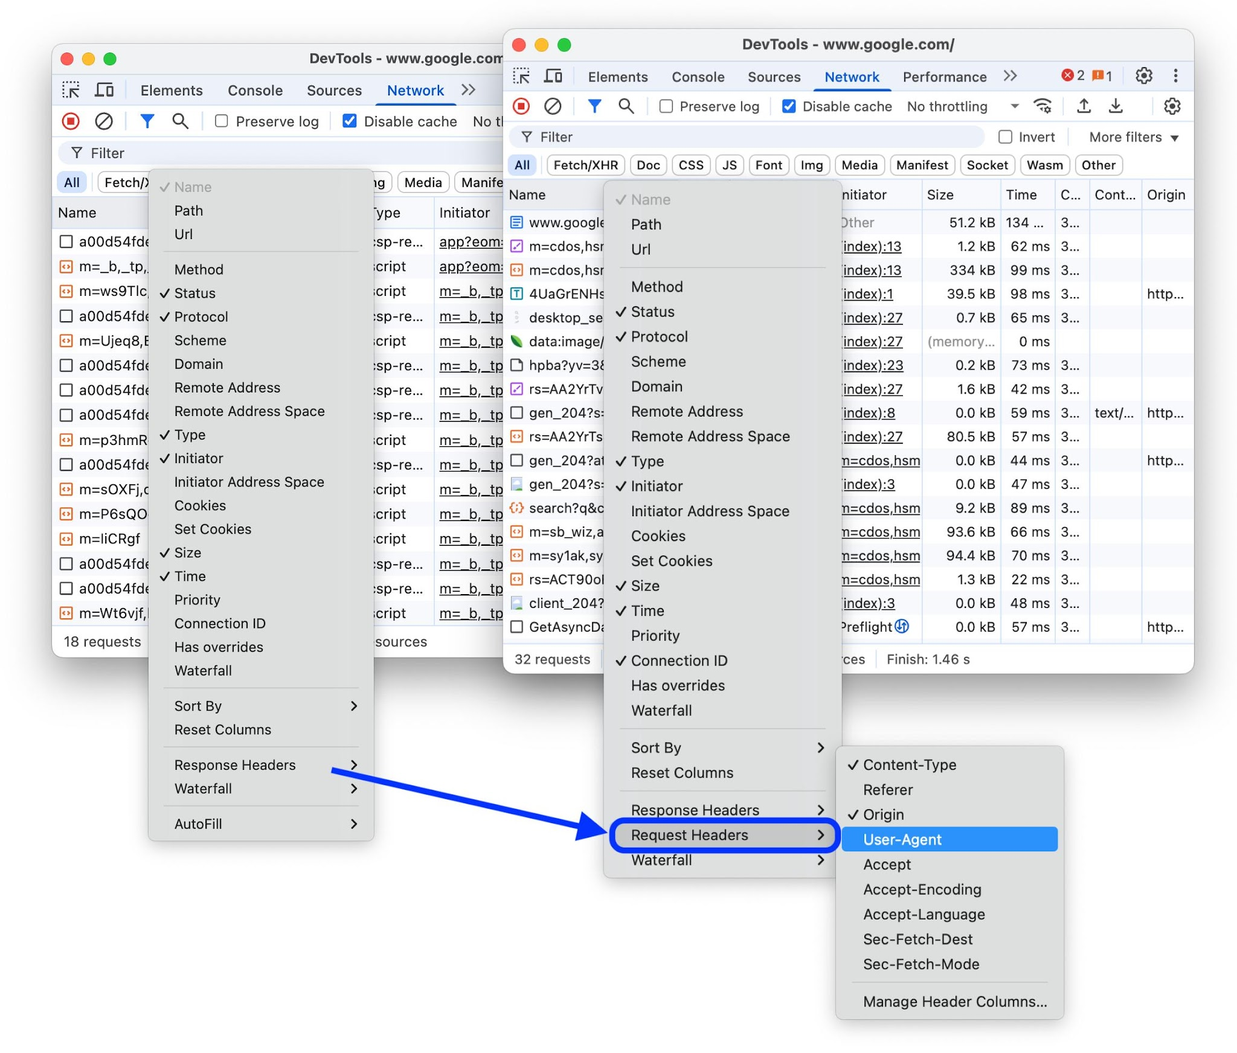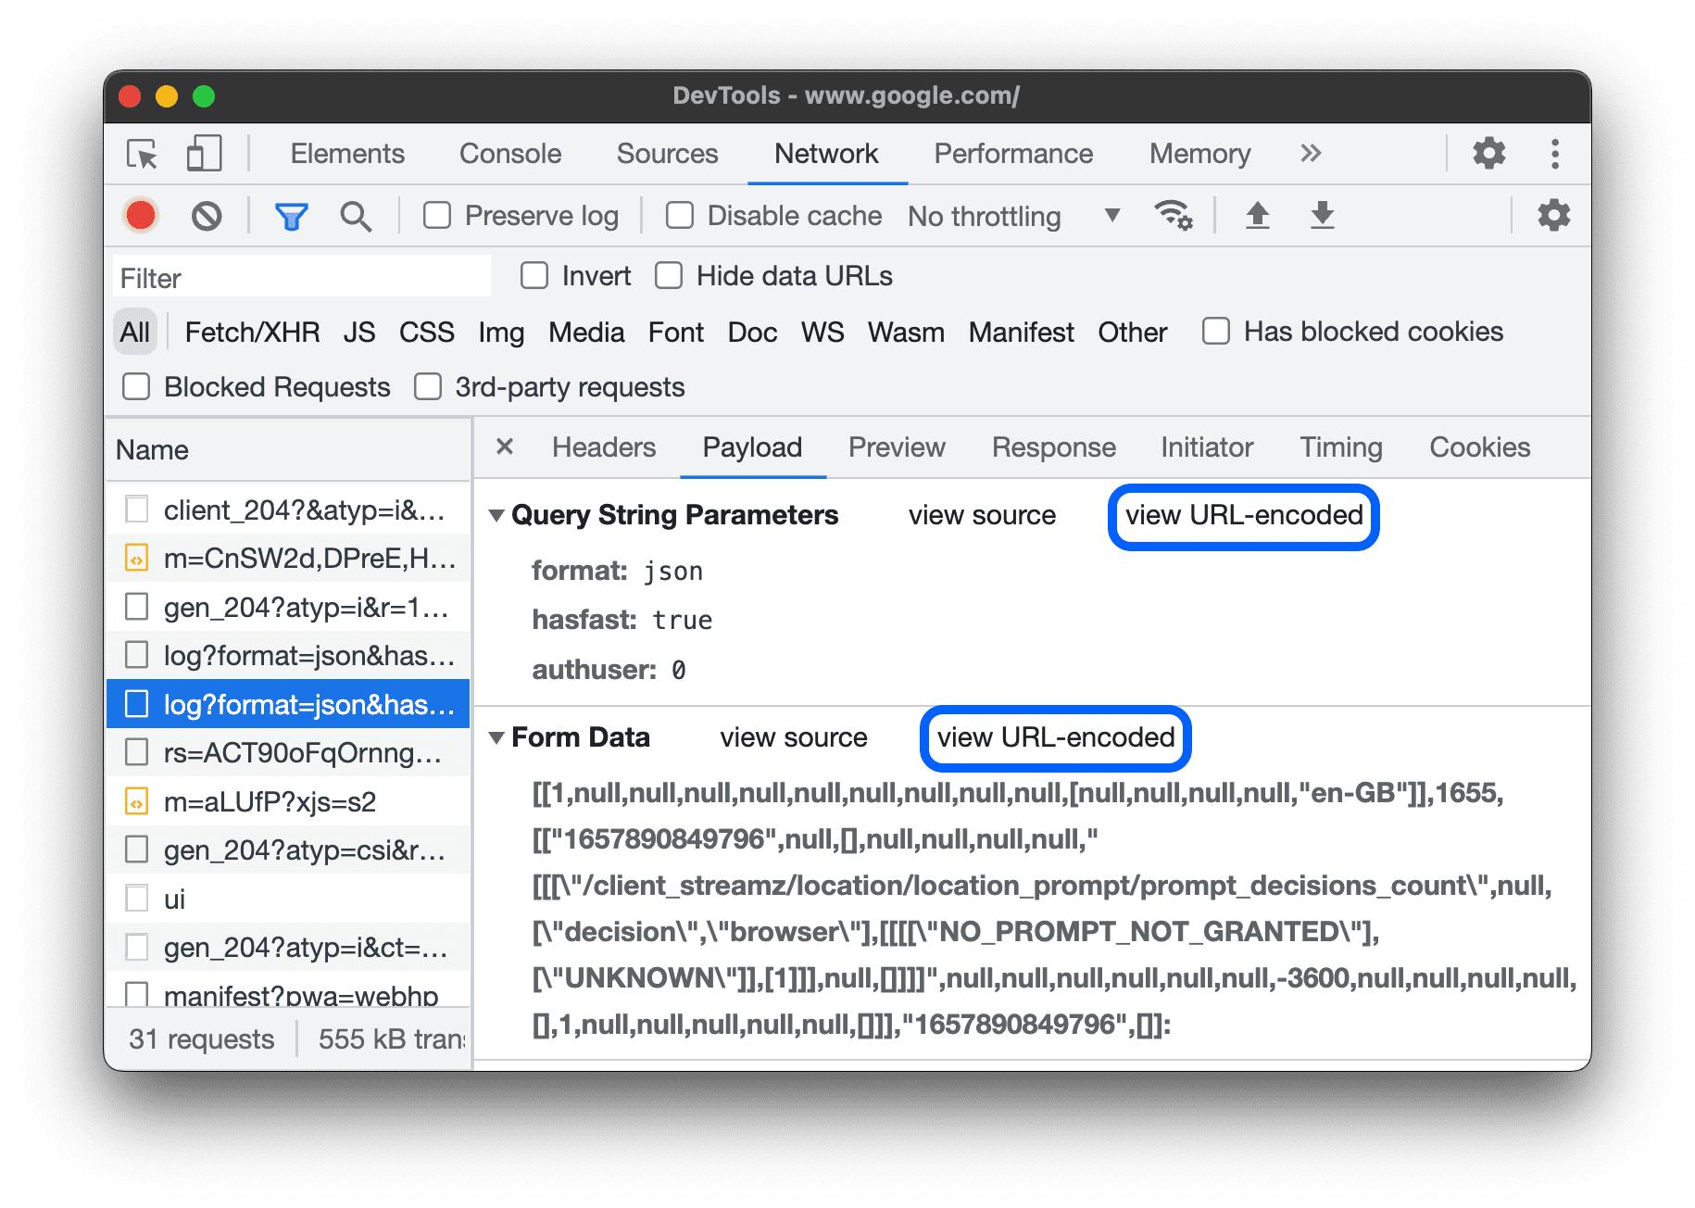

1. Headers
- URL (endpoint)
- Method (GET/POST)
- Status code

2. Request Payload
Data sent to server
Example:
{
"query": "laptop"
}

3. Response (Important)
Data received from server
Example:
{
"products": [
{"name": "Laptop", "price": 50000}
]
}

Working Flow

📸 Frontend–Backend Flow

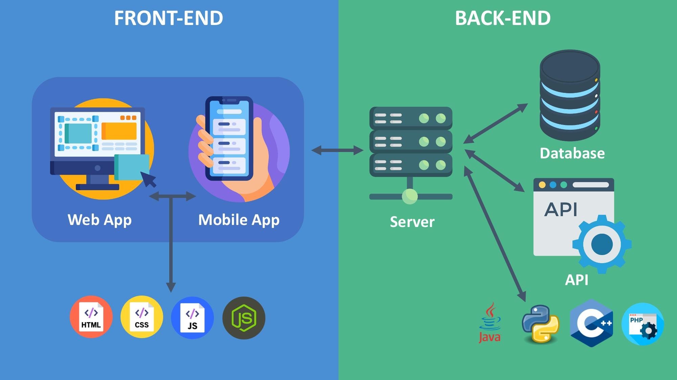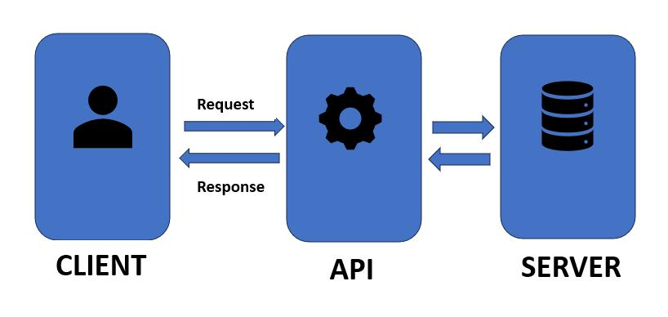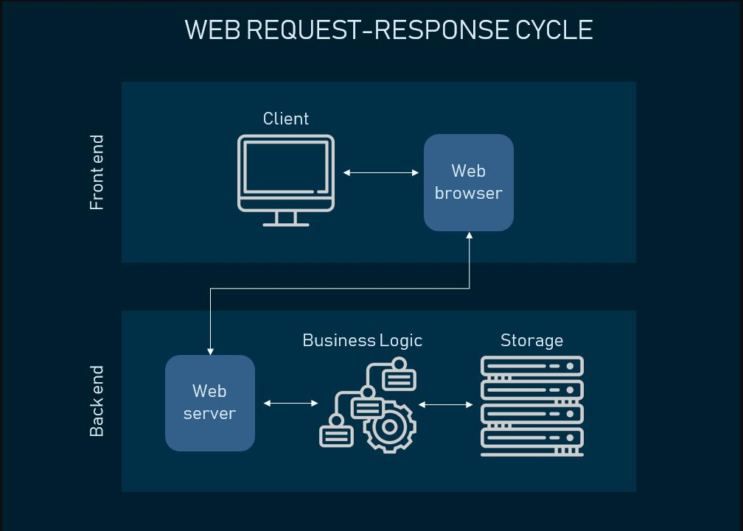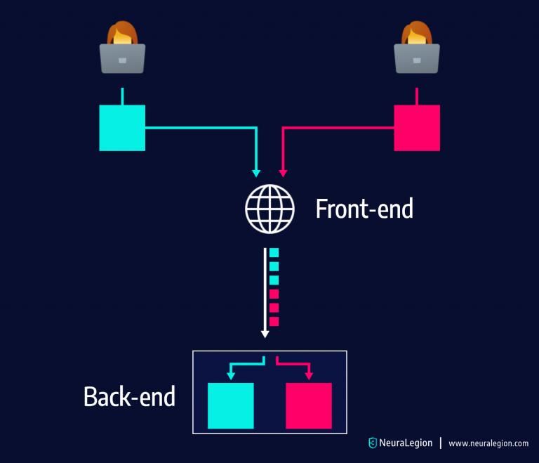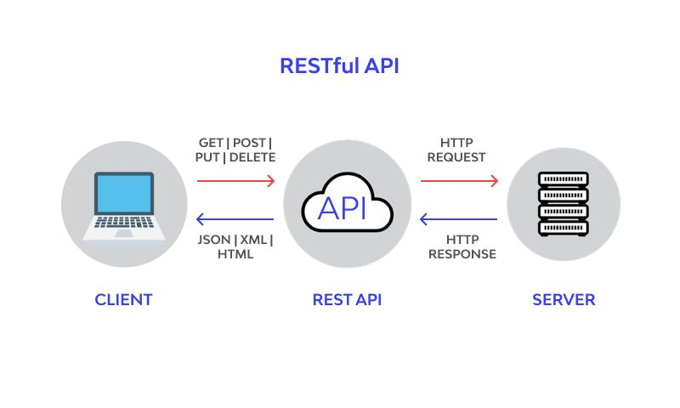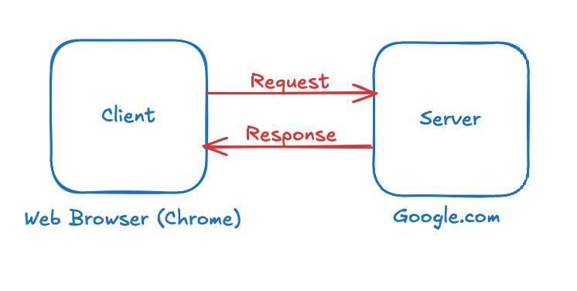

Steps:
- User action
- API request sent
- Backend processes
- Response returned
- UI updates

Types of API Requests
Method | Purpose
GET | Retrieve data
POST | Send data
PUT | Update
DELETE | Remove

Observations

Amazon
- Endpoint: /search
- Method: GET
- Output: Product list

Facebook
- Endpoint: /api/graphql
- Method: POST
- Output: Feed data

Advanced DevTools Features
- Preview tab → formatted response
- Timing tab → performance
- Initiator → source JS
- Copy as cURL → reuse API

6. Architect an entire database structure for an E-Commerce application for MongoDB. Discuss how the database would have been structured if you were using a SQL database.

MongoDB Database Structure (NoSQL)
MongoDB stores data in collections and documents using JSON-like format.
- Users Collection
{
"_id": "U001",
"name": "Krupali Prajapati",
"email": "krupali@gmail.com",
"password": "encrypted_password",
"phone": "9876543210",
"address": {
"street": "Satellite Road",
"city": "Ahmedabad",
"state": "Gujarat",
"pincode": "380015"
},
"role": "customer"
}

- Products Collection
{
"_id": "P001",
"name": "Wireless Mouse",
"description": "Bluetooth Mouse",
"price": 799,
"stock": 100,
"category": "Electronics",
"images": [
"mouse1.jpg",
"mouse2.jpg"
]
}

- Categories Collection
{
"_id": "C001",
"categoryName": "Electronics"
}

- Cart Collection
{
"_id": "CRT001",
"userId": "U001",
"items": [
{
"productId": "P001",
"quantity": 2
}
]
}

- Orders Collection
{
"_id": "O001",
"userId": "U001",
"orderDate": "2026-06-07",
"totalAmount": 1598,
"status": "Delivered",
"items": [
{
"productId": "P001",
"productName": "Wireless Mouse",
"price": 799,
"quantity": 2
}
]
}

- Payments Collection
{
"_id": "PAY001",
"orderId": "O001",
"paymentMethod": "UPI",
"amount": 1598,
"paymentStatus": "Success"
}

- Reviews Collection
{
"_id": "R001",
"productId": "P001",
"userId": "U001",
"rating": 5,
"comment": "Excellent Product"
}

MongoDB Architecture Diagram
Users
│
├── Cart
│ │
│ └── Products
│
└── Orders
│
├── Payments
│
└── Products

Products
│
├── Categories
│
└── Reviews
Advantages of MongoDB for E-Commerce
- Flexible schema.
- Easy handling of product variations.
- High scalability.
- Faster read operations.
- Suitable for large product catalogs.

SQL Database Structure (Relational Database)
If SQL databases such as MySQL or PostgreSQL were used, data would be stored in tables with relationships.
Users Table
UserID (PK) | Name | Email | Password | Phone

Address Table
AddressID (PK) | UserID (FK) | Street | City | State | Pincode

Categories Table
CategoryID (PK) | CategoryName
Products Table
ProductID (PK) | ProductName | Price | Stock | CategoryID (FK)

Cart Table
CartID (PK) | UserID (FK)

CartItems Table
CartItemID (PK) | CartID (FK) | ProductID (FK) | Quantity

Orders Table
OrderID (PK) | UserID (FK) | OrderDate | TotalAmount | Status

OrderItems Table
OrderItemID (PK) | OrderID (FK) | ProductID (FK) | Quantity | Price

Payments Table
PaymentID (PK) | OrderID (FK) | Method | Amount | Status

Reviews Table
ReviewID (PK) | ProductID (FK) | UserID (FK) | Rating | Comment

SQL Relationship Diagram
Users
│
├── Address
│
├── Cart
│ │
│ └── CartItems ─── Products ─── Categories
│
└── Orders
│
├── OrderItems ─── Products
│
└── Payments

Products ─── Reviews ─── Users

7. Create a Simple Login form using React JS
- Software Requirement
  - VS Code
  - Web Browser
- Program code
- Login-app
  - Public
    - Index.html
<!DOCTYPE html>
<html lang="en">
<head>
<meta charset="utf-8" />
<link rel="icon" href="%PUBLIC_URL%/favicon.ico" />
<meta name="viewport" content="width=device-width, initial-scale=1" />
<meta name="theme-color" content="#000000" />
<meta
name="description"
content="Web site created using create-react-app"
/>
<link rel="apple-touch-icon" href="%PUBLIC_URL%/logo192.png" />
<!--
manifest.json provides metadata used when your web app is installed on a
user's mobile device or desktop. See https://developers.google.com/web/fundamentals/web-app-manifest/
-->
<link rel="manifest" href="%PUBLIC_URL%/manifest.json" />
<!--
Notice the use of %PUBLIC_URL% in the tags above.
It will be replaced with the URL of the `public` folder during the build.
Only files inside the `public` folder can be referenced from the HTML.

Unlike "/favicon.ico" or "favicon.ico", "%PUBLIC_URL%/favicon.ico" will
work correctly both with client-side routing and a non-root public URL.
Learn how to configure a non-root public URL by running `npm run build`.
-->
<title>React App</title>
</head>
<body>
<noscript>You need to enable JavaScript to run this app.</noscript>
<div id="root"></div>
<!--
This HTML file is a template.
If you open it directly in the browser, you will see an empty page.

You can add webfonts, meta tags, or analytics to this file.
The build step will place the bundled scripts into the <body> tag.

To begin the development, run `npm start` or `yarn start`.
To create a production bundle, use `npm run build` or `yarn build`.
-->
</body>
</html>
    - Manifest.json
{
"short_name": "React App",
"name": "Create React App Sample",
"icons": [
{
"src": "favicon.ico",
"sizes": "64x64 32x32 24x24 16x16",
"type": "image/x-icon"
},
{
"src": "logo192.png",
"type": "image/png",
"sizes": "192x192"
},
{
"src": "logo512.png",
"type": "image/png",
"sizes": "512x512"
}
],
"start_url": ".",
"display": "standalone",
"theme_color": "#000000",
"background_color": "#ffffff"
}
    - Robots.txts
# https://www.robotstxt.org/robotstxt.html
User-agent: *
Disallow:
  - Src
    - App.css
.App {
text-align: center;
}

.App-logo {
height: 40vmin;
pointer-events: none;
}

@media (prefers-reduced-motion: no-preference) {
.App-logo {
animation: App-logo-spin infinite 20s linear;
}
}

.App-header {
background-color: #282c34;
min-height: 100vh;
display: flex;
flex-direction: column;
align-items: center;
justify-content: center;
font-size: calc(10px + 2vmin);
color: white;
}

.App-link {
color: #61dafb;
}

@keyframes App-logo-spin {
from {
transform: rotate(0deg);
}
to {
transform: rotate(360deg);
}
}
    - App.js
import logo from './logo.svg';
import './App.css';
import LoginForm from "../src/LoginForm ";

function App() {
return <LoginForm/>;
}

export default App;
    - App.test.js
import { render, screen } from '@testing-library/react';
import App from './App';

test('renders learn react link', () => {
render(<App />);
const linkElement = screen.getByText(/learn react/i);
expect(linkElement).toBeInTheDocument();
});
    - Index.css
import { render, screen } from '@testing-library/react';
import App from './App';

test('renders learn react link', () => {
render(<App />);
const linkElement = screen.getByText(/learn react/i);
expect(linkElement).toBeInTheDocument();
});
    - Index.js
import { render, screen } from '@testing-library/react';
import App from './App';

test('renders learn react link', () => {
render(<App />);
const linkElement = screen.getByText(/learn react/i);
expect(linkElement).toBeInTheDocument();
});
    - loginForm.js
import React, { useState } from "react";

function LoginForm() {
const [formData, setFormData] = useState({
email: "",
password: ""
});

const handleChange = (e) => {
const { name, value } = e.target;
setFormData({
...formData,
[name]: value
});
};

const handleSubmit = (e) => {
e.preventDefault();
console.log("Login Data:", formData);

// Simple validation
if (!formData.email || !formData.password) {
alert("Please fill all fields");
return;
}

alert("Login Successful!");
};

return (
<div style={styles.container}>
<form onSubmit={handleSubmit} style={styles.form}>
<h2>Login</h2>

<input
type="email"
name="email"
placeholder="Enter Email"
value={formData.email}
onChange={handleChange}
style={styles.input}
/>

<input
type="password"
name="password"
placeholder="Enter Password"
value={formData.password}
onChange={handleChange}
style={styles.input}
/>

<button type="submit" style={styles.button}>
Login
</button>
</form>
</div>
);
}

const styles = {
container: {
display: "flex",
justifyContent: "center",
alignItems: "center",
height: "100vh",
backgroundColor: "#f2f2f2"
},
form: {
background: "#fff",
padding: "20px",
borderRadius: "8px",
boxShadow: "0 0 10px rgba(0,0,0,0.1)",
width: "300px",
textAlign: "center"
},
input: {
width: "100%",
padding: "10px",
margin: "10px 0",
borderRadius: "5px",
border: "1px solid #ccc"
},
button: {
width: "100%",
padding: "10px",
backgroundColor: "#007bff",
color: "#fff",
border: "none",
borderRadius: "5px",
cursor: "pointer"
}
};

export default LoginForm;
    - reportWebVitals.js
const reportWebVitals = onPerfEntry => {
if (onPerfEntry && onPerfEntry instanceof Function) {
import('web-vitals').then(({ getCLS, getFID, getFCP, getLCP, getTTFB }) => {
getCLS(onPerfEntry);
getFID(onPerfEntry);
getFCP(onPerfEntry);
getLCP(onPerfEntry);
getTTFB(onPerfEntry);
});
}
};

export default reportWebVitals;
    - setupTests.js
// jest-dom adds custom jest matchers for asserting on DOM nodes.
// allows you to do things like:
// expect(element).toHaveTextContent(/react/i)
// learn more: https://github.com/testing-library/jest-dom
import '@testing-library/jest-dom';

8. Build a robust Todo List App with ReactJS.
- Software Requirement
  - VS Code
  - Web Browser
- Program code
  - Backend
    - Server.js
import express from "express";
import mongoose from "mongoose";
import cors from "cors";

const app = express();
app.use(cors());
app.use(express.json());

mongoose.connect("mongodb://127.0.0.1:27017/todo-app");

const todoSchema = new mongoose.Schema({
text: { type: String, required: true },
completed: { type: Boolean, default: false },
priority: { type: String, default: "medium" }
}, { timestamps: true });

const Todo = mongoose.model("Todo", todoSchema);

// Routes
app.get("/api/todos", async (req, res) => {
const todos = await Todo.find().sort({ createdAt: -1 });
res.json(todos);
});

app.post("/api/todos", async (req, res) => {
const { text, priority } = req.body;

const todo = new Todo({
text,
priority: priority || "medium"
});

await todo.save();
res.json(todo);
});

app.put("/api/todos/:id", async (req, res) => {
const todo = await Todo.findByIdAndUpdate(
req.params.id,
req.body,
{ new: true }
);
res.json(todo);
});

app.delete("/api/todos/:id", async (req, res) => {
await Todo.findByIdAndDelete(req.params.id);
res.json({ message: "Deleted" });
});

app.listen(5000, () => console.log("Server running on port 5000"));
  - Todo-frontend
    - Src
      - App.css
/* RESET */
* {
margin: 0;
padding: 0;
box-sizing: border-box;
font-family: "Segoe UI", sans-serif;
}

body {
background: linear-gradient(135deg, #667eea, #764ba2);
min-height: 100vh;
}

/* MAIN CONTAINER */
.container {
display: flex;
justify-content: center;
align-items: center;
min-height: 100vh;
padding: 20px;
}

/* GLASS CARD */
.card {
width: 100%;
max-width: 600px;
padding: 25px;
border-radius: 20px;
background: rgba(255, 255, 255, 0.15);
backdrop-filter: blur(15px);
box-shadow: 0 10px 30px rgba(0, 0, 0, 0.2);
color: white;
}

/* HEADER */
.title {
text-align: center;
font-size: 26px;
font-weight: bold;
margin-bottom: 20px;
}

/* ROW */
.row {
display: flex;
gap: 10px;
margin-bottom: 15px;
}

/* INPUTS */
input, select {
flex: 1;
padding: 10px;
border-radius: 10px;
border: none;
outline: none;
}

/* BUTTONS */
button {
padding: 10px 14px;
border-radius: 10px;
border: none;
cursor: pointer;
transition: 0.3s;
}

.add-btn {
background: #4ade80;
color: black;
}
.add-btn:hover {
transform: scale(1.05);
}

.save-btn {
background: #22c55e;
color: white;
}

.cancel-btn {
background: #9ca3af;
color: white;
}

/* LIST */
.todo-item {
display: flex;
justify-content: space-between;
align-items: center;
padding: 12px;
border-radius: 12px;
margin-bottom: 10px;
background: rgba(255,255,255,0.2);
backdrop-filter: blur(5px);
transition: 0.3s;
}

.todo-item:hover {
transform: translateY(-2px);
}

/* TEXT */
.todo-text {
margin-left: 8px;
}

.completed {
text-decoration: line-through;
opacity: 0.6;
}

/* BADGE */
.badge {
font-size: 11px;
padding: 3px 7px;
border-radius: 6px;
margin-left: 8px;
}

.high {
background: #f87171;
}

.medium {
background: #facc15;
color: black;
}

.low {
background: #34d399;
}

/* ACTION BUTTONS */
.actions button {
margin-left: 6px;
background: transparent;
color: white;
font-size: 14px;
}

.actions button:hover {
text-decoration: underline;
}

/* EMPTY */
.empty {
text-align: center;
opacity: 0.7;
margin-top: 20px;
}
      - App.jsx

import { useEffect, useState } from "react";
import axios from "axios";
import toast, { Toaster } from "react-hot-toast";
import "./App.css";

export default function App() {
const [todos, setTodos] = useState([]);
const [text, setText] = useState("");
const [priority, setPriority] = useState("medium");
const [loading, setLoading] = useState(false);
const [editId, setEditId] = useState(null);

const [search, setSearch] = useState("");
const [filter, setFilter] = useState("all");

const fetchTodos = async () => {
try {
setLoading(true);
const res = await axios.get("http://localhost:5000/api/todos");
setTodos(res.data);
} catch {
toast.error("Failed to load tasks");
} finally {
setLoading(false);
}
};

useEffect(() => {
fetchTodos();
}, []);

const addTodo = async () => {
if (!text.trim()) return;
try {
await axios.post("http://localhost:5000/api/todos", { text, priority });
toast.success("Task added");
setText("");
setPriority("medium");
fetchTodos();
} catch {
toast.error("Add failed");
}
};

const updateTodo = async (id) => {
try {
await axios.put(`http://localhost:5000/api/todos/${id}`, {
text,
priority,
});
toast.success("Task updated");
setEditId(null);
setText("");
setPriority("medium");
fetchTodos();
} catch {
toast.error("Update failed");
}
};

const toggleTodo = async (id, completed) => {
try {
await axios.put(`http://localhost:5000/api/todos/${id}`, {
completed: !completed,
});
fetchTodos();
} catch {
toast.error("Toggle failed");
}
};

const deleteTodo = async (id) => {
try {
await axios.delete(`http://localhost:5000/api/todos/${id}`);
toast.success("Deleted");
fetchTodos();
} catch {
toast.error("Delete failed");
}
};

const badge = (p) => {
if (p === "high") return "bg-red-100 text-red-600";
if (p === "low") return "bg-green-100 text-green-600";
return "bg-yellow-100 text-yellow-600";
};

// 🔍 Filter + Search Logic
const filteredTodos = todos.filter((todo) => {
const matchesSearch = todo.text.toLowerCase().includes(search.toLowerCase());

if (filter === "completed") return matchesSearch && todo.completed;
if (filter === "pending") return matchesSearch && !todo.completed;
if (filter === "high") return matchesSearch && todo.priority === "high";
if (filter === "low") return matchesSearch && todo.priority === "low";

return matchesSearch;
});

return (
<div className="container">
<Toaster position="top-right" />

<div className="card">
<h1 className="title">Task Manager</h1>

{/* Search + Filter */}
<div className="row">
<input
value={search}
onChange={(e) => setSearch(e.target.value)}
placeholder="Search tasks..."
/>

<select value={filter} onChange={(e) => setFilter(e.target.value)}>
<option value="all">All</option>
<option value="completed">Completed</option>
<option value="pending">Pending</option>
<option value="high">High</option>
<option value="low">Low</option>
</select>
</div>

{/* Add / Edit */}
<div className="row">
<input
value={text}
onChange={(e) => setText(e.target.value)}
placeholder="Enter task..."
/>

<select value={priority} onChange={(e) => setPriority(e.target.value)}>
<option value="low">Low</option>
<option value="medium">Medium</option>
<option value="high">High</option>
</select>

{editId ? (
<>
<button className="save-btn" onClick={() => updateTodo(editId)}>
Save
</button>
<button
className="cancel-btn"
onClick={() => {
setEditId(null);
setText("");
}}
>
Cancel
</button>
</>
) : (
<button className="add-btn" onClick={addTodo}>
Add
</button>
)}
</div>

{/* List */}
{loading ? (
<p className="empty">Loading...</p>
) : filteredTodos.length === 0 ? (
<p className="empty">No tasks found</p>
) : (
filteredTodos.map((todo) => (
<div className="todo-item" key={todo._id}>
<div>
<input
type="checkbox"
checked={todo.completed}
onChange={() => toggleTodo(todo._id, todo.completed)}
/>

<span className={`todo-text ${todo.completed ? "completed" : ""}`}>
{todo.text}
</span>

<span className={`badge ${todo.priority}`}>
{todo.priority}
</span>
</div>

<div className="actions">
<button
onClick={() => {
setEditId(todo._id);
setText(todo.text);
setPriority(todo.priority);
}}
>
✏️
</button>

<button onClick={() => deleteTodo(todo._id)}>🗑️</button>
</div>
</div>
))
)}
</div>
</div>
);
}
      - Index.css
:root {
--text: #6b6375;
--text-h: #08060d;
--bg: #fff;
--border: #e5e4e7;
--code-bg: #f4f3ec;
--accent: #aa3bff;
--accent-bg: rgba(170, 59, 255, 0.1);
--accent-border: rgba(170, 59, 255, 0.5);
--social-bg: rgba(244, 243, 236, 0.5);
--shadow:
rgba(0, 0, 0, 0.1) 0 10px 15px -3px, rgba(0, 0, 0, 0.05) 0 4px 6px -2px;

--sans: system-ui, 'Segoe UI', Roboto, sans-serif;
--heading: system-ui, 'Segoe UI', Roboto, sans-serif;
--mono: ui-monospace, Consolas, monospace;

font: 18px/145% var(--sans);
letter-spacing: 0.18px;
color-scheme: light dark;
color: var(--text);
background: var(--bg);
font-synthesis: none;
text-rendering: optimizeLegibility;
-webkit-font-smoothing: antialiased;
-moz-osx-font-smoothing: grayscale;

@media (max-width: 1024px) {
font-size: 16px;
}
}

@media (prefers-color-scheme: dark) {
:root {
--text: #9ca3af;
--text-h: #f3f4f6;
--bg: #16171d;
--border: #2e303a;
--code-bg: #1f2028;
--accent: #c084fc;
--accent-bg: rgba(192, 132, 252, 0.15);
--accent-border: rgba(192, 132, 252, 0.5);
--social-bg: rgba(47, 48, 58, 0.5);
--shadow:
rgba(0, 0, 0, 0.4) 0 10px 15px -3px, rgba(0, 0, 0, 0.25) 0 4px 6px -2px;
}

#social .button-icon {
filter: invert(1) brightness(2);
}
}

body {
margin: 0;
}

#root {
width: 1126px;
max-width: 100%;
margin: 0 auto;
text-align: center;
border-inline: 1px solid var(--border);
min-height: 100svh;
display: flex;
flex-direction: column;
box-sizing: border-box;
}

h1,
h2 {
font-family: var(--heading);
font-weight: 500;
color: var(--text-h);
}

h1 {
font-size: 56px;
letter-spacing: -1.68px;
margin: 32px 0;
@media (max-width: 1024px) {
font-size: 36px;
margin: 20px 0;
}
}
h2 {
font-size: 24px;
line-height: 118%;
letter-spacing: -0.24px;
margin: 0 0 8px;
@media (max-width: 1024px) {
font-size: 20px;
}
}
p {
margin: 0;
}

code,
.counter {
font-family: var(--mono);
display: inline-flex;
border-radius: 4px;
color: var(--text-h);
}

code {
font-size: 15px;
line-height: 135%;
padding: 4px 8px;
background: var(--code-bg);
}
      - Main.jsx
import { StrictMode } from 'react'
import { createRoot } from 'react-dom/client'
import './index.css'
import App from './App.jsx'

createRoot(document.getElementById('root')).render(
<StrictMode>
<App />
</StrictMode>,
)
    - Index.html
<!doctype html>
<html lang="en">
<head>
<meta charset="UTF-8" />
<link rel="icon" type="image/svg+xml" href="/favicon.svg" />
<meta name="viewport" content="width=device-width, initial-scale=1.0" />
<title>todo-frontend</title>
</head>
<body>
<div id="root"></div>
<script type="module" src="/src/main.jsx"></script>
</body>
</html>

9. Write a program to create a voting application using React JS
- Software Requirement
  - VS Code
  - Web Browser
- Program code
  - Voting-app
    - src
      - App.css
/* Background */
body {
margin: 0;
font-family: Arial, sans-serif;
background: linear-gradient(135deg, #3b82f6, #9333ea);
}

/* Layout */
.container {
display: flex;
justify-content: center;
align-items: center;
height: 100vh;
}

/* Card */
.card {
background: white;
padding: 25px;
width: 400px;
border-radius: 15px;
box-shadow: 0 10px 25px rgba(0,0,0,0.2);
}

/* Title */
.title {
text-align: center;
margin-bottom: 20px;
}

/* Row */
.row {
display: flex;
gap: 10px;
margin-bottom: 15px;
}

input {
flex: 1;
padding: 8px;
border-radius: 6px;
border: 1px solid #ccc;
}

button {
padding: 8px 12px;
border-radius: 6px;
border: none;
cursor: pointer;
}

/* Buttons */
.add-btn {
background: #3b82f6;
color: white;
}

.reset-btn {
margin-top: 15px;
width: 100%;
background: #ef4444;
color: white;
}

/* Candidate */
.candidate {
display: flex;
justify-content: space-between;
align-items: center;
padding: 10px;
border-radius: 10px;
margin-bottom: 10px;
background: #f3f4f6;
}

.candidate button {
background: #22c55e;
color: white;
}

/* Winner */
.winner {
border: 2px solid gold;
background: #fef9c3;
}

/* Empty */
.empty {
text-align: center;
color: gray;
}
      - App.jsx
import { useState } from 'react'
import reactLogo from './assets/react.svg'
import viteLogo from './assets/vite.svg'
import heroImg from './assets/hero.png'
import './App.css'

export default function App() {
const [candidates, setCandidates] = useState([]);
const [name, setName] = useState("");

// Add candidate
const addCandidate = () => {
if (!name.trim()) return;

setCandidates([...candidates, { name, votes: 0 }]);
setName("");
};

// Vote
const vote = (index) => {
const updated = [...candidates];
updated[index].votes += 1;
setCandidates(updated);
};

// Reset votes
const resetVotes = () => {
const reset = candidates.map((c) => ({ ...c, votes: 0 }));
setCandidates(reset);
};

// Find winner
const maxVotes = Math.max(...candidates.map((c) => c.votes), 0);

return (
<div className="container">
<div className="card">
<h1 className="title">Voting App</h1>

{/* Add Candidate */}
<div className="row">
<input
value={name}
onChange={(e) => setName(e.target.value)}
placeholder="Enter candidate name"
/>
<button className="add-btn" onClick={addCandidate}>
Add
</button>
</div>

{/* List */}
{candidates.length === 0 ? (
<p className="empty">No candidates yet</p>
) : (
<div className="list">
{candidates.map((c, index) => (
<div
key={index}
className={`candidate ${
c.votes === maxVotes && c.votes > 0 ? "winner" : ""
}`}
>
<div>
<h3>{c.name}</h3>
<p>Votes: {c.votes}</p>
</div>

<button onClick={() => vote(index)}>Vote</button>
</div>
))}
</div>
)}

{/* Reset */}
{candidates.length > 0 && (
<button className="reset-btn" onClick={resetVotes}>
Reset Votes
</button>
)}
</div>
</div>
);
}
      - Index.css
:root {
--text: #6b6375;
--text-h: #08060d;
--bg: #fff;
--border: #e5e4e7;
--code-bg: #f4f3ec;
--accent: #aa3bff;
--accent-bg: rgba(170, 59, 255, 0.1);
--accent-border: rgba(170, 59, 255, 0.5);
--social-bg: rgba(244, 243, 236, 0.5);
--shadow:
rgba(0, 0, 0, 0.1) 0 10px 15px -3px, rgba(0, 0, 0, 0.05) 0 4px 6px -2px;

--sans: system-ui, 'Segoe UI', Roboto, sans-serif;
--heading: system-ui, 'Segoe UI', Roboto, sans-serif;
--mono: ui-monospace, Consolas, monospace;

font: 18px/145% var(--sans);
letter-spacing: 0.18px;
color-scheme: light dark;
color: var(--text);
background: var(--bg);
font-synthesis: none;
text-rendering: optimizeLegibility;
-webkit-font-smoothing: antialiased;
-moz-osx-font-smoothing: grayscale;

@media (max-width: 1024px) {
font-size: 16px;
}
}

@media (prefers-color-scheme: dark) {
:root {
--text: #9ca3af;
--text-h: #f3f4f6;
--bg: #16171d;
--border: #2e303a;
--code-bg: #1f2028;
--accent: #c084fc;
--accent-bg: rgba(192, 132, 252, 0.15);
--accent-border: rgba(192, 132, 252, 0.5);
--social-bg: rgba(47, 48, 58, 0.5);
--shadow:
rgba(0, 0, 0, 0.4) 0 10px 15px -3px, rgba(0, 0, 0, 0.25) 0 4px 6px -2px;
}

#social .button-icon {
filter: invert(1) brightness(2);
}
}

body {
margin: 0;
}

#root {
width: 1126px;
max-width: 100%;
margin: 0 auto;
text-align: center;
border-inline: 1px solid var(--border);
min-height: 100svh;
display: flex;
flex-direction: column;
box-sizing: border-box;
}

h1,
h2 {
font-family: var(--heading);
font-weight: 500;
color: var(--text-h);
}

h1 {
font-size: 56px;
letter-spacing: -1.68px;
margin: 32px 0;
@media (max-width: 1024px) {
font-size: 36px;
margin: 20px 0;
}
}
h2 {
font-size: 24px;
line-height: 118%;
letter-spacing: -0.24px;
margin: 0 0 8px;
@media (max-width: 1024px) {
font-size: 20px;
}
}
p {
margin: 0;
}

code,
.counter {
font-family: var(--mono);
display: inline-flex;
border-radius: 4px;
color: var(--text-h);
}

code {
font-size: 15px;
line-height: 135%;
padding: 4px 8px;
background: var(--code-bg);
}
      - Main.jsx
import { StrictMode } from 'react'
import { createRoot } from 'react-dom/client'
import './index.css'
import App from './App.jsx'

createRoot(document.getElementById('root')).render(
<StrictMode>
<App />
</StrictMode>,
)

    - Index.html
<!doctype html>
<html lang="en">
<head>
<meta charset="UTF-8" />
<link rel="icon" type="image/svg+xml" href="/favicon.svg" />
<meta name="viewport" content="width=device-width, initial-scale=1.0" />
<title>voting-app</title>
</head>
<body>
<div id="root"></div>
<script type="module" src="/src/main.jsx"></script>
</body>
</html>

10. Build a simple calculator app with React. The user should be able to add numbers and operations to the app by clicking on buttons, just like you would do in a mobile phone. The moment the operation and the two operations are defined, the answer should be displayed
- Software Requirement
  - VS Code
  - Web Browser
- Program code
  - Calculator-app
    - Src
      - App.css
body {
margin: 0;
font-family: Arial, sans-serif;
background: linear-gradient(135deg, #1e293b, #0f172a);
}

/* Center */
.container {
display: flex;
justify-content: center;
align-items: center;
height: 100vh;
}

/* Calculator */
.calculator {
background: #020617;
padding: 20px;
border-radius: 20px;
width: 280px;
box-shadow: 0 10px 30px rgba(0,0,0,0.6);
}

/* Display */
.display {
background: #020617;
color: white;
text-align: right;
padding: 10px;
margin-bottom: 15px;
}

.input {
font-size: 20px;
color: #94a3b8;
}

.result {
font-size: 28px;
font-weight: bold;
}

/* Buttons grid */
.buttons {
display: grid;
grid-template-columns: repeat(4, 1fr);
gap: 10px;
}

/* Buttons */
button {
padding: 15px;
font-size: 16px;
border: none;
border-radius: 10px;
cursor: pointer;
background: #1e293b;
color: white;
transition: 0.2s;
}

button:hover {
background: #334155;
}

/* Special buttons */
.operator {
background: #f97316;
}

.equal {
background: #22c55e;
}

.control {
background: #ef4444;
}

.zero {
grid-column: span 2;
}
      - App.jsx
import { useState } from "react";
import "./App.css";

export default function App() {
const [input, setInput] = useState("");
const [result, setResult] = useState("");

const handleClick = (value) => {
const newInput = input + value;
setInput(newInput);

try {
// Evaluate only if valid expression
const res = eval(newInput);
setResult(res);
} catch {
setResult("");
}
};

const clearAll = () => {
setInput("");
setResult("");
};

const deleteLast = () => {
setInput(input.slice(0, -1));
};

return (
<div className="container">
<div className="calculator">

{/* Display */}
<div className="display">
<div className="input">{input || "0"}</div>
<div className="result">{result}</div>
</div>

{/* Buttons */}
<div className="buttons">

{/* Top Controls */}
<button onClick={clearAll} className="control">C</button>
<button onClick={deleteLast} className="control">DEL</button>
<button onClick={() => handleClick("/")} className="operator">÷</button>
<button onClick={() => handleClick("*")} className="operator">×</button>

{/* Numbers Row 1 */}
<button onClick={() => handleClick("7")}>7</button>
<button onClick={() => handleClick("8")}>8</button>
<button onClick={() => handleClick("9")}>9</button>
<button onClick={() => handleClick("-")} className="operator">−</button>

{/* Numbers Row 2 */}
<button onClick={() => handleClick("4")}>4</button>
<button onClick={() => handleClick("5")}>5</button>
<button onClick={() => handleClick("6")}>6</button>
<button onClick={() => handleClick("+")} className="operator">+</button>

{/* Numbers Row 3 */}
<button onClick={() => handleClick("1")}>1</button>
<button onClick={() => handleClick("2")}>2</button>
<button onClick={() => handleClick("3")}>3</button>
<button className="equal" onClick={() => setInput(result.toString())}>=</button>

{/* Bottom Row */}
<button onClick={() => handleClick("0")} className="zero">0</button>
<button onClick={() => handleClick(".")}>.</button>

</div>
</div>
</div>
);
}
      - Index.css
:root {
--text: #6b6375;
--text-h: #08060d;
--bg: #fff;
--border: #e5e4e7;
--code-bg: #f4f3ec;
--accent: #aa3bff;
--accent-bg: rgba(170, 59, 255, 0.1);
--accent-border: rgba(170, 59, 255, 0.5);
--social-bg: rgba(244, 243, 236, 0.5);
--shadow:
rgba(0, 0, 0, 0.1) 0 10px 15px -3px, rgba(0, 0, 0, 0.05) 0 4px 6px -2px;

--sans: system-ui, 'Segoe UI', Roboto, sans-serif;
--heading: system-ui, 'Segoe UI', Roboto, sans-serif;
--mono: ui-monospace, Consolas, monospace;

font: 18px/145% var(--sans);
letter-spacing: 0.18px;
color-scheme: light dark;
color: var(--text);
background: var(--bg);
font-synthesis: none;
text-rendering: optimizeLegibility;
-webkit-font-smoothing: antialiased;
-moz-osx-font-smoothing: grayscale;

@media (max-width: 1024px) {
font-size: 16px;
}
}

@media (prefers-color-scheme: dark) {
:root {
--text: #9ca3af;
--text-h: #f3f4f6;
--bg: #16171d;
--border: #2e303a;
--code-bg: #1f2028;
--accent: #c084fc;
--accent-bg: rgba(192, 132, 252, 0.15);
--accent-border: rgba(192, 132, 252, 0.5);
--social-bg: rgba(47, 48, 58, 0.5);
--shadow:
rgba(0, 0, 0, 0.4) 0 10px 15px -3px, rgba(0, 0, 0, 0.25) 0 4px 6px -2px;
}

#social .button-icon {
filter: invert(1) brightness(2);
}
}

body {
margin: 0;
}

#root {
width: 1126px;
max-width: 100%;
margin: 0 auto;
text-align: center;
border-inline: 1px solid var(--border);
min-height: 100svh;
display: flex;
flex-direction: column;
box-sizing: border-box;
}

h1,
h2 {
font-family: var(--heading);
font-weight: 500;
color: var(--text-h);
}

h1 {
font-size: 56px;
letter-spacing: -1.68px;
margin: 32px 0;
@media (max-width: 1024px) {
font-size: 36px;
margin: 20px 0;
}
}
h2 {
font-size: 24px;
line-height: 118%;
letter-spacing: -0.24px;
margin: 0 0 8px;
@media (max-width: 1024px) {
font-size: 20px;
}
}
p {
margin: 0;
}

code,
.counter {
font-family: var(--mono);
display: inline-flex;
border-radius: 4px;
color: var(--text-h);
}

code {
font-size: 15px;
line-height: 135%;
padding: 4px 8px;
background: var(--code-bg);
}
      - Main.jsx
import { StrictMode } from 'react'
import { createRoot } from 'react-dom/client'
import './index.css'
import App from './App.jsx'

createRoot(document.getElementById('root')).render(
<StrictMode>
<App />
</StrictMode>,
)
    - Index.html
<!doctype html>
<html lang="en">
<head>
<meta charset="UTF-8" />
<link rel="icon" type="image/svg+xml" href="/favicon.svg" />
<meta name="viewport" content="width=device-width, initial-scale=1.0" />
<title>calculator-app</title>
</head>
<body>
<div id="root"></div>
<script type="module" src="/src/main.jsx"></script>
</body>
</html>

11. Create a project on Grocery delivery application
- Software Requirement
  - VS Code
  - Web Browser
- Program code
  - Client
    - App
      - Admin/Page.js
"use client";
import { useEffect, useState } from "react";
import axios from "axios";

export default function Admin() {
const [products, setProducts] = useState([]);

const [name, setName] = useState("");
const [price, setPrice] = useState("");
const [category, setCategory] = useState("");
const [file, setFile] = useState(null);

useEffect(() => {
fetchProducts();
}, []);

const fetchProducts = async () => {
const res = await axios.get("http://localhost:5000/api/products");
setProducts(res.data);
};

const deleteProduct = async (id) => {
await axios.delete(`http://localhost:5000/api/products/${id}`);
fetchProducts();
};

// Upload image
const uploadImage = async (file) => {
const formData = new FormData();
formData.append("image", file);

const res = await axios.post(
"http://localhost:5000/api/upload",
formData
);

return res.data.url;
};

// Add product
const handleAddProduct = async (e) => {
e.preventDefault();

const imageUrl = await uploadImage(file);

await axios.post("http://localhost:5000/api/products", {
name,
price,
category,
image: imageUrl
});

alert("Product Added!");
fetchProducts();
};

return (
<div className="p-6">

<h1 className="text-xl font-bold mb-4">Admin Dashboard</h1>

{/* ADD PRODUCT FORM */}
<form onSubmit={handleAddProduct} className="mb-6 flex flex-col gap-2">

<input placeholder="Name" onChange={e => setName(e.target.value)} />
<input placeholder="Price" onChange={e => setPrice(e.target.value)} />
<input placeholder="Category" onChange={e => setCategory(e.target.value)} />

<input type="file" onChange={e => setFile(e.target.files[0])} />

<button className="bg-green-500 text-white p-2">
Add Product
</button>
</form>

{/* PRODUCT LIST */}
{products.map(p => (
<div key={p._id} className="flex justify-between border p-2 mb-2">
<span>{p.name}</span>

<button
onClick={() => deleteProduct(p._id)}
className="bg-red-500 text-white px-2"
>
Delete
</button>
</div>
))}

</div>
);
}
      - Cart/page.js
"use client";
import { useEffect, useState } from "react";
import axios from "axios";
import { useDispatch, useSelector } from "react-redux";
import { setProducts } from "../../redux/slices/productSlice";
import { addToCart } from "../../redux/slices/cartSlice";
import { useRouter } from "next/navigation";
import "../home.css";
export default function Home() {
const dispatch = useDispatch();
const router = useRouter();

const { products } = useSelector(state => state.product);

const [search, setSearch] = useState("");
const [loading, setLoading] = useState(false);

// 🔍 Search with debounce + loading
useEffect(() => {
const delay = setTimeout(() => {
setLoading(true);

axios
.get(`http://localhost:5000/api/products?search=${search}`)
.then(res => {
dispatch(setProducts(res.data));
})
.catch(err => {
console.log("Error:", err);
})
.finally(() => {
setLoading(false);
});

}, 400);

return () => clearTimeout(delay);
}, [search]);

return (
<div className="container">

{/* HEADER */}
<div className="header">
Grocery App 🛒
</div>

<div className="content">

{/* SEARCH */}
<input
placeholder="Search for items..."
value={search}
onChange={(e) => setSearch(e.target.value)}
className="search"
/>

{/* LOADING */}
{loading && <p>Loading...</p>}

{/* EMPTY STATE */}
{!loading && products.length === 0 && (
<p>No products found</p>
)}

{/* PRODUCTS */}
<div className="grid">
{products.map(p => (
<div key={p._id} className="card">

{/* IMAGE */}
<img
src={
!p.image || p.image.includes("via.placeholder")
? `https://source.unsplash.com/300x300/?${p.name}`
: p.image
}
className="image"
/>

{/* INFO */}
<h2>{p.name}</h2>
<p className="price">₹{p.price}</p>

{/* ADD BUTTON */}
<button
onClick={() => {
dispatch(addToCart(p));
console.log("Added:", p.name);
}}
className="btn"
>
Add
</button>

</div>
))}
</div>

</div>

{/* BOTTOM BAR */}
<div className="bottomBar">
<span>🛒 Cart</span>

<button
className="cartBtn"
onClick={() => router.push("/cart")}
>
View Cart
</button>
</div>

</div>
);
}
      - Tracking/page.js
"use client";
import socket from "../../utils/socket";
import { useEffect } from "react";

export default function Tracking() {

useEffect(() => {
socket.on("statusUpdated", (data) => {
console.log("Order update:", data);
});
}, []);

return (
<div className="p-6">
<h1>Order Tracking</h1>
<p>Waiting for updates...</p>
</div>
);
}
      - Globals.css
@import "tailwindcss";

:root {
--background: #ffffff;
--foreground: #171717;
}

@theme inline {
--color-background: var(--background);
--color-foreground: var(--foreground);
--font-sans: var(--font-geist-sans);
--font-mono: var(--font-geist-mono);
}

@media (prefers-color-scheme: dark) {
:root {
--background: #0a0a0a;
--foreground: #ededed;
}
}

body {
background: var(--background);
color: var(--foreground);
font-family: Arial, Helvetica, sans-serif;
}
      - Home.css
body {
margin: 0;
font-family: Arial, sans-serif;
background: #f5f5f5;
}

/* HEADER */
.header {
background: #22c55e;
color: white;
padding: 15px;
font-size: 20px;
font-weight: bold;
}

/* CONTENT */
.content {
padding: 15px;
}

/* SEARCH */
.search {
width: 100%;
padding: 10px;
margin-bottom: 15px;
border-radius: 8px;
border: 1px solid #ccc;
}

/* GRID */
.grid {
display: grid;
grid-template-columns: repeat(2, 1fr);
gap: 15px;
}

/* DESKTOP */
@media (min-width: 768px) {
.grid {
grid-template-columns: repeat(4, 1fr);
}
}

/* CARD */
.card {
background: white;
padding: 10px;
border-radius: 10px;
box-shadow: 0 2px 6px rgba(0,0,0,0.1);
display: flex;
flex-direction: column;
}

/* IMAGE */
.image {
width: 100%;
height: 120px;
object-fit: cover;
border-radius: 8px;
}

/* PRICE */
.price {
color: green;
font-weight: bold;
}

/* BUTTON */
.btn {
margin-top: auto;
background: #22c55e;
color: white;
border: none;
padding: 6px;
border-radius: 6px;
cursor: pointer;
}

.btn:hover {
background: #16a34a;
}

/* BOTTOM BAR */
.bottomBar {
position: fixed;
bottom: 0;
width: 100%;
background: white;
padding: 10px;
display: flex;
justify-content: space-between;
box-shadow: 0 -2px 5px rgba(0,0,0,0.1);
}

/* CART BUTTON */
.cartBtn {
background: #22c55e;
color: white;
border: none;
padding: 6px 12px;
border-radius: 6px;
}
      - Layout.js
"use client";
import { Provider } from "react-redux";
import { store } from "../redux/store";

export default function RootLayout({ children }) {
return (
<html>
<head>
<script src="https://checkout.razorpay.com/v1/checkout.js"></script>
</head>
<body>
<Provider store={store}>{children}</Provider>
</body>
</html>
);
}
      - Page.js
"use client";
import { useEffect, useState } from "react";
import axios from "axios";
import { useDispatch, useSelector } from "react-redux";
import { setProducts } from "../redux/slices/productSlice";
import { addToCart } from "../redux/slices/cartSlice";
import "./home.css";
import { useRouter } from "next/navigation";

export default function Home() {
const dispatch = useDispatch();
const router = useRouter();

const { products } = useSelector(state => state.product);

const [search, setSearch] = useState("");
// Search with debounce
useEffect(() => {
const delay = setTimeout(() => {
axios
.get(`http://localhost:5000/api/products?search=${search}`)
.then(res => dispatch(setProducts(res.data)));
}, 300);

return () => clearTimeout(delay);
}, [search]);

return (
<div className="container">

{/* HEADER */}
<div className="header">
Grocery App
</div>

<div className="content">

{/* SEARCH */}
<input
placeholder="Search for items..."
onChange={(e) => setSearch(e.target.value)}
className="search"
/>

{/* PRODUCTS */}
<div className="grid">
{products.map(p => (
<div key={p._id} className="card">

<img
src={
p.image?.includes("via.placeholder")
? `https://source.unsplash.com/300x300/?${p.name}`
: p.image
}
className="image"
/>

<h2>{p.name}</h2>
<p className="price">₹{p.price}</p>

<button
onClick={() => {
dispatch(addToCart(p));
alert(`${p.name} added`);
}}
className="btn"
>
Add
</button>

</div>
))}
</div>

</div>

{/* BOTTOM BAR */}
<div className="bottomBar">
<span>Cart</span>
<button
className="cartBtn"
onClick={() => {
console.log("Going to cart"); // debug
router.push("/cart");
}}
>
View Cart
</button>
</div>

</div>
);
}
    - Redux
      - Slices
        - authSlice.js
import { createSlice } from "@reduxjs/toolkit";

const initialState = {
user: null,
token: null
};

const authSlice = createSlice({
name: "auth",
initialState,
reducers: {
loginSuccess: (state, action) => {
state.user = action.payload.user;
state.token = action.payload.token;
},
logout: (state) => {
state.user = null;
state.token = null;
}
}
});

export const { loginSuccess, logout } = authSlice.actions;
export default authSlice.reducer;
        - cartSlice.js
import { createSlice } from "@reduxjs/toolkit";

const cartSlice = createSlice({
name: "cart",
initialState: { cartItems: [] }, // ✅ renamed

reducers: {
addToCart: (state, action) => {
state.cartItems.push(action.payload);
},

removeFromCart: (state, action) => {
state.cartItems = state.cartItems.filter(
item => item._id !== action.payload
);
}
}
});

export const { addToCart, removeFromCart } = cartSlice.actions;
export default cartSlice.reducer;
        - productSlice.js
import { createSlice } from "@reduxjs/toolkit";

const productSlice = createSlice({
name: "product",
initialState: { products: [] },
reducers: {
setProducts: (state, action) => {
state.products = action.payload;
}
}
});

export const { setProducts } = productSlice.actions;
export default productSlice.reducer;
      - store.js
import { configureStore } from "@reduxjs/toolkit";
import authReducer from "./slices/authSlice";
import productReducer from "./slices/productSlice";
import cartReducer from "./slices/cartSlice";

export const store = configureStore({
reducer: {
auth: authReducer,
product: productReducer,
cart: cartReducer
}
});
    - utils
      - socket.js
import { io } from "socket.io-client";

const socket = io("http://localhost:5000");

export default socket;
  - Server
    - Config
      - Cloudinary.js
import { v2 as cloudinary } from "cloudinary";

cloudinary.config({
cloud_name: process.env.CLOUD_NAME,
api_key: process.env.CLOUD_KEY,
api_secret: process.env.CLOUD_SECRET
});

export default cloudinary;
    - Middleware
      - Auth.js
import jwt from "jsonwebtoken";

export const auth = (req, res, next) => {
const token = req.headers.authorization;

if (!token) return res.status(401).json("No token");

try {
const decoded = jwt.verify(token, process.env.JWT_SECRET);
req.user = decoded;
next();
} catch {
res.status(401).json("Invalid token");
}
};
    - Models
      - Order.js
import mongoose from "mongoose";

const orderSchema = new mongoose.Schema({
user: { type: mongoose.Schema.Types.ObjectId, ref: "User" },
items: Array,
total: Number,
status: { type: String, default: "Pending" }
}, { timestamps: true });

export default mongoose.model("Order", orderSchema);
      - Product.js
import mongoose from "mongoose";

const productSchema = new mongoose.Schema({
name: String,
price: Number,
category: String,
image: String,
stock: Number
});

export default mongoose.model("Product", productSchema);
      - User.js
import mongoose from "mongoose";

const userSchema = new mongoose.Schema({
name: String,
email: { type: String, unique: true },
password: String,
role: { type: String, default: "user" }
}, { timestamps: true });

export default mongoose.model("User", userSchema);
    - Routes
      - Auth.js
import express from "express";
import bcrypt from "bcryptjs";
import jwt from "jsonwebtoken";
import User from "../models/User.js";

const router = express.Router();

router.post("/register", async (req, res) => {
const hashed = await bcrypt.hash(req.body.password, 10);

const user = await User.create({
...req.body,
password: hashed
});

res.json(user);
});

router.post("/login", async (req, res) => {
const user = await User.findOne({ email: req.body.email });

if (!user) return res.status(404).json("User not found");

const valid = await bcrypt.compare(req.body.password, user.password);
if (!valid) return res.status(400).json("Wrong password");

const token = jwt.sign({ id: user._id }, process.env.JWT_SECRET);

res.json({ token, user });
});

export default router;
      - Order.js
import express from "express";
import Order from "../models/Order.js";
import { auth } from "../middleware/auth.js";

const router = express.Router();

router.post("/", auth, async (req, res) => {
const order = await Order.create({
user: req.user.id,
items: req.body.items,
total: req.body.total
});

res.json(order);
});

router.get("/", auth, async (req, res) => {
const orders = await Order.find({ user: req.user.id });
res.json(orders);
});

export default router;
      - Payment.js
import dotenv from "dotenv";
dotenv.config(); // ✅ ADD THIS AT TOP

import express from "express";
import Razorpay from "razorpay";

const router = express.Router();

// 🔍 Debug (keep temporarily)
console.log("KEY:", process.env.RAZORPAY_KEY);

const razorpay = new Razorpay({
key_id: process.env.RAZORPAY_KEY,
key_secret: process.env.RAZORPAY_SECRET
});

router.post("/create-order", async (req, res) => {
try {
const options = {
amount: req.body.amount * 100,
currency: "INR"
};

const order = await razorpay.orders.create(options);
res.json(order);
} catch (err) {
console.error(err);
res.status(500).json("Payment error");
}
});

export default router;
      - Product.js
import express from "express";
import Product from "../models/Product.js";

const router = express.Router();

// ✅ GET PRODUCTS (with search + category)
router.get("/", async (req, res) => {
try {
const { search, category } = req.query;

let query = {};

if (search) {
query.name = { $regex: search, $options: "i" };
}

if (category) {
query.category = category;
}

const products = await Product.find(query);
res.json(products);

} catch (err) {
console.log(err);
res.status(500).json({ error: "Server error" });
}
});

// ✅ CREATE PRODUCT
router.post("/", async (req, res) => {
try {
const product = await Product.create(req.body);
res.json(product);
} catch (err) {
res.status(500).json({ error: "Error creating product" });
}
});

export default router;
      - Upload.js
import express from "express";
import multer from "multer";
import { CloudinaryStorage } from "multer-storage-cloudinary";
import cloudinary from "../config/cloudinary.js";

const router = express.Router();

const storage = new CloudinaryStorage({
cloudinary,
params: {
folder: "products"
}
});

const upload = multer({ storage });

router.post("/", upload.single("image"), (req, res) => {
res.json({ url: req.file.path });
});
export default router;
    - Server.js
import express from "express";
import mongoose from "mongoose";
import dotenv from "dotenv";
import cors from "cors";
import http from "http";
import { Server } from "socket.io";

import authRoutes from "./routes/auth.js";
import productRoutes from "./routes/product.js";
import orderRoutes from "./routes/order.js";
import paymentRoutes from "./routes/payment.js";
import uploadRoutes from "./routes/upload.js";

dotenv.config();

const app = express();
const server = http.createServer(app);

// Socket.io setup
const io = new Server(server, {
cors: {
origin: "*"
}
});

io.on("connection", (socket) => {
console.log("User connected");

socket.on("updateStatus", (data) => {
io.emit("statusUpdated", data);
});
});

// Middleware
app.use(cors());
app.use(express.json());

// Routes
app.use("/api/auth", authRoutes);
app.use("/api/products", productRoutes);
app.use("/api/orders", orderRoutes);
app.use("/api/payment", paymentRoutes);
app.use("/api/upload", uploadRoutes);

// DB + Server start
mongoose.connect(process.env.MONGO_URI)
.then(() => {
console.log("MongoDB Connected");

server.listen(process.env.PORT || 5000, () => {
console.log(`Server running on ${process.env.PORT}`);
});
});

