Track Width Measuring Principle RG600

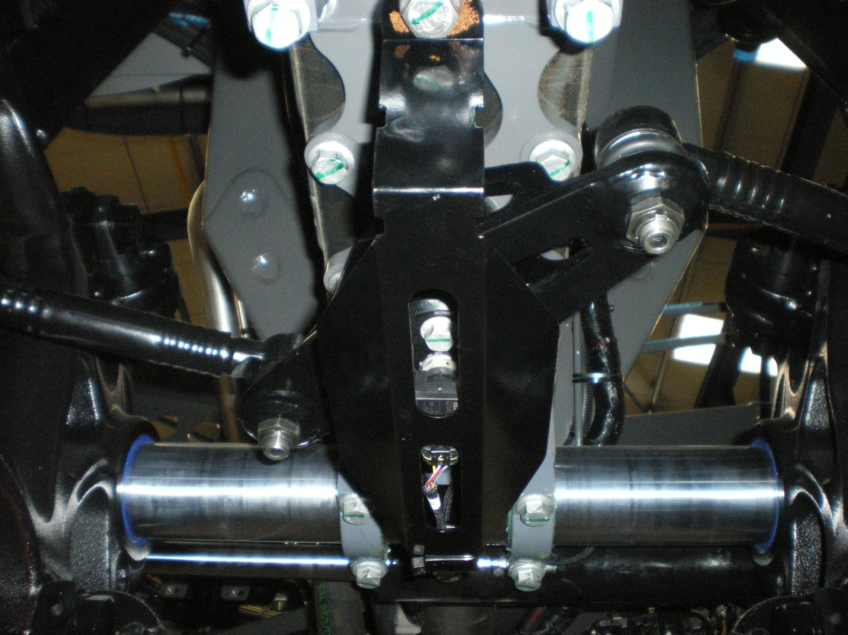
Transition of a rotary encoder signal to a linear movement.
c
a
b
α
βγ
γ
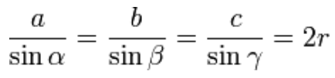
For the determination of the track width the sine law is used:
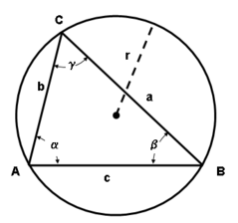
Length b (eep.dist_sensor_joint) and a (eep.dist_joint_axle) are known.

The first calculation step is the calculation of angle α, which is given by the sensor current signal. Therefor current is scaled to radians.

With help of the sine law 2r is calculated: 2r = length a / sin α.

The third step is calculation of axle angle β: β = arcsin(b / 2r)

Step four is determination of the joint angle γ: γ = π – β – α

The last calculation step is the calculation of the axle width.
The axle width is distance c times two: Axle width = 2 * (2r * sin γ) + 0.5

Translation of axle width to track width

The axle width can be calculated with the sensor value. The calculation of track width however needs extra information of the tire size and rim offset. Therefor the user has to set the right value for the track width at minimum axle width, i.e. smallest possible track width. This eeprom parameter is currently called “min_tire_track_width” or GD_ID_Min_Tire_Track_Width as GD index. These should be renamed in reference_track_width or something like that.

The track width is calculated as: current axle width – eep.min_axle_width + eep. min_tire_track_width

Situation with axles completely slided in to set reference track width value in NT01 (user setting)
Eep.min_tire_track_Track width (reference track width
Axle width (sensor signal)
Eep.Minimum axle width
Normal operation, when slided out.
Actual Track width
Axle width (sensor signal)

Eep.Minimum axle width

Example:
Minimum axle width: 400 mm
Reference track width: 1800 mm
Axle width: 800 mm

Current track width: 800 – 400 + 1800 = 2200 mm

Translation sensor signal(current) to angle

Eeprom parameter values: sensor_angle_min_width - 1.899 rad
sensor_angle_max_width - 0.456 rad
Eeprom calibration values: min_sensor_front - ca. 18 mA
max_sensor_front - ca. 5 mA
c
a
b
α
βγ
γ
Min width
Max width
α

Smallest angle and lowest current at max width – solid line.
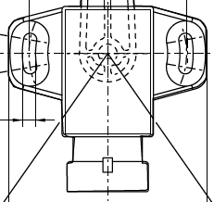
Biggest angle and highest current at min width – dashed line.

