

Module Specification

Specification of the AED WBZ Bridge Module

STRICTLY CONFIDENTIAL WITHIN AGCO

Author: AGCO GRU, Eric Bongaerts
Version: 0.1
Date: 2012 November 1

Change History
Revision Log
Revision | Date | Originator | Description
0.1 | 1-11-2012 | Eric Bongaerts | Initial creation. Merged separate documents.

Referenced Documents
Ref# | Date | Document | Version | Comment
1 | 01-04-2012 | MFA_EEPROM.pdf
2 | - | mfa_calib.pdf
3 | - | MFA_IDX.xls
4 | - | MFA_EEPROM.xls
5 | 21-01-2011 | EEM4 CAN INTERFACE SPECIFICATION

TODO:
- Lighthing J1939 messages (RG3)
- Four Wheel Steer State 1: PGN 61184 – PropA - XID 0xE30C. ?
- Four Wheel Steer State 2: PGN 61184 – PropA - XID 0xE30D. ?
- Height status 1: PGN 61184 – PropA - XID 0xE30E. ?
- Height status 2: PGN 61184 – PropA - XID 0xE30F. ?
- Wheel based direction

Table of Contents
Change History 2
Referenced Documents 2
Table of Contents 3
Definitions and Abbreviations 5
Introduction 6
TECU 7
Operator Interface 7
Armrest Inputs 7
Graphical User Interface 7
Application Logic 7
Functional Description 7
Conditions 7
Calibrations 7
I/O 8
Sensor Inputs 8
Interface Variables 8
Available Output Variables 8
Required Input Variables 8
Standards 8
Multifunctional Armrest AUX Interface 9
Operator Interface 9
Multifunctional Drive Lever Functions – Zone A 10
Throttle and Linear Module Functions 10
Keypad Functions 11
Application Logic 12
Background 12
MFA GD-Indices 12
Functional Description 13
Structure AUX Input Pool 14
I/O 14
Requirements 15
Interface variables 15
AUX input device defines 15
Available interface variables 15
Required interface variables 16
Calibrations 17
Standards 17
J1939 interface 18
Application Logic 18
Interface variables 18
Available interface variables 18
Required interface variables 19
Standards 19
Eeprom 20
Parameters 20
Calibrations 20
User settings 20
Options 20
Diagnostics 20
Diagnostics Error Codes 20
Appendix 21
Logic Flowcharts 21

Definitions and Abbreviations

MFA – Multifunctional Armrest

MFL – Multifunctional Lever

CHS-EXT – 32-bit controller for chassis control

IMP-EXT – 32-bit controller for implement control

NT01 – Terminal, graphical user interface

GD – Generic Driver

TECU – Tractor ECU

PGN – Parameter Group Number

SPN – Suspect Parameter Number

AUX-O – Auxiliary Input of the older type (type 1)

AUX-N – Auxiliary Input of the newer type (type 2)

ISOLib – ISO11783 protocol stack (code library)

Introduction

First a short explanation of the module name ‘WBZ Bridge Module”. WBZ is the name of the software house which created a ISOBUS driver for the CCI. CCI is the abbreviation of Competence Center ISOBUS, which is a consortium of agricultural machinery manufacturers. This WBZ drive can be compared with IsoAgLib. The main difference is the programming language. The WBZ-driver is coded in C and IsoAgLib is based on C++.
At the chassis side of AED CEA level-1 vehicles the WBZ-driver was chosen to be able to reuse a lot of already existing code in C. Besides that MOD has much experience using the driver on their tractors.
The part name ‘Bridge’ is chosen as the module bridges messages on the ISOBUS and J1939 bus to the GD bus and vice versa. It was firstly planned to have separate tasks, which could communicate directly with the J1939 and ISOBUS, but as the WBZ driver has no multithread functionality this was not possible. The originally defined tasks were the J1939-interface, TECU and MFA-interface module. In the new setting (Figure 1) the WBZ Bridge Module combines these different modules.
The module communicates directly with the MFA by GD. MFA input devices which are used for implement purposes are defined as AUX-N inputs in the module. The AUX-N inputs are part of the driver’s VT-client.
The J1939-interface and TECU are managed by the WBZ Driver Base.
Task controller chassis data will be provided to the ISOBUS by the TC-client.
As the different functions of this module are quite independent, the spec is divided in several chapters.

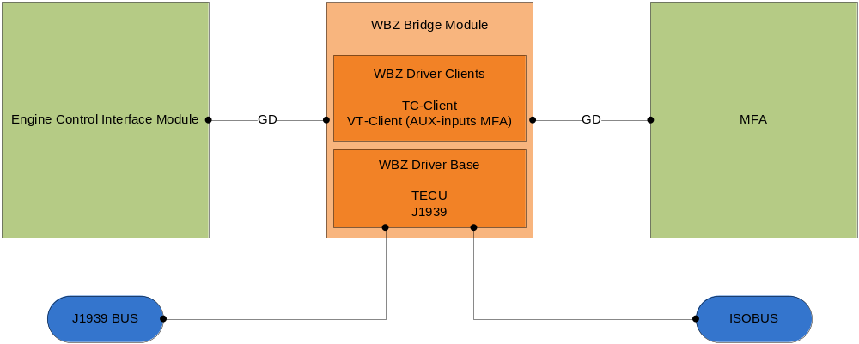
Figure 1 – WBZ Bridge Module Overview

TECU

Operator Interface
The only operator interface of this module is the calibration wizard of the optional radar sensor.

Armrest Inputs
This module needs no armrest inputs.

Graphical User Interface
There shall be a calibration wizard for the calibration of the radar sensor on the NT01.

Application Logic

Functional Description
This module is meant to be an input module of the TECU. It shall deliver the necessary inputs to let the TECU be able to send the right tractor/chassis information on the ISOBUS for implement purposes.
The two main areas are power management and speed information.
The selected speed message (TECU with suffix “P” required) is used for reporting the actual machine speed. The logic in the module will determine which source represents the best speed. After calibration of the optional radar sensor on basis of the amount of pulses per 100m the actual radar speed is calculated. If GPS speed is available, this speed is selected. If GPS speed isn’t present radar speed is the speed source, otherwise wheel speed. See Appendix, Figure 9.
The second speed, which is needed by the implement, is the engine speed. This variable is available on the GD-bus and shall be requested by the module and subsequently forwarded to the TECU.
The implement must be able to store data and control actuators after the ignition is switched off. Therefore the TECU shall send the key switch state on the ISOBUS. With that information the implement can request maintenance of ECU power and if needed actuator power as long as the maximum time of tractor power is not exceeded. Therefore the TECU needs the ignition state and the maximum allowed time for maintaining power at the current power load. This module will make these data available for the TECU. On the other side the TECU will inform the module about power maintain requests by the implement.

Conditions
See Appendix, Figure 9.

Calibrations
If a radar sensor is equipped, this speed signal has to be calibrated. Over a distance of 100m the pulses of the radar sensor are count. After finishing the calibration pulses per meter are calculated and this speed factor is stored in EEPROM.

I/O

Sensor Inputs
Description | #define * | Input Type
Radar sensor | RADAR_SENSOR | _DFI
*Suffix this name with the correct type

This module has further no outputs.

Interface Variables

Available Output Variables
Variable | Network | Source | Comments
Machine selected speed | ISO-11783 | TECU | PGN 0xF022, SPN 4305
Machine selected direction | ISO-11783 | TECU | PGN 0xF022, SPN 4309
Engine speed | ISO-11783 | TECU | PGN 0xF004, SPN 190
Key switch state (ignition) | ISO-11783 | TECU | PGN 0xFE48, SPN 1865
Maximum time of tractor power | ISO-11783 | TECU | PGN 0xFE48, SPN 1866
Alarm horn command | ISO-11783 | TECU | PGN 0xFE41, SPN 2391
Implement operating state cmd | ISO-11783 | TECU | PGN 0xFD03, SPN 5139
Street_Mode_Allowed | GD | Hydrostatic drive module | Immediate write to tell hydrostatic drive that street mode is not allowed
Speed_Limit | GD | Hydrostatic drive module | Immediate write speed limit implement

Required Input Variables
Variable | Network | Source | Comments
Actual machine speed | GD | Hydrostatic drive module | Current machine speed coming from GPS, radar or wheel sensors
Actual engine speed | GD | Engine interface module
Ignition state |  | Eos
Maximum power maintenance time | GD
Equipped with radar sensor | GD | Machine Information module
Alarm horn command | GD | Hydrostatic drive module
Maintain ECU power | ISO-11783 | Implement | PGN 0xFE47, SPN 1867
Maintain actuator power | ISO-11783 | Implement | PGN 0xFE47, SPN 1868
Implement transport state | ISO-11783 | Implement | PGN 0xFE47, SPN 1869
Speed limit | ISO-11783 | Implement | Settable DDI Device Pool Chassis

Standards
SAE-J1939:71 Vehicle application layer
ISO-11783:7 Implement messages application layer
ISO-11783:9 Tractor ECU - Class 2P

Multifunctional Armrest AUX Interface

Operator Interface
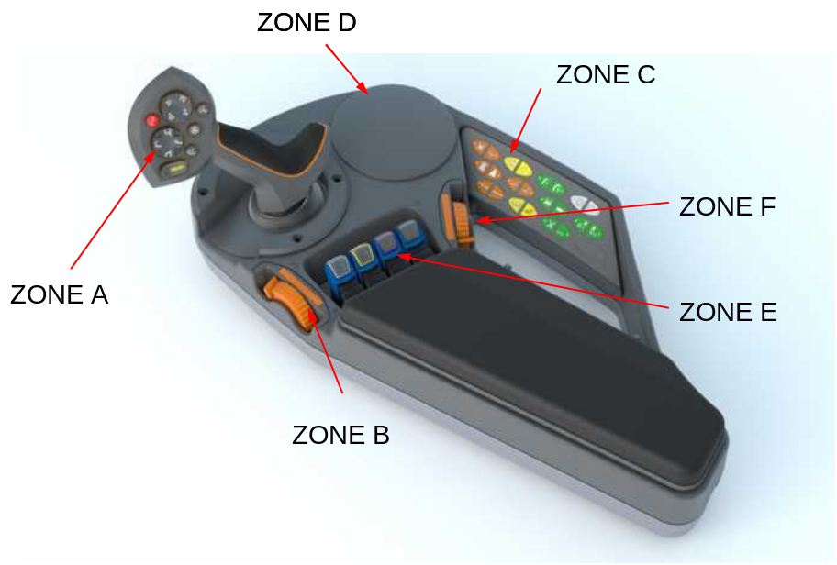
On AED equipment the MFA will be used as operator interface for both chassis and implement functions. The MFA has a graphical user interface on the NT01 for calibration purposes. Another interface is formed by the LED’s on the keypad. The armrest is divided into zone A till zone F, which can all be configured depending the machine series. This specification concentrates on the implement functions of the MFA. The next tables list the the button types and AUX-N input types of the MFA input devices.

Figure 2 – Multifunctional Armrest
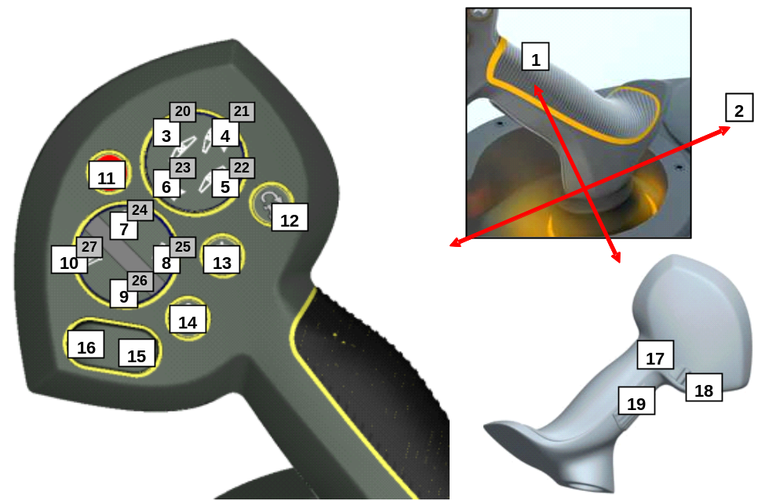

Figure 3 – Multifunctional Drive Lever Functions – Zone A

Multifunctional Drive Lever Functions – Zone A
Button | Input Type | AUX-N Inputtype | Object name
A-1 | Analog | Analog – return to 50% | axi2_A1
A-2 | Analog | Analog – return to 50% | axi2_A2
A-3 | Non-latching boolean | Boolean – Non-Latching | axi2_A3
A-4 | Non-latching boolean | Boolean – Non-Latching | axi2_A4
A-5 | Non-latching boolean | Boolean – Non-Latching | axi2_A5
A-6 | Non-latching boolean | Boolean – Non-Latching | axi2_A6
A-7 | Non-latching boolean | Boolean – Non-Latching | axi2_A7
A-8 | Non-latching boolean | Boolean – Non-Latching | axi2_A8
A-9 | Non-latching boolean | Boolean – Non-Latching | axi2_A9
A-10 | Non-latching boolean | Boolean – Non-Latching | axi2_A10
A-11 | Non-latching boolean | Boolean – Non-Latching | axi2_A11
A-12 | Non-latching boolean | Boolean – Non-Latching | axi2_A12
A-13 | Non-latching boolean | Boolean – Non-Latching | axi2_A13
A-14 | Non-latching boolean | Boolean – Non-Latching | axi2_A14
A-15 | Non-latching boolean | Boolean – Non-Latching | axi2_A15
A-16 | Non-latching boolean | Boolean – Non-Latching | axi2_A16
A-17 | Non-latching boolean | Boolean – Non-Latching | axi2_A17
A-18 | Non-latching boolean | Boolean – Non-Latching | axi2_A18
A-19 | Non-latching boolean | Boolean – Non-Latching | axi2_A19
A-20 | Non-latching boolean | Boolean – Non-Latching | axi2_A20
A-21 | Non-latching boolean | Boolean – Non-Latching | axi2_A21
A-22 | Non-latching boolean | Boolean – Non-Latching | axi2_A22
A-23 | Non-latching boolean | Boolean – Non-Latching | axi2_A23
A-24 | Non-latching boolean | Boolean – Non-Latching | axi2_A24
A-25 | Non-latching boolean | Boolean – Non-Latching | axi2_A25
A-26 | Non-latching boolean | Boolean – Non-Latching | axi2_A26
A-27 | Non-latching boolean | Boolean – Non-Latching | axi2_A27
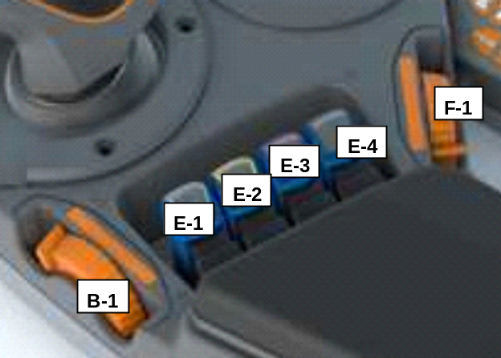
Figure 4 – Throttle and linear modules

Throttle and Linear Module Functions
Button | Input Type | AUX-N Inputtype | Object name
B-1 | Analog | Analog – 0 – 100% | axi2_B1
E-1 | Analog | Analog – return to 50%* | axi2_E1
E-2 | Analog | Analog – return to 50%* | axi2_E2
E-3 | Analog | Analog – return to 50%* | axi2_E3
E-4 | Analog | Analog – return to 50%* | axi2_E4
F-1 | Analog | Analog – 0 – 100% | axi2_F1
*Depending the hardware. Alternative would be Dual Boolean – Both Non-Latching.

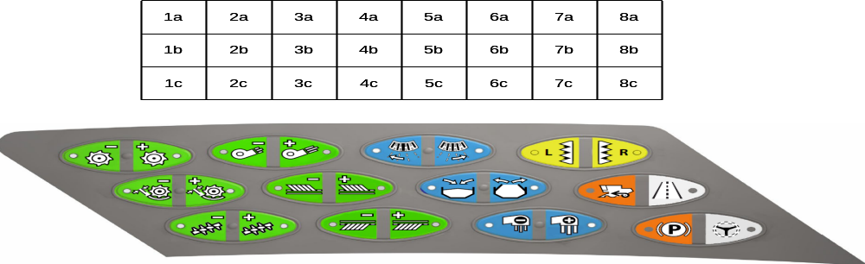
1 | 2 | 3 | 4 | 5 | 6 | 7 | 8
9 | 10 | 11 | 12 | 13 | 14 | 15 | 16
17 | 18 | 19 | 20 | 21 | 22 | 23 | 24

Figure 5 – Keypad

Keypad Functions
Button | Input Type | AUX-N Inputtype | Object name
C-1 | Non-latching boolean | Boolean – Non-Latching | axi2_C1
C-2 | Non-latching boolean | Boolean – Non-Latching | axi2_C2
C-3 | Non-latching boolean | Boolean – Non-Latching | axi2_C3
C-4 | Non-latching boolean | Boolean – Non-Latching | axi2_C4
C-5 | Non-latching boolean | Boolean – Non-Latching | axi2_C5
C-6 | Non-latching boolean | Boolean – Non-Latching | axi2_C6
C-7 | Non-latching boolean | Boolean – Non-Latching | axi2_C7
C-8 | Non-latching boolean | Boolean – Non-Latching | axi2_C8
C-9 | Non-latching boolean | Boolean – Non-Latching | axi2_C9
C-10 | Non-latching boolean | Boolean – Non-Latching | axi2_C10
C-11 | Non-latching boolean | Boolean – Non-Latching | axi2_C11
C-12 | Non-latching boolean | Boolean – Non-Latching | axi2_C12
C-13 | Non-latching boolean | Boolean – Non-Latching | axi2_C13
C-14 | Non-latching boolean | Boolean – Non-Latching | axi2_C14
C-15 | Non-latching boolean | Boolean – Non-Latching | axi2_C15
C-16 | Non-latching boolean | Boolean – Non-Latching | axi2_C16
C-17 | Non-latching boolean | Boolean – Non-Latching | axi2_C17
C-18 | Non-latching boolean | Boolean – Non-Latching | axi2_C18
C-19 | Non-latching boolean | Boolean – Non-Latching | axi2_C19
C-20 | Non-latching boolean | Boolean – Non-Latching | axi2_C20
C-21 | Non-latching boolean | Boolean – Non-Latching | axi2_C21
C-22 | Non-latching boolean | Boolean – Non-Latching | axi2_C22
C-23 | Non-latching boolean | Boolean – Non-Latching | axi2_C23
C-24 | Non-latching boolean | Boolean – Non-Latching | axi2_C24
* All the buttons are foreseen with a LED. The LED-status can be off, flashing or on.

Application Logic

Background
The MFA provides button statuses as GD-indices. The tasks on the CHS-EXT which need certain button statuses, request the MFA for the corresponding GD-indices.
Subsequently in case of a button press or release the MFA sends a response message. If the CHS-EXT needs to control a LED, it sends an immediate write message to the MFA.
As the IMP-EXT is no node of the GD-network, control of buttons for implement purposes shall be handled by AUX-control, which will be facilitated by this module.

MFA GD-Indices
The GD-indices of the MFA shall be added to the project specific header file (e.g. RG600_gd_id.h). The header is a list with all GD-indices, which belong to the different nodes. Both the logic and physical node ID of the MFA shall be configurable, which will result in a project specific MFA software. The MFA GD’s shall have a generic name, independent of the function the corresponding hardware (e.g. button) has, referring to the zone and button number. The GD-index of e.g. button C-8a will then be “GD_ID_MFA_Button_C_8_a”.
Mapping of these generic MFA GD-indices shall be done in a project specific interface header file (see example Figure 6). As the armrest module acts as an interface module between GD en AUX for implement button requests, there needs to be GD-mapping for the implement as well. In this way the well-understandable GD-index name of the implement (and chassis) functions are uncoupled of the hardware-specific GD-index name of the MFA. It makes it easy to switch a function to another button, if needed. Using an “enum” in the header file prevents errors as the compiler doesn’t allow the use of two or more same ID’s.

//Include here the header file containing the complete list of the project specific GD-indices
#include "RG600_gd_id.h"

//Map here the GD-indices used in the module vs. the GD-indices coming from other GD-nodes, which are listdd in XXXX_gd_id.h
//Only external GD's (coming from other nodes and not delivered by the module itself) have to be mapped
enum
{
WBZ_GD_ID_ButtonC8 = GD_ID_MFA_C8,//Coming from MFA
WBZ_GD_ID_ButtonC8 = GD_ID_MFA_C8,//Coming from MFA
};
Figure 6 – Code snippet example of module interface header file with mapped MFA GD-index.

Functional Description
This module ((Appendix, Figure 10) shall control the communication between the MFA and the IMP-EXT via the NT01 and shall be implemented on the CHS-EXT. As the IMP-EXT is not part of the GD-network, the necessary button requests for implement purposes shall be done by an AUX-input GD logic node, which is in fact represented by the WBZ Bridge Module. The MFA communicates with the CHS-EXT by GD, while on the other side the CHS-EXT, IMP-EXT and the NT01 are using the ISOBUS-protocol to facilitate the AUX-functionality (Figure 7). In fact the module will map the by AUX-input node requested MFA button GD-indices to AUX-N inputs.

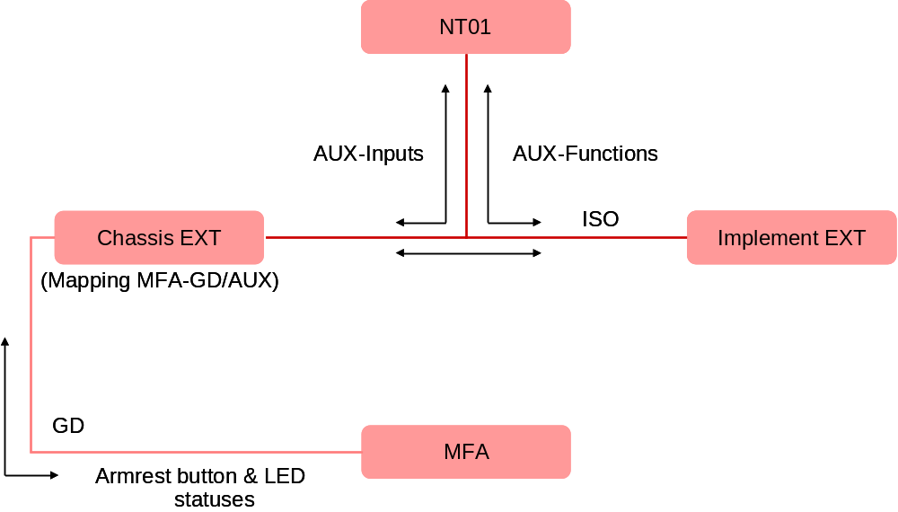
Figure 7 – Communication structure

The module shall contain an AUX input pool which is actually a mirror of the armrest inputs (buttons and analog devices). The AUX inputs shall be defined as Single Assignment Inputs, so that no multiple AUX function assignments can be done. The module will use ISOLib functions to control the AUX-communication (Figure 8):

- Upload of the AUX input pool to the NT01: The pool shall contain all possible inputs of the MFA. Only the inputs that are needed by the implement will be uploaded to the NT01. Otherwise it could happen that inputs are used by both chassis functions and AUX functions of another ISOBUS member, which would lead to a conflict situation. The inputs, which are uploaded, correspond to the requested buttons of the AUX-input node.
- Response (acknowledgement) on the Input Status Enable messages sent by the NT01. Otherwise the AUX inputs will not be available.
- Forwarding Key/button presses and releases to the NT01 and the IMP-EXT
(Aux Input Status).
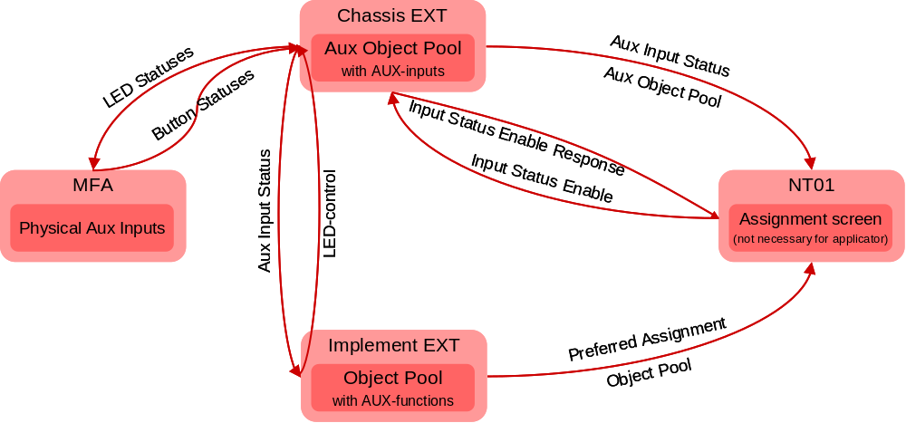

Figure 8 – AUX-control

LED-control is not foreseen in the ISO11783 standard. Therefore, if an implement function requires the control of a LED on the MFA, the IMP-EXT shall send a PROP A PGN to the CHS-EXT as LED-command. Subsequently the module shall control the MFA LED’s by GD. The CHS-EXT has full control over the MFA LED statuses, which will prevent double control of certain LED’s by both the IMP-EXT and CHS-EXT.

Not included in this module, but needed as background information:
To be able to connect an AUX-input of the MFA to an AUX-function of the IMP-EXT, the IMP-EXT shall upload an AUX function pool to the NT01. In addition the IMP-EXT will send a preferred assignment command to the NT01. This assignment is necessary to have a fix addressing between implement functions and MFA buttons. Assignment of implement functions by the operator will be blocked by the Assignment Lock.

Structure AUX Input Pool
The pool shall be a collection of XML-files (Appendix, Figure 11). Per MFA zone a XML-file with AUX-input objects shall be created. This modular approach makes it possible to adapt the pool in future very fast in case zones change or new zones are added.

I/O

The MFA interface has except ISOBUS and GD-bus no further in- and outputs as it’s an communication module.

Requirements
At the moment there are a couple of documents describing the most of the MFA features: MFA_EEPROM.pdf, mfa_calib.pdf, MFA_IDX.xls and MFA_EEPROM.xls. It’s recommended to bundle these documents and create a generic MFA specification. This document should also contain a list with the MFA GD-indices and their generic description as proposed in paragraph MFA GD-Indices.

To make a preferred assignment of AUX-functions possible and to be able to use the Analog – return to 50% input type the AUX-N type has to be used, as these features are not given by the AUX-O type. Therefore the NT01 should at least support VT level 3. The same requirement applies to the WBZ Driver and IMP-EXT software. The AUX assignment screen, provided by the VT on the NT01, should not show the preferred assignments with assignment lock. As a matter of fact is not necessary to display this screen at all.

Interface variables

AUX input device defines
Description | #define
Self configurable address | WSM_AXI_SELF_CONF
Industry group | WSM_AXI_IND_GROUP
Device class | WSM_AXI_DEV_CLASS
Device class instance | WSM_AXI_DEV_CLASS_INST
Function | WSM_AXI_FUNC
Manufacturer code | WSM_AXI_MANF_CODE
Serial number | WSM_AXI_SER_NO
Function instance | WSM_AXI_FUNC_INST
ECU instance | WSM_AXI_ECU_INST
Model identification code | WSM_AXI_MIC

Available interface variables
Variable | Network | Source | Comment
Auxiliary Input Type 2 Status | ISO-11783 | VT-client | PGN 0xE700, VT function 38
Auxiliary Input Type 2 Maintenance | ISO-11783 | VT-client | PGN 0xE700, VT function 35
Auxiliary Input Status Type 2 Enable reponse | ISO-11783 | VT-client | PGN 0xE700, VT function 37
Auxiliary LED state C-1* | ISO-11783 | Implement | Proprietary PGN
Auxiliary LED state C-2* | ISO-11783 | Implement | Proprietary PGN
Auxiliary LED state C-3* | ISO-11783 | Implement | Proprietary PGN
Auxiliary LED state C-4* | ISO-11783 | Implement | Proprietary PGN
Auxiliary LED state C-5* | ISO-11783 | Implement | Proprietary PGN
Auxiliary LED state C-6* | ISO-11783 | Implement | Proprietary PGN
Auxiliary LED state C-7* | ISO-11783 | Implement | Proprietary PGN
Auxiliary LED state C-8* | ISO-11783 | Implement | Proprietary PGN
Auxiliary LED state C-9* | ISO-11783 | Implement | Proprietary PGN
Auxiliary LED state C-10* | ISO-11783 | Implement | Proprietary PGN
Auxiliary LED state C-11* | ISO-11783 | Implement | Proprietary PGN
Auxiliary LED state C-12* | ISO-11783 | Implement | Proprietary PGN
Auxiliary LED state C-13* | ISO-11783 | Implement | Proprietary PGN
Auxiliary LED state C-14* | ISO-11783 | Implement | Proprietary PGN
Auxiliary LED state C-15* | ISO-11783 | Implement | Proprietary PGN
Auxiliary LED state C-16* | ISO-11783 | Implement | Proprietary PGN
Auxiliary LED state C-17* | ISO-11783 | Implement | Proprietary PGN
Auxiliary LED state C-18* | ISO-11783 | Implement | Proprietary PGN
Auxiliary LED state C-19* | ISO-11783 | Implement | Proprietary PGN
Auxiliary LED state C-20* | ISO-11783 | Implement | Proprietary PGN
Auxiliary LED state C-21* | ISO-11783 | Implement | Proprietary PGN
Auxiliary LED state C-22* | ISO-11783 | Implement | Proprietary PGN
Auxiliary LED state C-23* | ISO-11783 | Implement | Proprietary PGN
Auxiliary LED state C-24* | ISO-11783 | Implement | Proprietary PGN
*LED-command for the implement.

Required interface variables
Variable | Network | Source | Mapping Variable name
Auxiliary Input Status Type 2 Enable | ISO-11783 | VT-client | PGN 0xE600, VT function 37
Lever state A-1 | GD | MFA | WBZ_GD_ID_A1
Lever state A-2 | GD | MFA | WBZ_GD_ID_A2
Button state A-3 | GD | MFA | WBZ_GD_ID_A3
Button state A-4 | GD | MFA | WBZ_GD_ID_A4
Button state A-5 | GD | MFA | WBZ_GD_ID_A5
Button state A-6 | GD | MFA | WBZ_GD_ID_A6
Button state A-7 | GD | MFA | WBZ_GD_ID_A7
Button state A-8 | GD | MFA | WBZ_GD_ID_A8
Button state A-9 | GD | MFA | WBZ_GD_ID_A9
Button state A-10 | GD | MFA | WBZ_GD_ID_A10
Button state A-11 | GD | MFA | WBZ_GD_ID_A11
Button state A-12 | GD | MFA | WBZ_GD_ID_A12
Button state A-13 | GD | MFA | WBZ_GD_ID_A13
Button state A-14 | GD | MFA | WBZ_GD_ID_A14
Button state A-15 | GD | MFA | WBZ_GD_ID_A15
Button state A-16 | GD | MFA | WBZ_GD_ID_A16
Button state A-17 | GD | MFA | WBZ_GD_ID_A17
Button state A-18 | GD | MFA | WBZ_GD_ID_A18
Button state A-19 | GD | MFA | WBZ_GD_ID_A19
Button state A-20 | GD | MFA | WBZ_GD_ID_A20
Button state A-22 | GD | MFA | WBZ_GD_ID_A22
Throttle state B-1 | GD | MFA | WBZ_GD_ID_B1
Button state C-1 | GD | MFA | WBZ_GD_ID_C1
Button state C-2 | GD | MFA | WBZ_GD_ID_C2
Button state C-3 | GD | MFA | WBZ_GD_ID_C3
Button state C-4 | GD | MFA | WBZ_GD_ID_C4
Button state C-5 | GD | MFA | WBZ_GD_ID_C5
Button state C-6 | GD | MFA | WBZ_GD_ID_C6
Button state C-7 | GD | MFA | WBZ_GD_ID_C7
Button state C-8 | GD | MFA | WBZ_GD_ID_C8
Button state C-9 | GD | MFA | WBZ_GD_ID_C9
Button state C-10 | GD | MFA | WBZ_GD_ID_C10
Button state C-11 | GD | MFA | WBZ_GD_ID_C11
Button state C-12 | GD | MFA | WBZ_GD_ID_C12
Button state C-13 | GD | MFA | WBZ_GD_ID_C13
Button state C-14 | GD | MFA | WBZ_GD_ID_C14
Button state C-15 | GD | MFA | WBZ_GD_ID_C15
Button state C-16 | GD | MFA | WBZ_GD_ID_C16
Button state C-17 | GD | MFA | WBZ_GD_ID_C17
Button state C-18 | GD | MFA | WBZ_GD_ID_C18
Button state C-19 | GD | MFA | WBZ_GD_ID_C19
Button state C-20 | GD | MFA | WBZ_GD_ID_C20
Button state C-21 | GD | MFA | WBZ_GD_ID_C21
Button state C-22 | GD | MFA | WBZ_GD_ID_C22
Button state C-23 | GD | MFA | WBZ_GD_ID_C23
Button state C-24 | GD | MFA | WBZ_GD_ID_C24
Linear module state E-1 | GD | MFA | WBZ_GD_ID_E1
Linear module state E-2 | GD | MFA | WBZ_GD_ID_E2
Linear module state E-3 | GD | MFA | WBZ_GD_ID_E3
Linear module state E-4 | GD | MFA | WBZ_GD_ID_E4
Throttle state F-1 | GD | MFA | WBZ_GD_ID_F1
LED state C-1* | GD | MFA | WBZ_GD_ID_LED_C1
LED state C-2* | GD | MFA | WBZ_GD_ID_LED_C2
LED state C-3* | GD | MFA | WBZ_GD_ID_LED_C3
LED state C-4* | GD | MFA | WBZ_GD_ID_LED_C4
LED state C-5* | GD | MFA | WBZ_GD_ID_LED_C5
LED state C-6* | GD | MFA | WBZ_GD_ID_LED_C6
LED state C-7* | GD | MFA | WBZ_GD_ID_LED_C7
LED state C-8* | GD | MFA | WBZ_GD_ID_LED_C8
LED state C-9* | GD | MFA | WBZ_GD_ID_LED_C9
LED state C-10* | GD | MFA | WBZ_GD_ID_LED_C10
LED state C-11* | GD | MFA | WBZ_GD_ID_LED_C11
LED state C-12* | GD | MFA | WBZ_GD_ID_LED_C12
LED state C-13* | GD | MFA | WBZ_GD_ID_LED_C13
LED state C-14* | GD | MFA | WBZ_GD_ID_LED_C14
LED state C-15* | GD | MFA | WBZ_GD_ID_LED_C15
LED state C-16* | GD | MFA | WBZ_GD_ID_LED_C16
LED state C-17* | GD | MFA | WBZ_GD_ID_LED_C17
LED state C-18* | GD | MFA | WBZ_GD_ID_LED_C18
LED state C-19* | GD | MFA | WBZ_GD_ID_LED_C19
LED state C-20* | GD | MFA | WBZ_GD_ID_LED_C20
LED state C-21* | GD | MFA | WBZ_GD_ID_LED_C21
LED state C-22* | GD | MFA | WBZ_GD_ID_LED_C22
LED state C-23* | GD | MFA | WBZ_GD_ID_LED_C23
LED state C-24* | GD | MFA | WBZ_GD_ID_LED_C24
*Immediate write to MFA to set the LED to off, on or flashing.

Calibrations
The calibration procedure is described in the document mfa_calib.pdf. The chassis application shall provide a calibration page on the NT01 to be able to calibrate the hand throttle, linear modules and the drive lever. The CHS-EXT needs the calibration status of MFA analog devices to enable certain functions (e.g. hydrostatic drive).

Standards
AUX-control is according part 6 of ISO11783.

J1939 interface

Application Logic
This module is the interface between the J1939 bus and the rest of the system. The WBZ Driver will manage the the Address Claiming process, J1939 transport protocol. The driver will also process DM1 and DM2 messages. Subsequently the J1939 interface will report active and stored errors from J1939 sources (i.e. engine) to the error management node.

Interface variables

Available interface variables
Variable | Network | Source | Comment
TSC1 – Engine Override Control Mode | J1939 | Engine ECU | PGN 0, SPN 695
TSC1 – Engine Requested Speed/Speed Limit | J1939 | Engine ECU | PGN 0, SPN 898
OHECS – Engine Alternate Low Idle Switch | J1939 | Engine ECU | PGN 64971, SPN 2883
RQST – PGN Request (Engine Hours) | J1939 | Engine ECU | PGN 59904 (65253)

Variable Name | Value  DB5 | Value Range  DB6/DB7 | Dimension | Function
GD_ID_Engine_Rpm | n.a. | 0..32767 | [0.125 rpm] | Engine RPM
GD_ID_Engine_Load | n.a. | 0..10000 | [0.01 %] | Engine Load Factor
GD_ID_Engine_Coolant_Temp | n.a. | -40..130 | [deg Celsius] | Engine Coolant Temperature
GD_ID_Engine_Air_Intake_Temp | n.a. | -40..130 | [deg Celsius] | Engine Air Intake Temperature
GD_ID_Engine_Battery_Power | n.a. | 0..32767 | [0.05 V] | Battery voltage
GD_ID_Engine_Air_Intake_Pressure | n.a. | 0..255 | [1 kPa] | Engine air intake pressure
GD_ID_Engine_Oil_Pressure | n.a. | 0..255 | [1 kPa] | Engine oil pressure
GD_ID_Rpm_Setpoint_Hydrostat | 1/0 | 0..32767 | [0.125 rpm] | Engine RPM setpoint from Hydrostat task
 |  |  |  | status bit: Hydrostat has set setpoint
GD_ID_Engine_Standing_Still | 1/0 | n.a. | STILL/RUNNING | Engine is standing still
GD_ID_Engine_Oil_Pressure_Low | 1/0 | n.a. | LOW/OK | Engine oil pressure is low
GD_ID_Engine_Oil_Service_Interval | 1/0 | n.a. | EXCEEDED/OK | Engine oil service interval exceeded
GD_ID_Fuel_Rate | n.a. | 0..32767 | [0.05 l/h] | Current Fuel Rate
GD_ID_Trip_Fuel | n.a. | 0..32767 | [0.05 l] | Trip Fuel Consumption
GD_ID_Engine_Hours | n.a. | 0..32767 | [h] | Engine hours
GD_ID_Engine_Amber_Warning_Lamp | 1/0 | n.a. | ON/OFF | Engine amber warning lamp (#errors >= 1)
GD_ID_Engine_Red_Stop_Lamp | 1/0 | n.a. | ON/OFF | Engine red stop lamp (shutdown pending)
GD_ID_Fuel_Level | n.a. | 0..1000 | [0.1 %] | Fuel Level
GD_ID_Inlet_Air_Filter_Sensor | 1/0 | n.a. | ON/OFF | Inlet air filter pressure sensor
 |  |  |  | ON: pressure is okay
 |  |  |  | OFF: pressure is too high
GD_ID_Alt_Low_Idle | n.a. | 0..1 | ON/OFF | Alternative low idle state
GD_ID_Engine_Audible_Warning | 1/0 | n.a. | ON/OFF | Engine audible warning
GD_ID_Ambient_Temp | n.a. | -273..1775 | [deg C] | Ambient temperature
GD_ID_Ecu_Temp | n.a. | -273..1775 | [deg C] | Ecu temperature
GD_ID_LifeMsg_Engine
-> Fuel level sensor and inlet air filter sensor are moved to a RG600 specific task.

Required interface variables
Variable | Network | Source | Comment
EEC1 – Engine Speed | J1939 | Engine ECU | PGN 61444, SPN 190
EEC2 – Engine Percent Load At Current Speed | J1939 | Engine ECU | PGN 61443, SPN 92
ET2 – Engine ECU Temperature | J1939 | Engine ECU | PGN 65188, SPN 1136
AMB – Ambient Air Temperature | J1939 | Engine ECU | PGN 65269, SPN 171
LFE – Fuel Rate | J1939 | Engine ECU | PGN 65266, SPN 183
EFL/P1 – Oil Pressure | J1939 | Engine ECU | PGN 65263, SPN 100
IC1 – Engine Air Intake Pressure | J1939 | Engine ECU | PGN 65270, SPN 102
IC1 – Engine Air Intake Temperature | J1939 | Engine ECU | PGN 65270, SPN 105
ET1 – Engine Coolant Temperature | J1939 | Engine ECU | PGN 65262, SPN 110
VEP1 – Keyswitch Battery Potential (Voltage) | J1939 | Engine ECU | PGN 65271, SPN 158
HOURS – Engine Total Hours of Operation | J1939 | Engine ECU | PGN 65253, SPN 247
After treatment hours and status – Audible warning | J1939 | Engine ECU | PGN 65399, PROP
Engine Hours and Status – Engine hours | J1939 | Engine ECU | PGN 65333, PROP
Engine Hours and Status – Engine standing still | J1939 | Engine ECU | PGN 65333, PROP
Engine Hours and Status – Oil pressure low | J1939 | Engine ECU | PGN 65333, PROP
Engine Hours and Status – Oil service interval exceeded | J1939 | Engine ECU | PGN 65333, PROP
Engine Hours and Status – Trip fuel | J1939 | Engine ECU | PGN 65333, PROP
DM1 – Amber Warning Lamp Status | J1939 | Engine ECU | PGN 65226
DM1 – Red Stop Lamp Status | J1939 | Engine ECU | PGN 65226

Standards
J1939

Eeprom

Parameters
Type | Parameter | Units
uint16 | checksum

Calibrations
Size | Parameter | Units
uint16 | checksum
uint16 | radarSensorPulses | Pulses/100m

User settings
Size | Parameter | Units
uint16 | checksum

Options
Size | Parameter | Units
uint16 | checksum

Diagnostics

Diagnostics Error Codes
Error Number Name | Error Type | Environmental Variables | Description | Consequence

Appendix

Logic Flowcharts

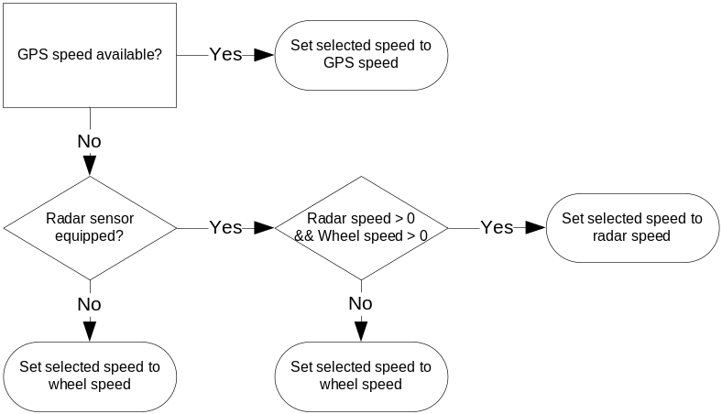

Figure 9 – Flow chart – speed source selection

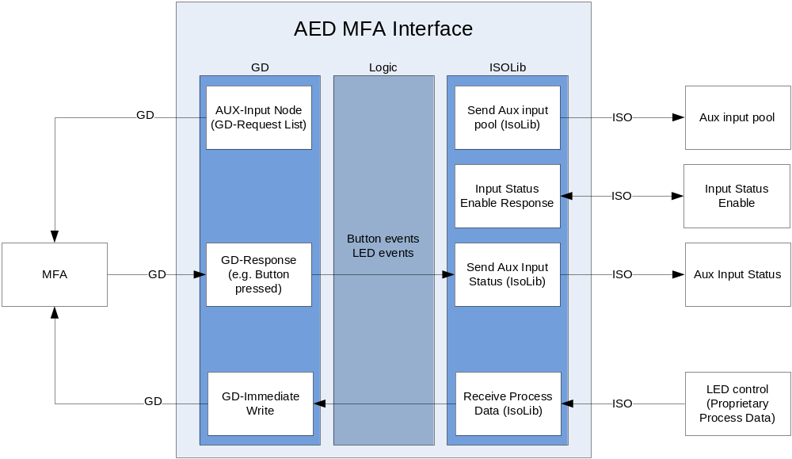

Figure 10 – MFA interface layout

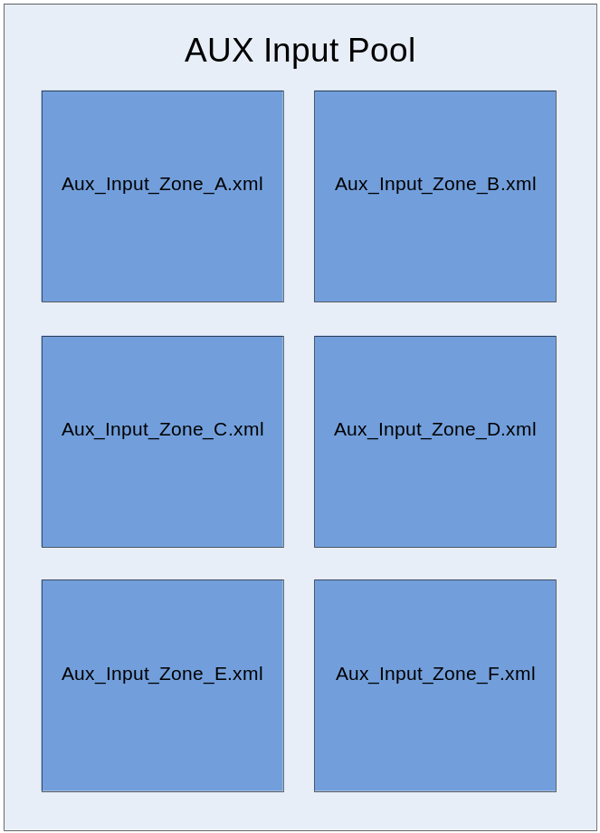
Figure 11 – Aux Input Pool layout

