Field Notes - UrbanRoof Inspection
Walked the site today (Nov 12). Met with the building mgr. Overall interior looks mostly fine but we found some weird stuff outside.
Notes on the North side:
- Saw a huge crack running down the masonry wall near the loading bay door. Looks pretty bad, paint is peeling everywhere.
- Tenant said it started leaking last week when it rained.
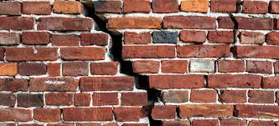
Notes on the Roof:
- Actually could not access the East sector of the roof at all because the access door was jammed. So no data there.
- On the Southwest corner, the drain is totally blocked by leaves and mud. I see a big puddle. The membrane looks okay visually though, no tears that I could spot.
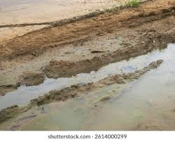
Server Room (Interior):
- No water on the server room floor, it was totally dry. HVAC is making a very loud screeching sound however.

