IR Drone & Handheld Thermography Logs
Drone swept the roof. Handheld IR used inside.
ROOF SWEEP:
- The Southwest corner shows a massive localized thermal anomaly directly under where the visual drone saw a puddle. Measurements read -5°C delta. This is absolutely subsurface water pooling between the insulation layers, meaning the membrane is actually torn and flooded underneath even if it looks okay on top!!
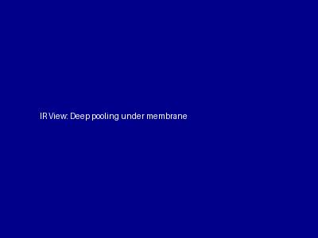
- Found some minor heat loss on the East sector roof vents, but overall it looks fine.
LOADING BAY WALL:
- Handheld scan of the masonry crack on the North wall loading bay: No active moisture plumes detected inside the crack itself right now, but there is heavy thermal bridging happening. Insulation is missing behind the block over a 3ft radius.
SERVER ROOM AC:
- The AC compressor casing is reading normal levels (around 30°C). Seems fine thermally.
