Site Inspection Report

1. General Information
Date: October 24, 2026
Inspector: John Doe
Location: Beta Warehouse Facility, Sector 4

2. Exterior Observations

North Wall
Observation: The exterior north wall exhibits visible cracking near the foundation. Protective coating is peeling off.
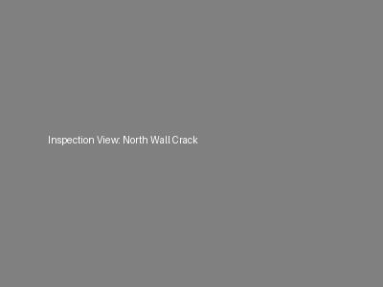

Roof Level
Observation: The Southwest Corner of the roof has accumulated debris. There are signs of water pooling (ponding) around the primary drain, suggesting a partial blockage. Missing shingles noted near the parapet.
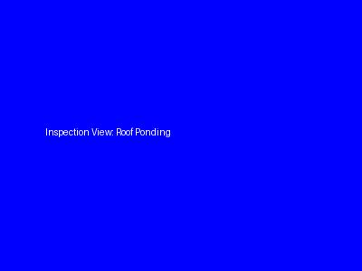

3. Interior Observations

Server Room
Observation: Environment feels unusually humid. The HVAC unit making a rattling noise. No visible water leaks on the floor.
