Comprehensive Thermal Imaging Report
Complete 100% drone thermal map and internal IR sweep completed successfully. No zones missed.

1. Root Cause & Severity Validation
Thermal profiles confirm the inspection team’s root cause analysis. Water ingress from the failed expansion joint is accelerating the shear cracking. The compressor failure severity is marked Critical based on extreme internal heat buildup surrounding the seized bearings.

2. Thermal Area Findings

East Wing Exterior
Finding: Massive thermal bridging observed throughout the shear crack pathway. A massive block of 4°C moisture is actively pooling inside the inner concrete cavity.
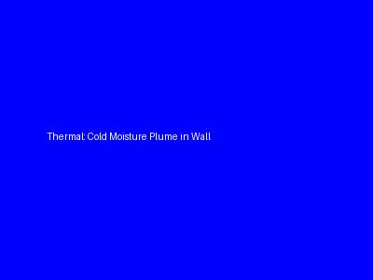

Central Plant
Finding: Despite being seized, internal electrical resistance in Compressor B is generating a catastrophic hotspot of 115°C across the stator. Absolute fire hazard.


