Thermal Imaging Report

1. Overview
Date: October 24, 2026
Equipment: FLIR T865
Technician: Jane Smith

2. Thermal Findings

Roof Level (Southwest Corner)
Finding: Significant thermal anomaly detected around the primary drain area. Severe temperature drop of 4.2°C compared to surrounding membrane, strongly indicating subsurface moisture saturation (water trapped under the membrane).
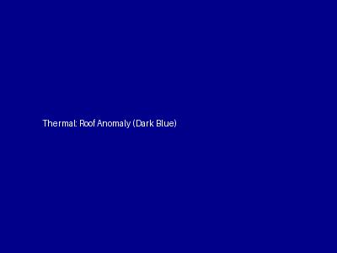

Server Room
Finding: The secondary cooling unit is showing a hotspot of 65°C on the compressor casing, which is 20°C above expected operating parameters. Suggests imminent overheating or mechanical friction issue.


North Wall Foundation
Finding: Slight thermal bridging noted along the baseline. No major insulation gaps detected, but cooling pattern matches the structural cracking seen visually.

