Ala :-3 Cloud Computing

Aim:- Student will individually use virtualization tools like VMware Workstation, VirtualBox, or Hyper-V to create and configure a virtual machine (VM). They will document the virtualization process, key challenges, and advantages, and upload their findings to the GMIU portal.

- Virtualization
Virtualization is the process of creating a virtual version of computer resources such as hardware platforms, storage devices, networks, or operating systems. Instead of using physical hardware directly, virtualization allows multiple virtual machines (VMs) to run on a single physical machine, each acting like an independent computer.

- Virtualization Process
- Install Virtualization Software
  - Use tools like VMware Workstation, VirtualBox, or Hyper-V.
- Create a Virtual Machine (VM)
  - Allocate CPU, RAM, disk space, and select an operating system (Windows, Linux, etc.).
- Install Guest Operating System
  - Boot VM using an ISO file and install the chosen OS inside the VM.
- Configure VM Settings
  - Enable networking (NAT/Bridged), USB access, and shared folders.
  - Install Guest Additions/VMware Tools for better integration.
- Run & Manage Virtual Machine
  - Start the VM, install applications, and take snapshots for backup/restore.

- Key Challenges in Virtualization
- Performance Issues – VMs may run slowly if host resources (RAM, CPU) are limited.
- Compatibility Problems – Some guest OS features may not work without additional drivers.
- Storage & Disk Space – VMs require large disk space; can fill up quickly.
- Networking Issues – Configuring NAT, Bridged, or Host-Only network can be confusing.
- Security Concerns – Misconfigured VMs may expose the host system to risks.

- Advantages of Virtualization
- Cost-Effective – Multiple VMs on one physical machine reduce hardware needs.
- Resource Optimization – Efficient use of CPU, memory, and storage.
- Flexibility – Run different operating systems on the same computer.
- Isolation & Security – Each VM is isolated, preventing one crash from affecting others.
- Testing & Development – Safe environment for testing new software, malware analysis, and OS experiments.
- Disaster Recovery – Easy backup and restore using snapshots.

- Output:-
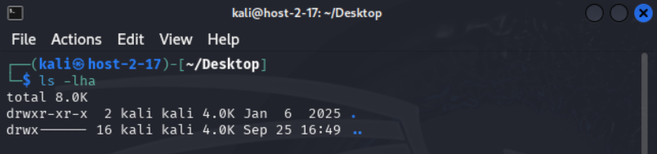
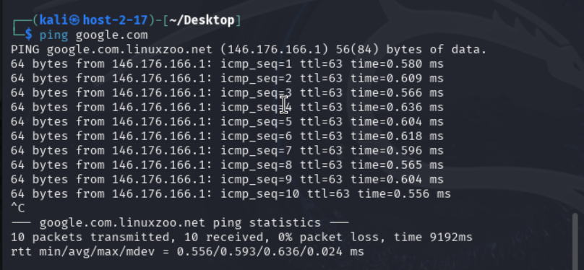
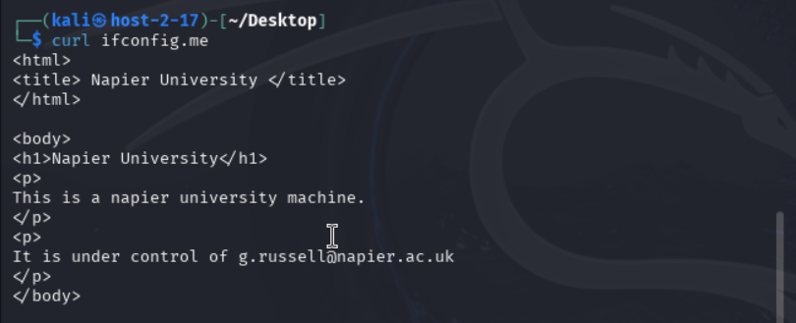

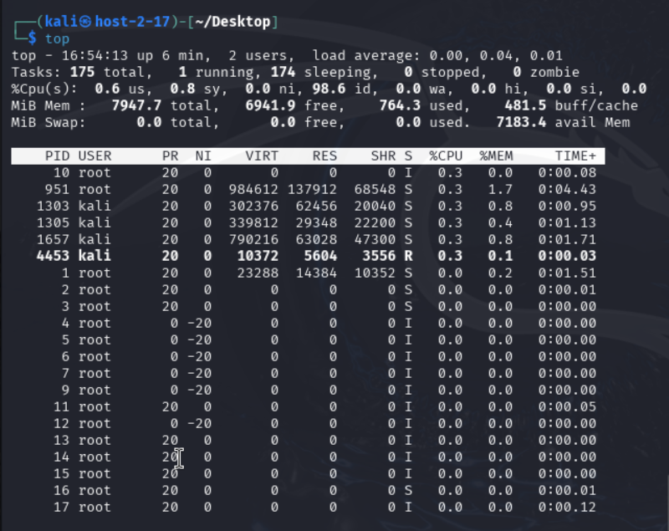
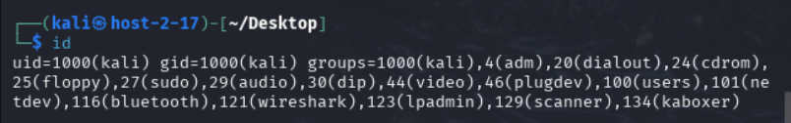

- Step 1: Getting Started on linuxzoo.net
• Go to https://linuxzoo.net
• Sign up or log in (free).
• Click Start Linux → you’ll get an online terminal.
• Type commands directly into that terminal and press Enter.

- Command 1: ls -lha

What it does:
- Lists files and folders in the current directory.
- Options used:
  - -l → long listing (permissions, size, date, etc.)
  - -h → human-readable sizes (KB, MB, GB)
  - -a → show hidden files (those starting with .)

- Command 2: top

What it does:
- Shows real-time running processes, CPU usage, memory usage.
- Like a task manager for Linux.

- Command 3: curl ifconfig.me

What it does:
- Shows your public IP address (the IP the internet sees).

- Command 4: ping google.com

What it does:
- Sends packets to google.com to test internet connectivity and response time.

- Command 5: id

What it does:
- Shows your current username, user ID, group ID, and groups you belong to.

