OFFLINE NOTEBOOK DOCUMENT QA
A Secure, Persistent and Multimodal Retrieval-Augmented Generation System
Project Report for Guide Review
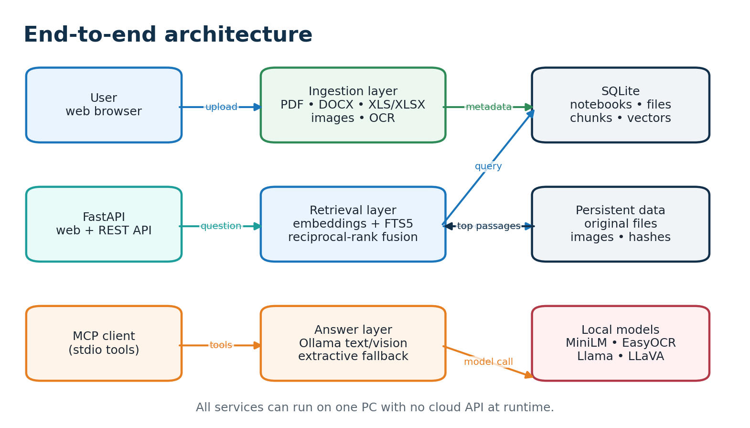
Figure 1. System overview
Prepared by: Cyril P. George
Repository: github.com/dhxvxn/URSC_RAG
Date: 10 November 2026

Abstract and executive summary
What the system delivers
This project implements an offline document question-answering service for secure offices and laboratories. Users create notebooks, add files or folders, and ask questions against one selected collection. The application extracts text from common office formats, applies OCR to scanned pages and images, creates local sentence embeddings, and stores the original files, images, chunks and vectors persistently. Later uploads of the same bytes are recognized by SHA-256 and reused without repeated embedding work.
Retrieval combines dense semantic similarity with SQLite FTS5 lexical search. This hybrid path is designed to retrieve both conceptually related passages and exact terms such as identifiers, acronyms and mission codes. Ollama supplies local text or vision answers using only retrieved evidence. If Ollama is unavailable, the service returns an extractive answer containing the strongest indexed passages.
Capability | Implemented behavior | Value to the lab
Persistent indexing | SQLite catalog, stored documents, embeddings and images | No repeated uploads or re-indexing
Multimodal retrieval | Text chunks, OCR text and image sources | Questions can use reports, scans and figures
Offline operation | Native Python/Ollama or Docker after preparation | Suitable for isolated networks
Notebook scope | Queries restricted to selected notebook | Separate topics and projects
Integration | FastAPI, Swagger and MCP tools | Browser, API and agent workflows
The report also identifies the next design step: a first-class topic and entity knowledge graph. The current implementation persists notebook–document–chunk relationships; the graph extension should add extracted entities, topics, relations and graph-aware ranking while preserving the existing local retrieval path.

Problem statement and motivation
Why an offline RAG system is needed
Secure offices often contain large collections of mission reports, technical notes, spreadsheets, scanned documents and diagrams. Manual search is slow because information is distributed across file types and folders. Cloud AI services may be unsuitable when documents are sensitive, when internet access is unavailable, or when the organization requires data to remain inside the lab.
The system addresses this gap by moving ingestion, indexing, retrieval and answer generation onto one controlled computer. A prepared machine may download software and model weights once. After that, the runtime can be disconnected from the internet while users continue to add documents and ask questions over the local store.
Challenge | Conventional workflow | Project response
Repeated uploads | User repeatedly attaches the same files | Content hash and persistent document catalog
Mixed formats | Separate viewers and search tools | PDF, Word, Excel and image extractors
Scanned material | Text search misses image-only pages | EasyOCR and image retention
Exact terminology | Embeddings may underweight codes | FTS5 lexical signal fused with vectors
Restricted network | Cloud APIs are unreachable or prohibited | Local Ollama and local storage
Topic separation | A single shared search pool creates noise | Notebook-scoped retrieval
The intended first deployment is a single Ubuntu or Windows PC for demonstration. Once the workflow is accepted, the same API can be bound to a protected lab interface so multiple workstations use the server without receiving the document store or Ollama port.

Objectives, scope and requirements
Functional and operational targets
The primary objective is to provide fast, repeatable question answering over a persistent local knowledge base. The design balances retrieval speed, evidence traceability, offline operation and the ability to add material incrementally.
Requirement | Acceptance interpretation
Persistent files | Original uploads and extracted images survive restarts and rebuilds.
One-time embeddings | Same SHA-256 bytes return cached and are not embedded again.
Incremental folders | A later folder scan indexes only new or changed files.
Supported formats | PDF, DOCX, XLS/XLSX and common raster images.
Fast retrieval | Notebook matrix cached in memory; semantic and lexical search fused.
Image support | Image OCR participates in retrieval; vision model can describe sources.
Offline runtime | No cloud API is required after preparation.
Network deployment | API can be exposed to a lab subnet while Ollama remains private.
Integration | REST, Swagger and MCP interfaces share the same database.
Out of scope for the current baseline are enterprise identity management, a production audit trail, distributed vector databases and automatic graph extraction. These are documented as controlled next steps rather than treated as completed functionality.

System architecture
Components and data flow
Figure 2. Components communicate locally; document evidence stays on the host.
FastAPI is the application boundary. The web interface is served by the same process, and the REST endpoints are available through the interactive Swagger documentation at /docs. MCP exposes notebook operations to compatible tool clients through stdio. Both interfaces call the same ingestion and retrieval functions, so deduplication and notebook scope are consistent.
SQLite provides the catalog and the durable embedding store. The application also retains the original file and extracted image paths. Ollama is treated as a local inference dependency: the API sends only bounded context and selected image payloads to the loopback service.

Multiformat ingestion
From files and folders to indexed evidence
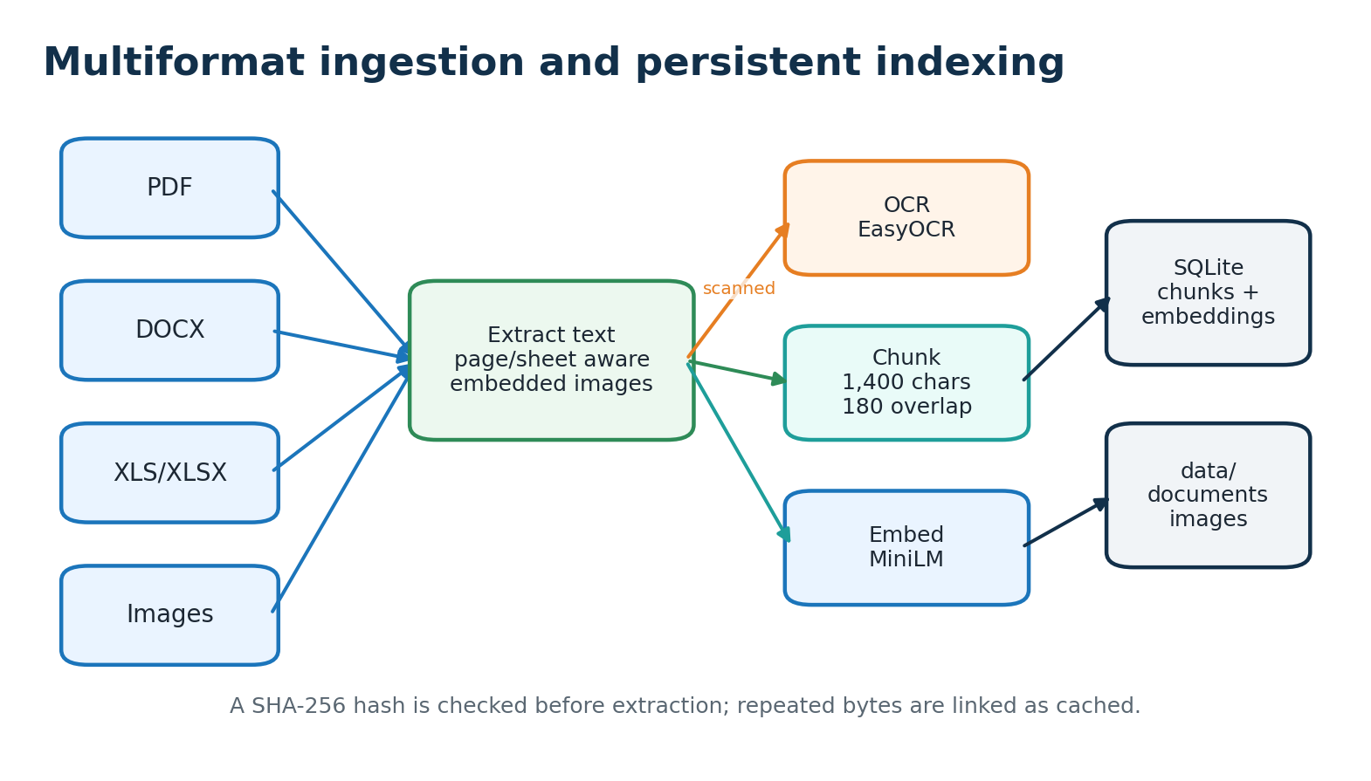
Figure 3. Ingestion pipeline for text, tables, scans and images.
The upload endpoint accepts multiple files in one request, and the browser file input supports selecting an entire folder. The MCP ingest_folder tool recursively scans a folder and passes each supported file through the same ingest_document routine. Unsupported extensions are reported as skipped rather than silently discarded.
PDF text is extracted page by page. DOCX paragraphs and tables are read from the package structure. Excel workbooks are converted to a readable representation for each sheet. Embedded media is extracted from PDF, DOCX and XLSX packages, retained under the data/images directory, and associated with its source document.
Input | Extraction result | Stored evidence
PDF | Page text; rendered-page OCR when text is absent | Original PDF, chunks, images
DOCX | Paragraphs and table rows | Original DOCX, chunks, embedded images
XLS/XLSX | Sheet name plus tabular text | Original workbook, chunks, media
Raster image | OCR text where available | Original image, OCR text, image URL

OCR and image evidence
Making scanned material searchable
Office archives frequently contain scanned pages, diagrams and photographs. When a PDF page has no selectable text, PyMuPDF renders the page and EasyOCR attempts to extract text. Embedded images receive their own OCR pass. OCR text is appended to the relevant page or image context so it can participate in embedding and lexical retrieval.
Images are not reduced to text only. The original extracted image is preserved and returned as a source URL. When a query retrieves a document with images, the service can pass a bounded number of images to the local LLaVA vision model. This allows answers to refer to chart labels, diagram structure or other visual details when the model is installed.
Evidence path | Benefit | Limitation
Native PDF text | Fast and precise for digital documents | Unavailable for image-only pages
Page OCR | Recovers searchable text from scans | Quality depends on resolution and layout
Image OCR | Finds labels and captions inside figures | May miss handwriting or complex diagrams
Vision model | Adds visual interpretation | Requires more RAM and model storage
For a controlled deployment, OCR models should be downloaded during preparation and copied with the offline bundle. At runtime, EasyOCR is configured with download_enabled=False, preventing accidental internet access.

Embedding and indexing
Turning documents into reusable vectors
After extraction, text is normalized and divided into chunks of approximately 1,400 characters with 180 characters of overlap. Chunking prevents very long documents from overwhelming the context window while keeping enough local continuity for technical explanations. Each chunk is encoded by the all-MiniLM-L6-v2 sentence-transformer model and stored as a normalized float32 vector.
The vector is stored as a SQLite BLOB alongside document ID, page number and chunk text. At query time, the selected notebook's rows are loaded into an in-memory matrix. Because vectors are normalized, a matrix multiplication provides cosine similarity without a remote vector service.
Index field | Purpose
document_id | Links chunks to original file and notebook membership
page | Preserves page or sheet provenance
text | Evidence supplied to lexical search and Ollama
embedding | Dense semantic representation
embedding_dim | Records vector shape for safe decoding
chunk_fts | SQLite FTS5 mirror for exact term retrieval
The embedding model is loaded once at application startup when PRELOAD_EMBEDDING_MODEL is enabled. This removes the model-load penalty from the first user query and is a direct optimization for demonstrations and repeated use.

Hybrid retrieval and speed
Combining meaning with exact terms
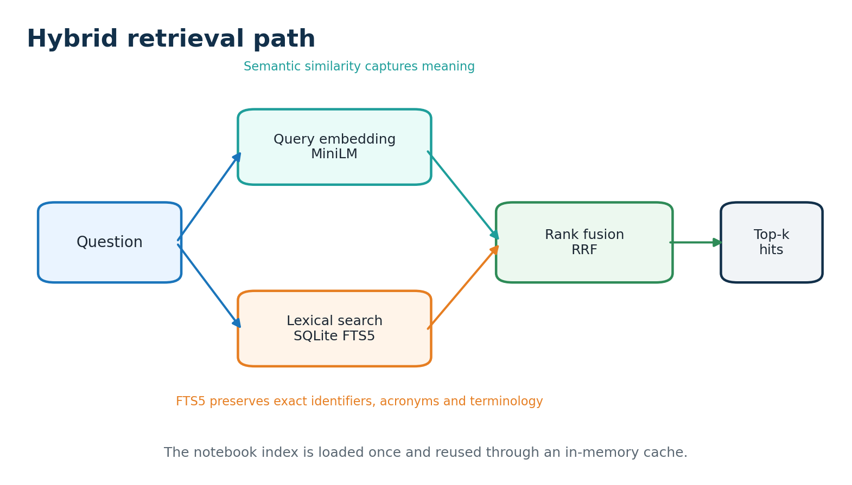
Figure 4. Retrieval uses complementary semantic and lexical signals.
Dense retrieval is effective when the question and source use different wording. Lexical retrieval is valuable for exact identifiers, acronyms, filenames and scientific notation. The service retrieves candidates from both paths and applies reciprocal-rank fusion (RRF): each result contributes 1/(60 + rank), and the combined score determines the top-k passages.
Two implementation choices reduce latency. First, the notebook embedding matrix is cached in memory and invalidated only after ingestion. Second, Ollama receives only the selected passages rather than the entire database. The API response exposes retrieval and answer timings separately, making it possible to demonstrate that model generation is usually the longer phase.
Optimization | Effect
In-memory notebook matrix | Avoids repeated SQLite BLOB decoding for every question
FTS5 candidate search | Fast exact-term filtering using SQLite's native index
RRF fusion | Combines signals without collection-specific score calibration
Top-k and context limits | Bounds prompt size and model latency
Keep-alive | Keeps the Ollama model loaded between questions

Answer generation and image-aware QA
Evidence-grounded local responses
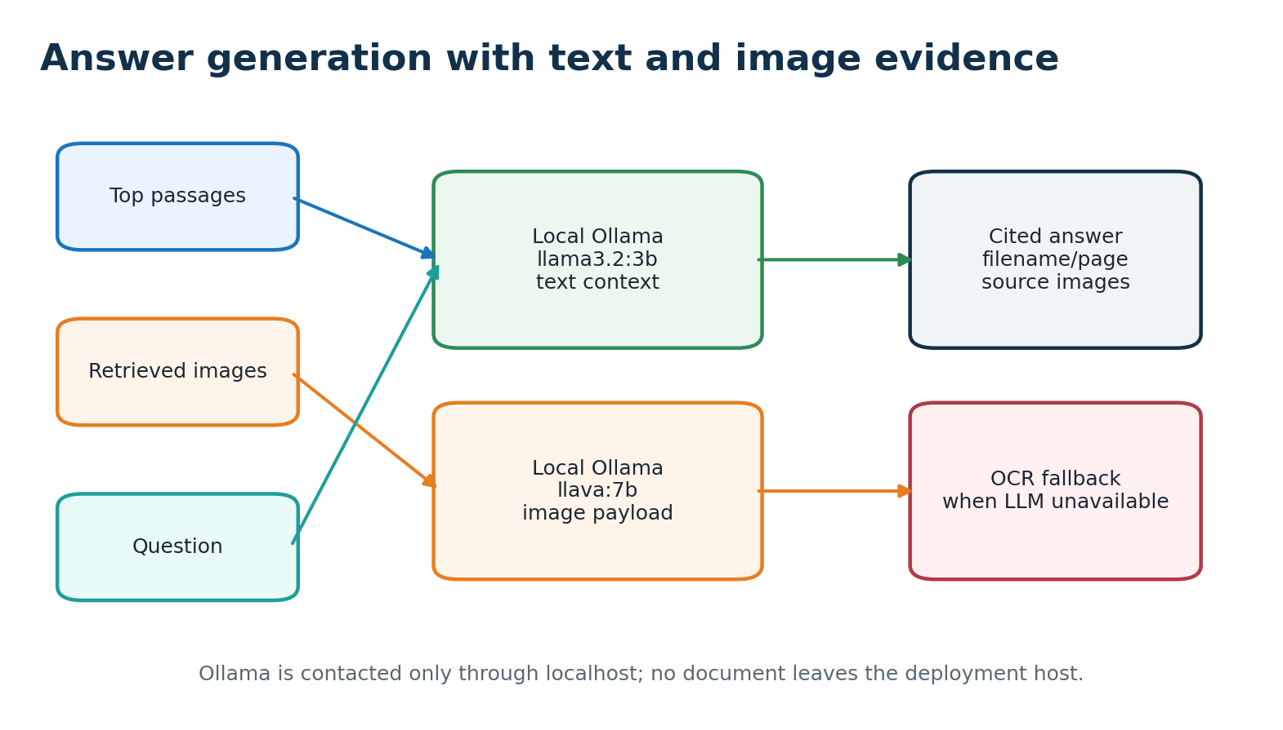
Figure 5. Text and visual evidence share the same local answer path.
The answer prompt instructs the local model to use only supplied notebook sources, cite filename and page where available, and state when the evidence is insufficient. The text model is llama3.2:3b by default. If images are attached to the retrieved sources, the application selects llava:7b as the vision model and includes up to MAX_VISION_IMAGES images.
If the Ollama request fails, the service does not return an empty response. It uses extractive_fallback to list the strongest indexed passages with source filenames and page numbers. This preserves useful search behavior during model startup, low-memory conditions or a temporarily stopped Ollama process.
Mode | Default model | Use case
Text answer | llama3.2:3b | Technical questions over retrieved passages
Vision answer | llava:7b | Questions involving retrieved diagrams/images
Fallback | None | Evidence display when Ollama is unavailable

Notebook model and information organization
Topic-scoped collections
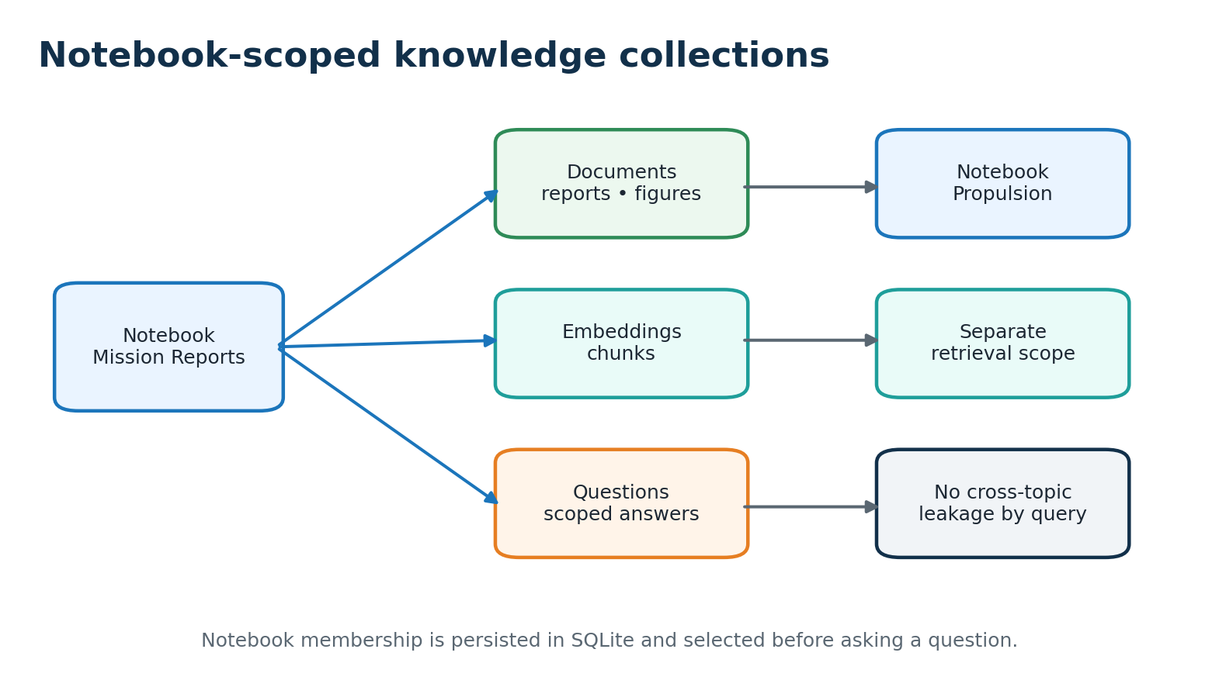
Figure 6. Notebook membership limits retrieval to the selected topic.
A notebook is a named collection such as Mission Reports, Propulsion or Finance. Documents are linked to notebooks through a join table rather than copied, so one file can belong to multiple collections without duplicate storage. Questions always include a notebook ID, and retrieval joins chunks through notebook membership before ranking.
This scope is important in a lab with multiple projects. It reduces unrelated hits, makes source lists easier to review and establishes the boundary needed for future access control. The browser interface exposes notebook creation, file selection, indexing and question asking in one flow.
User action | Persistent result
Create notebook | Unique notebook row with creation time
Select files/folder | Membership links plus indexed document records
Ask question | Top passages and images from only that notebook
Add files later | Existing bytes cached; new/changed bytes indexed

Deduplication and incremental updates
Why documents do not need to be uploaded again
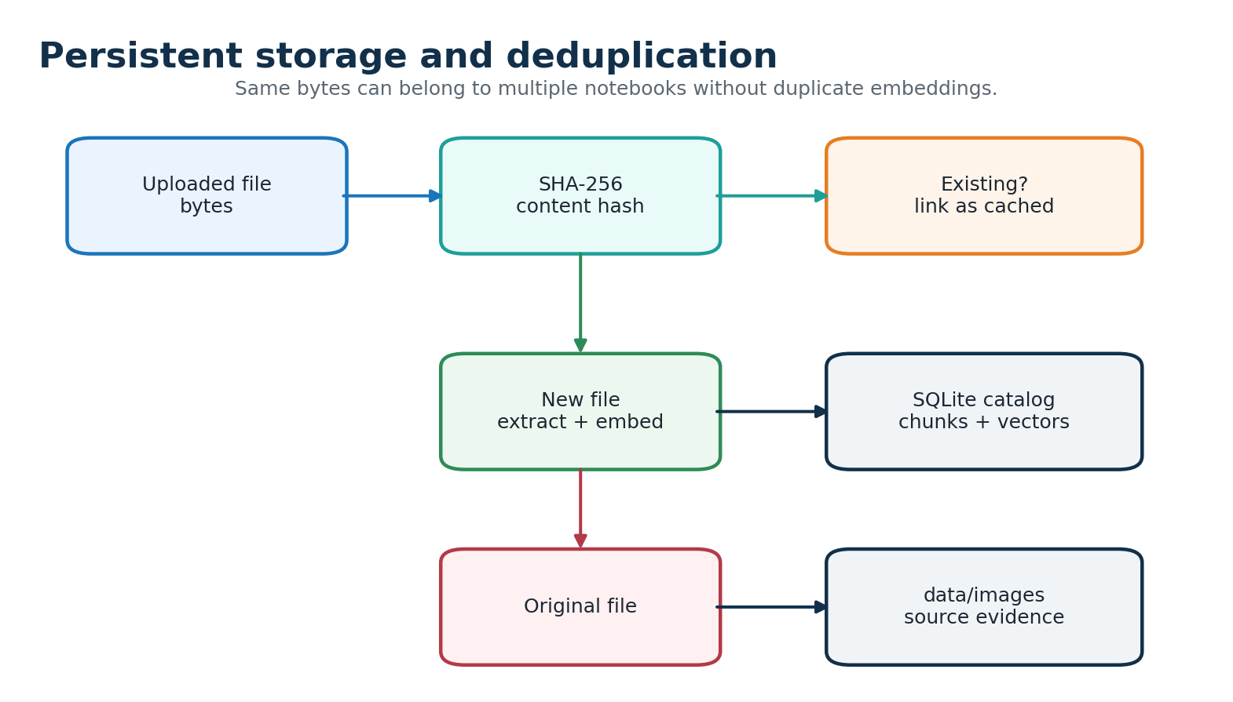
Figure 7. SHA-256 controls one-time extraction and embedding work.
Each upload is hashed before extraction. If the digest already exists, the service inserts a notebook membership link and returns status cached. It does not repeat OCR, chunking or embedding. If a file changes by even one byte, it receives a new digest and is indexed as a new version. This behavior is deterministic and avoids relying on filenames alone.
The persistent data directory contains knowledge.sqlite3, original documents and extracted images. Docker mounts it through rag_data; native deployment keeps it under the repository's data directory. Restarting services, rebuilding the application image or rebooting the host does not remove the catalog. The project explicitly warns against docker compose down -v because it deletes the volume.
Scenario | Expected status | Embedding work
Same file, same bytes | cached | None
Same file, modified bytes | indexed | Once for new hash
Same file added to another notebook | cached/link | None
New supported file | indexed | Once
Unsupported extension | skipped | None

Knowledge graph design
Current relationship model and proposed extension
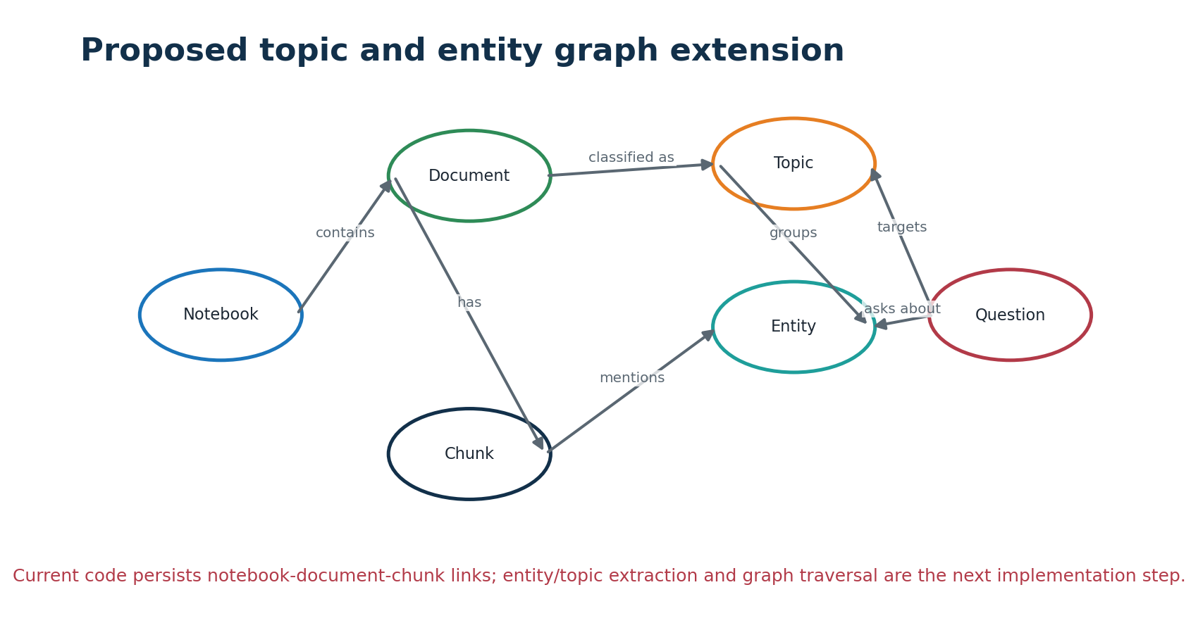
Figure 8. Proposed topic/entity graph layered over the current index.
The current code already stores useful graph-like relationships: notebooks contain documents; documents produce page- or sheet-aware chunks; chunks can be associated with extracted images. These links are sufficient for notebook scoping and source traceability, but they are not yet a standalone entity graph with nodes, typed relations or graph traversal.
A future graph layer should extract entities such as missions, spacecraft, sensors, locations, dates, organizations and technical parameters. It can create Topic, Entity, Relation and Mention tables in SQLite or a local Neo4j deployment. The graph should be built asynchronously after indexing so a slow extraction step does not block basic search.
Graph element | Example | Retrieval use
Topic | Trajectory prediction | Topic filter and related-topic expansion
Entity | LEO, ISRO, orbit number | Exact entity matching
Relation | mission uses sensor | Multi-hop context
Mention | chunk 184 mentions LEO | Evidence link back to source
Graph-aware ranking can add a small score bonus when a retrieved chunk is connected to the question's entities or topic. The dense-plus-FTS5 path should remain the fallback because it is already local, simple and fast.

API, web interface and MCP
Ways users and tools interact with the system
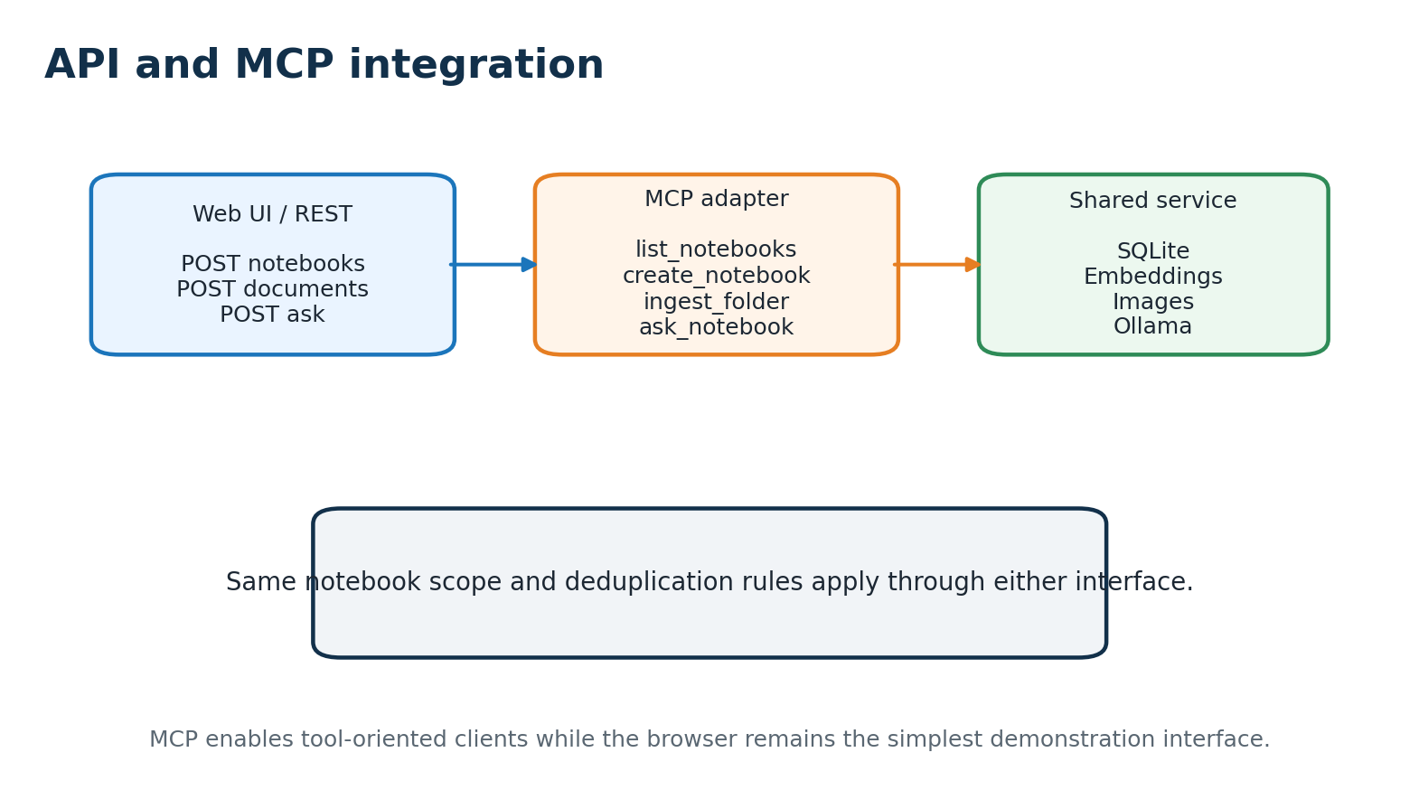
Figure 9. REST and MCP share the same persistence and retrieval implementation.
Endpoint/tool | Purpose
GET /health | Service state and counts for notebooks, documents and chunks
GET /api/notebooks | List notebooks and document counts
POST /api/notebooks | Create a named notebook
POST /api/notebooks/{id}/documents | Upload files for indexing
POST /api/notebooks/{id}/ask | Retrieve, answer and return sources/images
MCP ingest_folder | Recursively index a local folder
MCP ask_notebook | Ask through a tool-enabled client
The web UI is intentionally lightweight so it can be served by the API without a separate frontend build. It supports folder selection through the browser's directory input, displays indexing status and lists sources in the answer. Swagger at /docs is useful for integration testing and for demonstrating request/response shapes to a guide or deployment team.

Deployment architecture
Single PC first, lab server next
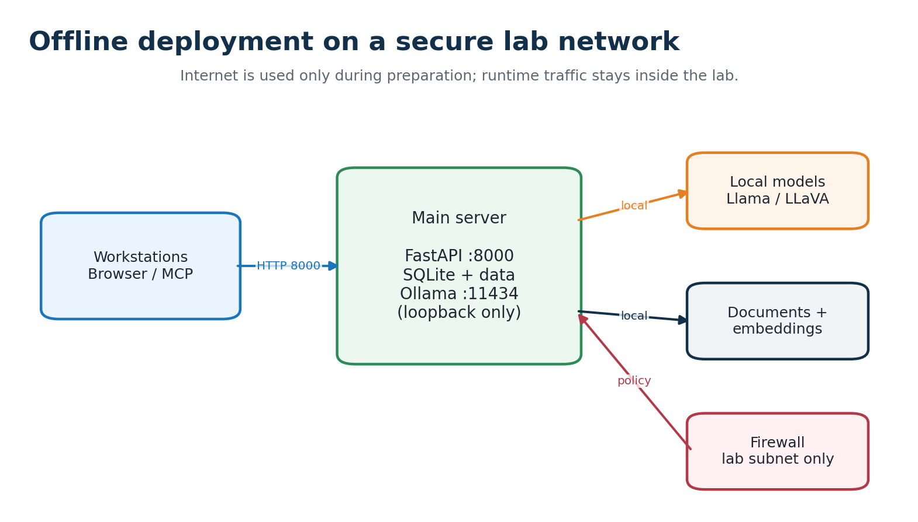
Figure 10. Recommended trust boundary for a lab deployment.
The simplest demonstration uses native Python and Ollama on one PC. This avoids Docker Desktop, WSL and Hyper-V, and is the recommended path when the host must be prepared quickly. The connected preparation machine downloads Python packages, embedding/OCR weights and Ollama models. The target machine receives the source, wheel bundle, model directories and optional data directory.
Docker Compose is also supported for Ubuntu and Windows Docker Desktop. The rag container serves port 8000, while Ollama is bound to 127.0.0.1:11434. Named volumes retain application data and model files. For a later lab rollout, bind only the API to the server interface, allow port 8000 from the approved subnet, and keep Ollama inaccessible to workstations.
Deployment mode | Best use | Persistence
Native Python + Ollama | Fast demonstration; no Docker/WSL | data/ and models/
Docker Compose | Repeatable Ubuntu/server deployment | rag_data and ollama_models volumes
Lab server | Multiple trusted workstations | API on subnet; Ollama loopback

Offline installation and operations
Preparation once; runtime without internet
A reproducible offline bundle should include the repository source, operating-system-specific wheel files, the Python installer, the Ollama installer, embedding and OCR model directories, and optionally the pre-existing data directory. A virtual environment must be rebuilt on the target operating system; copying a Windows environment to Ubuntu or vice versa is unsafe.
Stage | Windows native example | Ubuntu native example
Prepare environment | .\scripts\setup_native.ps1 | ./scripts/setup_native.sh
Start Ollama | .\scripts\run_ollama.ps1 | ./scripts/run_ollama.sh
Pull models | ollama pull llama3.2:3b; ollama pull llava:7b | same commands
Start API | .\scripts\run_native.ps1 | ./scripts/run_native.sh
Verify | curl.exe http://127.0.0.1:8000/health | curl http://127.0.0.1:8000/health
After verification, disconnect the target from the internet. Do not run pip install, ollama pull or Docker build on the isolated machine. Normal operation consists of starting Ollama, starting FastAPI, selecting a notebook, indexing new material and asking questions. Back up data/ or the Docker data volume while services are stopped.
The first indexing operation can be CPU-intensive because it performs extraction, OCR and embedding. Later questions benefit from the warm embedding cache and warm Ollama model. The README includes Windows, Ubuntu, Docker and no-WSL paths for the guide to reproduce the deployment.

Security, privacy and operational controls
Controls for a secure office
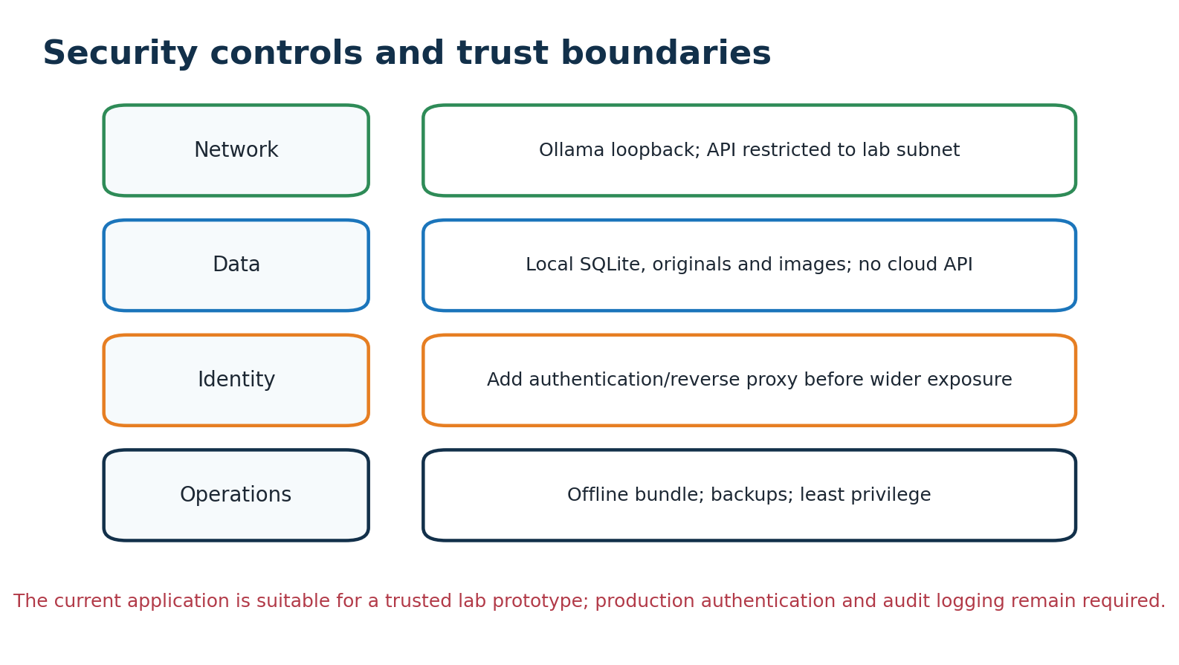
Figure 11. Security controls mapped to the local trust boundary.
The project is designed to keep document content inside the deployment host. The runtime makes no cloud API call; the only model request is to the local Ollama service. The default API and Ollama bindings are loopback-only. When network access is required, the administrator should expose only port 8000 to a known lab subnet and keep 11434 private.
Risk | Current mitigation | Required hardening before production
Unauthorized API access | Loopback default; subnet firewall guidance | User authentication, HTTPS, role policy
Sensitive backups | Local volumes and explicit backup guidance | Encrypted backups and access control
Prompt/source leakage | Local models and notebook scope | Audit logs and per-user authorization
Model supply chain | Offline model directories after preparation | Checksum and approved model registry
Resource exhaustion | Top-k/context limits | Upload size limits, quotas and monitoring
The current system should be treated as a trusted-lab prototype until authentication, authorization, audit logging and formal backup controls are added. This boundary is stated explicitly so deployment decisions remain evidence-based.

Performance and scalability
How to make retrieval faster
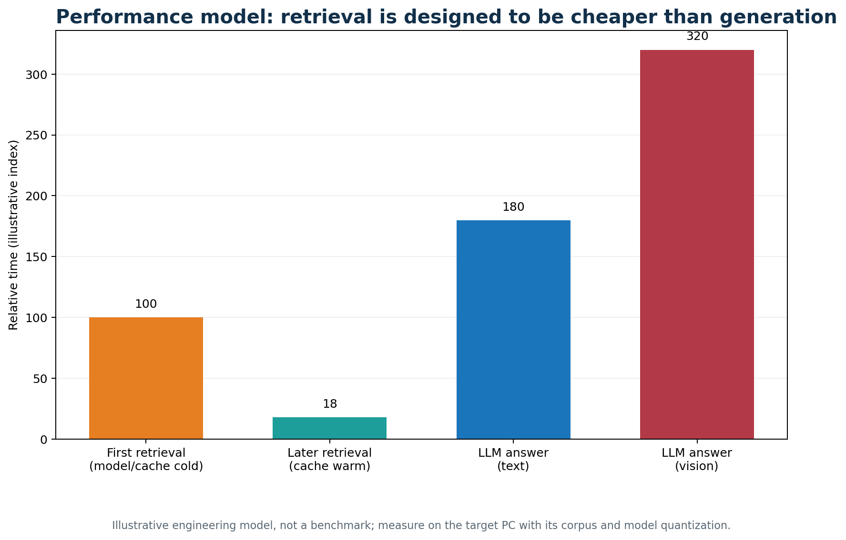
Figure 12. Illustrative timing model; measure on the target hardware.
The architecture places optimization effort where it has the most impact. Retrieval uses a cached in-memory matrix and FTS5, while generation is bounded by model context and token limits. The API reports retrieval and answer timings separately, allowing a proper demonstration benchmark rather than relying on subjective response speed.
Measurement | Method | Success signal
Index throughput | Files/minute by format and size | Stable incremental ingest
Warm retrieval | Repeated questions after cache warm-up | Low retrieval_ms
Answer latency | Text vs vision model timing | Model choice matches hardware
Cache reuse | Repeat same upload | cached; no new chunks
Corpus growth | 1k/10k/100k chunks | Know when SQLite needs replacement
For larger collections, the next performance steps are a persistent approximate-nearest-neighbor index, batch embedding during ingestion, background graph extraction, and a bounded per-notebook cache. SQLite remains appropriate for an initial single-server corpus because it keeps deployment simple and offline.

Validation, limitations and future work
What is verified and what remains
Area | Current verification | Remaining work
Code integrity | Python compilation succeeds for main.py and mcp_server.py | Automated CI test suite
Persistence | Schema, hashes, volumes and README workflow reviewed | Run full corpus test on target PC
Retrieval | Hybrid semantic/FTS5 implementation present | Collect latency baseline with real documents
Images | OCR extraction and source URLs implemented | Evaluate difficult diagrams and handwriting
Offline | Native and Docker instructions provided | Rehearse transfer bundle with no network
Knowledge graph | Notebook/document/chunk links available | Entity/topic/relation extraction
Security | Loopback defaults and firewall guidance | Authentication, HTTPS and audit trail
The main limitation is that the current baseline is a document RAG service rather than a completed knowledge graph platform. It can be made graph-aware without discarding the existing index: extract entities from chunks, persist typed edges, and add graph features to candidate generation and ranking.
Recommended next milestones are: (1) implement a graph schema and entity extraction job; (2) add login and notebook permissions; (3) add a benchmark command that records indexing and retrieval timings; (4) introduce background workers for large folder imports; and (5) add encrypted, tested backup and restore procedures.

Conclusion and guide discussion
A practical foundation for secure offline document intelligence
Offline Notebook Document QA provides a practical first deployment for a secure office: it accepts common files and folders, embeds them once, preserves evidence, retrieves quickly within a selected notebook, returns image sources, and uses local Ollama models for grounded answers. The same persistent data model supports a browser, REST clients and MCP tools.
The implementation is intentionally modular. The current SQLite and hybrid retrieval path is small enough to deploy on one PC and transparent enough to validate. A future knowledge graph can be layered on top of the same document, chunk and notebook identifiers, adding topic navigation and multi-hop retrieval without requiring cloud services.
Decision for guide review | Recommended question
Demonstration hardware | Is the target PC sufficient for llama3.2:3b and optional llava:7b?
Corpus boundary | Which notebooks and file types should be tested first?
Security boundary | What subnet, authentication and backup policies apply?
Graph scope | Which entities and relationships matter to the lab domain?
Success metric | What retrieval latency and answer quality are acceptable?
Repository and implementation reference: github.com/dhxvxn/URSC_RAG. The accompanying README contains step-by-step native Windows, native Ubuntu, Docker, offline bundle, lab network and troubleshooting instructions.
Prepared for technical review. The report describes the repository state inspected on 10 November 2026 and separates implemented behavior from proposed extensions.

