Game Design Document

Fill up the following document

1. Write the title of your project.

Race Through Space

1. What is the goal of the game?

The goal of the game is to control the main character (the spaceship) and take it along a path in space which has bits of fire lying around. Once the spaceship collects the fire, its gas tank fills up and prevents it from dying. The spaceship must collect all the bits of fire and reach the final destination

1. Write a brief story of your game.

An astrounaut has left Earth to visit the International Space Station and deliver materials. But on his way there, his spaceship gets blown away. He must find his way back by collecting bits of fire and reach the ISS in time to deliver the materials.

1. Which are the playing characters of this game?

* Playing characters are the ones who respond to the user based on the input from the user.
* Cars, monkeys, dinos, wizards, etc., are the playing characters in the game.

|  |  |  |
| --- | --- | --- |
| Number | Character Name | What can this character do? |
| 1 | Spaceship | It can move left, right, up, down |
| 2 |  |  |
| 3 |  |  |
| 4 |  |  |
| 5 |  |  |
| 6 |  |  |
| 7 |  |  |
| 8 |  |  |

1. Which are the Non-Playing Characters of this game?

* Non-Playing characters are the ones that don't have an action or behavior when the user interacts with the game.
* Hurdles, stones, bananas, coins, etc., are non-playing characters in the game.

|  |  |  |
| --- | --- | --- |
| Number | Character Name | What can this character do? |
| 1 | Fire | It is laid in a trail which leads to the ISS |
| 2 | Alien | It comes in between the spaceship and bits of fire to prevent the spaceship from reaching its destination. |
| 3 | ISS | The final desstination where the spaceship must go, but the alien cannot enter. |
| 4 | Planets | Add to the background |
| 5 |  |  |
| 6 |  |  |
| 7 |  |  |
| 8 |  |  |

Draw your imagination of this game. What does this game look like?

* Draw the game either on your computer or on paper.
* Add images of the game scenes to show each of the playing and non-playing characters at least once.

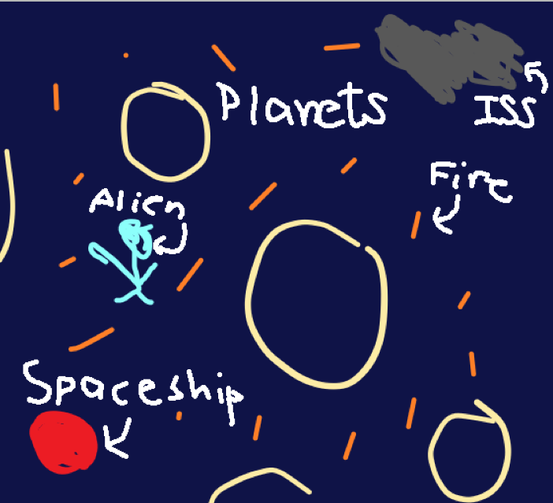

How do you plan to make your game engaging?

I will add sounds to make it lively and I will keep a time limit which keeps the player concentrated on the game.