# Name: Dhyan Kundhadia

**College: SVKM’s NMIMS MUKESH PATEL SCHOOL OF TECHNOLOGY, MANAGEMENT and ENGINEERING**

# SAP ID: 70471019076

**Year: 3rd, Semester: 6th Roll Number: N065**

# INDEX

|  |  |  |
| --- | --- | --- |
| Serial Number | Topic | Page Number |
| 1 | Technology Used | 2 |
| 2 | Prerequisites and Steps to Run | 4 |
| 3 | Output Screenshot of Database | 6 |
| 4 | Output Screenshot of Front End | 9 |

**TECHNOLOGY USED:**

**Visual Studio Code:**

Visual Studio Code is a freeware source-code editor made by Microsoft for Windows, Linux and macOS. Features include support for debugging, syntax highlighting, intelligent code completion, snippets, code refactoring, and embedded Git. We used HTML, CSS, PHP to make the website with the help of this IDE.

* Back End Development:

* We used PHP for backend development to retrieve values from forms and carry out mathematical operations on our page like total cost of products ordered
* Fetching required data from the Database and passing it into the templates for visual purpose like creating tables

* Front End Development:

* Frontend Development involves the code for creating the User Interface (UI).
* The languages that we used for creating it are HTML, CSS and used the Bootstrap framework.
* We created the home screen, the register and login pages, profile pages, nav bar, etc. The primary goal of frontend development is to make the website attractive, responsive, and user-friendly with the help of a simple and elegant UI.

## PHP My Admin:

phpMyAdmin is a free software tool written in PHP, intended to handle the administration of MYSQL over the Web. phpMyAdmin supports wide range of operations on MYSQL and MariaDB.

Frequently used operations are managing databases, tables, columns, users, and relations etc.

These operations can be performed via the user interface, while we still could directly execute any SQL Statement.

## MYSQL Databases:

*MYSQL is a database system used on web and runs on a server.

**Ideal for small and large applications. Fast, reliable, and easy to use.

**Can compile on different platforms (here, platform used is PHP My Admin) Free to use and download

*Developed, distributed, and supported by Oracle Corporation.

## XAMPP for localhost server:

XAMMP is a free and open-source cross-platform we server solution stack package developed by Apache Friends, consisting mainly of the Apache HTTP Server, MariaDB Database, and interpreters for scripts written in PHP and Perl programming languages.

**PRE-REQUISITES:**

* Visual Studio Code
* XAMPP Server
* MYSQL Server

**STEPS TO RUN:**

**Step 1:** Start XAMPP Server and MYSQL Server.

**Step 2:** Connect to MYSQL Database from localhost/phpMyAdmin and create a new Database named “attendance”, import file named “attendance.sql” on phpMyAdmin and all the tables will be visible once file is imported.

**Step 3:** Save the downloaded files in “htdocs” folder under “xampp”.

**Step 4:** Open Localhost on your preferred browser and the path is to be specified in address bar of your browser.

**Step 5:** Now, first page will be loaded which is Attendance Records. Here, you can check the attendance records of students in both divisions without logging in the web page. Attendance Records can be fetched via month and date field and roll number field. It will show a tabulated format of student name and roll number, total days classes were held, number of present days and number of absent days.

**Step 6:** Then, to mark attendance or add/remove students, two pages have been created (“markatt.php” and “add_remove.php”). To access these pages, professor login is required. Once, login is clicked from the navbar, it will redirect to login page where following credentials will help you to get logged in and mark attendance.

### LOGIN CREDENTIALS:

**Email:** [**dhyan@gmail.com**](mailto:dhyan@gmail.com)

### Password: dhyan16

**Step 7:** Now, on Mark Attendance page, we can select the day, month and year for which attendance is to be marked. Then, the division will be chosen for which attendance is to be marked. The show students’ button will show all the students present in the given division and a sliding button is enabling us to set their status as Present and Absent Students. Once attendance is marked for a day, it cannot be changed. Then pressing mark attendance button will update the records in the database.

**Step 8:** On Add/Remove Student Page.

For adding student, we can input student name and choose which division he/she is to be added via a radio button. Pressing the add student button, he/she will be added to respective division and updates will be shown in database.

Now, for removing student, we can input student roll number and remove student button will show student details like roll number, name, and division and a confirm delete button will be shown. If confirm delete is pressed, student entry from database will be removed and records will reflect in database

**Step 9:** From navbar, if we click on logout, then professor will be logged out of session and can no longer mark or change attendance and can no longer add or remove students from database as well.

# OUTPUTS of Database:

## Student Table Structure:

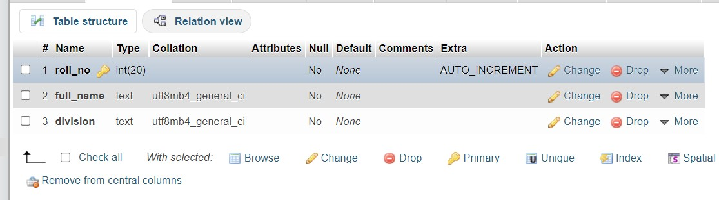

**Student Table with added student details:**

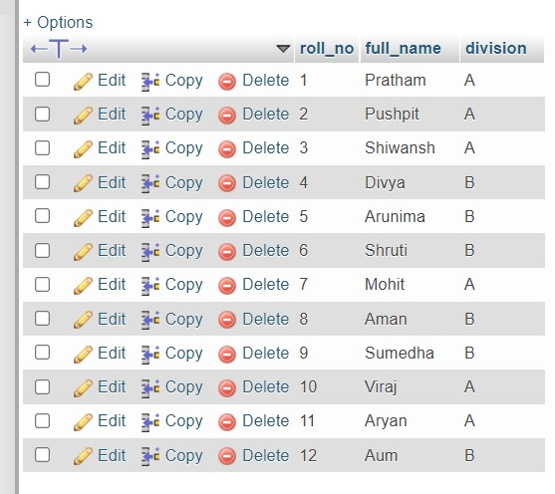

## Student Table with removed student details:

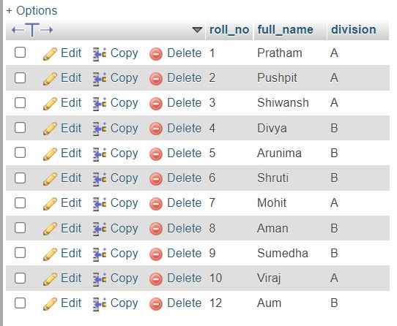

**Professor Table with Details:**

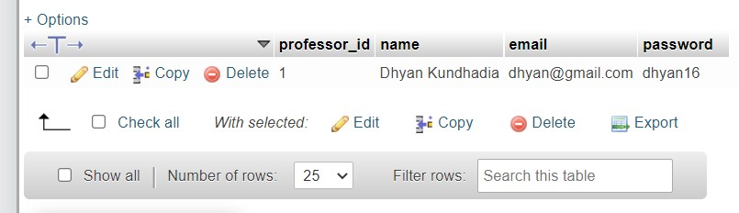

## Attendance Table Structure:

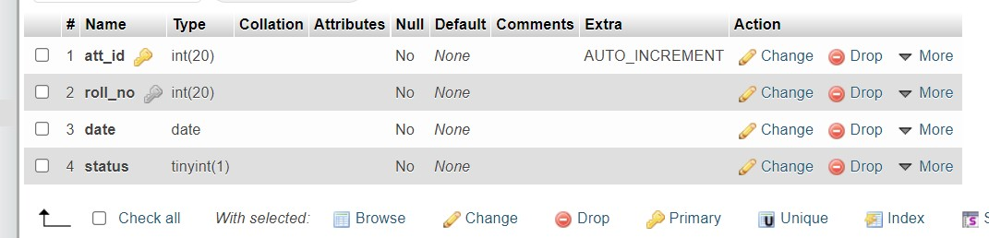

**Attendance Table with Details:**

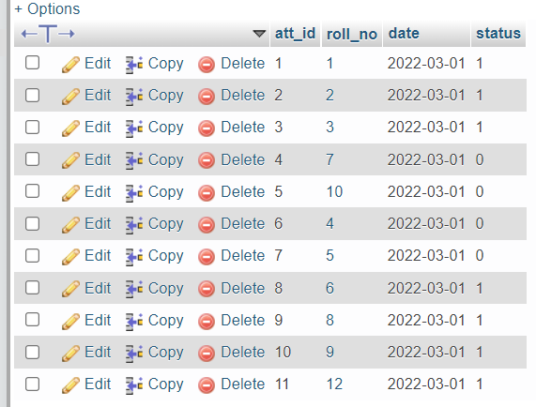

# OUTPUTS of Front End:

## Attendance Records:

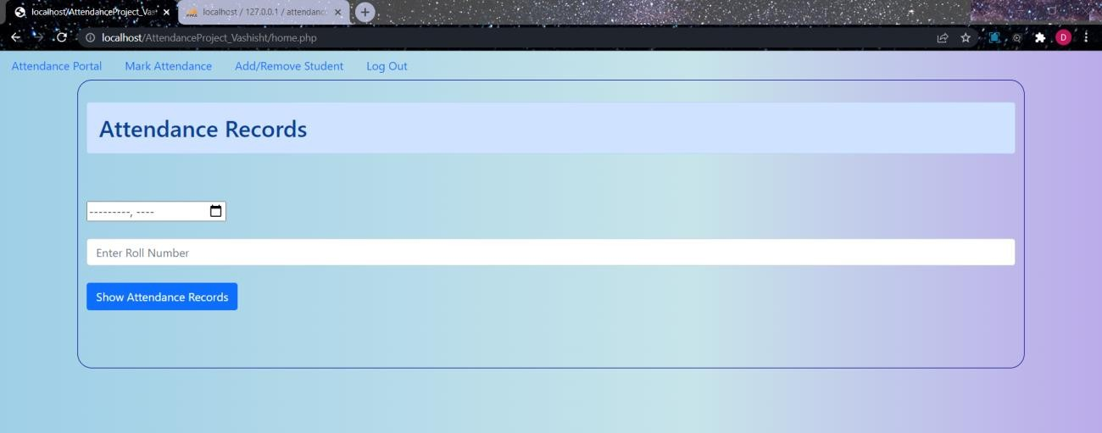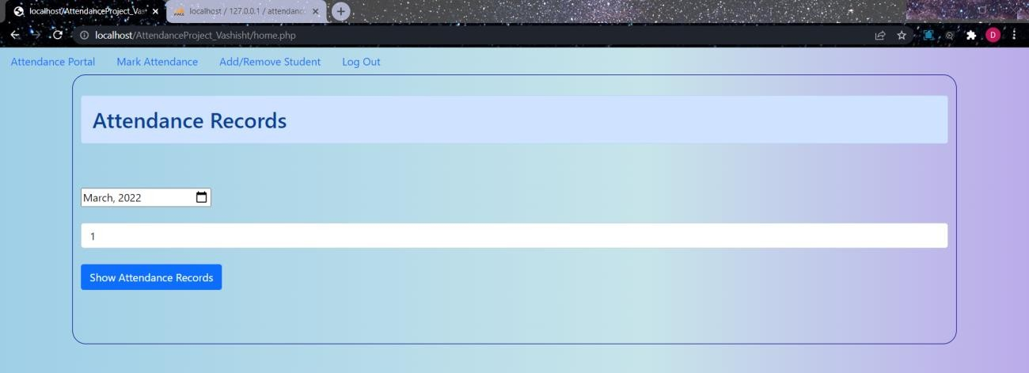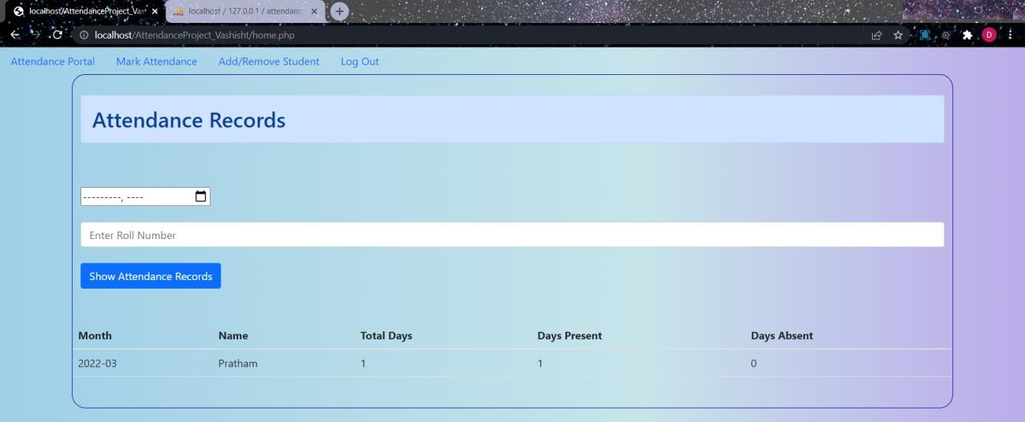

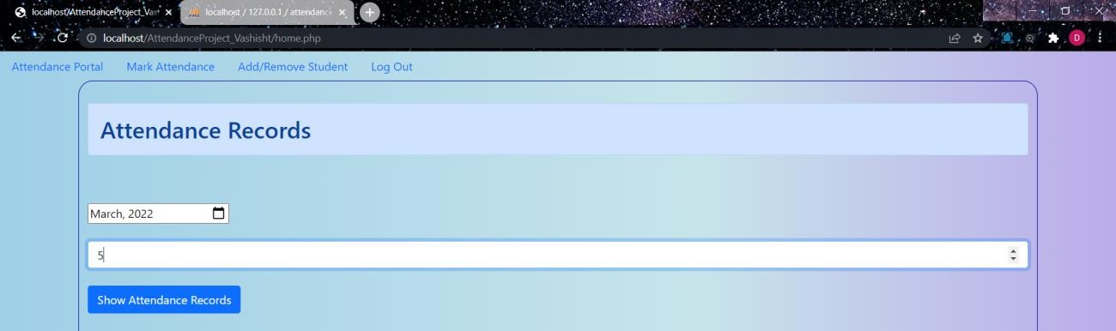

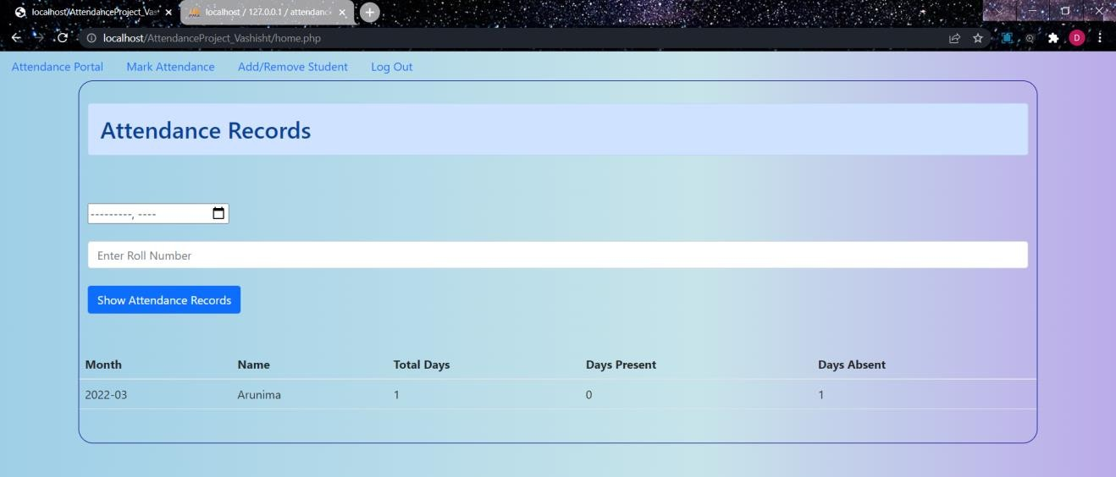

**Login without Credentials:**

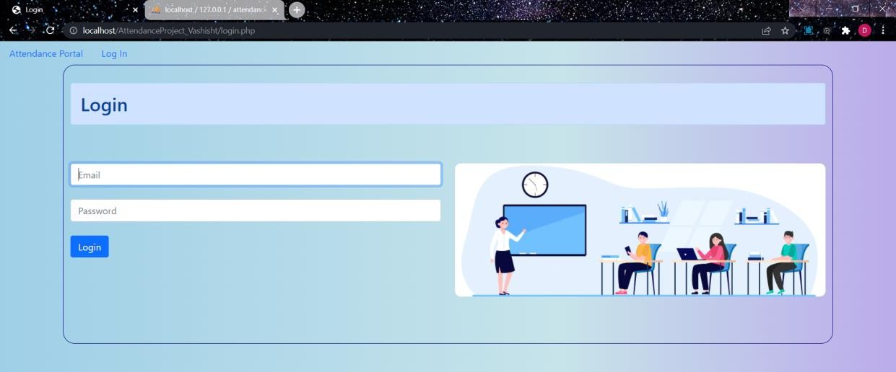

## Login with Credentials:

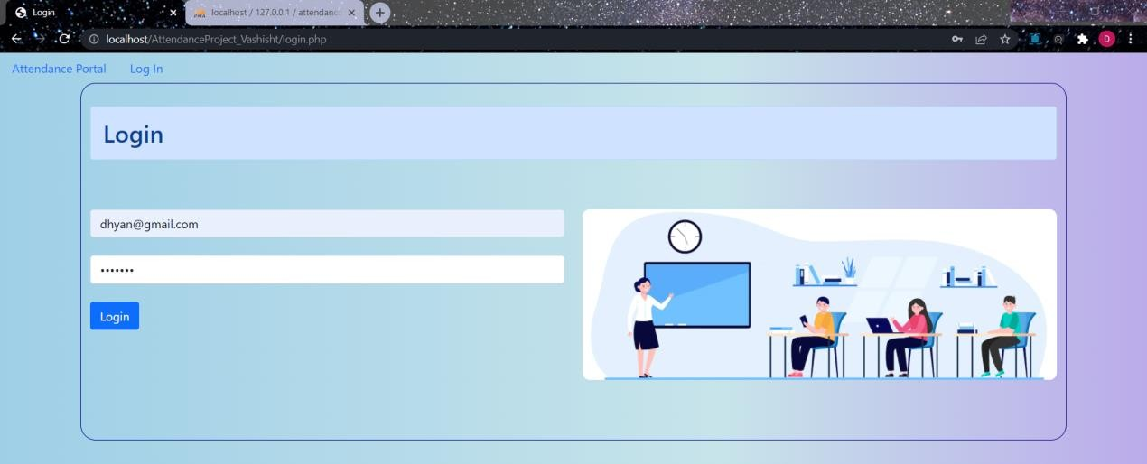

**After Logging in:**

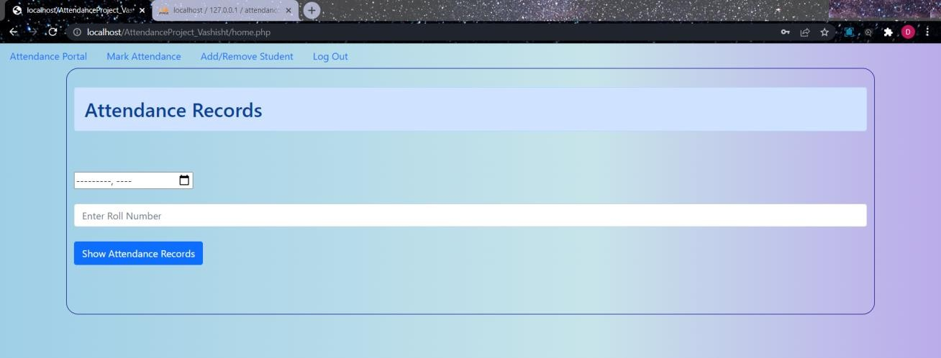

## Mark Attendance:

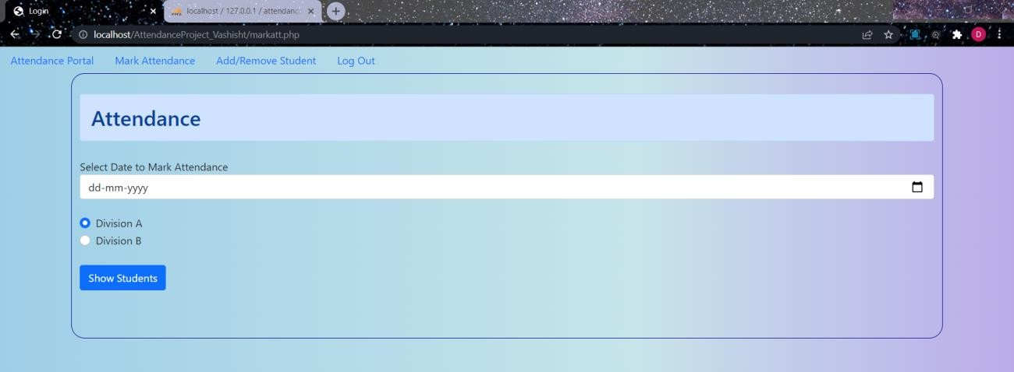

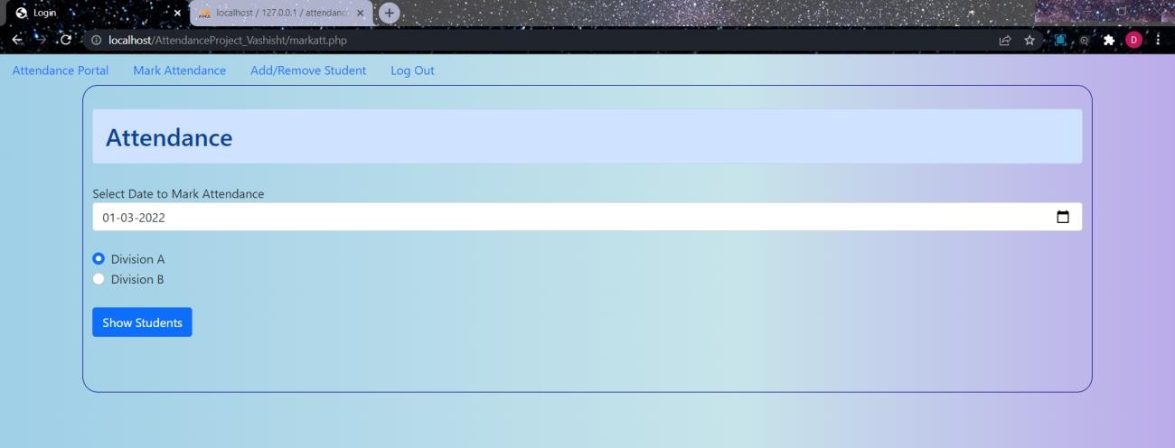

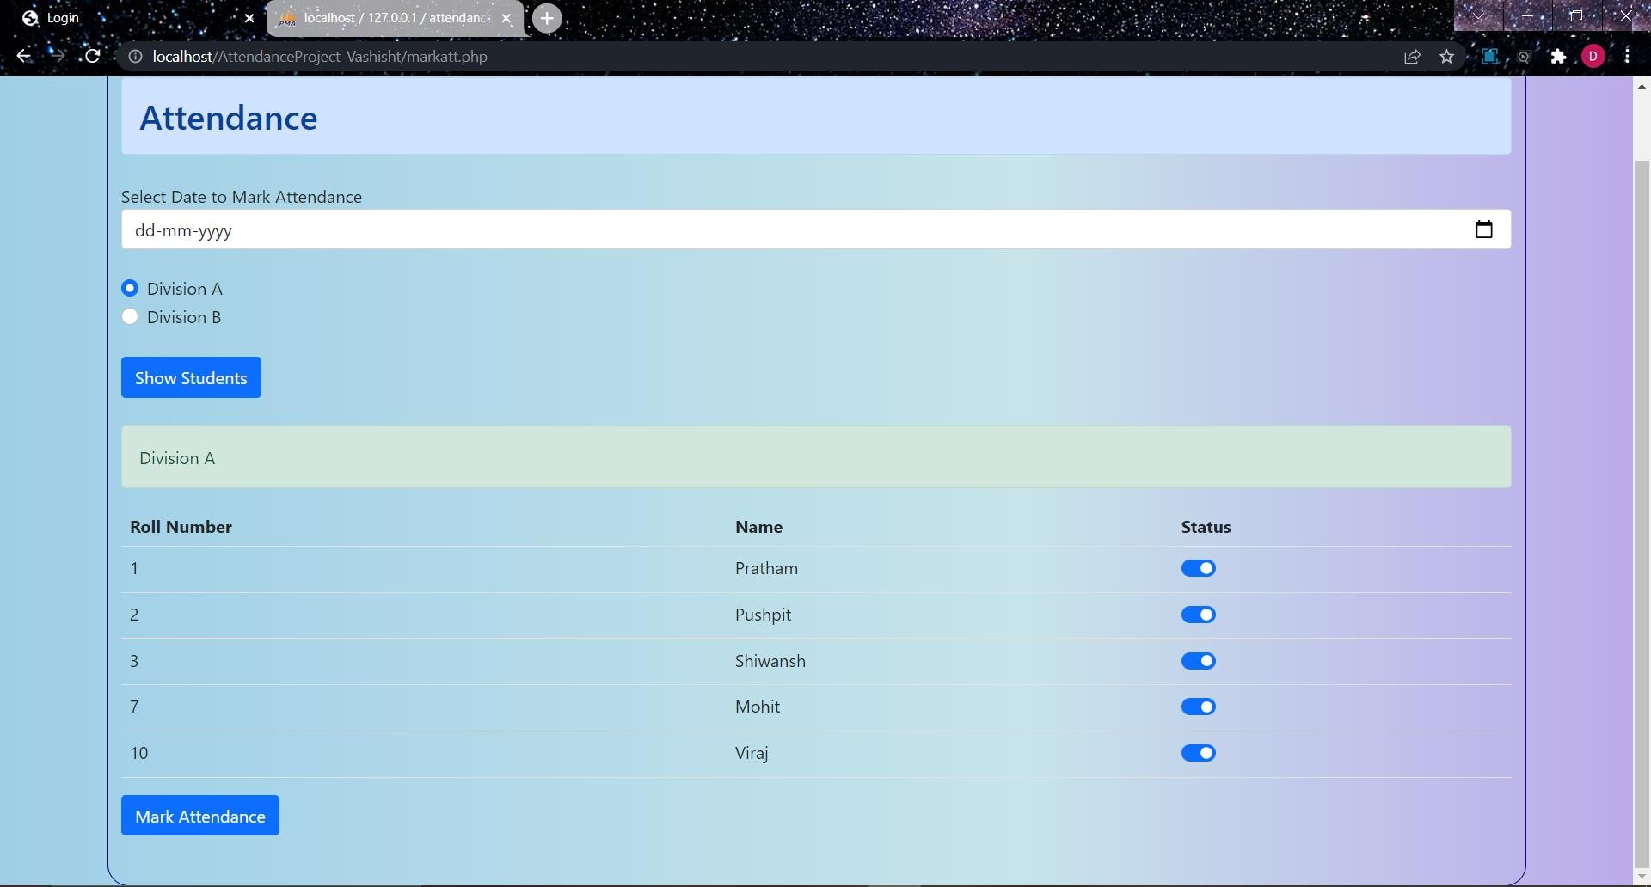

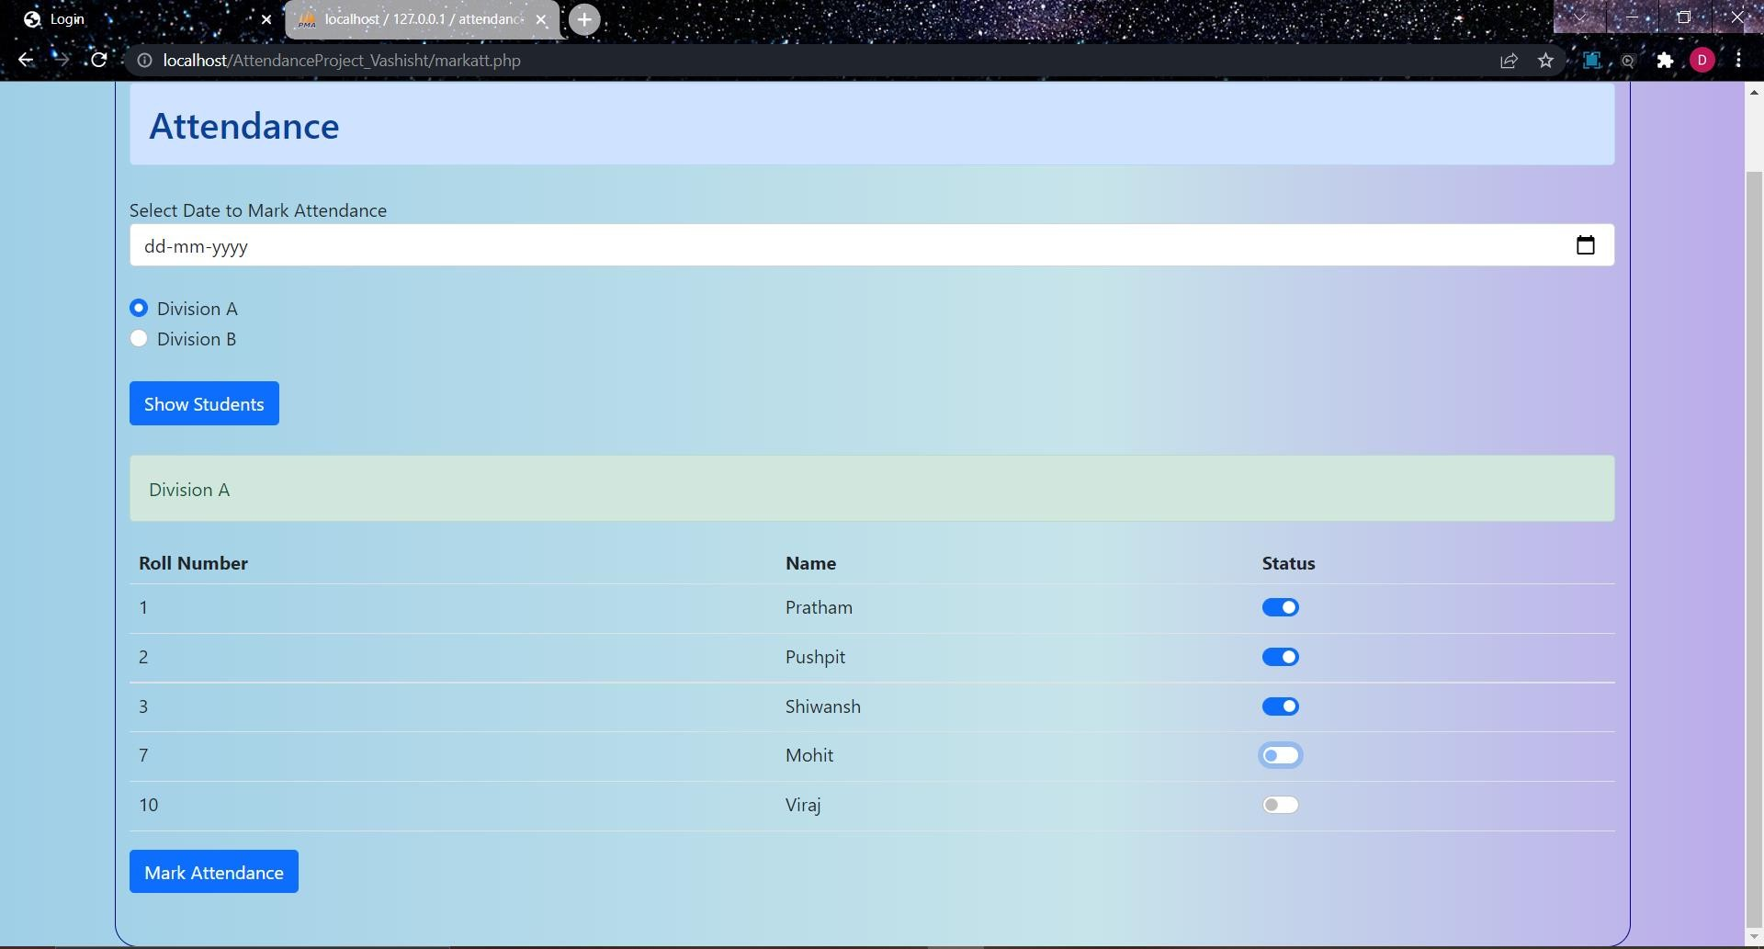

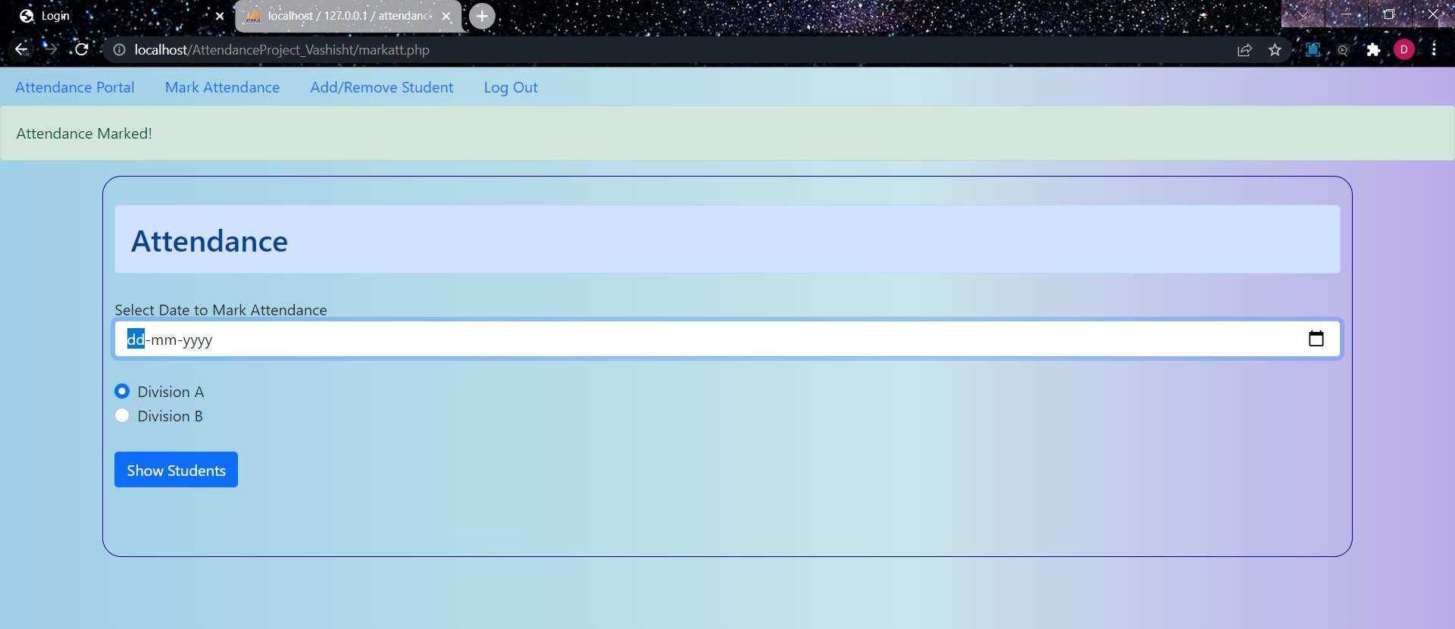

**Add/Remove Students:**

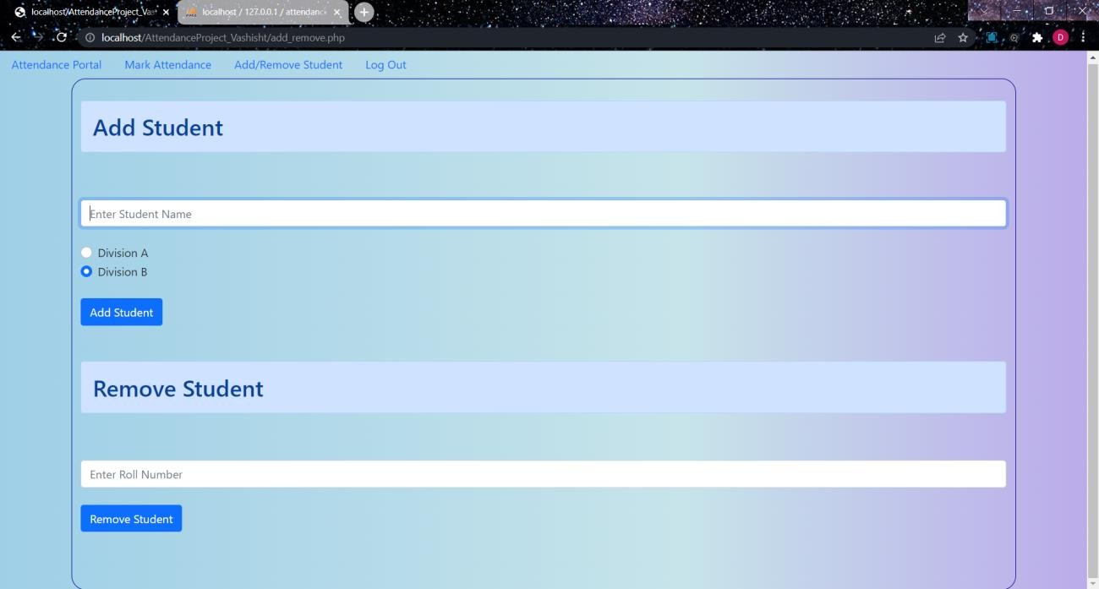

## Add Student:

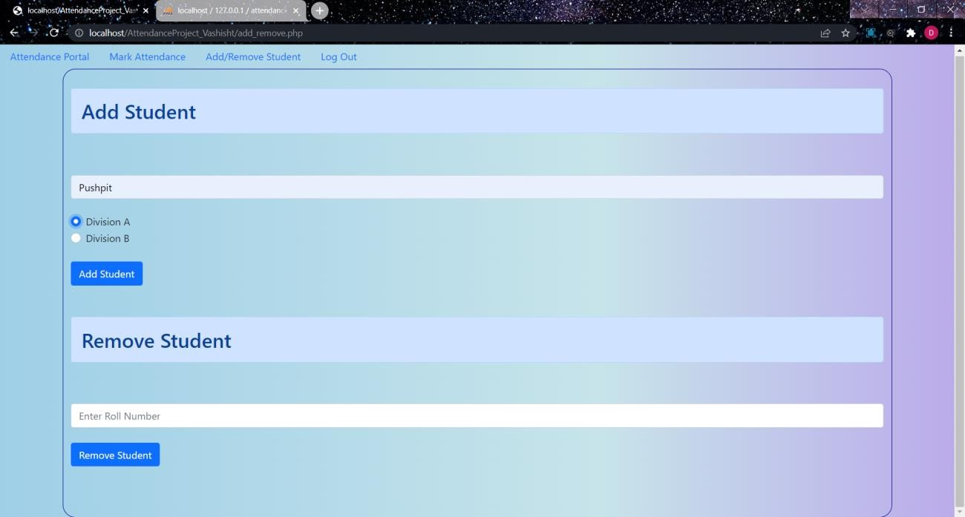

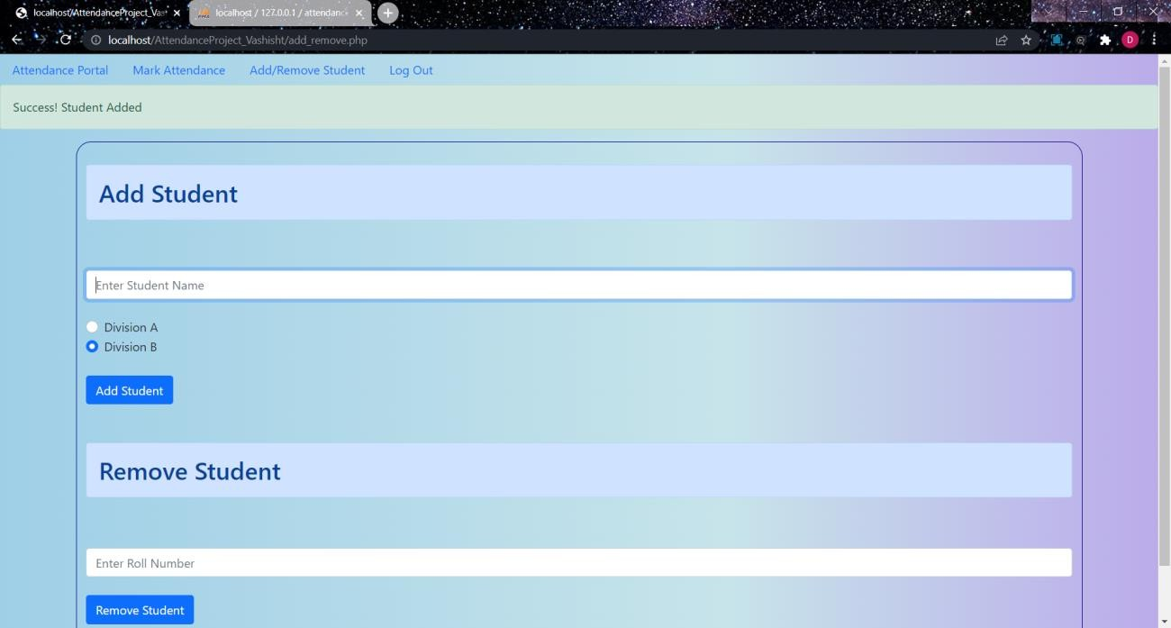

**Remove Student:**

