SuperDoc - Eng Sample Project
📝💬🧪 Visualize document contributions over time
Summary

Using SuperDoc Editor V2, create a full-stack web app that visualizes how collaborative DOCX (with real-time collaboration) content evolves over time and across multiple contributors.

It should especially capture major edit trends/activity volume over time including summarizing what those changes were about and who made the edits. The resulting summary should also be interactive and filterable.

Please bring your own ideas and creativity to this.

Example mock
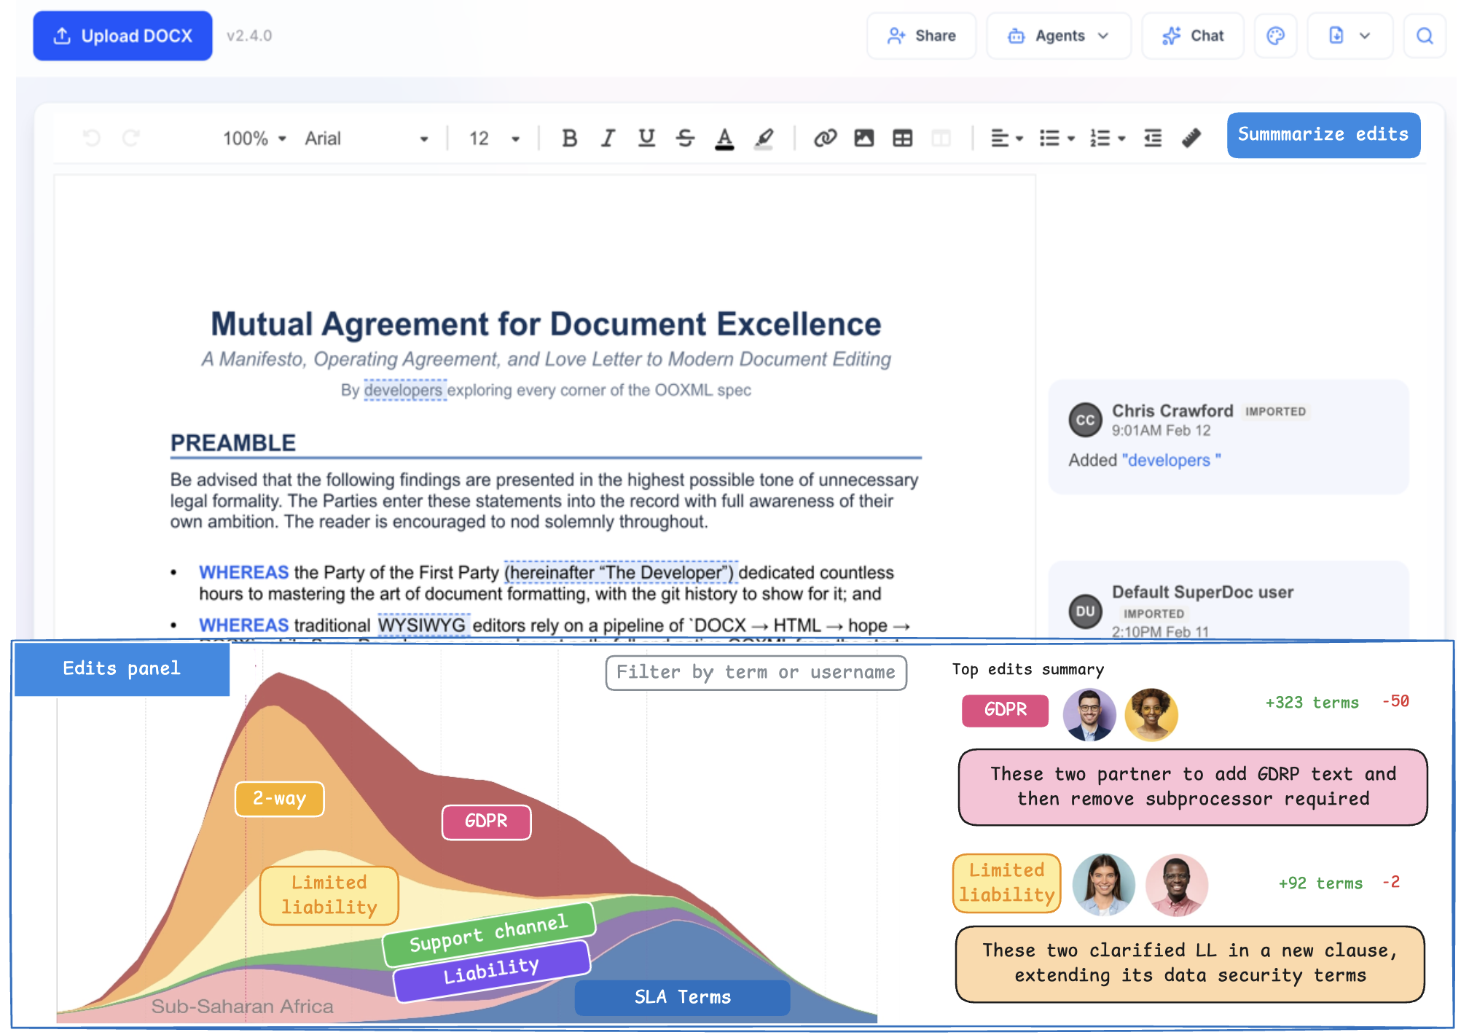
Full image url

Related references
- Wikipedia HistoryFlow
- Charted history of music
- Streamgraphs

Requirements
- At least the day prior to your demo to the SuperDoc team, deliver the following:
  - Send a deployed demo URL to the team
    - This should be functional and the team will test it against their own sample documents
    - You can deploy the demo anywhere you want (e.g., Cloudflare, Cloud Run, Remix, Lambda, Vercel, etc)
  - Also send the code by GitHub link
    - Feel free to make the code public
- Prepare for providing a working end-to-end demo to the team and walking through your demo, code, and approach
- Your web must have a frontend/UX (please use your UI framework of choice [e.g., React, Vue]) and feel free to design your own UX (does not have to perfectly reflect the mocks)
- The web app should use your JS-based environment of choice (e.g., Node, Bun, Deno, etc)
- It is great to use an LLM (e.g., Cursor, Antigravity, Claude Code, OpenAI Codex, Gemini CLI) when creating your project code; however, you are responsible for the code and must ensure it both represents clean code and you can fully speak to what it is doing
- Code must be well-structured, well-commented, well-documented, and well-cited
- We can assume that each uploaded DOCX file is <10MB in total size (aka not crazy big)
- At least use the SuperDoc library for reading, showing, updating DOCX content, where applicable
- You can additionally use any other pre-existing JS libraries you want for this project
- Not required, but creating this within Docker is a bonus (as it makes it easy to run locally/test it out)
- Do not utilize any third-party managed services/APIs (i.e., do not send data to other companies) for this project, with the exception of using LLM providers (e.g., Claude, Gemini, ChatGPT)
- Written code for this project (other than imported libraries) must be original by you and not provided/subcontracted/owned by another company, contractor, or copied from any undisclosed source
- If you used any starter code (e.g., from a template or LLM), please cite this in your README and be prepared to demo your process (cursor workflows, CLI prompts, creating .md plans etc)
- Optionally, after deliver, feel free to open source the result if you want (e.g., add work sample to own GitHub/portfolio)

Related research
*Why do we do a take-home work sample project? --> nice research review article

Out-of-scope
- No need to support non-DOCX documents (aka PDF)
- No need to support document image/illustration/drawing changes
- No need to support extreme documents (aka 500MB docx)
- No need to create a presentation/slides (we can just talk and review the UX and then the code together)
- No need for real user authentication (e.g., SSO/Oauth2 integration)

Success
- Great code delivered on time (at least the day before the presentation)
- Don’t rush the UX (common mistake) – make sure the UX is thoughtful and very much user-centric
- Well-presented demo/walkthrough of your work and approach
- Engaged team discussion – with openness, curiosity, clarity, and energy

