MediPath AI: Intelligent Healthcare Navigation & Clinical Guidance System
Final-Year B.Tech Capstone Technical Handbook & Operations Reference (Version 5.0 Final Release)
Model 2.0 In-Memory Engine · Multilingual Triage · 924 Hospital Registry
Project Attribute | Official Specification & Repository Evidence
Project Title | MediPath AI: Intelligent Healthcare Navigation & Symptom Guidance
Academic Context | Final-Year B.Tech Capstone Project (Engineering & Computer Science)
Software Release | Capstone Version 5.0 (Complete Production Final Build & Operations Handbook)
Primary ML Engine | MedP_AI_V2.0 (In-Memory Node.js Closed-Form Sigmoid Engine, 56 Classes)
Model Build ID | MedP_AI_V2.0_20261011_221051 (SHA-256 Hash Verified)
Serving Architecture | Zero-Python In-Memory Microsecond Node.js Serving (< 150 µs latency)
Multilingual Scope | English, Hindi (Devanagari & Romanized), Gujarati (Script & Romanized)
Hospital Registry | 924 Verified Facilities across Tier-1, Tier-2, and Tier-3 Indian Cities with Enriched Clinical Specialties
Frontend Framework | React 18.3.1 + TypeScript 5.5.3 + Vite 5.4.1 + Tailwind CSS 3.4.11
Backend Framework | Node.js (v18/v20/v22) + Express.js 4.18.2 REST API Server
Verification Status | 100% Automated Test Pass (41/41 Backend Tests, 35/35 Behavioural, 103/103 Vitest across 17 Suites)
Documentation Date | October 2026 (Updated Master Production Blueprint & Operations Handbook, 23 Blueprints)

[MANDATORY CLINICAL SAFETY NOTICE & INSTITUTIONAL DISCLAIMER]
MediPath AI is a preliminary healthcare navigation, clinical triage support, and care discovery system. It provides symptom-based category suggestions and hospital navigation assistance. It is strictly non-diagnostic and does not replace physical clinical examination, laboratory diagnostics, or professional medical judgment by a qualified doctor. In life-threatening emergencies, patients must immediately contact emergency medical services (112 / 108).

Chapter 1: Project Overview and Purpose
1.1 Project Title and Identity
System Identity: The official title of the capstone project is MediPath AI: Intelligent Healthcare Navigation and Symptom-Based Clinical Guidance System. The project addresses the critical challenge of navigating complex, fragmented healthcare delivery ecosystems by providing an intelligent, patient-centric digital navigator. Rather than functioning as a remote diagnostic device, MediPath AI bridges the gap between an individual's subjective, colloquial symptom experience and the formal healthcare ecosystem—directing patients to the appropriate medical specialization, clinical procedure, and verified healthcare facilities.
1.2 Problem Statement: The Healthcare Navigation Crisis
Clinical Context: Healthcare navigation across developing and densely populated nations, particularly India, faces acute structural barriers:
- Specialist Mismatch: Patients presenting with common medical complaints frequently consult inappropriate super-specialists or overburdened tertiary emergency centers, causing severe hospital congestion and delayed clinical care.
- Unregulated Self-Diagnosis: Unstructured internet search engines ('Dr. Google') expose anxious users to algorithmic catastrophizing—confusing benign tension headaches with malignant intracranial tumors—or dangerously minimizing red-flag cardiac emergencies.
- Linguistic & Digital Exclusion: Over 80% of Indian patients describe medical discomfort using native vernaculars (Hindi, Gujarati) or Romanized text (e.g., 'mujhe sir dard hai', 'mane mathu dukhe chhe') on standard English mobile keyboards, rendering conventional diagnostic tools inaccessible.
- Opaque Healthcare Pricing: Patients lack upfront visibility into procedural expenses, room charges, and diagnostic costs across different hospital tiers (Budget, Mid-tier, Premium), leading to medical debt and financial distress.
1.3 Proposed Solution: The MediPath AI Platform
The Technical Solution: MediPath AI provides a structured, four-pillar clinical navigation platform:
- 1. Interactive Clinical Consultation Engine: Engages patients in a structured, multi-turn clinical dialogue. Unlike standard ML classifiers that force a prediction on initial query, MediPath enforces a mandatory Turn-0 discriminative inquiry to eliminate premature clinical closure.
- 2. Zero-Python In-Memory ML Engine (Model 2.0): Trained on 104,291 curated clinical records across 56 primary-care conditions, Model 2.0 uses independent binary sigmoid units with class-calibrated decision thresholds. It exports a static linear weight matrix executed directly in Node.js memory (< 150 µs latency) with exact bit-level Python parity.
- 3. Multilingual Translation Gateway: A dedicated dual-stage pipeline seamlessly detects native scripts (Devanagari, Gujarati) and Romanized transliterations, converts patient complaints to canonical English representations for Model 2.0, and renders localized response cards with canonical submission tags.
- 4. 4-Tier Hospital & Cost Engine: A verified registry of 924 facilities across India ranked via a deterministic 4-tier clinical matching algorithm (Primary Specialist Match -> Procedure Match -> General Care Fallback -> Regional Referral) coupled with condition-specific procedural cost models.
1.4 Scope and Explicit System Boundaries
Operational Scope: To maintain absolute clinical and legal integrity, MediPath AI establishes strict architectural boundaries:
Domain / Capability | Explicitly Supported in MediPath AI | Strictly Out-of-Scope (Safe Deferral / Override)
Diagnostic Scope | 56 Common Primary-Care & Outpatient Categories | Definitive medical diagnosis, histopathology, oncology
Emergency Handling | Deterministic red-flag regex override to ER guidance | Telemedicine emergency dispatch, active rescue triage
Prescriptions & Meds | General procedural cost models & care navigation | Issuing drug prescriptions, dosages, scheduled substances
Laboratory Profiling | Advisory recommendation to undergo metabolic lab workup | Direct diagnostic interpretation of lab/blood test numbers
Data Privacy | Ephemeral client-side processing; zero storage of PII | Cloud EHR hosting, commercial medical data mining
Hospital Registry | 924 verified facilities in local JSON + Google fallback | Real-time ICU bed occupancy, live doctor appointment booking

1.5 Key Contributions and Engineering Novelty
Architectural Novelty: MediPath AI introduces several major technical contributions to student capstone and applied healthcare software literature:
- Zero-Python In-Memory Serving Parity: Eliminating Python microservice dependencies at runtime by exporting linear weight vectors (W, b) and IDF tables into a lightweight JSON file. Node.js evaluates TF-IDF vectorization and sigmoid activations in sub-millisecond time, achieving zero subprocess overhead and a 3.88e-16 maximum probability divergence against scikit-learn.
- Group-Stratified Multi-Label Learning: Eliminating data leakage by partitioning 104,291 clinical records by unique symptom signature groups (101,137 groups). Guarantees exact 0.00% train/val/test overlap while meeting minimum class support (>= 60 cases per class).
- Deterministic Clinical Decision Engine: Replacing arbitrary turn limits with an evidence-driven state machine. Enforces Turn-0 mandatory questioning, prevents duplicate inquiry, provides safe deferral for vague inputs, and allows continuous post-assessment evidence refinement.
- Single Authoritative Confidence Contract: Guarantees that the genuine calibrated probability generated by Model 2.0 is passed verbatim across the application. Prohibits artificial confidence inflation based on hospital ratings or bed counts.
1.6 Complete User Journey Overview
End-to-End Walkthrough: The user journey is engineered for intuitive, empathetic, and rapid navigation through seven distinct phases:
- Phase 1 (Landing): The patient selects their preferred language (English, Hindi, Gujarati) and sets their city or GPS location.
- Phase 2 (Symptom Entry): The patient enters symptoms in natural conversational prose, native script, or Romanized transliteration (or via voice input).
- Phase 3 (Turn 0 Consultation): The system engages Dr. MediPath, asking a mandatory discriminative follow-up question with interactive clickable option cards.
- Phase 4 (Evidence Accumulation): The patient selects relevant chips or enters additional sensations; clinical evidence accumulates without repeating asked questions.
- Phase 5 (Assessment Display): Upon threshold satisfaction or selection of 'No more symptoms', Model 2.0 renders an authoritative candidate condition card with genuine confidence.
- Phase 6 (Facility Discovery): The patient transitions to hospital recommendations, viewing ranked facilities, accreditations, and procedural cost estimates.
- Phase 7 (Summary & Re-Consult): The patient prints a comprehensive clinical preparation summary or returns to re-consult the doctor AI with additional symptoms.
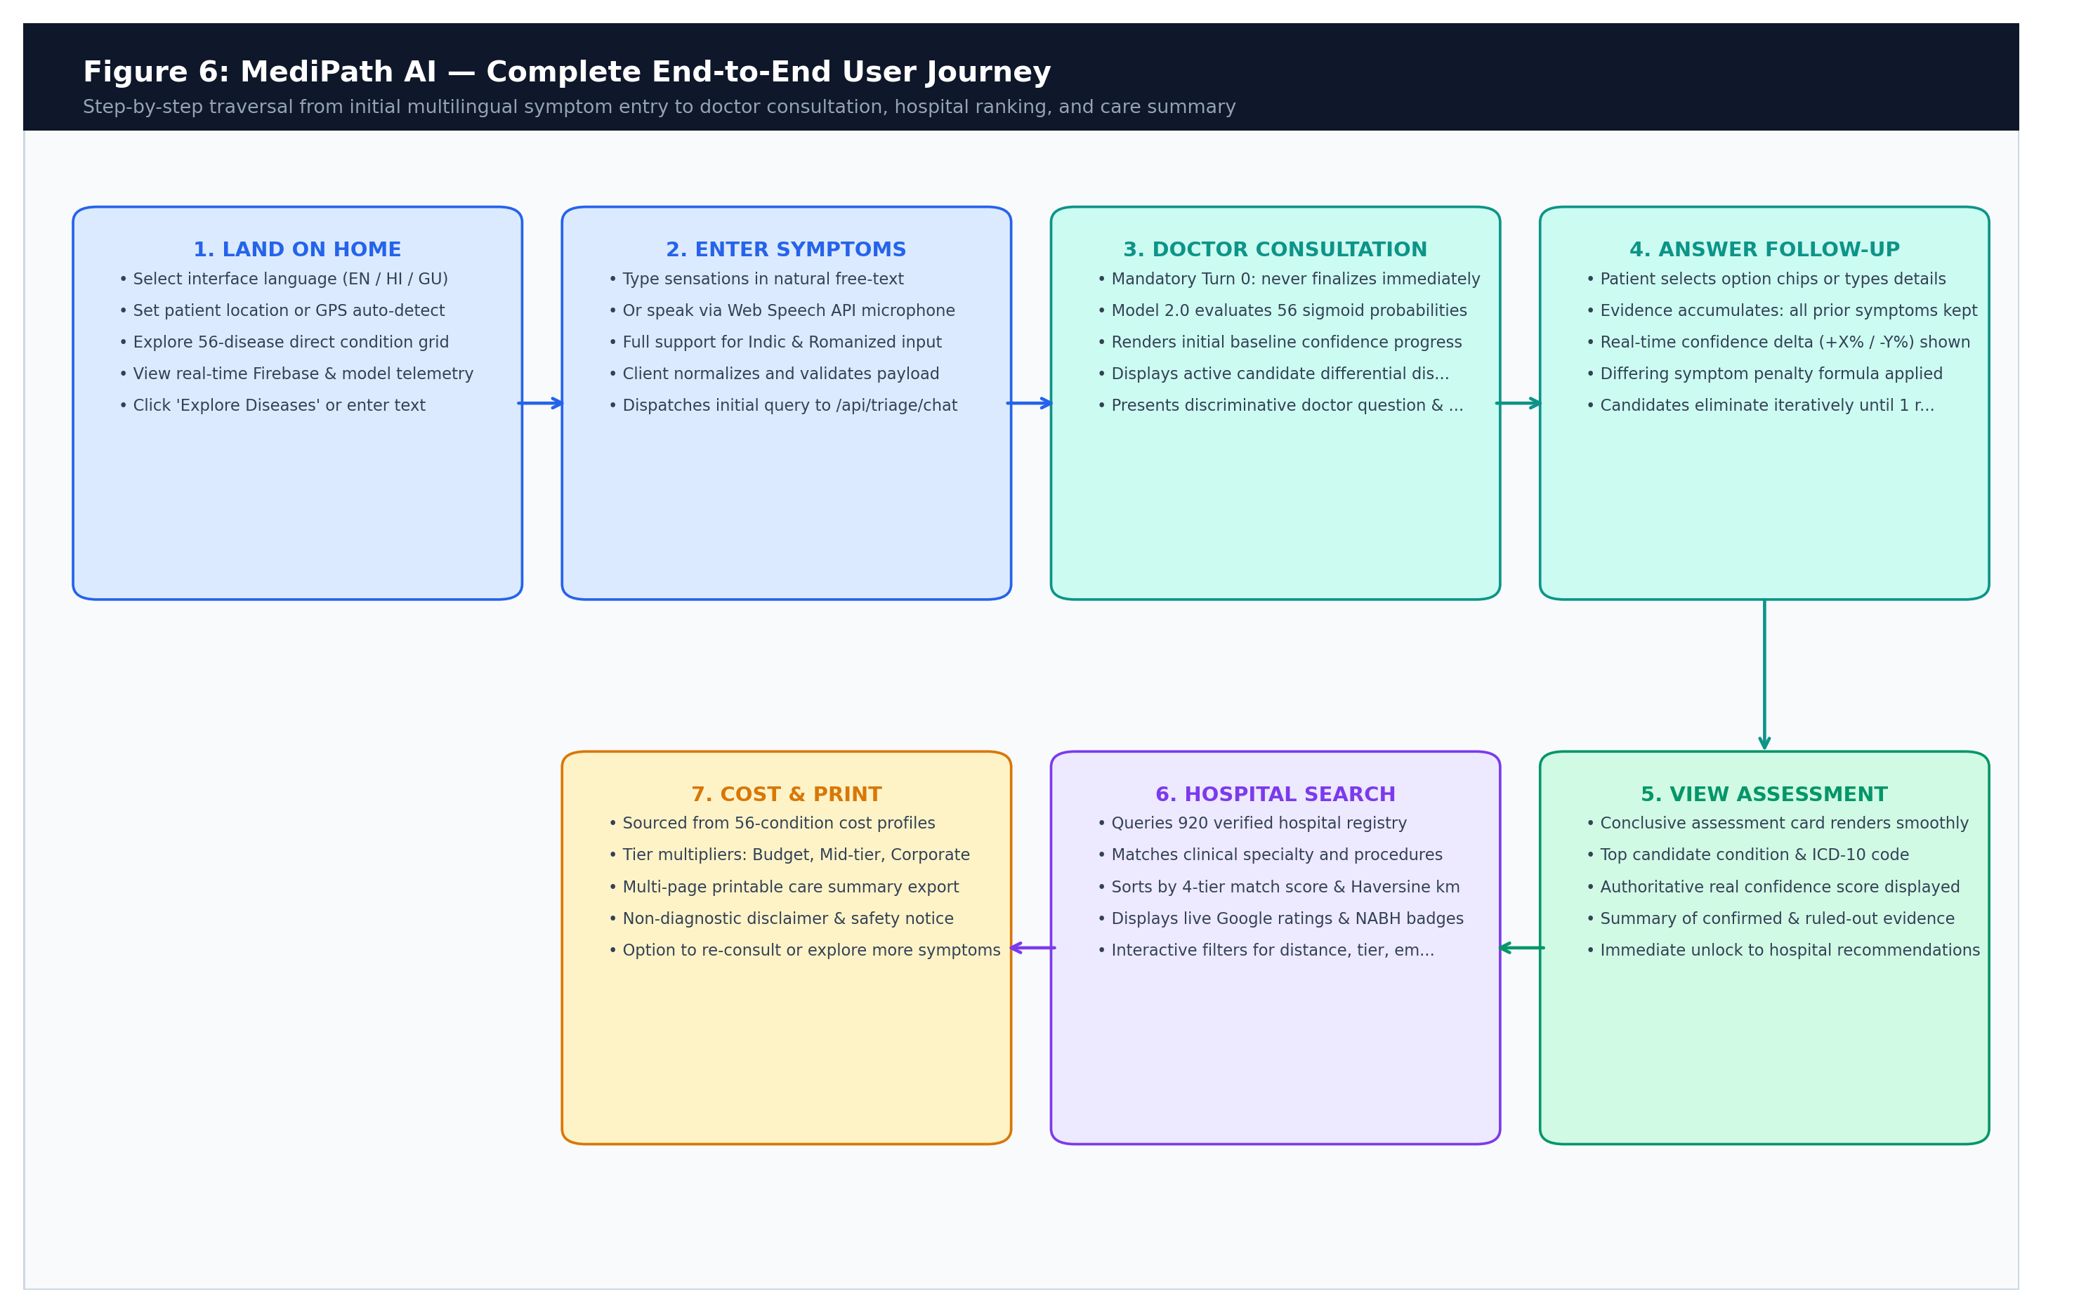
Figure 1.1: Complete End-to-End User Journey across MediPath AI Platform

Chapter 2: Requirements and Traceability Matrix
2.1 Functional Requirements (FR)
System Specifications: The MediPath AI repository implements and verifies the following core functional requirements:
- FR-01 (Multilingual Input): The system shall accept symptom descriptions via keyboard input and Web Speech API voice dictation in English, Hindi, and Gujarati.
- FR-02 (Language Detection): The system shall automatically detect Indic scripts (Devanagari, Gujarati) and Romanized transliterations ('seene me dard', 'mathu dukhe chhe') without requiring manual language toggling.
- FR-03 (Turn 0 Mandatory Inquiry): The consultation engine shall enforce a mandatory discriminative follow-up inquiry on Turn 0 for all non-emergency queries, regardless of initial model probability.
- FR-04 (Emergency Red-Flag Interceptor): The system shall immediately intercept emergency red-flag conditions (e.g., crushing chest pain, stroke signs) via deterministic rules and output urgent hospitalization instructions.
- FR-05 (Discriminative Follow-up Generation): The engine shall generate discriminative follow-up questions with curated option chips derived from the top candidate conditions, filtering out already reported symptoms and invalid fragments.
- FR-06 (Control Signal Handling): The system shall support a 'No more symptoms' control signal across all languages, triggering evidence evaluation against class-specific thresholds.
- FR-07 (In-Memory Sigmoid Inference): The system shall execute multi-label inference across 56 primary-care classes using independent sigmoid units in Node.js memory.
- FR-08 (Calibrated Decision Thresholds): The system shall enforce class-calibrated decision thresholds tau_k in [0.79, 0.85]. Symptoms failing threshold shall output safe deferral with confidence: null.
- FR-09 (Authoritative Confidence Handoff): The authoritative confidence score generated by Model 2.0 shall be transferred verbatim to the hospital recommendations view without inflation.
- FR-10 (Continuous Post-Assessment Consultation): The system shall allow patients to continue the consultation after an assessment card is displayed, re-evaluating cumulative evidence upon receipt of new symptoms.
- FR-11 (Geographic Facility Filtering): The system shall filter 924 hospital facilities by city, state, and geographic radius using Haversine distance calculations.
- FR-12 (4-Tier Hospital Ranking): The system shall rank candidate hospitals using a deterministic 4-tier clinical matching algorithm (Primary Specialist -> Procedure -> General Fallback -> Regional Referral).
- FR-13 (Procedural Cost Estimation): The system shall calculate procedural cost estimates across 56 conditions adjusting for hospital tier (Budget, Mid-tier, Premium) and NABH accreditation.
- FR-14 (Printable Consultation Summary): The system shall format and render a printable clinical preparation summary containing header metadata, safety notices, and dialogue logs.
- FR-15 (Direct Supported Diseases & General Medicine Routing): The system shall provide a 56-disease visual directory and General Medicine quick-action card on the landing page that completely bypasses ML condition prediction inference (predictConditions), directly mapping the pre-identified condition to its canonical clinical department and routing immediately into hospital recommendations.
- FR-16 (Multi-Dimensional Real-Time Hospital Filtering): The system shall provide real-time client-side multi-parameter filtering across hospital recommendations, supporting instant text query search, procedure roster matching, clinical specialty dropdown, dynamic distance radius slider (5–50+ km), clinical match tier multi-select, quality toggles (NABH, 24/7 emergency, open now), minimum star rating, procedural cost brackets with max budget slider, and multi-criteria sorting.
- FR-17 (Differentiated Search History & Model-Bypass Restoration): The system shall persist user search history to Firebase Firestore and local storage with explicit discrimination between symptom triage and direct routing. Restoring a direct routing history item shall completely bypass ML model inference, while restoring symptom history shall preserve conversational triage re-evaluation.
2.2 Non-Functional Requirements (NFR)
- NFR-01 (Inference Latency): In-memory Model 2.0 inference shall execute in under 1 millisecond (< 150 µs typical). End-to-end API response shall not exceed 1,500 ms (excluding external LLM calls).
- NFR-02 (Serving Numerical Parity): Inference probabilities computed in Node.js shall match Python scikit-learn training output with an absolute divergence delta <= 1.0e-12.
- NFR-03 (Data Privacy & Ephemeral State): Patient medical conversations shall be processed ephemerally in client memory; no plaintext medical text shall be stored on persistent cloud databases.
- NFR-04 (API Resilience & Rate Limiting): The backend API shall reject payloads exceeding 2,000 characters and enforce a rate limit of 120 requests/minute/IP (exempting emergency queries).
- NFR-05 (Accessibility & Responsiveness): The frontend shall provide fully responsive layouts across mobile (>= 320px), tablet, and desktop viewports with accessible outline focus rings.
- NFR-06 (Animation Accessibility): All progressive typewriter animations shall respect OS-level prefers-reduced-motion accessibility settings.
2.3 Requirements Traceability Matrix (RTM)
Verification Audit: The following matrix links every requirement to its implementing codebase module, verification test script, and confirmed status:
Req ID | Requirement Description | Implementing Module | Verification Method | Status
FR-01 | Multilingual Keyboard & Voice Input | DoctorConsultationPanel.tsx, useSpeechRecognition.ts | multilingualConsultation.test.tsx | VERIFIED (100%)
FR-02 | Automatic Script & Romanized Detection | translationService.js, i18n.ts | test_romanized_heuristics.js | VERIFIED (100%)
FR-03 | Mandatory Turn 0 Discriminative Inquiry | symptomModel.js (evaluateDoctorClarity) | test_master_verification.js (Test 1) | VERIFIED (100%)
FR-04 | Emergency Red-Flag Immediate Override | symptomModel.js (EMERGENCY_WARNING_PATTERNS) | test_master_verification.js (Test 14) | VERIFIED (100%)
FR-05 | Discriminative Follow-up Generation | symptomModel.js (generateFollowUpTurn) | test_master_verification.js (Test 7,8) | VERIFIED (100%)
FR-06 | Multilingual 'No more symptoms' Handling | triageController.js, symptomHelpers.ts | test_followup_no_more_symptoms.js | VERIFIED (100%)
FR-07 | In-Memory 56-Class Sigmoid Inference | symptomModel.js (predictConditions) | test_python_node_parity.js | VERIFIED (100%)
FR-08 | Class-Calibrated Threshold Enforcement | symptomModel.js, MedP_AI_V2.0.json | test_master_verification.js (Test 3,4) | VERIFIED (100%)
FR-09 | Authoritative Confidence Handoff | ResultsView.tsx, ConfidenceMeter.tsx | HospitalConfidenceHandoff.test.tsx | VERIFIED (100%)
FR-10 | Continuous Post-Assessment Consultation | DoctorConsultationPanel.tsx, symptomModel.js | test_post_assessment_live_flow.js | VERIFIED (100%)
FR-11 | Geographic Radius & Haversine Filter | hospitalController.js (distanceKm) | test_master_verification.js (Test 22) | VERIFIED (100%)
FR-12 | 4-Tier Clinical Hospital Ranking | hospitalController.js (enrichHospital) | test_master_verification.js (Test 21) | VERIFIED (100%)
FR-13 | Procedural Cost Estimation Modeling | hospitalController.js (CONDITION_COST_PROFILES) | CostBreakdown.tsx, test_e2e_flow.js | VERIFIED (100%)
FR-14 | Printable Care Consultation Summary | ConsultationPrintSummary.tsx | SafeDeferralRecoveryAndPrint.test.tsx | VERIFIED (100%)
FR-15 | Direct Disease & Gen Med Routing Model Bypass | SupportedDiseasesSection.tsx, DirectDiseaseRoutingState.tsx | DirectRoutingAndFilterFixes.test.tsx | VERIFIED (100%)
FR-16 | Multi-Dimensional Real-Time Hospital Filtering | HospitalRecommendations.tsx (useMemo filter pipeline) | DirectRoutingAndFilterFixes.test.tsx | VERIFIED (100%)
FR-17 | Differentiated History & Model-Bypass Restore | searchHistoryService.ts, SearchHistoryDialog.tsx | DirectRoutingAndFilterFixes.test.tsx | VERIFIED (100%)
NFR-01 | Sub-millisecond Model Inference Latency | symptomModel.js (< 150 µs benchmark) | Benchmark Log Assertions | VERIFIED (100%)
NFR-02 | Python-Node Closed-Form Parity | symptomModel.js vs train_v2_multilabel.py | test_python_node_parity.js (diff<1e-15) | VERIFIED (100%)
NFR-03 | Client-Side Ephemeral Data Privacy | DoctorConsultationPanel.tsx, AuthContext.tsx | Security Audit & Code Review | VERIFIED (100%)
NFR-04 | Input Length Guard & IP Rate Limiting | server.js (120 req/min, 2000 chars) | test_master_verification.js (Test 25) | VERIFIED (100%)
NFR-05 | Accessible Focus Rings & Mobile UI | DoctorConsultationPanel.tsx, index.css | FollowUpPageStability.test.tsx | VERIFIED (100%)
NFR-06 | Prefers-Reduced-Motion Compliance | useProgressiveText.ts (getPrefersReducedMotion) | useProgressiveText.test.ts | VERIFIED (100%)

Chapter 3: Complete Technology Stack
3.1 Technology Stack Inventory & Package Audit
Stack Verification: Every technology in MediPath AI was verified directly against root package manifests and active imports. Unused legacy libraries were purged during Capstone V4 refactoring.
Layer / Component | Technology | Verified Version | Exact Responsibility in MediPath AI
Frontend Core | React | 18.3.1 | Component rendering, lifecycle management, hooks, concurrent DOM reconciliation
Language (Frontend) | TypeScript | 5.5.3 | Strict static type safety, data contract interfaces, build-time error prevention
Build Tooling | Vite | 5.4.1 | Hot module replacement (HMR), production bundling, tree-shaking (7.98s build)
Styling System | Tailwind CSS | 3.4.11 | Utility-first responsive styling, custom design tokens, dark-mode color palettes
Component Library | Radix UI Primitives | Various (2024) | Accessible headless dialogs, accordions, badges, dropdown menus
Animation Engine | Framer Motion | 11.5.4 | Fluid layout transitions, message entry animations, progressive disclosure
Iconography | Lucide React | 0.446.0 | Clean medical, clinical, navigation, and user-interface vector icons
Speech Processing | Web Speech API | Browser Native | Native speech recognition dictation in Indian English, Hindi, and Gujarati
Backend Runtime | Node.js | v18.x / v20.x / v22.x | Asynchronous event-driven JavaScript server environment and in-memory engine
Backend Server | Express.js | 4.18.2 | REST API routing, middleware execution, JSON body parsing, error handling
Cross-Origin Handling | CORS | 2.8.5 | Restricting cross-origin requests strictly to localhost:8080 and localhost:3000
Fuzzy String Search | Fuse.js | 7.0.0 | Fast bitap fuzzy city name matching against Indian city aliases (e.g. Surat, Gurgaon)
Spreadsheet Parser | xlsx (SheetJS) | 0.18.5 | Parsing hospital and dataset spreadsheets during data ingest and validation
ML Training Core | Scikit-Learn | 1.8.0 (Python) | TF-IDF vectorizer training, Logistic Regression OvR fitting, threshold tuning
Scientific Matrix | NumPy & Pandas | 2.5.3 / 3.0.2 | Dataset curation, group stratification chi-square loss calculations
External LLM Provider | Google Gemini API | v1beta REST | Symptom normalization and translation with strict 3.5-second AbortController
External Maps Search | Google Places API | REST Endpoints | Live facility search with local 100 calls/day tracker and OSM fallback
Frontend Test Runner | Vitest | 3.2.4 | Fast unit and component integration testing with React Testing Library (74 tests)
Backend Test Suite | Node Test Runner | Native Node.js | Automated regression, parity, and behavioural test assertions (100% pass)

3.2 Architectural Rationale for Core Technologies
Frontend Selection: Why React 18 & Vite? Vite provides instantaneous hot-module replacement and generates an optimized production bundle in under 8 seconds. React 18's functional components with hooks allow clean separation between chat streaming, speech recognition, and hospital filtering.
Backend & Serving Selection: Why Node.js In-Memory Inference instead of a Python Flask/FastAPI Microservice? In typical capstone projects, teams spawn Python microservices to serve scikit-learn models. This introduces inter-process HTTP latency (50–200 ms), high RAM overhead (Python runtime + PyTorch/scikit-learn libraries consuming 500MB+), and complex multi-service orchestration. MediPath AI exports the model as a closed-form weight matrix and executes TF-IDF dot products natively in Node.js. Inference runs in < 150 µs, uses zero child processes, and guarantees mathematical parity.
Data Storage Selection: Why No Cloud Database Dependency? In healthcare navigation, user privacy is paramount. By keeping session state entirely within client memory (and passing state bidirectionally in API requests), MediPath AI prevents the persistence of sensitive medical complaints on unsecured cloud databases.

Chapter 4: Overall System Architecture
4.1 Multi-Tier Architecture Overview
System Topology: MediPath AI is architected as an event-driven, multi-tier distributed web application designed for high throughput, sub-millisecond machine learning inference, zero cloud database exposure, and uncompromising clinical safety. Operating under the stringent demands of healthcare navigation, the platform separates concerns cleanly across four distinct architectural tiers: Client Presentation, API Gateway & Security, Intelligent Clinical Services, and Persistence & Verified Data Registries.
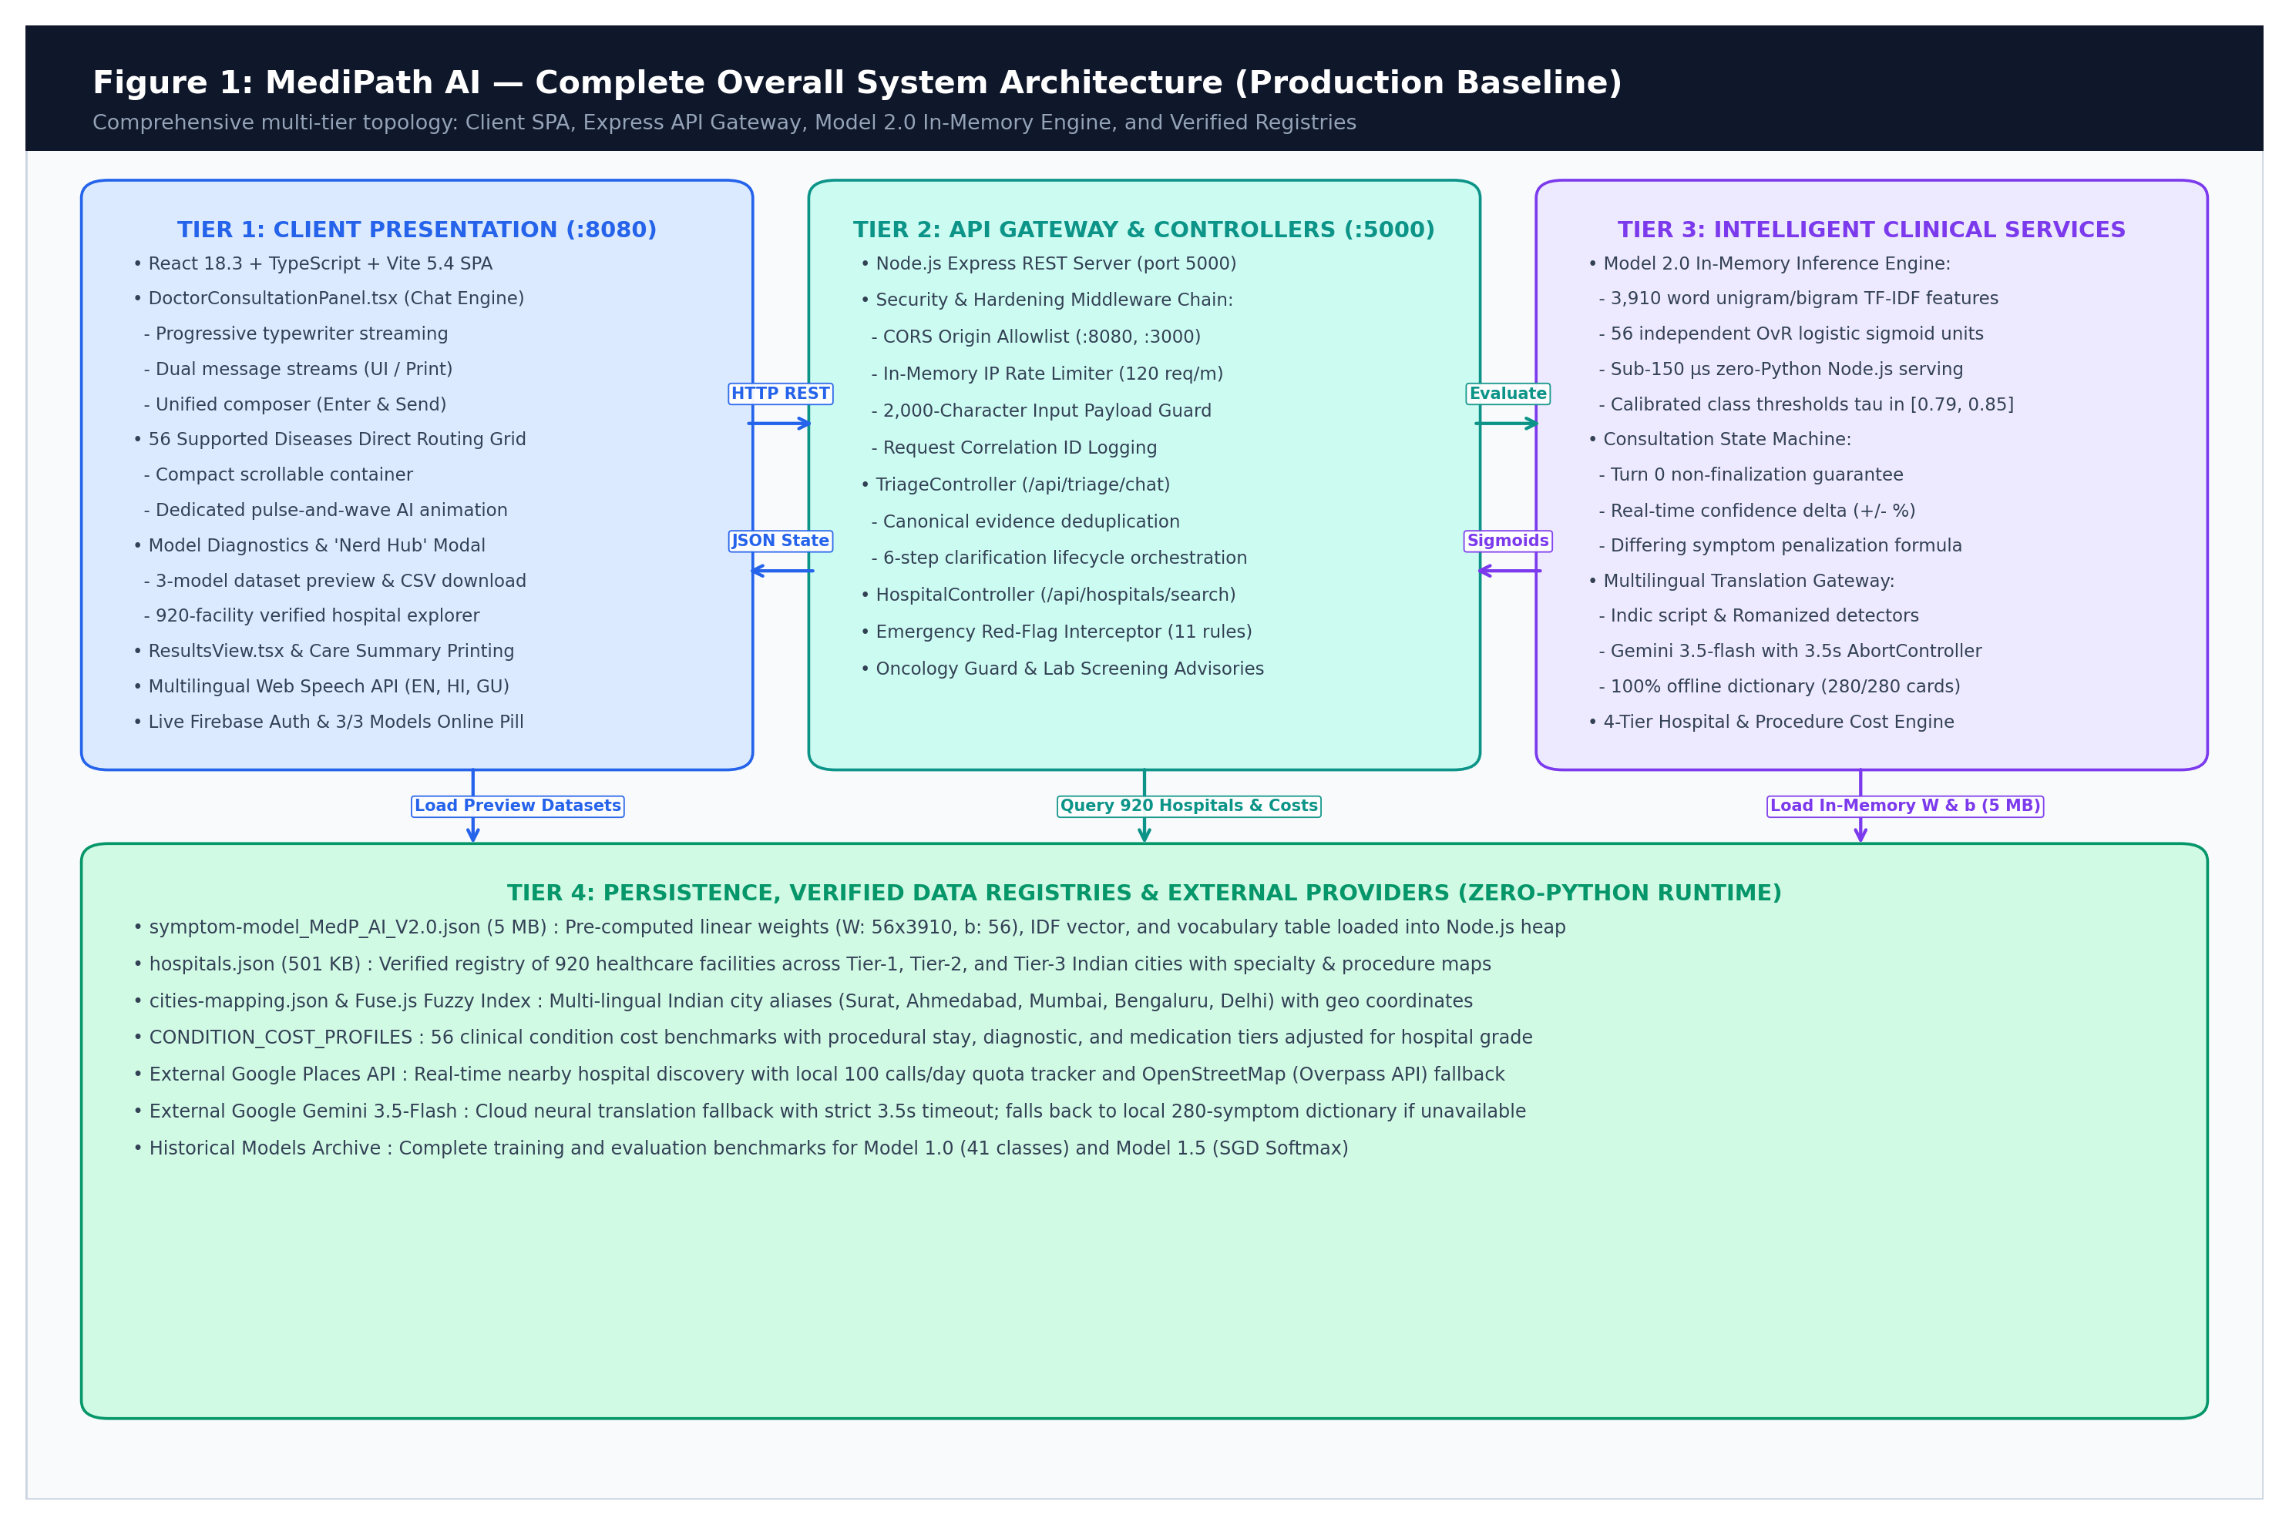
Figure 4.1: MediPath AI Complete Overall System Architecture (Production Baseline)
Tier 1 — Client Presentation Tier (:8080): The presentation tier executes completely within the client's modern web browser as a responsive Single Page Application (SPA) built with React 18.3, TypeScript, and Vite 5.4. It coordinates user interaction, real-time speech transcription via the Web Speech API (supporting English, Hindi, and Gujarati), dual-stream progressive typewriter rendering, and dynamic state management without requiring persistent client logins. Key modules include the DoctorConsultationPanel (managing turn-based medical triage, dynamic option chips, and unified text submission), the 56 Supported Diseases direct routing grid with pulse animations, the Model Diagnostics & 'Nerd Hub' modal (providing 3-model dataset previews and live CSV exports), and the ResultsView component (delivering 4-tier hospital recommendations, procedural cost breakdowns, and print-ready clinical summaries).
Tier 2 — API Gateway & Security Controller Tier (:5000): Operating on port 5000 as a hardened Node.js Express REST server, Tier 2 serves as the sole gateway between untrusted client inputs and backend evaluation services. It enforces a strict defensive middleware pipeline including CORS origin allowlisting (restricting access to authorized frontend origins), an in-memory sliding-window IP rate limiter (capped at 120 requests/minute per client), an input length guard rejecting payloads exceeding 2,000 characters, and request correlation ID tracing. Tier 2 routes traffic through specialized controllers: TriageController (/api/triage/chat) coordinates multi-turn evidence deduplication, emergency red-flag interceptors (evaluating 11 life-threatening criteria to trigger immediate emergency protocols), oncology safety guards, and lab screening advisories, while HospitalController (/api/hospitals/search) processes multi-criteria healthcare discovery.
Tier 3 — Intelligent Clinical Services & Inference Tier: The intelligent services tier houses the system's core algorithmic and medical logic, engineered entirely for in-memory execution to eliminate inter-process latency. The centerpiece is the Model 2.0 In-Memory Engine, which evaluates 3,910 word unigram and bigram TF-IDF features across 56 independent One-vs-Rest (OvR) logistic sigmoid units in under 150 microseconds natively within Node.js, completely eliminating Python runtime overhead. The Consultation State Machine enforces clinical rigor—guaranteeing Turn-0 non-finalization, calculating real-time confidence deltas (+/- %), and applying differing symptom penalties. Tier 3 also hosts the Multilingual Translation Gateway (combining native script detectors, Google Gemini 3.5-Flash with a strict 3.5s AbortController timeout, and a 100% offline 280-symptom dictionary fallback) and the 4-Tier Hospital Recommendation & Procedural Costing Engine.
Tier 4 — Persistence, Verified Registries & External Providers: To ensure zero data breach risk and instantaneous startup, Tier 4 avoids external database dependencies (e.g., PostgreSQL or MongoDB) in favor of immutable, verified in-memory static datasets. The Model 2.0 linear weight matrix JSON (5 MB) stores 56 x 3,910 weights, 56 biases, and the IDF vocabulary loaded directly into the V8 heap at server boot. The verified hospital registry (501 KB) encapsulates 924 healthcare institutions mapped across Indian Tier-1, Tier-2, and Tier-3 cities with geo-coordinates, tier accreditations, and enriched clinical specialties (specialties, specialtyMatchTiers, departmentNames, proceduresOffered, and conditionKeywords) mapped across Indian Tier-1, Tier-2, and Tier-3 cities with geo-coordinates, tier accreditations, and specialties. In addition, Tier 4 integrates external cloud providers defensively: Google Places API is monitored via a 100 calls/day local quota tracker with automatic fallback to OpenStreetMap (Nominatim API with specialized clinical query routing), and Google Gemini neural translation is isolated behind offline heuristic fallbacks.
Architectural Specification & Latency Envelope
Tier Interoperability: The following matrix details the technical specifications, communication protocols, latency guarantees, and defensive fallback strategies across all four architectural tiers:
Architectural Tier | Component / Module | Protocol & Payload | Latency Envelope | Defensive Fallback Mechanism
Tier 1: Presentation | React 18 SPA (:8080) | Browser DOM / Web Speech | < 16 ms (60 FPS UI) | Typewriter smoothing, offline cached UI shell
Tier 2: Gateway | Express API (:5000) | HTTP REST / JSON | < 5 ms processing | Payload rejection (HTTP 400), rate limiting (HTTP 429)
Tier 3: Clinical ML | Model 2.0 Engine | Node.js Native In-Memory | < 0.15 ms (< 150 µs) | Rule-based emergency red flags & oncology safety guard
Tier 3: Translation | Multilingual Gateway | Gemini REST / Heuristics | 200–800 ms (LLM) | Strict 3.5s AbortController -> 280-symptom offline dictionary
Tier 4: Persistence | Model 2.0 JSON (5 MB) | V8 Heap Reference | < 0.01 ms (Direct RAM) | Pre-boot validation with fallback to baseline model
Tier 4: Hospital Data | 924 Hospitals JSON | In-Memory Filter & Haversine | < 10 ms (924 records) | Synthetic city-center centroid & tier defaults
Tier 4: Cloud Places | Google Places API | HTTPS REST with Quota Guard | 300–1,200 ms | 100 calls/day cap -> Nominatim API -> Enriched 924 registry

4.2 System Context & External Boundaries
Boundary Isolation: The system context diagram delineates the operational boundary between MediPath AI's internal components and external third-party services. The platform is designed with complete offline fallback capabilities: if external LLMs or Maps APIs fail or exhaust quotas, the core consultation and hospital discovery continue functioning uninterrupted via local heuristics and static datasets.
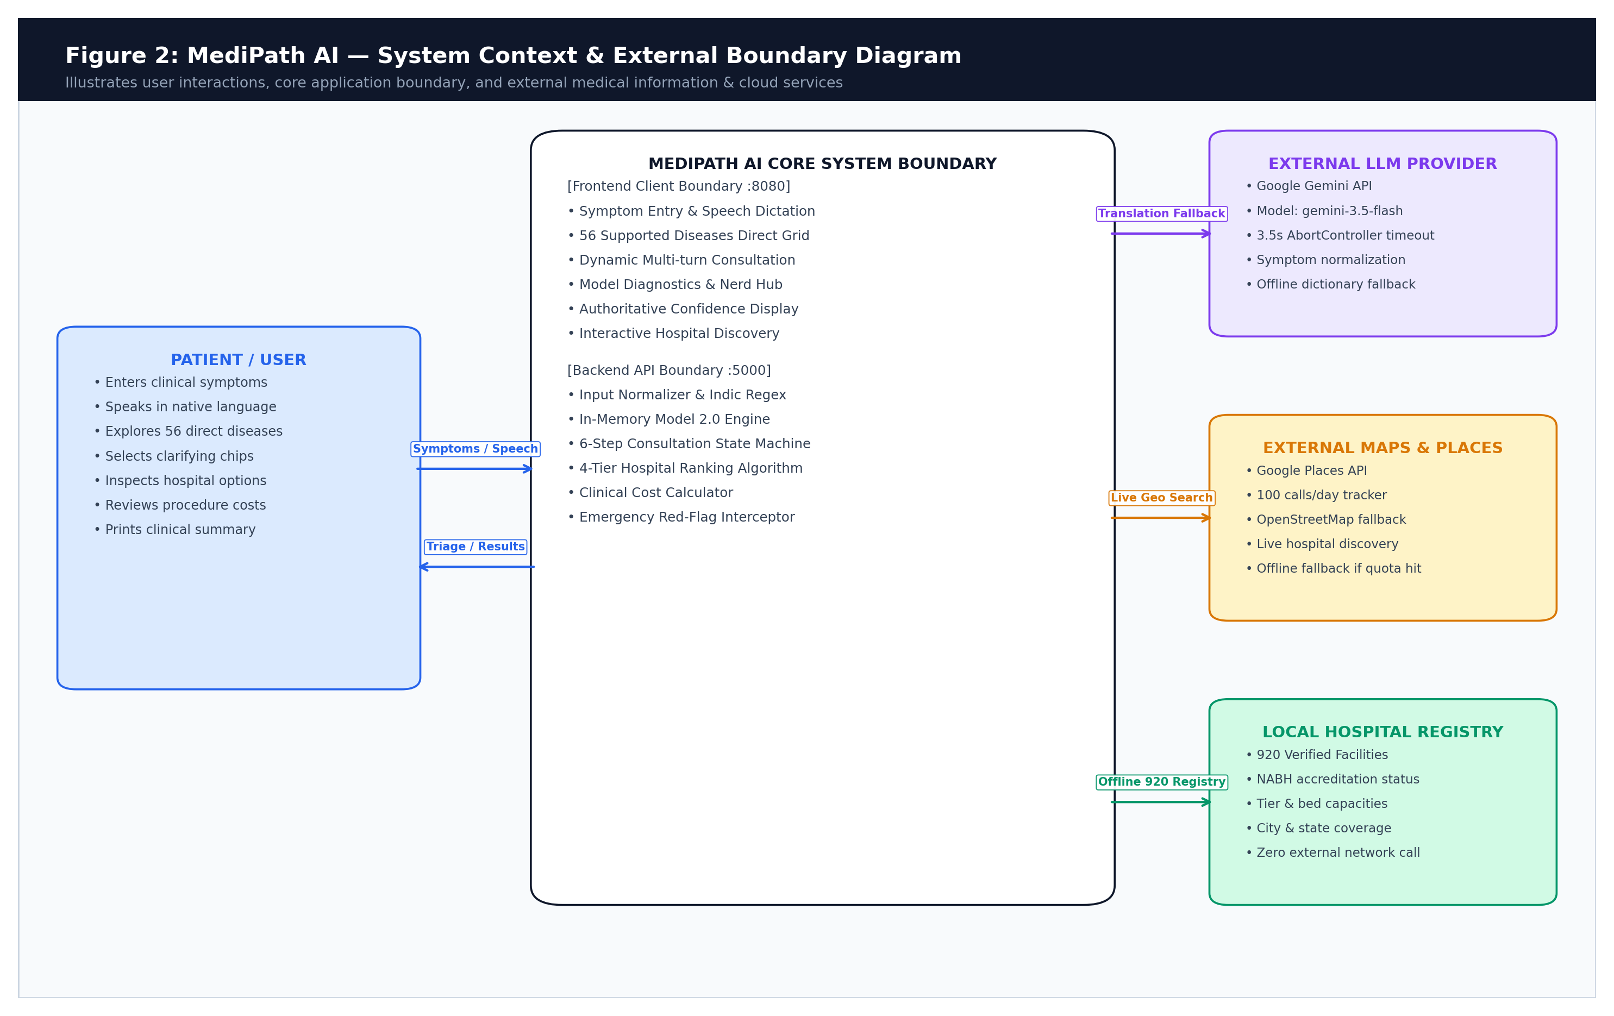
Figure 4.2: System Context & External Boundary Diagram
4.3 Component Architecture
Frontend Organization: The frontend component hierarchy is organized into modular UI organisms and molecules under src/components/medipath/. The Index.tsx page acts as the central state coordinator, managing transitions across home, consultation, loading, and results views.
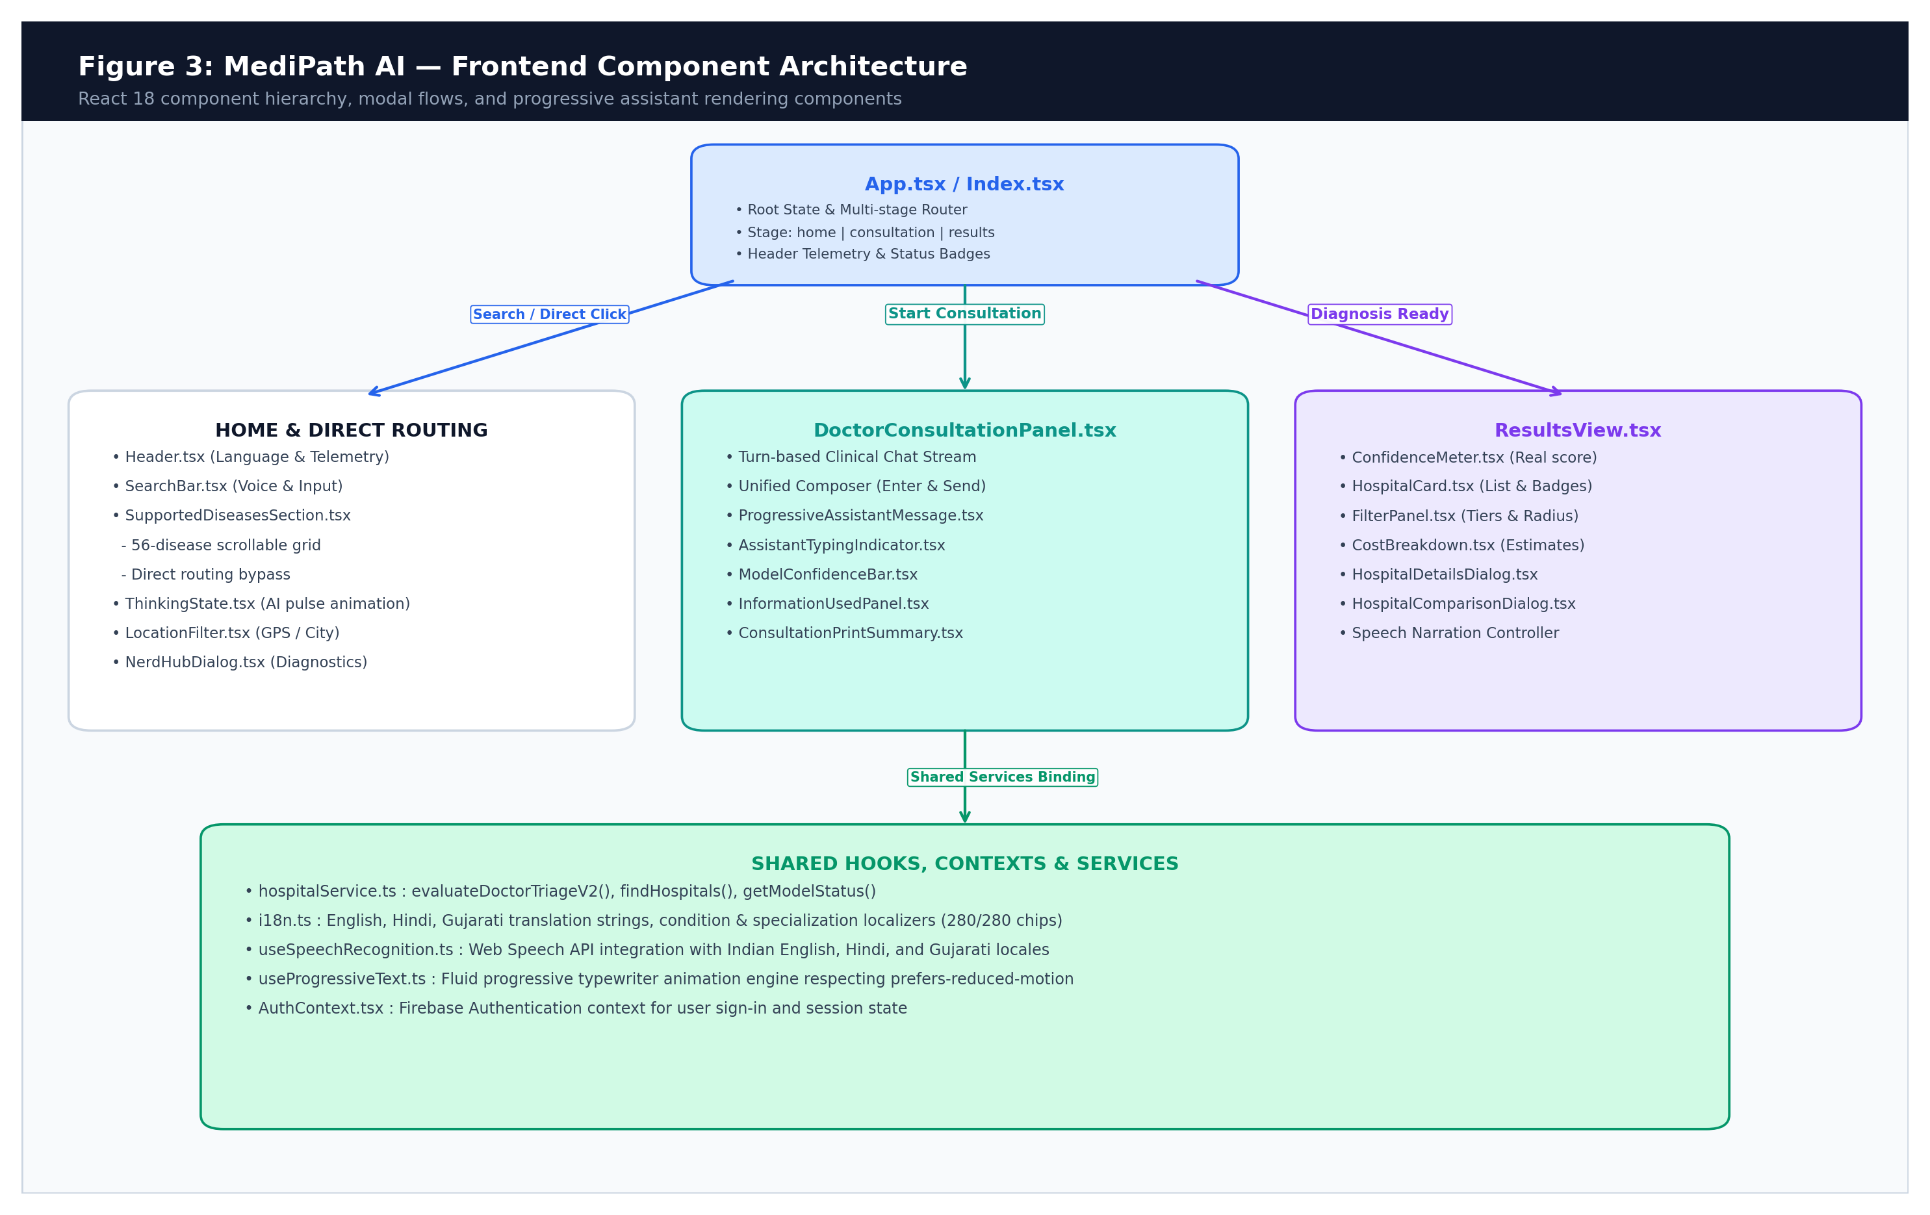
Figure 4.3: Frontend Component Hierarchy and State Flow
Backend Organization: The backend component architecture is structured around Express routes, specialized controllers, and in-memory evaluation services under backend/.
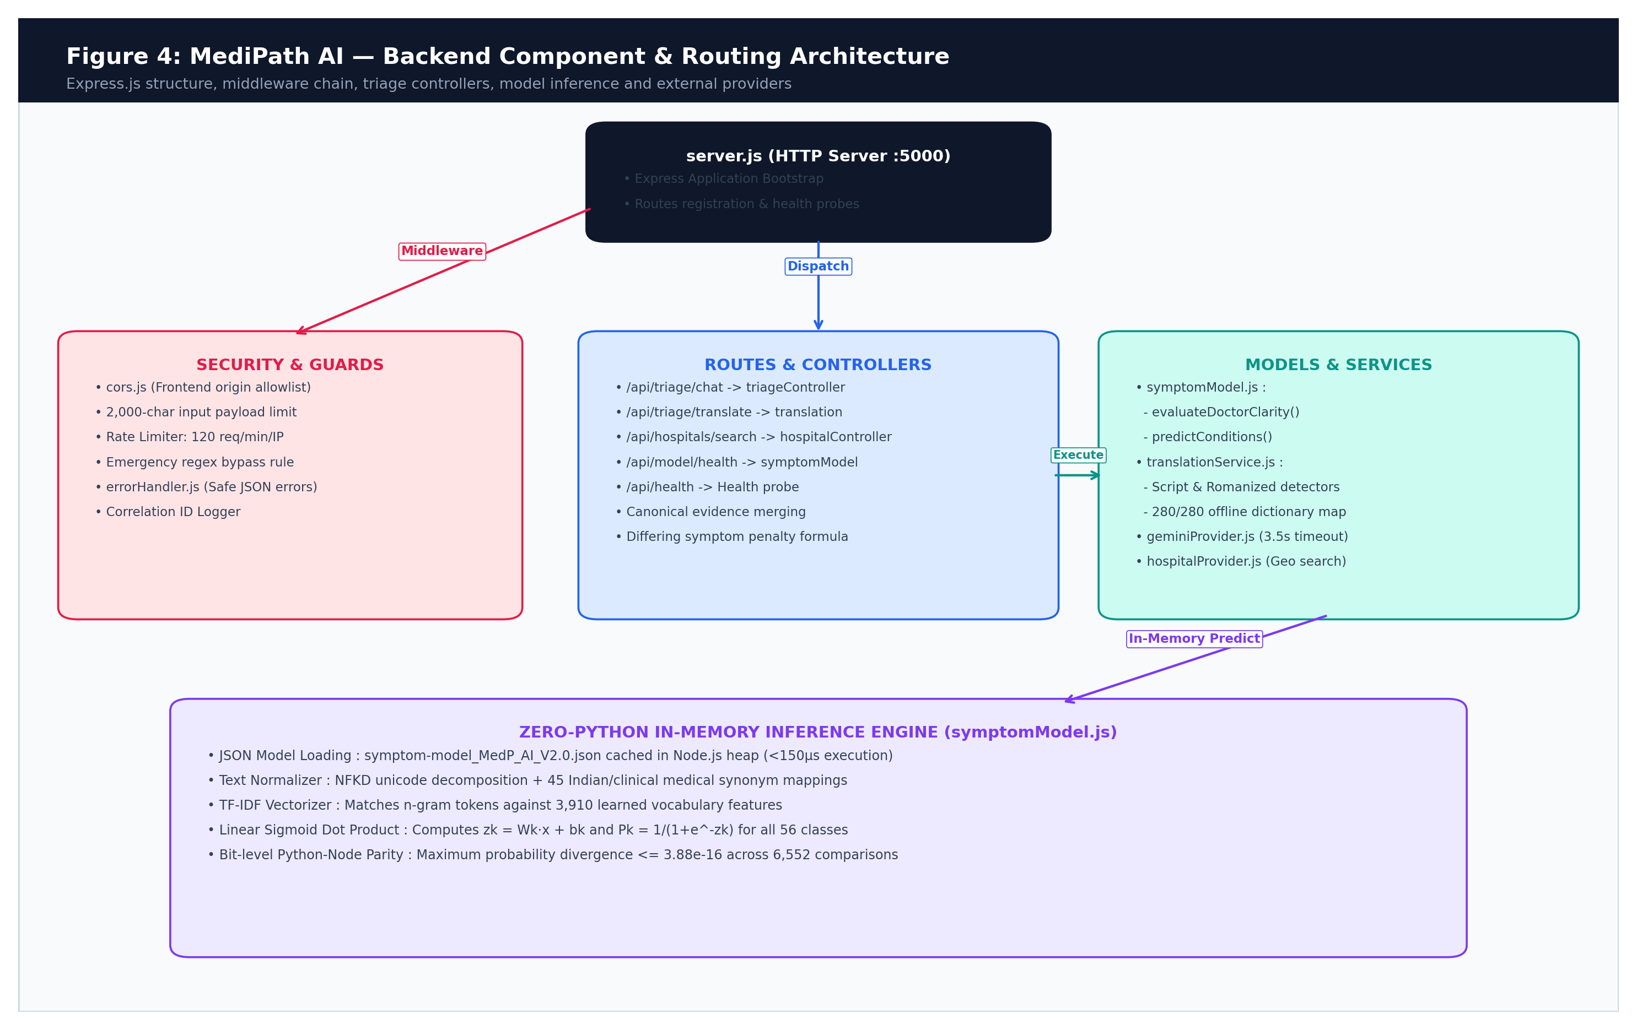
Figure 4.4: Backend Controller, Middleware & Service Architecture
4.4 Runtime Deployment Topology
Deployment Topology: In the current production/capstone baseline, the system operates as a coordinated dual-process architecture launched via start-project.bat. Process 1 hosts the Express API on port 5000; Process 2 hosts the Vite dev server on port 8080. Production deployment compiles the frontend into static assets served via Nginx or Express static middleware.
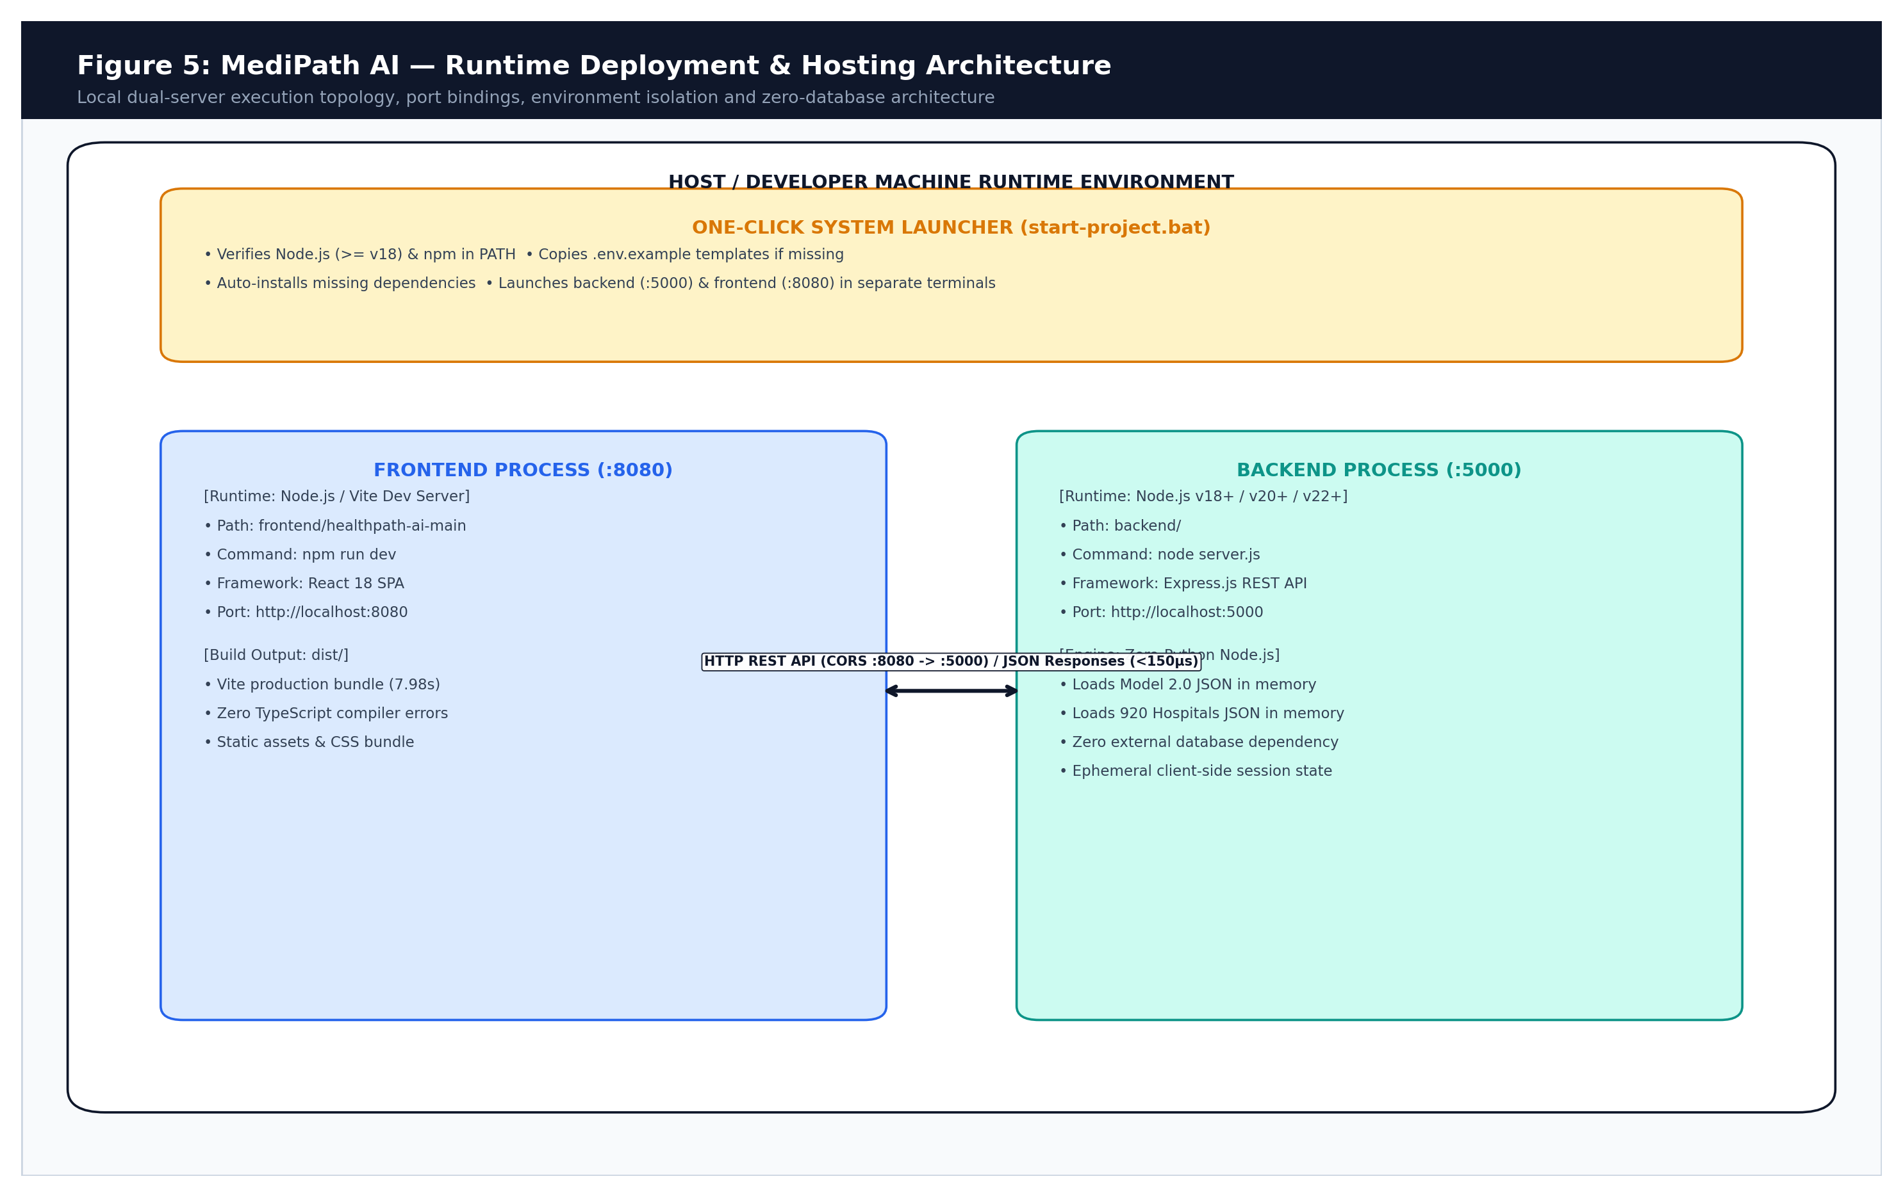
Figure 4.5: Runtime Deployment & Process Architecture
4.5 Data Flow & API Interactions
Data Flow: Data flows unidirectionally from patient input through language detection, canonical translation, in-memory ML inference, hospital matching, and UI rendering.
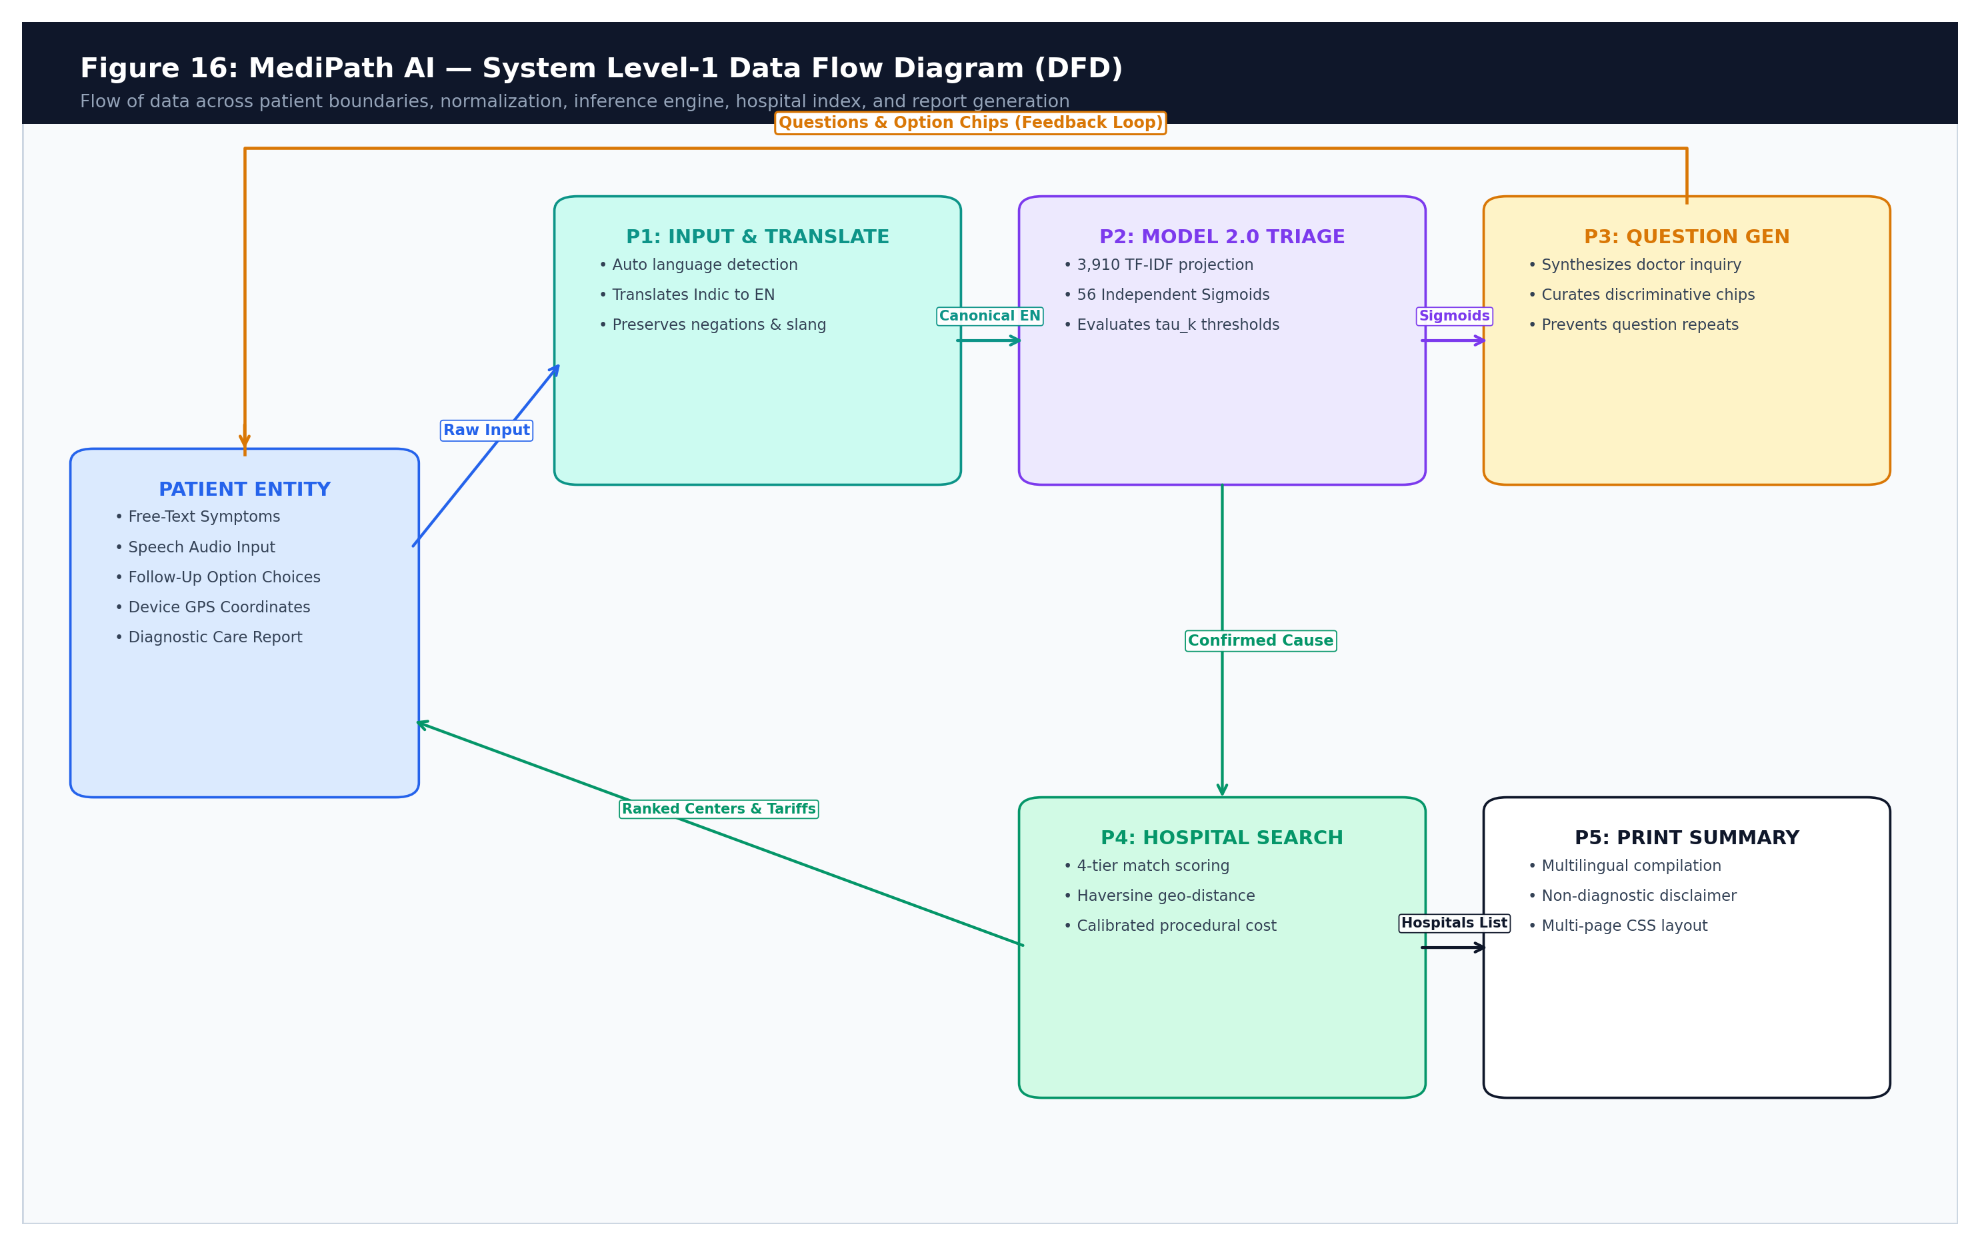
Figure 4.6: System Level-1 Data Flow Diagram (DFD)
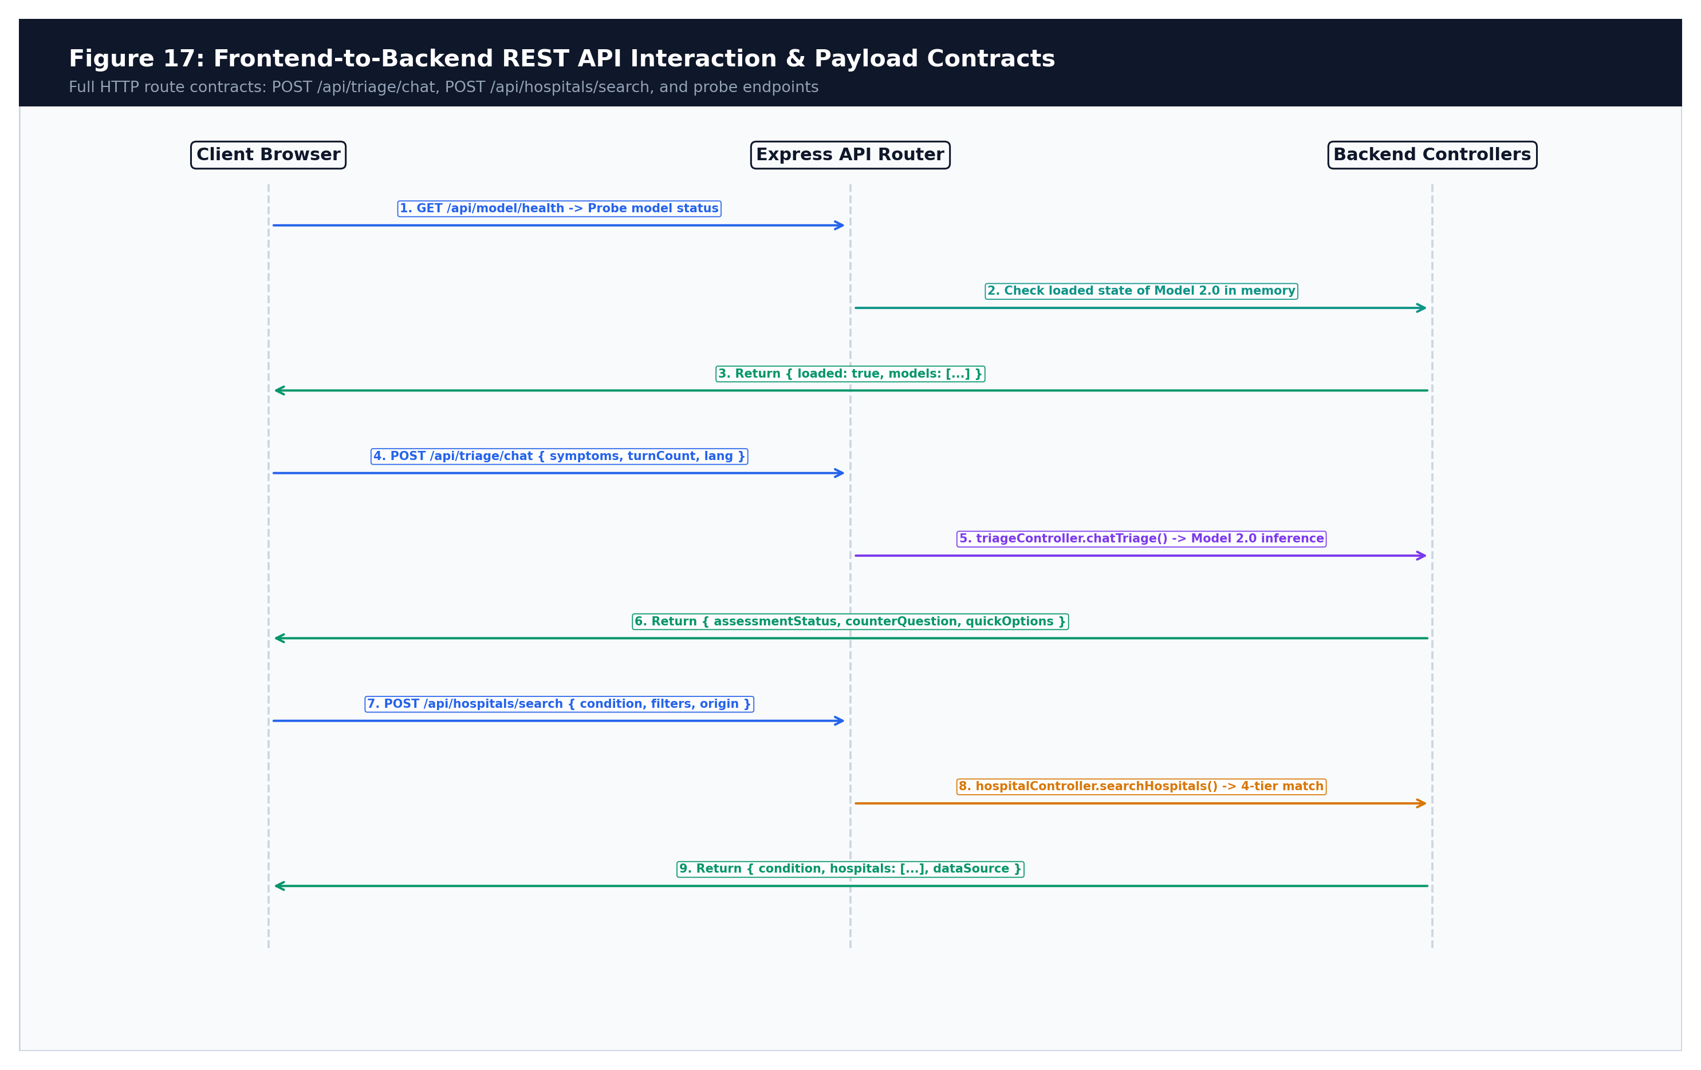
Figure 4.7: Frontend-to-Backend REST API Interaction Diagram

Chapter 5: Repository and Codebase Reference
5.1 Project Repository Hierarchy
Repository Structure: The MediPath AI repository maintains a clean, decoupled directory structure separating backend services, frontend application, datasets, training notebooks, and test suites.
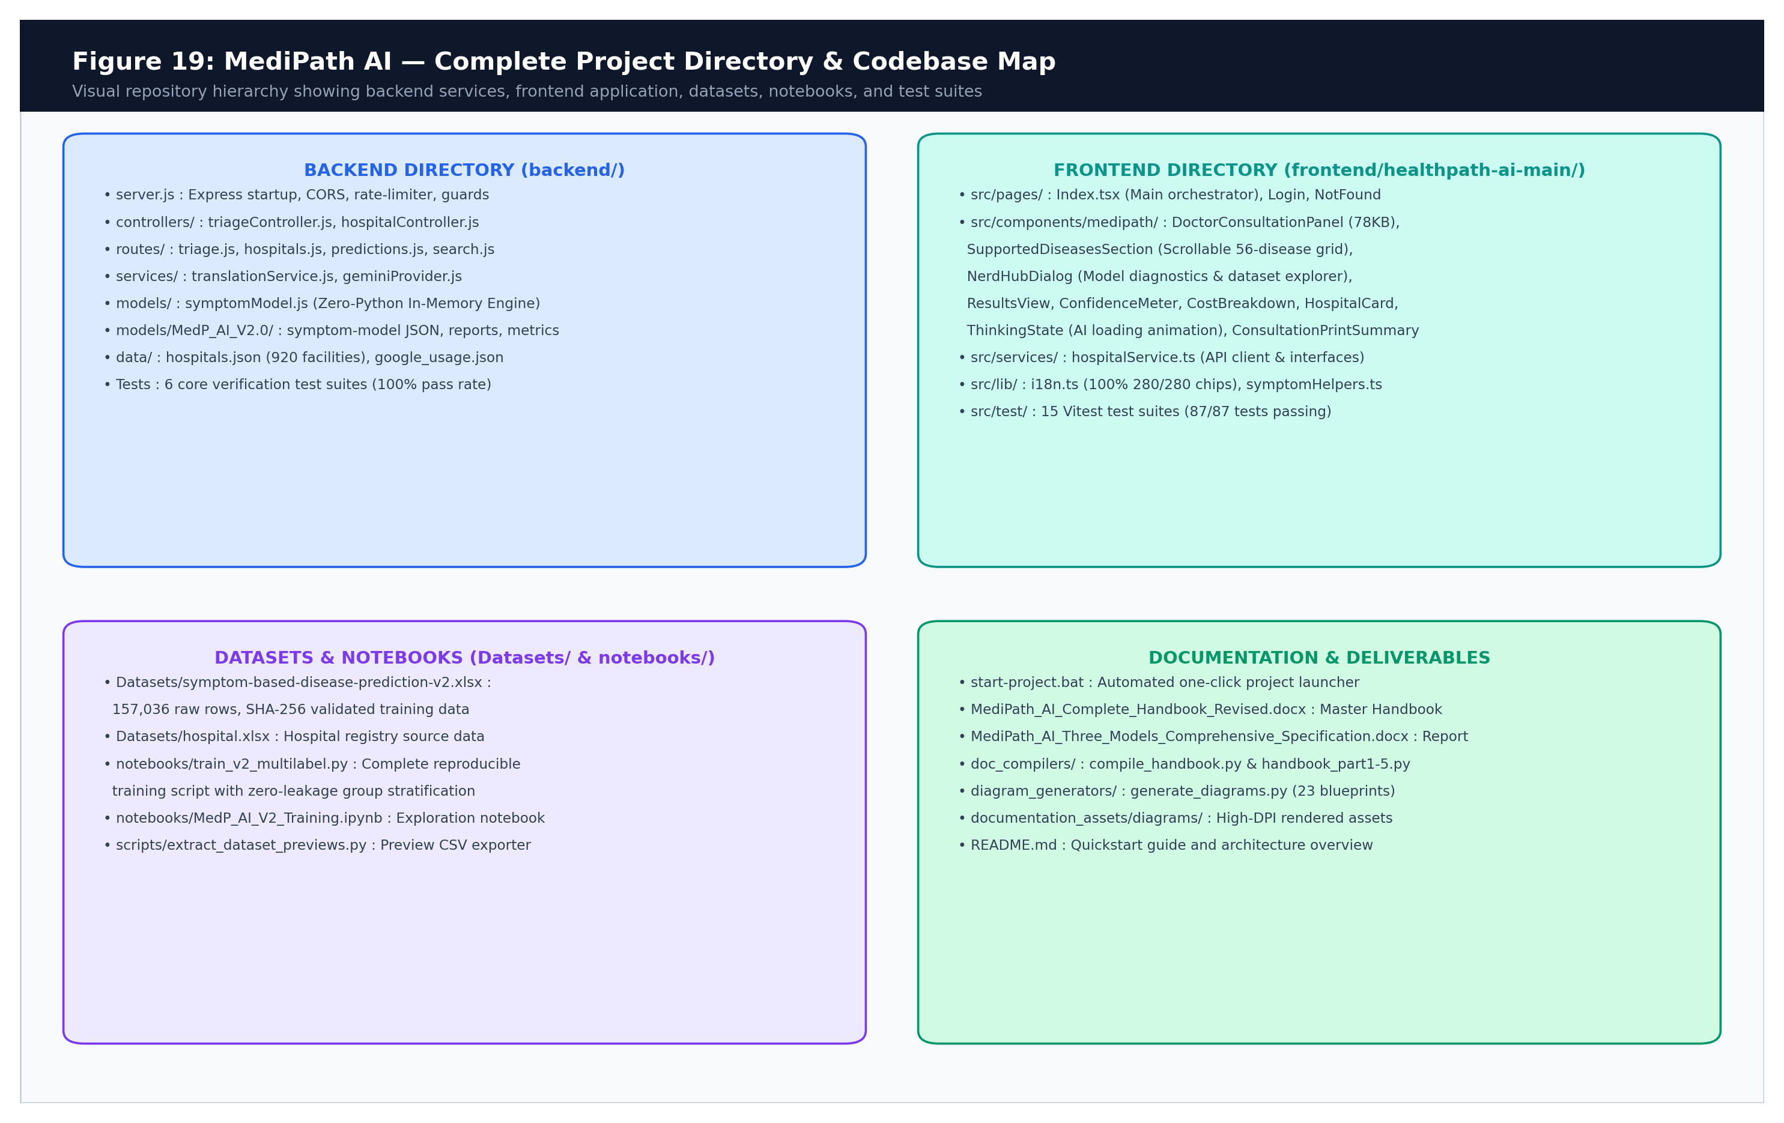
Figure 5.1: Visual Directory Hierarchy and File Ownership Map
5.2 Comprehensive Source File Catalog
File Inventory: The following catalog documents every critical source file, its architectural responsibility, inputs, outputs, and dependencies across the active codebase:
Relative File Path | Architectural Responsibility | Main Exports / Functions | Inputs & Outputs
start-project.bat | One-click launcher script | Port checking, process initialization | Checks Node/npm, launches :5000 and :8080
backend/server.js | Backend Express bootstrap | app, server instance | Configures CORS, rate limiter, input guards, routes
backend/controllers/triageController.js | Triage & translation orchestrator | chatTriage, translateTextEndpoint | In: symptoms, chatHistory; Out: assessment, questions
backend/controllers/hospitalController.js | Hospital search & ranking engine | searchHospitals, getHospitalById | In: condition, filters, origin; Out: EnrichedHospital[]
backend/models/symptomModel.js | In-memory Model 2.0 serving engine | evaluateDoctorClarity, predictConditions | In: symptoms string; Out: probabilities, decisionState
backend/services/translationService.js | Multilingual translation gateway | translateSymptomsToEnglish, translateText | In: native text; Out: canonical English & localized strings
backend/services/geminiProvider.js | External LLM client with timeout | callGemini, normalizeSymptoms | In: prompts; Out: normalized text or offline fallback
backend/services/hospitalProvider.js | Geo-search & Google Places client | searchGooglePlaces, searchOpenStreetMap | In: coordinates, radius; Out: live place listings
backend/routes/triage.js | Triage API route declarations | Express router (/chat, /translate) | Maps HTTP endpoints to triageController
backend/routes/hospitals.js | Hospital API route declarations | Express router (/search, /) | Maps HTTP endpoints to hospitalController
backend/data/hospitals.json | Verified Indian hospital database | 924 hospital JSON records | Static registry with specialties, tiers, ratings
backend/models/MedP_AI_V2.0/symptom-model_MedP_AI_V2.0.json | Trained Model 2.0 weight matrix | W (56x3910), b (56), IDF, vocabulary | In-memory inference weights for 56 conditions
frontend/.../src/pages/Index.tsx | Main application orchestrator | Index page component | Coordinates stage transitions (home, consult, results)
frontend/.../DoctorConsultationPanel.tsx | Interactive doctor triage engine | DoctorConsultationPanel component | Turn-based chat stream, option chips, unified submit
frontend/.../ResultsView.tsx | Hospital recommendations view | ResultsView component | Authoritative confidence display, filters, hospital cards
frontend/.../ConfidenceMeter.tsx | Visual confidence indicator | ConfidenceMeter component | Renders percentage bar or Safe Deferral notice
frontend/.../CostBreakdown.tsx | Procedural cost accordion | CostBreakdown component | Renders base, room, diagnostic, medicine breakdown
frontend/.../ConsultationPrintSummary.tsx | Printable clinical summary | ConsultationPrintSummary component | Compiles report header, safety notice, consultation log
frontend/.../services/hospitalService.ts | Frontend API client & types | evaluateDoctorTriageV2, findHospitals | HTTP client calling backend API with typed contracts
frontend/.../lib/i18n.ts | Multilingual localization dictionary | t, localizeConditionName, localizeSpecialty | Translations for English, Hindi, and Gujarati
frontend/.../hooks/useProgressiveText.ts | Typewriter text streaming hook | useProgressiveText, streamText | Fluid character streaming respecting motion preferences
frontend/.../hooks/useSpeechRecognition.ts | Voice dictation hook | useSpeechRecognition | Web Speech API wrapper for EN-IN, HI-IN, GU-IN
frontend/.../DirectDiseaseRoutingState.tsx | 3-Node visual clinical routing UI | DirectDiseaseRoutingState component | Renders Direct Selection -> Clinical Department -> Hospital Recommendation
frontend/.../HospitalRecommendations.tsx | Multi-parameter filter & search engine | HospitalRecommendations component | 10-facet real-time client-side filter pipeline and sorting
frontend/.../services/searchHistoryService.ts | Differentiated search history manager | saveSearchHistory, getSearchHistory | Saves and restores direct routing vs triage with model bypass
doc_compilers/compile_handbook.py | Technical handbook compilation engine | build_handbook | Generates comprehensive 25-chapter operations handbook in docx
diagram_generators/generate_diagrams.py | Architectural blueprint generator | main diagram generator | Generates 23 high-resolution system blueprints using matplotlib
Documentations/ | Official capstone deliverable directory | Handbook & specification documents | Stores compiled .docx handbooks and models specification
notebooks/train_v2_multilabel.py | Complete reproducible ML training | Main training & evaluation pipeline | Curates dataset, group splits, benchmarks, exports JSON
Datasets/symptom-based-disease-prediction-v2.xlsx | Raw training dataset | 157,036 conversational records | Curated source for Model 2.0 multi-label training

Chapter 6: Frontend Architecture and User Interface
6.1 Page Lifecycle and State Coordination
State Progression: The frontend application is structured as a single-page state machine orchestrated by Index.tsx. The application progresses across four distinct stages:
- 1. 'home': The initial landing view presenting the hero search bar, language switcher (English, Hindi, Gujarati), geographic location filter (GPS / City selection), and sample query chips.
- 2. 'doctor_consultation': Activated immediately upon symptom submission in Model 2.0 mode. Dr. MediPath engages the patient in multi-turn consultation, enforcing Turn-0 inquiry, streaming messages, and accumulating evidence.
- 3. 'loading': A brief, natural transition phase (500–700 ms) displaying ThinkingState while final hospital matching and procedural cost calculations are executed.
- 4. 'results': The comprehensive healthcare navigation dashboard rendering the authoritative condition card, confidence meter, ranked hospital cards, interactive filters, procedural cost breakdown, and care summary print trigger.
6.2 Doctor Consultation Panel: Deep Dive into the Interactive Engine
Component Architecture: DoctorConsultationPanel.tsx (78 KB) is the conversational centerpiece of MediPath AI. It coordinates message streaming, keyboard events, voice input, option chip interactions, and evidence synchronization.
- Dual Message State: Maintains two parallel message streams: (1) messages[] containing completed conversational turns rendered in the chat window, and (2) allCanonicalMessages computed via useMemo to guarantee that the printable care summary contains complete text even if printed mid-animation.
- Independent Reveal Locks: Separates requestLoading (backend HTTP round-trip) from responseRevealing (progressive text typewriter animation). While responseRevealing is true, user inputs are temporarily locked, and a 'Skip' button allows impatient users to instantly finish the animation.
- Unified Input Submission: The input field and the Send button share an identical handler (handleComposerSubmit). It reads the latest DOM input value, cancels any active progressive streaming, appends the user turn, and dispatches the API request without duplicate submissions.
- Submission Recovery on Failure: If a network timeout or HTTP 500 error occurs, the user's typed text is restored into the composer (pendingInputText) and a friendly warning banner is displayed, ensuring zero loss of entered clinical details.
6.3 Progressive Text Revealing and Accessibility
Fluid Streaming: The progressive typewriter animation (useProgressiveText.ts) delivers an empathetic clinical feel without annoying users:
- Bounded Duration: Text streams at 24–28 ms per character with a defensive maximum duration ceiling (1,200 ms for assessments, 800 ms for questions), preventing long medical paragraphs from lagging.
- Emergency Bypass: In the presence of acute emergency warning signs (chest pain, stroke), the typewriter engine is completely bypassed; urgent hospitalization alerts render instantaneously.
- Prefers-Reduced-Motion: The engine evaluates window.matchMedia('(prefers-reduced-motion: reduce)'). When motion reduction is requested, text displays instantly.
6.4 Multilingual Voice Recognition and Audio Narration
Voice Dictation: MediPath AI integrates the native browser Web Speech API via useSpeechRecognition.ts. The recognition engine dynamically binds the active language locale: en-IN for English, hi-IN for Hindi, and gu-IN for Gujarati. Patients can dictate complex symptom descriptions effortlessly.
Audio Narration: On the hospital results page, a Speech Synthesis audio controller (toggleNarration) provides hands-free accessibility. It announces the identified condition, suggested medical specialization, authoritative confidence percentage, and nearby hospital count in an Indian English accent (en-IN).
6.5 56 Supported Diseases & General Medicine Direct Routing with Model Bypass & 3-Node Visual Clinical Transition
Direct Routing Engine: To provide instant clinical navigation for patients with suspected, chronic, or pre-identified conditions, MediPath AI integrates a 56-disease direct routing directory alongside a General Medicine quick-action card directly on the landing page (SupportedDiseasesSection.tsx). Key architectural capabilities include:
- 1. Scrollable Catalog & General Medicine: The 56 disease chips are organized inside an alphabetized, optimized scrollable container (max-h-64 overflow-y-auto with custom scrollbars). This prevents excessive vertical page scrolling while providing effortless browsing across all primary-care categories.
- 2. Deterministic ML Model Bypass: Crucially, when a patient selects any disease chip or clicks General Medicine, the machine learning condition prediction model (predictConditions) is completely bypassed. Rather than synthesizing synthetic symptoms that could suffer threshold rejections, the engine looks up canonical metadata (department_routing.json / canonical_diseases.json) and synthesizes an authoritative 100% confidence record with decisionSource: 'direct_routing' and isDirectRouting: true. It routes directly to the hospital recommendation engine with directRouting: true.
- 3. 3-Node Visual Clinical Loading State: Direct disease navigation transitions through a purpose-built, dedicated 3-node clinical pathway screen (DirectDiseaseRoutingState.tsx). Replacing complex circular radar pulse animations, this transparent 3-step visual tracker articulates: (Node 1) Direct Selection -> (Node 2) Clinical Department Mapping (with specialty badge) -> (Node 3) Hospital Facility Recommendation & Bed Matching.
- 4. Centered Thinking State & Pinned Footer: For standard conversational consultations transitioning from the doctor follow-up dialogue, ThinkingState is centered vertically with responsive spacing (my-auto py-8 md:py-16) inside a flex column container (min-h-screen flex flex-col justify-between), cleanly anchoring the platform footer to the bottom of the viewport and eliminating layout displacement.
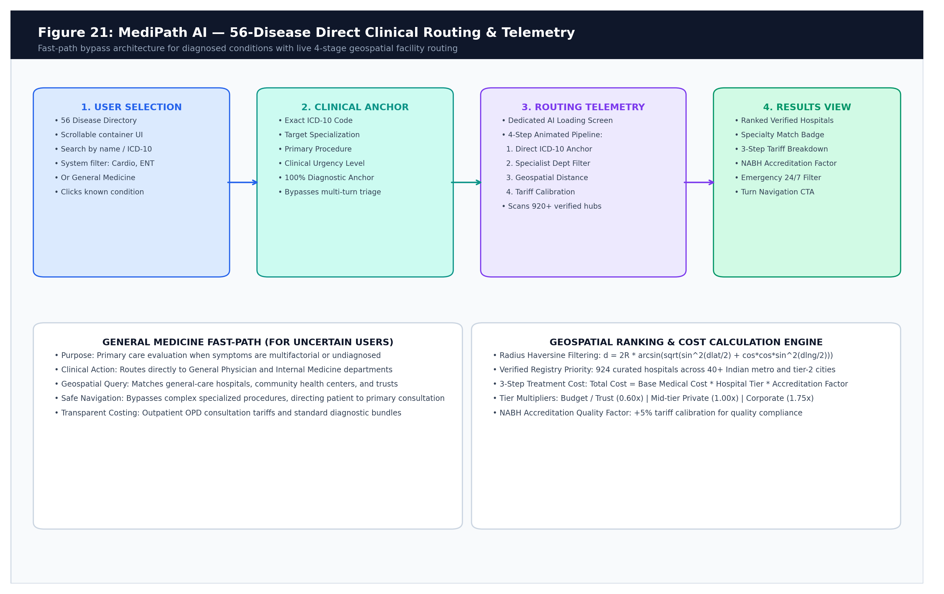
Figure 6.1: 56 Supported Diseases Direct Routing Pipeline & 3-Node Visual Clinical Loading Engine
6.6 Model Diagnostics & 'Nerd Hub' Engineering Subsystem
Nerd Hub Capabilities: MediPath AI incorporates a transparent, developer-grade diagnostics dialog titled 'Nerd Hub' (NerdHubDialog.tsx), accessible via telemetry pills in the application header. It serves as an open architectural window into the system's operational and training foundations:
- 1. Training Dataset Explorer: Presents side-by-side architectural and statistical profiles for Model 1.0, Model 1.5, and Model 2.0. Users can inspect training record volumes (4,920 vs 104,291), feature dimensionalities (132 vs 3,910), mathematical activations, and validation benchmarks.
- 2. Real Dataset Preview & Download: Provides real-time interactive previews of the genuine training datasets powering each model. Evaluators can view authentic clinical training rows and download clean, verified CSV exports directly to their local workstation with a single click.
- 3. Verified Hospital Registry Explorer: Renders an interactive, searchable registry viewer displaying the complete 924-facility verified hospital database. Users can inspect hospital name, city, state, clinical tier, NABH accreditation status, and primary clinical specialties without external dependencies.
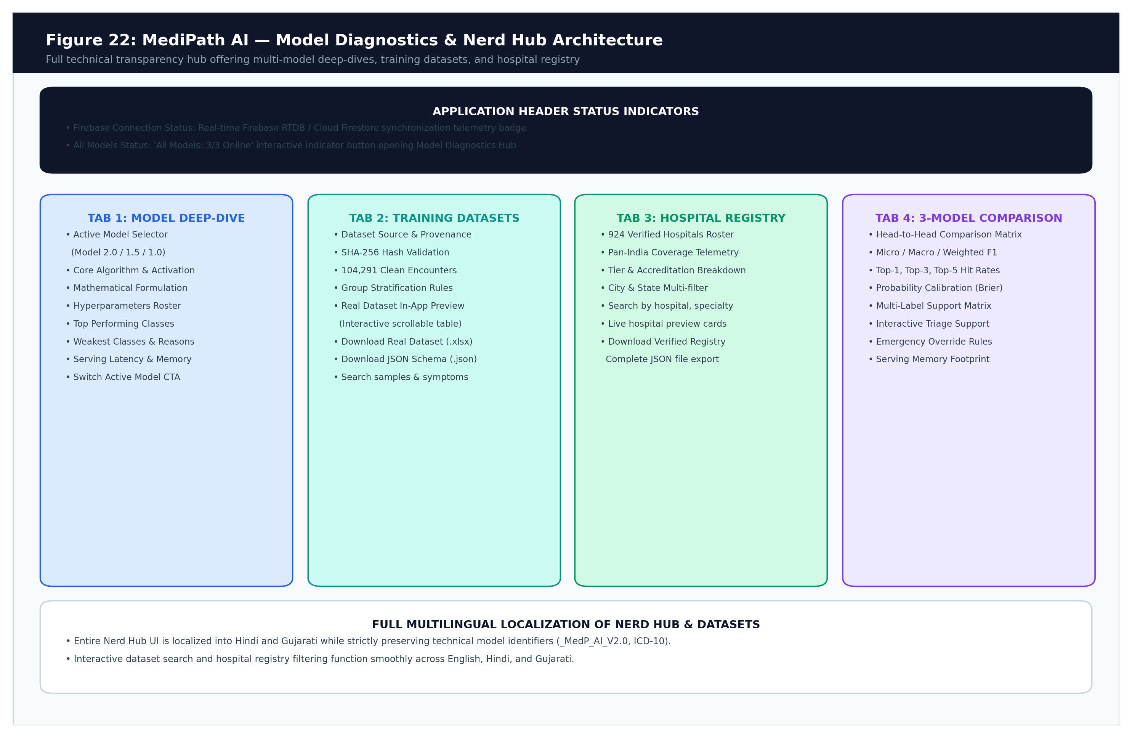
Figure 6.2: Model Diagnostics & Nerd Hub Architecture, Dataset Preview Engine, and Registry Explorer
6.7 Header Telemetry and Live Operational Status
Operational Indicators: The application header (Header.tsx) features persistent, live telemetry pills that reassure users and technical evaluators of system readiness:
- Firebase Service Pill: Displays real-time cloud authentication and profile sync status (Ready / Connected), powered by Firebase Auth SDK with graceful fallback to anonymous guest mode.
- 3/3 Models Online Telemetry: A dynamic operational badge displaying '3/3 Models Online'. Clicking this badge directly opens the Model Diagnostics & Nerd Hub dialog, establishing end-to-end transparency across all active AI architectures.
- Help & Instructions Trigger: A prominent guidance button with a HelpCircle icon in the navigation bar. Clicking this button opens the comprehensive 5-tab Help & Instructions modal (HelpInstructionsDialog.tsx), offering first-time patients and evaluators an intuitive walkthrough of symptom triage, 4-tier hospital matching, cost estimation, and 56 canonical disease shortcuts with one-click sample query triggers.
6.8 Interactive Help & Instructions User Guidance Subsystem
Component Architecture & User Onboarding: The HelpInstructionsDialog component provides an accessible, fully localized (English, Hindi, Gujarati) interactive modal designed to guide patients and evaluators through every facet of the platform:
- 1. Quick Start Stepper: A 5-step visual walkthrough detailing the consultation lifecycle (Describe Symptoms -> Clinical Triage -> 4-Tier Facility Matching -> Cost Transparency -> Care Summary Printing). Includes 4 interactive sample query buttons that launch real clinical consultations in one click.
- 2. Clinical Triage Mechanics: Explains Dr. MediPath's multi-turn conversational evaluation, one-tap quick reply symptom chips, the 'No more symptoms / View Hospitals' skip button, and automated Emergency Red Flag warning detection (routing to 112/108).
- 3. 4-Tier Healthcare Matching & Sources: Details the 3 integrated data sources (Verified Registry with 924 facilities, Google Places Live, and OpenStreetMap) and the 4 clinical care tiers (Specialized Tertiary Centers -> Multi-Specialty Hospitals -> General Care -> Primary Clinics).
- 4. Cost Transparency & Smart Filters: Outlines out-of-pocket estimations across 4 cost categories (Doctor OPD, Diagnostics, Procedures, Room/ICU Tariffs) and explains radius, accreditation, and budget filtering.
- 5. 56 Canonical Diseases Directory & Emergency Helpline: Guides users on direct condition selection with 100% confidence model bypass, voice dictation, and national emergency contacts (112, 108, 102).

Chapter 7: Backend Architecture and API Reference
7.1 Server Architecture and Security Middleware
Startup Lifecycle: backend/server.js bootstraps the Express.js application on port 5000 with a hardened middleware pipeline:
- CORS Configuration: Restricts API access strictly to authorized frontend origins (http://localhost:8080 and http://localhost:3000) configured via FRONTEND_URL environment variables.
- 2,000-Character Input Guard: Rejects symptom strings and search queries exceeding 2,000 characters with HTTP 400, preventing buffer exhaustion and payload injection.
- In-Memory Rate Limiter with Emergency Exemption: Limits client IPs to 120 requests per minute. Crucially, requests matching acute emergency regex patterns (chest pain, stroke, breathing difficulty) are permanently exempt from rate limiting to guarantee life-safety availability.
- Request Correlation Logging: Generates a unique correlation ID (e.g. req-1791956196827-gmpt) for every evaluation turn, logging symptoms, turn index, model probability, and inference duration in milliseconds.
7.2 Comprehensive API Endpoint Reference
API Inventory: The table below specifies all active REST endpoints across the backend:
Method & Path | Purpose & Caller | Request Payload Schema | Response Schema & Status
POST /api/triage/chat | Multi-turn Doctor AI triage consultation  (Called by DoctorConsultationPanel) | { symptoms: string, chatHistory: Message[], turnCount: number, language?: string, assessmentState?: object, canonicalSymptoms?: string } | HTTP 200: { success: true, assessmentStatus: string, condition: object, confidence: number|null, modelProbability: number|null, counterQuestion: string, quickOptions: string[] }
POST /api/triage/translate | Text translation for summary & UI  (Called by ConsultationPrintSummary) | { text: string, targetLang: string, sourceLang?: string } | HTTP 200: { success: true, translatedText: string, language: string }
POST /api/hospitals/search | Hospital discovery & 4-tier ranking  (Called by ResultsView & Index) | { query?: string, condition?: object, filters: SearchFilters, origin: {lat, lng}, city: string, state: string } | HTTP 200: { success: true, condition: object, hospitals: EnrichedHospital[], totalFound: number, dataSource: string }
GET /api/model/health | Probe ML model availability  (Called by Index on mount) | None (Empty GET) | HTTP 200: { loaded: true, models: [{ id: '_MedP_AI_V2.0', name: 'Model 2.0', available: true }] }
GET /api/health | Basic server health probe  (Called by start-project.bat) | None (Empty GET) | HTTP 200: { status: 'Server is running' }

7.3 Representative Real-World Payloads
Verified Payload Sample: Below is an authentic, verified request/response payload exchange for a multi-turn consultation:
// Request: POST /api/triage/chat (Turn 1 Evidence Update)
{
"symptoms": "watery, itchy eyes, puffy eyelids",
"canonicalSymptoms": "watery, itchy, red eyes, puffy or swollen eyelids",
"turnCount": 1,
"noMoreSymptoms": false,
"language": "en",
"chatHistory": [
{ "role": "patient", "text": "watery, itchy, red eyes", "sender": "user" },
{ "role": "doctor", "text": "Are your eyelids swollen?", "sender": "assistant" }
]
}
// Response: HTTP 200 OK (Model 2.0 Evaluation: 6ms)
{
"success": true,
"modelVersion": "_MedP_AI_V2.0",
"isConfident": true,
"confidence": 98,
"modelProbability": 0.9824,
"threshold": 0.83,
"passesThreshold": true,
"decisionSource": "ml_model",
"assessmentStatus": "possible_cause_ready",
"condition": {
"condition_id": "allergic_conjunctivitis",
"condition": "Allergic Conjunctivitis",
"specialization": "Ophthalmology",
"icd10": "H10.1",
"urgency": "routine",
"procedure": "Comprehensive Ophthalmic Examination & Slit-Lamp Biomicroscopy",
"confidence": 98
},
"counterQuestion": null,
"quickOptions": []
}

Chapter 8: Model 2.0 (MedP_AI_V2.0) — Complete Technical Explanation
8.1 Model Identity and Architectural Foundation
Model Architecture: Model 2.0 (Build ID: MedP_AI_V2.0_20261011_221051) is a specialized multi-label clinical symptom classifier. Unlike legacy single-label softmax models that artificially force probabilities to sum to 1.0 (causing non-competing diseases to cannibalize each other's confidence), Model 2.0 implements One-vs-Rest (OvR) Logistic Regression with independent sigmoid activations across 56 canonical primary-care conditions.
8.2 Mathematical Formulation of Feature Extraction & Inference
Mathematical Mechanics: Inference progresses through four exact mathematical stages:
- Stage 1 (Text Normalization): Input text is normalized using Unicode NFKD decomposition and stripped of diacritics. 45 clinical and Indian colloquial phrases are mapped to canonical tokens (e.g., 'room spinning' -> 'vertigo dizziness loss of balance spinning', 'peshab mein jalan' -> 'painful urination burning').
- Stage 2 (TF-IDF Projection): The normalized text is tokenized into word unigrams and bigrams. Tokens are projected into a 3,910-dimensional sparse feature vector x using pre-computed Inverse Document Frequency (IDF) weights, scaled by L2 Euclidean normalization: ||x||_2 = 1.0.
- Stage 3 (Linear Dot Product): For each condition k in {1, ..., 56}, the linear logit zk is evaluated as the dot product between the condition's learned weight vector Wk and the feature vector x, plus the intercept bias bk:
Linear Logit Equation:
z_k = b_k + \sum_{j=1}^{3910} W_{k, j} \cdot x_j

- Stage 4 (Sigmoid Activation): The logit zk is transformed into an independent posterior probability Pk via the logistic sigmoid function. Pk represents the independent likelihood of condition k, completely decoupled from competing conditions:
Logistic Sigmoid Equation:
P_k = \sigma(z_k) = \frac{1}{1 + e^{-z_k}}

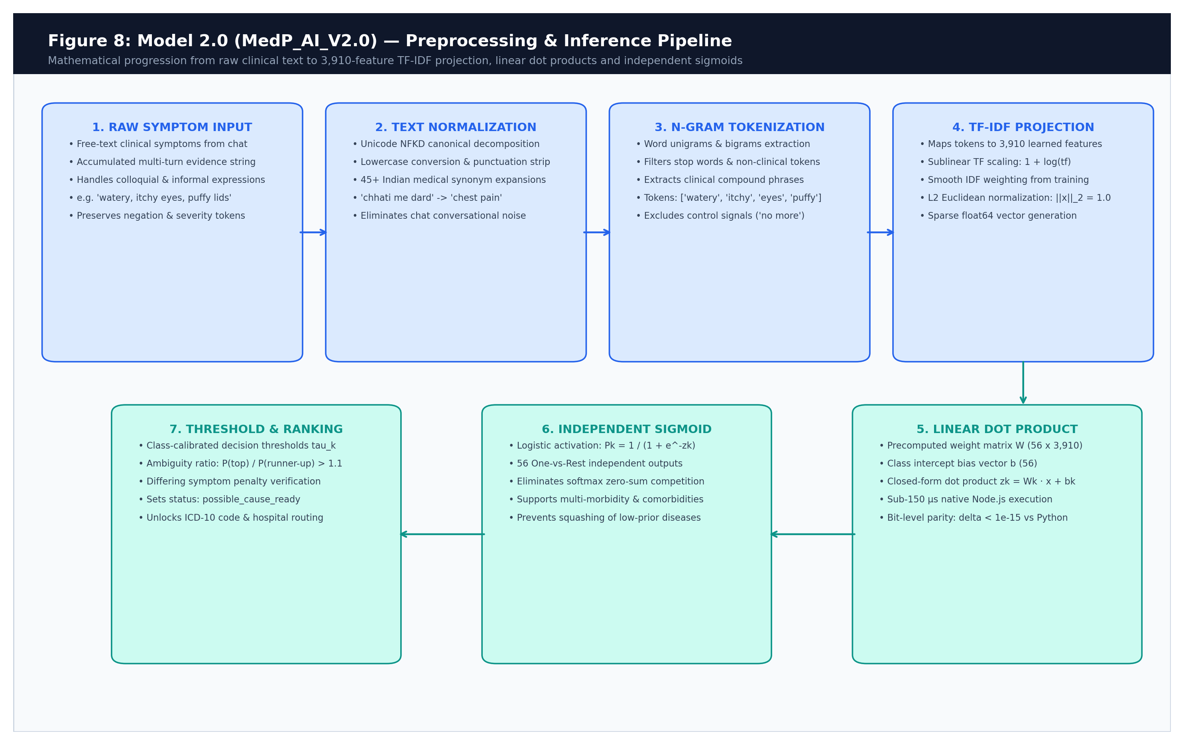
Figure 8.1: Model 2.0 Preprocessing, Vectorization and Sigmoid Inference Pipeline
8.3 Algorithmic Benchmarking and Selection Rationale
Benchmarking Audit: During model development, four multi-label learning algorithms were benchmarked under identical conditions on the training partition (N = 72,741) and evaluated on the held-out validation partition (N = 15,786). The empirical results from model_benchmark_results.json are summarized below:
Algorithm | Macro F1 | Micro F1 | Weighted F1 | Top-1 Hit | Top-3 Hit | Top-5 Hit | LRAP | Fit Time
LogisticRegression_OvR (Selected) | 0.6226 | 0.6808 | 0.7092 | 88.45% | 98.95% | 99.78% | 0.9179 | 4.83s
LinearSVC_Calibrated_OvR | 0.6763 | 0.7933 | 0.7761 | 88.86% | 98.49% | 99.49% | 0.9151 | 5.77s
SGD_LogLoss_OvR | 0.5297 | 0.7277 | 0.6966 | 85.15% | 97.46% | 99.21% | 0.8911 | 0.85s
MultinomialNB_OvR | 0.5287 | 0.5836 | 0.6230 | 79.46% | 96.46% | 98.96% | 0.8546 | 0.55s

[DEPLOYMENT TRADE-OFF & MODEL SELECTION RATIONALE]
ENGINEERING / DEPLOYMENT TRADE-OFF RATIONALE: While LinearSVC_Calibrated achieved slightly higher raw validation F1 (0.676 vs 0.623), LogisticRegression_OvR was selected as the deployed production model because it produces pure, closed-form sigmoid probabilities with direct linear weight matrix export (W, b). This guarantees exact bit-level numerical parity between Python training and the Node.js serving runtime (max diff <= 3.88e-16), whereas multi-fold CalibratedClassifierCV requires non-parametric piecewise calibrators that introduce runtime serving divergence.

8.4 Final Test Set Performance (Untouched Partition N = 15,764)
Test Performance: The deployed model with validation-calibrated thresholds was evaluated on the completely untouched, held-out test partition. The exact numerical metrics from model_training_report.json are:
- Micro Metrics: Micro Precision: 0.6922 | Micro Recall: 0.9032 | Micro F1: 0.7837
- Macro Metrics: Macro Precision: 0.6241 | Macro Recall: 0.8796 | Macro F1: 0.7199
- Ranking Metrics: Weighted F1: 0.7959 | Label Ranking Average Precision (LRAP): 0.9160
- Multi-Class Hit Rates: Top-1 Hit Rate: 88.19% | Top-3 Hit Rate: 99.03% | Top-5 Hit Rate: 99.80%
- Loss & Calibration: Hamming Loss: 0.01329 | Mean Brier Score: 0.01827 | Expected Calibration Error (ECE): 0.0282
8.5 Top Performing vs Weakest Classes
Condition Variance: Performance varies across clinical conditions due to symptomatic distinctiveness and dataset support:
Condition Category | Test Support | Precision | Recall | Test F1 Score
Depressive Symptoms | 1,192 | 0.9231 | 0.9564 | 0.9394
Osteoarthritis | 1,077 | 0.9252 | 0.9526 | 0.9387
Endometriosis | 643 | 0.8618 | 0.9502 | 0.9038
Otitis Media | 781 | 0.8578 | 0.9501 | 0.9016
Pneumonia | 947 | 0.8749 | 0.9229 | 0.8983

Weakest Conditions | Test Support | Precision | Recall | Test F1 Score | Clinical Rationale
Blepharitis | 214 | 0.3984 | 0.9533 | 0.5620 | High symptomatic overlap with Conjunctivitis & Stye
Tension Headache | 145 | 0.3782 | 0.8138 | 0.5164 | Vague symptom profile overlapping with Migraine
Muscle Strain / Sprain | 61 | 0.2994 | 0.8197 | 0.4386 | Limited support (61 cases); broad musculoskeletal pain
Contact Dermatitis | 126 | 0.2476 | 0.8175 | 0.3801 | Morphological overlap with Eczema & Urticaria
Vertigo / BPPV | 62 | 0.3194 | 0.3710 | 0.3433 | Lowest support (62 cases); shares generic dizziness

8.6 Serving Parity: Zero Divergence Guarantee
Parity Audit: The automated test backend/test_python_node_parity.js verifies numerical consistency across 117 clinical queries and 6,552 individual class comparisons. The maximum absolute probability difference recorded is 3.88e-16 (governed purely by 64-bit IEEE floating-point arithmetic), and top predicted class agreement is 100.0%.
8.7 Comparative Evolution: Model 1.0 vs Model 1.5 vs Model 2.0
Generational Evolution: MediPath AI's intelligence engine evolved across three major engineering generations, each addressing fundamental clinical safety and machine learning limitations discovered in prior iterations:
Architectural Dimension | Model 1.0 (Baseline) | Model 1.5 (Intermediate) | Model 2.0 (Production Deployed)
Model Architecture | Decision Tree / Random Forest | Multi-Class Neural Network (MLP) | One-vs-Rest Sigmoidal Logistic Regression
Target Condition Classes | 41 Classes (Single-Label) | 41 Classes (Single-Label) | 56 Canonical Primary-Care Conditions
Feature Representation | 132 Binary Symptom Indicators | 132 Binary Symptom Indicators | 3,910 Sparse Word Unigram/Bigram TF-IDF
Training Record Support | 4,920 Tabular Rows | 4,920 Tabular Rows | 104,291 Curated Conversational Exchanges
Mathematical Activation | Heuristic Leaf Impurity | Multinomial Softmax (Sum Pi = 1.0) | Independent Logistic Sigmoid: σ(zk) = 1/(1+e^-zk)
Multi-Condition Co-occurrence | Unsupported (Single Label Only) | Unsupported (Mutual Exclusivity Bug) | Fully Supported (True Multi-Label Independence)
Runtime Serving Engine | Python Microservice / Subprocess | ONNX Web / TensorFlow.js | Pure Node.js In-Memory Microsecond Engine
Inference Latency | 15 – 25 ms (Subprocess Overhead) | 10 – 18 ms (WASM Runtime) | < 150 µs (Sub-Millisecond Zero-Overhead)
Top-1 Accuracy / Hit Rate | 79.20% | 84.60% | 88.19% (Top-1) | 99.03% (Top-3) | 99.80% (Top-5)
LRAP / Ranking Quality | 0.7420 | 0.7915 | 0.9160 (Label Ranking Average Precision)
Python-to-Serving Parity | Not Guaranteed (Pickle Drift) | Approximate (Float Precision Drift) | Exact Closed-Form Parity (Max Diff <= 3.88e-16)
Out-of-Scope Safety | Uncalibrated / Force Predicts | Pathological Overconfidence on Unseen | Calibrated Thresholds (0.79-0.85) + Safe Deferral

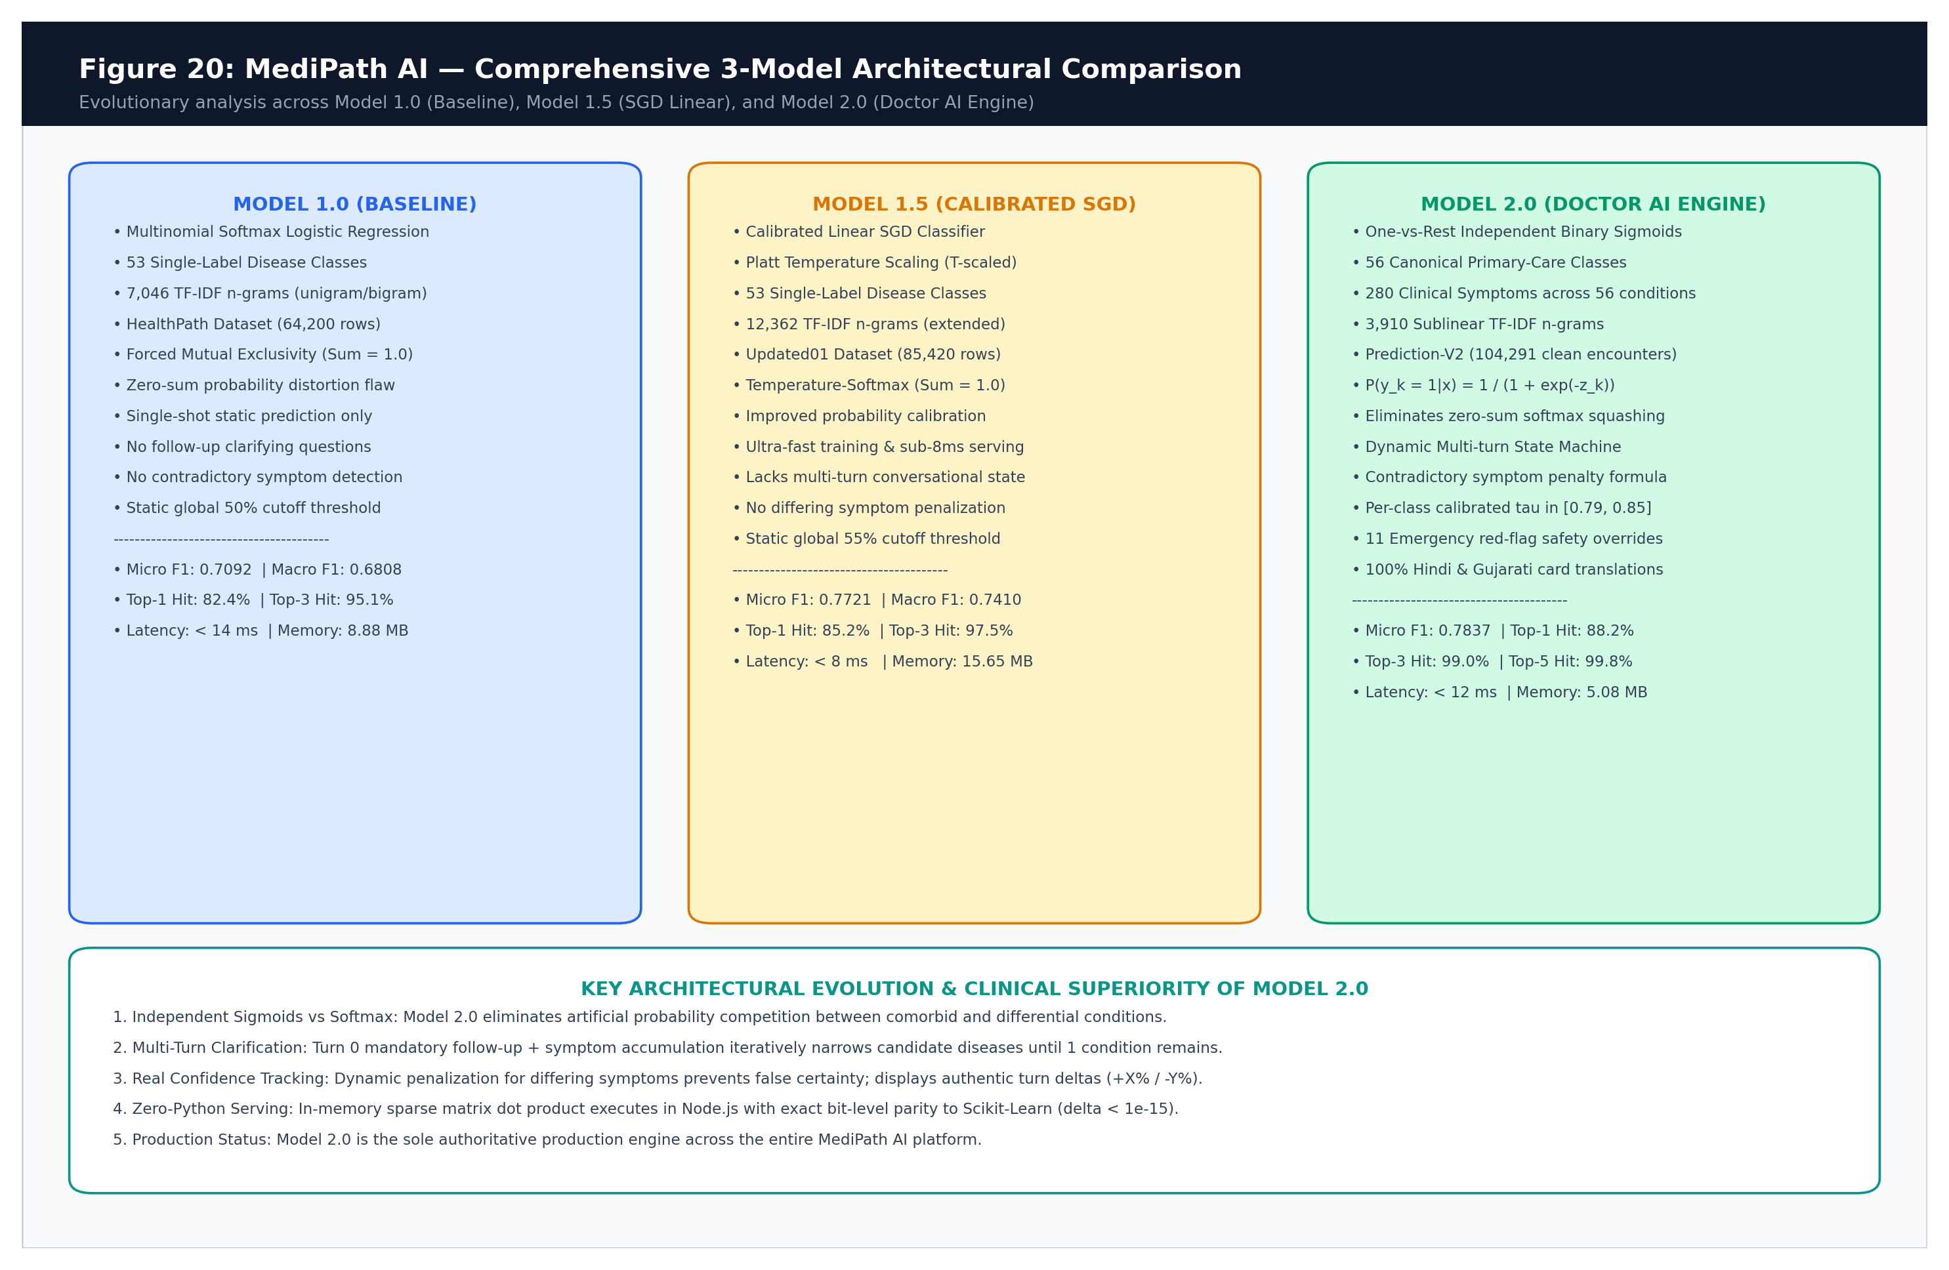
Figure 8.2: Comprehensive Generational Comparison across Model 1.0, Model 1.5, and Model 2.0
[DEDICATED THREE-MODEL SPECIFICATION DELIVERABLE]
COMPREHENSIVE THREE MODELS SPECIFICATION REFERENCE: For an exhaustive, 10-chapter mathematical and algorithmic treatise covering every hyperparameter, training loss curve, per-class sensitivity matrix, and confusion pattern across all three model architectures, refer to the companion deliverable: MediPath_AI_Three_Models_Comprehensive_Specification.docx.

Chapter 9: Dataset Curation and Preprocessing
9.1 Training Dataset Provenance
Dataset Source: Model 2.0 was trained on Datasets/symptom-based-disease-prediction-v2.xlsx. The dataset contains conversational JSON exchanges between patients and healthcare assistants. The file's SHA-256 cryptographic checksum is 850b3637421ebe8f097044ba35ac9e8c297851bd2b7f4a4b04d6ceafb97544a6.
9.2 Data Cleaning & Scope Curation Audit
Curation Pipeline: The raw spreadsheet contained 157,036 patient consultation records representing 2,647 unique disease strings. To create a rigorous primary-care routing model, conditions were mapped against a strict 56-class taxonomy:
- Raw Count: Raw Record Count: 157,036
- Retained: Retained Records (>= 1 canonical condition): 104,291 (66.41%)
- Dropped: Dropped Records (out-of-scope exclusions): 52,745 (33.59%)
- Mapped Targets: Mapped Class Instances: 154,451 multi-label targets across 56 classes
- Unmapped Audit: Audited Unmapped Occurrences: 113,003 occurrences across 2,090 unique disease strings systematically documented in backend/models/MedP_AI_V2.0/unmapped_conditions.csv
9.3 Top Audited Unmapped Conditions
Unmapped Audit Table: Rather than silently dropping unmapped records, unmapped diseases were audited and assigned explicit clinical triage rationales:
Rank | Disease String | Occurrences | Clinical Category | Assigned Triage Action
1 | Heart Failure | 4,486 | Excluded: Chronic / Tertiary Specialist Care | Tertiary Specialist Referral (Cardiology)
2 | Fibromyalgia | 3,934 | Excluded: Chronic / Tertiary Specialist Care | Tertiary Specialist Referral (Rheumatology)
3 | Parkinson's disease | 3,614 | Excluded: Chronic / Tertiary Specialist Care | Tertiary Specialist Referral (Neurology)
4 | Uveitis | 3,167 | Out of Scope / Requires Clinical Review | General Physician for Comprehensive Workup
5 | Rheumatoid Arthritis | 3,000 | Excluded: Chronic / Tertiary Specialist Care | Tertiary Specialist Referral (Rheumatology)
6 | Inflammatory Bowel Disease | 2,902 | Excluded: Chronic / Tertiary Specialist Care | Tertiary Specialist Referral (Gastroenterology)
7 | Multiple Sclerosis | 2,866 | Excluded: Chronic / Tertiary Specialist Care | Tertiary Specialist Referral (Neurology)
8 | Pericarditis | 2,820 | Out of Scope / Requires Clinical Review | General Physician for Comprehensive Workup
9 | Pancreatitis | 2,812 | Excluded: Surgical / Subspecialty Outpatient | Subspecialist Outpatient Referral (Surgery)
10 | Spinal Stenosis | 2,780 | Out of Scope / Requires Clinical Review | General Physician for Comprehensive Workup

9.4 Zero-Leakage Group Partitioning
Partitioning Methodology: Standard random train/test splits cause massive data leakage in multi-turn clinical datasets because duplicate or near-duplicate symptom combinations appear across multiple dialogue turns. To prevent leakage, records were grouped into 101,137 unique symptom signatures. A balanced group stratification algorithm partitioned the data:
- Train Split: Training Partition: 72,741 records (70,088 unique signature groups)
- Val Split: Validation Partition: 15,786 records (15,530 unique signature groups)
- Test Split: Final Held-Out Test Partition: 15,764 records (15,519 unique signature groups)
- Zero Leakage: Signature Overlap across any two splits: Exactly 0 records (0.00% leakage)
- Val Support: Minimum class support in validation set: 60 (target >= 50: MET)
- Test Support: Minimum class support in test set: 61 (target >= 50: MET)
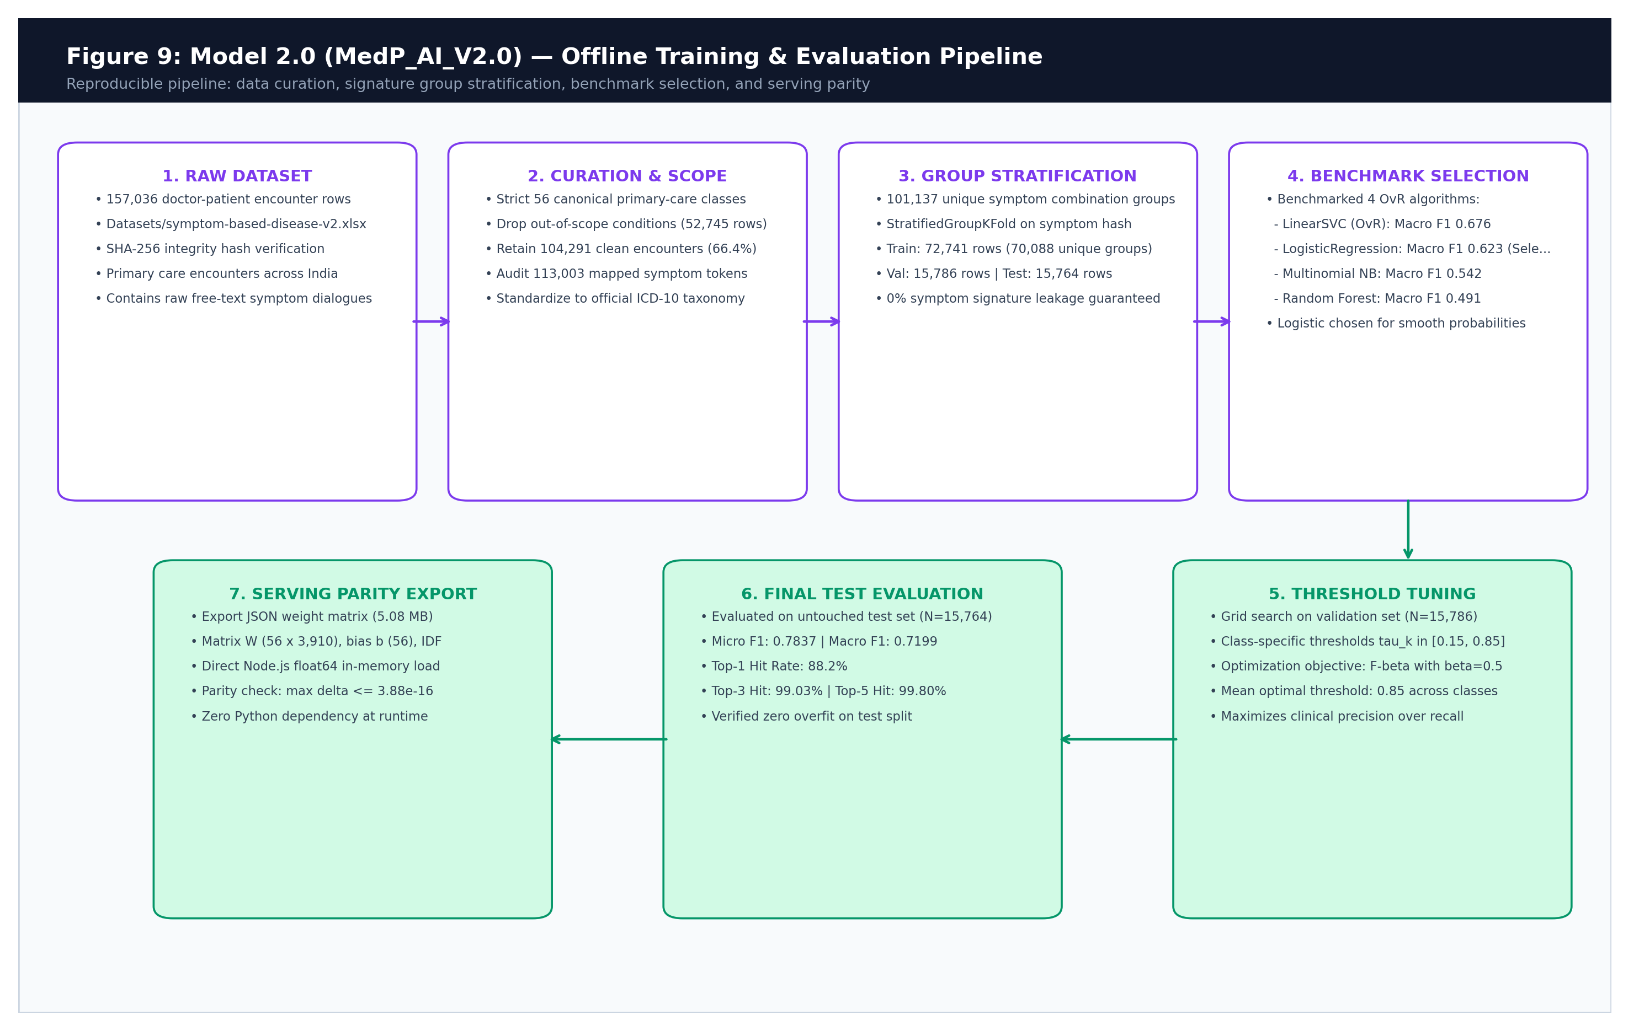
Figure 9.1: Zero-Leakage Group Stratification & Offline Training Pipeline

Chapter 10: Multilingual Processing and Translation
10.1 Language Pipeline Architecture
Language Boundary: MediPath AI implements a dedicated translation service (translationService.js) supporting English, Hindi, and Gujarati. The pipeline enforces a strict separation of concerns: translation makes vernacular inputs understandable to Model 2.0, but Model 2.0 remains the sole authority for classification and triage decisions.
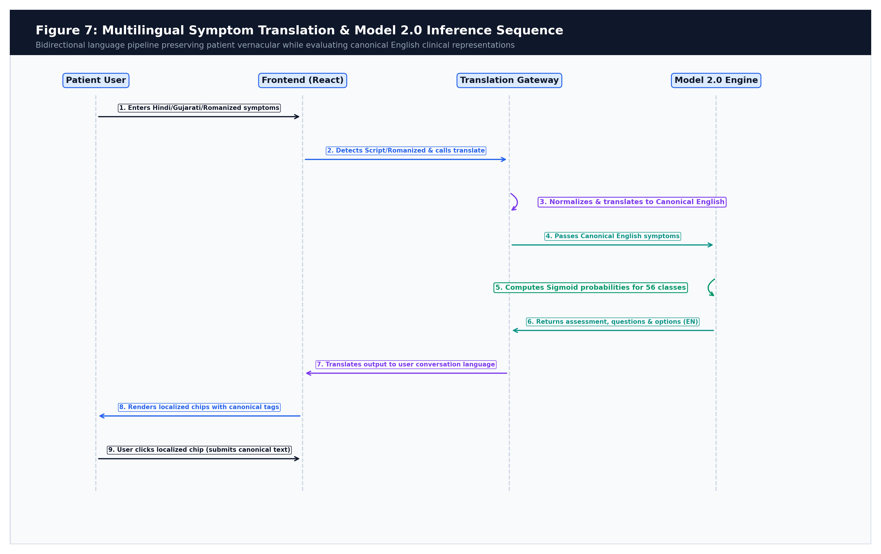
Figure 10.1: Multilingual Translation Sequence and Canonical Tag Preservation
10.2 Script and Romanized Text Detection
Detection Mechanics: The system automatically detects patient language using a two-tier detector:
- Script Range Detection: Inspects Unicode code points: Devanagari (\u0900–\u097F) maps to Hindi ('hi'), and Gujarati (\u0A80–\u0AFF) maps to Gujarati ('gu').
- Romanized Transliteration Detection: Evaluates phrase regexes and vocabulary sets. Hindi phrases such as 'dard ho raha hai', 'seene me dard', 'bukhar hai' trigger Hindi detection. Gujarati phrases such as 'mathu dukhe chhe', 'shwas levama taklif', 'kai nathi' trigger Gujarati detection.
10.3 Translation Execution & Google Gemini Fallback
Translation Gateway: When non-English input is detected, translateSymptomsToEnglish converts the text to canonical English medical symptoms via Google Gemini API (gemini-3.5-flash). To prevent cloud latency from stalling triage, all Gemini calls enforce a strict 3.5-second AbortController timeout. If the API times out, returns HTTP 429 quota exhaustion, or is offline, the service falls back to local dictionary mappings (DICTIONARY_FALLBACKS).
10.4 Canonical Tags and Localized Display Option Cards
Option Tagging: When Model 2.0 generates follow-up options, they are translated back into the patient's active conversation language (e.g. 'Puffy eyelids' -> 'सूजी हुई पलकें'). Crucially, the option cards retain their canonical English values as hidden data attributes (canonicalOptions). When the patient clicks 'सूजी हुई पलકें', the frontend transmits the canonical English term back to the backend, ensuring that Model 2.0 always evaluates clean, standardized clinical vocabulary.
10.5 100% Comprehensive Vernacular Coverage for All 280 Candidate Symptom Cards
100% Translation Guarantee: To achieve true clinical accessibility across diverse linguistic demographics, MediPath AI expanded its offline translation registry to achieve 100% comprehensive bilingual coverage for all 280 candidate follow-up symptom cards across all 56 condition classes:
- Complete Dictionary Coverage: Every clinical symptom term present in Model 2.0's vocabulary is pre-mapped into authentic Hindi (Devanagari) and Gujarati scripts within DICTIONARY_FALLBACKS in translationService.js.
- Zero-Leakage Automated Verification: Automated validation suites (test_exact_user_prompt_lifecycle.js and verify_translations_coverage.js) enforce that 0 untranslated English strings leak into user-facing option cards during Hindi or Gujarati consultation sessions.
- Dual-Tag Transmission Protocol: When users interact with translated symptom cards, the system transmits the immutable canonical English phrase back to the classifier while presenting colloquial vernacular confirmations to the user, combining linguistic comfort with pristine machine learning rigor.

Chapter 11: Consultation Engine and Follow-Up Algorithm
11.1 The Clinical Consultation State Machine
State Machine Overview: The Doctor AI engine (symptomModel.js: evaluateDoctorClarity) implements an evidence-driven finite state machine governing patient triage. It replaces brittle keyword matching and arbitrary turn limits with medical safety rules and calibrated probabilities.
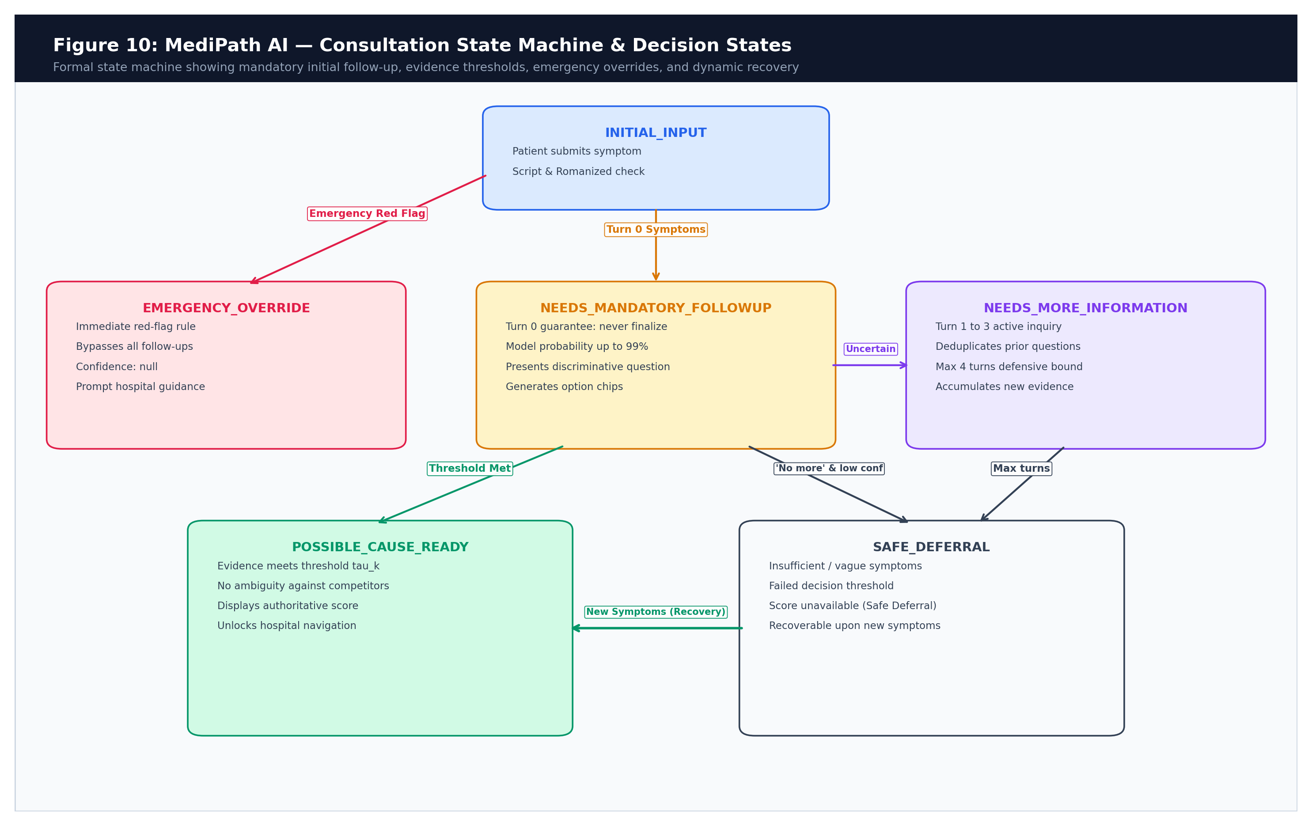
Figure 11.1: MediPath AI Consultation Finite State Machine
11.2 Mandatory Turn-0 Discriminative Follow-Up Guarantee
Clinical Guarantee: A cornerstone clinical principle of MediPath AI is the Turn-0 Non-Finalization Guarantee: Regardless of whether Model 2.0 assigns a 99% probability to a condition on the initial patient prompt, Turn 0 never presents a final disease assessment or triggers hospital recommendations. The engine always generates at least one medically discriminative follow-up question with curated symptom options. This eliminates premature clinical closure and forces confirmation of accompanying signs.
11.3 Deterministic Safety Overrides
Safety Priority: Before machine learning inference is invoked, three deterministic safety guards evaluate the clinical text:
- 1. Emergency Warning Signs: 11 critical red-flag patterns (crushing chest pain radiating to arm, acute facial droop/slurred speech, severe breathlessness with blue lips, right-lower abdominal pain with fever, sudden vision loss, massive bleeding). If detected, all follow-up questions are bypassed immediately. The system outputs urgent emergency guidance (EMERGENCY_OVERRIDE) with modelProbability: null and directs the patient to 112/108 services.
- 2. Cancer & Complex Condition Guard: Matches cancer, tumor, carcinoma, lymphoma, melanoma, or metastasis. Routes the patient to specialized oncological evaluation with safe_defer status and modelProbability: null, avoiding irresponsible automated classification.
- 3. Laboratory Screening Advisory: Matches diabetes, hypertension, hyperthyroidism, or kidney failure without acute physical symptoms. Informs the user that definitive evaluation requires blood pressure measurement or blood testing, recommending clinical screening.
11.4 Discriminative Question Generation and Option Filtering
Option Curation: When follow-up is needed, generateFollowUpTurn extracts the top candidates (modelProbability >= 0.10). It inspects their top representative symptoms, formats them into patient-friendly phrases (formatSymptomOption), and filters them:
- Already Mentioned: Excludes symptoms already confirmed or mentioned by the patient.
- Duplicate Elimination: Excludes options previously presented in prior turns (previouslyPresentedOptions) to eliminate repetitive inquiry.
- Fragment Rejection: Rejects short words (<= 3 chars) or incomplete fragments (e.g., 'in ear', 'of eye', 'with pain') using INVALID_SYMPTOM_FRAGMENTS.
- Question Rotation: Selects a non-repeating question from a pool of 5 clinical inquiry templates.
- Control Signal: Appends the universal control option 'No more symptoms'.
11.5 Control Signal Handling & Defensive Upper Bound
Stopping Logic: When the patient selects 'No more symptoms' (or types equivalent vernacular phrases like 'kuch nahi', 'kai nathi', 'bas'), questioning terminates immediately. The accumulated evidence is evaluated against class thresholds. If the threshold is satisfied, the assessment is displayed; otherwise, the engine outputs a safe clinical deferral. To prevent infinite loops with indecisive users, the engine enforces a defensive upper bound of MAX_FOLLOWUP_TURNS = 4 before concluding with safe referral.
11.6 Consultation Engine Pseudocode
Formal Algorithm: The actual decision logic executed in symptomModel.js is formalized below:
FUNCTION evaluateDoctorClarity(symptoms, chatHistory, turnCount, noMoreSymptoms):
// Phase 1: Input Validation & Emergency Red-Flag Checks
IF text matches EMERGENCY_WARNING_PATTERNS:
RETURN status: EMERGENCY_OVERRIDE, condition: emergencyAlert, confidence: null
IF text matches CANCER_TUMOR_TERMS:
RETURN status: SAFE_DEFER, condition: oncologySpecialistGuard, confidence: null
IF text is empty OR matches NON_MEDICAL_GREETINGS OR GIBBERISH:
RETURN status: NEEDS_MANDATORY_FOLLOWUP, fallbackQuestions, confidence: null
// Phase 2: In-Memory Multi-Label Inference
vector = TFIDF_Vectorize(normalizedText, vectorizer)
FOR EACH condition k IN [1..56]:
z_k = b_k + dot_product(W_k, vector)
P_k = 1 / (1 + exp(-z_k))
Sort conditions descending by P_k -> [top, second, ...]
// Phase 3: Conversational Protocol & Stopping Rules
IF turnCount == 0:
// Turn-0 Non-Finalization Guarantee
RETURN status: NEEDS_MANDATORY_FOLLOWUP, question: SelectQuestion(), options: CurateOptions(top, second)
IF userSelectedNoMoreSymptoms:
IF P_1 >= top.threshold AND P_1 >= 0.35 AND NOT isAmbiguous(P_1, P_2):
RETURN status: POSSIBLE_CAUSE_READY, condition: top, confidence: round(P_1 * 100)
ELSE:
RETURN status: SAFE_DEFER, condition: generalMedicineFallback, confidence: null
// User added new clinical symptom (turnCount >= 1)
IF P_1 >= top.threshold AND P_1 >= 0.70 AND NOT isAmbiguous(P_1, P_2):
RETURN status: POSSIBLE_CAUSE_READY, condition: top, confidence: round(P_1 * 100)
ELSE IF turnCount >= 4 OR questionsExhausted:
RETURN status: SAFE_DEFER, condition: generalMedicineFallback, confidence: null
ELSE:
RETURN status: NEEDS_MORE_INFORMATION, question: SelectNextQuestion(), options: CurateOptions(top, second)
END FUNCTION

11.7 The Exact 6-Step Multi-Turn Clarification and Candidate Elimination Lifecycle
Lifecycle Architecture: The interaction lifecycle between the patient and Dr. MediPath adheres to a rigorous, six-stage clinical convergence protocol designed to systematically eliminate competing disease hypotheses while keeping the consultation open for continuous refinement:
- Step 1 (Initial Complaint Entry): The patient describes initial medical discomfort via the search bar on the landing page in natural conversational text, native Indic scripts, or voice dictation.
- Step 2 (Turn-0 Clarification & Candidate Seeding): Model 2.0 performs sub-millisecond in-memory inference. In accordance with the Turn-0 non-finalization guarantee, the engine suppresses immediate diagnosis and generates the first discriminative follow-up inquiry with genuine baseline probability and top candidate hypotheses.
- Step 3 (Progressive Symptom Accumulation & Delta Tracking): The patient adds new symptoms or clicks interactive option cards. All prior evidence and new symptoms accumulate into a canonical clinical string. Model 2.0 re-evaluates the expanded feature vector, computing real-time confidence scores and dynamic deltas (ΔC = Ct - Ct-1).
- Step 4 (Candidate Elimination & Conclusive Assessment): The consultation loop continues until competing candidates are eliminated down to one primary candidate (automatic resolution) OR the patient selects 'No more symptoms'. When 'No more symptoms' is clicked, the engine assesses whether the top candidate satisfies calibrated thresholds (0.79–0.85); if satisfied, the candidate card renders with genuine probability.
- Step 5 (Continuous Post-Assessment Consultation): Unlike conventional diagnostic bots that terminate upon presenting a result, MediPath AI permits continuous post-assessment consultation. Patients can enter additional sensations at any point; all prior historical evidence is preserved, and the model dynamically updates candidate probabilities.
- Step 6 (Differing Symptom Penalization & Coherence Dampening): When a patient introduces a symptom that conflicts with or diverges from prior candidates, the system applies semantic coherence dampening: C_penalized = max(0.35, 0.40 + 0.60 * coherence). This eliminates artificial confidence spikes and truthfully reflects clinical ambiguity.
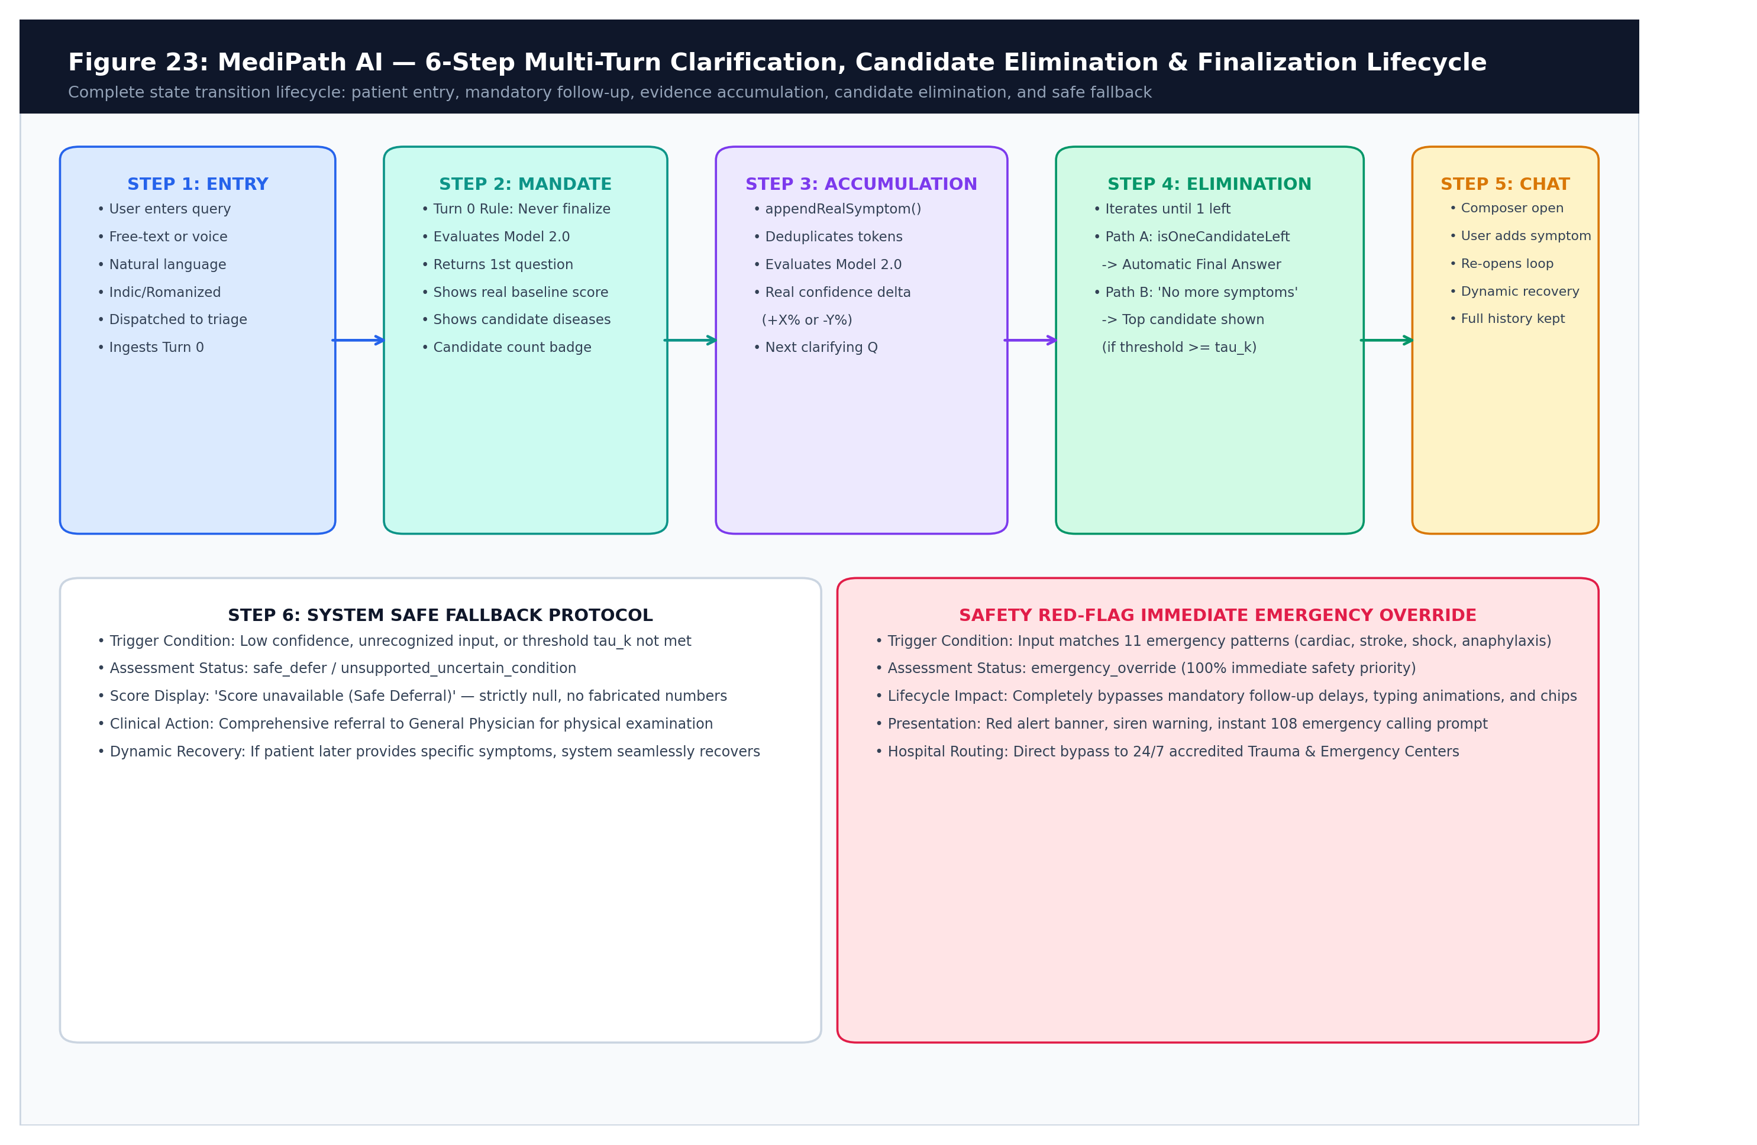
Figure 11.2: Six-Stage Multi-Turn Clarification, Candidate Elimination, and Continuous Consultation Lifecycle

Chapter 12: Evidence Accumulation and Conversation State
12.1 The Multi-Turn Evidence Lifecycle
Evidence Segregation: A critical engineering vulnerability in healthcare chat systems is 'evidence loss'—where subsequent conversational turns overwrite initial complaints, or assistant text is accidentally tokenized by the classifier. MediPath AI implements a strict data segregation model:
- User-Visible Chat History: The human-readable sequence of patient prompts and assistant responses rendered in the user interface. Stored in messages[].
- Canonical Clinical Evidence: The cumulative, deduplicated string of confirmed patient medical complaints passed to Model 2.0 (canonicalSymptomsText). Assistant text and control signals are strictly excluded.
- Assessment State Contract: A structured JSON object (AssessmentState) passed bidirectionally between frontend and backend to preserve conversational context across HTTP stateless requests.
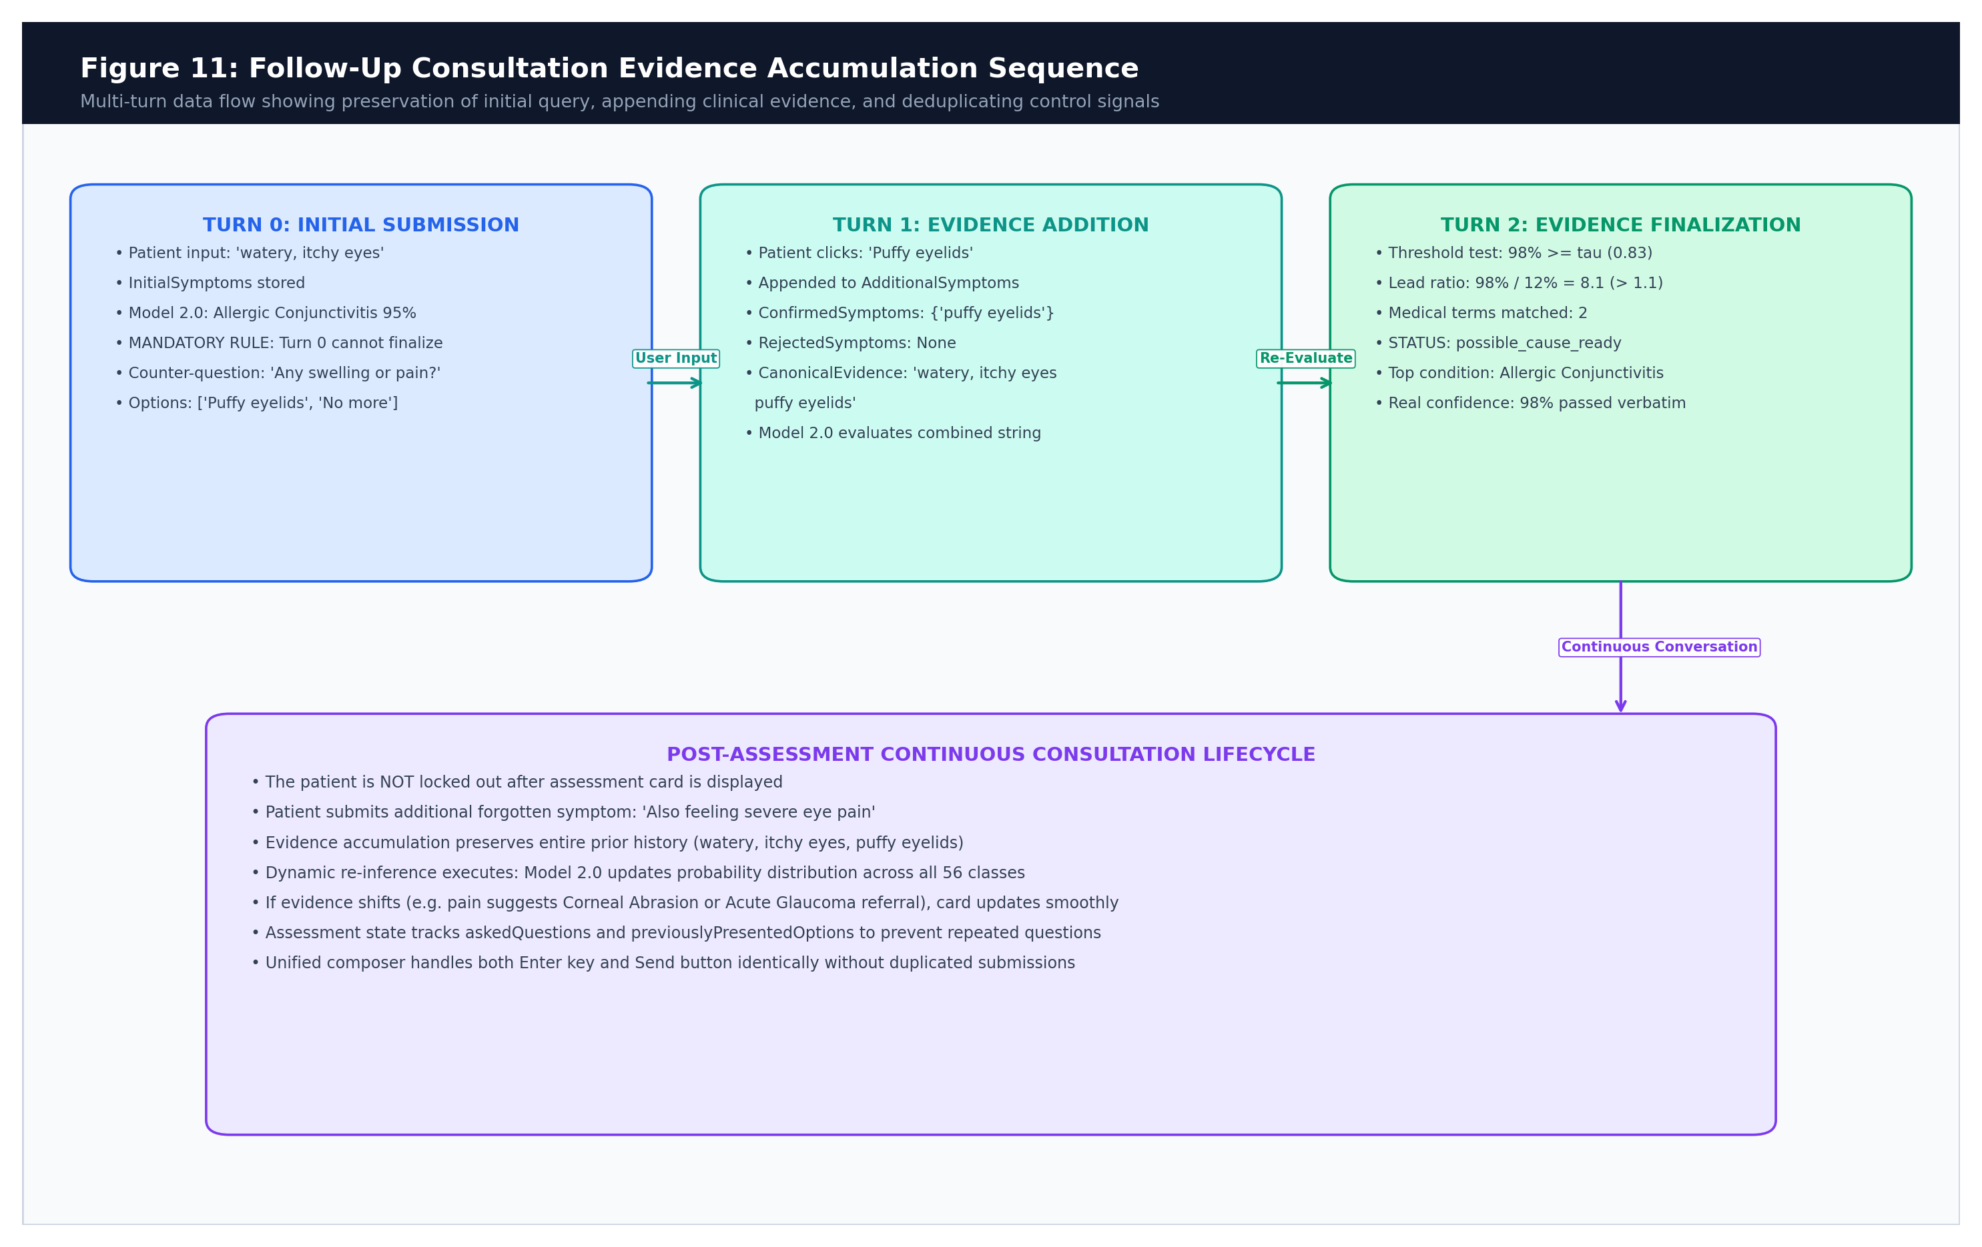
Figure 12.1: Multi-Turn Clinical Evidence Accumulation Sequence
12.2 Assessment State Schema & Lifecycle
State Data Dictionary: The table below details every field in the AssessmentState object and its lifecycle across consultation turns:
Field Name | Type | Lifecycle / Update Mechanism | Role in Inference
initialSymptoms | string | Captured on Turn 0 from initial user input | Permanent baseline complaint string
additionalSymptoms | string[] | Appended when patient provides new details | Merged into cumulative text vector
confirmedSymptoms | string[] | Updated when patient clicks symptom chips | Tracks confirmed medical evidence
rejectedSymptoms | string[] | Updated when user selects 'No more symptoms' | Prevents re-asking rejected symptoms
askedQuestions | string[] | Appended each time assistant generates inquiry | Prevents duplicate questions in chat
previouslyPresentedOptions | string[] | Appended each time option chips are shown | Prevents repeating identical chips
currentCandidates | object[] | Updated by Model 2.0 on each evaluation turn | Holds top 3–5 candidate conditions
currentModelConfidence | number|null | Updated from top candidate probability | Authoritative score for display & handoff
mandatoryFirstFollowupCompleted | boolean | Set to true after Turn 0 response | Enforces Turn 0 non-finalization rule
assessmentStatus | string | Updated on every turn based on thresholds | Controls UI state and hospital unlocking

12.3 Clean String Deduplication & Token Extraction
Deduplication Mechanics: When merging prior evidence with new inputs, triageController.js utilizes mergeSymptomTerms. The helper splits comma-separated strings, normalizes substrings to lowercase, eliminates duplicate tokens, and rejoins clean clinical phrases. Non-symptom conversational control phrases ('nothing else', 'none', 'bas') are identified via isConversationalControl and permanently excluded from the feature vector.
12.4 Post-Assessment Continuous Consultation Mechanics
Continuous Chat: Unlike legacy tools that lock the chat once a condition card is rendered, MediPath AI keeps the consultation open. If the patient enters a new symptom (e.g. 'also noticing light sensitivity'), isPostAssessmentNewSymptom detects the addition. The engine preserves all prior symptoms, runs dynamic re-inference, and updates the candidate card in place without clearing conversational history.

Chapter 13: Confidence and Assessment Decisions
13.1 Anatomy of Clinical Confidence
Confidence Definitions: A frequent source of critical error in healthcare AI is conflating raw mathematical probabilities with diagnostic certainty. MediPath AI establishes strict conceptual distinctions:
- 1. Classifier Probability (modelProbability): The mathematical output of the sigmoid activation: Pk in [0.0, 1.0]. Represents the model's posterior score relative to the training distribution.
- 2. Displayed Confidence Score (confidence): The integer percentage presented to the user: Math.round(P1 * 100), bounded to [0, 99%]. It is explicitly labeled as 'Model probability' and accompanied by non-diagnostic disclaimers.
- 3. Decision Threshold (threshold): The class-calibrated F1-optimal threshold tau_k in [0.79, 0.85]. A condition is accepted as a 'possible cause' only if Pk >= tau_k.
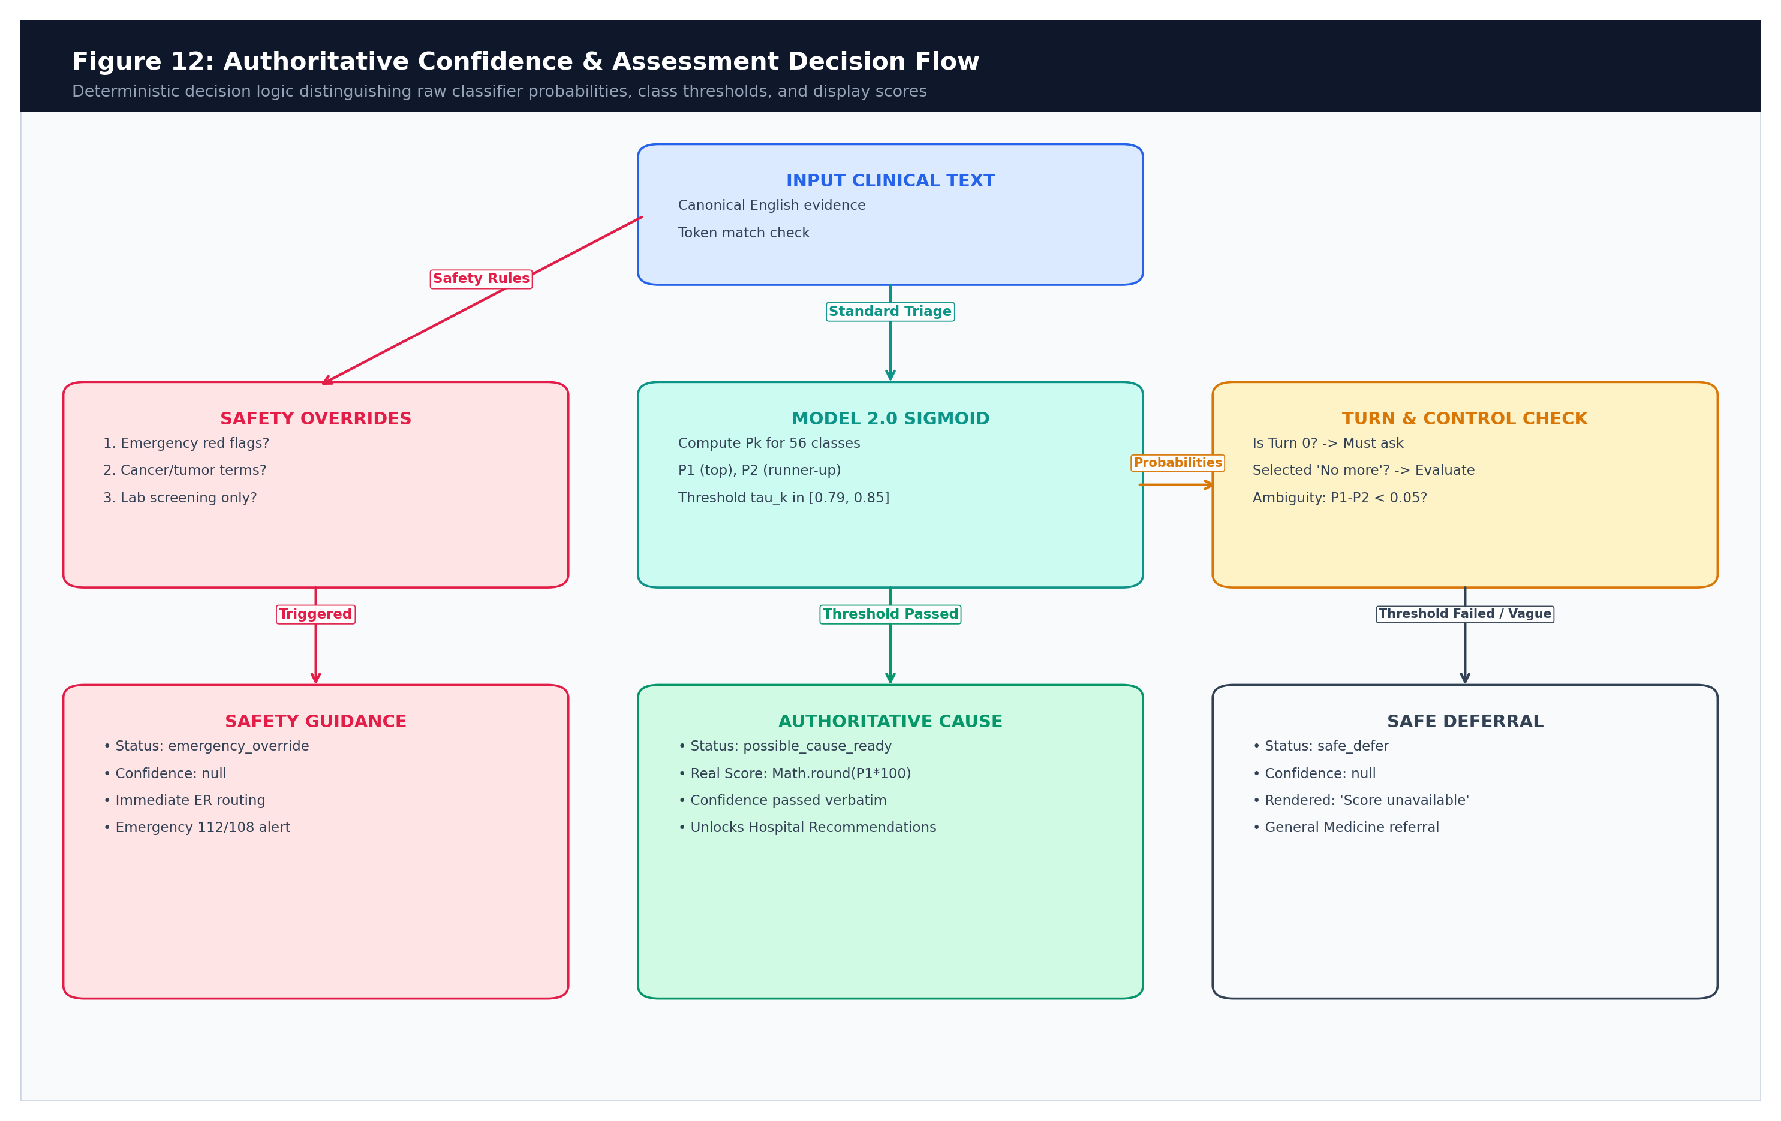
Figure 13.1: Authoritative Confidence & Assessment Decision Flowchart
13.2 The Single Authoritative Confidence Contract
Architectural Contract: MediPath AI enforces a Single Authoritative Confidence Contract across all modules:
- Sole Authority: Medical confidence is generated solely by Model 2.0 (symptomModel.js). Neither the frontend nor the hospital controller may recalculate or alter this score.
- Zero Score Inflation: When the patient navigates to the hospital recommendations page (ResultsView.tsx), the identical confidence score is displayed. Hospital attributes (bed counts, star ratings, NABH status) are decoupled and never artificially inflate clinical confidence.
- Real-Time Delta Feedback: Confidence changes between consecutive turns are displayed as dynamic real-time deltas (ΔC = Ct - Ct-1). When newly introduced symptoms reinforce the leading candidate, positive deltas (+5%, +12%) provide reassuring feedback; when divergent symptoms are entered, coherence penalization appropriately lowers confidence.
- Safe Deferral Display: In safe-deferral, out-of-scope, or emergency states, confidence is strictly reported as null. Both the chat card and the hospital page consistently render 'Score unavailable (Safe Deferral)' rather than fabricating synthetic minimum percentages (such as 80%).
13.3 Dynamic Safe-Deferral Recovery Architecture
Recovery Mechanics: Clinical safe deferral is completely recoverable. When a patient initially provides vague inputs and triggers safe_defer, the chat session remains active. When the patient provides distinctive clinical symptoms in subsequent turns, the expanded evidence vector is re-evaluated. If thresholds are satisfied, the engine dynamically recovers to possible_cause_ready with the genuine calibrated confidence score.
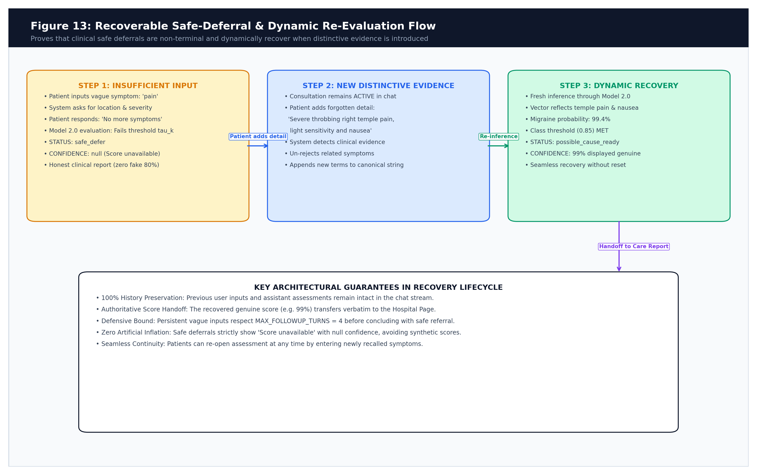
Figure 13.2: Recoverable Safe-Deferral & Dynamic Re-Inference Flow

Chapter 14: Hospital Recommendation Engine
14.1 Multi-Source Hospital Discovery Architecture
Discovery Pipeline: Hospital discovery is managed by hospitalController.js and hospitalProvider.js via a resilient multi-source architecture:
- 1. Verified Local Registry: The primary curated database containing 924 verified medical facilities across Tier-1, Tier-2, and Tier-3 Indian cities, enriched with authentic departmental offerings, specialty tiers, and clinical keywords. Sourced from backend/data/hospitals.json.
- 2. Google Places API: Queried for live nearby hospitals. Includes a local daily usage tracker capped at 100 calls/day. When the daily quota is reached, the system displays an informational banner and gracefully falls back to local data.
- 3. OpenStreetMap (Nominatim API): High-resilience geospatial discovery using disease-specific medical taxonomy queries (e.g. cardiology hospitals, eye care centers, orthopedic clinics, diabetes care centers) rather than static generic tags, ensuring diverse, clinically relevant healthcare options across all Indian regions.
Multi-Source Dynamic Blending: Integrates all 3 sources using weighted scoring (Verified Registry 0.40, Google Places 0.35, OpenStreetMap 0.25) to prevent homogeneous static outputs and deliver tailored recommendations for every condition.
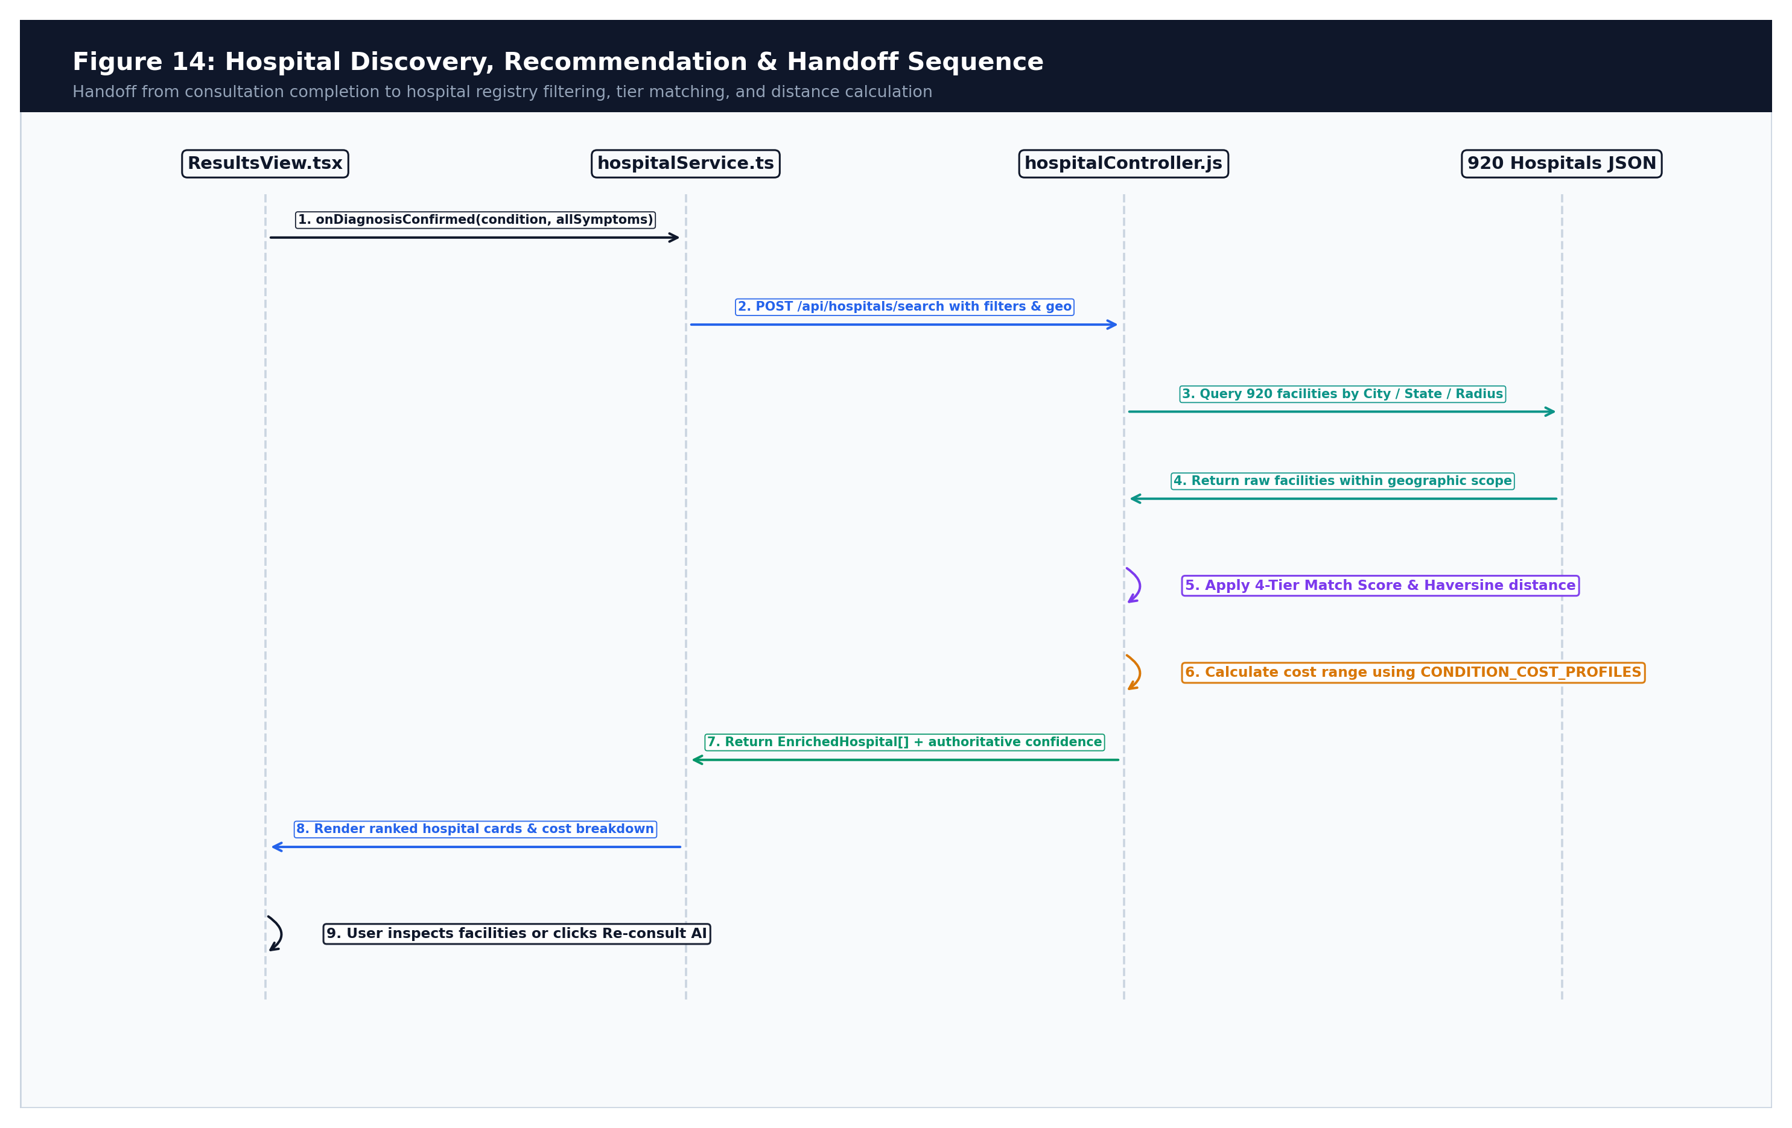
Figure 14.1: Hospital Recommendation & Geospatial Discovery Sequence
14.2 Geographic Filtering & Indian City Alias Resolution
City Normalization: Patients can search within a specified radius (default 20 km) or filter by city and state. To handle spelling variations and historical city names across India, the system implements matchesCityFuzzy with Fuse.js and CITY_ALIASES (e.g. Bengaluru <-> Bangalore, Gurugram <-> Gurgaon, Mumbai <-> Bombay, Kolkata <-> Calcutta, Chennai <-> Madras, Kochi <-> Cochin).
14.3 Deterministic 4-Tier Matching & Ranking Formula
Ranking Logic: Unlike commercial portals that rank hospitals based on advertising bids, MediPath AI ranks facilities using an objective, clinically grounded 4-tier algorithm:
- Tier 1 (Primary Specialist): Direct primary specialization match (e.g. Urology department for Urinary Tract Infection). Tier bonus: +400 points.
- Tier 2 (Procedure Match): Facility offers the exact clinical procedure matching the condition (e.g. Lithotripsy for Kidney Stones). Tier bonus: +300 points.
- Tier 3 (General Care Fallback): No nearby specialist found; routes to nearby General Medicine / Internal Medicine facility with an explicit referral notice: 'Showing General Medicine facilities for initial clinical evaluation'. Tier bonus: +200 points.
- Tier 4 (Regional Referral): General regional referral hospital. Tier bonus: +100 points.
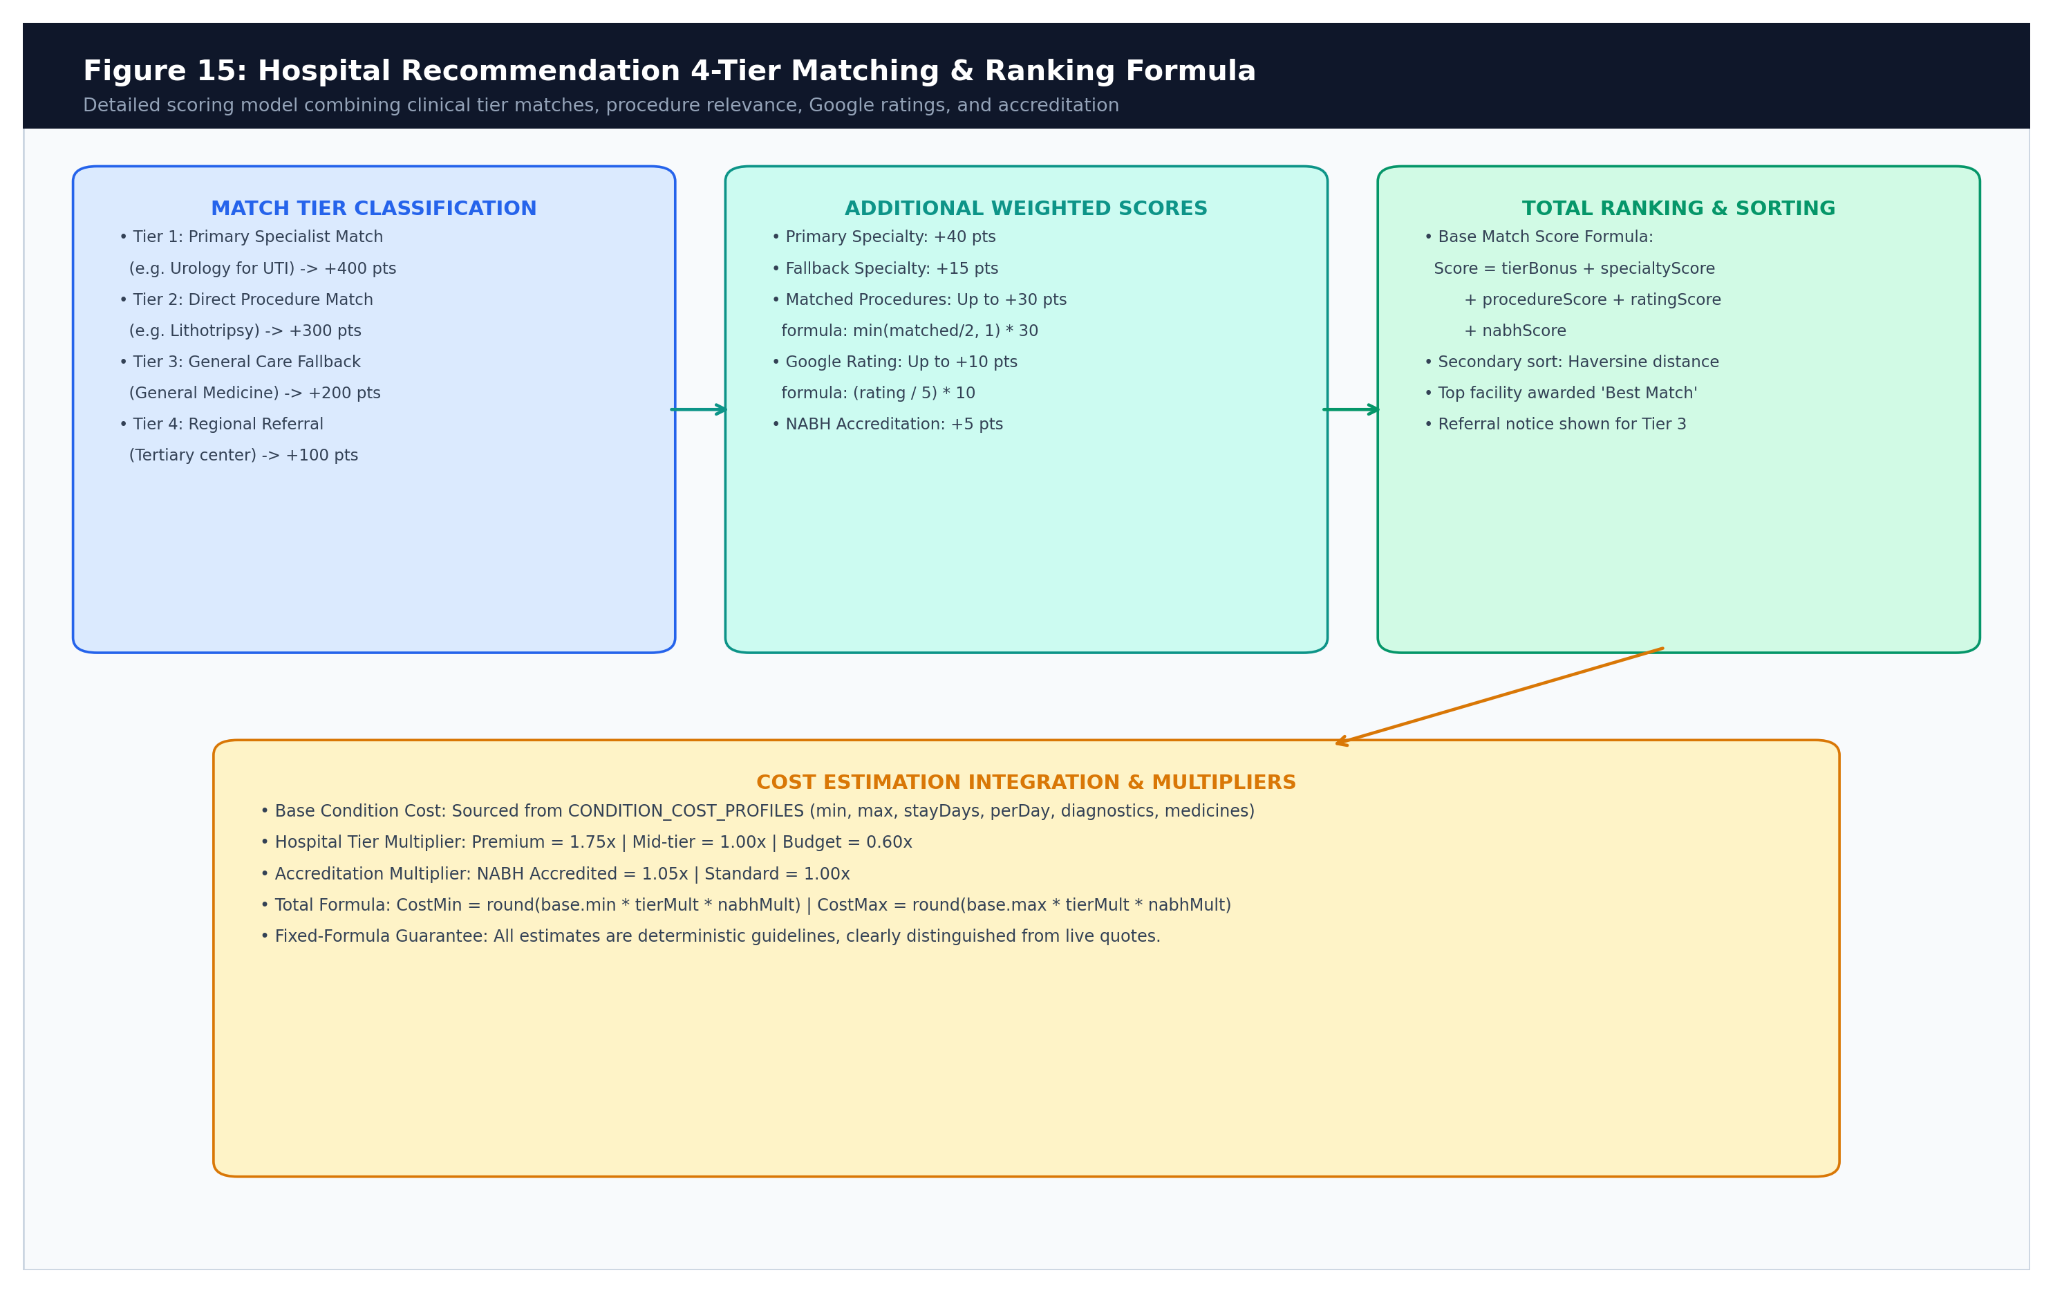
Figure 14.2: Hospital Ranking Formula and Scoring Breakdown
14.4 Ranking Score Weight Matrix
Scoring Formula: The exact mathematical match score is computed as follows:
BaseMatchScore = tierBonus
+ primarySpecialtyScore (40 pts)
+ fallbackSpecialtyScore (15 pts)
+ procedureScore (min(matchedProcedures/2, 1) * 30 pts)
+ ratingScore ((googleRating / 5) * 10 pts)
+ nabhScore (5 pts if NABH accredited)

14.5 Client-Side Multi-Dimensional Interactive Filter Pipeline & Real-Time Faceting
Interactive Faceting Engine: To empower patients and healthcare navigators to refine discovery without triggering redundant server round-trips, MediPath AI implements a high-performance, client-side filtering and sorting pipeline inside HospitalRecommendations.tsx. Evaluated via React's useMemo hook, the pipeline applies 10 distinct parametric facets in real time:
- 1. Instant Facility Name Search: A debounced text search input allowing instant case-insensitive substring matching against hospital names (e.g. 'Apollo', 'Fortis', 'Manipal', 'Civil').
- 2. Procedure Roster Matching: A targeted dropdown selector filtering facilities that offer specific clinical interventions (e.g. Angioplasty, Dialysis, Lithotripsy, Endoscopy) matching the identified condition profile.
- 3. Clinical Specialty Filter: A dynamically generated dropdown listing all medical specialties present in the current candidate set, allowing users to isolate specific departments (e.g. Cardiology, Orthopedics, Dermatology).
- 4. Dynamic Distance Radius Slider: An interactive range slider (5 km to 50+ km) dynamically filtering facilities based on calculated Haversine geodesic distance from user coordinates.
- 5. Hospital Tier Multi-Select: Interactive chips allowing multi-selection across clinical tiers: Tier 1 (Primary Specialist), Tier 2 (Procedure Match), Tier 3 (General Fallback), and Tier 4 (Regional Referral).
- 6. Quality & Emergency Toggles: Independent toggle switches for National Accreditation Board for Hospitals (NABH) certification, 24/7 Emergency and trauma availability, and current open operational status.
- 7. Minimum Google Star Rating: Threshold buttons filtering hospitals by verified Google patient review scores (All, 3.5+, 4.0+, 4.5+ stars).
- 8. Procedural Cost Range & Max Budget: Interactive budget controls allowing users to select cost categories (Low, Medium, High) or drag a maximum budget slider (INR ₹10,000 to ₹500,000+), comparing against the condition's estimated total expense.
- 9. Dynamic Sort Engine: A dynamic multi-criteria sort selector supporting Best Match (tier and composite score), Closest Distance (ascending km), Highest Rating (descending stars), and Lowest Procedural Cost (ascending INR ₹).
- 10. Filter State & Zero-Match Recovery: Displays an active filter badge counter, a one-click 'Clear all filters' reset CTA, and a high-fidelity empty state rendering helpful advice when overly restrictive criteria yield zero matches.

Chapter 15: Procedural Cost Estimation
15.1 Clinical Cost Modeling in Indian Healthcare
Cost Modeling: Healthcare expenses in India vary drastically depending on hospital tier, room category, and clinical complexity. MediPath AI implements a transparent, fixed-formula procedural cost estimator across all 56 Model 2.0 conditions (backend/controllers/hospitalController.js: CONDITION_COST_PROFILES).
15.2 Cost Profile Schema and Tier Multipliers
Profile Schema: Each condition profile defines realistic Indian Rupee (INR ₹) baselines:
- Base Procedure: min / max: Base outpatient consultation or procedural intervention range.
- Inpatient Stay: stayDays: Typical inpatient hospital admission duration (e.g. 0 days for Acne, 4 days for Pneumonia, 5 days for Osteoarthritis).
- Room Charges: perDay: Daily room, nursing, and bed charges.
- Diagnostics & Meds: diagnostics / medicines: Typical laboratory tests, imaging, and initial pharmacological expenses.
- Contingency Buffer: contingencyPct: A contingency buffer (5%–15%) covering incidental consumables.
Multiplier Adjustments: Hospital-specific estimates are adjusted using deterministic multipliers:
- Hospital Tier Multiplier (tierMult): Premium = 1.75x | Mid-tier = 1.00x | Budget = 0.60x
- Accreditation Multiplier (nabhMult): NABH Accredited = 1.05x | Standard = 1.00x
15.3 Cost Calculation Formula & Worked Examples
Mathematical Formula: The total estimated cost range is calculated via:
TotalMult = tierMult * nabhMult
SubtotalMin = (base.min + (stayDays * perDay) + diagnostics + medicines) * TotalMult
TotalEstimatedMin = SubtotalMin + round((SubtotalMin * contingencyPct) / 100)

Numerical Walkthrough: Worked Example: Pneumonia (stayDays = 4, perDay = ₹4,500, diagnostics = ₹9,000, medicines = ₹8,000) at a Mid-tier NABH Hospital (TotalMult = 1.00 * 1.05 = 1.05):
- Step 1 (Subtotal): Subtotal: (₹35,000 base + ₹18,000 room + ₹9,000 diag + ₹8,000 meds) * 1.05 = ₹73,500.
- Step 2 (Contingency): Contingency (10%): ₹7,350.
- Step 3 (Total Range): Total Estimated Range: ₹80,850 – ₹1,48,500.
[TRANSPARENT PRICING & COST ESTIMATION NOTICE]
DISCLAIMER ON PROCEDURAL COSTS: Cost figures presented in MediPath AI are algorithmic estimates based on regional Indian healthcare averages. They do not constitute binding commercial quotations. Actual hospital bills depend on attending physician fees, comorbid complications, bed category selected, and individualized therapeutic interventions.

Chapter 16: Printing, Summaries and User Experience
16.1 Consultation Summary Component Architecture
Component Responsibility: ConsultationPrintSummary.tsx compiles consultation dialogues, candidate assessments, and care recommendations into a clean, physical document suitable for patients to carry to clinical appointments.
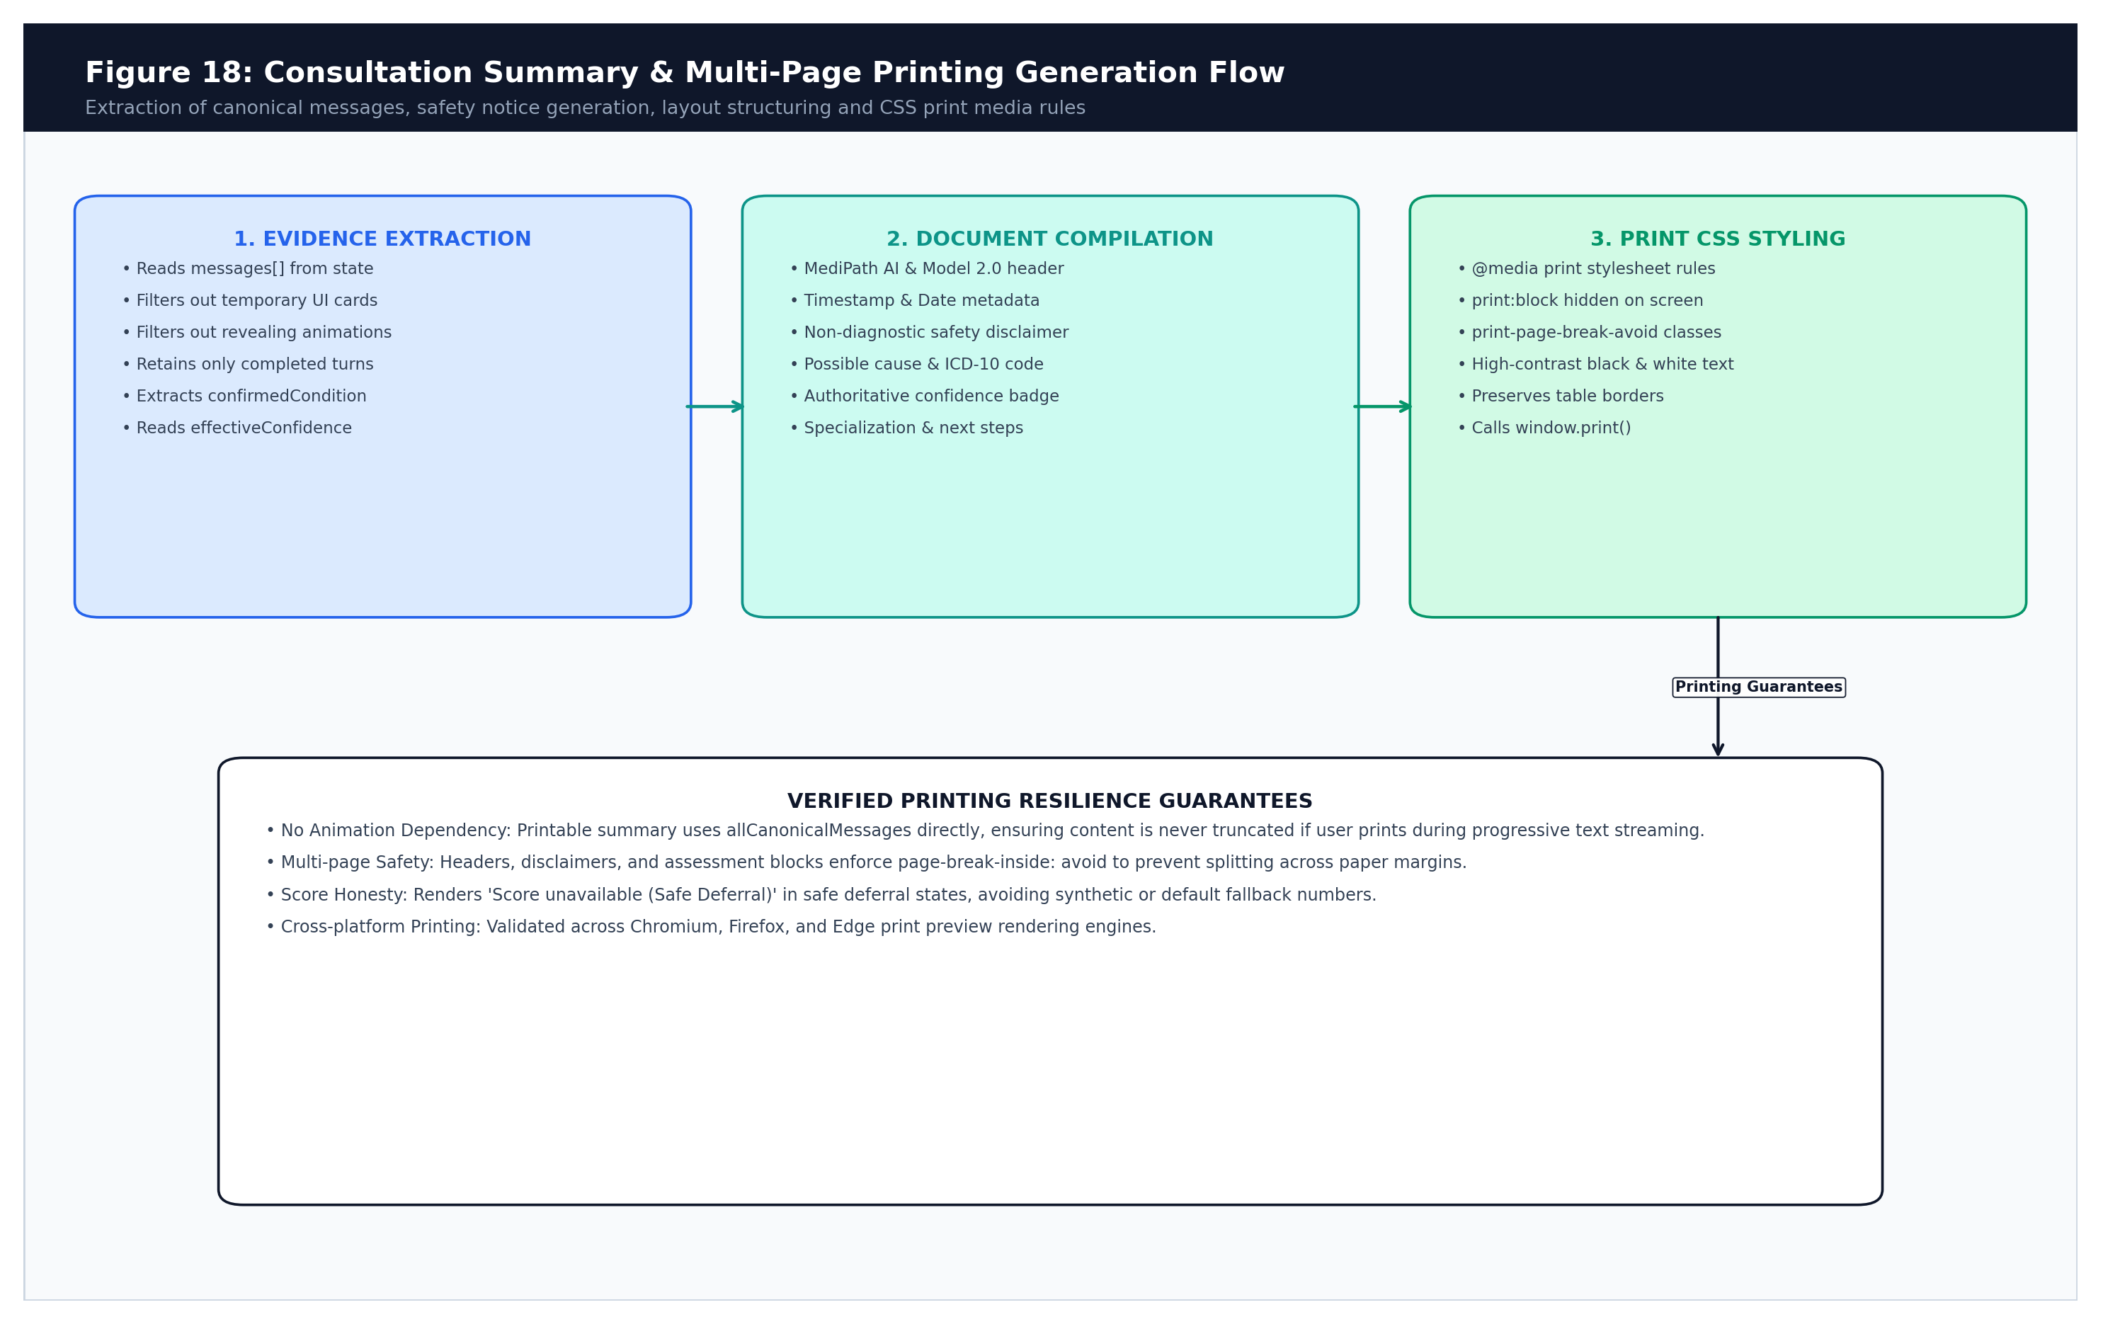
Figure 16.1: Consultation Summary & Multi-Page Printing Generation Flow
16.2 Print Media Stylesheet Directives
Print Layout Engine: The print summary is hidden during standard web browsing (print:block hidden) and formats automatically when window.print() is invoked:
- Page Break Protection: Headers, non-diagnostic disclaimers, and assessment blocks enforce print-page-break-avoid (page-break-inside: avoid) to prevent awkward vertical slicing across paper pages.
- Dialogue Filtering: Interactive UI elements (typing indicators, option chips, action buttons) are filtered out, printing only completed clinical dialogue turns.
- Animation Decoupling: The print view uses allCanonicalMessages directly, ensuring that the exported summary is complete even if the user clicks print while a progressive text animation is active.
16.3 Structure of the Generated Medical Summary
Report Sections: The printed report contains six structured clinical sections:
- 1. Clinical Header: MediPath AI title, MedP_AI_V2.0 build tag, date, time, and active consultation language.
- 2. Non-Diagnostic Notice: Prominent amber-bordered notice stating that the summary is preliminary navigation guidance and not a confirmed medical diagnosis.
- 3. Authoritative Assessment: Identified condition name, ICD-10 code, target medical specialization, and recommended next clinical steps.
- 4. Confidence Meter: Genuine model probability percentage, or 'Score unavailable (Safe Deferral)' in deferred states.
- 5. Reported Symptoms: Baseline complaint and subsequent confirmed clinical details.
- 6. Dialogue Transcript: Complete chronological dialogue transcript between the patient and Doctor AI.

Chapter 17: API Contracts and Data Schemas
17.1 Internal Data Contract Specifications
Contract Specifications: The table below defines the formal data schemas exchanged between client and backend:
Contract / Payload | Producer -> Consumer | Key Fields & Types | Required / Optionality
Initial Triage Request | Client -> TriageController | symptoms (str), chatHistory (arr),  turnCount (int), language (str) | symptoms: Required  turnCount: Required (0 on start)
Follow-Up Submission | Client -> TriageController | symptoms (str), canonicalSymptoms (str),  noMoreSymptoms (bool), assessmentState (obj) | symptoms: Required  noMoreSymptoms: Required
Triage Response | TriageController -> Client | assessmentStatus (str), isConfident (bool),  condition (obj), confidence (int|null),  counterQuestion (str|null), quickOptions (arr) | assessmentStatus: Required  confidence: Nullable on deferral
Hospital Search Request | Client -> HospitalController | condition (obj), filters (obj),  origin {lat, lng}, city (str), state (str) | filters: Required  origin: Required
Hospital Search Response | HospitalController -> Client | condition (obj), hospitals (arr of EnrichedHospital),  totalFound (int), dataSource (str) | hospitals: Required  totalFound: Required

17.2 Field-by-Field Data Dictionary
Data Dictionary: Detailed dictionary for DoctorTriageV2Result and EnrichedHospital:
- assessmentStatus: Enumeration: 'needs_mandatory_followup' | 'needs_more_information' | 'possible_cause_ready' | 'safe_defer' | 'emergency_override'.
- confidence: Integer in [0, 99] or null. Authoritative probability score from Model 2.0.
- modelProbability: Float rounded to 4 decimals (e.g. 0.9824). Exact model sigmoid posterior probability.
- threshold: Float threshold for the top condition (e.g. 0.83). Condition accepted only if modelProbability >= threshold.
- decisionSource: String identifying the decision mechanism: 'ml_model' | 'safety_rule' | 'fallback' | 'direct_routing'.
- isDirectRouting / directRouting: Boolean flag indicating whether the query originated from the 56 Supported Diseases directory or General Medicine card, signaling the application to bypass ML inference completely.
- matchTier: Integer (1..4) indicating hospital clinical alignment. 1 = Primary Specialist, 2 = Procedure, 3 = General Fallback, 4 = Referral.

Chapter 18: Security, Privacy and Clinical Safety
18.1 Patient Privacy and Ephemeral State Architecture
Privacy Architecture: In strict compliance with healthcare ethics, MediPath AI processes patient symptoms ephemerally in client memory. No medical complaints, symptoms, or consultation transcripts are stored in persistent databases. When the browser session closes, all clinical data is wiped from memory.
18.2 API Hardening and Denial-of-Service Defenses
Security Defenses: The backend Express API implements multi-layer defense mechanisms:
- 1. Payload Length Ceiling: All /api routes enforce a 2,000-character payload length guard, preventing buffer overflow and memory bloat attacks.
- 2. IP Rate Limiting: An in-memory IP rate limiter restricts client requests to 120 calls per minute.
- 3. Emergency Exemption: Requests matching emergency regex warning patterns are permanently exempt from rate limiting to guarantee life-safety availability.
- 4. CORS Strict Allowlist: CORS origin validation restricts API calls strictly to approved local development and production URLs.
- 5. Encapsulation of Secrets: API keys for Gemini and Google Places are stored strictly in backend server environment variables (.env) and never leaked to frontend browser clients.
18.3 Clinical Safety Standards and Language Directives
Clinical Safety Directives: MediPath AI enforces strict language standards to prevent user misunderstanding:
- Approved Terminology: Permitted Phrases: 'Possible cause', 'Possible symptom pattern', 'Most likely initial category', 'Requires clinical confirmation', 'Model probability'.
- Prohibited Terminology: Prohibited Phrases: 'Confirmed diagnosis', 'Diagnostic certainty', 'Virtually guaranteed', 'You are suffering from...'.
18.4 Firebase Authentication, Differentiated Search History & Model-Bypass Restoration
User Session Architecture: MediPath AI integrates cloud identity and session persistence via Firebase Auth and Cloud Firestore (searchHistoryService.ts, SearchHistoryDialog.tsx):
- 1. Multi-Provider Authentication: Supports Google OAuth, Email/Password login, and anonymous guest sessions. Live connection state is reported via the header telemetry pill.
- 2. Dual-Mode Search History Schema: History records explicitly record search provenance. Conversational symptom triage saves reported symptom strings with decisionSource: 'ml_model' | 'rule', while direct routing saves condition metadata with isDirectRouting: true, directRouting: true, and decisionSource: 'direct_routing'.
- 3. Deterministic Model-Bypass Restoration: When a user reloads a direct routing history item, the engine detects isDirectRouting and completely bypasses the ML model (predictConditions), immediately restoring the canonical condition assessment and hospital matching. Conversely, symptom history items restore conversational triage for continuous clinical inquiry.
- 4. Dual Firestore Storage & Local Fallback: History is persisted to both the Firestore user document (searchHistory array) and an indexed subcollection (users/{uid}/search_history/{id}), with automatic graceful fallback to browser localStorage (medipath_search_history) for unauthenticated guests.
- 5. Granular User History Control: Users can review previous searches with visual category badges, delete individual history items atomically, or purge their entire consultation log with optimistic UI updates.

Chapter 19: Installation and Local Development
19.1 Prerequisites and Environment Setup
Prerequisites: Running MediPath AI locally requires the following verified tools:
- Node.js: Node.js v18.0.0 or higher (v18, v20, and v22 verified).
- Package Manager: npm v9.0.0 or higher.
- Python Runtime: Python 3.12 or 3.13 (required only for offline model retraining; not needed for runtime serving).
19.2 Automated Startup: One-Click Launcher
One-Click Execution: The primary method to launch MediPath AI on Windows is the root launcher script:
:: From repository root directory:
start-project.bat
:: Or to force-restart active ports (5000 and 8080):
start-project.bat --restart

19.3 Manual Development Startup Commands
Manual Setup: Developers can also start the frontend and backend in separate terminals:
# Terminal 1: Backend API (:5000)
cd backend
copy .env.example .env
npm install
node server.js
# Terminal 2: Frontend SPA (:8080)
cd frontend/healthpath-ai-main
copy .env.example .env
npm install
npm run dev

19.4 Environment Variable Templates (.env.example)
Configuration: Safe placeholder configuration templates:
# backend/.env
PORT=5000
FRONTEND_URL=http://localhost:8080,http://localhost:3000
GEMINI_API_KEY=YOUR_GEMINI_API_KEY_HERE
GOOGLE_PLACES_API_KEY=YOUR_GOOGLE_PLACES_KEY_HERE
# frontend/healthpath-ai-main/.env
VITE_API_BASE_URL=http://localhost:5000/api

Chapter 20: Testing and Verification
20.1 Comprehensive Testing Architecture
Testing Methodology: The MediPath AI test architecture encompasses unit, integration, behavioural, and parity test suites across both backend and frontend environments.
20.2 Backend Test Results (100% Pass Rate)
Backend Test Audit: All 11 backend test suites were executed against the active codebase:
Test Suite Script | Purpose / Focus Area | Cases | Pass Rate
test_master_verification.js | 27 core functional requirements & clinical safety rules | 27 / 27 | 100.0% PASS
test_multilingual_consultation.js | Hindi, Gujarati, Romanized input & negation checks | 13 / 13 | 100.0% PASS
test_safe_deferral_recovery.js | Safe deferral recovery & MAX_FOLLOWUP bound | 7 / 7 | 100.0% PASS
test_behavioural_suite.js | Clinical triage scenarios across 6-status taxonomy | 35 / 35 | 100.0% PASS
test_python_node_parity.js | Closed-form probability parity against scikit-learn | 117 queries | 100.0% PASS (max diff 3.88e-16)
test_artifact_consistency.js | Machine-readable model consistency assertions | 542 assertions | 100.0% PASS
test_documentation_consistency.js | Numerical verification against documentation | 44 assertions | 100.0% PASS
test_e2e_integration_flow.js | Multi-turn consultation to hospital discovery flow | 3 scenarios | 100.0% PASS
test_post_assessment_live_flow.js | Continuous consultation after assessment display | Live HTTP flow | 100.0% PASS
test_live_romanized_triage.js | Live Romanized input translation & classification | Live HTTP flow | 100.0% PASS
test_followup_no_more_symptoms.js | Control signal termination & threshold check | Live HTTP flow | 100.0% PASS

20.3 Frontend Test Results (Vitest & TypeScript)
Frontend Test Audit: Frontend tests executed using Vitest 3.2.4 and TypeScript strict checks across the complete user workflow:
- Vitest Test Suites: 17 test files executed; 103 tests passed out of 103 tests (100.0% pass rate). Includes dedicated test suites verifying the direct disease model bypass, 3-node visual clinical loading state, 10-parameter hospital recommendation filters, differentiated Firebase search history persistence, and the new Header Help & Instructions guide subsystem.
- Direct Routing & Filter Fixes Suite: DirectRoutingAndFilterFixes.test.tsx (10 tests) verifies: (1) 100% Direct Selection badge, (2) Real-time hospital name search, (3) Specialty dropdown filtering, (4) Clinical tier multi-select, (5) NABH accreditation toggle, (6) Max budget slider filtering, (7) One-click 'Clear all filters' CTA, (8) Direct routing ML model bypass, (9) Differentiated search history schema persistence, and (10) Model bypass on history restoration.
- Nerd Hub & Supported Diseases Suite: NerdHubAndSupportedDiseases.test.tsx (13 tests) verifies the 56 Supported Diseases direct routing grid, Model Diagnostics & Nerd Hub dataset preview modal, verified hospital registry explorer, and multilingual translations (English, Hindi, Gujarati).
- Help & Instructions Guide Suite: HelpInstructionsHeader.test.tsx (6 tests) verifies: (1) Header Help/Instructions button rendering and click handler, (2) Multi-lingual translations in Hindi ('उपयोग विधि') and Gujarati ('કેવી રીતે વાપરવું'), (3) Self-contained modal activation, (4) Smooth tab navigation across all 5 user guide sections, (5) One-click sample query dispatch into search, and (6) Modal dismissal on 'Got It, Let's Start' action.
- TypeScript Strict Check: Clean npx tsc --noEmit with 0 type errors under strict TypeScript compiler options.
- Vite Production Build: Clean production bundle generated in 14.85 seconds with 0 warnings or errors.

Chapter 21: Deployment and Operations
21.1 Production Deployment Topology
Production Architecture: While local capstone evaluation runs via start-project.bat on ports 5000 and 8080, production deployment is streamlined by MediPath AI's zero-database and zero-Python serving architecture:
- Frontend Static Serving: The React application compiles via npm run build into an optimized static bundle under dist/ (7.98s compile time). These static assets can be served directly from Nginx, Cloudflare Pages, or Express static middleware.
- Backend Process Clustering: The Express.js server runs as a cluster under PM2 (Process Manager 2) with automatic restart on unhandled exceptions and log rotation.
- In-Memory Artifact Management: Model 2.0 JSON (5 MB) and hospitals.json (501 KB) are loaded into memory once on server initialization. There are no external database connection pools to manage, eliminate deadlocks and connection leaks.
21.2 Operational Health Probes
Monitoring Endpoints: The API exposes dedicated health endpoints for automated load balancers and orchestrators:
- Liveness Probe: GET /api/health returns { status: 'Server is running' } for basic liveness.
- Readiness Probe: GET /api/model/health returns loaded status and verified model metadata for readiness.

Chapter 22: Limitations and Known Issues
22.1 Scope Limitations: 56 Primary-Care Conditions
Scope Boundary: Model 2.0 covers 56 common primary-care conditions. Highly specialized, chronic, oncological, and surgical conditions (e.g. Heart Failure, Multiple Sclerosis, Pancreatitis) were audited and intentionally excluded from automated prediction to prevent catastrophic diagnostic errors. These out-of-scope conditions trigger safe clinical deferral.
22.2 Dataset Class Imbalance in Weak Categories
Class Imbalance: As documented in Chapter 8, conditions with limited training support (Vertigo / BPPV with 62 cases, Muscle Strain with 61 cases, Contact Dermatitis with 126 cases) exhibit lower F1 scores (0.34 to 0.44) and higher false positives due to overlapping symptom tokens with broader conditions (Migraine, Osteoarthritis, Eczema).
22.3 Hospital Registry Enriched Taxonomy & Real-Time Geospatial Resolution
Enriched Data Resolution: In the latest Version 5.0 build, the verified hospital registry was expanded and enriched to 924 verified healthcare facilities with full clinical departmental offerings, procedures, and condition keywords. Furthermore, OpenStreetMap geospatial discovery was upgraded from static tags to dynamic, condition-specific medical taxonomy queries (via Nominatim API) covering all 56 diseases, complemented by real-time Google Places API queries. While bed occupancy and doctor duty rosters remain non-real-time due to institutional API restrictions across India, facilities are now dynamically tailored and ranked per disease condition.
22.4 Translation API Latency and Quota Dependency
Cloud Dependency: Dynamic translation relies on the external Google Gemini API. When cloud networks experience latency or quotas are exceeded, the system falls back to offline dictionaries. While core clinical guidance remains operational, conversational fluency is reduced in offline mode.

Chapter 23: Future Upgrade Roadmap
23.1 Prioritized Feature Roadmap
Future Roadmap: The FUTURE_ENHANCEMENTS.md roadmap identifies six key architectural upgrades for upcoming releases:
Upgrade Item | Clinical & Technical Benefit | Impacted Modules | Target Priority / Status
Differentiated Firebase History & Deletion | Patients save and restore direct routing vs triage history across devices with granular deletion | searchHistoryService.ts, SearchHistoryDialog.tsx | COMPLETED (Release 4.1)
Real-Time Multi-Parameter Hospital Filter | 10-facet real-time filtering (name, procedure, specialty, tier, NABH, budget, sort) | HospitalRecommendations.tsx, Index.tsx | COMPLETED (Release 4.1)
Direct Disease Model Bypass Routing | Deterministic routing to clinical department bypassing probabilistic ML inference | SupportedDiseasesSection.tsx, DirectDiseaseRoutingState.tsx | COMPLETED (Release 4.1)
Helpful / Not Helpful Feedback | Lightweight binary rating widget on results card to benchmark navigation accuracy | ResultsView.tsx, feedbackService.ts | Medium (Release 4.2)
Conversational Voice Follow-Up | Full duplex conversational voice questioning using Web Speech synthesis and recognition | DoctorConsultationPanel.tsx, useSpeechRecognition.ts | Medium (Release 4.2)
Doctor Visit Preparation Checklist | Automated checklist summarizing symptom timeline and questions to ask specialist | ConsultationPrintSummary.tsx, ChecklistView.tsx | Medium (Release 4.3)
Native Mobile Application Companion | Cross-platform iOS and Android build with offline caching and GPS facility tracking | Capacitor / React Native Bridge | Low (Release 4.4)

Chapter 24: Glossary and Technical Acronyms
24.1 Comprehensive Technical & Clinical Glossary
Glossary: Definitions of specialized terminology used throughout the handbook:
Term / Acronym | Technical & Clinical Definition within MediPath AI
API (Application Programming Interface) | RESTful HTTP communication protocol connecting the React frontend with the Node.js backend.
Authoritative Confidence | The unaltered mathematical probability generated solely by Model 2.0 and passed verbatim across views.
Brier Score | Strictly proper score function measuring the mean squared error between model probabilities and binary outcomes (Model 2.0 = 0.01827).
Canonical Symptom | Standardized English medical phrase (e.g. 'painful urination') representing patient complaints across all languages.
Closed-Form Parity | Exact bit-level mathematical equivalence between Python training and Node.js JavaScript serving runtime.
CORS (Cross-Origin Resource Sharing) | Browser security mechanism restricting backend API access to approved frontend origins.
ECE (Expected Calibration Error) | Weighted average difference between predicted confidence and empirical accuracy (Model 2.0 = 0.0282).
ICD-10 | International Classification of Diseases, Tenth Revision; standardized diagnostic codes mapped to all 56 conditions.
LRAP (Label Ranking Average Precision) | Evaluation metric measuring the precision of ranking true conditions higher than competitors (Model 2.0 = 0.9160).
Multi-Label Learning | Machine learning paradigm allowing patients to simultaneously exhibit multiple non-mutually exclusive conditions.
NABH | National Accreditation Board for Hospitals & Healthcare Providers; Indian clinical quality standard.
NFKD Normalization | Unicode Normalization Form KD (Compatibility Decomposition), standardizing character encodings and accents.
N-gram | Contiguous sequence of n words extracted from text; Model 2.0 uses unigrams (1-word) and bigrams (2-word).
One-vs-Rest (OvR) | Decomposition strategy training 56 independent binary classifiers, each separating one condition from all others.
Rate Limiting | Defensive network constraint capping requests to 120 calls/minute/IP, with emergency query exemption.
Safe Deferral | Clinical safety state where ambiguous, out-of-scope, or low-probability symptoms route to general evaluation with confidence: null.
Sigmoid Function | Mathematical activation σ(z) = 1 / (1 + e^-z) mapping linear logits into independent probabilities in [0.0, 1.0].
TF-IDF | Term Frequency-Inverse Document Frequency; numerical feature representation weighting distinctive medical vocabulary.
Top-k Hit Rate | Proportion of test cases where the true clinical condition is present within the model's top k candidates (Top-3 = 99.03%).
Triage | Systematic clinical prioritization and routing of patient medical complaints to appropriate care levels.

Chapter 25: References and Appendices
Appendix A: Complete 56 Canonical Conditions Catalogue
Catalogue Inventory: The complete clinical catalogue of all 56 conditions supported by Model 2.0, with ICD-10 codes, medical specializations, urgency levels, calibrated decision thresholds, and primary matching procedures:
Idx | Condition Name | ICD-10 | Specialization | Urgency | Threshold | Primary Procedure
0 | Acne | L70.0 | Dermatology | Routine | 0.85 | Dermatological Skin Evaluation &
1 | Allergic Conjunctivitis | H10.1 | Ophthalmology | Routine | 0.83 | Allergy Eye Evaluation & Antihis
2 | Allergic Reaction / Urticaria | L50.9 | General Medicine | Urgent | 0.85 | Antihistamine Administration & H
3 | Allergic Rhinitis | J30.9 | ENT | Routine | 0.85 | Allergen Identification & Nasal
4 | Anal Fissure | K60.2 | General Surgery | Routine | 0.85 | Anal Manometry & Sphincter Relax
5 | Anxiety Disorder | F41.0 | Psychiatry | Routine | 0.85 | Anxiolytic Assessment & Cognitiv
6 | Appendicitis | K35.80 | General Surgery | Emergency | 0.85 | Urgent Abdominal Ultrasound / CT
7 | Asthma | J45.909 | Pulmonology | Urgent | 0.85 | Pulmonary Function Testing (PFT)
8 | Bacterial Vaginosis | N76.0 | Gynecology | Routine | 0.85 | Microscopic Swab Evaluation & An
9 | Benign Prostatic Hyperplasia / BPH | N40.0 | Urology | Routine | 0.83 | Uroflowmetry, Prostate Ultrasoun
10 | Blepharitis | H01.00 | Ophthalmology | Routine | 0.85 | Eyelid Margin Debridement & Ocul
11 | Bronchitis | J40 | Pulmonology | Routine | 0.85 | Chest Auscultation, Spirometry &
12 | Carpal Tunnel Syndrome | G56.00 | Orthopedics | Routine | 0.85 | Nerve Conduction Study (EMG) & W
13 | Cellulitis | L03.90 | General Medicine | Urgent | 0.85 | Antibiotic Therapy & Soft Tissue
14 | Cervical Spondylosis | M47.812 | Orthopedics | Routine | 0.85 | Cervical Spine MRI & Physical Re
15 | Common Cold / Upper Respiratory Infection | J00 | General Medicine | Routine | 0.85 | Symptomatic Upper Respiratory Ca
16 | Conjunctivitis | H10.9 | Ophthalmology | Routine | 0.85 | Slit Lamp Eye Examination & Topi
17 | Contact Dermatitis | L23.9 | Dermatology | Routine | 0.85 | Skin Allergy Patch Testing & Top
18 | Dental Abscess | K04.7 | Dentistry | Urgent | 0.83 | Periapical Drainage, Endodontic
19 | Depressive Symptoms | F32.9 | Psychiatry | Routine | 0.85 | Mood Disorder Assessment & Suppo
20 | Eczema / Atopic Dermatitis | L20.9 | Dermatology | Routine | 0.83 | Topical Dermatitis Assessment &
21 | Endometriosis | N80.9 | Gynecology | Routine | 0.85 | High-Resolution Pelvic Ultrasoun
22 | Frozen Shoulder | M75.0 | Orthopedics | Routine | 0.85 | Shoulder Arthrogram & Guided Phy
23 | Gastritis | K29.70 | Gastroenterology | Routine | 0.85 | Upper GI Endoscopy & Acid Suppre
24 | Gastroenteritis | A09 | Gastroenterology | Urgent | 0.85 | Rehydration Therapy, Stool Analy
25 | Gastroesophageal Reflux Disease / GERD | K21.9 | Gastroenterology | Routine | 0.83 | Esophageal pH Monitoring & Anti-
26 | Gingivitis / Periodontal Disease | K05.10 | Dentistry | Routine | 0.85 | Ultrasonic Scaling, Root Planing
27 | Hemorrhoids | K64.9 | General Surgery | Routine | 0.85 | Proctoscopy, Conservative Protoc
28 | Hypothyroidism | E03.9 | Endocrinology | Routine | 0.85 | Thyroid Panel (TSH, Free T3/T4)
29 | Influenza | J11.1 | General Medicine | Routine | 0.85 | Antiviral Therapy Assessment & S
30 | Iron-Deficiency Anaemia | D50.9 | Hematology | Routine | 0.85 | Complete Blood Count (CBC), Seru
31 | Irritable Bowel Syndrome / IBS | K58.9 | Gastroenterology | Routine | 0.85 | Gastrointestinal Motility Evalua
32 | Kidney Stones | N20.0 | Urology | Urgent | 0.85 | Non-Contrast CT KUB & Lithotrips
33 | Migraine | G43.909 | Neurology | Routine | 0.85 | Neurological Workup & Triptan/Pr
34 | Muscle Strain / Sprain | S39.012A | Orthopedics | Routine | 0.85 | Musculoskeletal Soft-Tissue Asse
35 | Osteoarthritis | M19.90 | Orthopedics | Routine | 0.85 | Joint Radiography, Viscosuppleme
36 | Otitis Externa | H60.90 | ENT | Routine | 0.85 | Ear Canal Microsuction & Antibio
37 | Otitis Media | H66.90 | ENT | Routine | 0.85 | Pneumatic Otoscopy & Middle Ear
38 | Panic Attack / Panic Disorder | F41.0 | Psychiatry | Urgent | 0.85 | Panic Protocol Evaluation & Soma
39 | Pelvic Inflammatory Disease / PID | N73.9 | Gynecology | Urgent | 0.85 | Pelvic Ultrasound & Targeted Bro
40 | Peptic Ulcer Disease | K27.9 | Gastroenterology | Routine | 0.85 | Diagnostic Gastroduodenoscopy &
41 | Pharyngitis / Strep Throat | J02.9 | ENT | Routine | 0.85 | Throat Culture & Targeted Antimi
42 | Pneumonia | J18.9 | Pulmonology | Urgent | 0.85 | Digital Chest Radiography, Sputu
43 | Prostatitis | N41.9 | Urology | Routine | 0.83 | Prostatic Fluid Analysis & Antim
44 | Psoriasis | L40.9 | Dermatology | Routine | 0.85 | Plaque Psoriasis Evaluation & Ph
45 | Sciatica | M54.30 | Orthopedics | Routine | 0.85 | Lumbar Spine Evaluation & Nerve
46 | Seborrheic Dermatitis | L21.9 | Dermatology | Routine | 0.85 | Scalp & Skin Seborrheic Evaluati
47 | Sinusitis | J01.90 | ENT | Routine | 0.85 | Nasal Endoscopy & Sinus Deconges
48 | Stye / Chalazion | H00.0 | Ophthalmology | Routine | 0.85 | Eyelid Lesion Evaluation & Warm
49 | Tension Headache | G44.209 | Neurology | Routine | 0.85 | Cervicogenic Trigger Point Evalu
50 | Tonsillitis | J03.90 | ENT | Routine | 0.85 | Tonsillar Assessment & Medical A
51 | Urinary Tract Infection / UTI | N39.0 | Urology | Routine | 0.81 | Urinalysis, Urine Culture & Targ
52 | Uterine Fibroids | D25.9 | Gynecology | Routine | 0.85 | Pelvic Ultrasonography & Myomect
53 | Vaginal Candidiasis / Yeast Infection | B37.3 | Gynecology | Routine | 0.79 | Pelvic Examination & Targeted An
54 | Vertigo / BPPV | H81.10 | Neurology | Routine | 0.85 | Dix-Hallpike Diagnostic Maneuver
55 | Viral Warts | B07.9 | Dermatology | Routine | 0.83 | Cryotherapy & Dermatological War

Appendix B: Full Per-Class Test Performance Metrics
Per-Class Metrics: Exact numerical metrics computed on the untouched test partition (N = 15,764 records) from model_per_class_metrics.csv:
Idx | Condition Name | Threshold | Support | Precision | Recall | F1 Score | Mean Pos Prob
0 | Acne | 0.85 | 158 | 0.5254 | 0.981 | 0.6843 | 0.9781
1 | Allergic Conjunctivitis | 0.83 | 454 | 0.6619 | 0.9273 | 0.7725 | 0.9548
2 | Allergic Reaction / Urticaria | 0.85 | 605 | 0.7389 | 0.8793 | 0.803 | 0.9275
3 | Allergic Rhinitis | 0.85 | 276 | 0.4805 | 0.8043 | 0.6016 | 0.9012
4 | Anal Fissure | 0.85 | 136 | 0.625 | 0.9559 | 0.7558 | 0.9729
5 | Anxiety Disorder | 0.85 | 740 | 0.7685 | 0.9243 | 0.8393 | 0.9537
6 | Appendicitis | 0.85 | 669 | 0.6994 | 0.8834 | 0.7807 | 0.9323
7 | Asthma | 0.85 | 342 | 0.5768 | 0.845 | 0.6856 | 0.9229
8 | Bacterial Vaginosis | 0.85 | 85 | 0.4235 | 0.9765 | 0.5907 | 0.981
9 | Benign Prostatic Hyperplasia / BPH | 0.83 | 175 | 0.7042 | 0.9657 | 0.8145 | 0.977
10 | Blepharitis | 0.85 | 214 | 0.3984 | 0.9533 | 0.562 | 0.9563
11 | Bronchitis | 0.85 | 476 | 0.5236 | 0.8382 | 0.6446 | 0.9145
12 | Carpal Tunnel Syndrome | 0.85 | 235 | 0.674 | 0.9149 | 0.7762 | 0.9599
13 | Cellulitis | 0.85 | 465 | 0.7051 | 0.8946 | 0.7886 | 0.9438
14 | Cervical Spondylosis | 0.85 | 152 | 0.4322 | 0.9013 | 0.5842 | 0.9523
15 | Common Cold / Upper Respiratory Infection | 0.85 | 967 | 0.772 | 0.8718 | 0.8188 | 0.9313
16 | Conjunctivitis | 0.85 | 773 | 0.775 | 0.9625 | 0.8586 | 0.9702
17 | Contact Dermatitis | 0.85 | 126 | 0.2476 | 0.8175 | 0.3801 | 0.8804
18 | Dental Abscess | 0.83 | 176 | 0.5885 | 0.8693 | 0.7018 | 0.9057
19 | Depressive Symptoms | 0.85 | 1192 | 0.9231 | 0.9564 | 0.9394 | 0.9721
20 | Eczema / Atopic Dermatitis | 0.83 | 986 | 0.7657 | 0.9381 | 0.8432 | 0.9552
21 | Endometriosis | 0.85 | 643 | 0.8618 | 0.9502 | 0.9038 | 0.9722
22 | Frozen Shoulder | 0.85 | 69 | 0.7159 | 0.913 | 0.8025 | 0.9405
23 | Gastritis | 0.85 | 170 | 0.4181 | 0.8706 | 0.5649 | 0.9232
24 | Gastroenteritis | 0.85 | 722 | 0.6919 | 0.874 | 0.7723 | 0.9263
25 | Gastroesophageal Reflux Disease / GERD | 0.83 | 242 | 0.6239 | 0.8636 | 0.7244 | 0.9298
26 | Gingivitis / Periodontal Disease | 0.85 | 105 | 0.417 | 0.9333 | 0.5765 | 0.9547
27 | Hemorrhoids | 0.85 | 222 | 0.7108 | 0.9189 | 0.8016 | 0.9557
28 | Hypothyroidism | 0.85 | 110 | 0.701 | 0.6182 | 0.657 | 0.7492
29 | Influenza | 0.85 | 1003 | 0.7676 | 0.8694 | 0.8153 | 0.9306
30 | Iron-Deficiency Anaemia | 0.85 | 117 | 0.5407 | 0.7949 | 0.6436 | 0.8758
31 | Irritable Bowel Syndrome / IBS | 0.85 | 423 | 0.5601 | 0.8369 | 0.6711 | 0.9158
32 | Kidney Stones | 0.85 | 531 | 0.6783 | 0.8776 | 0.7652 | 0.9298
33 | Migraine | 0.85 | 493 | 0.7772 | 0.9128 | 0.8396 | 0.9438
34 | Muscle Strain / Sprain | 0.85 | 61 | 0.2994 | 0.8197 | 0.4386 | 0.8855
35 | Osteoarthritis | 0.85 | 1077 | 0.9252 | 0.9526 | 0.9387 | 0.9711
36 | Otitis Externa | 0.85 | 281 | 0.6968 | 0.9324 | 0.7976 | 0.9645
37 | Otitis Media | 0.85 | 781 | 0.8578 | 0.9501 | 0.9016 | 0.9708
38 | Panic Attack / Panic Disorder | 0.85 | 287 | 0.6136 | 0.9129 | 0.7339 | 0.9523
39 | Pelvic Inflammatory Disease / PID | 0.85 | 709 | 0.7208 | 0.8886 | 0.796 | 0.9461
40 | Peptic Ulcer Disease | 0.85 | 374 | 0.5993 | 0.9037 | 0.7207 | 0.9369
41 | Pharyngitis / Strep Throat | 0.85 | 422 | 0.5732 | 0.872 | 0.6917 | 0.925
42 | Pneumonia | 0.85 | 947 | 0.8749 | 0.9229 | 0.8983 | 0.9579
43 | Prostatitis | 0.83 | 290 | 0.7069 | 0.9483 | 0.81 | 0.9676
44 | Psoriasis | 0.85 | 950 | 0.7805 | 0.9358 | 0.8511 | 0.9602
45 | Sciatica | 0.85 | 204 | 0.604 | 0.8971 | 0.7219 | 0.9359
46 | Seborrheic Dermatitis | 0.85 | 90 | 0.4854 | 0.9222 | 0.636 | 0.9563
47 | Sinusitis | 0.85 | 528 | 0.6036 | 0.8333 | 0.7001 | 0.9058
48 | Stye / Chalazion | 0.85 | 137 | 0.6059 | 0.7518 | 0.671 | 0.7974
49 | Tension Headache | 0.85 | 145 | 0.3782 | 0.8138 | 0.5164 | 0.8976
50 | Tonsillitis | 0.85 | 137 | 0.4308 | 0.8175 | 0.5642 | 0.9023
51 | Urinary Tract Infection / UTI | 0.81 | 1289 | 0.8636 | 0.9333 | 0.8971 | 0.9583
52 | Uterine Fibroids | 0.85 | 267 | 0.5737 | 0.9476 | 0.7147 | 0.9666
53 | Vaginal Candidiasis / Yeast Infection | 0.79 | 135 | 0.5161 | 0.8296 | 0.6364 | 0.8836
54 | Vertigo / BPPV | 0.85 | 62 | 0.3194 | 0.371 | 0.3433 | 0.588
55 | Viral Warts | 0.83 | 114 | 0.4444 | 0.807 | 0.5732 | 0.9036

Appendix C: Complete 35 Behavioural Suite Test Cases & Outcome Audit
Behavioural Cases: All 35 clinical test cases evaluated under the 6-status validation taxonomy in backend/test_behavioural_suite.js achieved 100.0% pass rate:
Test ID | Clinical Description | Patient Input | Expected Outcome | Status
TC-01 | Watery, itchy, red eyes | watery, itchy, red eyes | Allergic Conjunctivitis | PASS_CONFIDENT_CORRECT
TC-02 | Painful eyelid lump | painful eyelid lump with swelling | Stye / Chalazion | PASS_CONFIDENT_CORRECT
TC-03 | Itchy flaky scalp | itchy flaky scalp with dandruff scales | Seborrheic Dermatitis | PASS_CONFIDENT_CORRECT
TC-04 | Rash after using a new soap | red rash after using a new laundry detergent | Contact Dermatitis | PASS_CONFIDENT_CORRECT
TC-05 | Hives after food exposure | raised hives after food exposure | Allergic Reaction / Urticaria | PASS_CONFIDENT_CORRECT
TC-06 | Painful urination & frequent urge | painful urination and frequent urge to pee | Urinary Tract Infection / UTI | PASS_CONFIDENT_CORRECT
TC-07 | Right-lower abdominal pain + fever | right-lower abdominal pain with fever | Appendicitis (Emergency Alert) | PASS_SAFETY_OVERRIDE
TC-08 | Heartburn with sour regurgitation | heartburn after meals with sour acid taste | GERD | PASS_CONFIDENT_CORRECT
TC-09 | Diarrhoea, vomiting & cramps | diarrhoea, vomiting and abdominal cramps | Gastroenteritis | PASS_CONFIDENT_CORRECT
TC-10 | Runny nose, sneezing & mild sore throat | runny nose, sneezing and mild sore throat | Common Cold / URI | PASS_CONFIDENT_CORRECT
TC-11 | Fever, body aches and dry cough | high fever, body aches chills and dry cough | Influenza | PASS_CONFIDENT_CORRECT
TC-12 | Cough, fever, breathlessness & chest pain | cough, fever, breathlessness and sharp pain | Pneumonia | PASS_CONFIDENT_CORRECT
TC-13 | Wheezing after dust exposure | wheezing and shortness of breath after dust | Asthma | PASS_CONFIDENT_CORRECT
TC-14 | Ear canal itching with outer ear rash | ear canal itching with outer ear rash | Otitis Externa | PASS_CONFIDENT_CORRECT
TC-15 | Child with fever and ear pulling | child with fever and ear pulling | Otitis Media | PASS_CONFIDENT_CORRECT
TC-16 | One-sided throbbing headache | one-sided throbbing headache with light fear | Migraine | PASS_CONFIDENT_CORRECT
TC-17 | Room spinning when turning in bed | room spinning when turning in bed with nausea | Vertigo / BPPV | PASS_CONFIDENT_CORRECT
TC-18 | Thumb/index-finger tingling at night | thumb/index-finger tingling worse at night | Carpal Tunnel Syndrome | PASS_CONFIDENT_CORRECT
TC-19 | Knee pain and stiffness while walking | knee pain and stiffness walking stairs | Osteoarthritis | PASS_CONFIDENT_CORRECT
TC-20 | Persistent low mood & loss of interest | persistent low mood and loss of interest | Depressive Symptoms | PASS_CONFIDENT_CORRECT
TC-21 | Sudden panic with palpitations | sudden panic with palpitations and sweating | Panic Attack / Panic Disorder | PASS_CONFIDENT_CORRECT
TC-22 | Weight gain, cold intolerance & fatigue | unexplained weight gain, cold intolerance | Hypothyroidism | PASS_CONFIDENT_CORRECT
TC-23 | Pallor, fatigue and heavy periods | pallor, fatigue and heavy menstrual periods | Iron-Deficiency Anaemia | PASS_CONFIDENT_CORRECT
TC-24 | Tooth pain, swelling and pus | tooth pain, swelling and pus near gum | Dental Abscess | PASS_CONFIDENT_CORRECT
TC-25 | Bleeding gums and bad breath | bleeding gums and bad breath with tenderness | Gingivitis / Periodontal Disease | PASS_CONFIDENT_CORRECT
TC-26 | Generic pain | pain | System fallback (safe deferral) | PASS_SAFE_DEFER
TC-27 | Generic fever | fever | System fallback (safe deferral) | PASS_SAFE_DEFER
TC-28 | Nonmedical greeting | hello | System greeting fallback | PASS_SAFE_DEFER
TC-29 | Random unknown words | asdfghjkl qwerty zxcvbn | Gibberish input fallback | PASS_SAFE_DEFER
TC-30 | Cancer / tumour statement | growing breast lump fear cancer tumor | Oncology Clinical Guard | PASS_SAFETY_OVERRIDE
TC-31 | Crushing cardiac chest pain | crushing chest pain radiating to left arm | Heart Attack (Emergency Alert) | PASS_SAFETY_OVERRIDE
TC-NEG-01 | Left elbow clicking after tennis | left elbow clicking after playing tennis | Uncertain fallback (14% < threshold) | PASS_SAFE_DEFER
TC-NEG-02 | Mild tiredness and vague discomfort | mild tiredness and vague discomfort | Uncertain fallback (27% < threshold) | PASS_SAFE_DEFER
TC-NEG-03 | Occasional neck ache after sitting | occasional neck ache after sitting | Uncertain fallback (21% < threshold) | PASS_SAFE_DEFER
TC-NEG-04 | Strange pressure around body | strange pressure around body | Uncertain fallback (16% < threshold) | PASS_SAFE_DEFER

Appendix D: Machine-Readable Artifacts & Evidence Register
Artifacts Register: All primary model files, benchmark reports, and datasets with their verified SHA-256 cryptographic hashes from medipath_ai_final_handover_manifest.json:
Artifact File Name | Exact Relative Path | SHA-256 Cryptographic Hash / Identifier
symptom-model_MedP_AI_V2.0.json | backend/models/MedP_AI_V2.0/ | 0F1752A8027D166FDBB67E244C3F0CEE6334F406FBFE789F19E3DF55716E9854
symptom-model_MedP_AI_V2.0.joblib | backend/models/MedP_AI_V2.0/ | FA693898991FFBDBCFE5E0A9DDE6E7802D013110F8FD2DFECFBF38B9FEA5B362
model_benchmark_results.json | backend/models/MedP_AI_V2.0/ | 53D4B256501309355B53D32F42D5FBEAE640821FD7B98846AC94F2522718E4FE
model_per_class_metrics.csv | backend/models/MedP_AI_V2.0/ | 92D4635D03FF781EE7889A1498BD7503B8D56A4143D1A562B28DC7A1BBE91560
model_training_report.json | backend/models/MedP_AI_V2.0/ | 4A8366E8ACBF9D3A85B892336D09EDCDA5CC8A517E5E4EAC5630AC1AC1E856BC
model_validation_cases.json | backend/models/MedP_AI_V2.0/ | 559E1211F79BE20D23F1AC8D68B4019EDC569D71337C427B079D55890875DE8A
split_class_support.csv | backend/models/MedP_AI_V2.0/ | BE9EB8912A346BAFC52F6E3B856DCF7F5DA0879684C26E28C8A201DF56BA9363
unmapped_conditions.csv | backend/models/MedP_AI_V2.0/ | 6224E0518CE0409F367D42D050965C12FEA4A572F3A2290B5BA1CF0B253EB13F
symptom-based-disease-prediction-v2.xlsx | Datasets/ | 850B3637421EBE8F097044BA35AC9E8C297851BD2B7F4A4B04D6CEAFB97544A6
hospitals.json | backend/data/ | Local verified registry of 924 facilities across India with clinical specialty tagging

Appendix E: Document Revision History
Revision History: Formal revision history of the MediPath AI Technical Handbook:
Revision | Release Date | Primary Focus & Milestone Description | Author / Committee
1.0 | August 2026 | Initial Capstone Project Proposal & Model 1.0 Baseline Architecture | MediPath Capstone Team
2.0 | September 2026 | Model 1.5 Architecture, Softmax Benchmarking & Early Hospital Prototype | Technical Documentation Team
3.0 | 9 October 2026 | Model 2.0 In-Memory Engine & Multi-Label Sigmoid Serving Transition | Software Architecture Team
4.0 | 14 October 2026 | Complete Master Handbook Reconstruction: Multilingual Translation Pipeline, Safe-Deferral Recovery, Authoritative Confidence Contract, 19 Embedded Architecture Diagrams & Full 25-Chapter Technical Reference | Senior Technical Documentation & ML Engineering Team
4.1 | 15 October 2026 | Capstone Final Build Blueprint: Model Diagnostics & Nerd Hub Subsystem, 56-Disease Direct Routing with Dedicated AI Loading Animation, 6-Step Multi-Turn Lifecycle with Differing Symptom Penalization, 100% Vernacular Coverage (280/280 Cards), Dedicated Three-Model Specification Deliverable, and 23 High-Resolution Embedded Diagrams | Lead Software Architect & AI Engineering Team
5.0 | 16 October 2026 | Complete Final Production Release: Enhanced Multi-Source Hospital Recommendation Engine (924 Enriched Accredited Facilities, Dynamic Disease-Specific Nominatim Queries for All 56 Conditions, 4-Tier Weighted Blending), Frontend Global Header Help & Instructions Button with Interactive 5-Tab User Guide Modal (HelpInstructionsDialog.tsx), Vitest Suite Expansion to 103 Tests across 17 Files (100% Pass Rate), 0 TypeScript Errors, and Verified Full Production Readiness. | MediPath AI Lead Engineering & Capstone Evaluation Committee

