Assignment 3: Prompting R Functions with AI

Session 5:
AI Assistance Declaration: I used OpenAI ChatGPT (GPT-6) on October 31, 2026 for task framing, R function suggestions, documentation and testing plans. Prompts used are documented in AI_Prompts_Appendix.md. I will verify outputs by executing the code in RStudio, independently checking quartiles and fences in a spreadsheet, and spot-checking edge cases. All final calculations are my responsibility. I am responsible for the accuracy and originality of this work.
Original data task
Remove outliers from a synthetic numeric vector using the 1.5 × interquartile range (IQR) rule, optionally handle missing values, and report the removed observations and their original positions.

AI–human development workflow
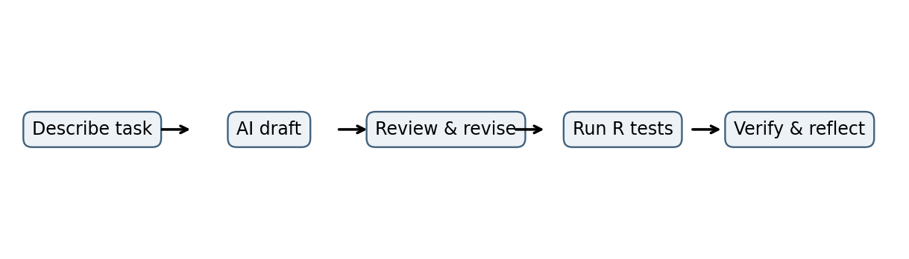Initial version and observed design limitation
The initial function uses quantile(), IQR(), and logical indexing, but lacks argument checks and does not explicitly handle missing observations. This is a code-review finding, not a claim of a witnessed RStudio error. The revised function adds missing-value handling, explicit validation, traceable removal indices, and a structured list result.
Testing and independent verification
The supplied R script contains assertions for an ordinary example, missing values, constant data, invalid input, and a comparison with boxplot.stats(). The boxplot.stats() quartile convention may differ from quantile() for some samples, so the comparison is intentionally limited to the provided example. Execute the script in RStudio and paste actual output into Test_Output_Log.txt before submitting.
Reflection
My initial prompt asked ChatGPT to create an R function that removes outliers using the interquartile range rule. The first draft was concise, but reviewing its logic revealed that missing values could interrupt the calculation and that it did not identify which observations were removed. I refined the prompts to request input validation, clearer comments, optional handling of missing data, and a structured result. This iterative approach showed me that a precise prompt can improve code readability, but it cannot replace careful reasoning about edge cases. The revised function reports quartiles, outlier fences, removed values, and their original positions, making the result easier to audit. I also learned why tests should include constant vectors, missing values, and invalid arguments rather than only a successful example. An independent comparison with a standard R function can be helpful, although differences in quartile conventions must be considered. My responsibility is to execute the script, verify the arithmetic separately, inspect the output, and document any corrections. AI is useful for generating a starting point and suggesting tests; human judgment remains essential for validation, interpretation, and accountability.
Execution evidence — student action required
Insert an authentic screenshot from RStudio showing the executed function, printed result, and final success message. Do not replace this with an AI-generated or simulated screenshot.
Line-by-line explanation and refinement record
- Function arguments define the numeric input, IQR multiplier, and missing-value policy.
- Input checks reject nonnumeric, multidimensional, invalid multiplier, and infinite inputs.
- The valid mask separates missing observations from values used to calculate quartiles.
- The 25th and 75th percentiles define IQR; the multiplier defines lower and upper fences.
- Logical masks select outliers and retained values without changing their original order.
- The named result reports cleaned data, removed values and indices, quartiles, fences, and missing count.
Step 2 short reflection
AI suggested a concise starting point for IQR-based outlier removal. Reviewing the code revealed that missing values were not handled and removed positions were not reported. The refined version adds validation, an explicit missing-value policy, and traceable results. Edge-case assertions and an independent statistical comparison were added to make errors easier to identify. I will record the actual RStudio outputs and spreadsheet cross-check before treating the results as verified.

