Testing command
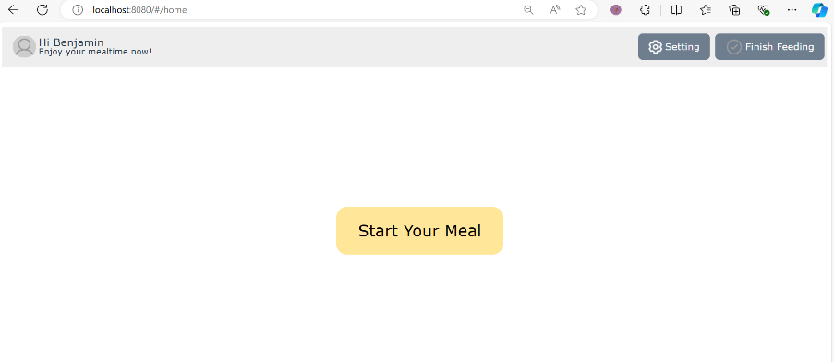
ROS Received：
data: "{\"state\":\"home\",\"status\":\"move_to_above_plate\"}"

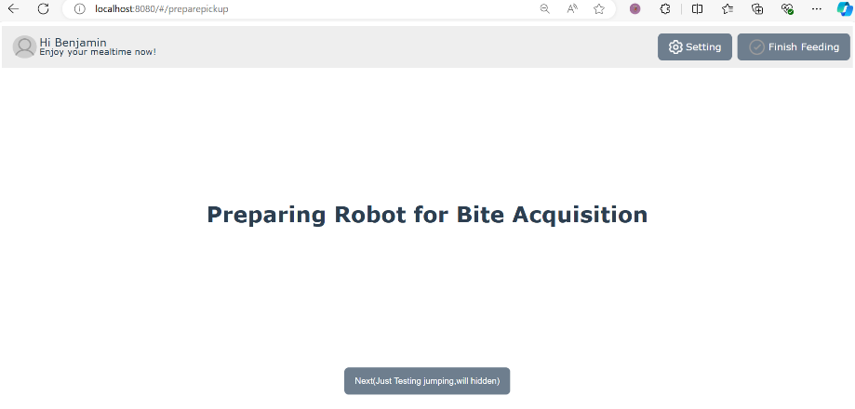
Command：
rostopic pub /ServerComm std_msgs/String "{data: '{\"state\": \"prepare_bite\", \"status\": \"completed\"}'}"

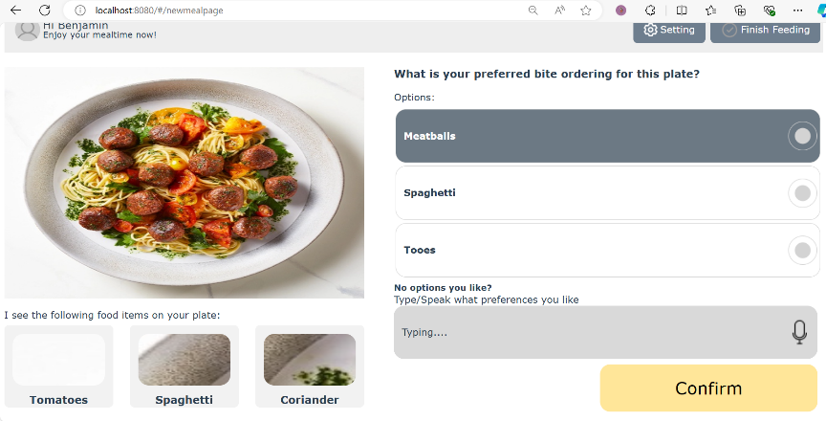
ROS Received：
data: "{\"state\":\"order_selection\",\"status\":\"ready_for_initial_data\"}"

click confirm：
data: "{\"state\":\"order_selection\",\"status\":\"Meatballs\"}"

command

Imag
rosrun video_publisher video_publisher.py

Box
rostopic pub /ServerComm std_msgs/String "{data: '{n_food_types\": 3, \"data\": [{\"Tomatoes\": [[40, 35, 50, 50], [100, 100, 60, 60], [160, 170, 70, 70]]}, {\"Spaghetti\": [[80, 120, 50, 50], [150, 180, 60, 60], [220, 240, 70, 70]]}, {\"Coriander\": [[100, 150, 50, 50], [180, 230, 60, 60], [260, 300, 70, 70]]}], \"current_bite\": {\"Spaghetti\": [[120, 150, 80, 80], [220, 250, 90, 90], [320, 350, 100, 100]]}}'}"

Options
rostopic pub /ServerComm std_msgs/String "{data: '{n_ordering\": 3, \"data\": [\"Meatballs\", \"Spaghetti\", \"Tooes\"]}'}"

rostopic pub /ServerComm std_msgs/String "{data: '{\"n_ordering\": 2, \"data\": [\"Meatballs\", \"Spaghetti\"]}'}"

rostopic pub /ServerComm std_msgs/String "{data: '{\"n_ordering\": 6, \"data\": [\"Meatballs\", \"Spaghetti\", \"Tomato\", \"Cucumber\", \"Carrot\", \"Broccoli\"]}'}"

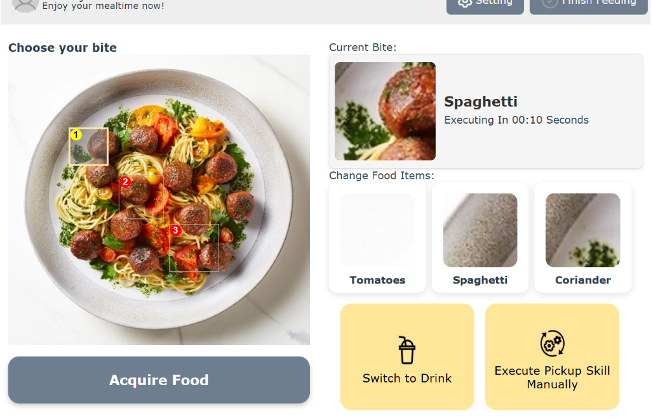
ROS Received：

data: "{\"state\":\"bite_selection\",\"status\":\"ready_for_initial_data\"}"

Click acquire food
data: "{\"state\":\"bite_selection\",\"status\":\"aquire_food\",\"data\":[\"Spaghetti\"\
,1]}"

Click switch to drink
data: "{\"state\":\"bite_selection\",\"status\":\"drink_pickup\"}"

click execute pickup and select scooping and select two positions：
data: "{\"state\":\"bite_skill_selection\",\"status\":1,\"positions\":[{\"index\":1,\"x\"\
:245.27864837646484,\"y\":205.5104217529297},{\"index\":2,\"x\":257.27864837646484,\"\
y\":360.5104217529297}]}"

command
Img
rosrun video_publisher video_publisher.py

Box
rostopic pub /ServerComm std_msgs/String "{data: '{n_food_types\": 3, \"data\": [{\"Tomatoes\": [[40, 35, 50, 50], [100, 100, 60, 60], [160, 170, 70, 70]]}, {\"Spaghetti\": [[80, 120, 50, 50], [150, 180, 60, 60], [220, 240, 70, 70]]}, {\"Coriander\": [[100, 150, 50, 50], [180, 230, 60, 60], [260, 300, 70, 70]]}], \"current_bite\": {\"Spaghetti\": [[120, 150, 80, 80], [220, 250, 90, 90], [320, 350, 100, 100]]}}'}"

rostopic pub /ServerComm std_msgs/String "{data: '{\"n_food_types\": 4, \"data\": [{\"Tomatoes\": [[40, 35, 50, 50], [100, 100, 60, 60], [160, 170, 70, 70]]}, {\"Spaghetti\": [[80, 120, 50, 50], [150, 180, 60, 60], [220, 240, 70, 70]]}, {\"Coriander\": [[100, 150, 50, 50], [180, 230, 60, 60], [260, 300, 70, 70]]}, {\"Carrot\": [[90, 130, 50, 50], [170, 200, 60, 60], [250, 270, 70, 70]]}], \"current_bite\": {\"Tomatoes\": [[120, 150, 80, 80], [220, 250, 90, 90], [320, 350, 100, 100]]}}'}"

rostopic pub /ServerComm std_msgs/String "{data: '{\"n_food_types\": 2, \"data\": [{\"T\": [[40, 35, 50, 50], [100, 100, 60, 60], [160, 170, 70, 70]]}, {\"Spaghetti\": [[80, 120, 50, 50], [150, 180, 60, 60], [220, 240, 70, 70]]}], \"current_bite\": {\"Tomatoes\": [[120, 150, 80, 80], [220, 250, 90, 90], [320, 350, 100, 100]]}}'}"

rostopic pub /ServerComm std_msgs/String "{data: '{\"n_food_types\": 4, \"data\": [{\"GoodRedTomato\": [[40, 35, 50, 50], [100, 100, 60, 60], [160, 170, 70, 70]]}, {\"VeryLongSpaghettiNameForTestingPurpose\": [[80, 120, 50, 50], [150, 180, 60, 60], [220, 240, 70, 70]]}, {\"Coriander\": [[100, 150, 50, 50], [180, 230, 60, 60], [260, 300, 70, 70]]}, {\"Carrot\": [[120, 160, 50, 50], [200, 260, 60, 60], [290, 330, 70, 70]]}], \"current_bite\": {\"GoodRedTomato\": [[120, 150, 80, 80], [220, 250, 90, 90], [320, 350, 100, 100]]}}'}"

Bite
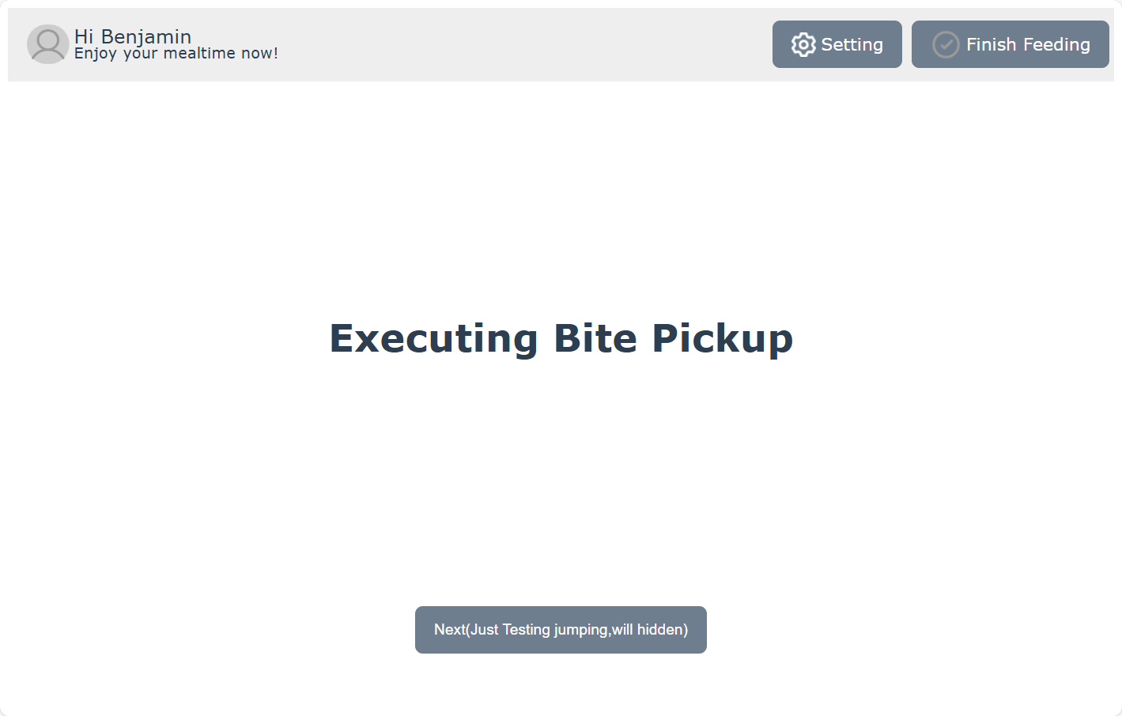
rostopic pub /ServerComm std_msgs/String "{data: '{\"state\": \"bite_pickup\", \"status\": \"completed\"}'}"
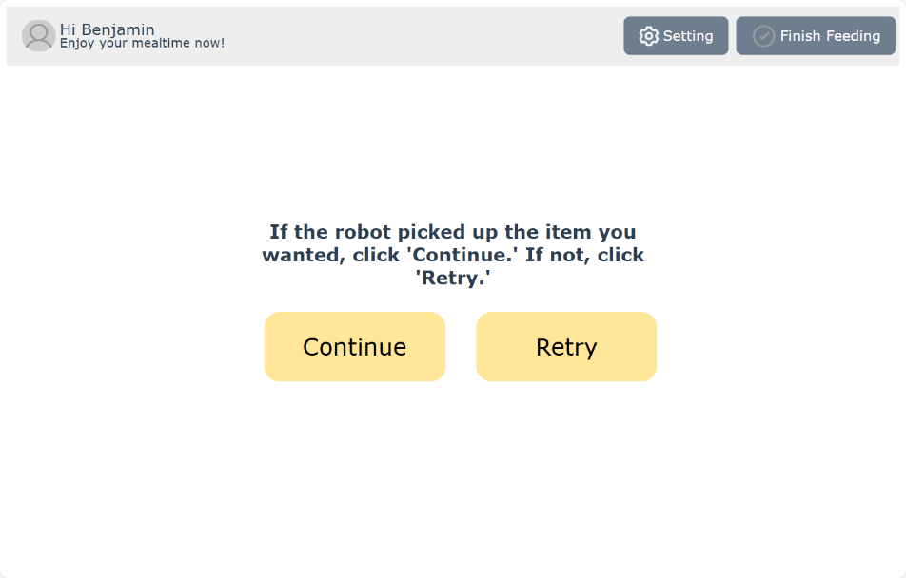
Click continue
data: "{\"state\":\"post_bite_pickup\",\"status\":\"bite_transfer\"}"

click retry
data: "{\"state\":\"post_bite_pickup\",\"status\":\"return_to_main\"}"

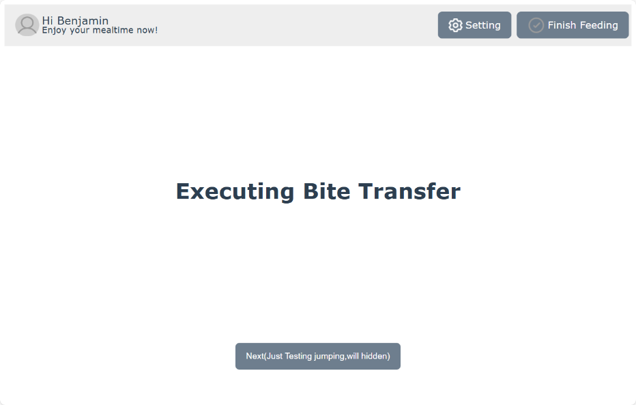
rostopic pub /ServerComm std_msgs/String "{data: '{\"state\": \"bite_transfer\", \"status\": \"completed\"}'}"

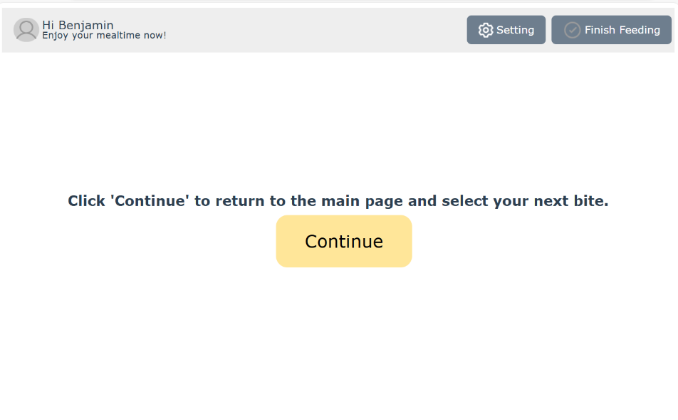
data: "{\"state\":\"post_bite_transfer\",\"status\":\"return_to_main\"}"

Drinking
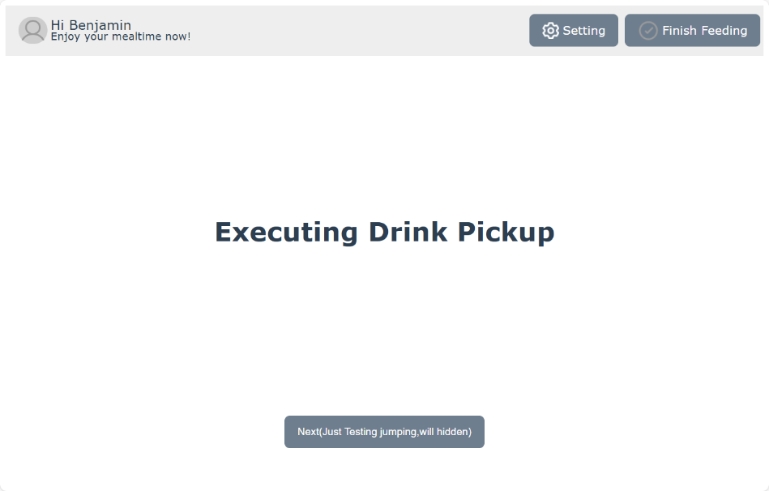
rostopic pub /ServerComm std_msgs/String "{data: '{\"state\": \"drink_pickup\", \"status\": \"completed\"}'}"

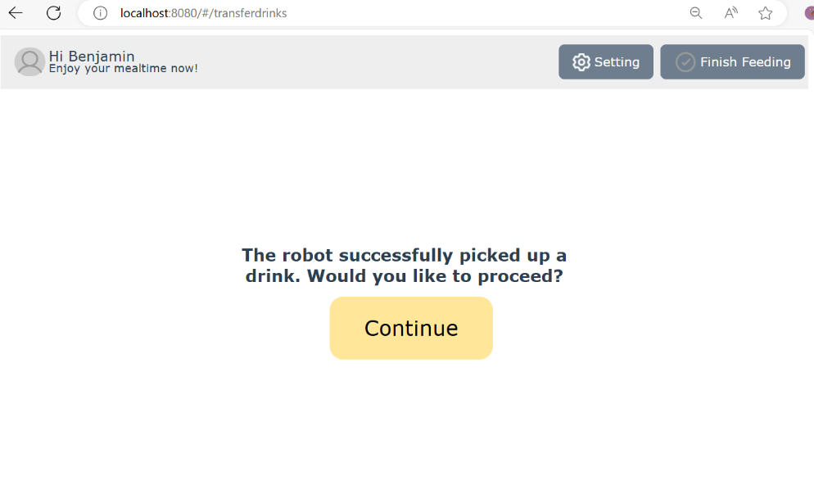

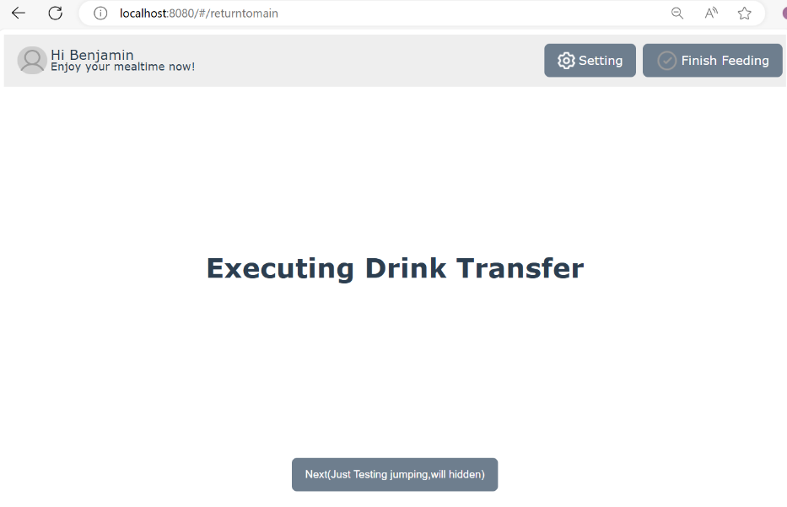
rostopic pub /ServerComm std_msgs/String "{data: '{\"state\": \"drink_transfer\", \"status\": \"completed\"}'}"

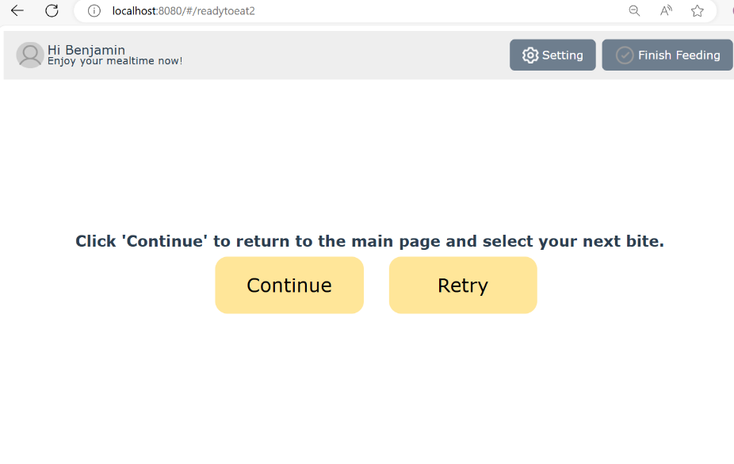

Other：
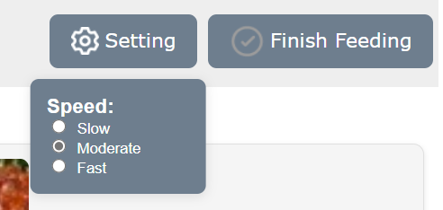
Click finish feeding
data: "{\"status\":\"finish_feeding\"}"

click setting---select moderate---close
data: "{\"command\":\"set_speed\",\"value\":\"moderate\"}"

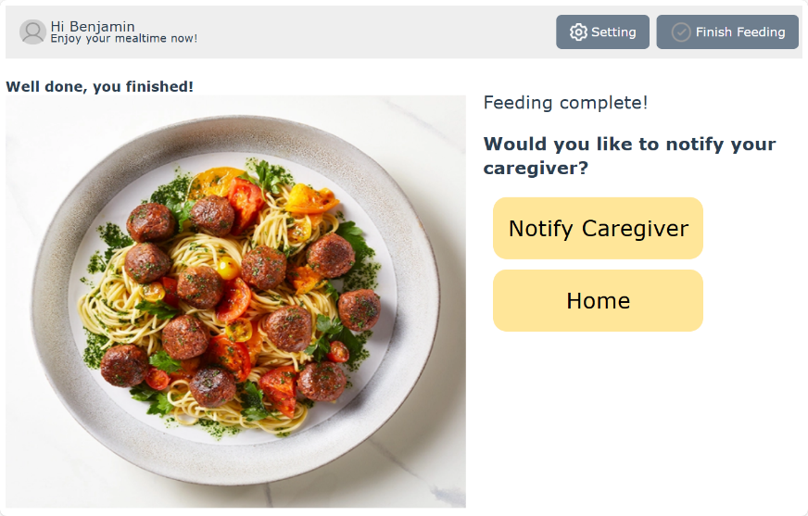
Click notify
data: "{\"status\":\"call_caregiver\"}"

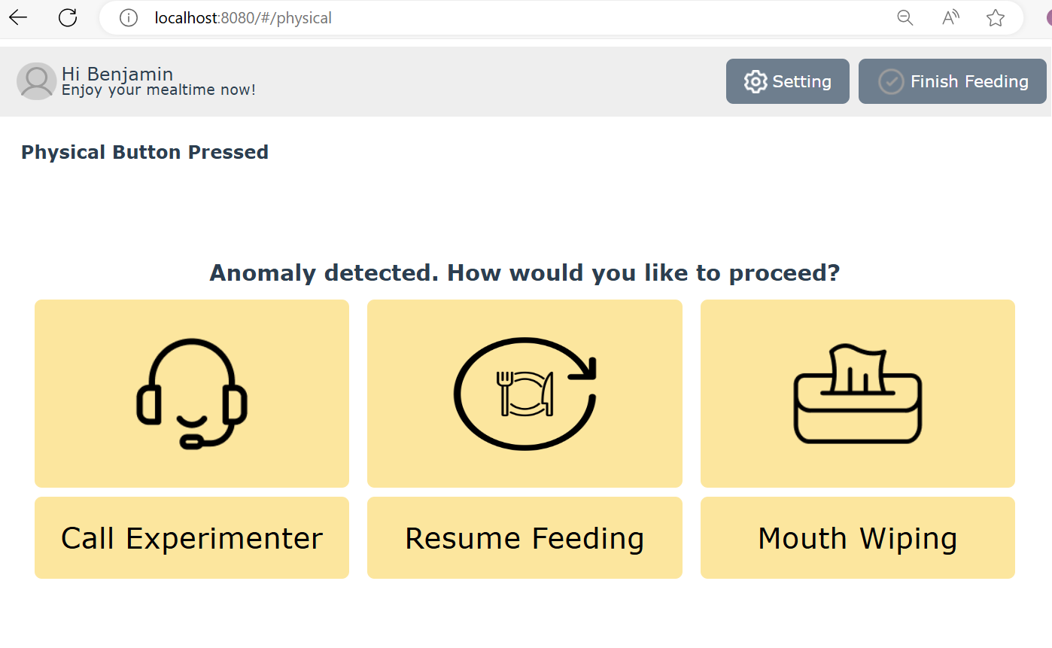
rostopic pub /ServerComm std_msgs/String "{data: '{\"state\": \"emergency_stop\", \"status\": \"completed\"}'}"

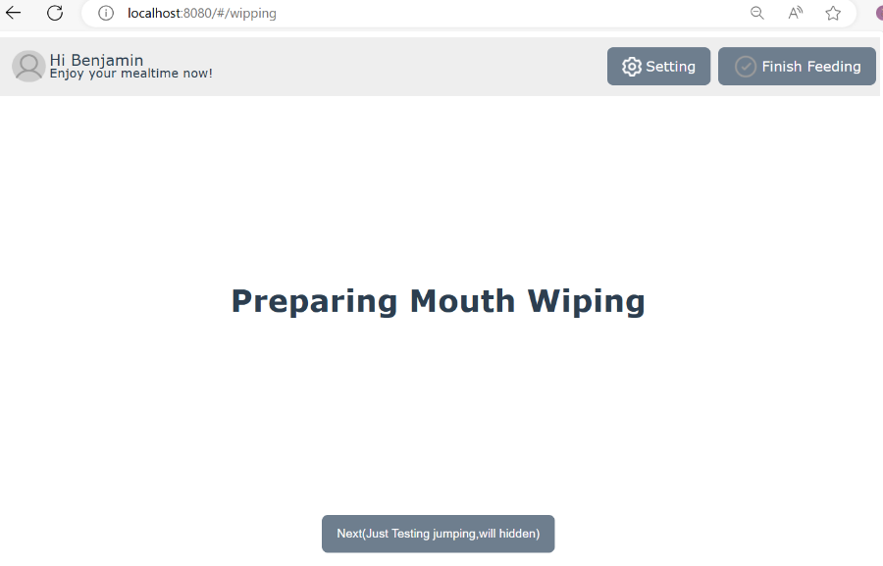
rostopic pub /ServerComm std_msgs/String "{data: '{\"state\": \"prepare_mouth_wiping\", \"status\": \"completed\"}'}"
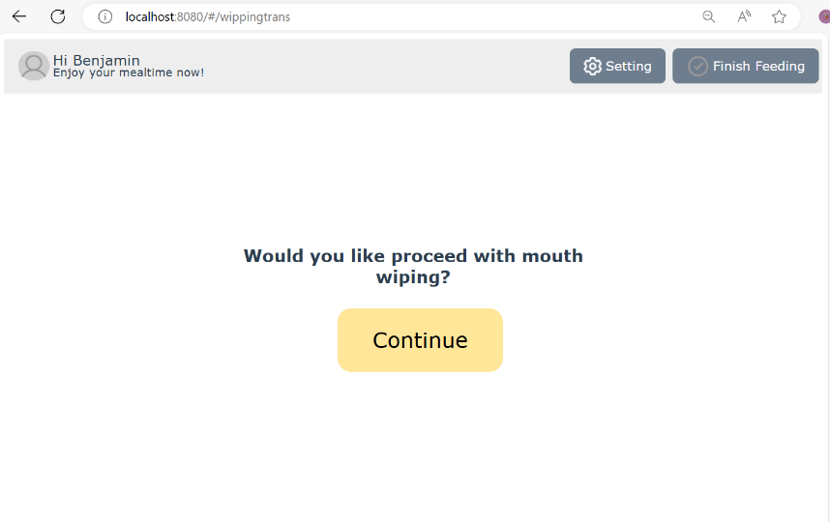

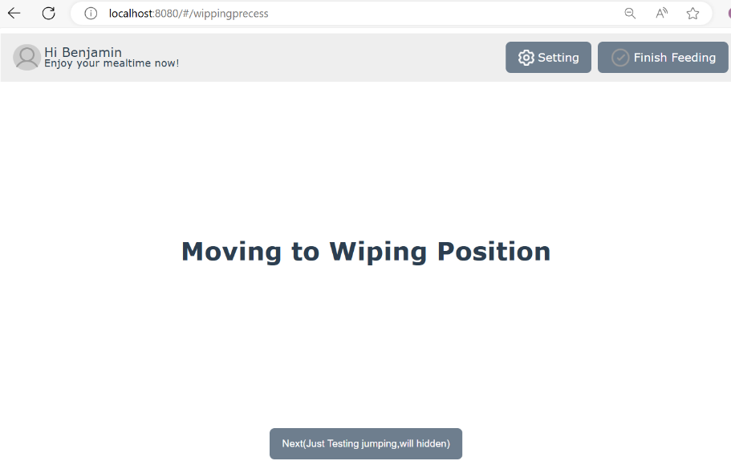
rostopic pub /ServerComm std_msgs/String "{data: '{\"state\": \"moved_to_wiping_position\", \"status\": \"completed\"}'}"

