HIK Thermal Camera Viewer
Neural Network Target Detection
Technical Overview for Colleagues

Build: 2026-03-29 | Raspberry Pi 5 | Hikvision USB Thermal Camera

1. What Is This Software?
The HIK Thermal Camera Viewer is a real-time thermal imaging application running on a Raspberry Pi 5. It connects to a Hikvision USB thermal camera and automatically detects, prioritises, and tracks small hot objects moving independently within the scene.
It uses a custom neural network to score every candidate object in every frame, with heavy emphasis on independent motion and small size. The system is designed to reject false positives — if nothing genuinely interesting is present, it correctly reports "no target" rather than locking onto background noise.
Key capabilities:
- Live thermal display at 25 fps with per-pixel absolute temperature
- Neural network scoring: 7 features → 10 hidden neurons → priority score
- False positive rejection: minimum score (200) and minimum motion (0.8) thresholds
- Sticky lock: once acquired, holds through occlusion for up to 3 seconds
- Trajectory prediction with frame-exit detection
- Video recording (raw + annotated) and replay with scrub slider
- Replay auto-saves annotated output for post-analysis

2. Processing Pipeline
Every frame passes through seven stages, running 25 times per second:
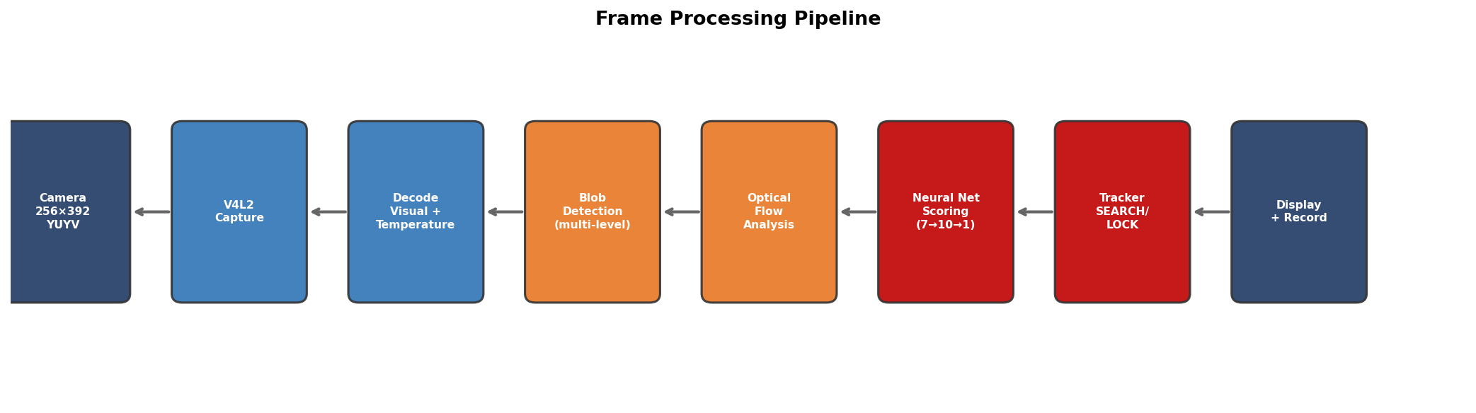
- Camera Capture: Raw V4L2 capture of 256×392 YUYV frames containing both visual and temperature data.
- Decode: Split into visual image (192 rows) and temperature grid (192 rows of big-endian uint16, formula: T = u16/100 − 273.15).
- Multi-Level Blob Detection: Finds hot regions using adaptive statistical thresholding: tries mean+2.5σ first (without morphological opening, to preserve tiny targets), falls back to 90th percentile. Blobs over 1500 pixels are suppressed — they are background, not targets.
- Optical Flow Analysis: Farneback dense optical flow computes per-pixel motion. Background camera motion (median flow) is subtracted to isolate independent movement of each blob.
- Neural Network Scoring: Each blob receives a priority score from a 7→10→1 feedforward network. Motion is amplified 5× and multiplied by inverse size, so small moving blobs massively outscores large static areas.
- Two-State Tracker: SEARCHING confirms the best blob after 0.5s of stability. LOCKED follows via velocity prediction with a tight 20px search radius to prevent jumping.
- Display + Record: Annotated image with target markers, candidate panel, position graphs. Recording saves raw + annotated simultaneously.

3. The Neural Network
The core intelligence is a feedforward neural network (7 inputs → 10 hidden ReLU neurons → 1 output) that scores every candidate blob. Blobs scoring below 200 are rejected entirely — "no target" is an acceptable answer.

The Seven Input Features
Size (inverse): 1/(1 + area/25). A 20-pixel blob = 0.56; a 1000-pixel region = 0.024. Smaller is dramatically better.
Independent Motion (size-gated): Raw optical flow is amplified 5× then multiplied by size inverse × 5. A small 20px blob moving at 0.5 px/frame → effective motion 5.5. A 1000px region at 1.0 px/frame → effective 0.6. The small blob wins 9×.
Growth Rate: Linear regression of area over time for nearby blobs. Positive = approaching (getting larger). Computed from 150 entries of size history.
Temperature Ratio: Blob mean temperature / frame maximum. A tiebreaker, not a primary selector.
Thermal Contrast: Standard deviations above frame mean. Helps detect faint targets against a cool background.
Centering: 1 − (distance to image centre / max possible distance). Rewards targets on an approach trajectory toward the camera.
Motion History: EMA of past motion per spatial bucket (α=0.7). A blob that moved strongly a few seconds ago keeps scoring even if it momentarily pauses.

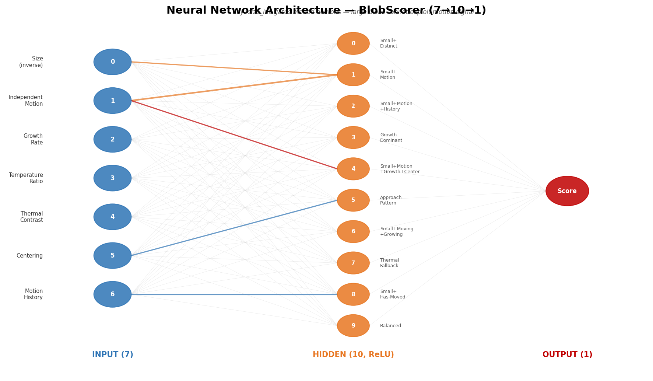
Figure: Neural network architecture. Size gates the motion neurons so large blobs cannot exploit the motion signal.

Why This Works
In testing, a real small moving target (area 15, motion 0.85) scores 600–850. A large static warm region (area 3000+, motion 0.0) scores 0–30. The minimum score threshold of 200 sits cleanly between these ranges, eliminating false positives while catching all real targets.
The minimum motion threshold (0.8) provides a second line of defence: even if noise creates a moderately high score, a blob with no real independent motion is rejected before lock can be acquired.

4. Object Tracking
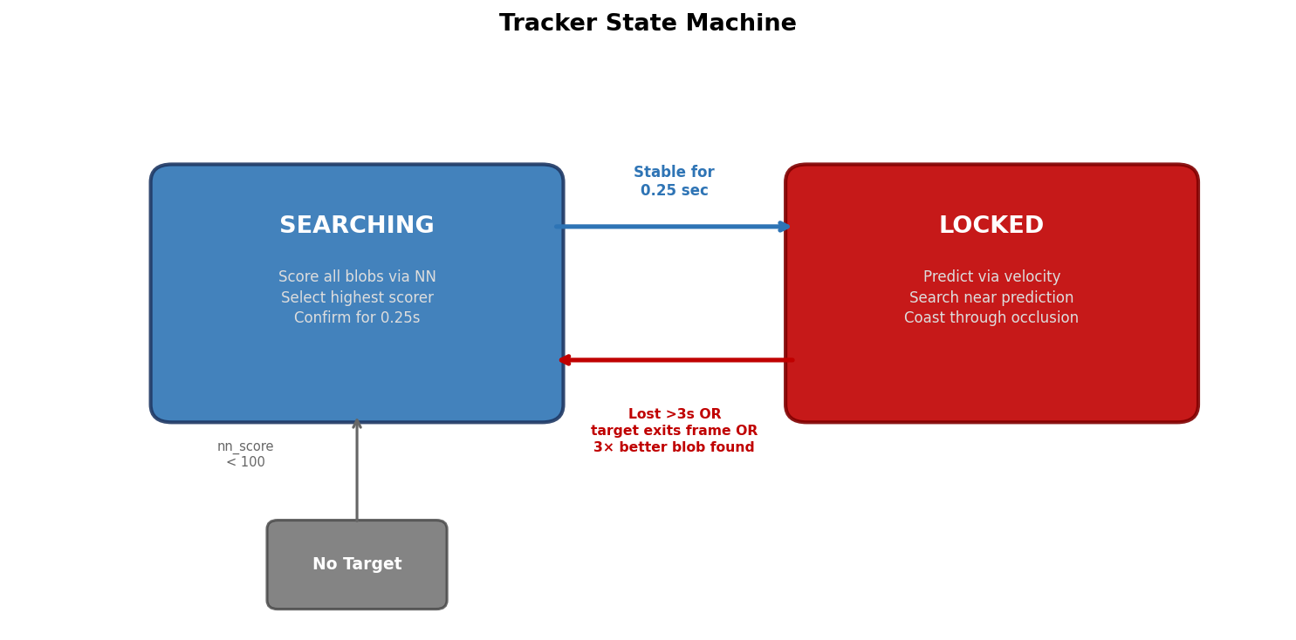

SEARCHING: Finding a Target
The tracker evaluates all blobs every frame. To acquire lock, a blob must:
- Score ≥ 200 in the neural network (rejects background noise)
- Have independent motion ≥ 0.8 (rejects static hot regions)
- Maintain a stable position (within 20px, relaxed to 50px for high scorers) for 0.5 seconds
If no blob meets all three criteria, the system reports "no target found" — this is correct behaviour, not a failure.

LOCKED: Following a Target
Once locked, the tracker is deliberately sticky — it resists switching targets:
- Tight search radius (20px) around the velocity-predicted position prevents jumping to nearby hot spots
- Distance penalty of 1.5× in the scoring heavily penalises blobs far from the predicted position
- Preemption requires a 5× score advantage — only overwhelmingly better targets break lock
- Velocity is smoothed with α=0.75 EMA, reducing jitter

Releasing Lock
Lock is released when:
- The predicted trajectory exits the frame (5px margin) — the target has left
- No matching blob found for 3 seconds (coasting timeout)
- The target becomes stationary (speed < 0.5 and motion < 0.3 for 2+ seconds)
- A blob elsewhere scores 5× better (preemption)

5. The Display
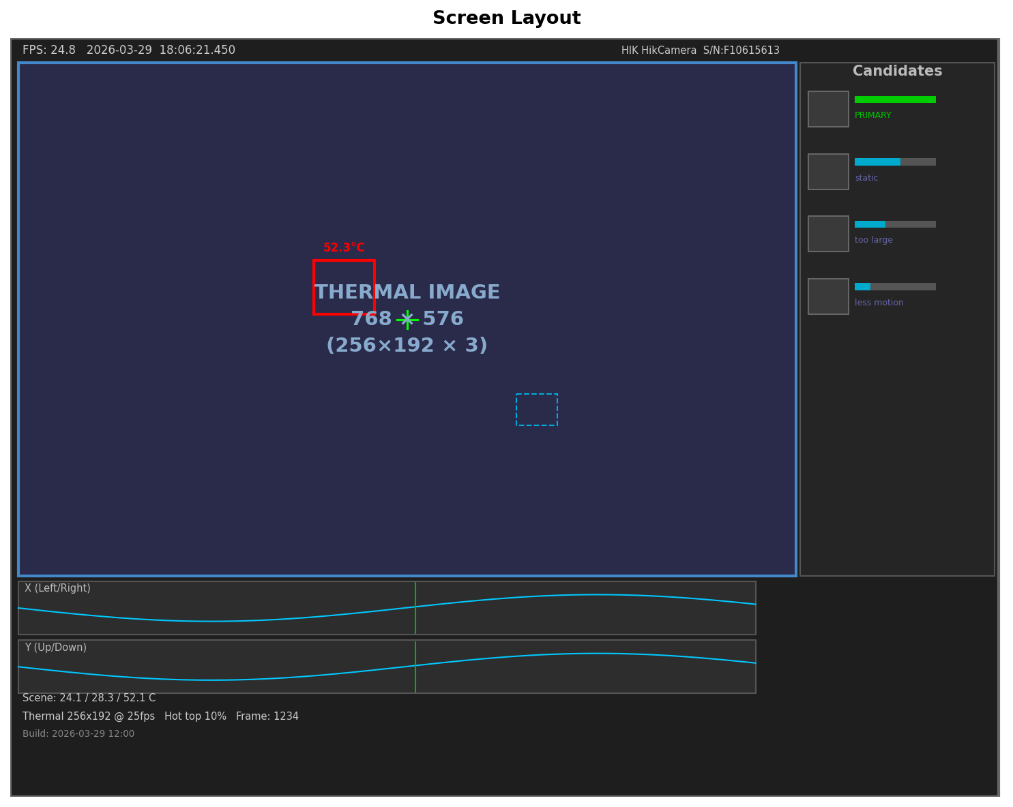
The thermal image is never obscured — all information is in the margins:
- Thermal image: greyscale with adaptive colour only for genuine statistical outliers (mean + 3σ)
- Red box + crosshair = locked primary target; blue dotted boxes = other candidates
- Right panel: top 6 candidates with thumbnails, probability bars, feature values, and rejection reasons (e.g., "static", "too large", "less motion")
- Candidate thumbnails persist for 3 seconds after disappearing, with fade effect
- Position graphs: 30-second history of X/Y with green markers at target changes

6. Recording and Replay

Recording
Press R to start/stop. Each session creates a folder:
thermal_recordings/run_YYYY-MM-DD_HH-MM-SS/
- raw_<timestamp>_build-<version>.avi — clean thermal image, no overlay
- annotated_<timestamp>_build-<version>.avi — full display with all annotations

Replay
Press O or P during live mode, or use --replay from the command line. A dialog offers:
- Browse... — file chooser
- Last Recorded — opens the most recent recording
- Last Replayed — re-opens the previously played file (persisted across sessions)
Replay features:
- Slider/trackbar for scrubbing to any frame position
- Space = play/pause, < > = step frame by frame
- Auto-saves annotated replay as <source>_REPLAY.avi alongside the original
- Full neural net + tracker pipeline runs on every frame for performance assessment
- Press O during replay to open a different file

7. Keyboard Controls

Live Mode
Key | Action
Q | Quit
F | Toggle fullscreen
T | Toggle temperature display
R | Start / stop recording
O / P | Open replay file browser
S | Save screenshot
K | Set hot calibration (80°C)
A | Set ambient calibration (22°C)
0 | Reset calibration
D | Diagnostic dump to terminal

Replay Mode
Key | Action
Q | Quit replay
F | Toggle fullscreen
Space | Play / pause
. (period) | Step forward one frame
, (comma) | Step backward one frame
O | Open different file
Slider | Drag to scrub to any position

8. Key Design Decisions
No target is better than a false positive: The MIN_SCORE (200) and MIN_MOTION (0.8) thresholds mean the system stays silent when nothing interesting is present. In testing, static hot regions score 0–105 while real targets score 600+. The gap is clean.
Size-gated motion: Without this, a 1000-pixel warm wall with slight camera shake scores higher than a 20-pixel moving target. Multiplying motion by inverse size gives the small target a 9× advantage.
Sticky lock, hard to break: Once a target is confirmed (0.5s stability, motion > 0.8, score > 200), the tracker becomes deliberately resistant to switching. Tight 20px search radius, heavy 1.5× distance penalty, and 5× preemption ratio keep it on target through noise and partial occlusion.
Multi-level blob detection: Simple "top 10%" thresholding merges a small bright target with a warm background it passes through. Statistical thresholding (mean + 2.5σ) without morphological opening isolates the bright peak — this was critical for tracking targets through larger warm regions.
Trajectory exit detection: When the velocity-predicted position leaves the frame, the target has departed. This cleanly ends tracking without a long timeout, typically within 1–2 seconds of the target exiting.
Replay saves annotated output: Every replay session automatically saves its annotated video as <source>_REPLAY.avi, creating a permanent record of how the neural network performed on that footage for later review.

9. Tunable Constants
Constant | Value | Effect
BLOB_MIN_AREA | 9 | Minimum blob size (3×3 pixels)
BLOB_MAX_AREA | 1500 | Blobs larger than this are suppressed entirely
MIN_SCORE | 200 | Neural net score floor — below this, blob is rejected
MIN_MOTION | 0.8 | Minimum independent motion to confirm lock
CONFIRM_SECS | 0.5 | Seconds of stability before lock is acquired
SEARCH_RADIUS | 20 | Pixel radius to search around predicted position when locked
MAX_MISS_SECS | 3.0 | Seconds to coast through occlusion before releasing lock
PREEMPT_RATIO | 5.0 | Must score 5× better to break an existing lock
VEL_ALPHA | 0.75 | Velocity smoothing (higher = smoother, less jitter)
PANEL_STICKY | 3.0 | Seconds a candidate stays in the panel after disappearing
GRAPH_SECS | 30 | Seconds of position history shown in graphs
HOT_DISPLAY_PCT | 90 | Percentile for colour display (combined with mean+3σ)

